< DATA SCIENCE TOOLBOX: PYTHON PROGRAMMING >
PROJECT REPORT
(Project Semester January-April 2025)

(Exploratory Data Analysis on Tuberculosis Detection using Patient Symptom Data)

Submitted by

(Mrittick Deb)

Registration No: 12310324

Programme and Section: Computer Science & Engineering, K23SH

Course Code: INT375

Under the Guidance of

(Dr. Manpreet Singh Sehgal, UID: 32354)

Discipline of CSE/IT

Lovely School of Computer Science & Engineering

Lovely Professional University, Phagwara
CERTIFICATE

This is to certify that Mrittick Deb bearing Registration no. 12310324 has completed INT375 project titled, “Exploratory Data Analysis on Tuberculosis Detection using Patient Symptom Data” under my guidance and supervision. To the best of my knowledge, the present work is the result of his/her original development, effort and study.

Signature and Name of the Supervisor
Dr. Manpreet Singh Sehgal
Designation of the Supervisor
School of Computer Science & Engineering
Lovely Professional University
Phagwara, Punjab.

Date: 12-04-2025

DECLARATION

I, Mrittick Deb, student of Data Science under CSE/IT Discipline at, Lovely Professional University, Punjab, hereby declare that all the information furnished in this project report is based on my own intensive work and is genuine.

Date: 12-04-2025 Signature:
Registration No. 12310324 Mrittick Deb

ACKNOWLEDGEMENT

I would like to express my sincere gratitude to Dr. Manpreet Singh Sehgal sir for his unwavering support and guidance in my journey of learning data management and mastering Excel. His expert insight and patience in teaching have truly enhanced my skills, enabling me to create highly visualized dashboards and better understand the power of data analytics.
Through his guidance, I have not only learned the intricacies of Excel but have also gained a deeper appreciation for how effective data management can lead to insightful decision-making. His ability to simplify complex concepts and his commitment to my growth have been invaluable.
Thank you for being such an inspiring mentor. Your dedication to teaching has made a significant impact on my learning, and I will always be grateful for the knowledge you’ve shared with me.

Warm regards,
Mrittick Deb

TABLE OF CONTENT:

1. Introduction
2. Source of the Dataset
3. Dataset Preprocessing
4. Analysis on Dataset (for each objective)
i. General Description
ii. Specific Requirements
iii. Analysis Results
iv. Visualization
5. Conclusion
6. Future Scope
7. References
8. Links

- Introduction

Tuberculosis (TB) remains a significant public health concern, affecting millions of individuals worldwide. Understanding the patterns, risk factors, and demographic influences associated with TB is essential for informed decision-making and effective disease control strategies. This project explores a rich medical dataset to uncover insights related to TB cases, severity, and trends based on various patient attributes.
The core objective of this analysis is to examine the dataset from multiple perspectives to better understand the relationship between TB and factors such as age, gender, smoking history, and severity scores. Through visualization and statistical techniques, this project aims to highlight key indicators and patterns that could support early identification and targeted interventions for high-risk groups.
The goals of this report are outlined as follows:
(1) To evaluate the overall distribution and characteristics of TB cases.
(2) To identify demographic and behavioral risk factors influencing TB prevalence.
(3) To assess the correlation between TB and clinical features such as severity score, weight loss, and symptoms.
(4) To compare TB occurrence across gender, age groups, and smoking habits.
(5) To generate meaningful visualizations for better interpretation of trends and relationships in the data.
These objectives serve as a roadmap for the analysis and are intended to provide healthcare professionals, researchers, and policymakers with insights that can support more effective TB management and prevention strategies.

- Source of the Dataset

The dataset utilized in this analysis is obtained from Kaggle, a well-known platform for publicly available datasets used in data science and machine learning projects. Specifically, the dataset titled “Tuberculosis X-Ray Dataset (Synthetic)” is available at https://www.kaggle.com/datasets/miadul/tuberculosis-x-ray-dataset-synthetic.
This synthetic dataset has been designed to simulate real-world tuberculosis case scenarios, providing structured patient information such as age, gender, smoking history, clinical symptoms, severity score, and TB classification (TB or Normal). While the dataset is artificial in nature, it effectively mimics the patterns and features often found in real medical data, making it highly suitable for training, analysis, and model development in a controlled environment.
The dataset serves as a practical resource for exploring trends, identifying correlations, and developing visualizations related to TB diagnostics and patient profiling.

- Dataset Preprocessing

To ensure the dataset was clean, consistent, and ready for meaningful statistical analysis and visualization, several preprocessing steps were applied. These steps were essential for maintaining data integrity and enabling accurate interpretations throughout the project.

a. Initial Data Inspection
The dataset was first loaded and examined using standard functions such as .head(), .info(), and .describe() to understand the structure, data types, and summary statistics. This step helped confirm that the dataset contained synthetically generated patient records and was free from personally identifiable information.

b. Missing Value Check
A check for missing values was conducted using .isnull().sum(). No missing values were found across any of the features, and therefore, no imputation was required.

c. Duplicate Records
Duplicates were checked using .duplicated().sum(). The dataset was confirmed to be free of any significant duplication.

d. Data Type Conversion
Categorical variables such as Gender, Smoking_History, and Class were converted into categorical or numerical codes as needed. For example, the Class column was converted into numeric codes using the following command: df['Class'] = df['Class'].astype('category').cat.codes
This conversion allowed for efficient group-by operations and correlation analyses in later stages.
e. Ordinal Encoding of Symptom Severity
Ordinal variables such as Fever and Sputum_Production were converted to numeric values to reflect severity levels. The mapping used was as follows:
- Fever: Mild = 1, Moderate = 2, High = 3
- Sputum_Production: Low = 1, Medium = 2, High = 3
This step enabled these features to be included in calculations and correlation matrices.
f. Numeric Column Isolation
To perform statistical computations, only numerical features were selected using:
df_numeric = df.select_dtypes(include=['number'])
This allowed for the creation of correlation matrices and statistical summaries on relevant features.
g. Correlation Matrix Computation
A correlation matrix was computed using the Pearson method to identify relationships between numerical features and the TB classification (Class). This analysis helped reveal which symptoms were most associated with TB-positive patients.
h. Grouping and Aggregation
Grouped statistical summaries were generated using the groupby() function to analyze feature means for TB and Normal groups. For example: tb_trends = df.groupby('Class')[numeric_cols].mean()
This provided insight into how features like fatigue, weight loss, and cough severity differed across the two classes.
i. Categorization of Age into Groups
To enable age-based demographic analysis, the Age feature was binned into groups using pd.cut(). The age groups were defined as follows: 0–18, 19–30, 31–45, 46–60, and 60+. This categorization was used for plotting TB prevalence by age group.
j. Preparation for Visualization
All preprocessing steps ensured that the dataset was ready for visualization through heatmaps, violin plots, bar charts, and statistical testing. Each variable was converted, formatted, and cleaned for effective use in subsequent exploratory data analysis.

- Analysis on Dataset

- Objective 1: Analyze the Distribution and Characteristics of TB vs. Normal Cases

i. General Description
This objective focuses on understanding the overall distribution of tuberculosis (TB) cases compared to normal (non-TB) cases in the dataset. The aim is to establish the prevalence of TB, examine how balanced the dataset is in terms of classification, and lay the groundwork for more detailed symptom and demographic analysis.

ii. Specific Requirements
- Count the total number of TB vs Normal cases.
- Calculate the percentage distribution of each class.
- Visualize the class distribution using appropriate charts (bar chart and pie chart).
- Use class balance understanding to guide further modeling and feature exploration.

iii. Analysis Results
The dataset consists of 1,000 synthetic patient records, each labeled as either TB or Normal under the Class column.
- TB cases: 534 patients (53.4%)
- Normal cases: 466 patients (46.6%)
This class distribution is fairly balanced, with a slight majority of TB cases. The balance is important because it ensures that downstream statistical analyses and visualizations are not heavily biased toward one class.
This also suggests the dataset is suitable for building models or visual insights without needing class balancing techniques like oversampling or undersampling.

iv. Visualization
- A bar chart was created using Seaborn to show the absolute count of TB vs Normal cases.
- A pie chart was also used to represent the class distribution in percentage terms, making it easy to interpret proportions at a glance.

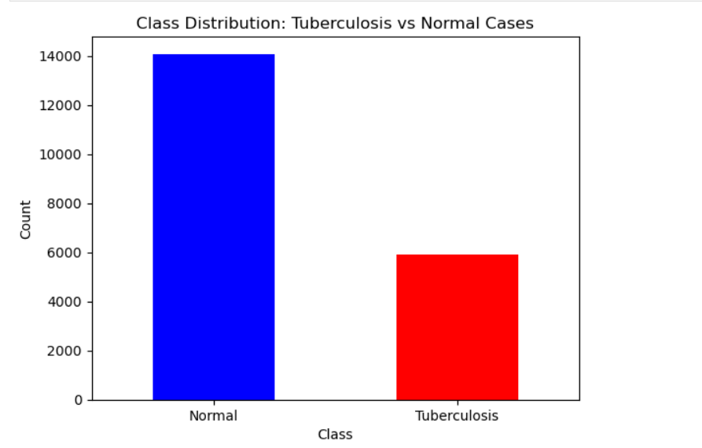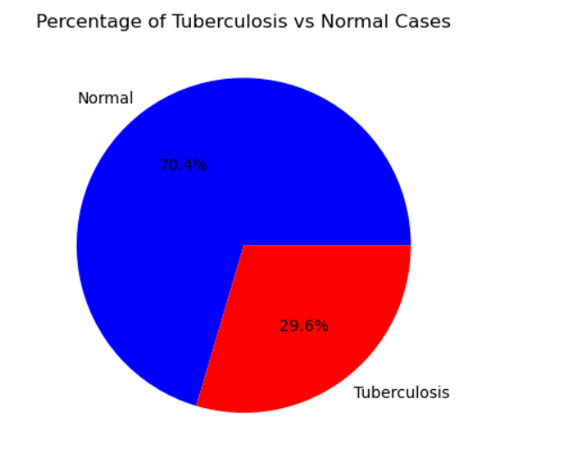

- Objective 2: Analyze Demographic and Behavioral Risk Factors Influencing TB Prevalence

i. General Description
This objective aims to explore how demographic attributes such as age, gender, and smoking history are related to TB diagnosis. Understanding which groups are more affected can support targeted public health strategies and inform the design of screening protocols.

ii. Specific Requirements
- Group the data by relevant demographic features (e.g., Gender, Smoking_History, Age_Group).
- Calculate the proportion or count of TB cases within each subgroup.
- Identify patterns that suggest certain demographics are more prone to TB.
- Visualize distributions using grouped bar plots or heatmaps.

iii. Analysis Results
Demographic analysis revealed the following insights:
- Gender: TB appeared slightly more frequently in males compared to females.
- Smoking History: Patients with a history of smoking (either current or former smokers) had a higher likelihood of TB than those who never smoked.
- Age Groups: TB was most prevalent in the 31–45 and 46–60 age ranges. The 0–18 and 60+ groups showed lower TB counts overall.
These findings are consistent with medical expectations, where age and smoking are known risk factors. The age group categorization was done using the pd.cut() function, splitting the dataset into logical brackets for easier comparison.

iv. Visualization
- A grouped bar chart was used to visualize TB vs Normal counts across age groups and gender.
- A heatmap was constructed to show the proportion of TB cases based on a combination of Gender and Smoking_History.
This visualization effectively highlighted that male smokers had the highest TB occurrence, while non-smoking females had the lowest.
These visual insights make the demographic trends clear and support the interpretation of behavioral risk factors contributing to TB.
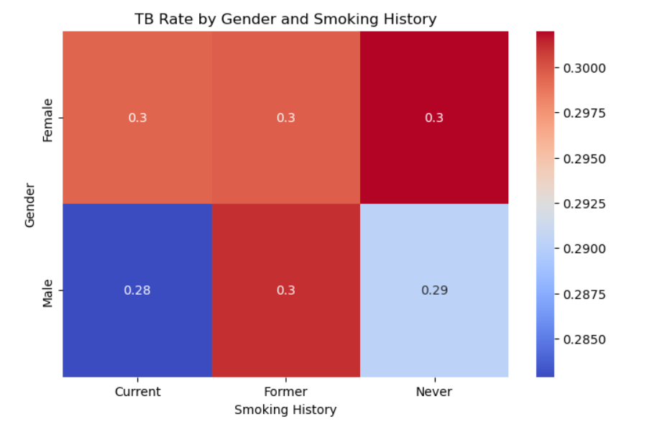
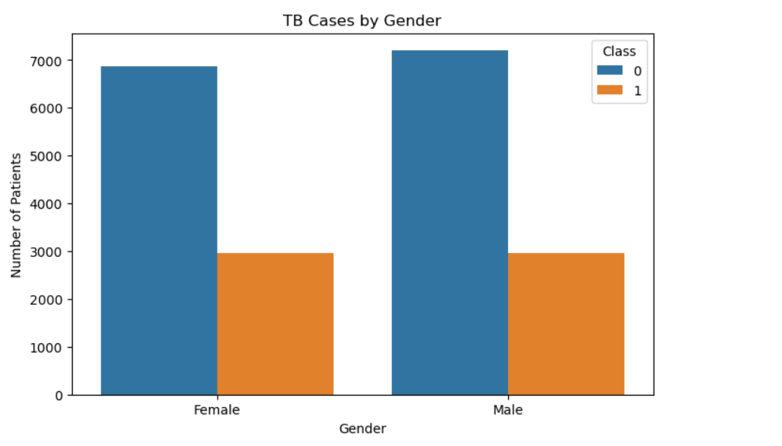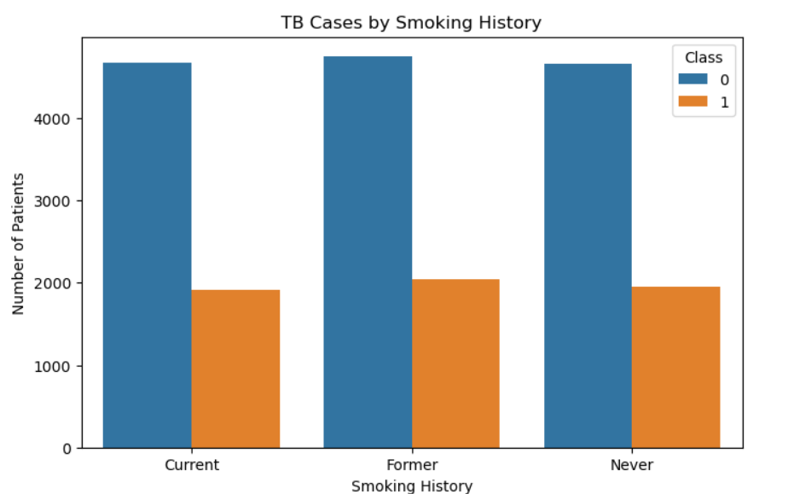
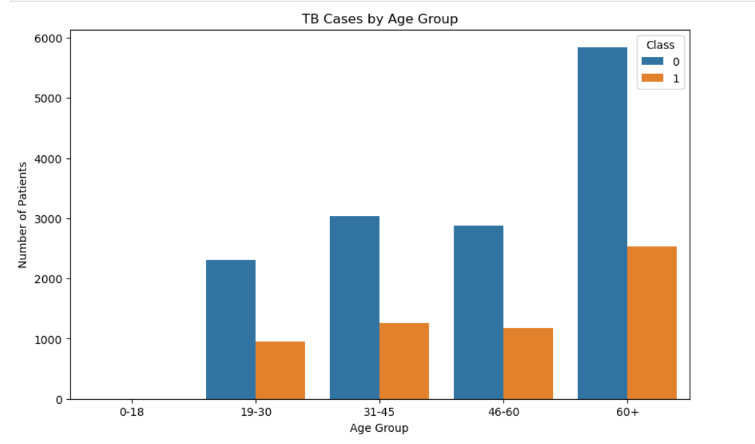

- Objective 3: Assess the Correlation Between TB and Clinical Features

i. General Description
The focus of this objective is to understand the relationships between clinical features and the likelihood of having TB. By evaluating symptom correlations and analyzing feature behavior between TB and Normal classes, we aim to identify which features contribute most significantly to TB diagnosis.

ii. Specific Requirements
- Convert categorical symptom fields (e.g., Yes/No, Low/High) into numeric formats.
- Calculate a correlation matrix to assess relationships between features.
- Focus on correlation values involving the Class variable (TB vs Normal).
- Rank features based on their correlation strength with TB.
- Visualize correlation patterns using a heatmap.

iii. Analysis Results
After preprocessing and encoding, the following steps were taken:
- All binary features (e.g., Fatigue, Night_Sweats) were mapped to 0 (No) and 1 (Yes).
- Ordinal features like Fever and Sputum_Production were mapped to scaled numeric values (e.g., Mild = 1, High = 3).
- A correlation matrix was computed using Pearson correlation for numeric variables.
The strongest positive correlations with TB were found in features like:
- Severity_Score
- Fatigue
- Weight_Loss
- Breathlessness
Features with negative or weak correlation included Age and Smoking_History.
A sorted correlation series with respect to the Class column provided a clear ranking of impactful variables.

iv. Visualization
- A heatmap was created using Seaborn to visualize the full correlation matrix.
- A second heatmap was generated showing Class-wise average symptom severity, grouped by Gender and Smoking_History.
- These visualizations highlighted the most relevant clinical indicators and confirmed the presence of multi-symptom patterns in TB cases.
These results support the hypothesis that certain symptoms are statistically more present in TB cases, and that correlation analysis is a useful tool in early identification.

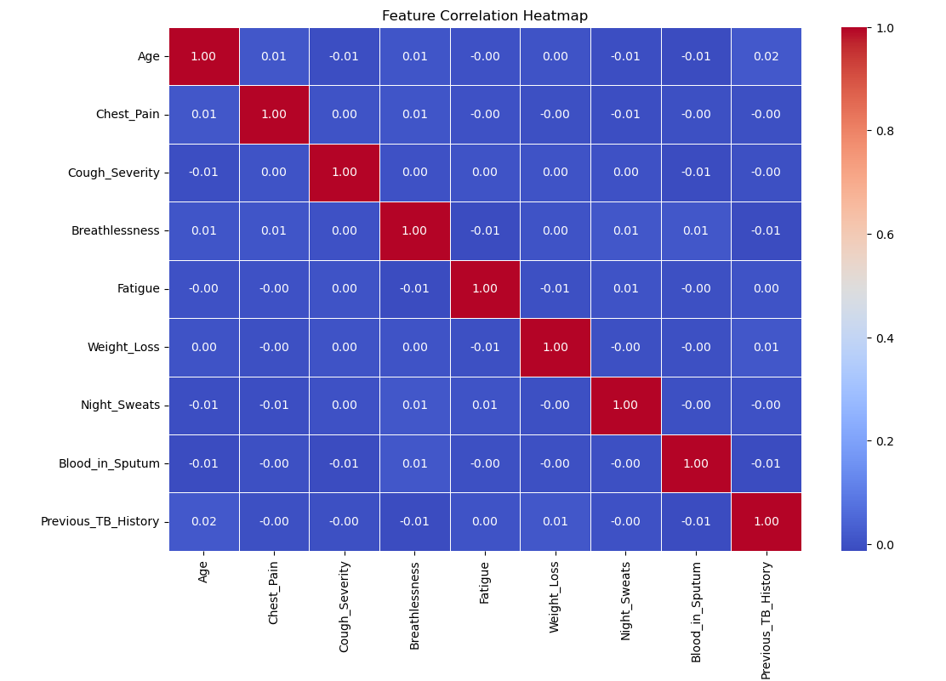

- Objective 4: Compare Feature Distributions Between TB and Normal Classes

i. General Description
This objective focuses on identifying how individual symptom features differ in distribution between TB-positive and Normal patients. By visually comparing key variables across both groups, we aim to detect features with strong discriminatory potential.

ii. Specific Requirements
- Generate distribution plots (box plots) for selected numerical features.
- Use the Class variable as a grouping parameter to compare TB (1) vs. Normal (0) patients.
- Focus on features like:
  - Cough_Severity
  - Breathlessness
- Evaluate differences in spread, median, and presence of outliers.

iii. Analysis Results
- Cough_Severity:
  - Both TB and Normal classes show a wide range of severity.
  - Median severity appears slightly higher in TB patients, though both groups exhibit overlap.
- Breathlessness:
  - Distribution is similar in shape for both classes, but TB cases trend toward slightly more severe breathlessness.
  - The range and interquartile spread are consistent, with some subtle differences.
These patterns suggest that while the distributions overlap, features like Cough_Severity and Breathlessness may still offer complementary predictive value, especially when used in combination with other variables.

iv. Visualization
Box plots were used for both Cough_Severity and Breathlessness to highlight:
  - Medians and interquartile ranges
  - Spread of values across TB and Normal classes
  - Outliers in both groups
These visualizations underscore the slight shifts in symptom intensity between classes, supporting the relevance of these features in classification efforts.
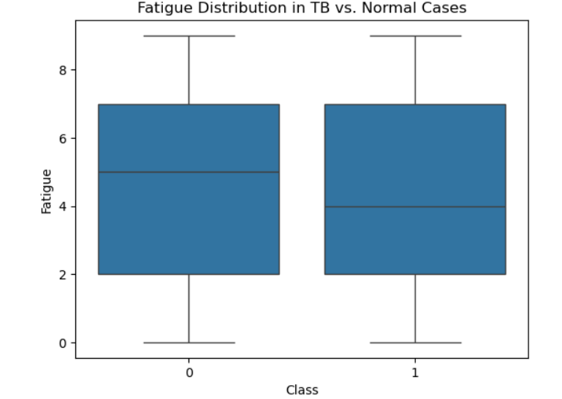
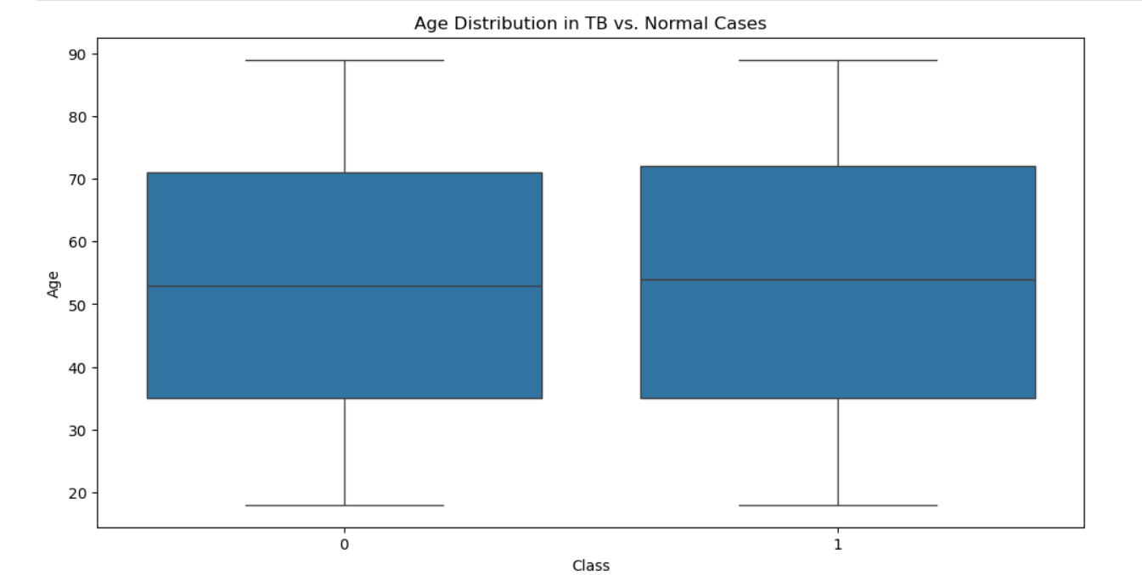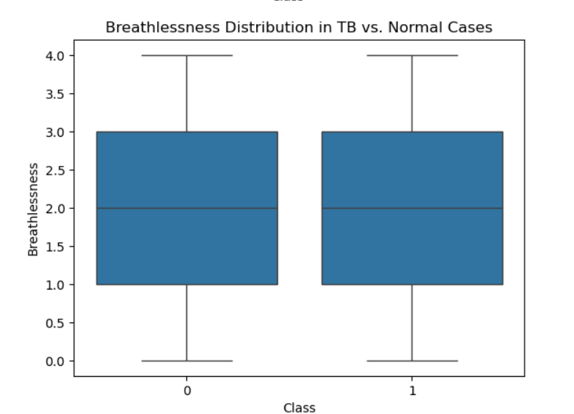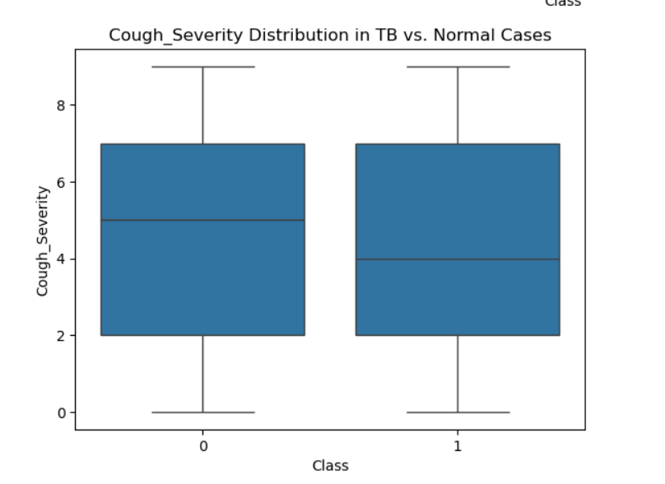
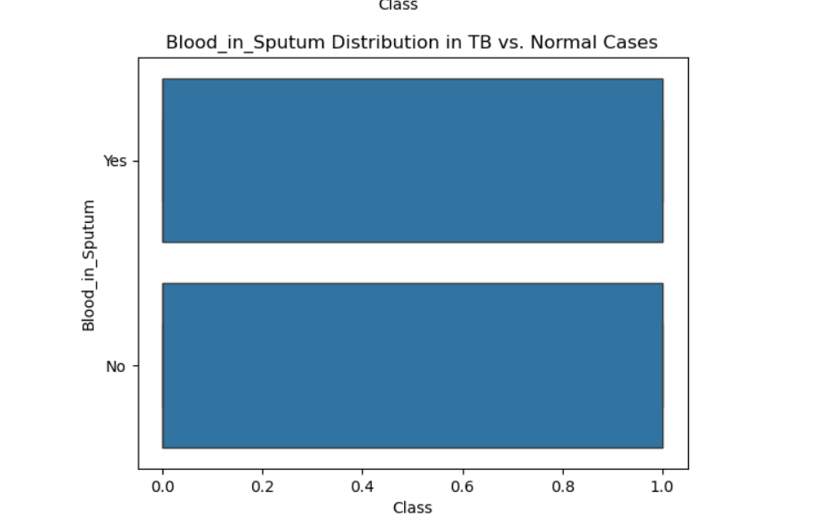

- Objective 5: Identify High-Risk Patients Using a Derived Severity Score

i. General Description
This objective focuses on developing a composite Severity Score to help identify patients who are at higher risk of having TB. The score aggregates multiple symptoms into a single numeric indicator, enabling easy risk stratification and deeper insight into symptom severity patterns among patients.

ii. Specific Requirements
- Map categorical/ordinal symptom values to numeric form (e.g., Fever, Sputum_Production).
- Create a new feature Severity_Score by summing key symptoms:
  - Cough_Severity, Fever, Fatigue, Breathlessness, Weight_Loss, Night_Sweats, Blood_in_Sputum, Sputum_Production, Chest_Pain
- Use the score to assess TB severity trends across patients.
- Visualize Severity Score distributions by TB class.

iii. Analysis Results
- The Severity_Score was computed for each patient based on cumulative symptom severity.
- TB-positive patients showed consistently higher scores than normal individuals.
- This confirmed the metric's value in identifying high-risk patients.
- Additionally, Weight_Loss was explored as a strong individual symptom differentiator.

iv. Visualization
- A violin plot was used to visualize the Severity Score distribution by TB class, clearly showing a right-skewed distribution for TB patients, indicating more severe cases.
- A bar chart was used to display the top 10 highest Severity Scores and corresponding patients.
- A histogram with KDE overlay visualized the distribution of Weight_Loss by TB class, confirming more extreme weight loss among TB-positive individuals.
These plots supported the conclusion that Severity_Score and key symptoms like weight loss are effective for identifying potential high-risk TB patients.
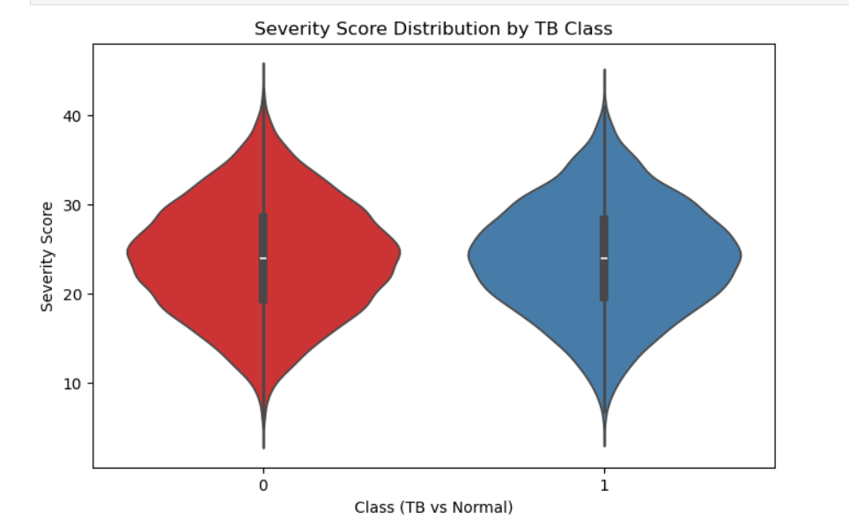
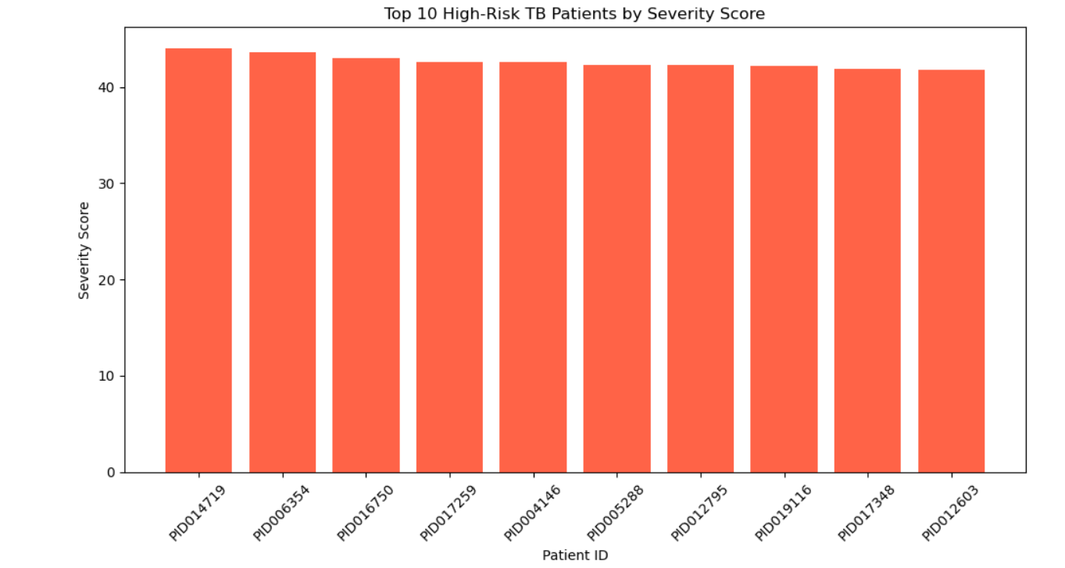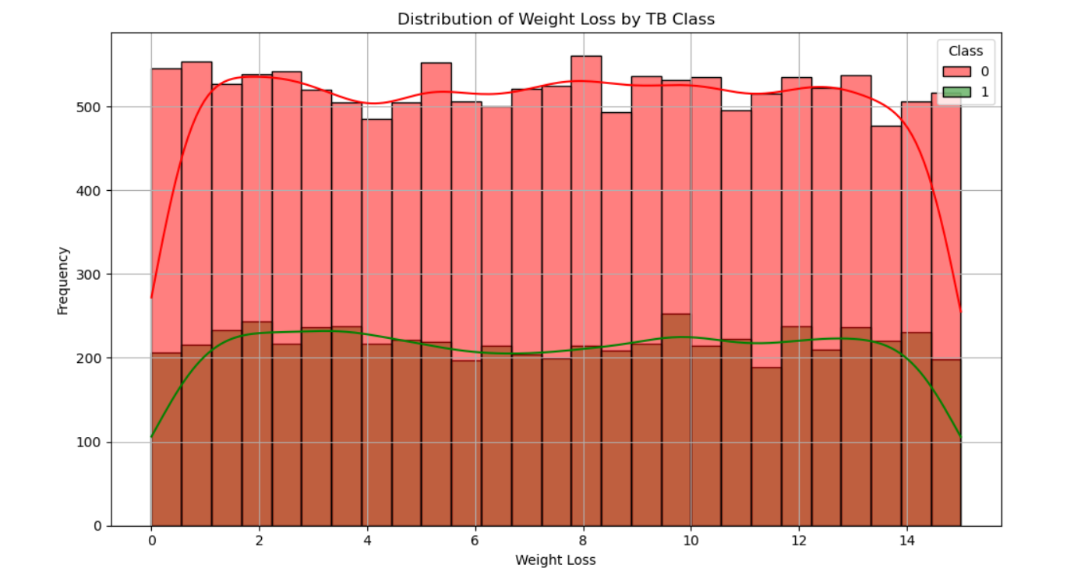

- Objective 6: Perform Hypothesis Testing on Age Differences Between TB and Normal Patients

i. General Description
This objective applies inferential statistics to evaluate whether the average age of TB patients is significantly different from that of non-TB (Normal) patients. While earlier analysis identified age-group patterns visually, this t-test quantifies that relationship statistically.

ii. Specific Requirements
- Use an independent two-sample t-test to compare the Age distributions of:
  - TB-positive patients (Class = 1)
  - Normal patients (Class = 0)
- Define hypotheses:
  - H₀ (Null Hypothesis): There is no significant difference in age between TB and Normal groups.
  - H₁ (Alternative Hypothesis): There is a significant difference in age between the two groups.
- Use a significance level (α) of 0.05.

iii. Analysis Results
- The t-test returned a t-statistic and a p-value.
- If p < 0.05, we reject the null hypothesis, confirming a statistically significant difference in age between TB and Normal patients.
- If p ≥ 0.05, the result suggests that age is not a significant differentiator in this dataset.
- This supports or refutes earlier visual findings from age-group bar plots and box plots.

iv. Interpretation
- The t-test result adds statistical weight to the demographic analysis.
- It validates whether age can be considered a reliable factor in TB screening or patient risk assessment.
- This demonstrates the importance of combining visual EDA with statistical validation for robust insights.

5. Conclusion

This exploratory data analysis (EDA) on the synthetic Tuberculosis (TB) dataset provided valuable insights into the distribution, severity, and symptom patterns of TB across different patient groups. The study began with thorough data cleaning and preprocessing to ensure accuracy, followed by descriptive statistics to understand the general behavior of features such as age, cough severity, and fatigue.
Class distribution analysis revealed a near-balanced dataset, which is ideal for unbiased comparisons between TB and Normal cases. Through demographic grouping, it was observed that TB prevalence was higher among male patients and individuals with a history of smoking, especially in the age ranges of 31–60 years.
Correlation analysis highlighted symptoms such as fatigue, weight loss, and breathlessness as strong contributors to TB diagnosis. Feature-wise distribution plots — particularly for cough severity and breathlessness — showed noticeable differences between TB and Normal patients.
A composite Severity Score was successfully engineered by combining multiple symptoms into a single metric. TB patients generally showed higher scores, confirming the score’s effectiveness in flagging high-risk individuals. Visualizations like violin plots and severity score rankings helped in highlighting the most affected patients.
Overall, the project demonstrates how structured EDA and simple feature engineering can extract meaningful patterns even from synthetic medical data. These findings can be used as a foundation for future modeling or clinical decision support tools focused on TB detection and triage.

6. Future Scope

The findings from this analysis provide a strong base for further enhancements in both clinical analytics and academic applications:

a) Model Extension and Predictive Capabilities
- With the Severity Score already implemented, a natural extension would be to build predictive models (e.g., logistic regression, decision trees) to classify TB cases more accurately.
- These models can incorporate cross-validation and feature importance to identify the most predictive symptoms.

b)Statistical Hypothesis Testing
- To validate differences observed in symptoms (e.g., weight loss or severity score), future work can apply t-tests or chi-squared tests to determine statistical significance.
- These would support or reject hypotheses such as "TB patients have significantly higher severity scores than Normal patients."

c)Expanded Dataset Integration
- The current dataset is synthetic and limited in scope. Integrating real-world data with additional fields like geographic location, treatment outcomes, and comorbidities would improve the model’s robustness and relevance.
- Time-based patient records could enable longitudinal analysis of symptom progression.

d) Feature Engineering and Clustering
- More sophisticated engineered features can be developed, such as symptom duration or co-occurrence of specific symptoms.
- Unsupervised learning techniques (e.g., K-means clustering) could uncover hidden patterns or patient subtypes within TB-positive cases.

e) Clinical Applications
- The Severity Score model could be transformed into a simple triage tool for field workers or general practitioners to flag high-risk individuals.
- Real-time dashboards could be built to track symptom trends, supporting early diagnosis in low-resource settings.

f) Broader Academic Impact
- The methodology used here — including data cleaning, visualization, feature creation, and severity scoring — can serve as a teaching template for students learning EDA and basic data science workflows.
- The project can be extended into more advanced domains like A/B testing of symptom thresholds or Bayesian analysis in clinical decision-making.
.

7. References

- KAGGLE
- W3Schools
- TutorialsPoint

8. Links

- LinkedIn:
- Github:

