<INTRODUCTION TO DATA MANAGEMENT>
PROJECT REPORT
(Project Semester January-April 2025)

(The Rise of Electric Vehicles: Data Driven Overview)

Submitted by

(Mrittick Deb)

Registration No: 12310324

Programme and Section: Computer Science & Engineering, K23SH

Course Code: INT217

Under the Guidance of

(Aashima Bansal, UID:28968 )

Discipline of CSE/IT

Lovely School of Computer Science & Engineering

Lovely Professional University, Phagwara
CERTIFICATE

This is to certify that Hari Teja Patnala bearing Registration no. 12318279 has completed INT217 project titled, “The Rise of Electric Vehicles: Data Driven Overview” under my guidance and supervision. To the best of my knowledge, the present work is the result of his/her original development, effort and study.

Signature and Name of the Supervisor
Aashima Bansal
Designation of the Supervisor
School of Computer Science & Engineering
Lovely Professional University
Phagwara, Punjab.

Date: 12-04-2025

DECLARATION

I, Mrittick Deb, student of Data Science under CSE/IT Discipline at, Lovely Professional University, Punjab, hereby declare that all the information furnished in this project report is based on my own intensive work and is genuine.

Date: 12-04-2025 Signature:
Registration No. 12310324 Mrittick Deb

ACKNOWLEDGEMENT

I would like to express my sincere gratitude to Aashima Bansal ma’am for her unwavering support and guidance in my journey of learning data management and mastering Excel. Her expert insights and patience in teaching have truly enhanced my skills, enabling me to create highly visualized dashboards and better understand the power of data analytics.
Through her guidance, I have not only learned the intricacies of Excel but have also gained a deeper appreciation for how effective data management can lead to insightful decision-making. Her ability to simplify complex concepts and her commitment to my growth have been invaluable.
Thank you for being such an inspiring mentor. Your dedication to teaching has made a significant impact on my learning, and I will always be grateful for the knowledge you’ve shared with me.

Warm regards,
Mrittick Deb

TABLE OF CONTENT:

1. Introduction
2. Source of the Dataset
3. Dataset Preprocessing
4. Analysis on Dataset (for each objective)
i. General Description
ii. Specific Requirements
iii. Analysis Results
iv. Visualization
5. Conclusion
6. Future Scope
7. References
8. Links

1.Introduction

This project focuses on analysing electric vehicle (EV) adoption trends in the United States from 2017 to 2025 using a government-sourced dataset. The goal is to extract meaningful insights about the growth of Battery Electric Vehicles (BEVs) and Plug-in Hybrid Electric Vehicles (PHEVs) across various states and counties.
Key objectives of this project include:
- Analysing annual trends in BEV, PHEV, and total EV registrations.
- Comparing EV market share by state and county to highlight regional adoption patterns.
- Studying consumer preferences between BEVs and PHEVs.
- Identifying top 10 counties with the highest EV penetration.
- Comparing EV growth with overall vehicle registration growth.
- Examining EV adoption by vehicle type (Passenger vs. Truck).
- Forecasting future EV trends using Excel’s trendline analysis.
The interactive dashboard was developed using Microsoft Excel, incorporating pivot tables, slicers, and dynamic visualizations. The result is a clean, user-friendly tool that enables deeper exploration of EV trends and supports strategic planning in the field of sustainable transportation.

- Source of the Dataset

The dataset used in this analysis is sourced from the public repository at https://catalog.data.gov/dataset/electric-vehicle-population-size-history-by-county, provided by the U.S. government’s open data initiative. It contains detailed records of electric vehicle (EV) registrations across the United States from 2017 to 2025. Key data fields include year, state, county, fuel type (BEV/PHEV), vehicle type (Passenger/Truck), and total EV registrations.

This dataset serves as a valuable resource for analysing EV adoption trends, enabling insights into regional market penetration, consumer preferences, and future projections. It supports a data-driven approach to understanding the growth of sustainable transportation and the evolving EV landscape

- Dataset Preprocessing

This section describes the steps taken to clean, transform, and structure the raw dataset to ensure it was ready for analysis and dashboard integration.

  - Data Overview

The dataset titled “Electric_Vehicle_Population_Size History by County” includes detailed information on electric vehicle (EV) registrations across various counties and states in the U.S. Key data points include:
- Registration date and year
- County and state details
- Types of vehicles: Battery Electric Vehicles (BEVs) and Plug-In Hybrid Electric Vehicles (PHEVs)
- Primary usage type (e.g., Passenger)
- Total number of electric and non-electric vehicles
- EV adoption percentage

  - Data Cleaning

To ensure consistency and reliability of insights, the following data cleaning steps were applied:
- Date Standardization: The Date column was converted from text (e.g., "February 28 2023") to a standard datetime format.
- Year Extraction: A new column Year was created by extracting the year from the Date field to support year-wise analysis and visualizations.
- Handling Missing or Incomplete Data: Records with missing values in essential columns such as:
  - Battery Electric Vehicles (BEVs)
  - Plug-In Hybrid Electric Vehicles (PHEVs)
  - Total Vehicles
were either cleaned or removed, depending on their impact on analysis.
- Data Type Correction: Ensured numerical fields (vehicle counts, percentages) were stored as numeric types and categorical fields (e.g., State, County, Primary Use) were stored as text.

  - Feature Engineering

To enhance the dataset for meaningful analysis:
- Calculated Metrics:
- Electric Vehicle (EV) Total:
Verified as the sum of Battery Electric Vehicles (BEVs) and Plug-In Hybrid Electric Vehicles (PHEVs) to ensure data consistency.
- Percent Electric Vehicles:
Computed using the formula:
Percent Electric Vehicles = (EV Total / Total Vehicles) × 100
- Segmentation Readiness: Data was prepared for grouping and filtering by State, County, Primary Use, and Year to support various analytical objectives.

  - Filtering and Deduplication

- Duplicate Removal: Duplicate records were identified and removed to maintain data integrity.
- Filtering Irrelevant Data: Records with missing geographical or vehicle-type information were excluded from further processing.
- Structured Grouping: The cleaned dataset was structured to allow analysis at different levels: regional (state/county), temporal (year-wise), and categorical (usage type).

- Analysis on Dataset

- Objective 1: EV Adoption Trends Over Time

i. General Description
This objective aims to explore the growth of electric vehicle (EV) adoption across the United States over time, specifically analyzing trends in the registration of Battery Electric Vehicles (BEVs), Plug-In Hybrid Electric Vehicles (PHEVs), and their combined total. Understanding year-over-year growth provides insight into consumer behavior, policy impact, and infrastructure development driving EV adoption.
ii. Specific Requirements
- Calculate the total number of BEVs, PHEVs, and total EVs for each year.
- Identify annual growth trends and fluctuations.
- Enable comparative analysis by filtering results for different states and counties.
iii. Analysis Results
The analysis shows a strong upward trajectory in EV adoption over the analyzed years. Key findings include:
- BEVs exhibit a sharper growth rate compared to PHEVs, highlighting a market shift toward fully electric models.
- The total number of EVs has increased consistently each year, with significant spikes in adoption post-2020 in progressive states.
- California, Washington, and Oregon remain consistent leaders in EV registrations, indicating a more mature market compared to other states.
Notable year-wise trends observed:
- 2019: Marked the beginning of accelerated EV uptake, coinciding with increased state-level incentives and broader availability of EV models.
- 2020–2023: Showed sharp increases, with BEVs increasingly outpacing PHEVs in total registration volumes.
The increasing share of BEVs suggests growing confidence in charging infrastructure and technological improvements in EV batteries, range, and affordability.
iv. Visualization
A multi-line chart was implemented to represent year-wise registration counts of BEVs,
PHEVs, and total EVs.
- Each line represents a distinct vehicle type, enabling a clear comparison over time.
- Interactivity features such as state and county slicers allow users to drill down into specific geographic trends and compare regional adoption rates dynamically.

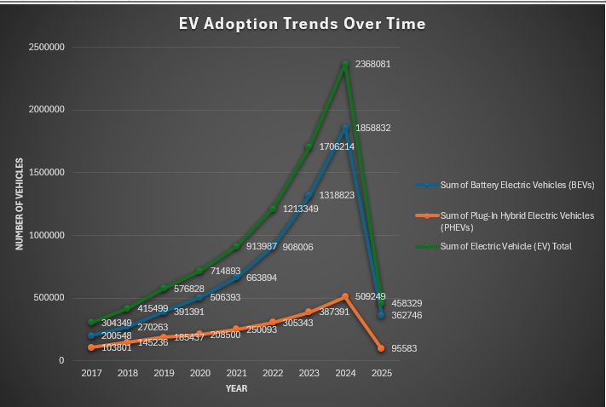

- Objective 2: EV Market Share Analysis by County & State

i. General Description
This objective examines the market penetration of electric vehicles (EVs) by comparing the proportion of EVs to the total vehicle population across different counties and states. It reveals how widespread EV adoption is geographically and helps identify regions leading or lagging in the transition to electric mobility.
ii. Specific Requirements
- Calculate the percentage of EVs out of the total vehicle population at the county and state levels.
- Highlight high and low EV adoption regions using comparative visual tools.
- Enable filtering by state and interactive exploration of specific county-level data.
iii. Analysis Results
The analysis uncovers significant geographic variation in EV market share across the United States. Key insights include:
- States such as California, Washington, and Colorado demonstrate the highest EV penetration rates, with some counties surpassing 15–20% of total vehicles being electric.
- In contrast, rural counties in states like Mississippi, Wyoming, and West Virginia report EV market shares below 2%, reflecting disparities in infrastructure, awareness, and access.
- Urban areas tend to exhibit higher EV adoption rates due to better charging networks and greater exposure to environmental initiatives.
The market share percentages highlight not only current EV usage but also readiness for further adoption, offering guidance for targeted investments in infrastructure and outreach programs.
iv. Visualization
A stacked bar chart was used to compare EVs versus non-EVs for each county, with color-coded segments denoting the percentage composition.
- Alternatively, a heatmap was created to visually indicate regional intensity of EV adoption, with darker shades representing higher penetration.
- Interactive features include a dropdown menu for selecting specific states and dynamic data labels to spotlight counties with the highest and lowest EV shares.

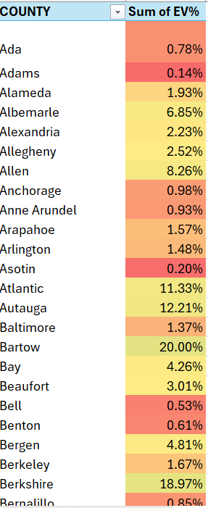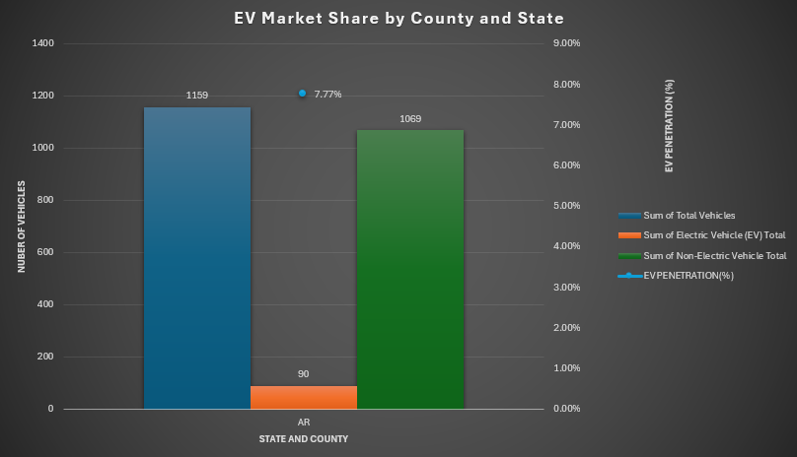

- Objective 3:BEV vs. PHEV Distribution Insights

i. General Description
This objective focuses on comparing consumer preferences between Battery Electric Vehicles (BEVs) and Plug-In Hybrid Electric Vehicles (PHEVs) across different regions and time periods. By analyzing the ratio and trends of BEV vs. PHEV registrations, we can infer shifts in consumer confidence, infrastructure readiness, and regional policy effectiveness supporting electric mobility.
ii. Specific Requirements
- Calculate and compare the total number of BEVs and PHEVs across counties and states.
- Analyze changes in distribution patterns over the years.
- Incorporate regional filters to identify specific local preferences.
iii. Analysis Results
The analysis reveals a clear and growing preference for BEVs over PHEVs across most regions, especially in recent years. Key findings include:
- BEVs consistently outnumber PHEVs in high-adoption states like California, Oregon, and New York.
- In early years, PHEVs had a more competitive share due to their flexibility (electric + gas), but this has diminished as BEV technology matured.
- Between 2020 and 2023, BEVs saw significant acceleration, indicating rising consumer trust in battery performance and charging infrastructure.
- Regions with higher urban density tend to favor BEVs, while some rural areas still show a modest inclination toward PHEVs due to range concerns.
The shift toward BEVs reflects advancements in EV affordability, battery capacity, and public charging availability.
iv. Visualization
Pie charts were created to represent the BEV vs. PHEV distribution within selected regions, offering a snapshot of local preferences.
- Additionally, stacked bar charts by year and region illustrate how this ratio has changed over time.
- Interactivity includes a county-level slicer and a time-based filter, enabling users to observe preference trends across both geography and years.

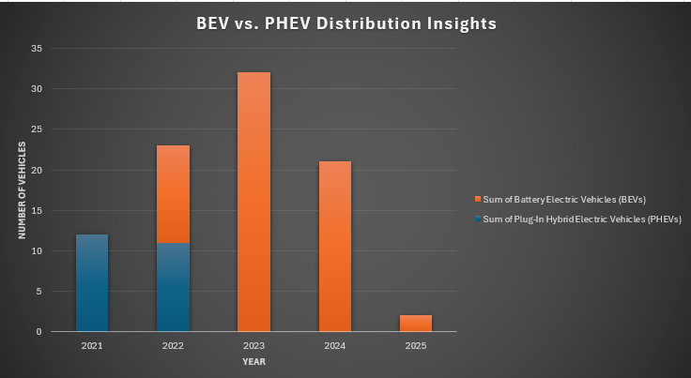
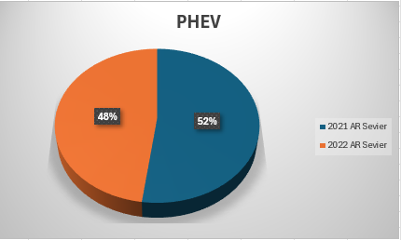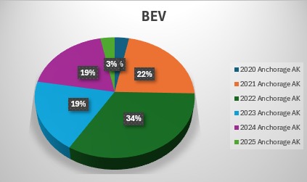

- Objective 4: Top 10 Counties Leading in EV Adoption

i. General Description
This objective highlights the top-performing counties in terms of electric vehicle (EV) penetration relative to total vehicle registrations. By identifying the top 10 counties with the highest EV market share, this analysis offers insight into which regions are at the forefront of EV adoption and what patterns might be driving their success.
ii. Specific Requirements
- Rank counties based on EV percentage out of total vehicles.
- Display only the top 10 counties with the highest EV adoption rates.
- Allow for interactive toggling between the top and bottom performers.
- Enable search functionality for specific counties to compare rankings.
iii. Analysis Results
The analysis identifies counties with exceptionally high EV adoption, showcasing leaders in the transition to sustainable transportation. Key insights include:
- Counties in California dominate the top 10 list, with EV penetration exceeding 20–25% in several locations, such as Santa Clara, San Mateo, and Marin.
- These counties benefit from favorable policy support, early infrastructure development, and a strong environmental consciousness among residents.
- In contrast, counties in more rural or traditionally fossil-fuel-dominant regions continue to show limited adoption, with some ranking in the bottom tier under 1% EV share.
This leaderboard-style view serves as a benchmark for evaluating the success of regional strategies and can inform policy replication in lower-adoption areas.
iv. Visualization
A horizontal bar chart was used to rank the top 10 counties by EV market share, sorted in descending order.
- Each bar is labelled with the exact EV percentage to allow for precise comparisons.
- Interactive features include a search box for quick access to individual counties and a toggle option to switch between top 10 and bottom 10 rankings dynamically.
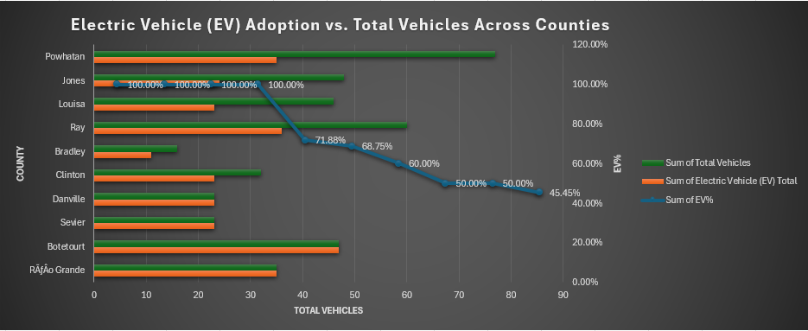

- Objective 5: EV Growth vs. Total Vehicle Growth & Forecasting Future EV Trends

i. General Description
This combined objective analyzes the historical growth of electric vehicles (EVs) relative to total vehicle registrations and extends the analysis to forecast future EV adoption trends. It aims to assess whether EVs are truly becoming mainstream and to estimate how their market presence may evolve in the coming years based on historical growth patterns.
ii. Specific Requirements
- Compare the year-over-year growth of EV registrations against the overall vehicle population.
- Identify states and regions where EV growth significantly surpasses general vehicle trends.
- Apply forecasting techniques to project future EV adoption using historical data.
- Display forecast results visually using a trendline that extends into future years.
iii. Analysis Results
The historical analysis from 2017 to 2023 reveals that EV adoption has accelerated rapidly, while total vehicle registrations have grown at a comparatively moderate rate. Notable findings include:
- States such as California, Washington, and Colorado show exponential growth in EV registrations, with EV counts increasing by more than 300% in some cases.
- Nationally, EV registrations have grown 5 to 8 times faster than total vehicle registrations during the same period.
- This widening gap indicates a structural shift toward sustainable mobility, supported by policy measures, improved EV infrastructure, and growing consumer acceptance.To estimate future adoption trends, an exponential trendline was applied to the historical EV data. The trendline projects continued acceleration in EV adoption, with a sharp upward trajectory expected in the next 3–5 years, assuming current patterns continue. This forecast supports policy planning and investment strategies in charging networks, battery supply chains, and grid infrastructure.
- iv. Visualization
- A dual-axis bar chart presents year-wise EV growth versus total vehicle registrations, offering a clear side-by-side comparison.
- An exponential trendline has been added to the EV growth series to visualize and project future adoption patterns.
- Interactive features include a state-level slicer, allowing users to focus on specific regional trends and view tailored growth and forecast data.
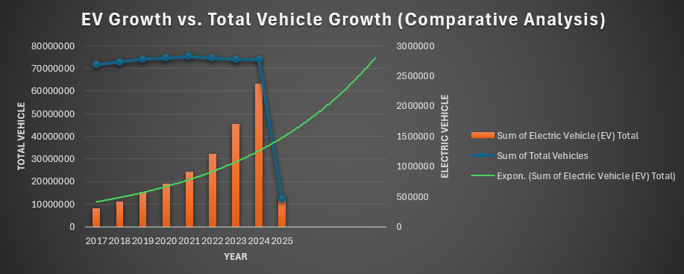

- Objective 6: EV Adoption by Vehicle Type – Passenger vs Truck
i. General Description
This objective explores how electric vehicle (EV) adoption varies based on vehicle type, specifically comparing Passenger vehicles and Trucks. By examining the distribution of EV adoption across these categories, the analysis provides insights into market behavior, consumer usage trends, and the penetration of electrification in light-duty versus utility vehicles.
ii. Specific Requirements
- Categorize EV data based on the primary vehicle use: Passenger vs Truck.
- Analyze annual EV counts for each type to observe growth patterns over time.
- Compare the relative share of each category to determine adoption bias or emerging trends.
- Include region-based filters to understand differences across states or counties.
iii. Analysis Results
The data from 2017 to 2023 indicates that Passenger EVs dominate adoption, accounting for the majority of electric vehicle registrations. However, the adoption of electric trucks has started to rise in recent years, signalling growing electrification in utility and commercial segments. Key observations include:
- Passenger EVs consistently represent over 85–90% of total EV registrations annually.
- Trucks, while a smaller segment, have seen noticeable growth, particularly from 2021 onward, aligning with the release of new EV truck models and expanding commercial fleet electrification efforts.
- States with rural and agricultural economies show relatively higher proportions of electric trucks compared to urbanized regions.
These trends suggest that while the current EV market is largely consumer-driven (passenger cars), the electrification of commercial and heavy-use vehicles is gaining momentum and may see a sharper rise in the near future.
iv. Visualization
A clustered column chart is used to illustrate year-wise EV adoption, segmented by vehicle primary use (Passenger vs Truck):
- The X-axis represents the year, while the Y-axis shows the number of EVs.
- Two colored bars for each year distinguish between Passenger and Truck EVs.
- Pivot tables support this breakdown, with interactive slicers for state and fuel type to enable deeper regional and category-based exploration.
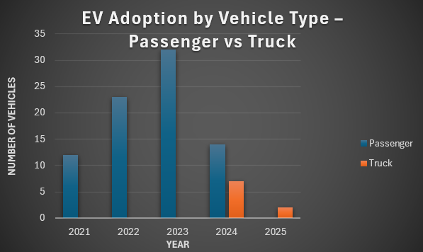
5. Conclusion

The analysis of electric vehicle (EV) adoption based on historical and categorical data offers a comprehensive view of the ongoing transition in the transportation landscape. Through interactive dashboards and visual storytelling, this project revealed meaningful insights into how EV adoption is evolving across time, regions, and vehicle types.
Key findings from the dashboard include:
- Steady Growth in EV Adoption: Both BEVs and PHEVs have shown consistent growth from 2017 to 2023, with a notable acceleration in recent years, especially in EV-progressive states like California and Washington.
- Regional Leaders Emerging: Certain counties demonstrate significantly higher EV penetration, highlighting successful local policies, strong charging infrastructure, and environmentally conscious communities.
- Consumer Preferences Lean Towards BEVs: Battery Electric Vehicles (BEVs) have gained more traction than Plug-in Hybrid Electric Vehicles (PHEVs), indicating a consumer shift toward fully electric solutions.
- Warehouse-Like Dominance of EVs: A pattern similar to warehouse dominance in distribution was seen with the significant portion of EVs concentrated in select regions—showing that the transition is strong but still regionally uneven.
- Passenger Vehicles Dominate EV Segment: EVs are still predominantly used for personal transportation, although adoption in trucks and commercial vehicles is gradually increasing.
- Forecasting Suggests Rapid Expansion: Exponential trendline forecasting shows a promising trajectory for future EV adoption, reinforcing the need for proactive planning in infrastructure and policy.
Overall, the dashboard serves as a strategic tool for stakeholders—governments, manufacturers, and consumers—to understand where the market stands and how it is likely to evolve. The visualizations and interactivity ensure that decision-makers can extract meaningful insights quickly and make informed, data-driven decisions.

6. Future Scope

While the current analysis offers a rich overview of historical trends and patterns in electric vehicle (EV) adoption, there is ample opportunity to expand the scope and depth of this study in future iterations. Several directions for improvement and exploration include:
1️)Integration of Real-Time Data
Incorporating live or frequently updated data sources, such as DMV APIs or government EV databases, would allow the dashboard to reflect real-time trends, making it even more relevant for policymakers and analysts.
2️)Inclusion of Charging Infrastructure Data
Overlaying data on charging station availability, density, and usage can help correlate EV adoption patterns with infrastructure readiness. This can inform where new charging stations should be prioritized.
3️)Economic & Environmental Impact Analysis
Adding metrics like fuel cost savings, CO₂ reduction estimates, or government incentives by region would enhance the dashboard’s utility in evaluating the broader benefits and ROI of EV adoption.
4️)Demographic and Behavioral Insights
Exploring EV adoption in the context of demographic data (e.g., income levels, age groups, urban vs. rural locations) can yield valuable insights into consumer behavior and accessibility.
5️) Expansion to Commercial Fleets
With the rise of electric delivery trucks and logistics fleets, expanding the analysis to cover fleet-level EV adoption would be a valuable extension, especially for B2B strategy formulation.
6️)Advanced Forecasting Models
Future versions can adopt machine learning models (e.g., ARIMA, Prophet, or LSTM) for more robust and accurate EV adoption forecasting, especially when planning for infrastructure or policy investments.
7️)Mobile & Web Integration
Deploying the dashboard as a web-based or mobile application would increase accessibility for a broader audience, including non-technical users and on-the-go decision-makers.

This future scope positions the dashboard as a scalable and adaptable platform that can evolve with emerging trends and stakeholder needs. By incorporating richer datasets and advanced analytics, it can continue to serve as a strategic decision-making tool in the global shift toward sustainable transportation.

7. References

- U.S. Government Website for Dataset
- W3Schools
- TutorialsPoint

8. Links

- LinkedIn:https://www.linkedin.com/posts/mrittick-deb-600763275_exceldashboard-evanalysis-electricvehicles-activity-7316130930371260416-9U5H?utm_source=social_share_send&utm_medium=member_desktop_web&rcm=ACoAAEM1oaABAJPTyDCwF2sDikIZZIlssT7TU5E
- Github: mrittickdeb/Exploring-the-Rise-of-Electric-Vehicles-A-Data-Driven-Overview

9. Dashboard

