**TRAFFIC SIGN RECOGINITION**

*-presented by Coffee2Code*

**What is Traffic Signs Recognition?**

There are several different types of traffic signs like speed limits, no entry, traffic signals, turn left or right, children crossing, no passing of heavy vehicles, etc. Traffic signs classification is the process of identifying which class a traffic sign belongs to.

**Motivation behind this project:**

This project will act as a Driver support system by providing knowledge to a variety of traffic signs. It will also enable new learners to learn about the traffic signs. The many millions of roadway signs necessary to keep roadways safe and traffic flowing present a particular logistical challenge for those responsible for the installation and maintenance of those signs. Road signs must be properly installed in the necessary locations and an inventory of those signs must be maintained for future reference.

### Traffic Signs Recognition – About the Python Project

In this Python project example, we will build a deep neural network model that can classify traffic signs present in the image into different categories. With this model, we are able to read and understand traffic signs which are a very important task for all autonomous vehicles.

### The Dataset of Python Project

For this project, we are using the public dataset available at Kaggle:

<https://www.kaggle.com/meowmeowmeowmeowmeow/gtsrb-german-traffic-sign>

The dataset contains more than 50,000 images of different traffic signs. It is further classified into 43 different classes. The dataset is quite varying, some of the classes have many images while some classes have few images. The size of the dataset is around 300 MB. The dataset has a train folder which contains images inside each class and a test folder which we will use for testing our model.

### Prerequisites

This project requires prior knowledge of

* Keras,
* Matplotlib,
* Scikit-learn,
* Pandas,
* PIL,
* flask and
* image classification.

### Approach Towards the Problem:

Our approach to building this traffic sign classification model is discussed in four steps:

* Explore the dataset
* Build a CNN model
* Train and validate the model
* Test the model with test dataset
* Predict the images
* Build an interface using Flask

**How to use this System:**

- Clone this repository.

- Open CMD in working directory.

- Run `Traffic_app.py`.

- Go to the `http://127.0.0.1:5000` and test it. It is a local Flask App.

**Future of this Project**

In future this recognition project can be combined with a detection algorithm to detect and then recognize the traffic signs in real time

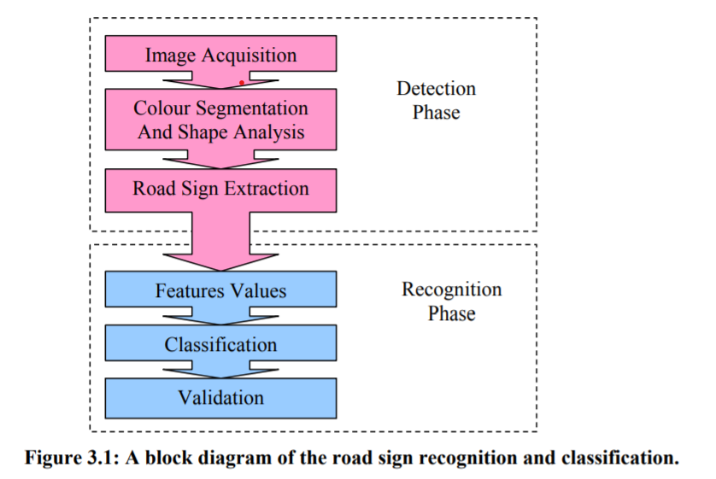

**Fig: A block diagram of the road sign recognition and classification**

### Screenshots:

### 

### 

### 

### 

### Conclusion:

### In this Python project with source code, we have successfully recognized the traffic sign with 93.14% accuracy and also visualized how our accuracy and loss changes with time, which is pretty good from a simple CNN model.