|  |  |
| --- | --- |
| Endpoint | URL |
| Route 53 Endpoint | http://mritunjay.cf/ |
| Load Balancer Endpoint | http://myint-loadb-1sm0rnj3pb2s5-852431859.eu-west-1.elb.amazonaws.com/ |

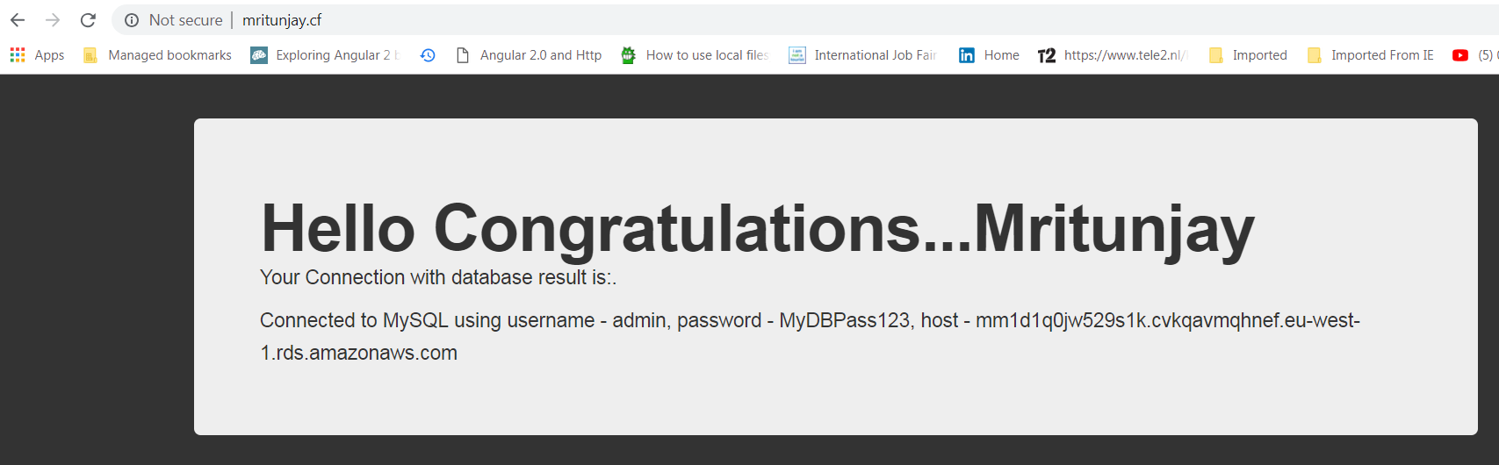

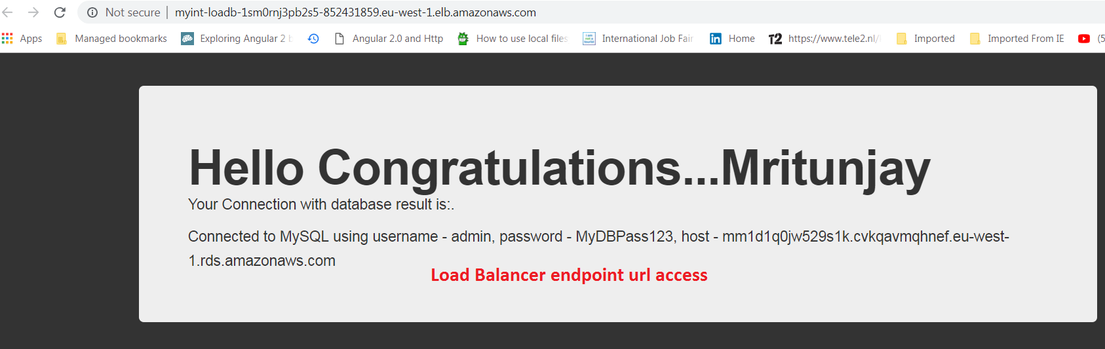

Application code is divided into 2 parts.

1. Application source code.
2. Cloud formation template for Amazon web services (AWS)

# Application Source Code:

Source code of application are located on my GitHub repository.

Url: <https://github.com/mritunjayemail/code-base-github-interview>

Git Repository URL for clone : <https://github.com/mritunjayemail/code-base-github-interview.git>

# Cloud formation template for Amazon web services (AWS)

Url: <https://github.com/mritunjayemail/CloudFormation-templates-continuous-deployment>

Git Repo: <https://github.com/mritunjayemail/CloudFormation-templates-continuous-deployment.git>

# Load balancer Cloud formation stack gives us output of load balancer Service URL.

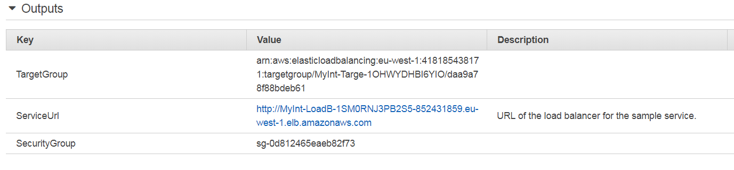

# Complete stack overview on AWS console:

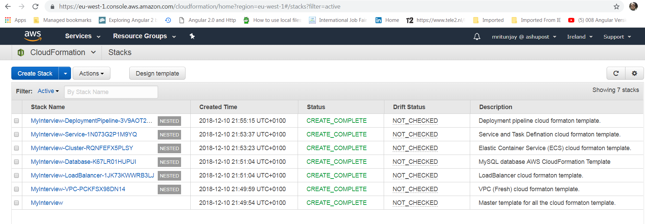

AWS CodePipeline is a fully managed continuous delivery service. CodePipeline automates the build, test, and deploy phases of your release process every time there is a code change.

## GitHub Configuration

Repo: The repo name of the sample service.

Branch: The branch of the repo to deploy continuously.

User: Your username on GitHub.

Personal Access Token: Token for the access of github.

