**AWS Cloud Practitioner Exam**

**What is cloud Computing**

* Cloud computing is on-demand delivery of computer, database, storage, application, and other IT resources through a cloud services platform via the internet with pay as you go pricing.

**The 6 advantages of Cloud computing**

1. **Trade Capital Expenses for Variable Expense.**

Instead of having to invest heavily in data centers and servers before you know how you are going to use them, you can pay only you consume computing resources, and pay only for how much you consume.

1. **Benefits from massive economics of scale**

You never have the same purchasing power as Amazon. They literally build their own servers.

1. Stop guessing about Capacity

You will probably either buy too much or too little, if you buy too much, you are wasted money and if you buy too little you will have down time. Cloud can scale with your business needs, with no long-term contract.

1. Increase speed and agility

The A cloud Guru platform was built in 3 weeks, using a new type of design called serverless architecture, it scales infinitely with demand. 15 year ago, we would have had to buy servers and rent data center space and we probably never would have got off the ground.

1. Stop spending money running and maintaining data center.

Focus on what you are good at, not at managing infrastructure, let someone else manage that for you.

1. Go global in minutes.

**3 Type of Cloud Computing**

* IAAS (Infrastructure as a Service) ... Ex. AWS EC2
* PAAS (Platform as service) … Ex. go daddy

Someone else worries about security, patching, update and maintenance etc.

* SAAS (Software as a Service) … Gmail

**3 Types of Cloud computing deployment**

**Public Cloud** – AWS, Azure, GCP

**Hybrid**- Mixture of public and private

**Private Cloud** (or on premise) – You manage it, in your datacenter, Openstack or Vmware.

* A Region is a Physical location in world which consists of two or more AZ.
* An AZ is one or more discreate data centers, each with redundant power, networking and connectivity, housed in separate facilities.
* Edge locations are endpoint of AWS which are used for caching content, typically this consists of CloudFront, Amazon’s content Delivery Network (CDN).

**Understand the differences support packages**

* Basic – Free
* Developer - $ 29/ month
* Business - $100 / month
* Enterprise - $15000/month – TAM Technical account manager.

**IAM:**

IAM stands for identity access Management, it is global, you do not specify a region when dealing with IAM, when you create a user or group. This is created GLOBALLY.

**You can access the AWS platform in 3 ways.**

1. Console
2. Programmatically
3. Software development Kit (SDK)

* Root account has full administrator access. You should not have given these credentials away to anyone. Instead create a user for each individual within your organization. You should always secure this root account using multi-factor authentication.
* A Group is simply a place to store your user, your users will inherit all permission that the group has.
* To set the permission in a group you need to apply a policy to that group. Polices consist of JSON. These are referred to as key value pairs.
* S3 is a universal namespace. That is, names must be unique globally.

<https://s3-eu-west-1.amazonaws.com/mybucket>

* HTTP 200 when successful upload to S3 bucket.
* S3 is Object based. Think of Objects just as files.

**Key**: Name of the Object

**Value**: Data and is made up of a sequence of bytes.

**Version ID**: used for versioning

**Metadata**: Data about data.

**Subresources**:

Access control list.

Torrent

**How does data consistency work for S3?**

* Read after write consistency for PUTS of new objects.
* Eventual consistency for overwrite PUTS and Deletes (Can take some time to propagate).

**S3 has the following guarantees from Amazon**

* Build for 99.99% availabilities for the S3 platform
* Amazon Guarantee 9.9 % availabilities
* 99.999999999% durability (11x9).

**S3 has following feature.**

* Tiered storage available
* Lifecycle Management
* Versioning
* Encryption
* Secure you data using access control lists and bucket polices.

**S3 Storage classes:**

* **S3 standard.**
* **S3-IA**
* **S3 one zone-IA**
* **S3** – intelligent tiering: Designed to optimize costs by automatically moving data to the most cost-effective access tier, without performance impact or operational overhead.
* **S3 Glacier**: S3 Glacier is a secure, durable and low-cost storage class for data archiving, you can reliably store any amount of the data at costs that are competitive with cheaper than on-premises solution. Retrieval times configurable from minutes to hours.
* **S3 Glacier Deep Archive**: S3 Glacier deep archive is Amazon S3 lowest cost storage class where a retrieval time of 12 hours is acceptable.

**You are charged for S3 in the following ways:**

* Storage
* Requests #
* Storage Management pricing
* Data transfer pricing
* Transfer acceleration
* Cross region replication pricing

**S3 Transfer Acceleration**

* Amazon S3 transfer acceleration enables fast, easy and secure transfers of files over long distances between your end user and an S3 Bucket.
* Transfer Acceleration takes advantages of CloudFront’s globally distributed edge locations, data is routed to Amazon S3 over an optimized network path.
* You can use bucket polices to make entire S3 bucket public.
* You can use S3 to host STATIC websites. Websites that require database connection such as WordPress etc. cannot be hosted on S3.
* S3 Scales automatically to meet you demand. Many enterprises will put static websites on S3 when they think there is going to be large number of requests.

**What is CloudFront?**

A Content delivery network (CDN) is a system of distributed servers (network) that deliver webpages and other web content to a user based on the geographic location of the user, the origin of the webpage, and a content delivery server.

**Edge Location**: This is the location where content will be cached. This is separate Region/AZ.

**Origin**: This is the origin of all the files that the CDN will distribute. This can be an S3 bucket, and Ec2 instance, and Elastic Load Balancer or Route 53.

**Distribution**: This is the name given the CDN which consists of collection of edge locations.

**Web distribution:** Typically used for websites.

**RTMP**: Used for media streaming

* Edge locations are not just READ only- you can write to them too (i.e. put an object on to them)
* Objects are cached for the life of the TTL (Time to Live)
* You can clear cached objects, but you will be charged.

**EC2- Elastic Compute Cloud.**

**On Demand**: Allows you to pay fixed rate by the hour or by the second) with no commitment.

* User that want the low cost and flexibility of Amazon EC2 without any up-front payment or long-term commitment.
* Application with short term, spiky, or unpredictable workloads that cannot be interrupted.
* Application being developed or tested on EC2 for the first time.

**Reserved**: Provides you with a capacity reservation, and offer a significant discount on the hourly charge for an instance. Contract terms are 1-year or 3-year terms.

* Applications with steady state or predictable usages.
* Applications that require reserved capacity.
* User able to make upfront payments to reduce their total computing costs even further.

**Standard Reserved Instances:** These offer up to 75% off on demand instances. The more you pay up front and the longer the contract, the greater the discount.

**Convertible Reserved Instances:** There offer up to 54% off on demand capabilities to charge the attributes of the Reserved instances (RI) as long as the exchange result in the creation of Reserved instance or equal or greater value.

**Scheduled Reserved Instances:** These are available to launch within the time window you reserve. This option allows you to match your capacity reservation to a predictable recurring schedule that only requires a fraction of a day, week or a month.

**Spot:** Enables you to bid whatever price you want for instance capacity, providing for even greater saving if your application has flexible start and end times.

* Application that have flexible start and end and end times.
* Application that are only feasible at very low compute prices.
* Users with urgent computing needs for large amount of additional capacity.

**Dedicated Host**: Physical EC2 server dedicated for your use. dedicated hosts can help you reduce costs by allowing you to use your existing server-bound software licenses.

* Useful for regulatory requirement that may not support multi-tenant virtualization.
* Great for licensing which does not support multi-tenancy or cloud deployments.
* Can be purchased on Demand (hourly).
* Can be purchased as Reservation for up to 70% off the on-demand price.

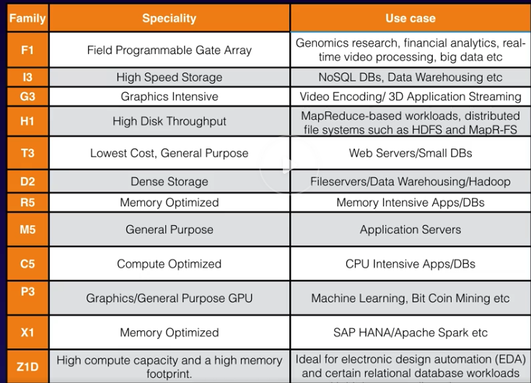

**What is EBS?**

**A**mazon EBS allows you to create storage volumes and attached them to EC2 instance. Once attached, you can create a file system on top of these volumes, run a database, or use them in any other way you would use a block device. Amazon EBS volumes are places in a specific Availability Zone, where they are automatically replicated to protect you from the failure of a single component.

**SSD:**

* **General Purpose SSD(GP2)-** Balances price and performance for a wide variety of workloads.
* **Provisioned IOPS SSD (IO1):** Highest- performance SSD volume for mission critical low latency for high throughput workloads.

**Magnetic**:

* **Throughput Optimized HDD (ST1):** Low cost HDD volumes designed for frequently accessed, throughput-intensive workload.
* **Cold HDD (SC1):** Lowest cost HDD~ volume designed for less frequently accessed workloads. (File Servers).
* **Magnetic:** Previous generation.

**Roles**:

* Roles are much more secure than using access key id’s and secret access keys and are easier to manage.
* You can apply roles to EC2 instance at any time. When you do this the change takes place immediately.
* Role is universal. You do not need to specify what region they are in, similar to users.

**Load Balancers**

Load balancers comes in 3 different flavors.

* Application Load balancer:

Layer 7 (Makes intelligent decision)

* Network load balancer:

Extremely Performance / Static IP address.

* Classic load balancer:

Test and Dev, Keep costs low.

**Database 101**

RDS has two key features:

* **Multi-AZ** – for Disaster Recovery
* **Rad Replica**: For performance.

RDS (SQL/OLTP)

* SQL
* MySQL
* PostgreSQL
* Oracle
* Aurora
* MariaDB

DynamoDB (NoSQL)

Red shift OLAP: Business intelligent tools or data ware housing.

* Elasticache to speed up performance of existing database (frequent identical queries).

**Billing and pricing**

**The AWS Pricing white Paper:**

**The basic pricing policies are as follow:**

* Pay as you go
* Pay less when you reserve
* Pay even less per unit by using more.
* Pay even less as AWS grows

Pricing polices:

While pricing models vary across services, it’s worthwhile to review key principle and best practices that are broadly applicable.

These are three fundamental drivers of cost with AWS:

* Compute
* Storage
* And Data outbound

Adopting cloud services is not just a technical evolution. It also requires changes to how organization operate. As you move from IT being treated as capital investment that happens periodically to a world where pricing is closely tied to efficient use of resources, it pays to understand what drives cloud pricing so you can build a strategy for optimizing it.

The following services are free

* Amazon VPC
* Elastic beanstalk
* CloudFormation
* IAM
* Auto scaling
* Opsworks
* Consolidating billing

**What Determines Price?**

* Clock Hours of server time
* Instance Type
* Pricing model
* Number of instances
* Load balancing type
* Detailed monitoring
* Auto scaling
* Elastic IP address
* Operating System and software Packages.

What Determines price for Lambda?

Request Pricing

* Free Tier: 1 million request per month
* $0.20 per million requests thereafter

Duration Pricing

* 400,000 GB -second per month free, up to 3.2 million second of compute time
* $0.00001667 for every GB-second used thereafter

**What determines price of Lambda?**

Additional charges: You may additional charges if your lambda function uses other AWS services or transfer data. For example. If Lambda function reads and writes data to or from S3, you will be billed for the read/write requests and the data stored in S3.

What determines price for EBS?

* Volumes (Per GB)
* Snapshot (Per GB)
* Data transfer

What determines price for S3?

* Storage class (Standard or IA or 1AZ IA etc.)
* Storage
* Request (GET, PUT, copy)
* Data transfer

What determines price for Glacier?

* Storage
* Data Retrieval times

**What is snowball?**

AWS Snowball is a PB-scale data transport solution that uses secure appliances to transfer large amounts of data into and out of the AWS cloud.

Think of it as gigantic disk to move your data in to AWS.

What determines price for snowball?

* Service fee per job

Snowball 50 TB: $200

Snowball 80 TB: $250

* Daily charges

First 10 days are free, after that it is $15 a day

* Data Transfer

Data transfer in to S3 is free. Data transfer out is not.

What determines price for RDS?

* Clock hours of server time.
* Database purchase type
* Number of databases instances
* Provisioned storage
* Additional storage
* Request
* Deployment type

DynamoDB pricing:

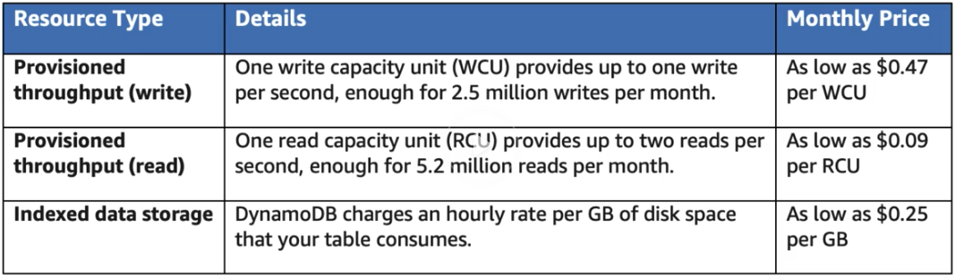

**What determines price for CloudFront?**

* Traffic Distribution
* Requests
* Data Transfer out

**What are Tags**

* Key value Pairs attached to AWS resources
* Metadata (data about data)
* Tags can sometimes be inherited

Resource Groups make it easy to group your resources using the tags that are assigned to them. You can group resources that share one or more tags.

Resources Group contains information such as:

* Region
* Name
* Employee ID
* Department

Specific information about tags

EC2- public or private IP address

ELB – Port configuration

RDS – Database engine

Using resources Group you can apply automation to resource tagged with specific tags. For Example, we stopped all the EC2 instances in the Stockholm region.

Resource Group in combination with AWS System Manager allow you to control and execute automation against entire fleets of EC2 instances, all at the push of a button.

Tag editor is a global service that allow us to discover resources and to add additional tags to them as well. Newer regions may take some times to be compatible with tag editor.

**AWS Organization & Consolidated billing:**

AWS Organization is an account management service that enables you to consolidate multiple AWS accounts into an organization that you create and centrally manage.

Available in Two feature sets:

* Consolidated billing
* All feature

Some Best Practices with AWS Organization

* Always enable multi-factor authentication o root account
* Always use a string and complex password on root account
* Paying account should be used for billing purpose only. Do not deploy resources into the paying account

CloudWatch vs CloudTrail

* CloudWatch monitors performance
* CloudTrail monitors API calls in the AWS platform.

How to use CloudTrail with AWS Organization

CloudTrail:

* Per AWS account and it enabled per region.
* Can consolidate logs using an S3 bucket?

1. Turn on Cloud trail in paying account
2. Create a bucket policy that allow cross account access
3. Turn on CloudTrail in the other accounts and use the bucket in the paying account.

**AWS Quick start and AWS Landing Zone**

**AWS Quick start** is a way of deploying environment quickly, using CloudFormation templates built by AWS solutions architect who are experts in that particular technology.

**AWS Landing Zone** is a solution that helps customers more quickly set up a secure, multi-account AWS environment based on AWS best practices.

**AWS Calculator**

AWS help you to calculate your cost using a couple of different calculators.

Available in two feature sets

* **AWS simple Monthly Calculator (Hosted in S3)**

AWS Simple Monthly Calculator is used to calculate your running costs on AWS on a per month basis. It is not a comparison tool.

* **AWS Total Cost of Ownership (TCO) Calculator.**

AWS TCO Calculator is used to compare costs of running your infrastructure on premise vs in the AWS cloud. It will generate report that you can give to your C-Level execs to make a business case to move to the cloud.

**Security in the cloud**

* PCI-DSS Payment Card standard

**The Shared Responsivities**

While AWS manages **security of the cloud**, **security on the cloud is responsibilities of the customer**. Customer retain control of what security they choose to implement to protect their own content, platform, application, systems and networks, no differently than they would in an on-site datacenter.

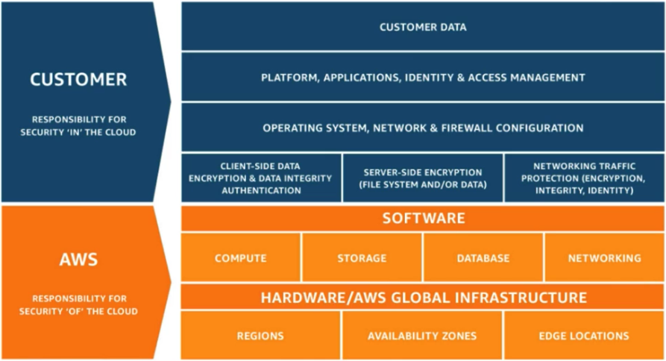

**AWS WAF and AWS Shield**

**What are AWS WAF? [level 7]**

~ AWS WAF is a **web application firewall** that helps protect your web application from common web exploits that could affect application availabilities, compromise security, or consume excessive resources.

* Protect from cross side scripting or SQL injection
* This is extra layer before load balancer.

**What is AWS Shield?**

~ AWS Shield is managed Distributed Denial of Service (DDoS) protection service that safeguards web applications running on AWS.

~ AWS Shield provides always-on detection and automatic inline mitigation that minimize downtime and latency. So, there is no need to engage AWS support to benefits from DDoS protection. There is two AWS Shield- Standard(default) and Advanced ($3000).

**What is AWS Inspector.?**

**~ AWS** Inspector, is used for inspecting EC2 instances for vulnerabilities.

AWS Inspector is an automated security assessment service that helps improve the security and compliance of applications deployed on AWS.

~ AWS Inspector automatically assesses application for vulnerabilities or deviations from best practices. After performing an assessment, AWS Inspector produces a detailed list of security finding prioritized by level of severity. These finding can be reviewed directly or as part of detailed assessment repots which are available via the AWS Inspector console or API.

~ This is agent to install on EC2.

**What is AWS Trusted Advisor. ?**

An online resource to help you reduce cost, increase performance and improve security by optimizing your AWS environment. Trusted Advisor provides real time guidance to help you provision your resource following AWS best practice.

* This is Global service.
* AWS trusted adviser inspects your AWS account as a whole (not just EC2), it does more than just security check.

~ Advise you can code Optimization, Performance, Security and Fault Tolerance.

* Core Checks and Recommendation.
* Full Trusted Advisor- Business and Enterprise Companies only.

**What is AWS Cloud Trail?**

* Like CC TV.
* AWS CloudTrail increases visibilities into your user and resources activities and recording AWS Management console actions and API Calls, you can identify which users and account called AWS, the source IP address from which the calls were made, and when the calls occurred.
* Who and when S3 bucket, EC2 who has created and when- example.

**What is Data Warehousing?**

Used for business intelligence, tool like Cognos, Jaspersoft, SQL Server Reporting services, Oracle Hyperion, NAP NetWeaver.

Used to pull in very in very large and complex data sets, usually used by management to do queries on data (such as current performance vs targets etc.).

Data warehousing databases use different type of architecture both from a database prospective and infrastructure layer.

Redshift – AWS Data Warehouse solution is Called Redshift.

**What is ElastiCache?**

ElastiCache is a web service that makes it easy to deploy, operate, and scale an in-memory cache in the cloud. The service improves the performance of web application by allowing you to retrieve information fast, managed, in-memory caches instead of relying entirely on slower disk-based databases.

ElastiCache supports two open source in-memory caching engines.

* Memcached
* Redis