1. What is constructor overloading? Can constructors be overloaded in a derived class?

Answer:

Constructor overloading is mechanism of having more than one constructor with different parameters list, in such a way so that each constructor performs a different task.

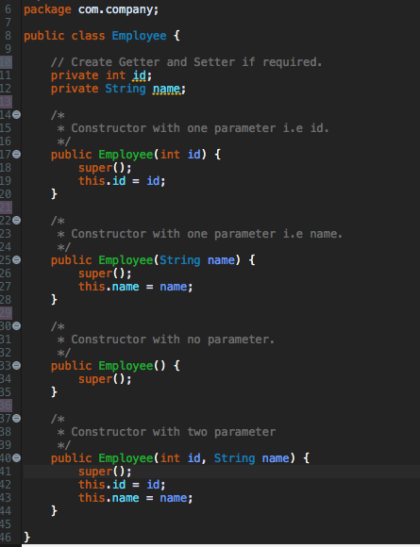

The constructor must be having the same name as that of a class. Hence a constructor of one class can't even be defined in another(derived) class. Since the constructors can't be defined in derived class, it can't be overloaded too, in derived class.

**2)  What is a templated class? How is it different from function overloading?**

Templated classes more abstract by letting you define the behavior of the class without actually knowing what datatype will be handled by the operations of the class. Templates can be used in conjunction with abstract datatypes in order to allow them to handle any type of data. For example, you could make a templated Vehicle class that can handle a Vehicle of any type i.e. 2-wheeler or 4-wheeler vehicle, rather than having to create a vehicle class for every different datatype for which you want the vehicle to function. The ability to have a single class that can handle several different datatypes means the code is easier to maintain, and it makes classes more reusable.

3)  **Write a function to remove duplicate characters from a string.**

 Input: aaaabbbccdexxaaaa

Output: abcdex

Answer: Please refer attached java file i.e. DuplicateUtil.java

Execute the main method of this file in Java8+ environment. Because it uses the functional programming as well, which available in Java8+.

Screen shot:

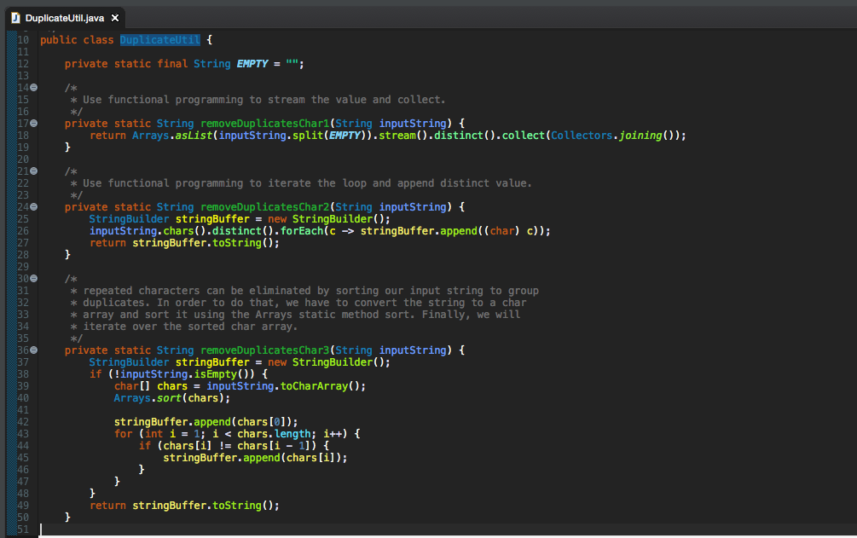

4)  **Write method to expose a service as a post endpoint. Expose method in 1 as an endpoint**

Answer: Complete Application source are attached, this is spring boot application.

Please download the source code execute Spring boot application in the following way.

Prerequisites:

1. Setup Java 8
2. Setup Maven 3+
3. Download my project source code.
4. Execute the following way in current directory of source code.

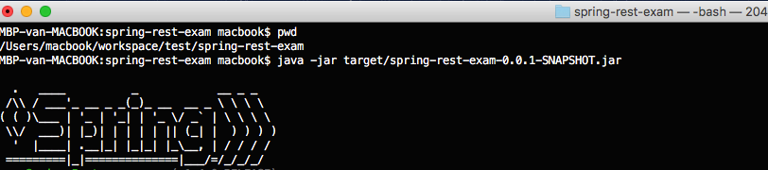

Screen shot 1: POST the entity, result HTTP status 201 (created)

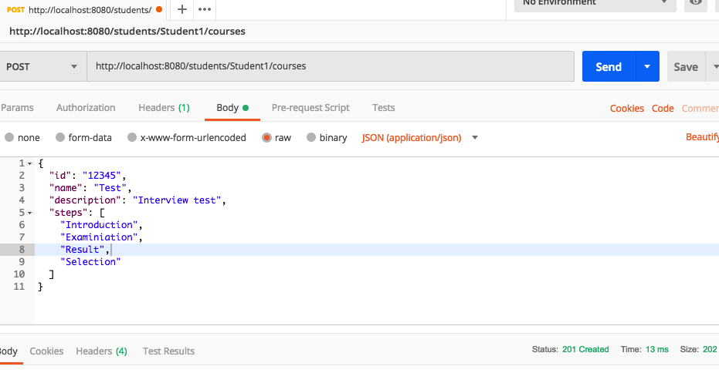

Screen-shot: 2, Integration testing

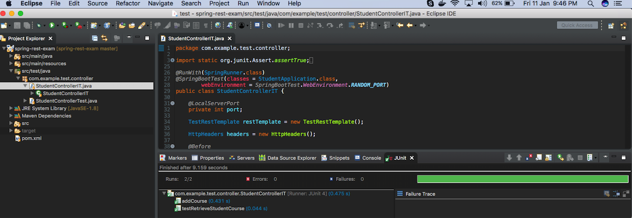

Screen-shot: 3, Unit testing

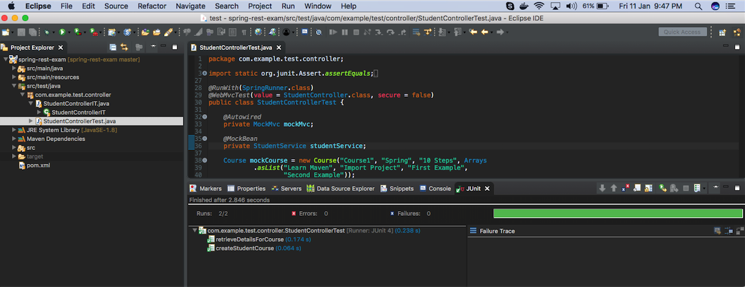

Screen-shot: 4, Spring boot application running

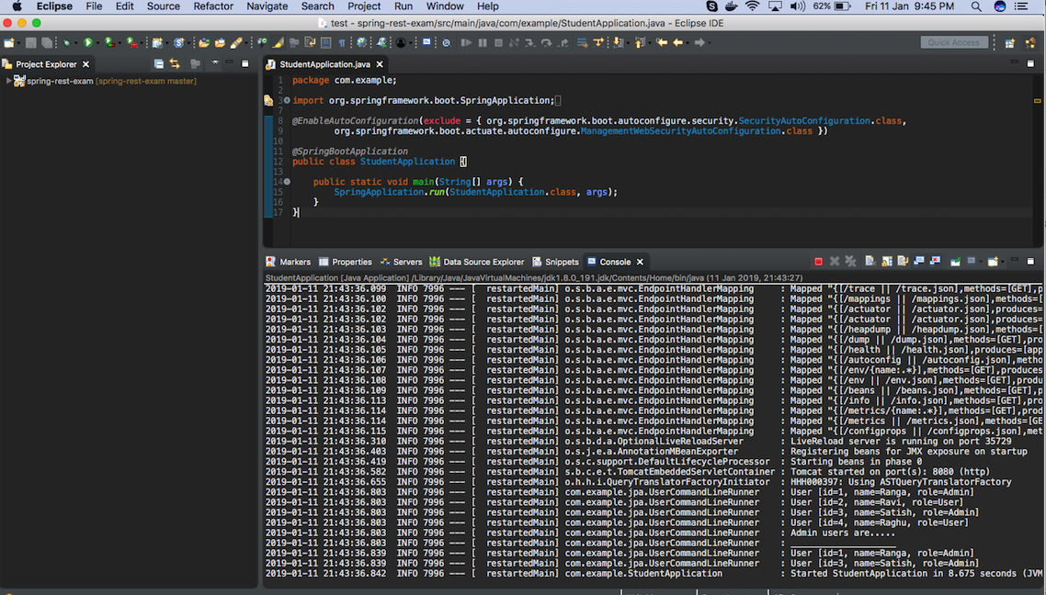

5)  **Write the difference between singleton pattern and singleton class in java examples**.

Singleton pattern restricts the instantiation of a class and ensures that only one instance of the class exists in the java virtual machine.

The singleton class must provide a global access point to get the instance of the class.

Singleton pattern is used for logging, caching and thread pool.

The Singleton pattern has several advantages over static classes. First, a singleton can extend classes and implement interfaces, while a static class cannot (it can extend classes, but it does not inherit their instance members). A singleton can be initialized lazily or asynchronously while a static class is generally initialized when it is first loaded, leading to potential class loader issues. However, the most important advantage, though, is that singletons can be handled polymorphically without forcing their users to assume that there is only one instance.

**6)  How do you initialize an application in Spring Framework**

The ApplicationContext is the central interface within a Spring application for providing configuration information to the application. It is read-only at run time, but can be reloaded if necessary and supported by the application. A number of classes implement the ApplicationContext interface, allowing for a variety of configuration options and types of applications.

The Application Context is Spring's advanced container. Similar to BeanFactory, it can load bean definitions, wire beans together, and dispense beans upon request. Additionally, it adds more enterprise-specific functionality such as the ability to resolve textual messages from a properties file and the ability to publish application events to interested event listeners. This is defined by *org.springframework.context.ApplicationContext*interface.

The *ApplicationContext* includes all functionality of the *BeanFactory*, it is generally recommended over BeanFactory. implementations are −

FileSystemXmlApplicationContext

ClassPathXmlApplicationContext

WebXmlApplicationContext

**7)  How do you configure a java application to be deployable to K8S**

Packaging and deploying Java applications within Docker containers. Minikube is a tool that makes it easy to run Kubernetes for local development. Kubectl is a command line application that executes commands against K8S clusters. Kubernetes pulls container images from publicly available registries. We will define a Kubernetes service object for this application yaml file .The next step is to define and create a deployment for our application. This is where we specify the image we previously created and published to the registry.

**8)  Draw an ERD for a School Management System**

* 1. **i)  List different Entities**
  2. **ii)  Identify the relationships**

Answer: This entity relationship diagram shows that relationship between Student, school, teacher and with the parent of student. An ERD is a conceptual and representational model of data used to represent the entity framework infrastructure

List of entities:

* Student
* School
* Teacher
* Homework
* Student address
* Student parent
* Family member of student
* Address
* Parents address
* Parents
* Family
* Subject
* Class
* Student class
* Report and etc.

Relationship:

* School has-a one to many relationships with teacher. (compositions)
* Teacher has-a one to many relationships with student. (compositions)
* Student has-a one to one relation with parents. (compositions)
* Student has-a one to many relationships with homework. (compositions)
* Student has-a one to one relationship with reports. (compositions)
* Student has-a one to many relationships with student classes. (compositions)
* school and student having association relationship.
* teacher and school having association relationship.

Follow the notation style in the follow way:

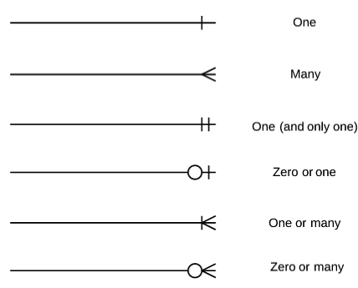

Screen-shot attached:

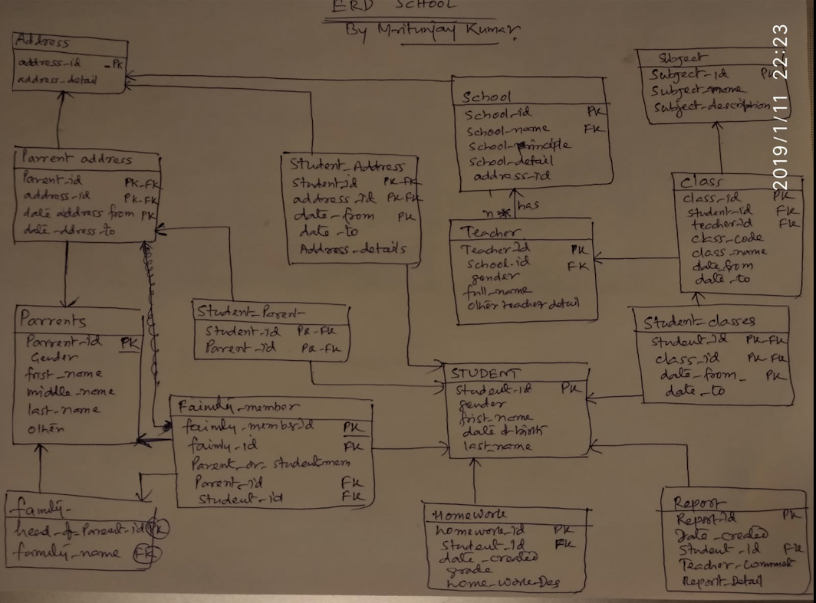

The end