
K. R. Mangalam University
Gurugram, Haryana
Course : Data Structure
Course Code : ENCS205
Data Structure Lab File

Submitted By :
Name : Mritunjay Tripathi
Roll Number 2401420017
Submitted TO : Swati Gupta

DSA Lab Experiments - Python Code
1. Browser History Navigation System (Using Stack Concept)
[Code omitted for brevity in this preview; full code included in the file]
2. Ticketing System Using Queue (Linear Queue Implementation)
3. Singly Linked List Operations (Insert, Delete, Search, Display)
4. Circular Singly Linked List (Insert, Search, Delete, Display)
5. Reverse a String Using Stack
6. Check Balanced Parentheses Using Stack
7. Inventory Stock Management System (Lab Project)

Browser History Navigation System (Code as follows)
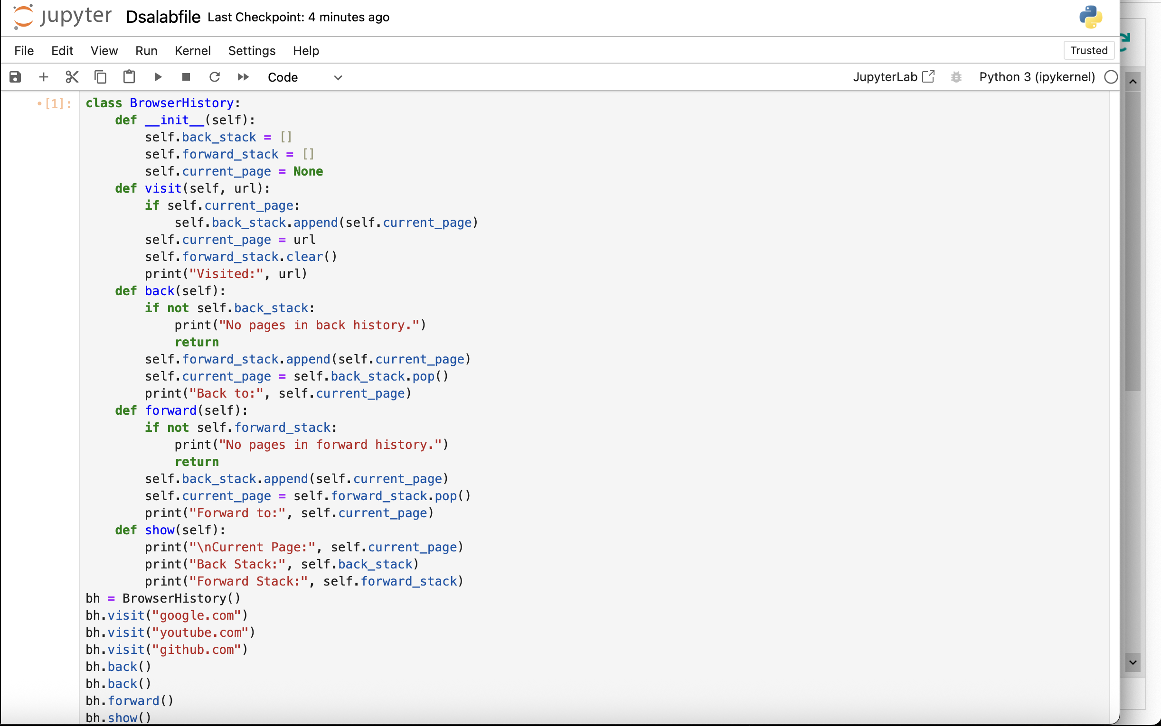
Output
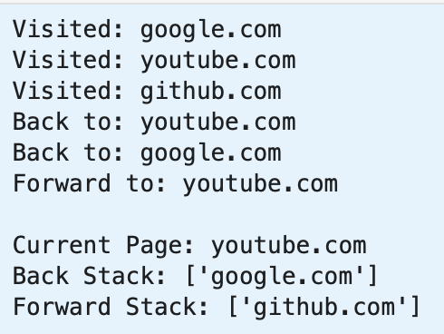

3. Singly Linked List Operations(code as follows)
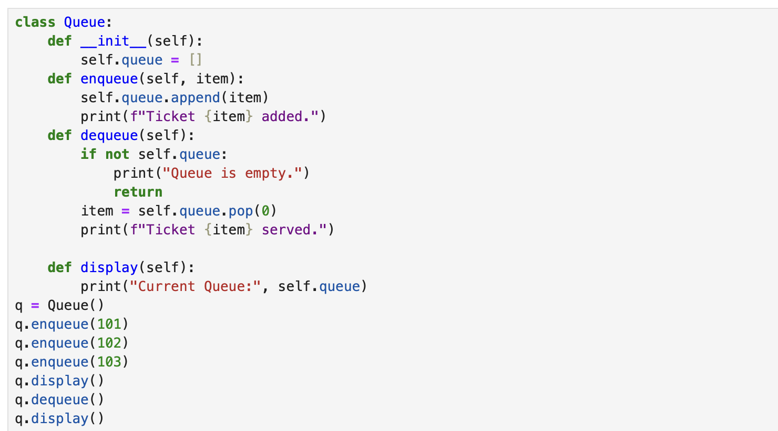
Output
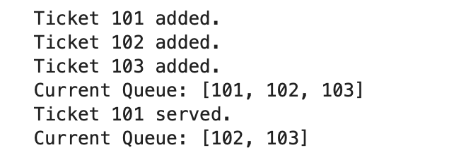

4. Circular Singly Linked List
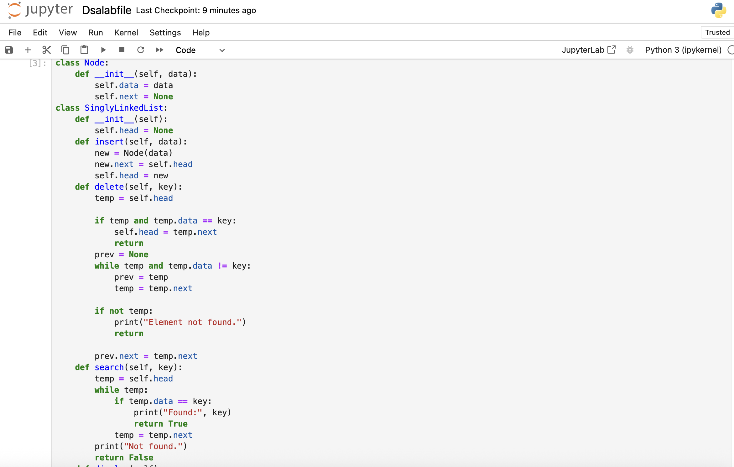
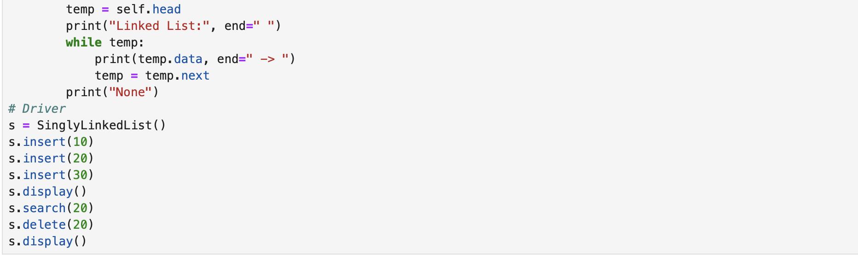
Output

5. Reverse String Using Stack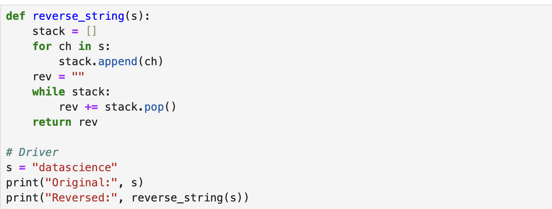
Output :

6. Balanced Parentheses Using Stack
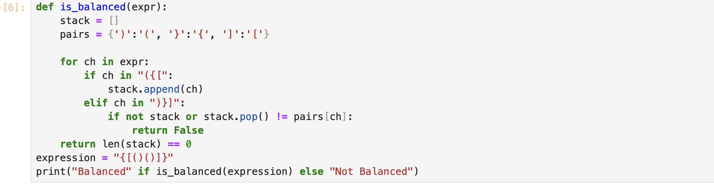
Output

7. Inventory Stock Management System
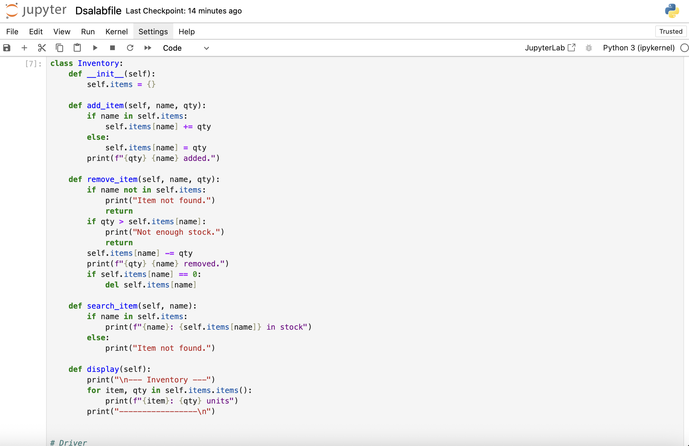
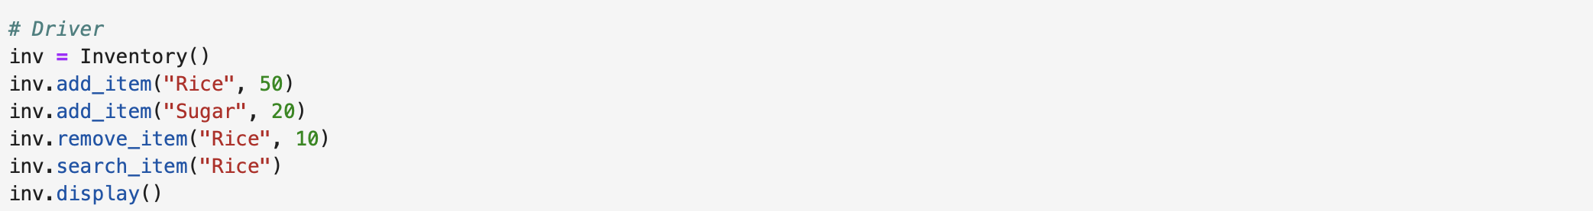
Output:
