AbleSpace Walkthrough
Part 2 – Product Understanding
Take Data Workflow – Caseload

This walkthrough explains the workflow I observed while exploring the Caseload and Take Data experience in AbleSpace.

1 | 2 | 3 | 4 | 5
Caseload | Student | Goals | Take Data | Review
Caseload → Student Profile → Goals → Take Data → Graph / Stats / Info

1. Product & Workflow Overview
Purpose. The Take Data workflow provides a focused way for a professional to select a student, choose an IEP goal, record goal-specific data, and review the student's performance.
Observed workflow. The experience follows a clear progression from the caseload list to the individual student, then to goals and finally to data capture and review.
- Caseload: identify the student and access student actions.
- Student Profile: view key student details and access goals.
- Goals: review active goals and their measurement types.
- Take Data: record observations/trials using a goal-specific input.
- Review: use Graph, Stats, and Info to understand collected data.

2. Step 1 — Caseload
What I observed: The Caseload screen presents students in a table and provides important information such as IEP due date, evaluation due date, collaborators, service time, school, grade, DOB, teacher, and room. Each student row also provides a Take Data action.
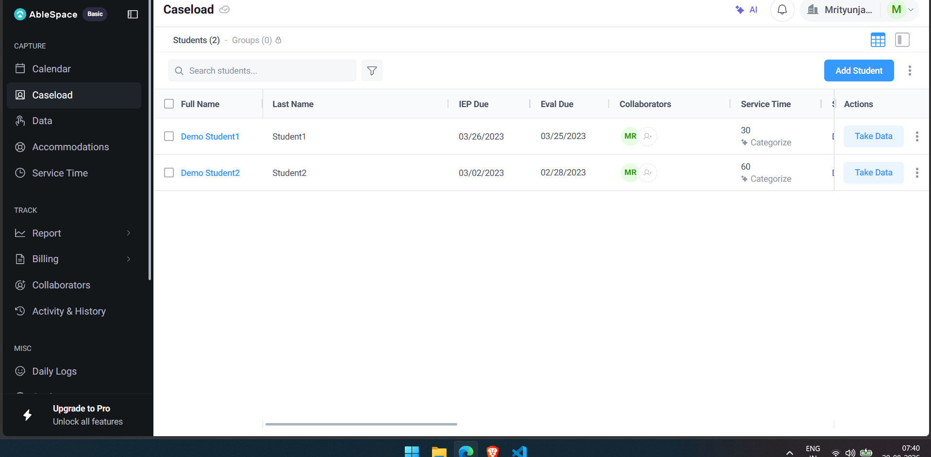
Figure 1. Caseload provides a central student list and direct access to Take Data.

3. Step 2 — Student Profile
What I observed: Selecting a student opens a profile with tabs for Goals, Worksheets, Notes, Service Time, Accommodation, Attachments, Daily Logs, Progress, and Strength/Need. The Take Data and View Data actions are visible at the top, keeping data collection close to the student's information.
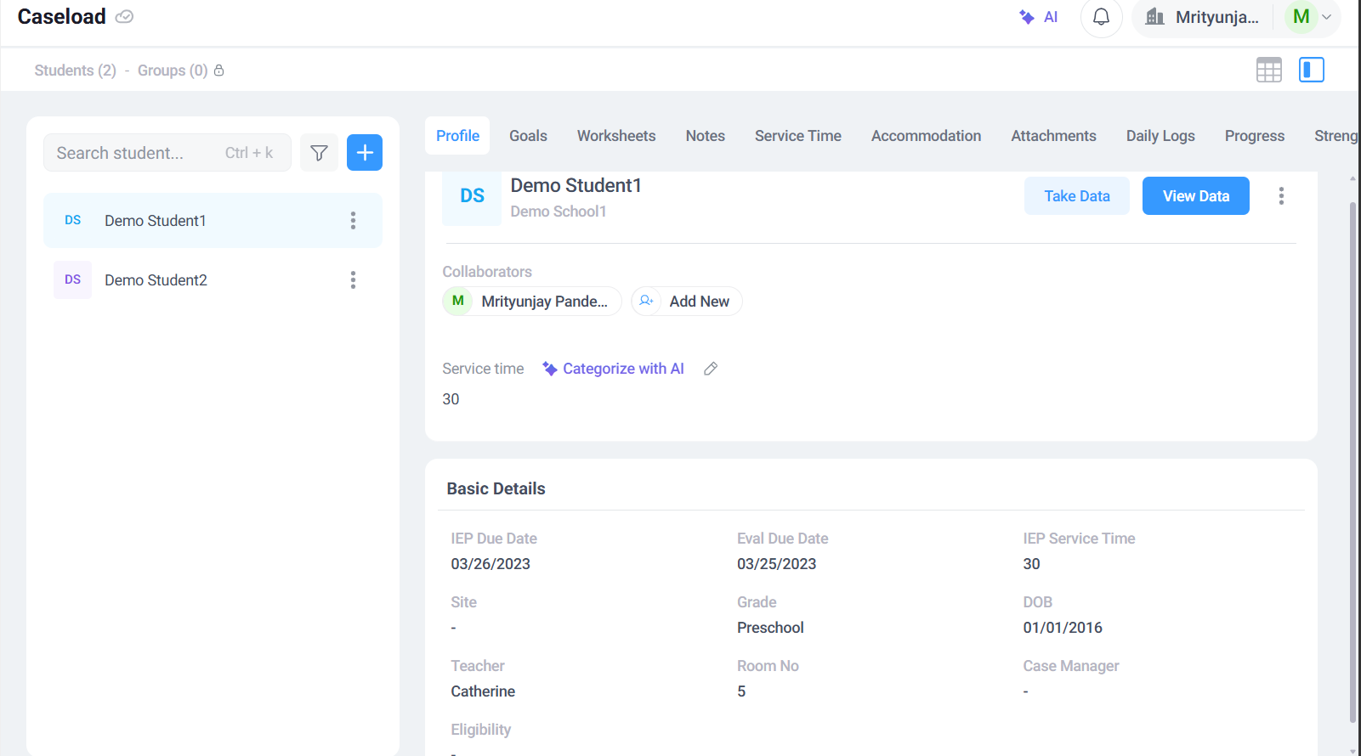
Figure 2. Student Profile keeps student information and data actions together.

4. Step 3 — Review Goals
What I observed: The Goals page shows 7 goals and 2 objectives for the demo student. Each goal is associated with a measurement type such as Frequency, Task Analysis, Accuracy, Task with Prompts, Prompting Levels, Rating Scale, or Opportunity. Goal status is also summarized as Not Started, Behind, On Track, or Mastered.
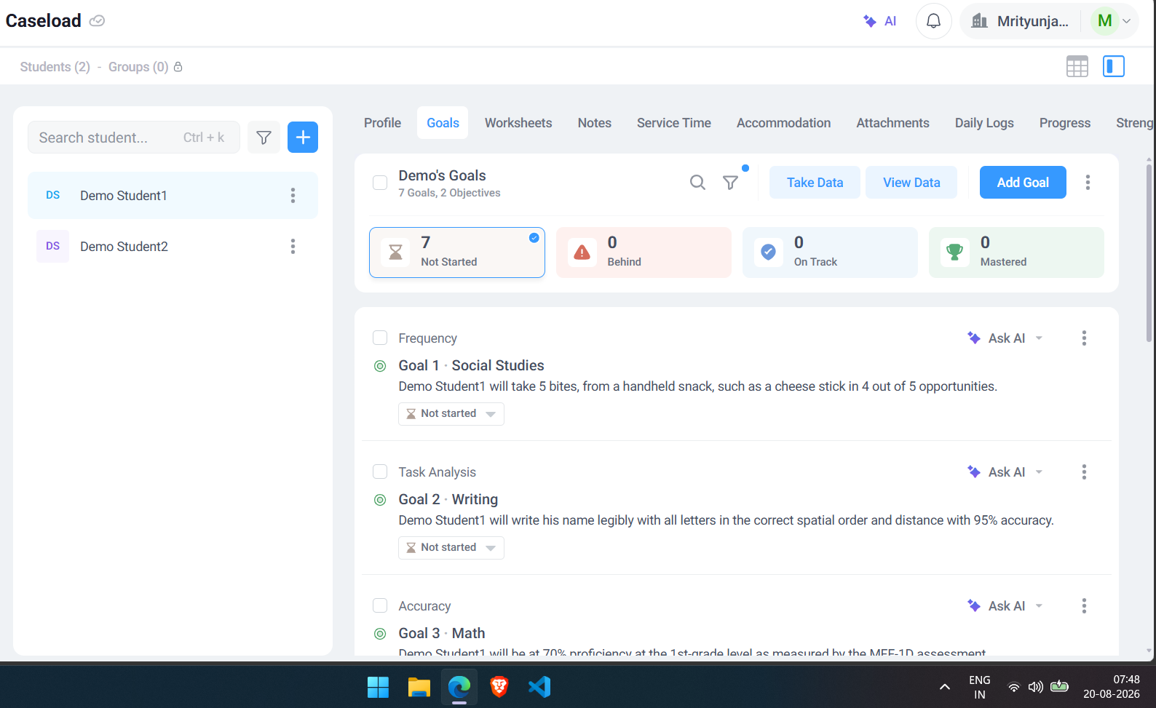
Figure 3. Goals are organized by measurement type and progress status.

5. Step 4 — Take Data / Capture
What I observed: The Take Data view opens a dedicated session. The selected goal and its full description are shown above the capture area. For the Social Studies goal, a large + control is used to record frequency. Each click increments the recorded value, while Undo allows the latest entry to be corrected. Notes and a Lesson Plan area are also available during the session.
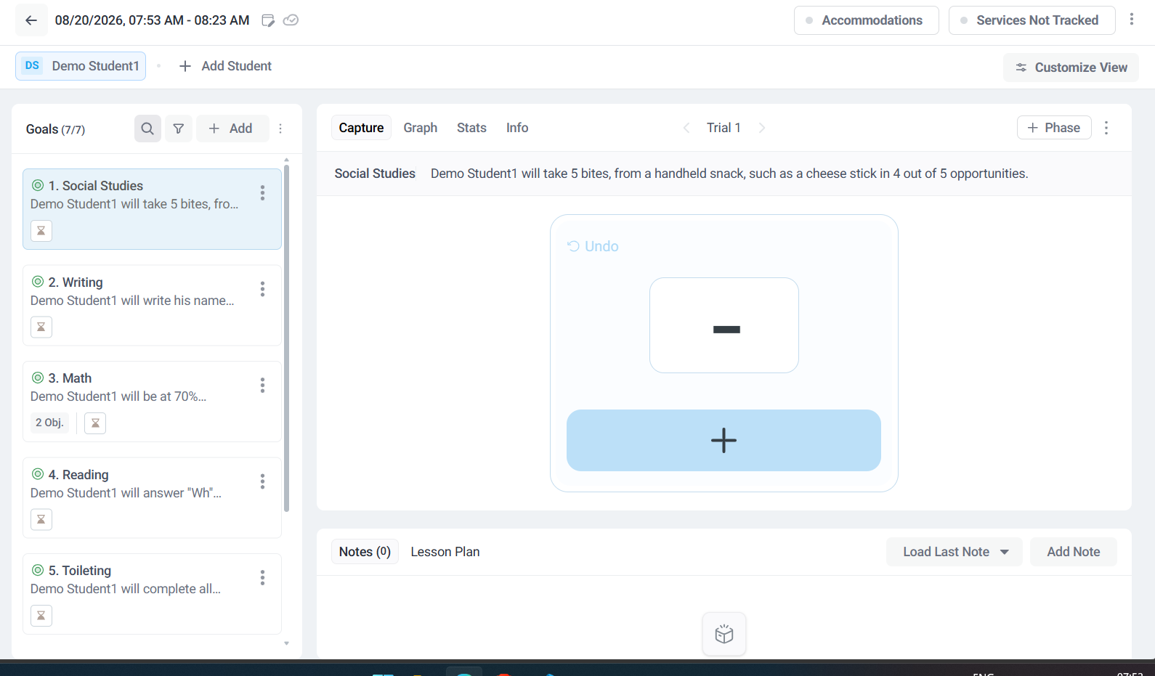
Figure 4. Take Data provides a simple, large interaction for recording a trial.

6. Step 5 — Review the Data

6.1 Graph
What I observed: The Graph view visualizes performance over time. The user can adjust the time range and graph options, making trends easier to understand than a list of individual observations.
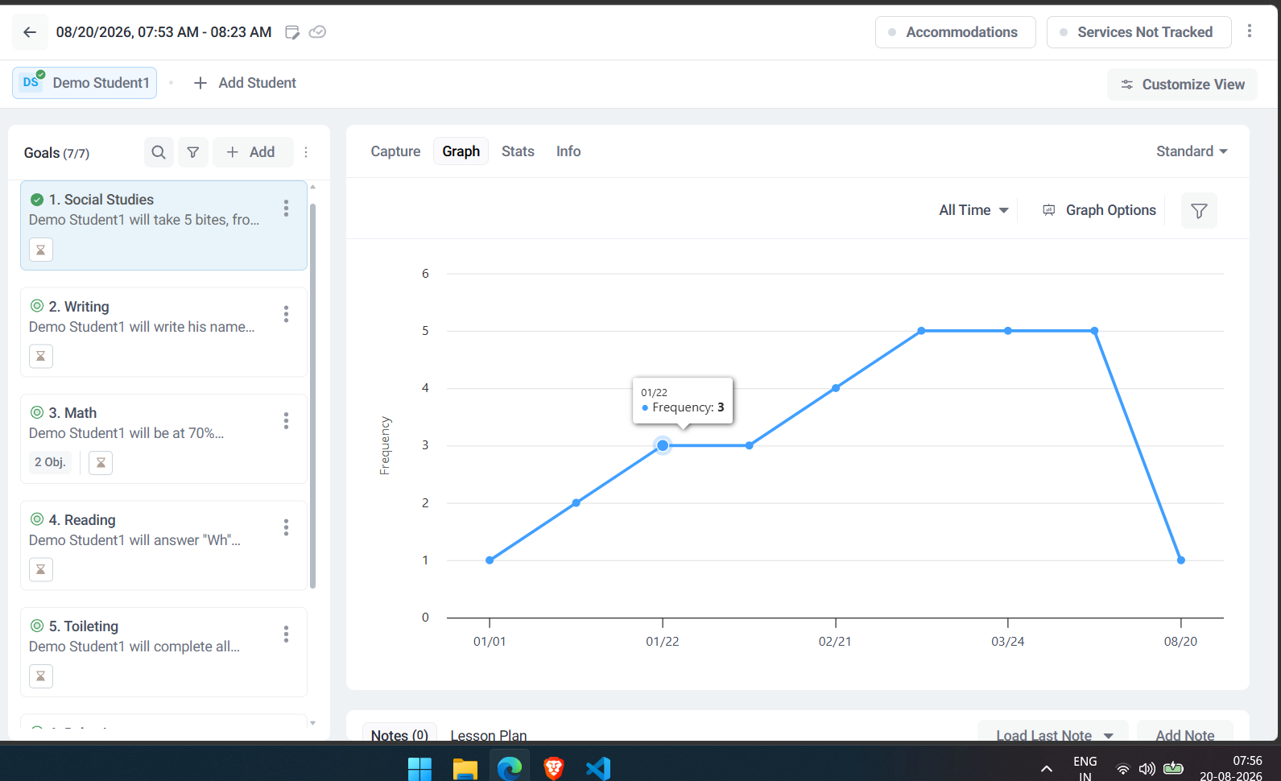
Figure 5. Graph view visualizes frequency data over time.

6.2 Stats
What I observed: The Stats view presents individual data points with session/trial date, editor, frequency, and notes. The interface also provides options to add data, download data, view more data, and access a performance summary.
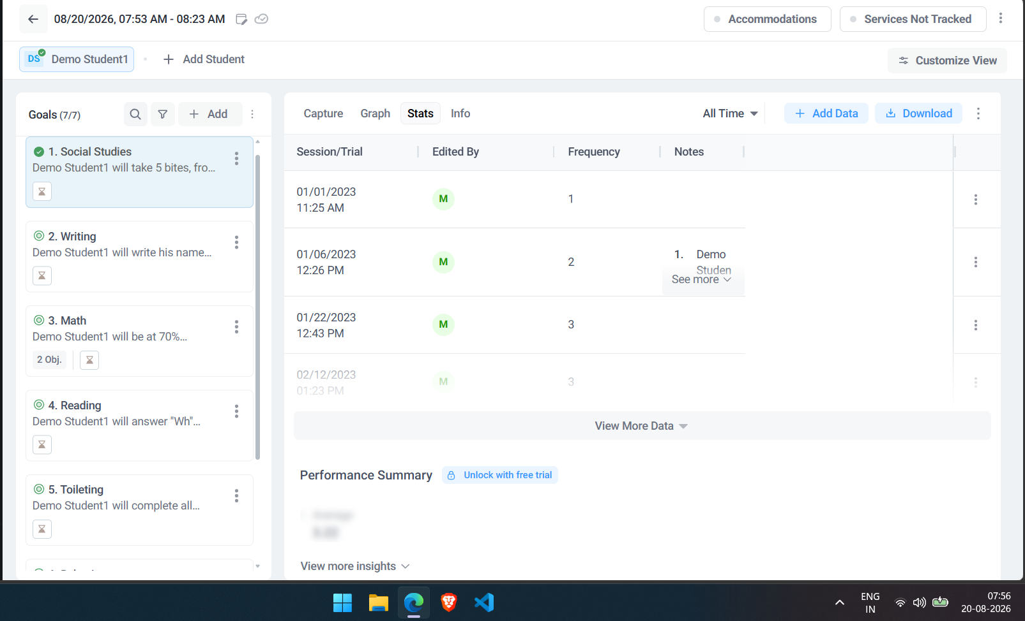
Figure 6. Stats provides a structured view of recorded observations.

6.3 Info
What I observed: The Info view summarizes the measurement type, last data update, number of data points, notes count, and a performance summary. In the observed example, the measurement was Frequency and the displayed average was 3.22.
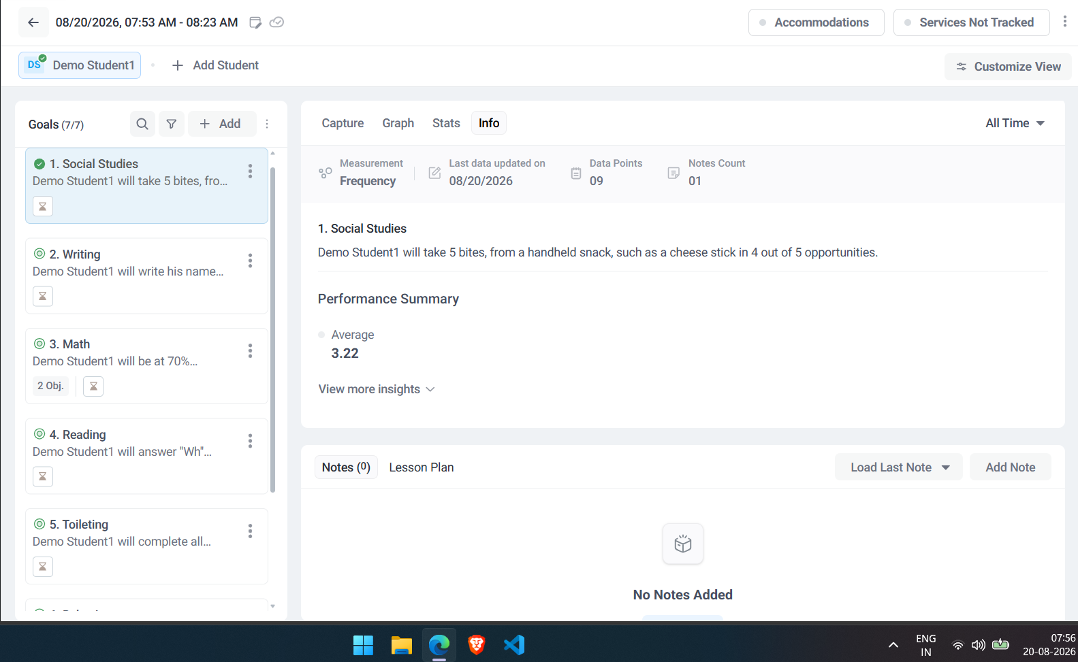
Figure 7. Info summarizes the selected goal and collected data.

7. UX/UI & Functionality Observations
Strengths observed
- The workflow is easy to understand: Caseload → Student → Goals → Take Data → Review.
- The large + control makes repeated data entry fast during a live session.
- Goal-specific measurement types reduce the need for the professional to decide how data should be recorded.
- Graph, Stats, and Info provide different ways to review the same collected data.
Potential improvements
1. Show trial progress: During a goal such as 4 out of 5 opportunities, display progress such as “3/5 opportunities” so the professional immediately knows how far the current trial is from completion.
2. Quick access to frequently used goals: Allow professionals to pin or mark frequently collected goals so they can start data collection faster without scanning the full goal list.
3. Stronger completion feedback: After data is saved, provide a clear confirmation such as “Data saved successfully” and show the latest recorded value. This would reduce uncertainty during a busy session.
4. Mobile-first capture controls: The large capture control is already helpful. Further optimizing the essential capture actions for one-handed mobile/tablet use could make live data collection even easier.
5. Compact session summary: After capture, show the latest result, goal target, and recent trend together in a compact summary before the professional leaves the session.

8. Overall Product Understanding
The main value I observed in the Take Data workflow is that it turns a potentially repetitive data-entry task into a focused interaction. The professional can move from a student's caseload record to a specific goal, capture observations with minimal interaction, and then review the same information through visual and statistical views. The workflow is therefore centered around reducing friction in data collection while keeping the resulting information useful for progress monitoring.
End of Walkthrough

