PS C:\Users\Mrityunjoy\Desktop\MeanRegistration> **git init**

PS C:\Users\Mrityunjoy\Desktop\MeanRegistration> **git add .**

PS C:\Users\Mrityunjoy\Desktop\MeanRegistration> **git commit -m "First Commit"**

PS C:\Users\Mrityunjoy\Desktop\MeanRegistration> **git remote add origin** [**https://github.com/mrityunjoylaha/MEAN_Form_Registration.git**](https://github.com/mrityunjoylaha/MEAN_Form_Registration.git)

PS C:\Users\Mrityunjoy\Desktop\MeanRegistration> **git push -f origin master**

**Type in Command Prompt:-**

***C:\Users\Mrityunjoy\Desktop>cd bootstrap***

***C:\Users\Mrityunjoy\Desktop\bootstrap>git init***

***Initialized empty Git repository in C:/Users/Mrityunjoy/Desktop/bootstrap/.git/***

***C:\Users\Mrityunjoy\Desktop\bootstrap>git remote add origin https://github.com/mrityunjoylaha/Bootstrap.git***

***-***

***C:\Users\Mrityunjoy\Desktop\bootstrap>git remote -v***

***origin https://github.com/mrityunjoylaha/Bootstrap.git (fetch)***

***origin https://github.com/mrityunjoylaha/Bootstrap.git (push)***

***C:\Users\Mrityunjoy\Desktop\bootstrap>npm install -g angular-cli-ghpages***

***C:\Users\Mrityunjoy\Desktop\bootstrap>ng build --prod --base-href https://mrityunjoylaha.github.io/Bootstrap/***

***Generating ES5 bundles for differential loading...***

***An unhandled exception occurred: [BABEL] C:\Users\Mrityunjoy\Desktop\bootstrap\dist\bootstrap\main-es2015.3ccc82f5d0adbd06b99c.js: Could not find plugin "proposal-numeric-separator". Ensure there is an entry in ./available-plugins.js for it. (While processing: "C:\\Users\\Mrityunjoy\\Desktop\\bootstrap\\node_modules\\@babel\\preset-env\\lib\\index.js")***

***See "C:\Users\MRITYU~1\AppData\Local\Temp\ng-jjEEHb\angular-errors.log" for further details.***

***C:\Users\Mrityunjoy\Desktop\bootstrap>code .***

Add  "devDependencies": {

"@babel/compat-data": "7.8.0",

"@babel/preset-env": "7.8.0",

"babel-loader": "8.1.0",

...

},

...

"resolutions": {

"@babel/preset-env": "7.8.0"

}

1. to package.json.
2. run npx npm-force-resolutions
3. npm install or yarn.

***C:\Users\Mrityunjoy\Desktop\bootstrap>npx npm-force-resolutions***

npx: installed 5 in 10.14s

***C:\Users\Mrityunjoy\Desktop\bootstrap>npm install***

***C:\Users\Mrityunjoy\Desktop\bootstrap>ng build --prod --base-href https://mrityunjoylaha.github.io/Bootstrap/***

Generating ES5 bundles for differential loading...

ES5 bundle generation complete.

chunk {2} polyfills-es2015.5b10b8fd823b6392f1fd.js (polyfills) 36.2 kB [initial] [rendered]

chunk {0} runtime-es2015.c5fa8325f89fc516600b.js (runtime) 1.45 kB [entry] [rendered]

chunk {0} runtime-es5.c5fa8325f89fc516600b.js (runtime) 1.45 kB [entry] [rendered]

chunk {3} polyfills-es5.3e8196928d184a6e5319.js (polyfills-es5) 124 kB [initial] [rendered]

chunk {1} main-es2015.3ccc82f5d0adbd06b99c.js (main) 169 kB [initial] [rendered]

chunk {1} main-es5.3ccc82f5d0adbd06b99c.js (main) 169 kB [initial] [rendered]

chunk {4} styles.3ff695c00d717f2d2a11.css (styles) 0 bytes [initial] [rendered]

Date: 2020-03-28T19:24:05.675Z - Hash: 4fead7257f0628c19452 - Time: 99745ms

***C:\Users\Mrityunjoy\Desktop\bootstrap>ngh --no-silent --dir=dist/bootstrap***

***👨‍🚀 Uploading via git, please wait...***

***❌ An error occurred when trying to deploy:***

***\*\*\* Please tell me who you are.***

***Run***

***git config --global user.email "you@example.com"***

***git config --global user.name "Your Name"***

***to set your account's default identity.***

***Omit --global to set the identity only in this repository.***

***fatal: unable to auto-detect email address (got 'Mrityunjoy@Joy.(none)')***

***C:\Users\Mrityunjoy\Desktop\bootstrap>git config --global user.email "mrityunjoylaha1997@gmail.com"***

***C:\Users\Mrityunjoy\Desktop\bootstrap>git config --global user.name "mrityunjoylaha"***

***C:\Users\Mrityunjoy\Desktop\bootstrap>ngh --no-silent --dir=dist/bootstrap***

***👨‍🚀 Uploading via git, please wait...***

***🚀 Successfully published via angular-cli-ghpages! Have a nice day!***

***\*\*\*\*\*\*\*\*\*\*\*\*\*\*\*\*\*\*\*\*\*\*\*\*\*\*\*\*\*\*\*\*\*\*\*\*\*\*\*\*\*\*\*\*\*\*\*\*\*\*\*\*\*\*\*\*\*\*\*\*\*\*\*\*\*\*\*\*\*\*\*\*\*\*\*\*\*\*\*\*\*\*\*\*\****

***PS C:\Users\Mrityunjoy\Desktop\bootstrap> git init***

***PS C:\Users\Mrityunjoy\Desktop\bootstrap> git add .***

***PS C:\Users\Mrityunjoy\Desktop\bootstrap> git commit -m "First Commit"***

***PS C:\Users\Mrityunjoy\Desktop\bootstrap> git remote add origin https://github.com/mrityunjoylaha/Bootstrap.git***

***PS C:\Users\Mrityunjoy\Desktop\bootstrap> git push -f origin master***

**Step 1**

To create a project using Angular CLI, run the command:

ng new demo

You need to make sure that Angular CLI is installed globally on your machine.

**Step 2**

Change the directory to demo and open the project in VS Code or any other IDE of your choice.

## Step 3

Before we publish this application to GitHub, let us run it locally. To run it locally, run the command:

ng serve

## ****Step 4****

To deploy your Angular application, first create a repository on GitHub. To do that navigate, to <https://github.com/> and click on New Repository. I am creating a repository named " **demo9**."

After the repository is created, use a git command to add this repository as a remote file to the local project. To do that, run the  below command:

git remote add origin https://github.com/USERNAME/PROJECT_NAME.git

Do not forget to change the username and project name. Once the remote repository is added, you can verify that using the below command:

git remote -v

As output, you should get a repository listed as below:

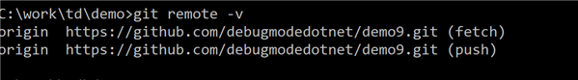

## ****Step 5****

To deploy the Angular application to GitHub, you need to first globally install the **angular-cli-ghpages**:

npm install -g angular-cli-ghpages

After installing ghpages, use Angular CLI to build the project. For that, run the command as shown below:

 ng build --prod --base-href <https://debugmodedotnet.github.io/demo9/>

Make sure that you are using your GitHub username and repository name. After the successful execution of the command, you should get bundle.js created as shown in the image below:

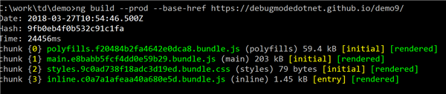

For the last step, run the command ngh -no-silent to publish the application as shown in the image below:

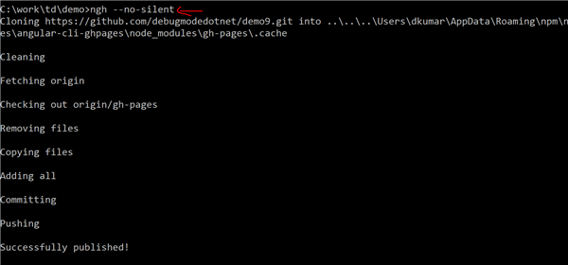

After successfully publishing your app, navigate to https://<username>.github.io/<reponame>/ to see it on GitHub. This is all you need to do to deploy the Angular application to GitHub.