**Field Map Estimation in MRI Using Compressed Sensing algorithm**

Kang Yan

Shanghai Jiao Tong University  
 1954 huashan Road, Xuhui district  
Shanghai, China  
 (+86)18710895918

sjtu_yankang@sjtu.edu.cn

Huajun She

Shanghai Jiao Tong University  
 1954 huashan Road, Xuhui district  
Shanghai, China  
(+86)13964861703

shehuajun@hotmail.com

**ABSTRACT**

For non-cartesian magnetic resonance imaging, like spiral imaging, field inhomogeneity could cause image blurring, especially for long readout time. General correction method required field map estimation. However, when images are in low spin density, the estimated field map suffers from noise. A regularized method which utilizes the physical feature that field map is spatial smoothing, is proposed to estimate field map with little noise. The field map estimated by regularized method only have good performance while the images in low noise level. Once image suffers from severe noise, an accurate field map is still hard to obtain. In reality, to shorten scan time in spiral imaging, we would decrease the number of interleaves of sampling. As results of that, Signal-to-noise Ratio (SNR) of image gets lower, and effect of B0 inhomogeneity becomes serious problem. In such situation, a better way to calculate field map is required. In this paper, we propose optimized field map estimation method which employs compressed sensing algorithm. Actually, recovery expected signal of compressed sensing (CS) algorithm is noise reduction process, which could be used to estimate field map when images are in low SNR. The experiments show that using Wavelet transform as regularization term could perform better when images are in low Signal-to-Noise Ratio (SNR). To improve calculated field map further, both Total Variation (TV) term and Waveform term as regularization term are adapted. The method in this paper promises great field map estimation.

**CCS Concepts**

•**Applied computing ➝ life and medical sciences**

**Keywords**

Spiral imaging; field inhomogeneity; Compressed Sensing

# INTRODUCTION

Fast imaging technique such as Echo-planar imaging (EPI) and spiral imaging shorten the scanning time significantly, which is of great importance to magnetic resonance imaging (MRI). Unfortunately, imperfect system condition would induce image blurring, distortion and other problems in such fast imaging sequence when it’s not notable in cartesian imaging. In spiral imaging, field inhomogeneity and chemical shift could induce imaging blurring. There are many methods to correct image[1-7]. But all of them need a smooth field map. A conventional way of image deblurring needs to estimate field map. This field map is obtained by collecting signal of object twice with slightly difference echo time. After images have been constructed, the phase difference rate between the two images were taken as field map.

Conventional method works well when the signal of object is far stronger than noise. Once the signal of object gets weak in the level of noise, the assumption that noise could be ignored is invalid. the image region in low proton density wouldn’t be able to generate ideal field map under this assumption. Fessler et al [8] proposed the regularized method which make use of smooth variation feature of field. However, when images suffer from high noise level, it is still hard to estimate a satisfying field map even using the regularized method offered by Fessler et al. Generally speaking, Compressed Sensing (CS)[9] is used to improve speed of sampling. There are three requirements needed to be satisfied, a) sparsity; b) incoherent artifacts; c) non-liner reconstruction. As we know, B0 field varies slowly in space domain, which means it is sparse at least in Total Variation transform (TV). Noise in image is random. Therefore, it’s perfect application of Compressed Sensing to estimate field map. Meanwhile, Wavelet transformation provides more sparser image than Total Variation (TV) when image suffer from server noise. To get better results, we combine Wavelet and Total Variation (TV) term as regularization term to provide stable alternative method to estimate field map.

# METHODS

In spiral imaging, the received signal can be described by:

where is the spiral trajectory and denotes the off-resonance field map, which displays offset frequency at each voxel. is distance between location of k-space point and center of k-space. donates sampling time. Noll DC and Man LC [1, 2] proposed two different method to correct the image blurring caused by offset frequency, based on image domain and k-space domain respectively. Both of those methods require the field map. The common model used to calculate field map is as followed[8]:

Here, denotes the proton magnetization in the voxel, and denote the noise. is the difference between two echo time. is off-resonance frequency at each voxel. are constructed images at different echo times. Common way to calculate field map used phase difference between two images:

(4)

denotes the phase difference between image and are estimated by .

As mentioned above, filed map calculated by this model is sensitive to noise. Regularized method is a better way to denoise. Due to prior information that offset frequency varies slowly in space, the regularized method with non-linear iteration provides acceptable field map. But, when Signal-to-Noise Ratio (SNR) gets lower, field map estimated by only Total Variation (TV) term as L1 norm used in [4] still suffers from noise. Essentially, field map estimation algorithm is just like denoising process in compressed sensing (CS)[9]. It means that, the sparser image we transformed in some domain, the better results we will get theoretically. In order to improve the quality of estimated filed map profoundly, we use both Wavelet and Total Variation (TV) as L1 norm. The more powerful method used to estimate field map, which could be described as followed:

Where , is estimated field map by common model. denotes expected field map estimated by compressed sensing algorithm. denotes Wavelet transformation while denotes spatial Total Variation transformation. and are the weighting factors. Used and are 0.8 and 0.5.

# RESULTS

All simulation and experiments are achieved by spiral imaging. The value selection of and is very important, which is directly related to quality of calculated field map. The rang of and are always set as 0~1. We set step size as 0.1, and then calculate Mean-Square Error (MSE) between ground-truth and estimated field map. The value having minimize Mean-Square Error (MSE) is chosen as weighting factor. At first, we change value of while set = 0. When best value of is chosen, the same operation is done again to get best value of .

## Simulation

Simulation has done on MATLAB (R2019a, version 9.6) to verify algorithm feasibility in a brain image. The matrix size of brain image is 256*256 (Figure 1). In reality, calculated field map could suffer from noise, when used images are in low Signal-to-Noise Ratio. Thus, we add complex gaussian noise to brain image. The inhomogeneous field map is simulated with gaussian matrix to cover the entire image area. K-space data without offset frequency is obtained using NUFFT operator with spiral trajectory. The spiral trajectory is designed by using variable density spiral with 32 interleaves (see: <http://www-mrsrl.stanford.edu/~brian/vdspial>). We use equation (1) to simulate the k-space data collected under inhomogeneous field, and get blurring image. For furthermore observing performance of different methods, we use conjugate phase method [1] to correct blurring image with estimated field map.

Figure 1 shows the simulation results using different methods. To verify algorithm, we reconstructed blurring image by modulated simulated gaussian field map (bottom of (a)). Many details of brain image are lost because of off-resonance frequency, as we can see at meddle image of (a). In general, field map suffers from noise. We add complex gaussian white noise (dB = 10) to images. Then, the calculated field maps are used to correct blurring image using frequency segment method [3]. (b) shows corrected image using conventional method, Penalized Weighted Least Square (PWLS) (.6) and Compressed Sensing (CS) method (, .5). CS estimated field map have less noise than common method and PWLS method. Results imply that the field map estimated by CS algorithm performs best.

## Phantom experiments

Phantom experiments are performed on 3.0T scanner (uMR790, UIH) using 2D Variable-Density Spiral (VDS) protocol with 11 head/neck coil elements. Used TE and TR are 6ms and 100ms, is 2ms. 32 interleaves are used, while sampling bandwidth is 100kHz. Slice thickness is chosen as 1mm. In-plane resolution are set as 1mm*1mm.

### Single coil field map estimation

It’s possible to estimate field map from only one coil element using compressed sensing algorithm. Figure 2 shows the results of field map estimation from one coil element by using different methods. Noisy filed map estimated by common method (4) with one coil element has trouble in introducing error to image, though blurring has been corrected partly. Penalized Weighted Least Square (PWLS) method calculates field map with less noise. But, the edge of filed map is still contaminated by noise. Only Compressed Sensing (CS) algorithm provides excepted field map, which is in great smoothness. Field map estimated by CS algorithm achieves greater deblurring effect than common method and PWLS method, which corrected image region in dotted box give convincing evidence of that.

For further argumentation of feasibility of field map estimated with one coil element, we plot profile of all field maps estimated by single coil compressed sensing algorithm. Meanwhile, the profile of field map estimated by common method using adaptive phase coils combination is plotted as well. Figure 3 shows the profile. In this plot, Compressed sensing estimated field map from each coil element has almost similar smoothness and value, while the profile of field map calculated by adaptive phase coil combination suffer from noise. In first 1-50 pixels, Compressed sensing estimated field map have relatively large changes. However, noise level of field map estimated by adaptive phase coil combination is higher.

Figure 4 gives the results of corrected image using CS algorithm with one coil element, common method with one coil element and common method with adaptive phase coils combination. The CS algorithm estimated field map have best ability to correct image blurring without introducing server error into image like noisy field map does.

### Adaptive phase coils combination field map estimation

Figure 5 compares the deblurring effect based on different field maps. All methods used to estimate field map are based on adaptive phase coils combination[10]. It means that, we get adaptive combined field map at first, and then use common method, PWLS and CS algorithm to estimate a smooth field map. As results of that, compressed sensing method estimates a smoother field map, which has better deblurring effect. After correction, image corrected by field map estimated under common method and PWLS method still suffer from more server blurring than image corrected by CS estimated field map.

# CONCLUSION

The Simulation experiments provide intuitive evidence that field map estimated by compressed sensing algorithm have better smoothness characteristic than common method and PWLS method. Image corrected by compressed sensing estimated field map have the smallest Root-Mean-Square Error (RMSE) which is 1.48 for CS method, 3.70 for PWLS method and 8.21 for common method. The same conclusion that CS method have better performance (image has litter noise and blurring) is obtained in phantom experiments. Besides, we can get ideal field map from only single coil element using compressed sensing algorithm without coils adaptive combination. Due to sparsity provided by wavelet transform, the proposed method based on compressed sensing (CS) algorithm provides a more alternative stable way to calculate field map, even when images are in low Signal-to-Noise Ratio (SNR). It’s valuable to apply it to fast imaging technique for image deblurring in spiral imaging and distortion correction in EPI imaging. However, as problem of compressed sensing (CS), the artificial selection value of weighting factor isn’t a good option and could cause deviation. A further work reminds to be finished is to calculate field map with Neural Network. Furthermore, we could obtain a clear image directly from blur image caused by off-resonance frequency. A deblurring Neural Network could be used to estimate image directly without calculating field map.

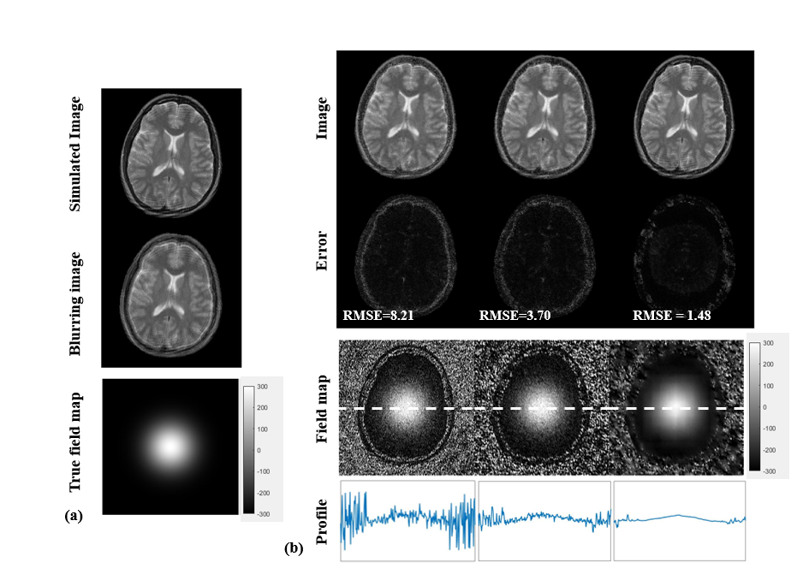

Figure 1. Simulation results of offset frequency correction with different methods. In (a), the brain image (upper image) is modulated with offset resonance frequency (bottom of (a)), and then we get a blurring image (middle of (a)). (b) shows corrected image with common method, Penalized Weighted Least Squares (PWLS) and proposed method, when the field map suffers from high noise level (dB = 10) (bottom of (b)). The middle of (b) shows error between corrected image without offset-suffered images. Image corrected by field map, which is estimated by proposed method, has better performance than common and PWLS method. Filed map are shown on a gray bar of [-300 300] Hz. Profile are scaled in same rang of [-2000 2000] Hz.

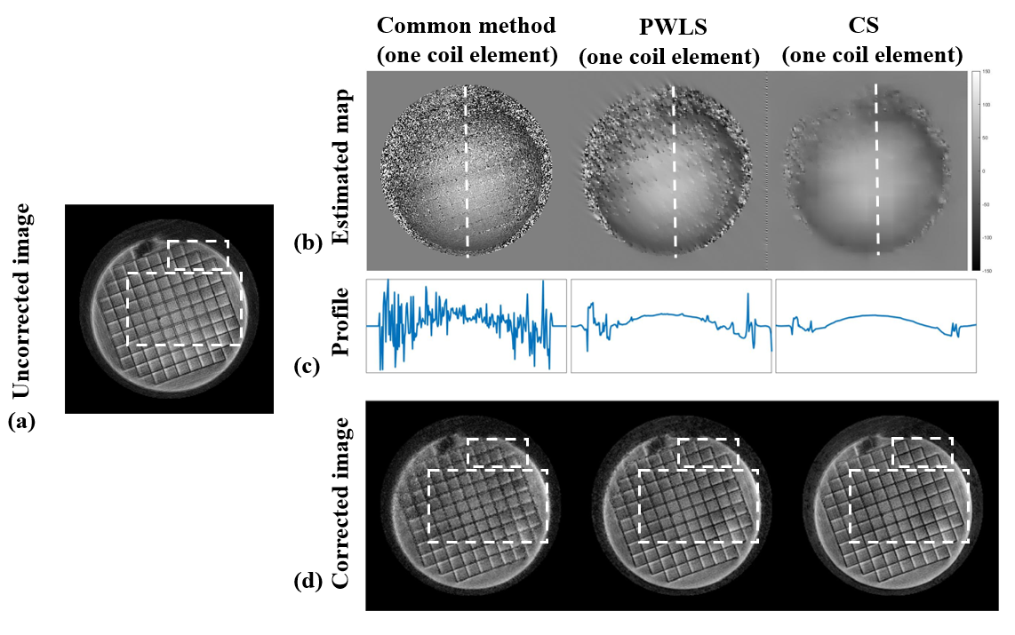

Figure 2. Phantom experiments. (a) image without field map correction. (b) shows field map calculated by different methods. The value of field map is showed at rang from -150Hz to 150Hz in gray bar. The profiles of white line in (b) are plotted in (c). Corrected images using corresponding field map are displayed at (d). Dotted boxes indict regions of blurring in (a), and blurring corrected regions in (d). Profile are scaled in same rang of [-2500 2500] Hz.

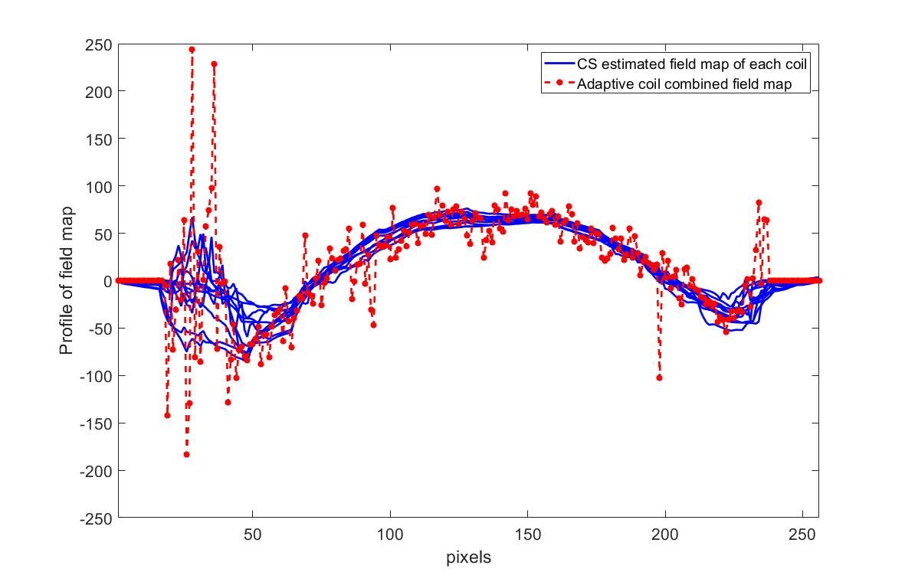

**Figure 3. Profile of field map. Blue line shows value of field map for each coil element. The red dotted line displays the value of field map acquired by adaptive coils combination.**

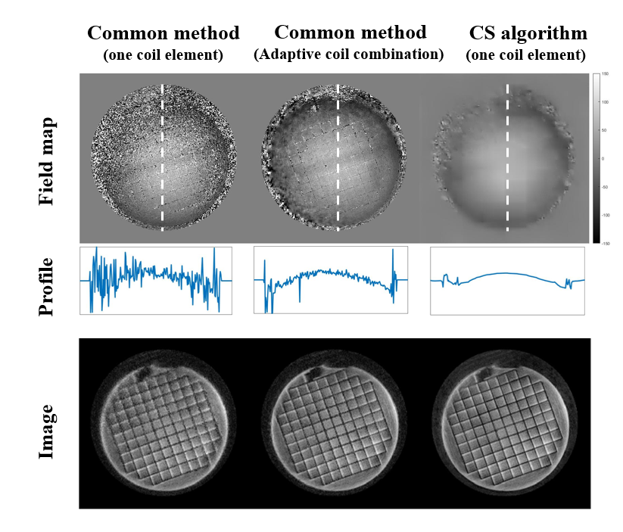

Figure 4. Results of corrected images using single coil CS algorithm and common method with adaptive phase coil combination, and corrected image with field map from one coil element. Profile are scaled in same rang of [-2500 2500] Hz.

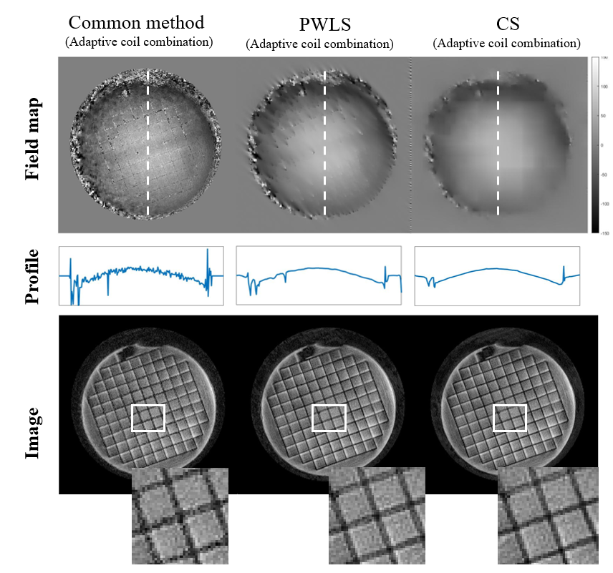

Figure 5. Field map estimation based on adaptive coil combination. Profile of white line plotted on field map have been shown. The corrected image and local region in white box tell deblurring effect. Profile are scaled in rang of [-2500 2500] Hz

# ACKNOWLEDGMENTS

Our thanks to UIH staff for helping us to solve problems of protocol development, and Prof. Yiping Du’s valuable discussion.

# REFERENCES

[1] Noll DC, Pauly JM, Meyer CH,. Nishimura DG, and Albert Macovskj. 1992. Deblurring for non-2D fourier transform magnetic resonance imaging. *Magnetic Resonance in Medicine*. 25,2,319–333. DOI=http://dx.doi.org/10.1002/mrm.1910250210

[2] Man LC, Pauly JM, and Macovski A. 1997. Multifrequency interpolation for fast off-resonance correction. *Magnetic Resonance in Medicine.* 37, 5, 785–792. DOI=http://dx.doi.org/10.1002/mrm.1910370523

[3] Weitian Chen, Christopher T. Sica, and Craig H. Meyer. 2008. Fast conjugate phase image reconstruction based on a Chebyshev approximation to correct for B0 field inhomogeneity and concomitant gradients. *Magnetic Resonance in Medicine*. 60,5, 1104–1111. DOI=http://dx.doi.org/10.1002/mrm.21703

[4] B.P. Sutton, D.C. Noll, and J.a. Fessler. 2003. Fast, iterative image reconstruction for MRI in the presence of field inhomogeneities. *IEEE Transactions on Medical Imaging*.22,2,178–188. DOI=http://dx.doi.org/10.1109/tmi.2002.808360

[5] A. Matakos, J. M. Balter, and Y. Cao. 2017. A Robust Method for Estimating B0 Inhomogeneity Field in the Liver by Mitigating Fat Signals and Phase-Wrapping. *Tomography*.3,2,79–88. DOI=http://dx.doi.org/10.18383/j.tom.2017.00003

[6] Junmin Liu and Maria Drangova. 2014. Method for B0 off-resonance mapping by non-iterative correction of phase-errors (B0-NICE). *Magnetic Resonance in Medicine*.74,4,1177–1188. DOI=http://dx.doi.org/10.1002/mrm.25497

[7] Dinghui Wang, Nicholas R. Zwart, and James G. Pipe. 2017. Joint water-fat separation and deblurring for spiral imaging. *Magnetic Resonance in Medicine* 79, 6,3218–3228. DOI=http://dx.doi.org/10.1002/mrm.26950.

[8] J.A. Fessler, D. Yeo, and D.C. Noll. Regularized Fieldmap Estimation in MRI. *3rd IEEE International Symposium on Biomedical Imaging: Macro to Nano, 2006.* DOI=http://dx.doi.org/10.1109/isbi.2006.1625014.

[9] Michael Lustig, David Donoho, and John M. Pauly. 2007. Sparse MRI: The application of compressed sensing for rapid MR imaging. *Magnetic Resonance in Medicine* 58, 6,1182–1195. DOI=http://dx.doi.org/10.1002/mrm.21391.

[10] David O. Walsh, Arthur F. Gmitro, and Michael W. Marcellin. 2000. Adaptive reconstruction of phased array MR imagery. *Magnetic Resonance in Medicine* 43, 5 (2000), 682–690.

DOI=https://doi.org/10.1002/(SICI)1522-2594(200005)43:5<682::AID-MRM10>3.0.CO;2-G

Authors’ background

|  |  |  |  |
| --- | --- | --- | --- |
| Your Name | Title* | Research Field | Personal website |
| Kang Yan | Master student | MRI | None |
| Huajun She | associate professor | MRI | http://bme.sjtu.edu.cn/Web/FacultyDetail/119 |

*This form helps us to understand your paper better, the form itself will not be published.

*Title can be chosen from: master student, Phd candidate, assistant professor, lecture, senior lecture, associate professor, full professor