1. BRAINSTORMING & IDEATION PHASE

1.1 Introduction
The brainstorming and ideation phase is the starting point of the project life cycle. Its purpose is to study the problem area, generate and compare possible solutions, and decide clearly what the system must achieve before design and development begin. A structured ideation phase reduces the risk of unclear requirements and provides a common direction for all later phases.
The idea for ContentGen (also referred to as BlogNest) developed from examining how blogs are created and maintained in practice. Writing, organising, reviewing, publishing and moderating content involves many repetitive manual tasks, and traditional blogging tools offer little help with the writing process itself. Recent progress in Generative AI made it possible to consider a system that can draft and summarise content automatically.
There is therefore a clear need for an AI-powered blogging and content management system that simplifies blog creation, management, summarisation and content organisation within a single secure platform. ContentGen was conceived to meet this need.

1.2 Problem Identification
A review of the typical blogging workflow highlighted the following major problems faced by bloggers and content creators:
- Difficulty managing multiple blog drafts: As the number of articles increases, it becomes hard to track drafts, unfinished work and published posts.
- Time-consuming manual content creation: Researching, structuring and writing each article requires considerable time and effort.
- Difficulty organising categories and tags: Inconsistent classification makes content harder to find and reduces its usefulness to readers.
- Difficulty summarising lengthy articles: Preparing short summaries or excerpts of long posts is repetitive and time-consuming.
- Comment moderation challenges: Reviewing and removing reader comments manually becomes burdensome as engagement grows.
- Managing different user permissions: Without clear roles, it is difficult to control who may create, edit, publish or delete content.
- Lack of centralised content management: Posts, comments, media details and user information are often handled in separate places.
- Limited AI assistance in traditional blogging systems: Conventional systems mainly store and publish content and do not help users generate or summarise it.

1.3 Brainstorming Process
The brainstorming process began with a discussion of the problems identified above. Possible solutions were proposed, written down and grouped according to their purpose. Each idea was then evaluated for its relevance to the identified problems, its feasibility for a college project, and the value it would offer to users. The accepted ideas were finally combined into a single project concept. The ideas discussed were:
- AI blog generation: producing draft articles from a topic or prompt.
- AI content summarisation: creating concise summaries of long articles.
- Blog CRUD operations: creating, reading, updating and deleting blog posts.
- User authentication: secure registration, login and token-based access.
- Role-based access control: restricting operations according to user roles.
- Categories and tags: classifying posts for easier organisation and retrieval.
- Comment management: submitting, reviewing and removing comments.
- Media management: storing descriptive metadata about media used in posts.
- Search: locating posts by keywords, categories or tags.
- Content scheduling: planning publication of posts for a later time.
- Analytics: observing views and reader engagement.
Authentication, authorisation, blog management and the two AI features were given the highest priority because they directly address the core problems. Content scheduling and analytics were recognised as useful enhancements that may be considered in later development. The relationship between the main idea areas is shown in Figure 1.
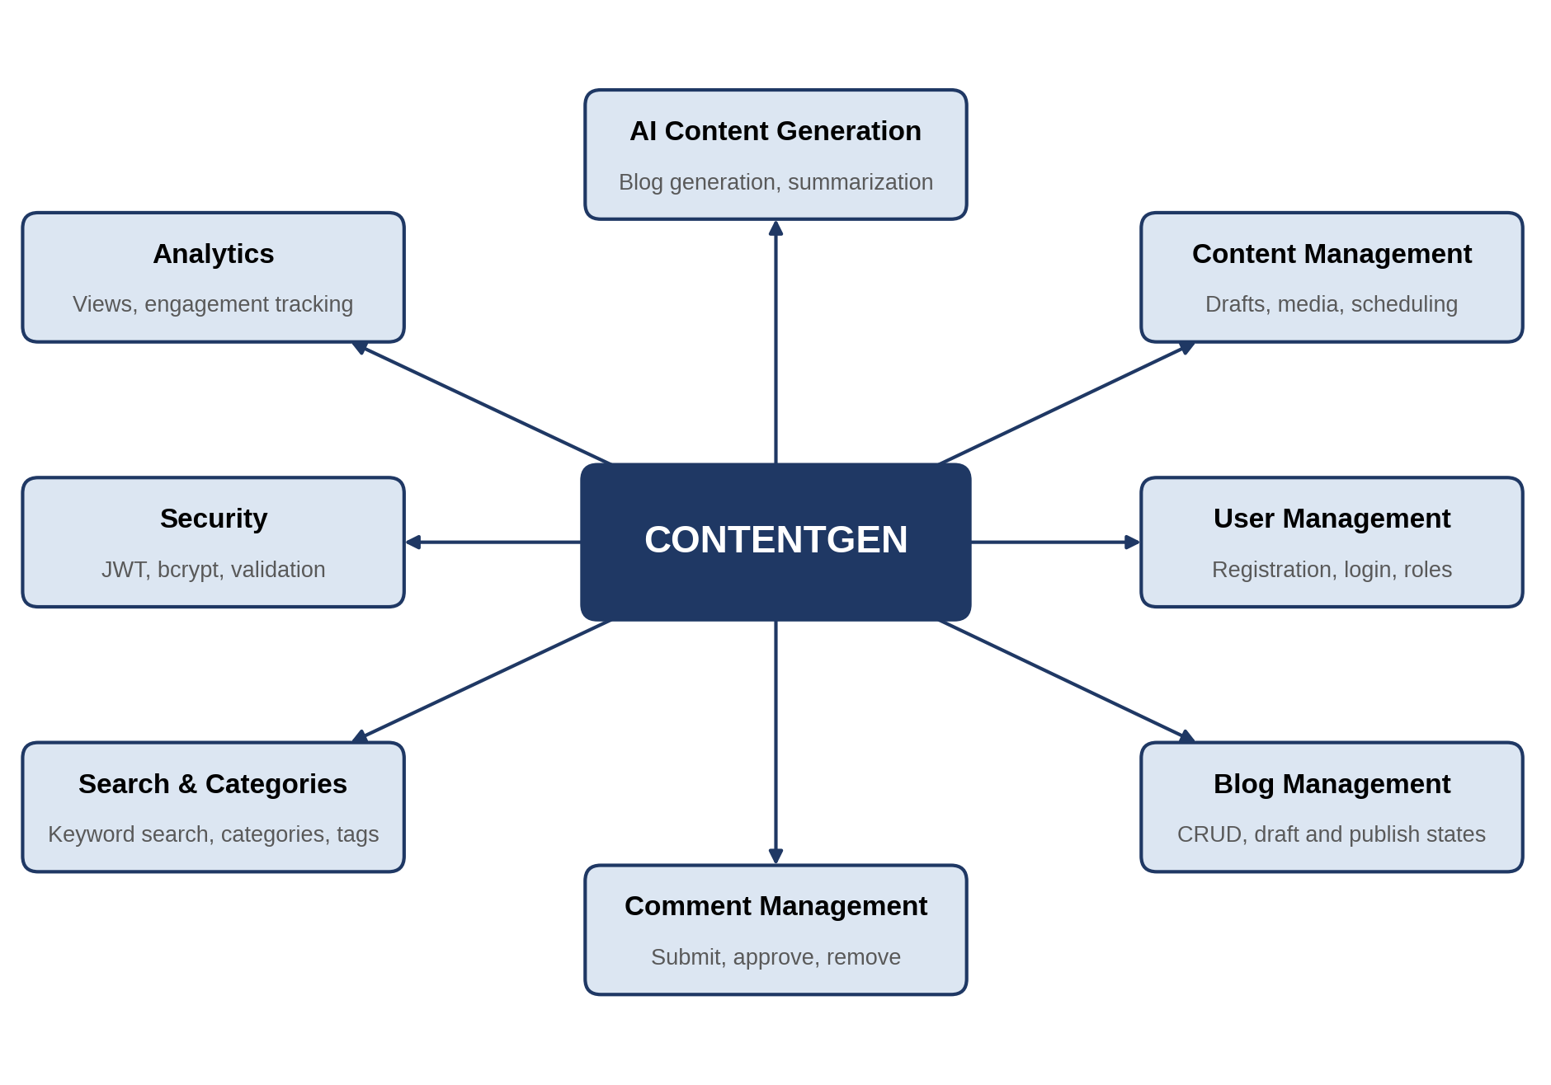
Figure 1: ContentGen Brainstorming Mind Map

1.4 Proposed Project Idea
The proposed solution is ContentGen, a centralised backend/API platform that combines traditional blogging features with Generative AI. It is developed using Node.js, Express.js, MongoDB and Mongoose, and exposes its functions through REST APIs. Access is protected by JWT-based authentication and bcrypt.js password hashing, and operations are restricted according to user roles.
Google Gemini AI is integrated into the platform to support content creation in three ways:
- AI-powered blog generation: a user provides a topic, title or keywords and receives a structured draft that can be reviewed and edited.
- Content summarisation: the full text of an existing blog post is submitted and a short, readable summary is returned.
- Intelligent content assistance: AI output helps authors overcome writing difficulty by suggesting content that they can refine, improving the overall quality and speed of the writing process.
The AI features are intended to assist users rather than replace them; generated content remains subject to review by the author or editor before publication.

1.5 Target Users
Four categories of users were identified for ContentGen, each with distinct responsibilities:
- Admin: has complete control of the system, including management of users and their roles.
- Editor: reviews and manages blog content and handles publishing workflows, including comment moderation.
- Author: creates and manages their own blog posts and drafts, and may use the AI features while writing.
- Reader: reads published blogs, searches for content and submits comments.
Figure 2 illustrates these roles and the main operations associated with each of them.
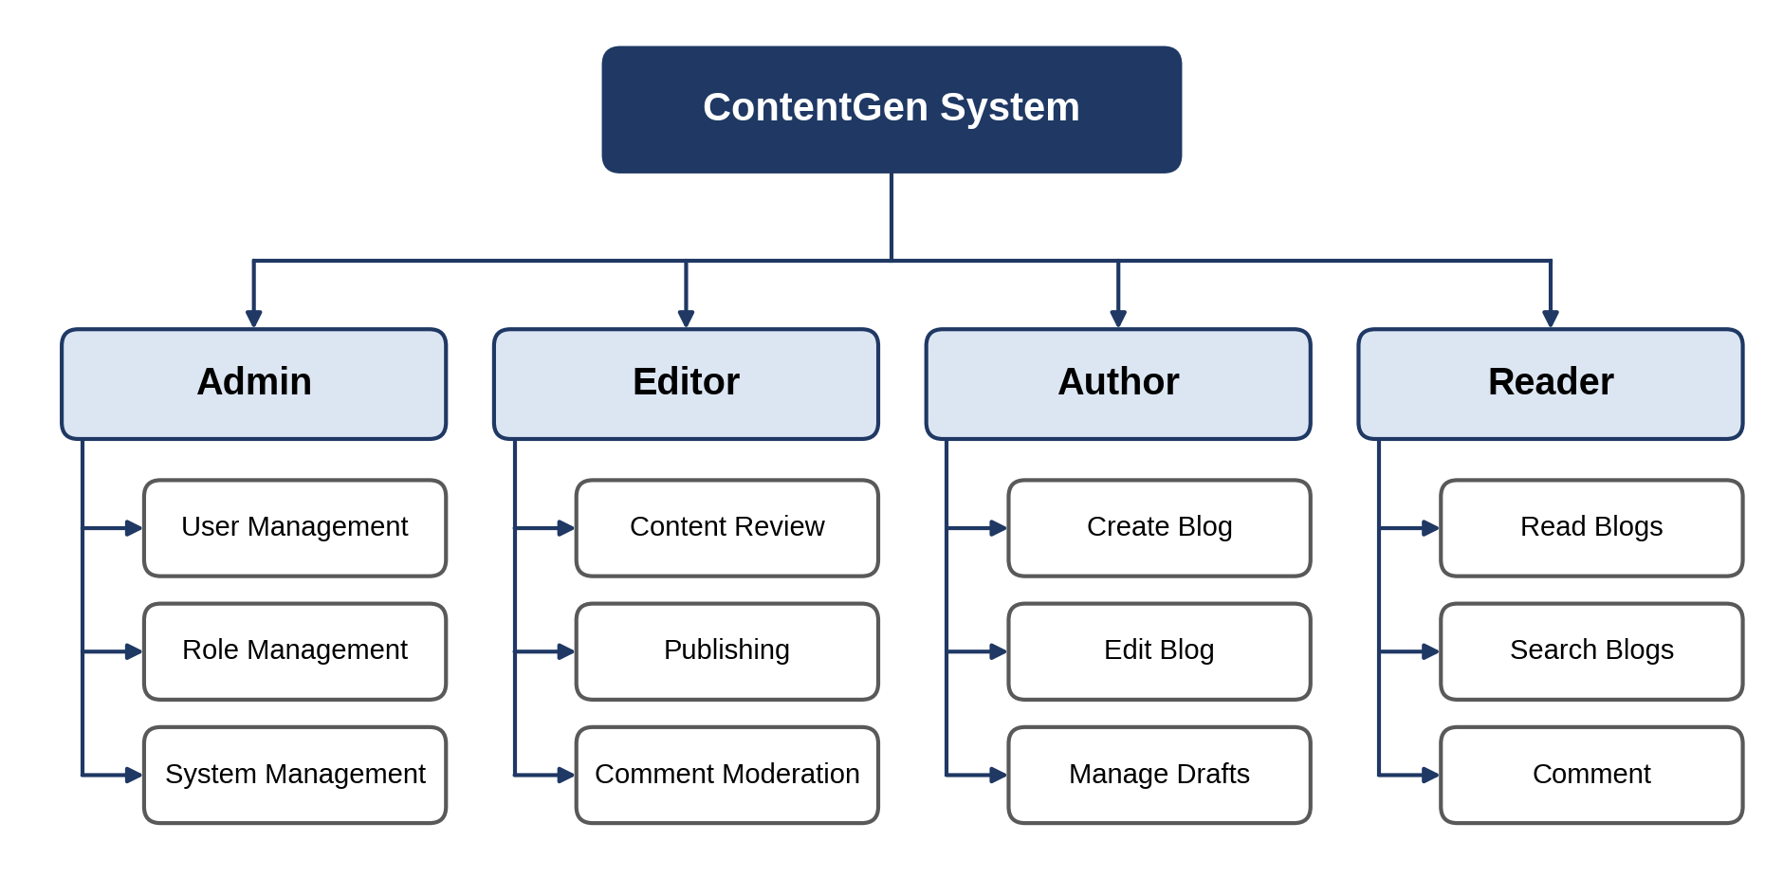
Figure 2: ContentGen User Role Diagram

1.6 Major Features Identified
Based on the brainstorming outcomes, the following major features were selected for the project:
- User Registration: allows new users to create an account in the system.
- User Login: allows registered users to sign in with their credentials.
- JWT Authentication: issues signed tokens so that protected API requests can be verified.
- Role-Based Authorization: permits or denies operations according to the Admin, Editor, Author or Reader role.
- Blog CRUD: supports creation, retrieval, updating and deletion of blog posts, including drafts.
- AI Blog Generation: generates draft blog content using Google Gemini AI.
- AI Blog Summarization: generates concise summaries of existing blog posts.
- Categories and Tags: organises posts into meaningful groups for easier navigation.
- Comment Management: allows comments to be submitted, reviewed and removed.
- Search: retrieves posts using keywords, categories or tags.
- Media Metadata: records descriptive information about media associated with posts.
- Security and Validation: protects passwords through hashing and checks incoming data for validity.
The relationship of these features to the system is shown in Figure 3.
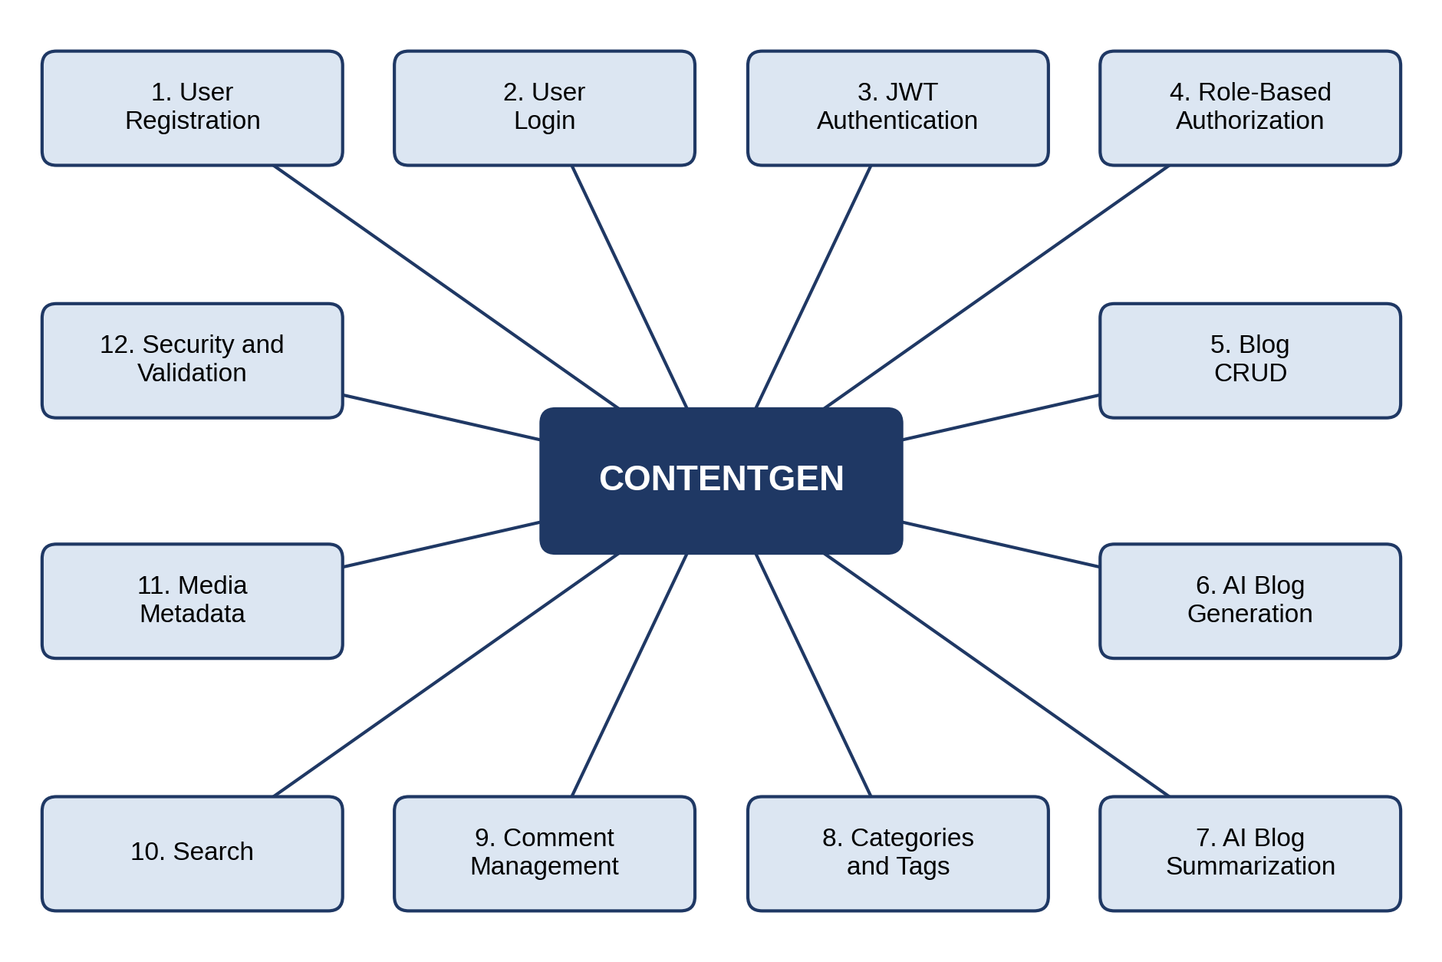
Figure 3: ContentGen Feature Map

1.7 Technology Selection
The technologies listed in Table 1 were selected because they are widely used, well documented and suitable for building a REST-based backend within a college project.
Table 1: Technologies Selected for ContentGen
Technology | Purpose | Reason for Selection
Node.js | Backend runtime | Allows server-side development in JavaScript and handles many requests efficiently.
Express.js | REST API framework | Provides simple routing and middleware support for building REST APIs.
MongoDB | Database | Its flexible document structure suits blog posts, comments and tags.
Mongoose | Database modeling and interaction | Offers schemas, validation and convenient queries for MongoDB.
Google Gemini AI | Generative AI features | Provides API-based text generation and summarisation capabilities.
JWT | Authentication | Enables stateless, token-based verification of users on protected routes.
bcrypt.js | Password hashing | Stores passwords in hashed form instead of plain text.
Postman | API testing | Allows API endpoints to be tested easily during development.
Visual Studio Code | Development environment | A lightweight editor with debugging and JavaScript support.

1.8 Initial System Concept
The initial concept of ContentGen is a secure and scalable backend API in which every client request passes through a defined sequence of layers. A request from a user or from Postman first reaches the Express.js REST API. It is then checked by the authentication and authorization layer, which verifies the JWT and the role of the user. Valid requests are passed to the controllers, which apply the business logic and interact with MongoDB for storage and retrieval.
When a request needs AI assistance, the controller forwards an AI request to Google Gemini AI. The generated blog content or summary is returned to the backend, where it is processed and provided to the user. The AI flow is therefore connected to the backend through the controllers. Figure 4 presents this high-level concept.
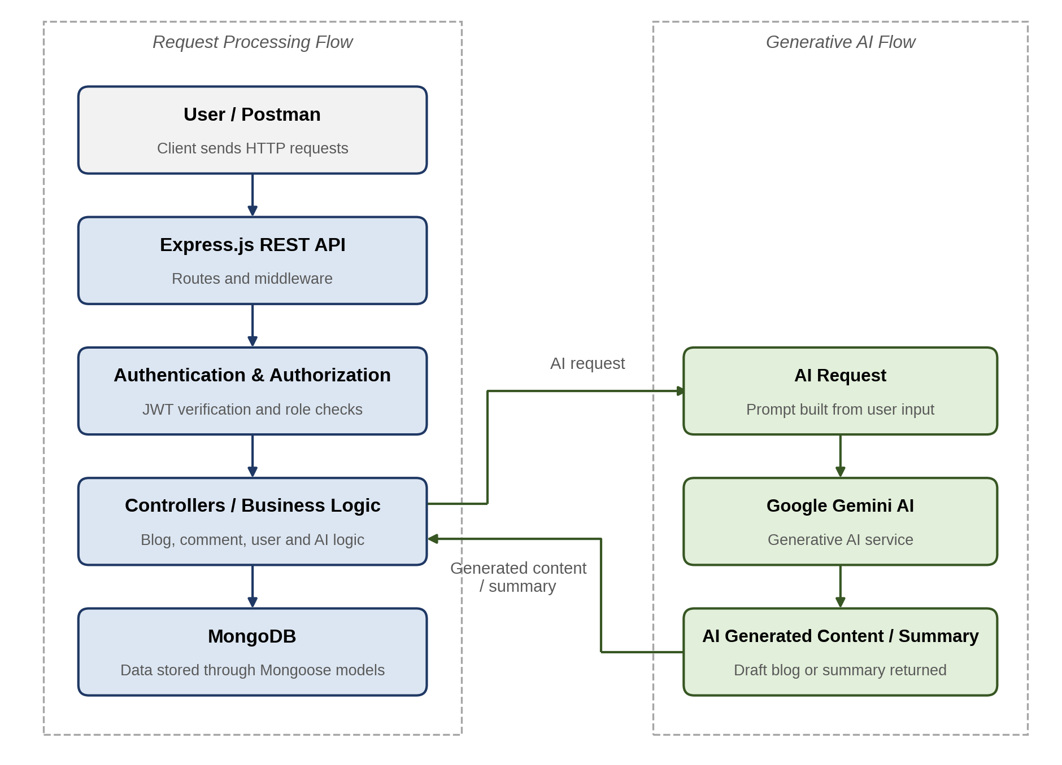
Figure 4: ContentGen High-Level Concept Diagram

1.9 Expected Outcome
The brainstorming and ideation phase is expected to establish the following foundations for the project:
- Project scope: a clear boundary of what ContentGen will and will not include.
- User roles: the Admin, Editor, Author and Reader roles and their responsibilities.
- Functional requirements: the features to be implemented, from authentication to search and comment management.
- AI capabilities: blog generation, content summarisation and content assistance using Google Gemini AI.
- Technology stack: Node.js, Express.js, MongoDB, Mongoose, JWT, bcrypt.js and supporting tools.
- Main modules: authentication, user and role management, blog management, comments, search and categories, media metadata and AI services.
- Initial architecture: the layered request flow and the connection between the backend and the AI service.
- Development direction: a clear path towards requirement analysis, system design and implementation.

1.10 Conclusion
The brainstorming and ideation phase transformed the initial idea of a blogging system into the structured concept of ContentGen, an AI-powered content management system. By identifying the problems of traditional blogging, evaluating possible solutions, defining user roles and features, and selecting suitable technologies, this phase established a clear foundation for the subsequent stages of analysis, design and development.

