2. REQUIREMENT ANALYSIS PHASE

2.1 Introduction
The Requirement Analysis Phase is the foundation of the software development life cycle. Its purpose is to understand what the proposed system must do, who will use it, which technologies it depends on, and which quality attributes it must satisfy before design and implementation begin. A clear set of requirements reduces ambiguity, prevents rework in later phases, and provides a common reference for development, testing, and evaluation.
For ContentGen, the requirements were identified by examining the problems associated with manual blog writing and content management: creating structured content takes considerable effort, publishing needs controlled review, and different people need different levels of access to the same content. These observations were studied against the intended users of the system (Admin, Editor, Author, and Reader) and the operations each of them must perform. The findings were then analyzed and organized into related groups such as authentication, blog management, AI-assisted content creation, community interaction, and discovery. Finally, each group was converted into precise functional requirements, which describe what the system shall do, and non-functional requirements, which describe how well the system shall do it.
ContentGen is designed as a secure and scalable REST API backend for blog management and AI-assisted content creation. It is built on Node.js and Express.js, stores its data in MongoDB through Mongoose, and integrates Google Gemini AI to generate blog content and summarize articles. The requirements documented in this chapter therefore address not only blog and user management but also security, external AI service integration, database design, and API testing.

2.2 Project Requirement Overview
The overall requirements of ContentGen cover the complete life cycle of a blog post, from account creation to publication and reader engagement. The major requirement areas are summarized below.
- User registration and login: Visitors must be able to create an account and log in to access protected features.
- Secure authentication: Identity must be verified using JWT-based authentication, and passwords must be stored in hashed form using bcrypt.js.
- Role-based authorization: Access to operations must depend on the assigned role of Admin, Editor, Author, or Reader.
- Blog creation and management: Authorized users must be able to create, view, update, and manage blog posts.
- AI-powered blog generation: Users must be able to submit a topic or prompt and receive generated blog content from Google Gemini AI.
- AI-powered content summarization: The system must produce concise summaries of blog or article content using AI.
- Categories and tags: Blog posts must be organized and grouped using categories and tags.
- Comment management: Readers must be able to comment on posts, and authorized users must be able to moderate those comments.
- Media metadata management: Metadata and path information for media used in blog posts must be stored and managed.
- Search functionality: Users must be able to locate relevant blog content easily.
- Content scheduling: Blog posts must be able to move through a workflow that includes a scheduled state before publication.
- Analytics and engagement tracking: The system must support tracking of engagement information related to blog content.
- Input validation and sanitization: Incoming request data must be checked and cleaned before it is processed.
- Error handling: Failures must be handled gracefully and reported through clear, structured responses.
- API testing: All endpoints must be testable using an API client such as Postman or Thunder Client.

2.3 Functional Requirements
Functional requirements define the specific behavior and services that the ContentGen backend shall provide. Each requirement is assigned an identifier so that it can be traced through design, implementation, and testing.
FR-01: User Registration. The system shall allow users to create accounts by providing required details such as name, email, and password. The submitted data shall be validated, and the password shall be stored only in hashed form.
FR-02: User Authentication. The system shall authenticate users using secure login credentials and JWT-based authentication. After a successful login, the user shall receive a token that is verified on every protected request.
FR-03: Role-Based Access Control. The system shall provide different permissions for four roles: Admin, Editor, Author, and Reader. Every protected operation shall be available only to the roles authorized to perform it.
FR-04: Blog Management. Authorized users shall be able to create, read, update, and manage blog posts. Authors shall manage their own posts, while Editors and Admins shall have wider control according to their roles.
FR-05: AI Blog Generation. The system shall allow users to provide a topic or prompt and generate blog content using Google Gemini AI. The generated content shall be returned to the user so that it can be reviewed, edited, and saved.
FR-06: AI Content Summarization. The system shall accept blog or article content and generate a concise summary using AI, helping readers and editors understand long content quickly.
FR-07: Category and Tag Management. The system shall allow blog posts to be organized using categories and tags so that related content can be grouped and discovered easily.
FR-08: Comment Management. Readers shall be able to submit comments on blog posts, while authorized users shall be able to moderate those comments.
FR-09: Search. The system shall provide search functionality for locating relevant blog content.
FR-10: Media Metadata. The system shall support storing and managing metadata and path information related to media used in blog posts. The media files themselves are referenced through this information rather than being processed by the API.
FR-11: Content Workflow. The system shall support different blog states, following the workflow Draft → Pending Approval → Scheduled → Published. This allows content to be reviewed and approved before it becomes visible to readers.
FR-12: API Responses. The backend shall return structured JSON responses for both successful and unsuccessful requests, so that client applications can interpret results consistently.

2.4 Non-Functional Requirements
Non-functional requirements describe the quality attributes and operating constraints of ContentGen. They do not add new features but determine how well the features perform and how dependable the system is.

2.4.1 Performance
The API should process requests efficiently and respond without unnecessary delay. Database access through Mongoose and the non-blocking, event-driven nature of Node.js support this goal for routine operations such as authentication, blog retrieval, and search.

2.4.2 Security
The system should protect user credentials and restricted resources using the following mechanisms:
- JWT – for stateless, token-based authentication of users;
- bcrypt.js – for hashing passwords so that plain-text passwords are never stored;
- Input validation – for checking that incoming data is complete and correctly formed;
- Input sanitization – for cleaning incoming data before it is processed or stored;
- Rate limiting – for restricting excessive repeated requests to the API;
- Role-based authorization – for allowing each role to perform only its permitted operations.

2.4.3 Scalability
The modular backend architecture should allow additional features and users to be added in the future. Because each concern is separated into its own module, new capabilities can be introduced without restructuring existing code.

2.4.4 Reliability
The system should provide appropriate error handling and maintain database consistency. Unexpected failures, invalid input, and unavailable external services should result in controlled error responses rather than application crashes.

2.4.5 Maintainability
The MVC and modular architecture should make the application easier to maintain and modify. Separating models, controllers, and routes allows developers to locate, understand, and change individual components independently.

2.4.6 Usability
The REST API should provide clear and predictable endpoints and responses. Consistent naming and a uniform JSON response format make the API easy for client developers to learn and integrate.

2.4.7 Compatibility
The backend should operate across Windows, macOS, and Linux environments. Since it is built on the cross-platform Node.js runtime and MongoDB, the same code base can be developed and executed on all three.
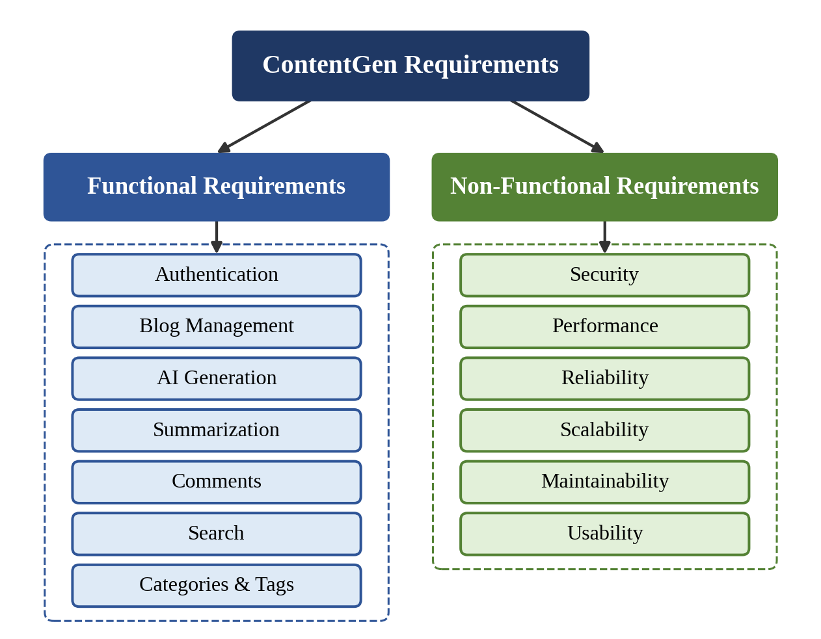
Figure 1: ContentGen Requirement Classification

2.5 User Requirements
ContentGen serves four types of users, each with a distinct set of responsibilities. Table 2.1 summarizes the requirements of each user role, and Figure 2 illustrates them in relation to the system.
Table 2.1: User Requirements
User | Requirements
Admin | Manage users, roles, comments, system resources and logs
Editor | Review blogs, approve content, manage publishing and comments
Author | Create, edit and manage their own blogs
Reader | View published blogs and submit comments

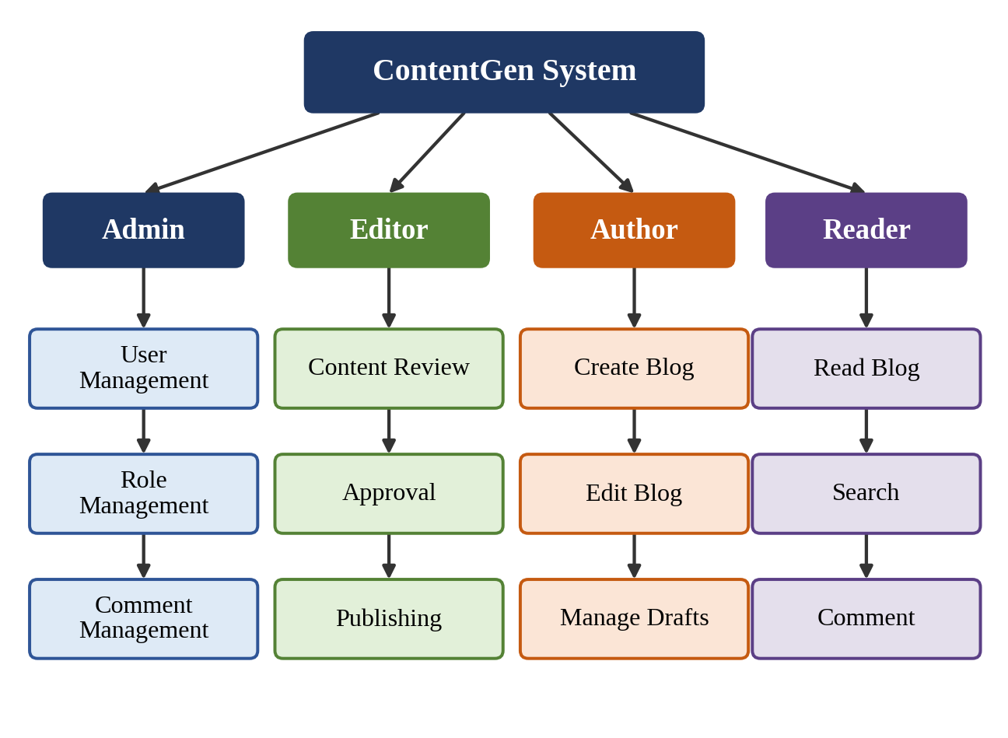
Figure 2: User Requirement Diagram

2.6 Hardware Requirements
The hardware requirements specify the minimum and recommended resources for developing, running, and testing the ContentGen backend.
Table 2.2: Hardware Requirements
Resource | Requirement
Processor | Intel Core i5 8th Gen or equivalent AMD Ryzen 5
RAM (minimum) | 8 GB
RAM (recommended) | 16 GB
Storage | At least 1 GB of available storage
Network | Internet connection for AI/API services

Processor: A mid-range multi-core processor is needed to run the Node.js server, the MongoDB database, the code editor, and the API testing tool at the same time without noticeable slowdown.
Memory: A minimum of 8 GB of RAM allows these applications to run together. 16 GB is recommended for smoother multitasking, larger datasets, and comfortable use of development tools.
Storage: At least 1 GB of free space is required for the project files, installed npm dependencies, and stored database data.
Internet connection: Content generation and summarization depend on the external Google Gemini AI service, which can only be reached over the Internet.

2.7 Software Requirements
Table 2.3 lists the software components required for ContentGen and the purpose of each.
Table 2.3: Software Requirements
Software | Purpose
Windows 10/11, macOS, or Linux | Operating system on which the backend is developed and executed.
Node.js v16 or above | JavaScript runtime environment used to run the server-side application.
npm v8 or above | Package manager used to install and manage project dependencies.
Express.js | Web framework used to define routes, middleware, and the REST API.
MongoDB | NoSQL document database used to store users, posts, and related data.
Mongoose | Object Data Modeling (ODM) library used to define schemas and interact with MongoDB.
Google Gemini AI | External AI service used for blog generation and content summarization.
Visual Studio Code | Source code editor used for writing and debugging the application.
Postman or Thunder Client | API clients used to send requests to the endpoints and verify responses.

Figure 3 shows the sequence in which a request travels through the system, from user access to data storage, and therefore how the functional requirements relate to one another.
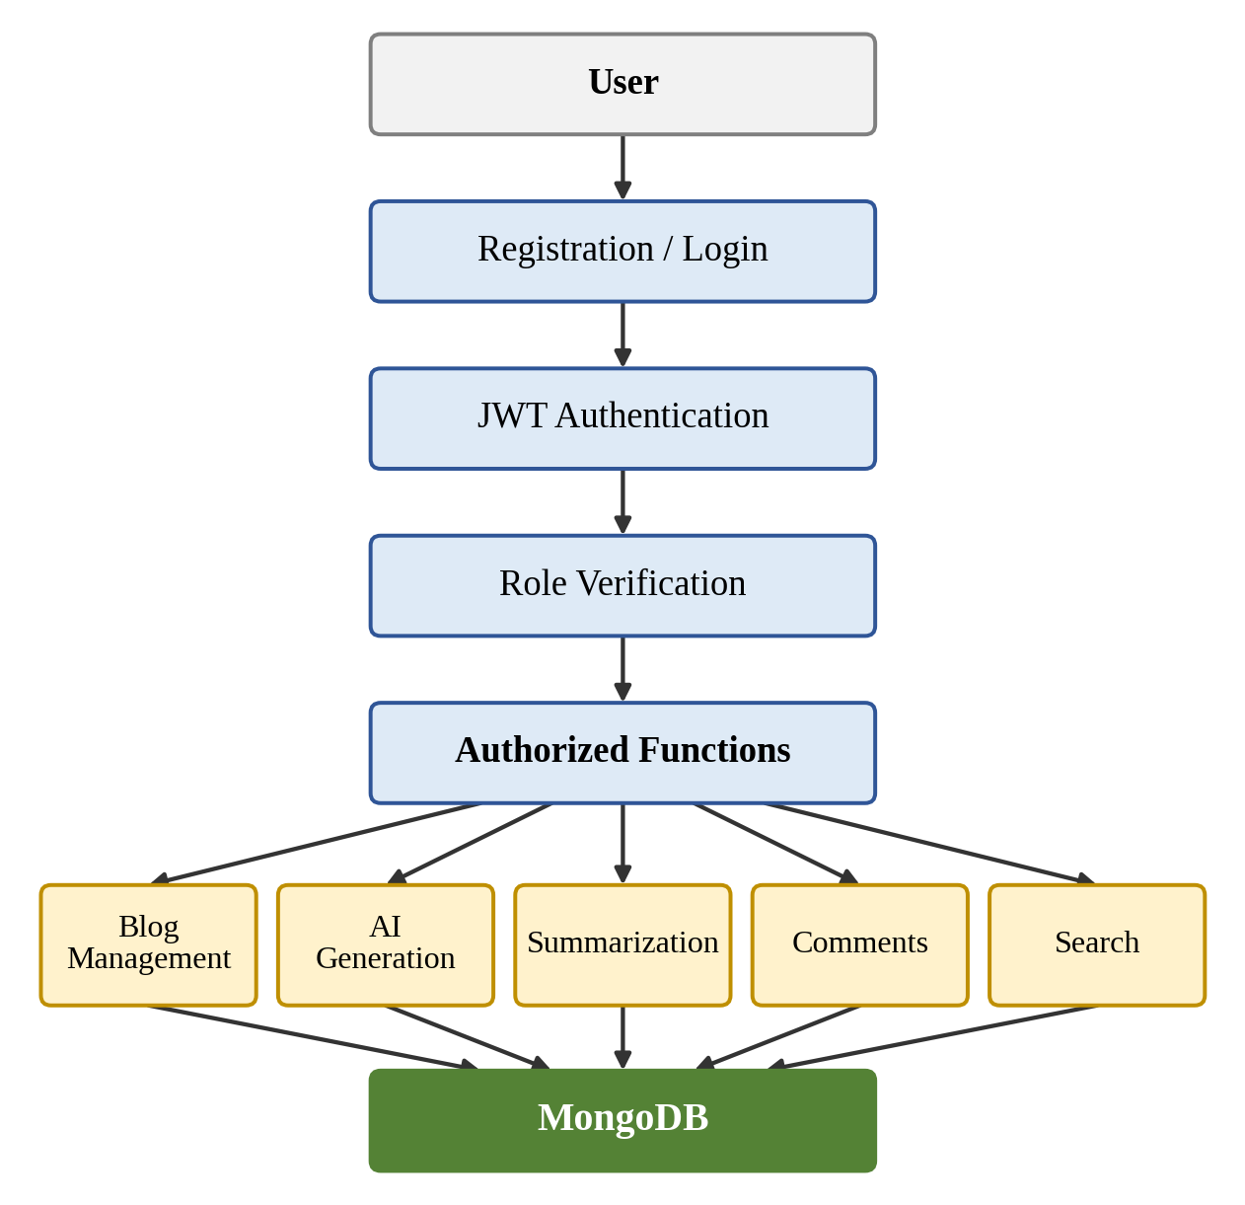
Figure 3: Functional Requirement Flow
The AI-related requirements are illustrated in Figure 4. The first flow covers blog generation from a topic or prompt, and the second covers summarization of an existing blog.
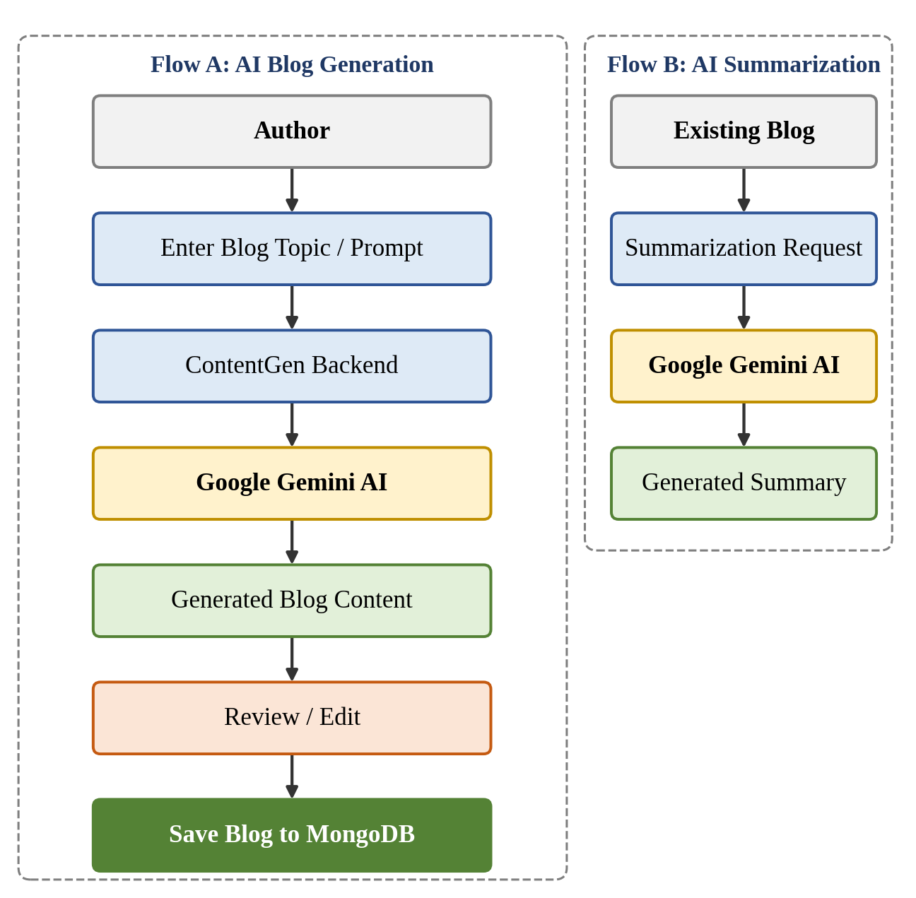
Figure 4: AI-Based Functional Requirement Flow
The security requirements are applied in layers, as shown in Figure 5. A request must pass each layer before it reaches the business logic and the database.
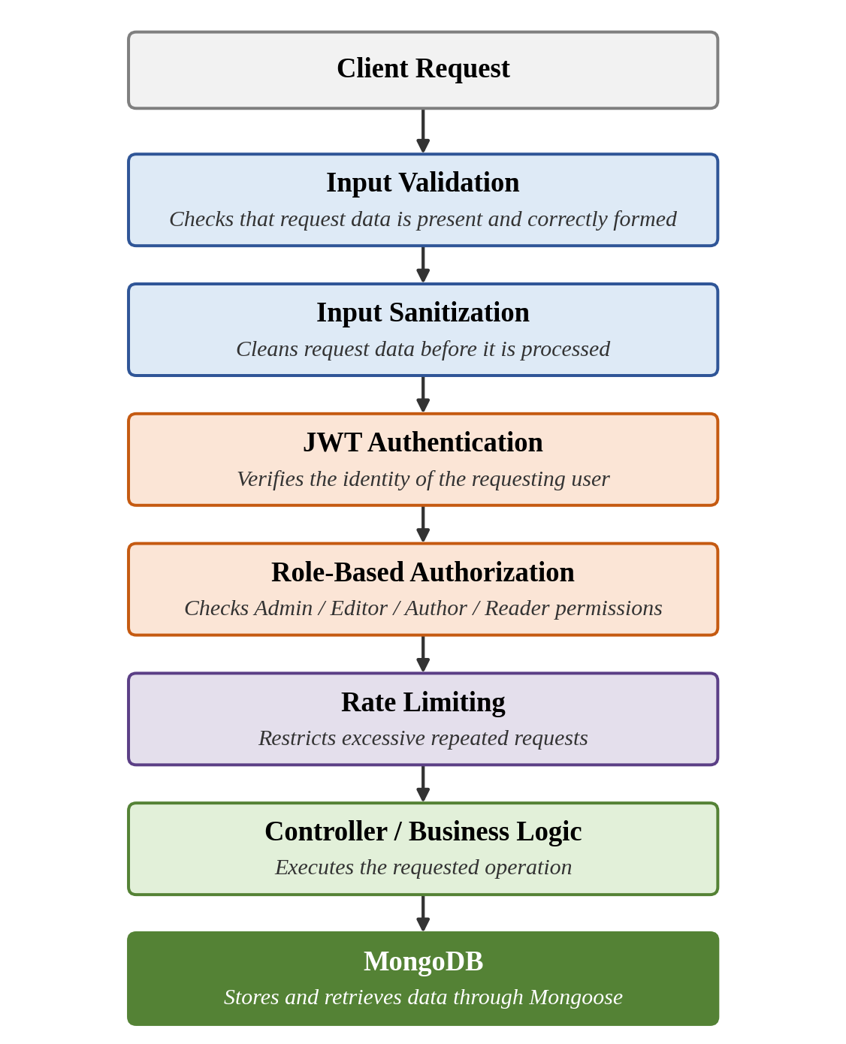
Figure 5: ContentGen Security Requirements

2.8 API Requirements
The backend shall expose a REST API in which each major function is reachable through a clear, resource-oriented endpoint. The major endpoints identified during requirement analysis are listed in Table 2.4. Their detailed request and response structures will be finalized in the design phase.
Table 2.4: Major API Endpoints
Endpoint | Purpose
/api/auth/register | Registers a new user account using details such as name, email, and password.
/api/auth/login | Authenticates a user with credentials and issues a JWT for accessing protected resources.
/api/blogs | Handles blog post operations such as creating, retrieving, and managing blogs, subject to role-based permissions.
/api/ai/generate-blog | Accepts a topic or prompt and returns blog content generated by Google Gemini AI.
/api/ai/summarize | Accepts blog or article content and returns a concise AI-generated summary.
/api/comments | Handles submission of reader comments and their moderation by authorized users.

All endpoints shall return structured JSON responses, use appropriate HTTP status codes for success and failure, and protect restricted operations through JWT authentication and role-based authorization.

2.9 Database Requirements
ContentGen uses MongoDB as its database, with Mongoose defining the structure of stored documents. The main entities identified during requirement analysis are described below.

2.9.1 User Collection
The User collection stores account information and the role that determines the user’s permissions.
Table 2.5: User Entity
Field | Description
_id | Unique identifier of the user generated by MongoDB
name | Name of the user
email | Email address used for identification and login
password | User password, stored in hashed form using bcrypt.js
role | Assigned role: Admin, Editor, Author, or Reader

2.9.2 Post Collection
The Post collection stores the blog post records created by users.
Table 2.6: Post Entity
Field | Description
_id | Unique identifier of the post generated by MongoDB
userID | Reference to the user who created the post
name | Name or title associated with the post
photo | Photo or image information associated with the post
message | Textual content of the post
likes | Engagement information recorded for the post
timestamps | Creation and last-update times maintained automatically

2.9.3 Logical Relationships
The entities are connected through the following logical relationships:
- User → Posts: A single user can create many posts, and each post refers back to its creator through userID.
- User → Comments: A single user can submit many comments, so each comment is associated with the user who wrote it.
- Post → Comments: A single post can receive many comments, so each comment is associated with the post it belongs to.
Supporting information such as categories, tags, and media metadata will also be associated with posts. Their exact structure will be defined during the design phase.

2.10 Requirement Traceability
Requirement traceability links each major requirement to the module that implements it and the technology it relies on. This ensures that every requirement has an owner in the design and can be verified during testing.
Table 2.7: Requirement Traceability Matrix
Requirement | Module | Technology
Authentication | Auth Module | JWT, bcrypt.js
Blog Management | Blog Module | Node.js, Express.js, MongoDB
AI Generation | AI Module | Google Gemini AI
Summarization | AI Module | Google Gemini AI
Data Storage | Database Module | MongoDB, Mongoose
API Testing | Testing Module | Postman

2.11 Constraints and Assumptions

2.11.1 Constraints
- Internet connectivity may be required for external AI services.
- The availability of the Google Gemini API may affect the AI features.
- A MongoDB connection must be available for database operations.
- User permissions depend on assigned roles.
- API access may be restricted by authentication and authorization.

2.11.2 Assumptions
- The required software components are installed and configured correctly in the development environment.
- Users interact with the system through API clients or front-end applications that send properly formatted HTTP requests.
- Every registered user is assigned one of the defined roles: Admin, Editor, Author, or Reader.

2.12 Expected Outcome
The Requirement Analysis Phase provides a clear specification for developing ContentGen. It establishes the functional requirements for authentication, blog management, AI-assisted generation and summarization, comments, search, and content workflow; the technical requirements for hardware, software, and API design; the security requirements for protecting users and resources; the database requirements for storing users, posts, and their relationships; and the AI requirements for integrating Google Gemini AI. Together, these outcomes give the development team a well-defined scope and a reliable basis for design, implementation, and testing.

2.13 Conclusion
This chapter identified, analyzed, and documented the requirements of ContentGen as a secure, scalable REST API backend for blog management and AI-assisted content creation. The requirements were classified into functional and non-functional categories, mapped to user roles, supported by hardware and software specifications, and linked to project modules through a traceability matrix. The identified requirements form the foundation for the next phase, the Project Design Phase, in which the system architecture, module structure, database schemas, API design, and security workflows will be designed to satisfy them.

