4. PROJECT PLANNING PHASE

4.1 Introduction
The Project Planning Phase converts the requirements and design decisions of the earlier phases into an organized, executable plan. Its purpose is to define what will be built, how the work will be divided, which resources and technologies will be used, in what order the activities will be carried out, and how quality and risk will be controlled. Planning is carried out before implementation so that development proceeds in a deliberate manner rather than through unstructured trial and error.
For ContentGen, the planning activities cover the following areas: the project scope, which fixes the boundaries of the system; the objectives, which state what the project must achieve; the development activities, which describe the work to be performed; the module allocation, which divides the backend into manageable units; the technology planning, which confirms the use of Node.js, Express.js, MongoDB, Mongoose, Google Gemini AI, JWT, bcrypt.js, REST API principles, and MVC architecture; the timeline, which sequences the project phases; the testing strategy, which defines how correctness and security will be verified using Postman; the risk identification, which anticipates likely problems; the resource planning, which lists the hardware and software required; and the documentation planning, which ensures that the work is properly recorded.
Proper planning supports the systematic development of ContentGen in several ways. It ensures that dependent modules are built in a logical order, for example authentication before role-based access, and role-based access before protected blog operations. It also allows testing to be scheduled alongside development, gives early warning of risks such as database or AI service failures, and provides a clear checklist against which progress can be measured. As a result, the project can move into implementation with a shared understanding of its goals, structure, and expected deliverables.

4.2 Project Objectives
The main objectives of ContentGen are listed below. They are derived from the requirements identified during the Requirement Analysis Phase and act as the criteria against which the completed project will be evaluated.
- Develop a secure REST API backend. Provide a well-structured backend, built on Node.js and Express.js, that exposes its functionality through REST API endpoints.
- Provide user authentication and authorization. Allow users to register and log in, and verify their identity using JWT before granting access to protected resources.
- Implement role-based access control. Restrict operations according to the Admin, Editor, Author, and Reader roles.
- Provide complete blog management functionality. Support creation, retrieval, updating, and management of blog posts, including draft and publishing states.
- Integrate Google Gemini AI for blog generation. Generate blog content from a topic or prompt supplied by the user.
- Provide AI-powered content summarization. Produce concise summaries of blog or article content using Google Gemini AI.
- Implement categories and tags. Organize blog posts so that related content can be grouped and filtered.
- Provide comment management. Allow readers to comment on posts and authorized users to moderate those comments.
- Implement search functionality. Enable users to locate relevant blog content.
- Maintain data securely using MongoDB. Store users, posts, and related data reliably through Mongoose, with passwords protected by bcrypt.js hashing.
- Provide API testing through Postman. Verify every endpoint and its behavior using Postman or Thunder Client.
- Design a modular and scalable backend. Follow MVC architecture so that features can be maintained, modified, and extended.

4.3 Project Scope
The scope of ContentGen defines the functionality that the project will deliver and the boundaries within which it is developed. The project focuses on a REST API backend that supports blog management with AI-assisted content creation.

4.3.1 Included in Scope
- User registration and login
- JWT authentication
- Role-based access
- Blog CRUD operations
- AI blog generation
- AI summarization
- Categories and tags
- Comments
- Media metadata
- Search
- Publishing workflow
- MongoDB database
- REST API
- Security mechanisms

4.3.2 Outside the Current Scope
The following limitations apply to the current version of the project:
- Advanced production-scale infrastructure, such as large-scale deployment, load balancing, or clustered hosting, is not part of the current work.
- The availability, response behavior, and usage conditions of external services such as Google Gemini AI are controlled by their providers and cannot be guaranteed by the project.
- Any dedicated client-side or graphical interface is outside the scope, since ContentGen is delivered as a backend REST API exercised through API clients.
- Features that are not implemented in the supplied project are treated as future enhancements and are not part of the present deliverables.

4.4 Project Modules and Work Breakdown
To keep the development manageable, ContentGen is divided into eight modules. Each module has a clear responsibility, can be developed and tested independently, and is later integrated with the others. This division follows the MVC and modular architecture of the backend.
Module 1 – Authentication. This module handles user registration and login. Passwords are hashed using bcrypt.js before storage, and successful login results in a JWT that is verified on protected requests.
Module 2 – User and Role Management. This module manages user accounts and enforces the permissions of the four roles. Admin permissions cover the management of users, roles, comments, and system resources; Editor permissions cover reviewing, approving, and publishing content; Author permissions cover the creation and management of the author’s own blogs; and Reader permissions cover viewing published content and commenting.
Module 3 – Blog Management. This module implements creating, reading, updating, and deleting or otherwise managing blog posts. It also manages the draft and publishing states through which a post moves before it becomes visible to readers.
Module 4 – AI Services. This module integrates Google Gemini AI with the backend. It provides AI blog generation from a topic or prompt and AI summarization of existing content, and it isolates all communication with the external service in one place.
Module 5 – Comments. This module supports comment creation by readers, comment retrieval for a blog post, and comment moderation by authorized users.
Module 6 – Categories and Tags. This module provides categorization of posts, tag-based organization, and filtering of content by category or tag.
Module 7 – Database. This module covers the MongoDB database and the Mongoose layer, including the definition and management of schemas and models for users, posts, and related data.
Module 8 – Testing and Security. This module covers Postman-based testing, input validation, sanitization, authentication testing, authorization testing, and error handling. It runs alongside the other modules rather than after them.
The overall organization of project activities is shown as a Work Breakdown Structure (WBS) in Figure 1. It decomposes the project into six major work packages, each divided into specific tasks.
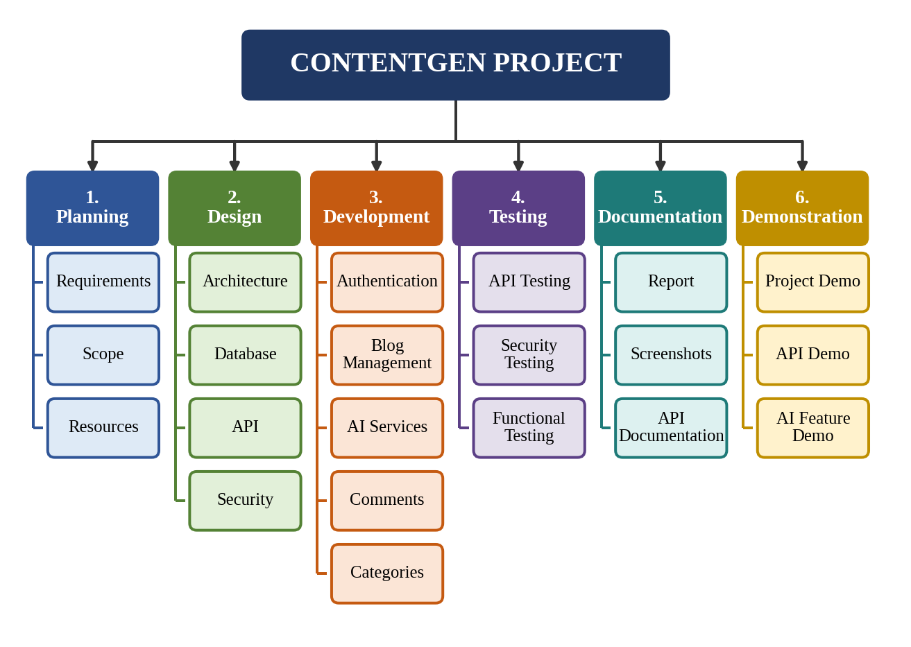
Figure 1: ContentGen Work Breakdown Structure

4.5 Development Methodology
An iterative and incremental approach is the most suitable for ContentGen. In this approach, development proceeds through repeated stages of Requirements → Design → Development → Testing → Refinement, and each pass produces a working and verified portion of the system. This is preferable to building the entire backend before testing, because defects are found early, when they are easier and cheaper to correct.
Under this approach the modules described in Section 4.4 are developed and tested incrementally. For example, the authentication module can be implemented first and verified in Postman for registration, login, and token generation. Role management can then be added and tested against protected routes, followed by blog management, categories and tags, comments, search, and the AI services. After each increment, the module is refined and integrated with the previously completed modules, so that the system grows in a controlled manner.
The development cycle is illustrated in Figure 2. If testing of an integrated module reveals defects, the work returns to testing and refinement before the next increment begins.
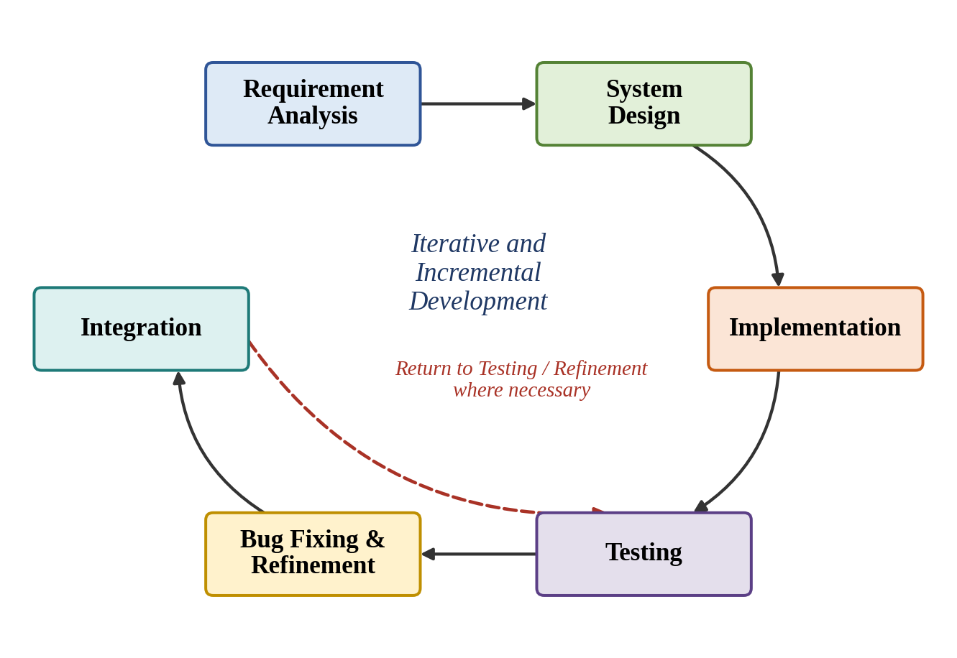
Figure 2: ContentGen Development Cycle

4.6 Project Schedule
The project is organized as nine sequential phases. As no calendar dates are prescribed, the schedule is expressed in terms of the order of phases and their major activities, as shown in Table 4.1.
Table 4.1: Project Schedule by Phase
Phase | Major Activities
Phase 1 | Brainstorming & Ideation – selecting the project idea, understanding the problem of blog management and AI-assisted writing, and defining the initial concept.
Phase 2 | Requirement Analysis – identifying functional and non-functional requirements, user roles, and technology needs.
Phase 3 | Project Design – designing the MVC architecture, database structure, API structure, and security flow.
Phase 4 | Project Planning – defining scope, modules, resources, risks, testing strategy, and deliverables.
Phase 5 | Backend Development – implementing the authentication, role, blog, comment, category, and tag modules using Node.js and Express.js.
Phase 6 | Database & AI Integration – connecting MongoDB through Mongoose and integrating Google Gemini AI for generation and summarization.
Phase 7 | Testing & Debugging – testing endpoints, authentication, authorization, AI features, and error handling, and fixing identified defects.
Phase 8 | Documentation – preparing technical documentation, screenshots, API documentation, and the project report.
Phase 9 | Demonstration – presenting the working system, the API behavior, and the AI features.

Figure 3 presents the same sequence as a Gantt-style timeline. Ideation to Planning cover the preparatory phases, Development and Integration correspond to Phases 5 and 6, and Testing, Documentation, and Demonstration complete the project.
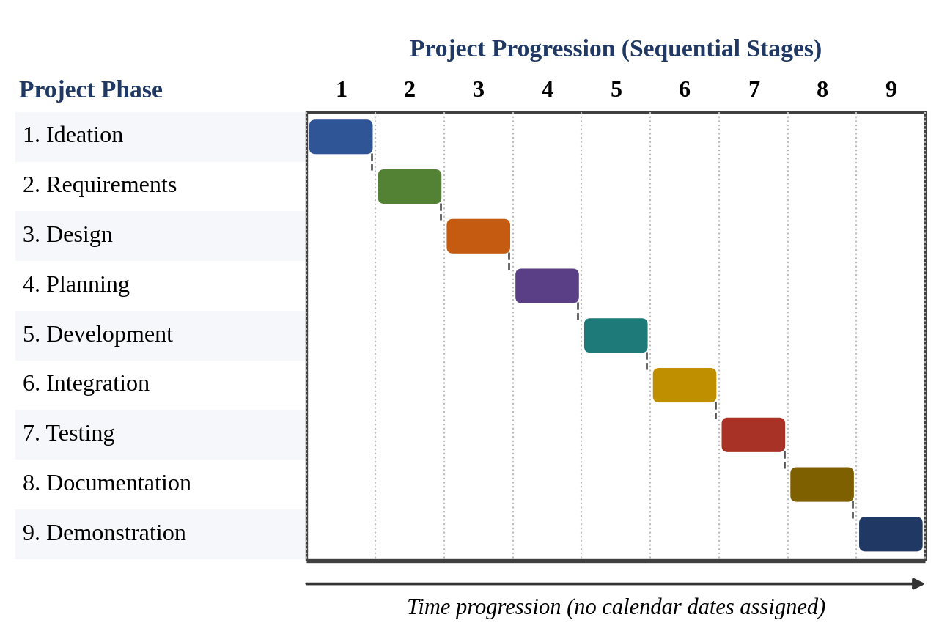
Figure 3: ContentGen Project Timeline

4.7 Resource Planning
Resource planning identifies the hardware and software needed to develop, run, and test ContentGen. Selecting these resources in advance avoids interruptions during implementation.

4.7.1 Hardware Resources
Table 4.2: Hardware Resources
Resource | Purpose
Intel Core i5 8th Gen or equivalent AMD Ryzen 5 | Provides sufficient processing capability to run the Node.js server, MongoDB, the code editor, and the API testing tool together.
Minimum 8 GB RAM | Allows the development tools and database to run simultaneously.
16 GB RAM (recommended) | Improves multitasking and performance when working with larger data or several tools.
At least 1 GB available storage | Stores project files, npm dependencies, and database data.
Internet connection | Needed to reach Google Gemini AI and to download packages.

4.7.2 Software Resources
Table 4.3: Software Resources
Resource | Purpose
Windows 10/11, macOS, or Linux | Operating system for developing and running the backend.
Node.js v16 or above | JavaScript runtime that executes the server-side code.
npm v8 or above | Package manager for installing and managing dependencies.
Visual Studio Code | Code editor used for writing, organizing, and debugging the source code.
MongoDB | Database that stores users, posts, and related data.
Mongoose | Object Data Modeling library that defines schemas and models and communicates with MongoDB.
Express.js | Web framework used to build routes, middleware, and the REST API.
Google Gemini AI | External AI service used for blog generation and summarization.
Postman / Thunder Client | API clients used to send requests and verify responses during testing.

4.8 Human Resource / Role Planning
The responsibilities for the project are described in general terms and are grouped into development, testing, and documentation. Table 4.4 summarizes them.
Table 4.4: Project Responsibilities
Responsibility | Activities
Project Developer | Backend development, API implementation, database integration, and AI integration.
Testing Responsibility | API testing, authentication testing, authorization testing, and error testing.
Documentation Responsibility | Technical documentation, screenshots, API documentation, and the project report.

If the project is developed individually, all of these responsibilities can be handled by the individual project developer, who then acts as developer, tester, and documenter in turn. If the work is shared, the same grouping allows the responsibilities to be assigned separately. Figure 4 shows the overall responsibility structure, including the demonstration activities.
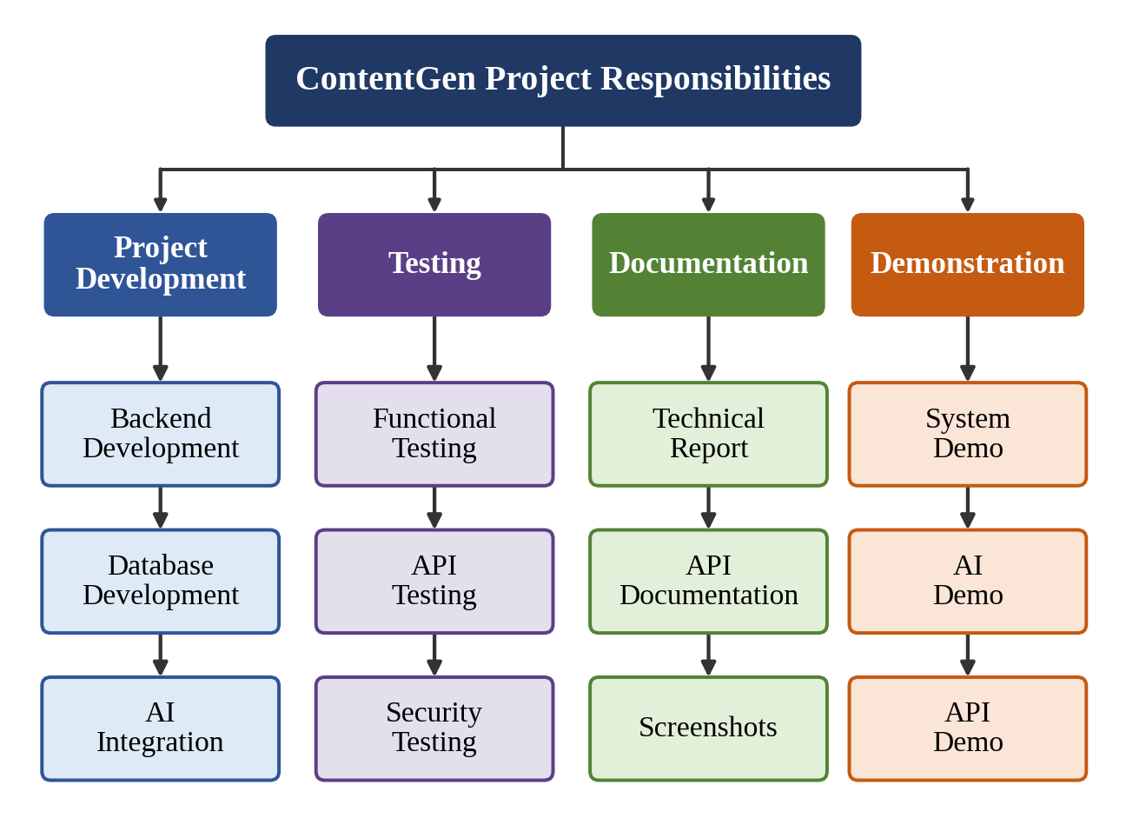
Figure 4: Project Responsibility Structure

4.9 Risk Management
Risk management involves identifying events that could disrupt the project and planning how to reduce their effect. The risks considered most relevant to ContentGen, together with their mitigation approaches, are given in Table 4.5.
Table 4.5: Risks and Mitigation Approaches
Risk | Description | Mitigation Approach
Risk 1 – Database Connection Failure | MongoDB may become unavailable or fail to connect. | Keep the connection settings in environment variables, handle connection errors explicitly, confirm that MongoDB is running before testing, and return controlled error responses when the database cannot be reached.
Risk 2 – AI Service Failure | Google Gemini AI requests may fail or become temporarily unavailable. | Handle AI request errors in the AI module, return a clear error message, keep the AI module separate so that other features continue to work, verify the API key configuration, and retry the request later.
Risk 3 – Authentication Errors | Incorrect JWT handling may prevent authorized access. | Perform token verification in a single reusable middleware, keep the secret key in configuration, and test valid, missing, invalid, and expired tokens for every role.
Risk 4 – Invalid Input | Incorrect or malicious input may cause unexpected API behavior. | Apply input validation and sanitization to incoming data, reject malformed requests early with clear messages, apply rate limiting, and test with invalid and unexpected values.
Risk 5 – API Errors | Incorrect request formats or server-side errors may affect API testing. | Define consistent request and response formats, use centralized error handling with proper status codes, and maintain organized Postman requests for repeatable testing.
Risk 6 – Development Environment Issues | Node.js, npm, environment variables, or dependency configuration may cause development problems. | Use the specified Node.js and npm versions, document the setup steps, manage settings through environment variables, and keep dependencies consistent through the project’s package configuration.

The risk management process followed in the project is shown in Figure 5. A risk is identified and analyzed, its impact is determined, a mitigation is planned and implemented, and the outcome is monitored and reviewed. The process is repeated whenever new risks arise.
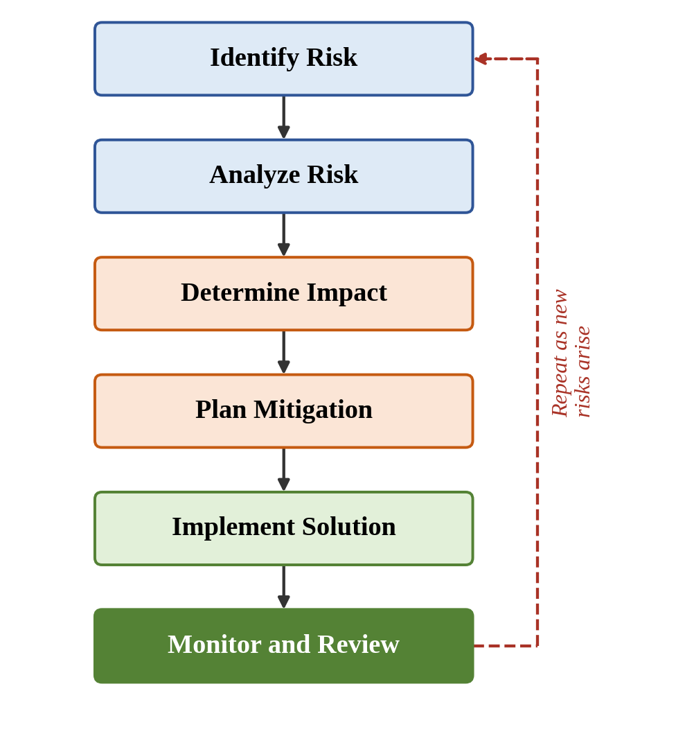
Figure 5: ContentGen Risk Management Process

4.10 Security Planning
Because ContentGen manages user accounts and restricted content, security is planned as part of the design rather than added afterwards. The following measures are planned:
- JWT authentication: Users receive a token after login, which is verified on protected requests to establish identity.
- bcrypt.js password hashing: Passwords are hashed before being stored, so plain-text passwords are never kept in the database.
- Role-based authorization: Each operation is allowed only for the roles permitted to perform it (Admin, Editor, Author, Reader).
- Input validation: Incoming data is checked for presence and correct format before processing.
- Input sanitization: Incoming data is cleaned to reduce the risk of harmful content reaching the application or database.
- Rate limiting: Repeated requests are restricted to reduce misuse of the API.
- Protected routes: Restricted endpoints require authentication and, where needed, a suitable role.
- Centralized error handling: Errors are handled in one place so that failures produce consistent, structured responses without exposing internal details.
Figure 6 shows the order in which these measures are applied to a request before it reaches the database or the AI service.
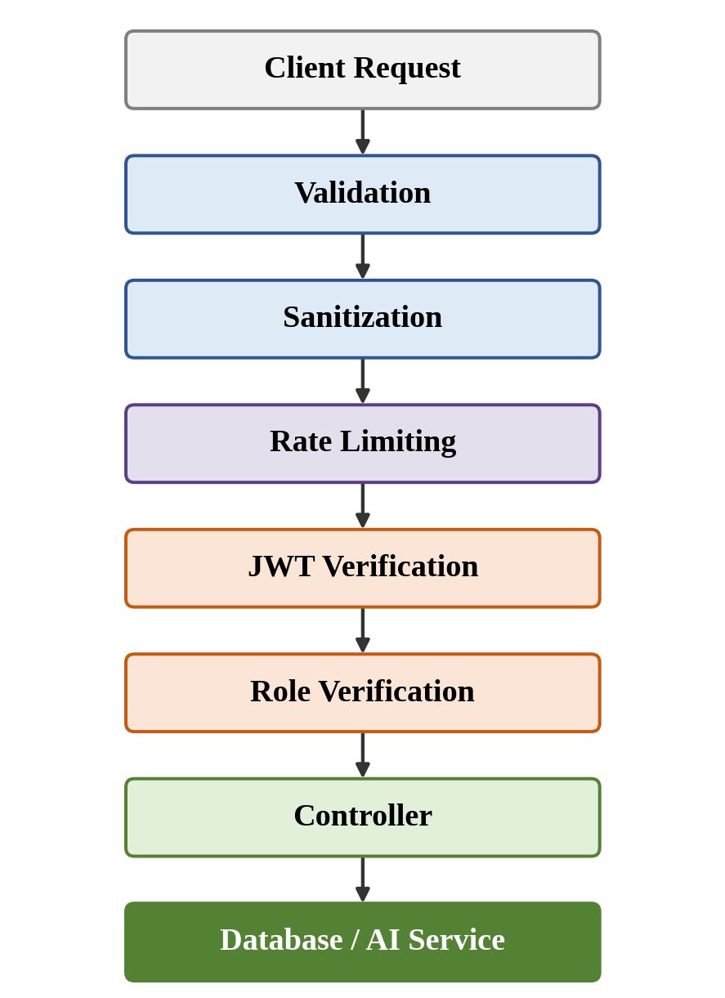
Figure 6: ContentGen Security Planning

4.11 Testing Plan
Testing is planned as a continuous activity that accompanies each module and is completed before the final demonstration. Table 4.6 lists the planned testing activities, which are carried out using Postman or Thunder Client.
Table 4.6: Planned Testing Activities
Testing Type | Description
Functional Testing | Verify that each major feature performs its intended function.
API Testing | Use Postman or Thunder Client to test API endpoints, request formats, and responses.
Authentication Testing | Verify registration, login, token generation, and protected routes.
Authorization Testing | Verify that Admin, Editor, Author, and Reader permissions are correctly enforced.
AI Testing | Verify AI blog generation and summarization requests.
Database Testing | Verify that data is correctly stored in and retrieved from MongoDB.
Error Testing | Verify appropriate responses for invalid requests and failures.
Security Testing | Verify that validation, sanitization, rate limiting, and protected access behave as planned.

The testing activities are summarized in Figure 7.
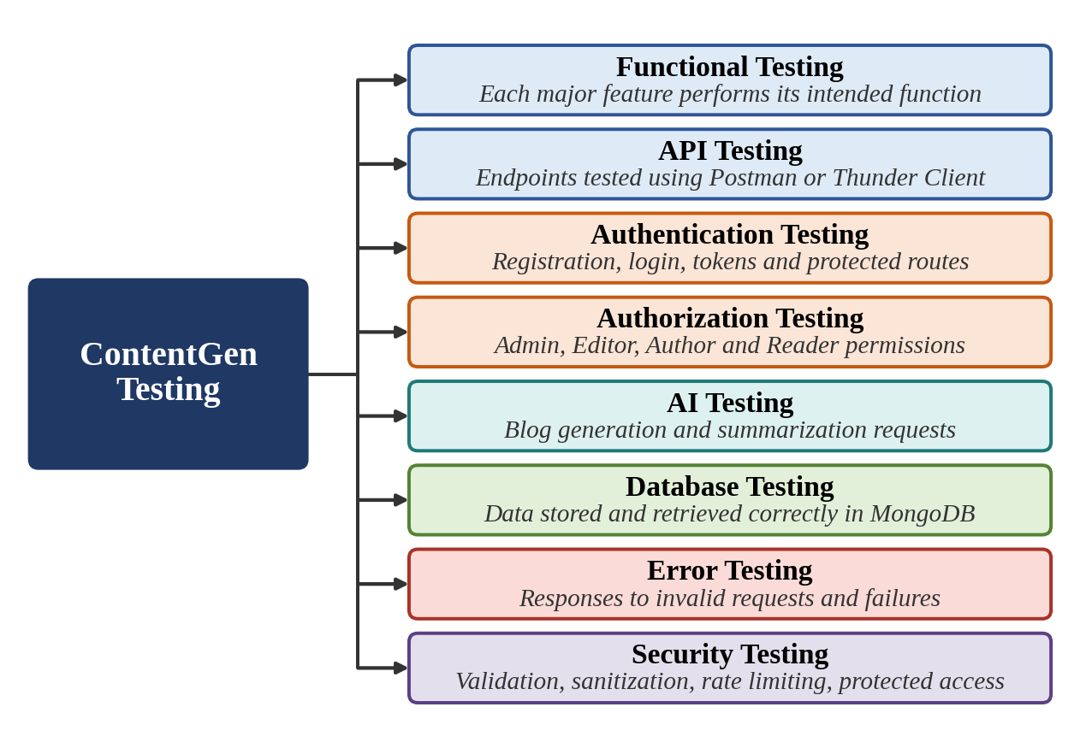
Figure 7: ContentGen Testing Plan

4.12 Project Deliverables
The expected outputs of the project are as follows:
- Working ContentGen backend: the complete Node.js and Express.js application.
- REST API endpoints: the endpoints for authentication, blogs, AI services, and comments.
- MongoDB database integration: data storage through MongoDB and Mongoose.
- Authentication and authorization: JWT-based login and role-based access control.
- AI blog generation: blog content produced from a topic or prompt using Google Gemini AI.
- AI summarization: concise summaries generated from blog or article content.
- Postman API testing results: records of the tests performed on the endpoints.
- Technical documentation: documentation describing the structure and usage of the backend.
- Project report: the complete written report of the project.
- Demonstration: a presentation of the working system, API behavior, and AI features.

4.13 Project Monitoring and Progress Tracking
Progress is monitored by comparing the work done with the plan. The indicators used are the completed modules, the pending modules, the testing status, the bugs identified, the bugs resolved, the documentation status, and the demonstration readiness. Reviewing these indicators regularly shows which activities are on track and which need attention. Table 4.7 gives a sample tracking format.
Table 4.7: Sample Project Tracking Format
Activity | Status | Remarks
Requirement Analysis | Completed | Requirements identified
System Design | Completed | Architecture designed
Backend Development | In Progress / Completed | Modules implemented
Database Integration | In Progress / Completed | MongoDB configured
AI Integration | In Progress / Completed | Gemini integration
Testing | Planned / In Progress | API testing
Documentation | Planned / In Progress | Report preparation
Demonstration | Planned | Final demo
Note: This table is a sample project tracking format. The statuses are illustrative and should be updated as the project progresses.

4.14 Expected Outcome
Effective planning is expected to provide the following benefits for ContentGen:
- Clear project direction: defined objectives and scope guide every activity.
- Organized development activities: the module and work breakdown structure order the work.
- Proper resource allocation: hardware, software, and responsibilities are identified in advance.
- Defined testing strategy: each type of testing is planned and linked to the modules.
- Risk mitigation: likely problems are anticipated and have planned responses.
- Better time management: the sequential phases and incremental approach make progress easier to control.
- Structured documentation: report, screenshots, and API documentation are planned from the start.
- Smooth project demonstration: a tested and documented system can be presented with confidence.

4.15 Conclusion
The Project Planning Phase organizes the development of ContentGen by defining its objectives and scope, dividing the backend into eight manageable modules, choosing an iterative and incremental methodology, and sequencing the work into clearly defined phases. It also specifies the hardware, software, and role requirements, anticipates the main risks together with their mitigation, and sets out the security measures, testing activities, deliverables, and progress-tracking approach. With these elements in place, the project has a clear structure and a reliable basis for execution. The plan prepares ContentGen for the next stage, the Project Development Phase, in which the modules will be implemented, integrated, and tested according to the plan described in this chapter.

