5. PROJECT DEVELOPMENT PHASE

5.1 Introduction
The Project Development Phase is the stage in which the requirements identified during the Requirement Analysis Phase, the architecture prepared during the Project Design Phase, and the schedule and modules defined during the Project Planning Phase are converted into a working software system. In this phase, the planned modules of ContentGen are implemented, connected to the database and to the external AI service, and prepared for verification.
ContentGen is developed as a backend application using Node.js and Express.js. Data is stored in MongoDB through Mongoose, user identity is managed with JWT authentication and bcrypt.js password hashing, and AI-assisted features are provided through Google Gemini AI. The application follows MVC architecture, and its functionality is exposed through REST API endpoints that are exercised using Postman or Thunder Client. Visual Studio Code is used as the development environment.
The backend is designed as a modular system. Routes define the API endpoints, controllers handle requests, models describe the data stored in MongoDB, services contain business logic such as communication with Google Gemini AI, and middleware performs authentication, authorization, validation, and error handling. This separation allows each module to be developed, tested, and improved independently, and it provides the base on which authentication, authorization, blog management, AI services, comments, and search are integrated in the sections that follow.

5.2 Development Environment Setup
Before any application code is written, the development environment is prepared. Node.js and npm are installed, Visual Studio Code is used as the code editor, and Postman or Thunder Client is prepared for sending test requests. The project is then created in the following steps.
Step 1 – Project Folder Creation. The main project folder is created for ContentGen (also referred to as BlogNest). It contains everything belonging to the project and provides a single location for the source code and related documents.
Step 2 – Server Folder. Inside the main folder, a backend folder named Server is created. All server-side code, configuration, and dependencies are kept in this folder.
Step 3 – Node.js Project Initialization. The command npm init -y is executed inside the Server folder. It creates a package.json file using default values, without asking the usual initialization questions. This file records the project name, version, entry point, scripts, and dependencies, and it allows the required packages to be installed and managed using npm.
mkdir ContentGen
cd ContentGen
mkdir Server
cd Server
npm init -y
After initialization, the packages required by the project, such as Express.js, Mongoose, JWT handling, and bcrypt.js, are installed using npm and are listed automatically in package.json.
Step 4 – Project Structure. A modular folder structure is then created so that each kind of code has a clear place. A typical structure for the ContentGen backend is shown in Figure 1. The exact structure can vary depending on the implementation, but the separation of routes, controllers, models, services, middleware, and configuration is retained.
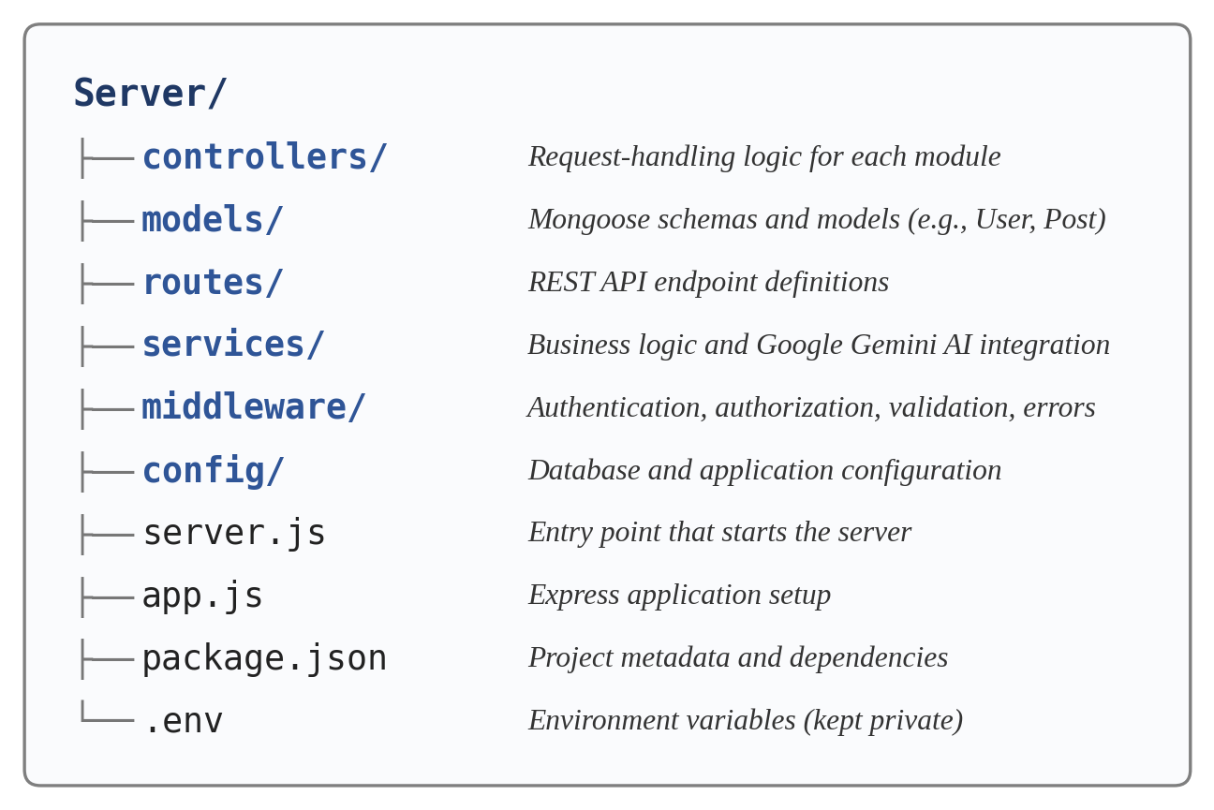
Figure 1: ContentGen Backend Project Structure

5.3 Backend Server Development
The backend server is developed using Express.js, which provides routing and middleware handling on top of Node.js. Development of the server involves the following tasks:
- Express application initialization: The Express application object is created, and it becomes the central point to which middleware and routes are attached.
- Middleware configuration: Middleware functions are registered in a defined order so that every request passes through them before reaching a route handler.
- JSON request parsing: Middleware is enabled so that request bodies sent as JSON, which is the format used by the API, are parsed and made available to controllers.
- CORS configuration: Cross-Origin Resource Sharing is configured so that the API can decide which client origins are permitted to access it.
- Route registration: The route modules for authentication, blogs, AI services, and comments are attached to their base paths such as /api/auth, /api/blogs, /api/ai, and /api/comments.
- Error handling: An error-handling middleware is placed after the routes so that failures are converted into structured JSON responses.
- Server startup: The server begins listening on a configured port after the required connections, such as the database connection, have been prepared.
- Environment configuration: Values such as the port, database connection string, JWT secret, and Gemini API key are read from environment variables rather than written in the code.
Where the application is divided into two files, app.js is responsible for creating and configuring the Express application, including middleware and routes, while server.js is the entry point that loads the environment configuration, connects to the database, and starts the server. Separating these responsibilities keeps the application setup independent of the code that starts it, which makes the application easier to maintain and to test.
The path followed by a request through the backend is shown in Figure 2.
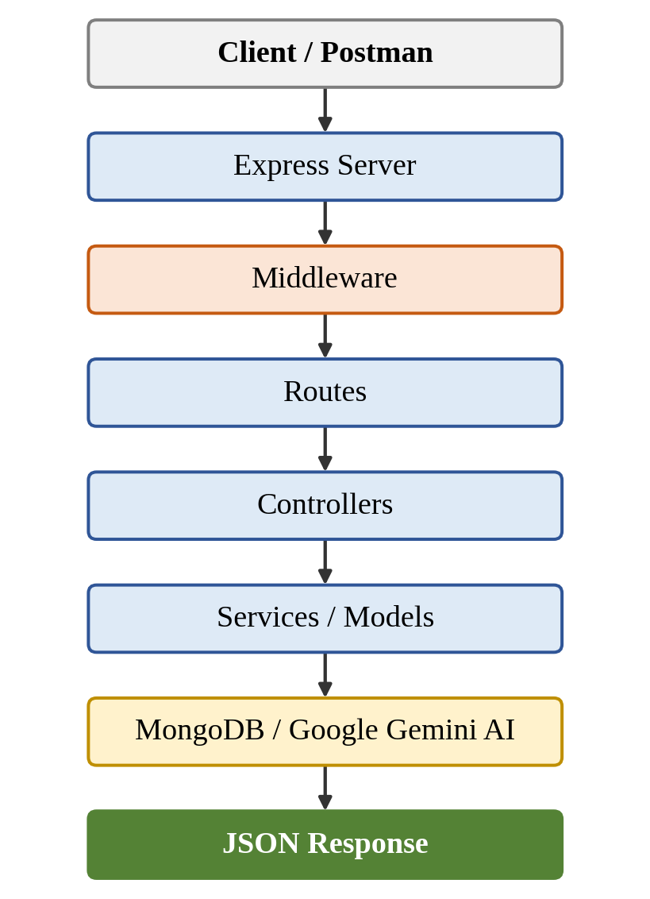
Figure 2: ContentGen Backend Request Processing Flow

5.4 Database Development
ContentGen stores its data in MongoDB, a document-oriented NoSQL database, and uses Mongoose as the Object Data Modeling library. Mongoose allows the structure of each collection to be described as a schema and converted into a model through which the application creates, reads, updates, and deletes documents. Before any database operation can be performed, the application connects to MongoDB using the connection configuration supplied through the environment. This connection is normally established at startup, and the server begins accepting requests once it has been prepared. A failed connection is reported as an error so that the problem can be corrected.

5.4.1 User Model
The User model stores account information and the role used for authorization.
Table 5.1: User Model Fields
Field | Description
_id | Unique identifier automatically generated by MongoDB for each user.
name | Name of the user, supplied during registration.
email | Email address of the user, used to identify the user at login.
password | User password, stored only in hashed form produced by bcrypt.js.
role | Role assigned to the user (Admin, Editor, Author, or Reader), which determines permitted operations.

5.4.2 Post Model
The Post model stores the blog post records created by users.
Table 5.2: Post Model Fields
Field | Description
_id | Unique identifier automatically generated by MongoDB for each post.
userID | Reference to the user who created the post.
name | Name or title associated with the post.
photo | Photo or image information associated with the post.
message | Textual content of the post.
likes | Engagement information recorded for the post.
timestamps | Creation and last-update times, which Mongoose can maintain automatically.

5.4.3 Logical Relationships
The collections are related logically through references. One user can create many posts, and each post refers to its creator through userID. One user can also write many comments, and one post can receive many comments. Information such as the workflow status of a post, its categories and tags, media metadata, and the fields of a comment are defined in the schemas according to the implementation, and they follow these relationships. The relationships are shown in the entity-relationship style diagram in Figure 3.
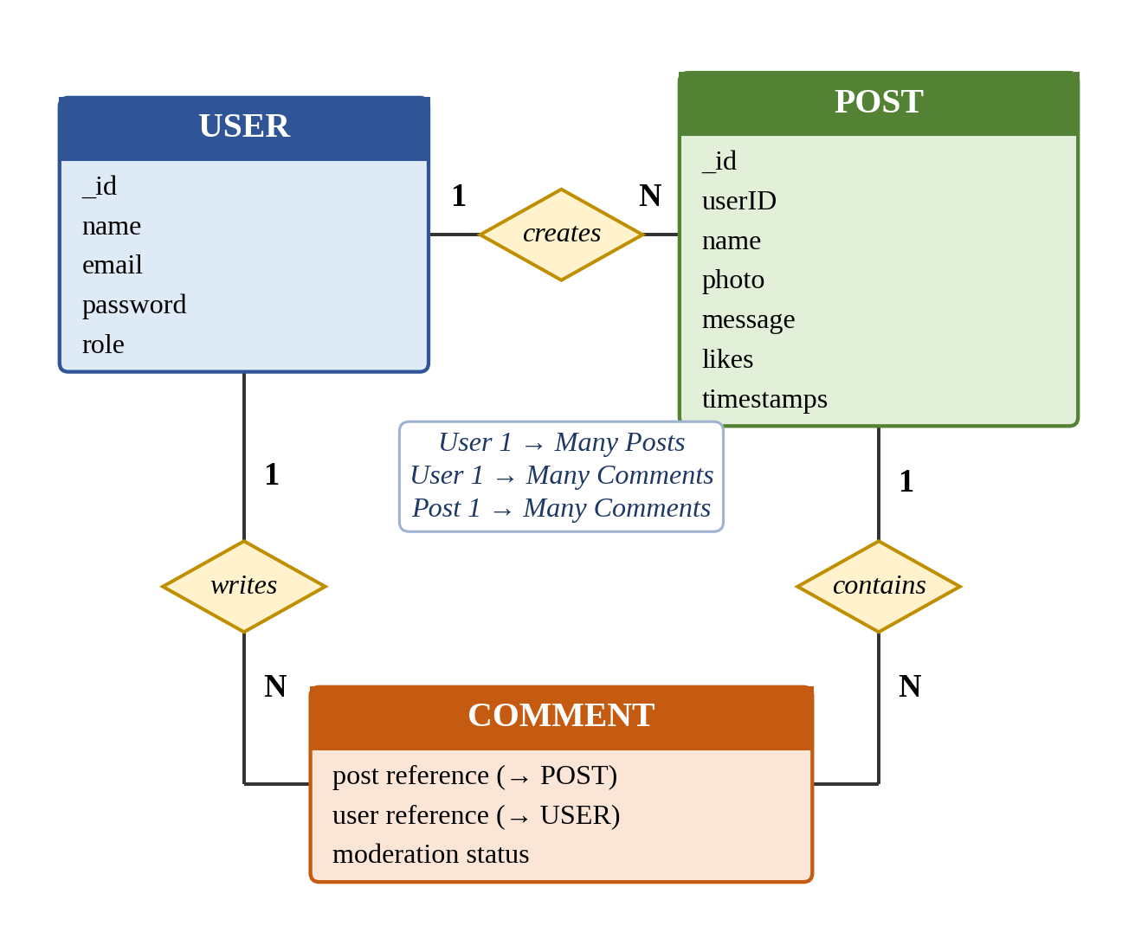
Figure 3: ContentGen Database Relationship Design

5.5 Authentication Development
Authentication verifies who a user is before access to restricted resources is allowed. In ContentGen it is implemented using password hashing with bcrypt.js and JWT-based tokens.

5.5.1 User Registration
When a registration request is received, the backend performs the following steps:
- The user details, such as name, email, and password, are received in the request.
- The input is validated to confirm that the required fields are present and correctly formed.
- The password is hashed using bcrypt.js so that the original password is not stored.
- The user data, including the hashed password, is stored in MongoDB, and a response is returned to confirm that the account has been created.

5.5.2 User Login
During login, the backend receives the email and password and locates the corresponding user. The submitted password is compared with the stored hash using bcrypt.js. If the credentials are valid, a JWT is generated and returned in the authentication response; otherwise a clear error response is returned. The token is then sent by the client with later requests.

5.5.3 Protected Routes
Restricted API endpoints are protected by authentication middleware. This middleware reads the token that accompanies the request, verifies it, and identifies the user. If the token is missing or invalid, the request is rejected before it reaches the controller. If it is valid, the request continues to the next step, where the role of the user can be checked. The registration and login processes are illustrated in Figure 4.
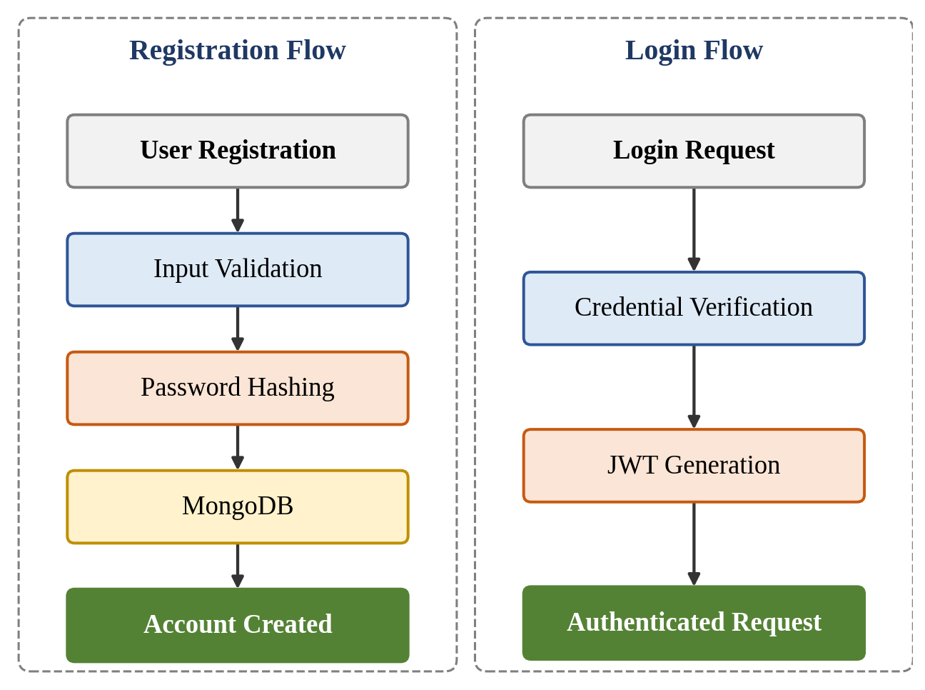
Figure 4: ContentGen Authentication Flow

5.6 Role-Based Authorization Development
Authorization decides what an authenticated user is allowed to do. ContentGen defines four roles, whose access is summarized in Table 5.3.
Table 5.3: Roles and Access Levels
Role | Access
Admin | Full administrative access, including management of users, roles, comments, and system resources.
Editor | Content review and publishing-related access, including approval of content and management of comments.
Author | Creation and management of the author’s own blog content.
Reader | Access to published content and comments.

Authorization is implemented as middleware that runs after the token has been verified. The middleware reads the role of the authenticated user and compares it with the roles permitted for the requested operation. If the role is permitted, the request proceeds to the controller; otherwise the request is rejected with an appropriate error response. Keeping this check in reusable middleware means that the same rule can be applied to any route without repeating code in each controller. The flow is shown in Figure 5.
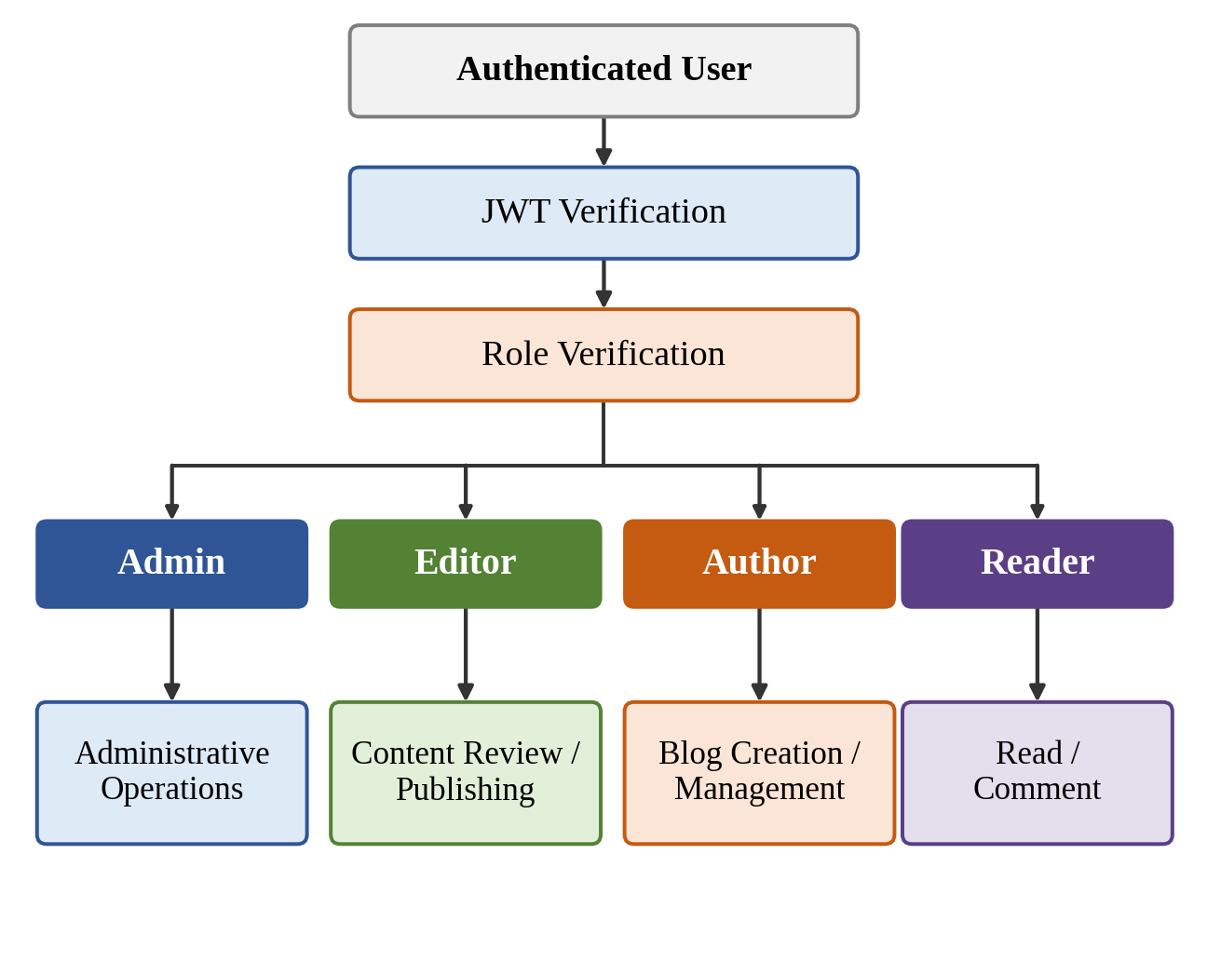
Figure 5: Role-Based Authorization Implementation

5.7 Blog Management Development
Blog management is the core functionality of ContentGen. It is implemented through controllers and models, and its access rules depend on the roles described above.
Create Blog. Authorized authors create blog posts by submitting the post content. The controller validates the input, associates the post with the authenticated user, and stores it in MongoDB.
Read Blog. Users retrieve available blog content. Readers see published content, while authorized users can access additional content according to their role.
Update Blog. Authorized users modify permitted content. An author is limited to their own posts, while Editors and Admins have wider access according to their roles.
Delete / Manage Blog. Authorized users manage blog records according to their permissions, for example removing a post or changing how it is handled in the workflow.
Blog Status. Each post moves through a content lifecycle of Draft → Pending Approval → Scheduled → Published. A new post begins as a draft, is submitted for approval, is reviewed by an Editor, and is then either scheduled or published. This workflow allows content to be checked before it becomes visible to readers.
The complete workflow, including the path followed when an Editor requires revisions, is shown in Figure 6.
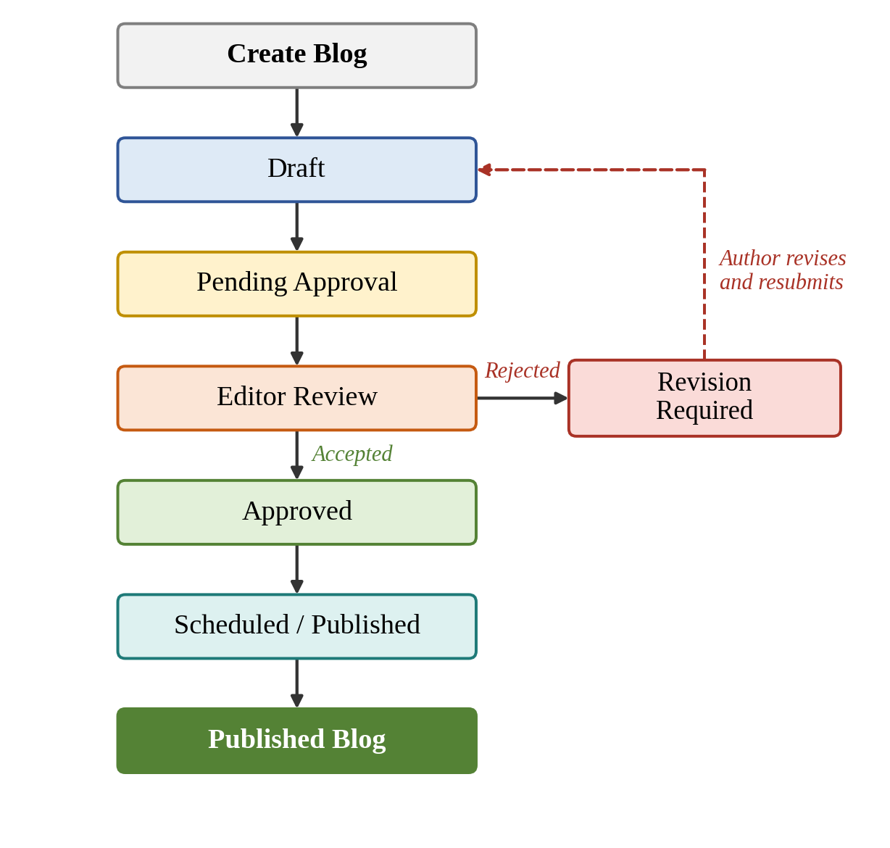
Figure 6: Blog Content Management Workflow

5.8 AI Blog Generation Development
Google Gemini AI is integrated into the backend as an external service that generates blog content from a topic or prompt. The integration is placed in the services layer so that the controller does not depend on the details of the AI provider. The process is as follows:
- The user enters a topic or prompt.
- The backend receives the request through the AI endpoint.
- The AI controller or service processes the request.
- The prompt is sent to Google Gemini AI.
- Gemini generates the blog content.
- The backend receives the AI response.
- The generated content can be reviewed and managed as blog content.
The Gemini API key is read from the environment configuration and is never included in the source code. Because an external service is involved, the AI service handles request errors and returns a clear error response if generation fails. The generated text is returned to the user, who can review and edit it before saving it as a blog post in MongoDB. This review step keeps the author in control of the final content. The process is shown in Figure 7.
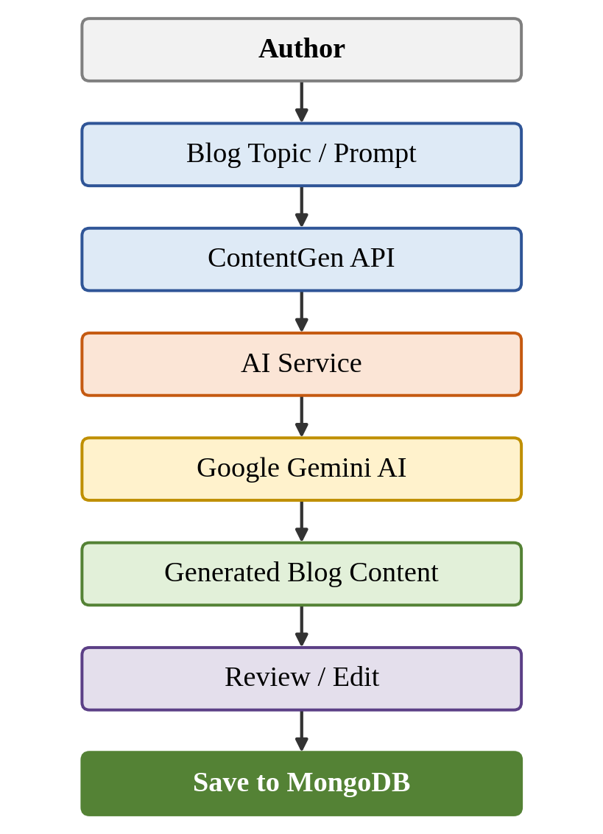
Figure 7: AI-Powered Blog Generation Process

5.9 AI Content Summarization Development
The summarization feature converts longer content into a concise summary. The user submits existing blog or article content in a summarization request. The ContentGen AI service prepares the request and sends the content to Google Gemini AI, which generates a summary. The backend receives the summary and returns it to the client as a JSON response. This helps readers and editors understand long content quickly and shows how the same AI service layer can support more than one feature. As with blog generation, request errors from the AI service are handled and reported clearly. The process is shown in Figure 8.
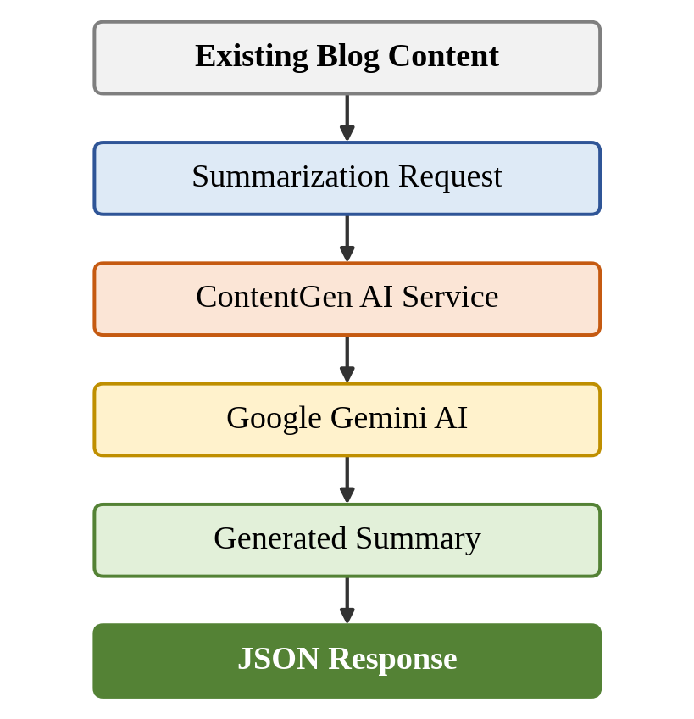
Figure 8: AI Content Summarization Process

5.10 Category and Tag Development
Categories and tags organize blog content so that it is easier to manage and find. A category places a post in a broad grouping, while tags add more specific descriptive labels. The functionality covers the following aspects:
- Categorizing blog posts: Each blog post can be assigned to a category when it is created or updated.
- Assigning tags: One or more tags can be attached to a post to describe its subject.
- Filtering content: Posts can be retrieved according to a chosen category or tag.
- Improving content discoverability: Consistent grouping and labeling help readers find related content and help editors manage posts.
The process is shown in Figure 9.
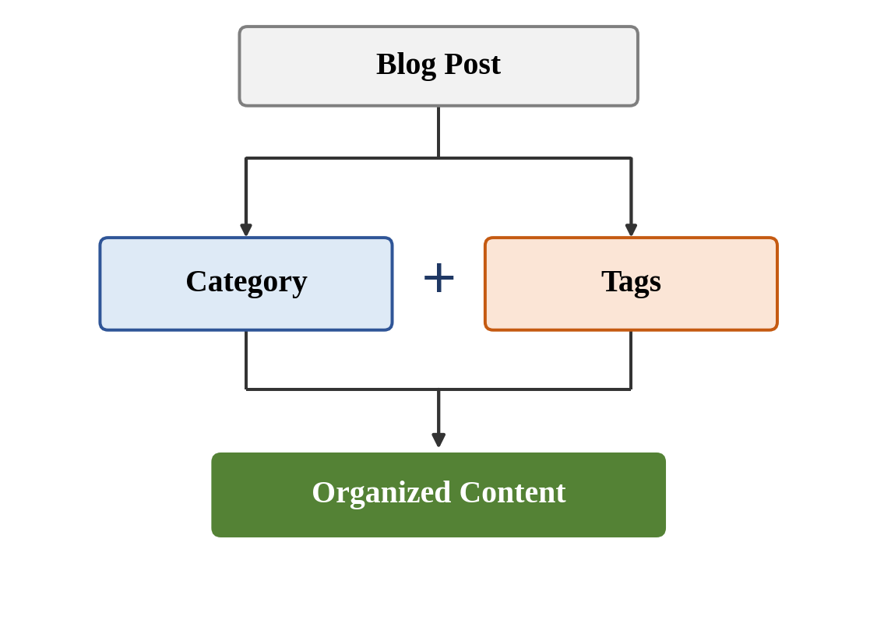
Figure 9: Blog Categorization and Tagging Process

5.11 Comment Management Development
Comment management allows readers to respond to blog posts while giving authorized users control over what is shown. The process is as follows:
- A reader submits a comment on a blog post.
- The comment is associated with the user who wrote it and the post to which it belongs, following the relationships shown in Figure 3.
- Authorized users can review submitted comments.
- Moderation can be applied where required.
Moderation is described in terms of three states: Pending, for a comment awaiting review; Approved, for a comment accepted for display; and Spam, for a comment identified as unwanted. Only these states are considered in this project, and no further comment features are assumed. The comment management process is shown in Figure 10.
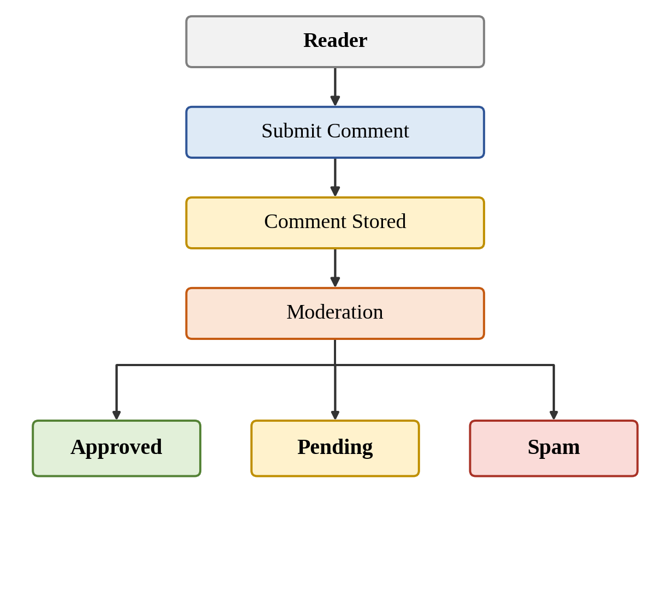
Figure 10: Comment Management Process

5.12 Search Development
Search functionality helps users locate relevant blog posts without browsing all content. A user submits a search query, which is sent to the backend as an API request. The search logic in the backend interprets the query and searches the blog data in MongoDB. The matching blog posts are returned to the client as a JSON response. Search operates on the same data as blog management, so it needs no separate storage. Its results should respect the access rules of the system, so that readers are shown only content they are permitted to view. The process is shown in Figure 11.
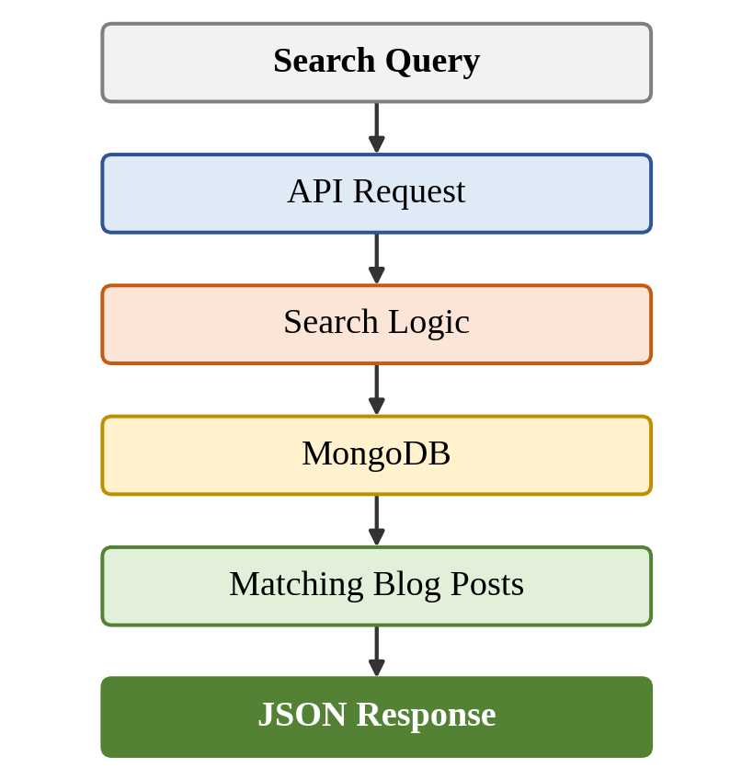
Figure 11: ContentGen Search Process

5.13 API Development
ContentGen exposes its functionality through a REST API. The standard HTTP methods are used according to the nature of the operation:
- GET retrieves data, such as blog posts or comments, without changing it.
- POST creates a resource or submits data, such as registering a user, logging in, creating a blog, or requesting AI content.
- PUT updates an existing resource, such as modifying a blog post.
- DELETE removes a resource, according to the permissions of the user.
Table 5.4 lists the representative endpoints of the project. All responses are returned as structured JSON, and restricted endpoints are protected by authentication and role-based authorization.
Table 5.4: Representative API Endpoints
Endpoint | Method | Purpose
/api/auth/register | POST | User registration
/api/auth/login | POST | User login
/api/blogs | GET / POST | Retrieve / create blogs
/api/ai/generate-blog | POST | Generate AI blog
/api/ai/summarize | POST | Summarize content
/api/comments | POST / GET | Manage comments

The architecture through which these endpoints are processed is shown in Figure 12.
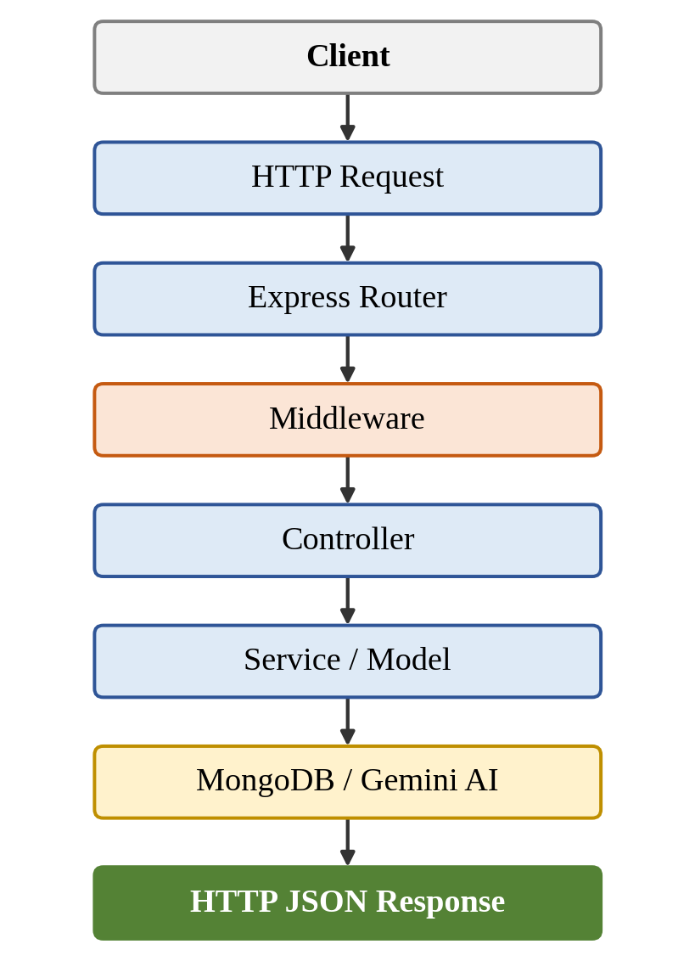
Figure 12: ContentGen REST API Architecture

5.14 Security Implementation
Security is implemented as a series of protective measures around the application logic:
- JWT authentication: Users receive a token on login, and protected requests must present a valid token.
- bcrypt.js password hashing: Passwords are hashed before storage, so the original passwords are not kept in the database.
- Role-based authorization: Each operation is available only to the roles permitted to perform it.
- Input validation: Incoming data is checked for the required fields and correct format.
- Input sanitization: Incoming data is cleaned before it is processed or stored.
- Rate limiting: Repeated requests are limited to reduce misuse of the API.
- Protected routes: Restricted endpoints require authentication and, where needed, an appropriate role.
- Centralized error handling: Errors are converted into consistent responses in one place, without exposing internal details.
Figure 13 shows the order in which these measures are applied to an incoming request.
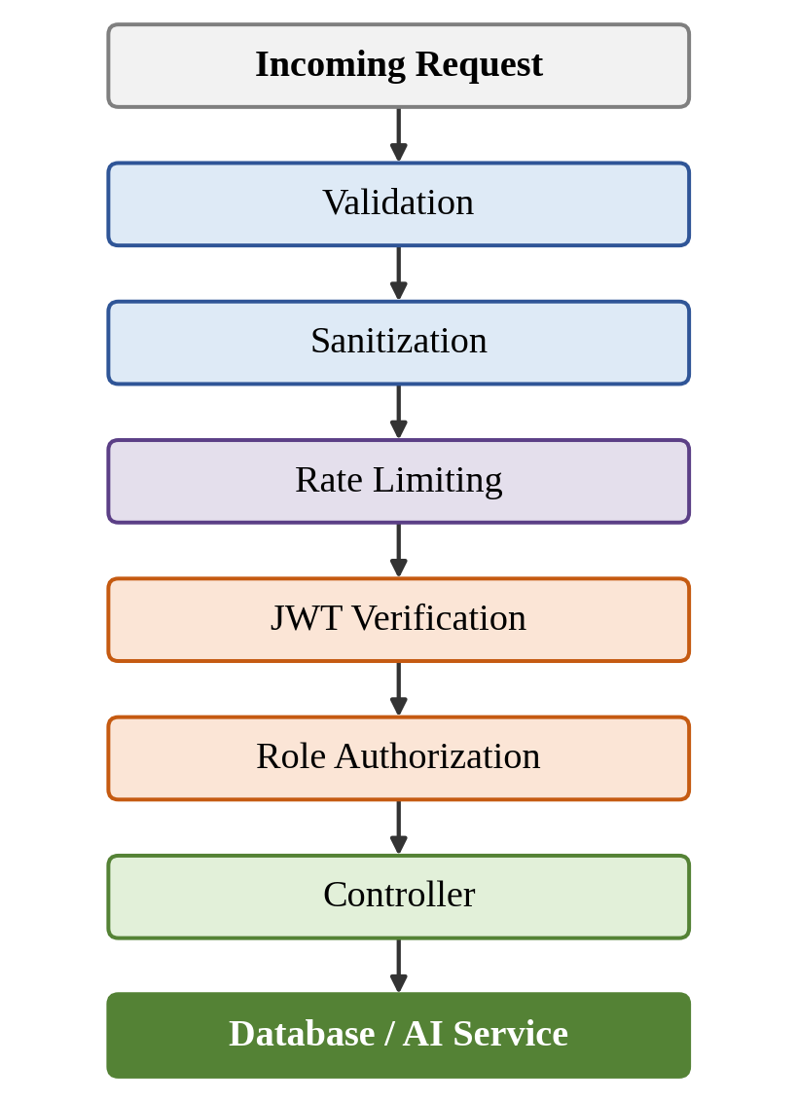
Figure 13: ContentGen Security Processing Flow

5.15 Error Handling
A reliable backend must respond predictably when something goes wrong. In ContentGen, errors are detected in controllers, services, and middleware and are passed to a centralized error handler, which returns a structured JSON response containing a clear message and an appropriate HTTP status code. Table 5.5 gives examples of the situations handled.
Table 5.5: Examples of Error Handling
Situation | Expected Handling
Invalid login credentials | The login is rejected, and a clear error message is returned without revealing which detail was wrong.
Missing required fields | The request is rejected by validation, and the response identifies the missing information.
Unauthorized access | The request is refused because the user is not authenticated or lacks the required role.
Invalid JWT | The token is rejected, and the user is asked to authenticate again.
Database connection problems | The failure is reported as a server-side error and does not stop the application unexpectedly.
Invalid API requests | Malformed requests or unknown routes receive an error response instead of being processed.
AI service errors | A failed Gemini request produces a clear error response, while other features continue to work.

Returning clear and structured error responses is important because client developers and testers can then understand the cause of a failure and react appropriately, and because the application avoids exposing internal implementation details.

5.16 Environment Configuration
Sensitive and environment-specific settings are stored in environment variables, kept in the .env file of the Server folder and read by the application at startup. Table 5.6 lists the main configuration items. The variable names shown are illustrative and may differ in the implementation, and the values are deliberately left as placeholders.
Table 5.6: Environment Configuration Items
Configuration | Purpose | Illustrative Variable
MongoDB connection configuration | Allows the application to connect to the database. | MONGODB_URI
JWT secret | Used to sign and verify authentication tokens. | JWT_SECRET
Google Gemini API key | Authorizes requests to Google Gemini AI. | GEMINI_API_KEY
Server port | Specifies the port on which the server listens. | PORT
MONGODB_URI=<your-mongodb-connection-string>
JWT_SECRET=<your-secret-value>
GEMINI_API_KEY=<your-api-key>
PORT=<port-number>
Credentials should never be hard-coded in the source code or committed to public repositories. Code that is shared or published would otherwise reveal them, allowing unauthorized access to the database, forged tokens, or misuse of the AI service. Keeping them in an environment file that is excluded from version control also allows different values to be used for different environments without changing the code.

5.17 Integration of Major Modules
After the individual modules are developed and tested, they are integrated into a single backend application. Authentication, authorization, blog management, the database layer, AI services, comments, and search are all connected through the Express application. Requests pass through common middleware and are directed by the routes to the appropriate controllers. The controllers use services and models to work with MongoDB and, for AI features, with Google Gemini AI.
The modules depend on each other in a defined way. Authentication supplies the identity of the user, authorization uses that identity to check permissions, blog management applies those permissions to blog content, and comments and search operate on the stored blog data. The AI services provide generated content and summaries to the blog workflow. Integration is carried out incrementally, and each module is tested after being added, in line with the iterative approach described in the planning phase. The complete arrangement is shown in Figure 14.
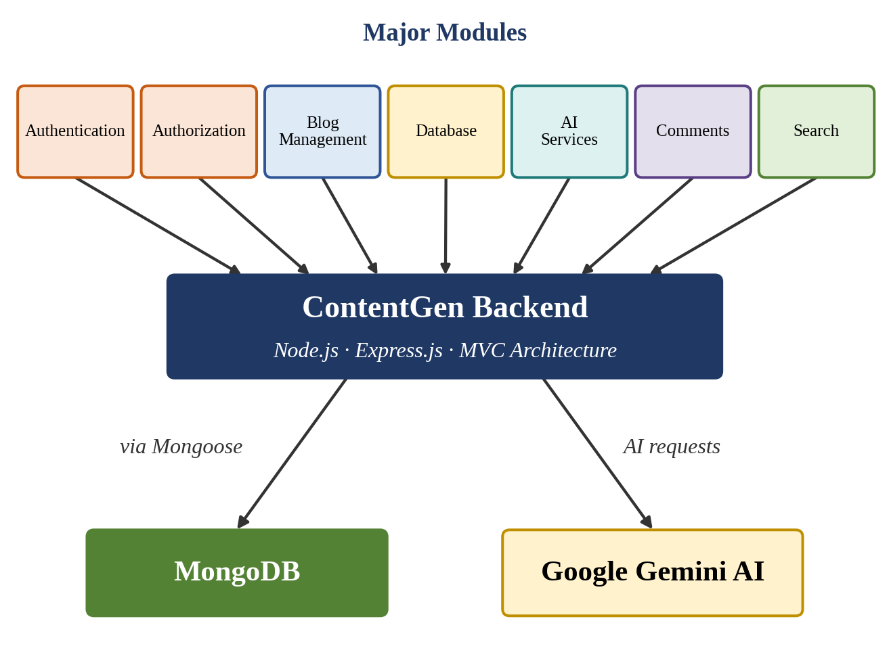
Figure 14: Complete ContentGen Module Integration

5.18 Development Output
The expected result of the development phase is an operational ContentGen backend with the following characteristics:
- A working Node.js backend
- An Express REST API
- MongoDB database connectivity
- User authentication
- Role-based authorization
- Blog management
- AI blog generation
- AI summarization
- Comment management
- Search
- Security mechanisms
- Structured JSON responses
These outputs describe the functionality defined for the project. The degree to which each feature is complete and correct is to be confirmed through the testing described in the next phase.

5.19 Development Challenges and Solutions
Several challenges are expected during the development of a backend of this kind. Table 5.7 lists the main ones together with the corresponding solutions.
Table 5.7: Development Challenges and Solutions
Challenge | Solution
MongoDB connection issues | Verify the connection configuration and network access.
Authentication errors | Validate credentials and JWT configuration.
Invalid API requests | Apply request validation.
AI request failures | Handle API errors and validate requests.
Unauthorized access | Implement role-based middleware.
Dependency/configuration issues | Verify Node.js and npm configuration.

5.20 Conclusion
The Project Development Phase transforms the ContentGen design into an operational backend system. Starting from the environment setup and modular project structure, the Express server, MongoDB and Mongoose database layer, authentication, role-based authorization, blog management, AI blog generation and summarization, categories and tags, comments, and search are developed and connected through a REST API. Security measures, structured error handling, and environment-based configuration are applied throughout, and the modules are integrated into a single backend that communicates with MongoDB and Google Gemini AI. The resulting system is ready to be verified in the next stage, the Project Testing Phase, in which the endpoints, authentication, authorization, AI features, and error handling will be tested using Postman or Thunder Client.

