CHAPTER 8

8. PROJECT DEMONSTRATION PHASE

8.1 Introduction
The Project Demonstration Phase is the stage in which the completed ContentGen system, an AI-powered blog content generation and content management backend (also referred to in the source code as BlogNest), is presented, verified, and shown to project evaluators, faculty members, and prospective users. Earlier phases of the project concentrated on analysis, design, and implementation. This phase shows that the implemented system behaves as designed and that its features work together as a coherent, secure, and usable backend service.
Because ContentGen is a backend-oriented system built with Node.js, Express.js, MongoDB, and Mongoose, the demonstration is carried out mainly through REST API requests issued from Postman or Thunder Client, supported by inspection of the database contents and the server console. The demonstration concentrates on the following aspects:
- System architecture, based on the MVC (Model–View–Controller) pattern;
- Backend functionality and the REST API layer;
- Authentication using JWT and password hashing with bcrypt.js;
- Authorization through Role-Based Access Control (RBAC);
- Blog management, categories and tags, comments, and search;
- AI features: blog generation and summarization through Google Gemini AI;
- Database operations performed through Mongoose on MongoDB;
- API testing, security features, and the overall workflow of the system.

8.2 Demonstration Objectives
The demonstration is planned around the following objectives:
- To demonstrate the working backend system, from server start-up to request handling.
- To verify the major API functionalities exposed by the implemented backend.
- To demonstrate user authentication through registration, login, and JWT issuance.
- To demonstrate role-based authorization for the Admin, Editor, Author, and Reader roles.
- To demonstrate blog creation and management by an authorized user.
- To demonstrate AI-powered blog generation using Google Gemini AI.
- To demonstrate AI-powered summarization of existing content.
- To demonstrate MongoDB data storage and the effect of API operations on stored records.
- To demonstrate comment functionality and its moderation states.
- To demonstrate API testing using Postman or Thunder Client.
- To explain the security mechanisms protecting the system.
- To present the overall project architecture and workflow.
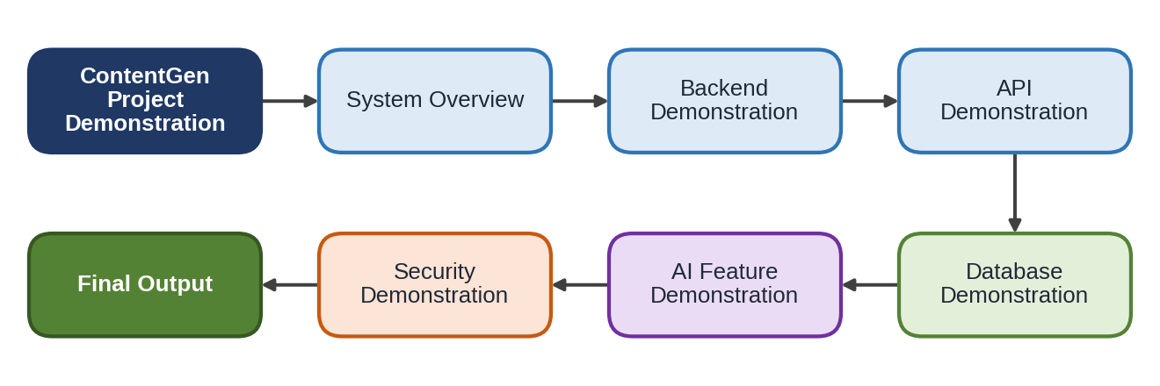
Figure 1: ContentGen Project Demonstration Overview
Figure 1 shows the order of the demonstration. It begins with a system overview and moves through backend, API, database, AI, and security demonstrations, ending with the final output of the complete workflow.

8.3 Demonstration Environment
The demonstration is carried out on a standard development computer. The hardware and software used are summarized in Table 8.1 and Table 8.2.
Table 8.1: Hardware Requirements for the Demonstration
Component | Requirement
Computer / Laptop | A desktop or laptop capable of running Node.js and MongoDB
Memory | Minimum 8 GB RAM
Processor | A suitable modern multi-core processor
Network | Internet connection where required (for example, for Google Gemini AI requests)

Table 8.2: Software Requirements for the Demonstration
Software | Purpose
Operating System | Windows 10/11, macOS, or Linux
Visual Studio Code | Code editor and integrated terminal
Node.js and npm | JavaScript runtime and package manager
MongoDB | Database used for persistent storage
Postman / Thunder Client | Sending HTTP requests and inspecting responses
Google Gemini AI service | AI blog generation and summarization

The backend server must be running, and connected to MongoDB, before any API demonstration is performed. Every request sent from Postman or Thunder Client depends on the Express server being available to receive it.

8.4 Starting the Backend Server
The backend is started using the following sequence of steps:
- Open the ContentGen project folder in Visual Studio Code.
- Open the integrated terminal.
- Navigate to the server or project directory that contains the package.json file.
- Install the dependencies, if required, using npm install.
- Configure the environment variables (for example, the database connection string, the JWT secret, and the Google Gemini AI key) in the environment file. Actual values must not be displayed or shared during the demonstration.
- Start the backend server using the project's configured npm command, for example: npm start. If the project defines a different command in its package.json scripts (such as a development-mode script), that configured command should be used instead.
- Verify that the server is running by checking the console message confirming that Express is listening on its configured port.
- Verify MongoDB connectivity by checking the console message confirming a successful database connection.
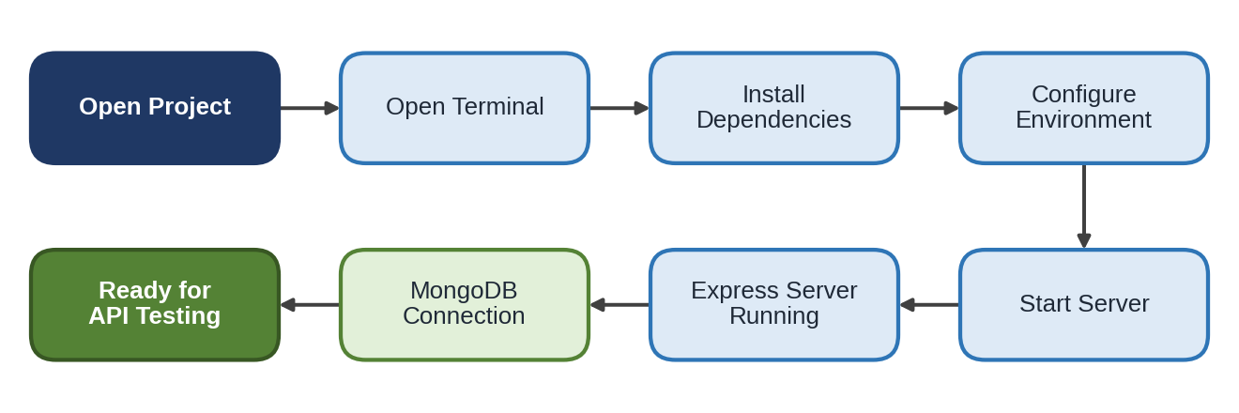
Figure 2: ContentGen Backend Startup Process
Once the Express server is running and the database connection is established, the system is ready for API testing.

8.5 User Registration Demonstration
User registration is demonstrated first, because authentication and role-based access can only be shown once user accounts exist in the database. In Postman or Thunder Client, the registration endpoint is called with an HTTP POST request whose body carries the user details, such as name, email, and password, as required by the implemented User model.
The backend validates the submitted data, hashes the password using bcrypt.js so that the plain-text password is never stored, and saves the new user document in MongoDB through Mongoose. A registration response is then returned to the client. During the demonstration, the evaluator can confirm that the stored password appears in hashed form in the users collection.
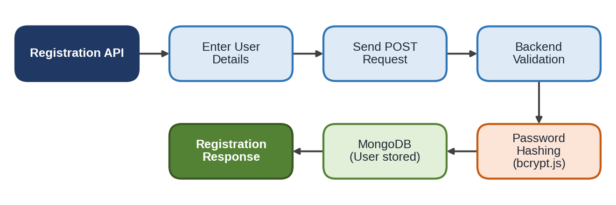
Figure 3: User Registration Demonstration Flow

8.6 User Login Demonstration
The login demonstration shows how a registered user is authenticated. It is carried out in the following steps:
- Enter the registered email address.
- Enter the password.
- Send the login request to the login endpoint.
- The backend looks up the user and verifies the credentials.
- The submitted password is compared securely with the stored hash using bcrypt.js.
- On success, a JWT (JSON Web Token) is generated.
- The authentication response, including the token, is returned to the client.
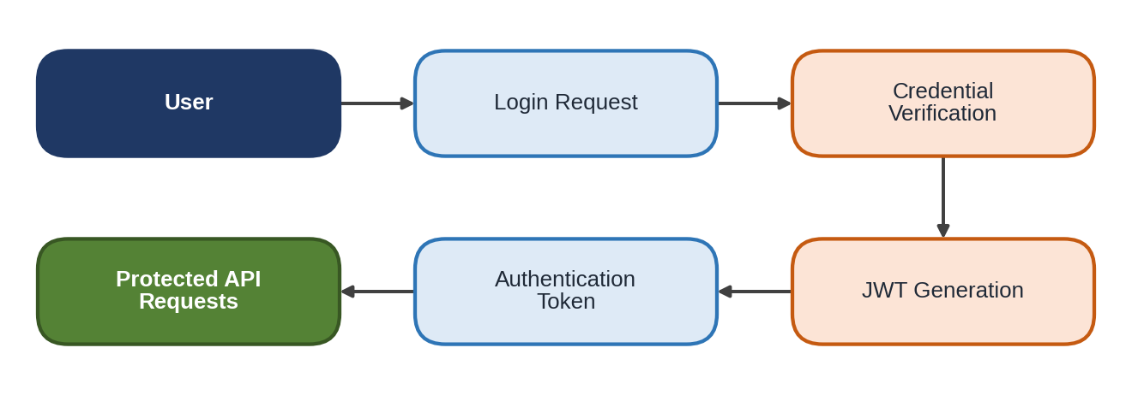
Figure 4: User Login and JWT Authentication Demonstration
The returned token is then supplied with subsequent requests, typically in the Authorization header, to access protected APIs. A request made without a valid token should be rejected, which is shown later in the security demonstration.

8.7 Role-Based Access Demonstration
ContentGen applies Role-Based Access Control so that each operation is available only to the roles permitted to perform it. The demonstration uses accounts with different roles and shows what each role can and cannot do.
Table 8.3: Roles Demonstrated
Role | Demonstration Focus
Admin | Administrative operations available to the Admin role.
Editor | Content review and publishing-related permissions.
Author | Blog creation and management.
Reader | Reading published content and adding comments.

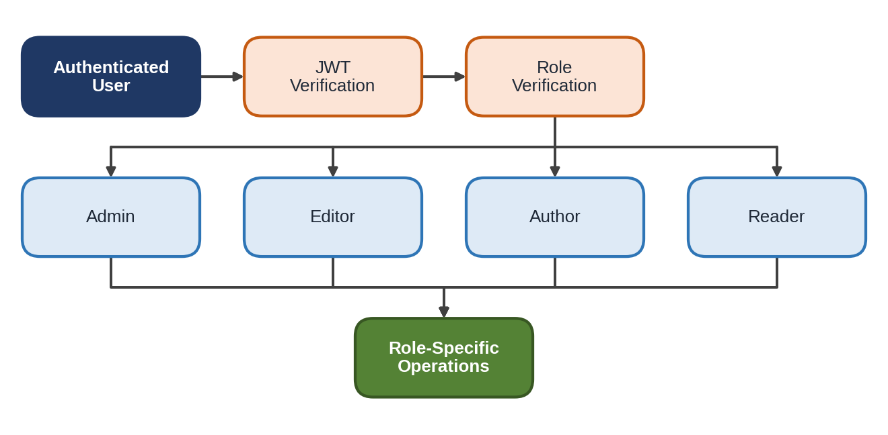
Figure 5: Role-Based Access Demonstration
In each case the request first passes JWT verification, after which the authorization middleware checks the role. Operations attempted by a role that is not permitted to perform them should be rejected by the authorization middleware. Showing both an allowed and a rejected operation for the same endpoint gives evaluators clear evidence that authorization is enforced.

8.8 Blog Creation Demonstration
The Author role is used to demonstrate blog creation. The Author first logs in and obtains a JWT. The token is attached to a create-blog request, which the backend validates before the controller stores the blog in MongoDB.
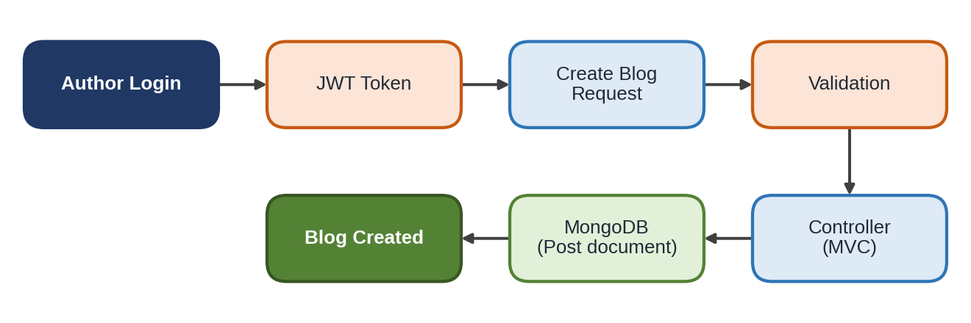
Figure 6: Blog Creation Demonstration
After creation, the evaluator can inspect the stored record. The Post model is represented by the following fields:
- Title/name of the blog post;
- Content/message of the blog post;
- Photo/media pathway, where applicable;
- User reference, linking the post to its author;
- Likes;
- Timestamps recording creation and update times.
Updating or managing an existing blog can be demonstrated in the same way, using the implemented update or management endpoints, and the change can be confirmed in the response and in the database.

8.9 AI Blog Generation Demonstration
The AI blog generation feature shows how ContentGen uses Google Gemini AI to produce blog content from a topic. The demonstration proceeds as follows:
- The user provides a blog topic or prompt.
- The request is sent to the AI generation endpoint.
- The backend validates the request.
- The AI service prepares the request for Google Gemini AI.
- Gemini generates the content.
- The backend receives the generated content.
- The generated content is returned to the user.
- The content can be reviewed and managed as a blog.
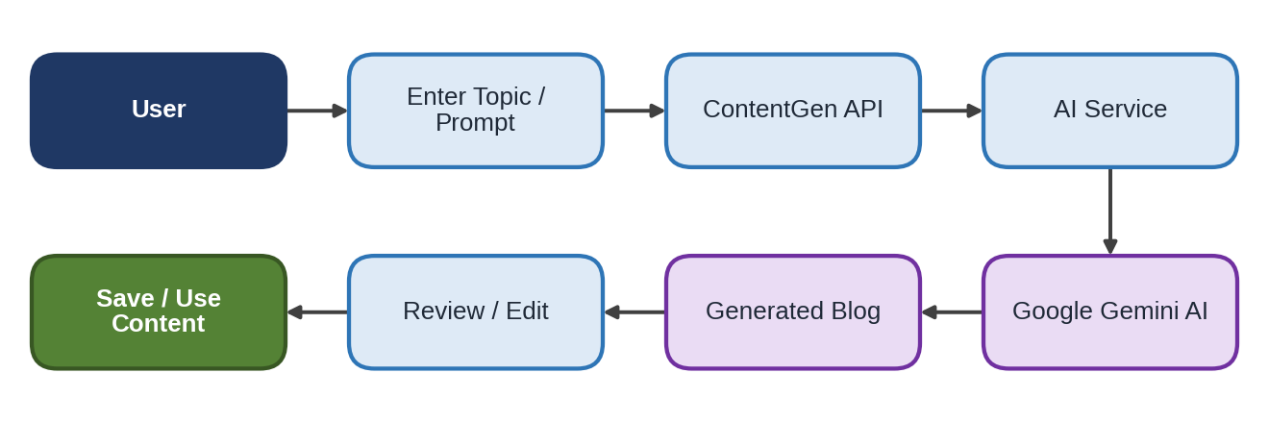
Figure 7: AI-Powered Blog Generation Demonstration
The generated text is a draft. The user reviews and, if necessary, edits it before saving it through the blog management APIs. The generated output will vary between requests, so the demonstration records the actual output produced at the time.

8.10 AI Summarization Demonstration
The summarization demonstration submits an existing blog or article to the summarization API. The ContentGen AI service forwards the content to Google Gemini AI, receives a shorter summary, and returns it to the client as a JSON response.
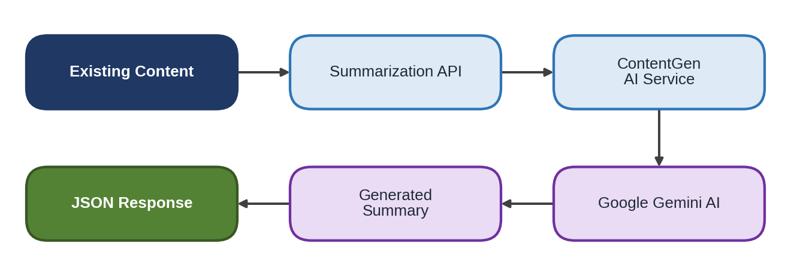
Figure 8: AI Content Summarization Demonstration
This feature helps users understand lengthy content quickly, since they can read a concise summary before deciding whether to read the complete article. During the demonstration, the summary is compared with the original text to show that it reflects the main points.

8.11 Blog Retrieval Demonstration
Blog retrieval is demonstrated by sending GET requests to the blog endpoints. The request is received by an Express route and passed to the controller. The controller queries MongoDB through Mongoose, and the resulting blog data is returned to the client as a JSON response. The demonstration should show retrieval of published or available blog posts as supported by the implemented endpoints.
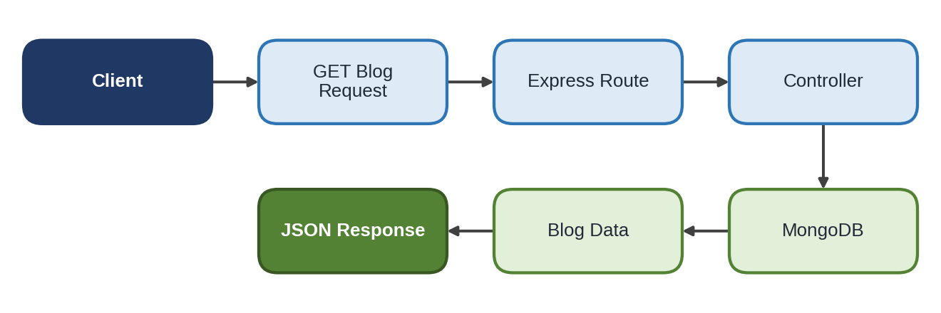
Figure 9: Blog Retrieval Demonstration

8.12 Comment Demonstration
The comment demonstration follows this sequence:
- The Reader authenticates and obtains a JWT.
- The Reader submits a comment on a blog post.
- The backend validates the request.
- The comment is stored in MongoDB.
- Authorized users review and moderate comments.
The moderation states used during the demonstration are Pending, Approved, and Spam. A newly submitted comment can be shown in the moderation queue, and an authorized user can then change its state. No moderation functionality beyond the implemented states is presented.
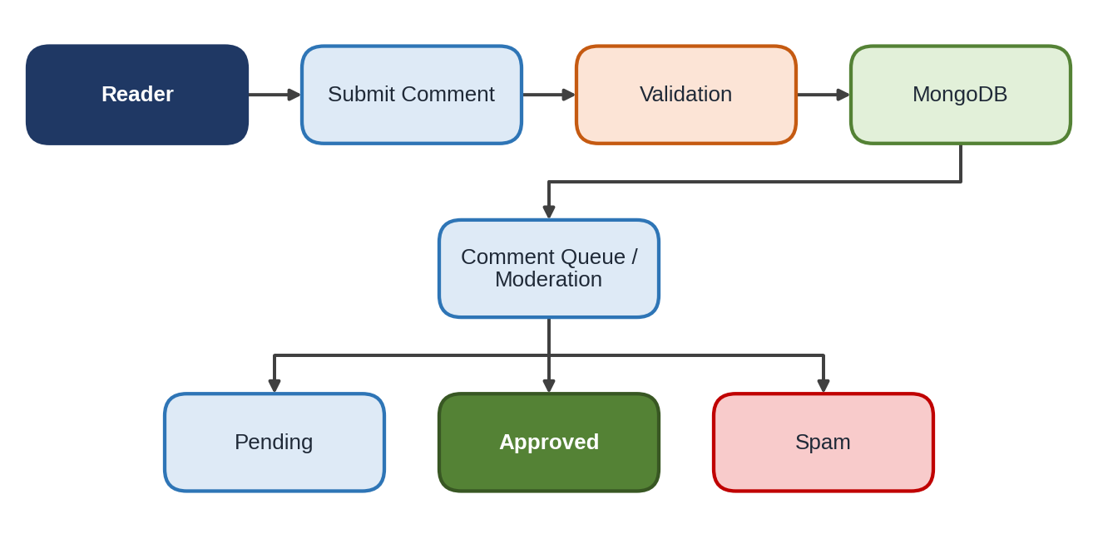
Figure 10: Comment Management Demonstration

8.13 Search Demonstration
The search functionality is demonstrated by sending a request that contains a search term to the search API. The backend applies its search logic, queries MongoDB, and returns the matching blog posts as a JSON response. The evaluator can check that returned posts relate to the term and that a term with no matches returns an appropriate result.
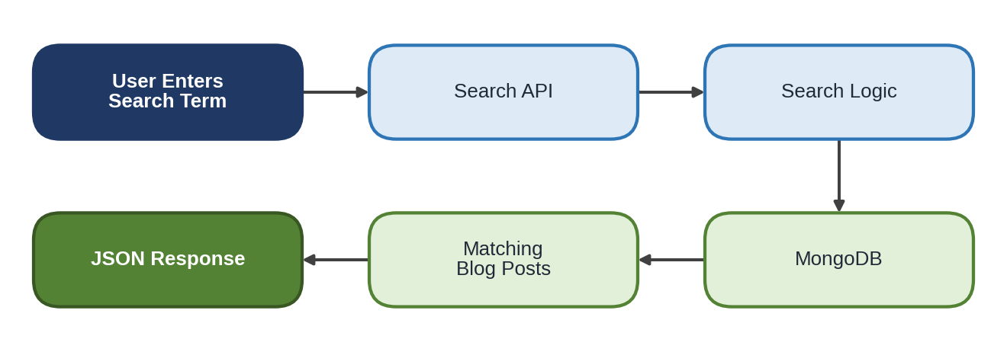
Figure 11: Blog Search Demonstration

8.14 Postman API Testing Demonstration
Postman or Thunder Client is the main tool of the demonstration. It is used to build HTTP requests, set request bodies and headers (including the JWT), send the requests to the ContentGen REST API, and inspect the responses. Table 8.4 lists the API testing categories.
Table 8.4: API Testing Categories
Category | Operations Tested
Authentication APIs | Registration; Login
Blog APIs | Create; Retrieve; Update/manage
AI APIs | Generate blog; Summarize content
Comment APIs | Create; Retrieve/manage

The actual endpoints demonstrated should be those implemented in the backend, as defined in its route files.
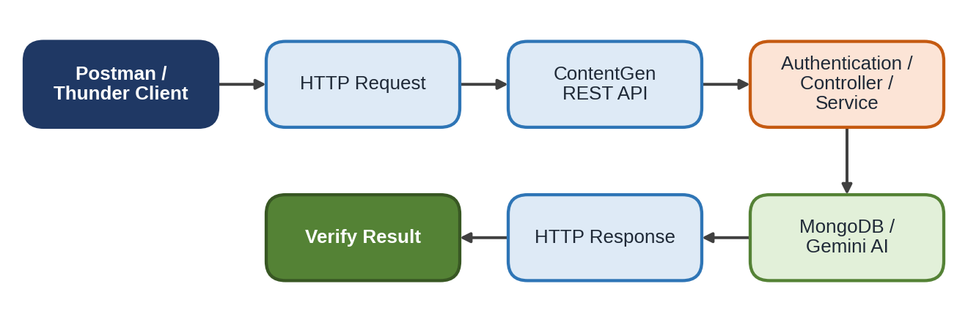
Figure 12: API Testing Demonstration Flow

8.15 Database Demonstration
The database demonstration shows how API operations change the data stored in MongoDB. Requests reach the database through Mongoose models, and the results can be viewed in a MongoDB client or shell. The data categories shown are:
- Users: created by registration, with hashed passwords and roles;
- Posts: created and updated through the blog APIs;
- Comments: created through the comment APIs and carrying a moderation state;
- Categories and Tags: used to organize blog posts.
The recommended method is to view the relevant collection before an API call, send the request, and then view the collection again to confirm the change.
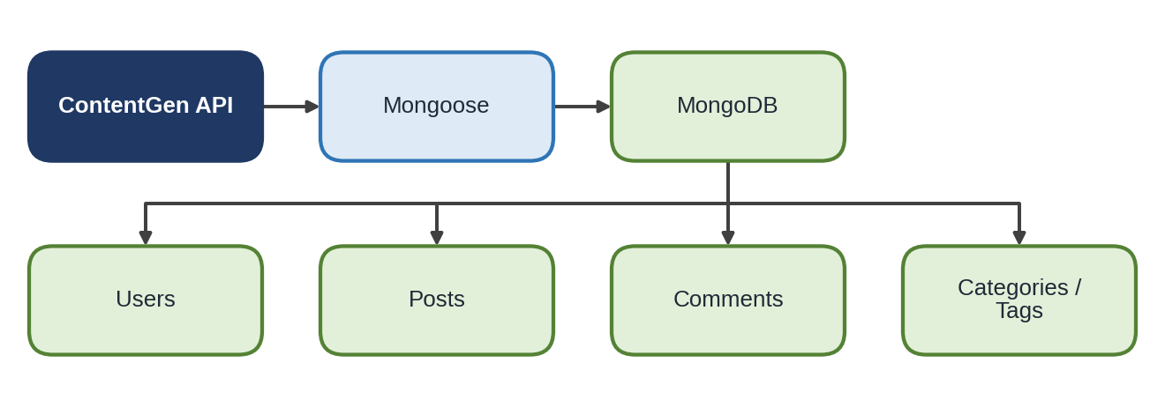
Figure 13: MongoDB Database Demonstration

8.16 Security Demonstration
The security demonstration shows that protected operations are available only to authorized users. The following mechanisms are shown, to the extent they are implemented in the backend:
- Password hashing: stored passwords are hashes, not plain text;
- JWT authentication: requests carry a token that is verified;
- Protected routes: requests without a valid token are rejected;
- Role-based authorization: requests from an unpermitted role are denied;
- Input validation and input sanitization: invalid or unsafe input is checked before processing;
- Rate limiting: repeated requests are restricted;
- Error handling: failures return controlled error responses without exposing internal details.
A typical scenario is an unauthorized request: a request is sent without a token, or with a token whose role does not permit the operation. The JWT or role check fails, and access is denied.
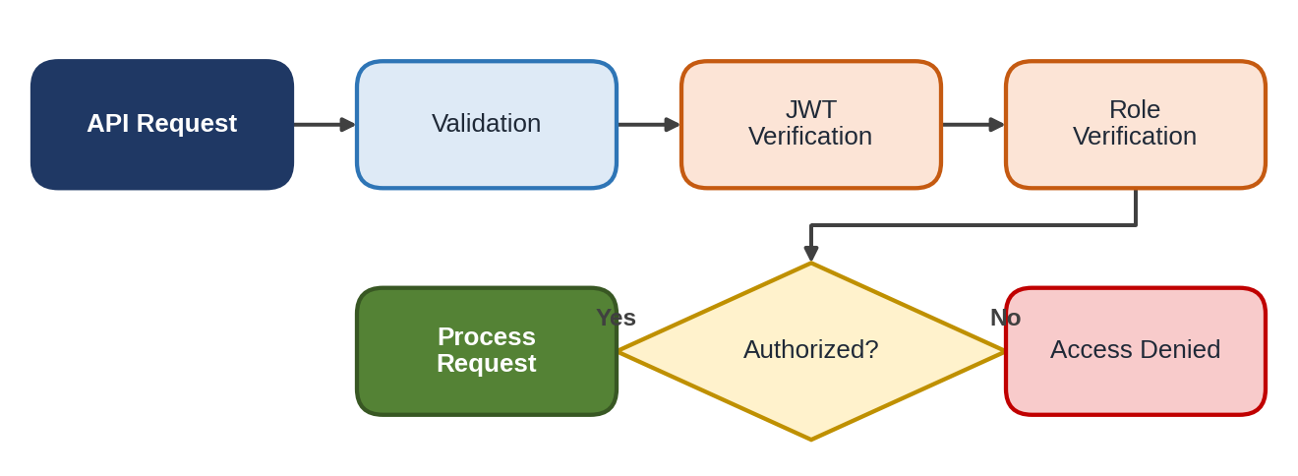
Figure 14: Security Verification Demonstration

8.17 Complete End-to-End Demonstration
The final scenario combines all the features into one workflow. A user registers and logs in, and receives a JWT. The user then creates or generates a blog; when the AI feature is used, Google Gemini AI produces the content. The content is reviewed and saved, then retrieved through the blog APIs. A Reader views the blog and adds a comment, which goes through moderation. The final result is published content with an approved comment.
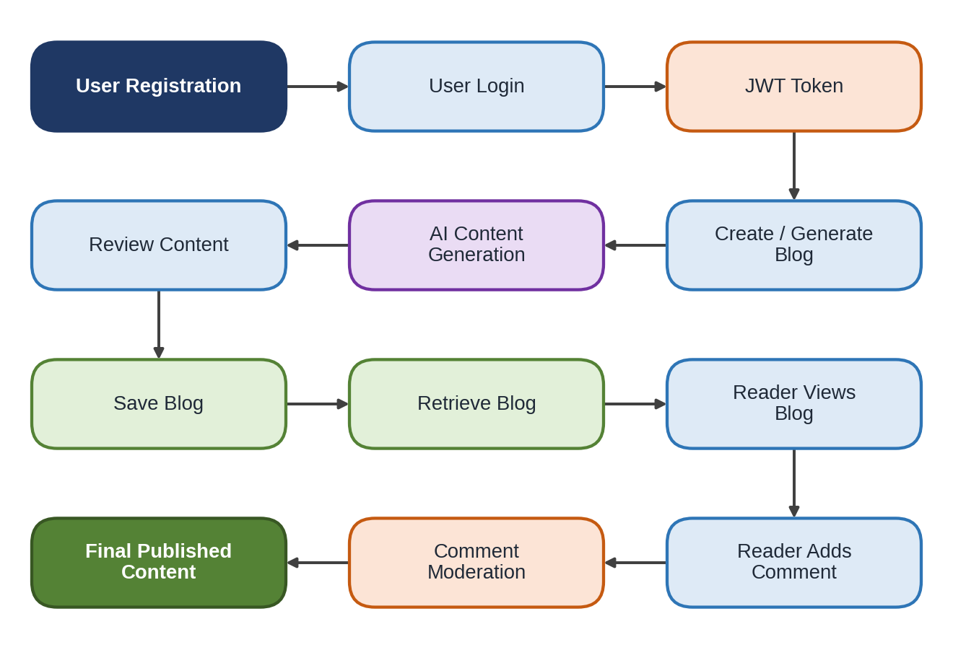
Figure 15: Complete ContentGen End-to-End Demonstration
This sequence represents the complete ContentGen workflow and shows authentication, authorization, AI integration, database storage, and content management working together.

8.18 Demonstration Checklist
Table 8.5 is a demonstration checklist template. The status column is to be completed only after each item has actually been verified; it does not claim that any item has already been tested.
Table 8.5: Demonstration Checklist (Template)
S.No. | Demonstration Item | Verification | Status
1 | Backend Server | Server starts successfully | ☐
2 | MongoDB | Database connection verified | ☐
3 | Registration | User registration tested | ☐
4 | Login | Authentication tested | ☐
5 | JWT | Protected API tested | ☐
6 | Role Authorization | Role permissions tested | ☐
7 | Blog Management | Blog operations tested | ☐
8 | AI Generation | AI blog generation tested | ☐
9 | AI Summarization | Summary generation tested | ☐
10 | Comments | Comment functionality tested | ☐
11 | Search | Search functionality tested | ☐
12 | Security | Protected access tested | ☐
13 | API Testing | Postman/Thunder Client tested | ☐

8.19 Demonstration Results
Results should be recorded from the actual demonstration, using real screenshots and observed outputs. No response codes or test outcomes should be written unless observed. The following should be recorded:
- Successful API responses;
- Database operations;
- Authentication results;
- Authorization results, including rejected requests;
- AI-generated content;
- AI-generated summaries;
- Comment operations;
- Search results;
- Error handling behavior.
[Insert Screenshot – User Registration API]
[Insert Screenshot – Login API]
[Insert Screenshot – AI Blog Generation]
[Insert Screenshot – AI Summarization]
[Insert Screenshot – MongoDB Data]
[Insert Screenshot – Postman Testing]

8.20 Demo Video and Code Submission
The resources submitted along with the demonstration are listed in Table 8.6. The links are to be filled in by the project team.
Table 8.6: Project Submission Resources
Resource | Link
Demo Video | [Insert Demo Video Link]
API Testing Video | [Insert API Testing Video Link]
Source Code / CodeDrive | [Insert Repository or CodeDrive Link]

8.21 Conclusion
The Project Demonstration Phase presents the working features of ContentGen and validates the implemented workflow, from registration and login through blog creation, AI generation and summarization, retrieval, search, and comment moderation. By showing the server, the API tests, the database records, and the security checks, it gives evaluators a clear understanding of the backend, the database, the AI integration, the security measures, and the REST API functionality of the system.

