7. PROJECT DOCUMENTATION PHASE
ContentGen – Generate High-Quality Blog Content Using AI
B.Sc. Computer Science – Final Year Project Report

7.1 Introduction
The Project Documentation Phase is the stage of the software development life cycle in which all information produced while building a system is organised, recorded and presented in a structured form. For ContentGen – Generate High-Quality Blog Content Using AI, this phase consolidates the technical knowledge of an AI-powered Blog Content Management System (the BlogNest backend) developed using Node.js, Express.js, MongoDB, Mongoose, Google Gemini AI, JWT authentication, bcrypt.js and REST APIs, structured according to the MVC architecture and tested with Postman/Thunder Client.
Documentation converts design decisions, source code and testing activities into a permanent reference. In the ContentGen project it serves the following purposes:
- Records the complete development process – from the initial idea to the final demonstration.
- Improves understanding and maintainability – clear records make the system easier to read, correct and update.
- Supports future enhancements – new features can be planned using the documented architecture and database design.
- Helps developers and evaluators – both can understand how the system is organised and how it works.
- Preserves technical knowledge – implementation details remain available even when the original developer is no longer working on the project.
- Assists testing and deployment – documented APIs and setup steps make verification and installation straightforward.
Documentation for ContentGen is not prepared only at the end of the project. It is developed throughout the life cycle: requirements are recorded during analysis, design decisions during architecture planning, code and API details during development, and observations during testing. These records are finally consolidated in this phase. Figure 1 shows the documentation life cycle followed for the project.
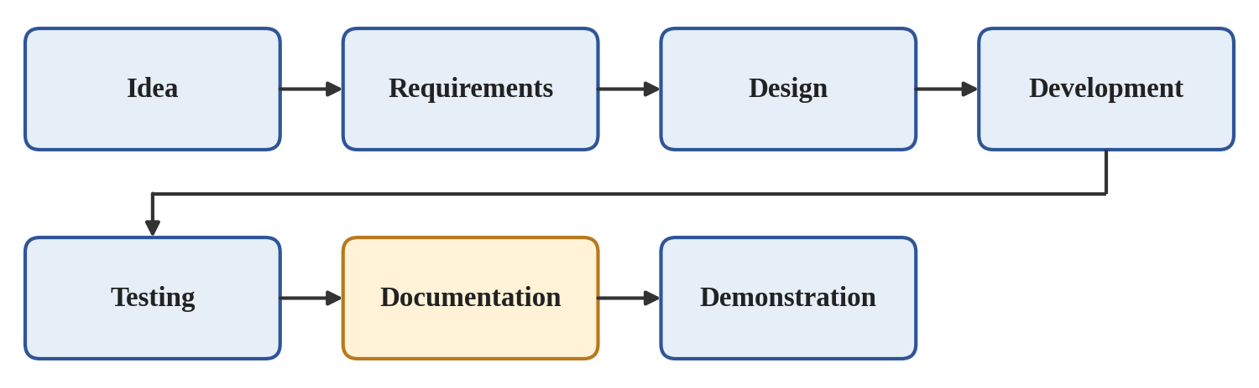
Figure 1: ContentGen Documentation Life Cycle

7.2 Objectives of Documentation
The main objectives of the documentation phase for ContentGen are as follows:
- Document project requirements – capture the functional and non-functional needs of the system.
- Document system architecture – describe the layers and components and how they interact.
- Document database design – describe the MongoDB collections, fields and relationships.
- Document APIs – describe the REST API categories and example endpoints.
- Document authentication mechanisms – explain registration, password hashing, login and JWT-based access control.
- Document AI integration – explain how Google Gemini AI is used for blog generation and summarization.
- Document testing activities – record test types, test cases, results and defect handling.
- Record deployment and setup instructions – provide the steps to install, configure and run the project.
- Support future maintenance – give maintainers the information needed to extend or correct the system.

7.3 Types of Documentation
Several categories of documentation are prepared for ContentGen, each addressing a different purpose and audience.

7.3.1 Requirement Documentation
Describes what the system must achieve. Functional requirements cover the services offered to users, such as registration and login, blog management, AI-assisted blog generation and summarization, commenting and searching. Non-functional requirements cover qualities such as security and maintainability.

7.3.2 Design Documentation
Explains how the requirements are realised. It includes the architecture design, the MVC structure that separates models, controllers and routes, and the database design of the MongoDB collections.

7.3.3 Technical Documentation
Records the source code structure, the API documentation describing the endpoints and their purposes, and the configuration details required to run the application.

7.3.4 User Documentation
Provides usage instructions for the different types of users and API usage guidelines explaining how to send requests and interpret responses using tools such as Postman.

7.3.5 Testing Documentation
Contains test cases, their results and defect tracking records showing how issues were identified, fixed and retested.

7.3.6 Demonstration Documentation
Includes screenshots, demo steps and presentation materials used to present the working project to evaluators. Figure 2 summarises the documentation categories.
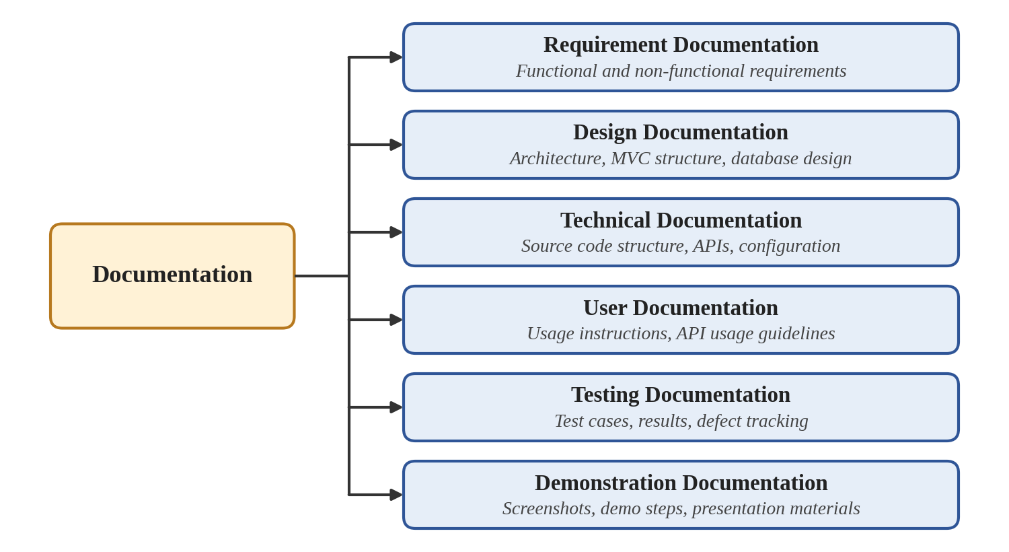
Figure 2: Types of Documentation

7.4 Project Structure Documentation
ContentGen follows a modular folder organisation in which each folder has a single responsibility. This separation of concerns keeps the code readable and simplifies maintenance. Figure 3 shows the backend structure, and Table 1 explains the purpose of each folder and file.
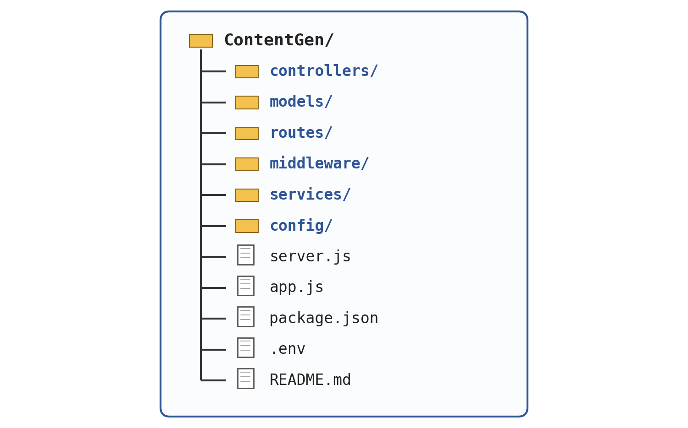
Figure 3: ContentGen Project Structure
Table 1: Purpose of Project Folders and Files
Folder / File | Purpose
controllers/ | Contains the functions that receive requests, apply business logic and return responses.
models/ | Defines the Mongoose schemas for the User, Post and Comment collections.
routes/ | Maps API endpoints to the corresponding controller functions.
middleware/ | Holds reusable functions executed before controllers, such as authentication, authorization and validation.
services/ | Contains service logic, such as communication with Google Gemini AI, kept separate from controllers.
config/ | Stores configuration setup, such as the database connection.
server.js | Entry point that starts the server.
app.js | Creates and configures the Express application, including middleware and routes.
package.json | Lists the project dependencies and scripts.
.env | Holds environment-specific configuration values; it must not be shared publicly.
README.md | Provides an overview of the project and its setup instructions.

7.5 System Architecture Documentation
ContentGen follows a layered architecture in which every request passes through a defined sequence of layers before a response is returned (Figure 4). The role of each layer is as follows:
- Client / Postman – sends HTTP requests to the API and receives JSON responses.
- Express.js API – receives requests and routes them to the appropriate handlers.
- Middleware – processes requests before controllers, for example authentication, validation and authorization checks.
- Controllers – implement request handling and business logic.
- Services – encapsulate reusable operations such as database access and communication with Google Gemini AI.
- MongoDB / Google Gemini AI – MongoDB stores application data through Mongoose, while Gemini AI generates and summarizes blog content.
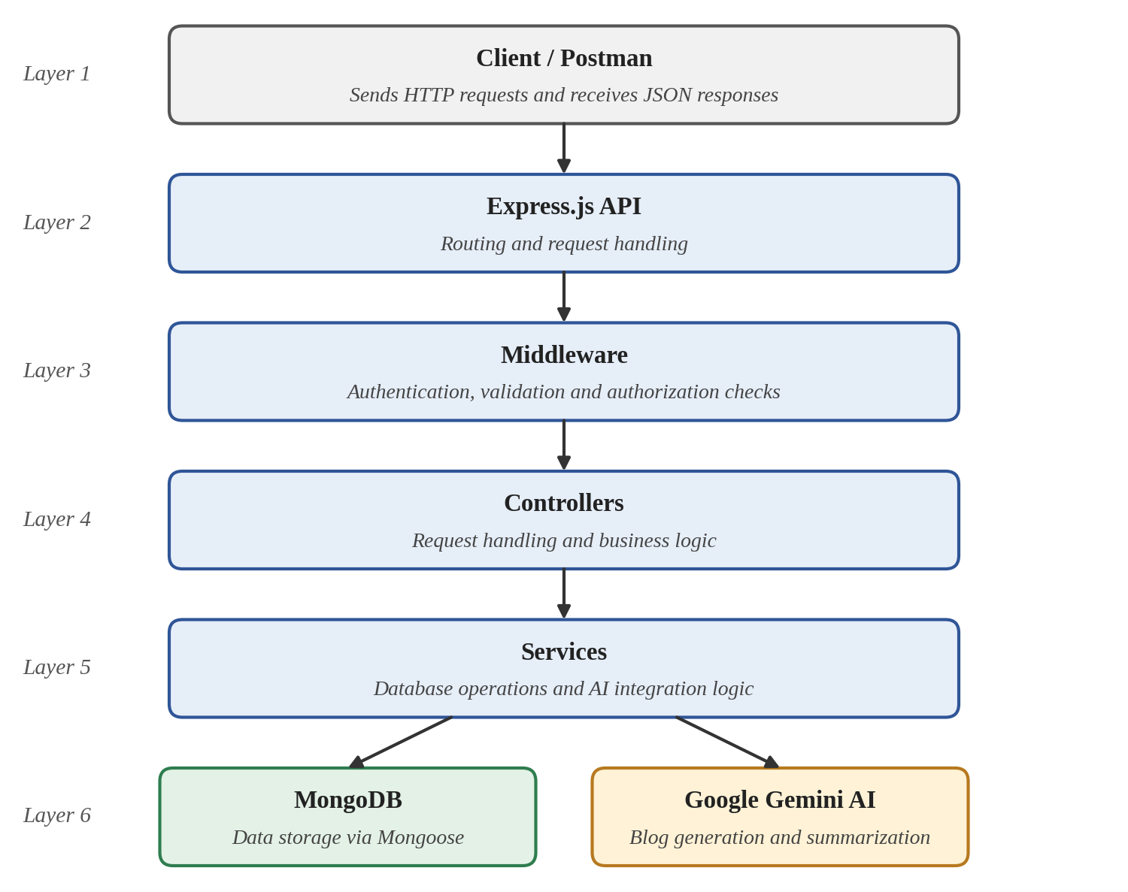
Figure 4: ContentGen Architecture Documentation

7.6 MVC Documentation
ContentGen applies the Model–View–Controller (MVC) pattern to separate data, logic and request handling.

7.6.1 Model Layer
Defines the structure of the stored data using Mongoose schemas. The project contains the User, Post and Comment models.

7.6.2 Controller Layer
Handles incoming requests, applies business logic, interacts with the models and services, and prepares the response.

7.6.3 API / View Layer
As ContentGen is a backend system, the view layer is represented by REST APIs that return data as JSON instead of rendered pages. Figure 5 shows how these layers work together.
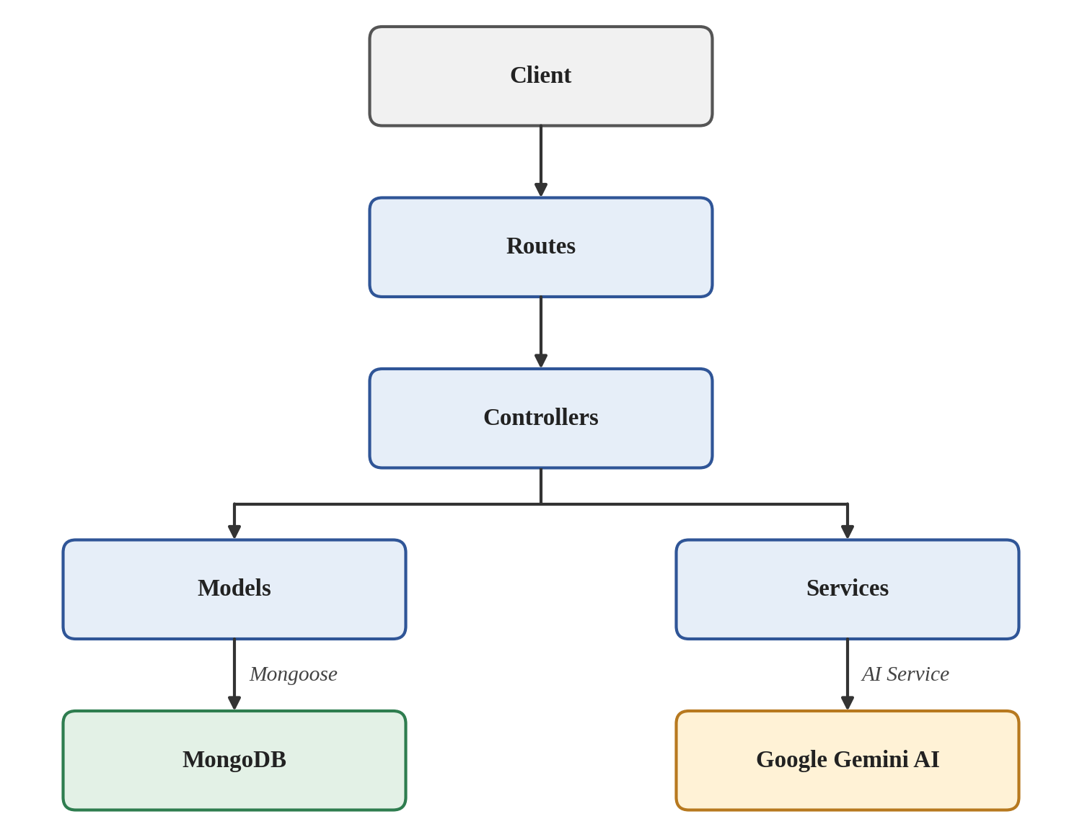
Figure 5: MVC Documentation

7.7 Database Documentation
ContentGen stores its data in MongoDB and accesses it through Mongoose. The three collections are described in Table 2.
Table 2: MongoDB Collections
Collection | Fields | Description
User | _id, name, email, password, role | Stores registered user details. The password is stored in hashed form and the role is used for access control.
Post | _id, userID, title / name, message, photo, likes | Stores blog posts. The userID field refers to the user who created the post.
Comment | user (reference), post (reference), content | Stores comments, linking a user to a post.

The relationships between the collections are:
- User → Posts – one user can create many posts.
- User → Comments – one user can write many comments.
- Post → Comments – one post can have many comments.
These one-to-many (1:N) relationships are shown in the ER diagram in Figure 6.
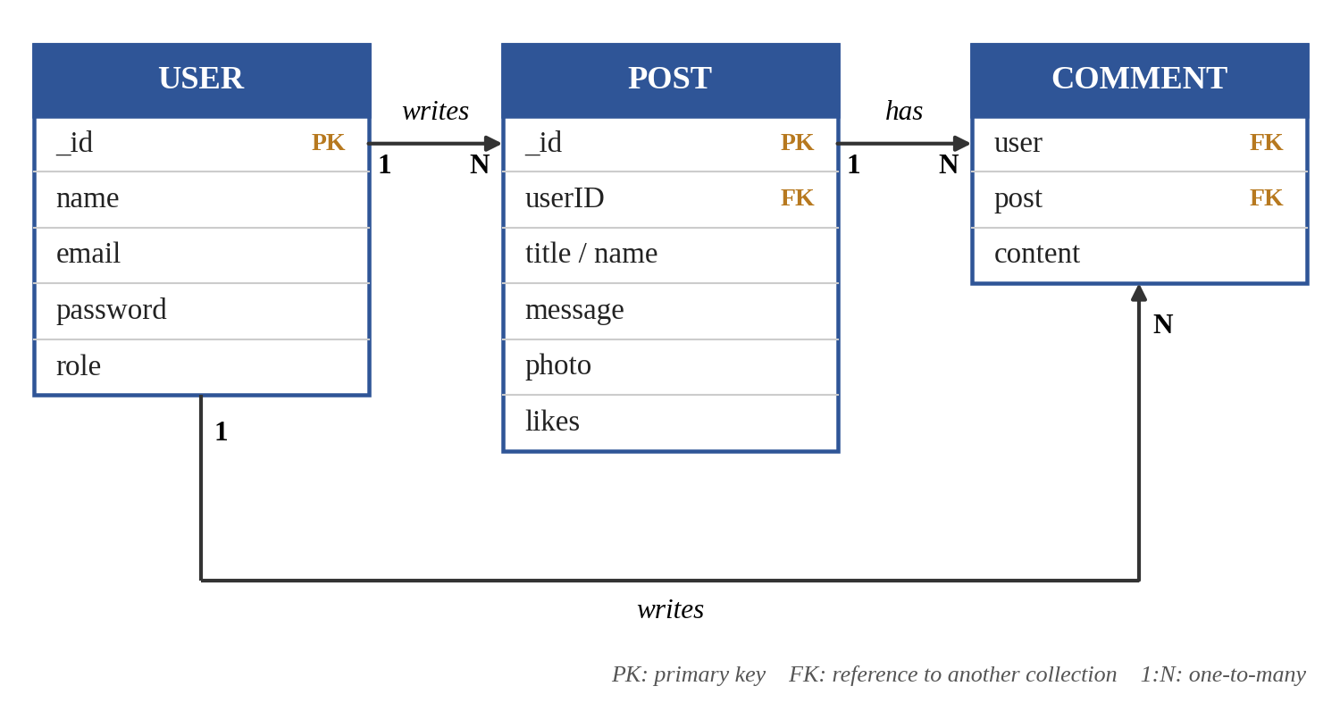
Figure 6: Database Documentation ER Diagram

7.8 API Documentation
The REST APIs of ContentGen are grouped by function. Table 3 lists the categories and gives example endpoints where they are defined for the project.
Table 3: API Categories
API Category | Purpose | Example Endpoint(s)
Authentication APIs | Registration and login | /api/auth/register, /api/auth/login
Blog APIs | Blog management | /api/blogs
AI APIs | Blog generation and summarization | /api/ai/generate-blog, /api/ai/summarize
Comment APIs | Comment management | [Insert Endpoint Here]
Search APIs | Search operations | [Insert Endpoint Here]

Requests are sent from Postman or Thunder Client to the REST API and processed by the controllers, which read or write data in MongoDB or call Gemini AI. A JSON response is then returned to the client, as shown in Figure 7.
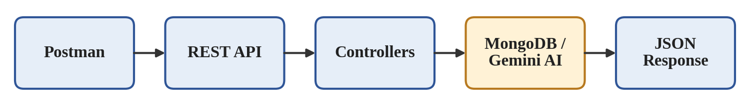
Figure 7: API Documentation Flow
[Insert API Example Here]

7.9 Authentication Documentation
Authentication in ContentGen is based on JSON Web Tokens (JWT) and password hashing with bcrypt.js. The documented process is:
- Registration – a new user submits their details, which are saved to the User collection.
- Password hashing – bcrypt.js converts the password into a hash before storage, so the plain password is not stored.
- Login – the user submits credentials, and the entered password is compared with the stored hash.
- JWT generation – after successful verification, the server issues a signed token.
- JWT verification – for later requests, the token supplied by the client is verified by the server.
- Protected routes – only requests carrying a valid token can access protected APIs.
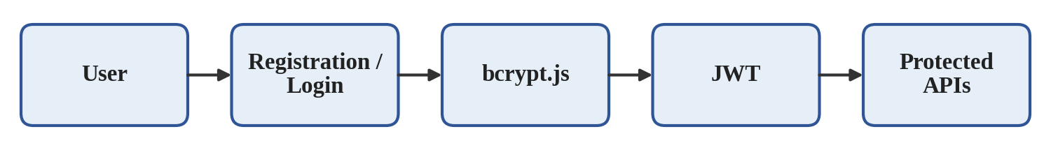
Figure 8: Authentication Documentation

7.10 AI Integration Documentation
ContentGen integrates Google Gemini AI to assist with blog creation. Two AI workflows are documented, as shown in Figure 9.

7.10.1 AI Blog Generation
The user provides a topic to ContentGen, which forwards it to Gemini AI. The generated blog content is returned in the API response (for example through /api/ai/generate-blog).

7.10.2 AI Summarization
The content of a blog is sent to Gemini AI, which returns a shorter summary (for example through /api/ai/summarize).
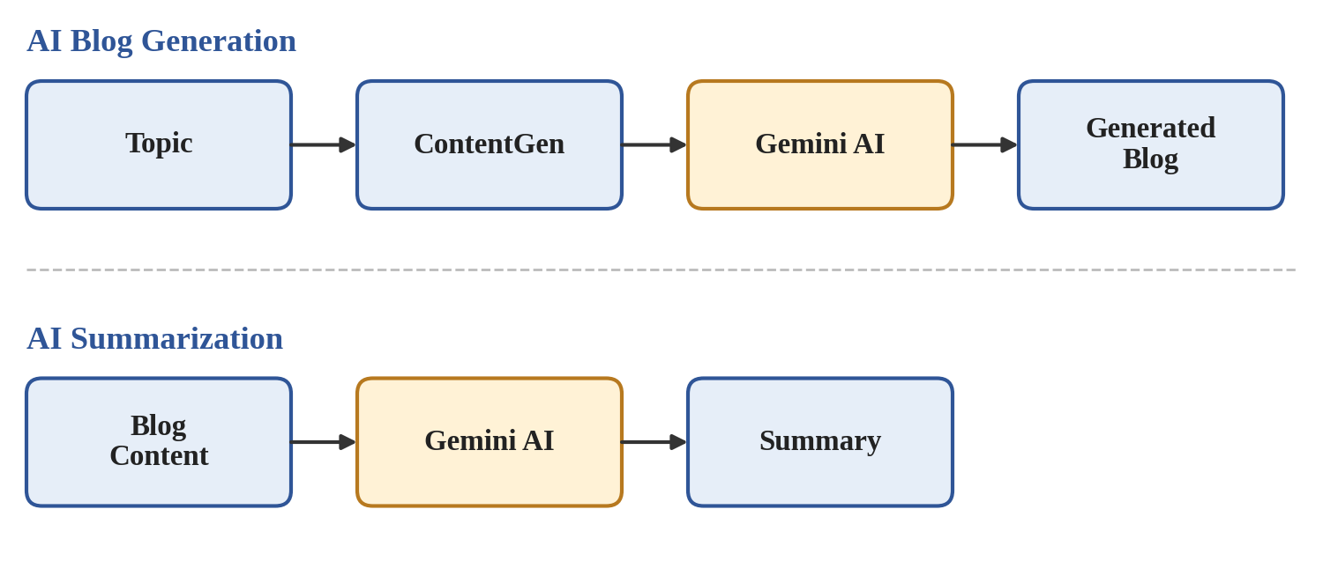
Figure 9: AI Integration Documentation

7.11 Setup and Installation Documentation
The following steps describe how to set up and run ContentGen:
- Install Node.js – install Node.js and npm on the system.
- Install dependencies – run the following command in the project folder:
npm install
- Configure environment variables – create a .env file and add the configuration values required by the project. Secret values must never be shared publicly.
[Insert Configuration Details Here]
- Connect MongoDB – provide the MongoDB connection details in the configuration so that the application can connect to the database.
- Configure Gemini API – add the Google Gemini API credential to the configuration to enable the AI features.
- Start the server – run the following command:
npm start
- Test the APIs – use Postman or Thunder Client to send requests to the endpoints and verify the responses.
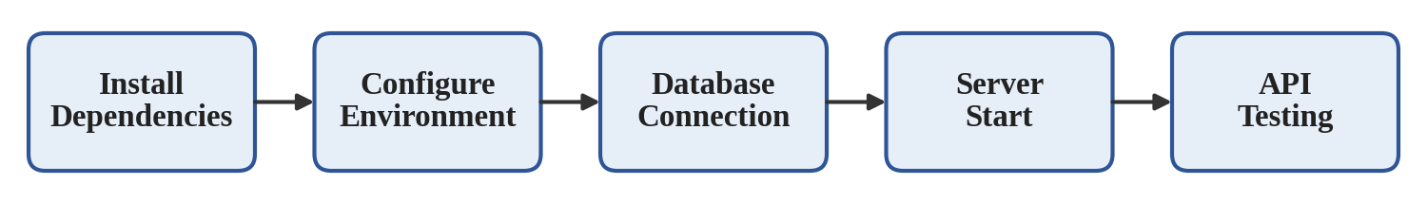
Figure 10: Setup and Installation Process

7.12 Testing Documentation
Testing activities are documented so that the behaviour of ContentGen can be verified and repeated. Table 4 lists the testing areas and the focus of their documentation.
Table 4: Testing Areas
Testing Type | Documentation Focus
Functional testing | Verifies that features such as blog management and comments behave as specified.
API testing | Verifies the requests and JSON responses of the REST endpoints using Postman/Thunder Client.
Authentication testing | Verifies registration, login, JWT issuing and access to protected routes.
AI testing | Verifies blog generation and summarization through Gemini AI.
Database testing | Verifies that data is stored and retrieved correctly in MongoDB.
Security testing | Verifies password hashing, token verification and role-based access restrictions.

[Insert Test Case Table]
[Insert Postman Screenshot]
[Insert Test Result Here]
Each test is executed, its results are recorded, any defects are fixed and the test is repeated, as shown in Figure 11.
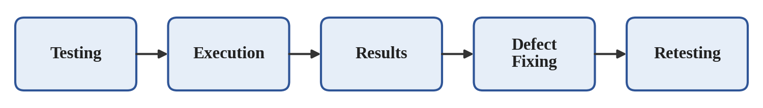
Figure 11: Testing Documentation Process

7.13 User Guide Documentation
Users interact with ContentGen according to their roles. After authentication, the system identifies the user’s role and makes the corresponding features available (Figure 12). Table 5 summarises the interaction of each role.
Table 5: User Roles and Interactions
Role | Interaction with the System
Admin | Manages users and manages roles.
Editor | Reviews content.
Author | Creates blogs and generates AI content.
Reader | Reads blogs and comments.

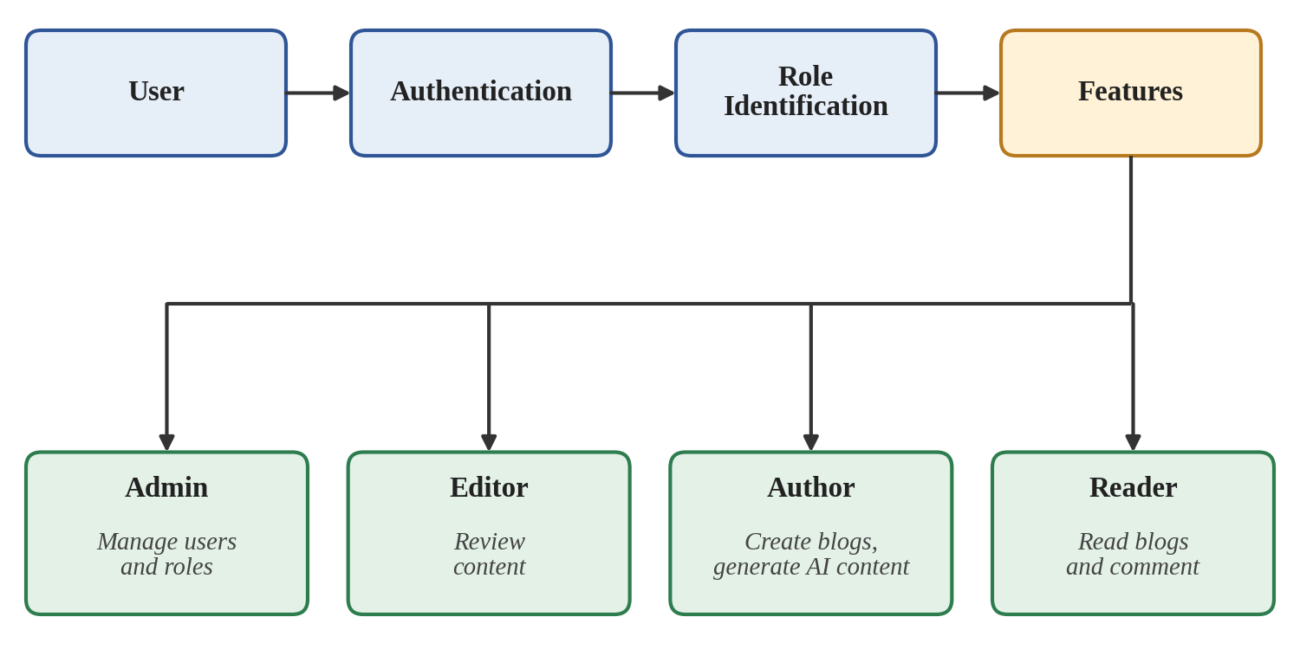
Figure 12: User Interaction Documentation

7.14 Security Documentation
Security documentation describes the measures used to protect ContentGen data and APIs:
- JWT – tokens identify authenticated users and protect restricted routes.
- bcrypt.js – passwords are hashed before they are stored.
- Validation – incoming data is checked before it is processed.
- Sanitization – input is cleaned to reduce the risk of harmful data entering the system.
- Rate limiting – restricts the number of requests to reduce misuse of the APIs.
- Role-based authorization – access to features is restricted according to the user’s role.
Figure 13 shows the order in which a request is checked before it reaches the database.
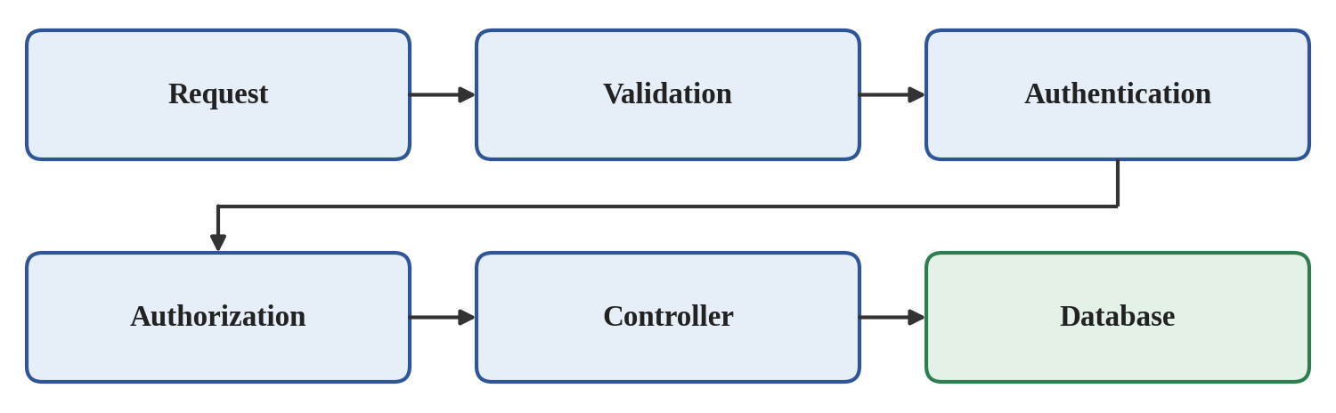
Figure 13: Security Documentation

7.15 Documentation Standards
To keep the report consistent and professional, the following standards are followed:
- Consistent formatting – the same font, spacing and alignment are used throughout.
- Proper headings – numbered headings and subheadings organise the content.
- Diagrams – diagrams explain architecture, workflows and relationships visually.
- Tables – tables present structured information such as APIs and collections.
- Figure numbering – every figure and table is numbered and captioned.
- Version control – changes to code and documents are tracked so that earlier versions can be reviewed.
- Clear technical writing – simple, precise language is used to describe technical details.

7.16 Future Maintenance Documentation
Well-maintained documentation reduces the effort needed to modify ContentGen. It supports the following future work:
- New APIs – the project structure and API documentation show where new routes and controllers belong.
- New AI features – the AI integration documentation explains how the service layer communicates with Gemini AI.
- Additional user roles – the authentication and user guide documentation show how roles are identified and used.
- Database changes – the database documentation identifies the collections and relationships affected by a change.
- Security improvements – the security documentation records the existing measures that can be strengthened.
The documentation should be updated whenever the system is changed so that it remains accurate.

7.17 Documentation Deliverables
The Project Documentation Phase of ContentGen produces the following deliverables (Figure 14):
- Project Report
- Architecture Diagrams
- ER Diagram
- API Documentation
- Test Documentation
- Screenshots
- Demo Documentation
- Source Code Documentation
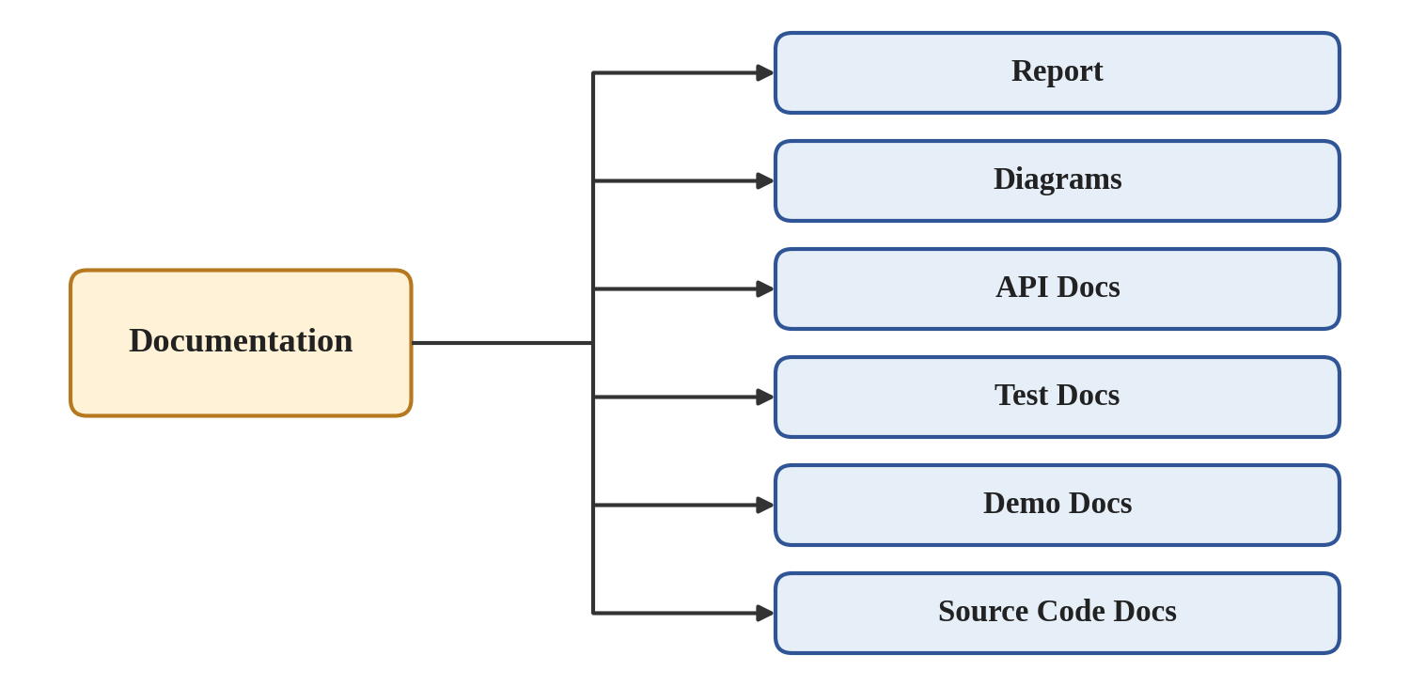
Figure 14: Documentation Deliverables
[Insert Screenshot Here]

7.18 Conclusion
The Project Documentation Phase provides a complete record of the ContentGen project, from requirements and design to implementation, testing and demonstration. Proper documentation preserves technical knowledge, improves maintainability, supports future development and helps developers and evaluators understand the architecture, database, APIs, authentication and AI integration of the system. ContentGen is therefore not only a working application but also a well-documented project that can be understood, maintained and extended with confidence.

