B.Sc. COMPUTER SCIENCE – PROJECT REPORT
ContentGen – Generate High-Quality Blog Content Using AI
(Also referred to as BlogNest)
Chapter 6: Project Testing Phase
Student Name: [Enter Student Name] Register No.: [Enter Register Number] Guide: [Enter Guide Name]

6. PROJECT TESTING PHASE
This chapter documents the testing phase of ContentGen, an AI-powered blog and content management backend. It describes the objectives, strategy, environment, test cases and procedures used to verify the system. Because the chapter is a test plan and reporting framework, all fields that depend on actual execution (test results, dates, counts and screenshots) are left as clearly marked placeholders, to be completed by the project team after the tests are run.

6.1 Introduction to Testing

6.1.1 Meaning and Purpose of Software Testing
Software testing is the systematic process of executing a software system, or parts of it, with the intention of finding defects and confirming that the system behaves as specified. It compares the actual behavior of the software with the expected behavior defined by the requirements. Testing is performed to identify defects, validate requirements, verify expected behavior, and improve the reliability and security of the software before it is delivered to users.

6.1.2 Importance of Testing in ContentGen
ContentGen (BlogNest) is a backend system developed using Node.js, Express.js, MongoDB, Mongoose, Google Gemini AI, JWT authentication, bcrypt.js and REST APIs. It manages users, roles, blog posts, comments and AI-assisted content operations. Since the backend handles user credentials, controls access through roles, stores content in a database and depends on an external AI service, a defect in any layer can affect data integrity, security or the availability of features. Systematic testing therefore gives confidence that each layer works correctly on its own and in combination with the others.

6.1.3 Testing Objectives
- Identify defects: find errors in logic, data handling and API behavior before deployment.
- Validate requirements: confirm that each specified feature has been implemented.
- Verify expected behavior: check that valid and invalid inputs produce the correct responses.
- Improve reliability: ensure stable behavior under normal and erroneous conditions.
- Improve security: confirm that authentication, authorization and validation mechanisms protect the system.

6.1.4 Why Backend API Testing Is Important
ContentGen exposes its functionality through REST APIs. Every client, whether a frontend application or an API testing tool, interacts with the system only through HTTP requests and responses. Testing the APIs directly, without depending on a user interface, allows the request format, headers, authorization token, status codes and JSON responses to be checked precisely. It also allows failure cases, such as missing parameters or invalid tokens, to be reproduced easily.
The following areas receive particular attention:
- Authentication: ensures that only registered users with valid credentials obtain access, and that passwords are stored securely.
- Authorization: ensures that each role can perform only the operations permitted to it.
- Database operations: ensures that users, blogs and comments are created, retrieved, updated and deleted correctly.
- AI services: ensures that requests to Google Gemini AI are handled correctly and that failures do not crash the backend.
- REST APIs: ensures consistent request handling, status codes and JSON responses.
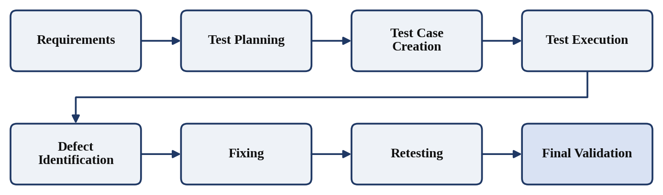
Figure 1: Software Testing Process

6.2 Testing Objectives
The main objectives of testing ContentGen are to verify the following:
- User registration, including valid, incomplete and duplicate registrations.
- Login and JWT authentication.
- Role-based authorization for the Admin, Editor, Author and Reader roles.
- Blog creation, retrieval, updating and deletion.
- AI-powered blog generation using Google Gemini AI.
- AI-powered summarization of content.
- Categories and tags.
- Comment management.
- Search functionality.
- Database operations through MongoDB and Mongoose.
- API request and response handling.
- Input validation.
- Error handling.
- Security mechanisms.

6.3 Testing Strategy
The testing strategy combines several complementary levels and types of testing. Testing begins with individual functions and endpoints and progresses towards complete user workflows, so that defects are detected as early as possible and are easier to locate. The strategy consists of the following activities:
- Requirement-based testing: test cases are derived from the project requirements so that every specified feature is covered.
- Functional testing: each module is tested against its expected inputs and outputs.
- API testing: REST endpoints are exercised using Postman or Thunder Client.
- Authentication testing: registration, login, password hashing and JWT handling are verified.
- Authorization testing: role restrictions are verified for each role.
- Database testing: persistence, references and retrieval in MongoDB are verified.
- AI feature testing: blog generation and summarization through Google Gemini AI are verified.
- Input validation testing: incorrect or malformed input is checked for correct rejection.
- Error handling testing: error conditions are checked for correct status codes and structured responses.
- Security-oriented testing: protective mechanisms are checked against unauthorized or improper requests.
- Integration testing: interaction between routes, middleware, controllers, database and AI service is verified.
- End-to-end testing: a complete user workflow is executed from registration to search.
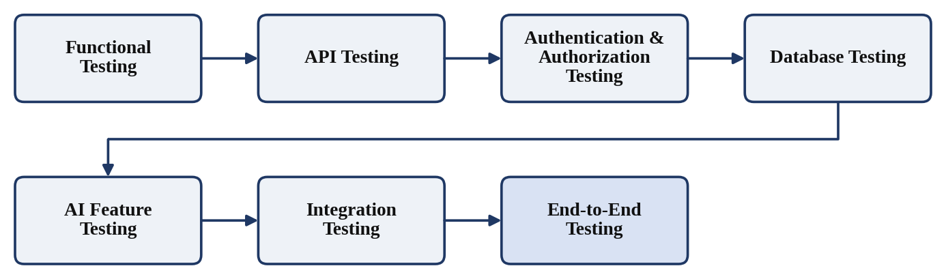
Figure 2: ContentGen Testing Strategy

6.4 Test Environment
The test environment uses only the technologies of the ContentGen project. Specific version numbers are not stated here and may be entered by the project team where required by the institution.
Table 6.1: Test Environment
Component | Testing Environment
Operating System | Windows 10/11 or equivalent development environment
Backend | Node.js
Framework | Express.js
Database | MongoDB
ODM | Mongoose
AI Service | Google Gemini AI
Authentication | JWT
Password Security | bcrypt.js
API Testing | Postman / Thunder Client
Development Tool | Visual Studio Code

6.5 Functional Testing
Functional testing checks that each module behaves according to its requirements. The test cases in Table 6.2 cover registration, login, JWT handling, protected access, role-based access, blog management, AI features, categories and tags, comments, comment moderation and search. Inputs are described in general terms so that the actual data used during execution can be recorded by the tester. The Status column is intentionally left unfilled and must be completed only after the tests have actually been executed.
Table 6.2: Functional Test Cases
Test Case ID | Module | Test Scenario | Input / Condition | Expected Result | Status
TC-01 | Registration | Register with valid details | All required registration details supplied in valid format | User account is created and stored in MongoDB; success response returned | Pass/Fail – to be filled after actual execution
TC-02 | Registration | Register with missing details | One or more required fields omitted | Request rejected with a client error (e.g., 400 Bad Request); no user is stored | Pass/Fail – to be filled after actual execution
TC-03 | Registration | Register with duplicate email | Email address already used by an existing account | Registration rejected; no duplicate user document is created | Pass/Fail – to be filled after actual execution
TC-04 | Authentication | Login with valid credentials | Registered email and correct password | Login succeeds and a JWT is returned | Pass/Fail – to be filled after actual execution
TC-05 | Authentication | Login with invalid credentials | Incorrect password or unregistered email | Login rejected with an authentication error (e.g., 401 Unauthorized); no token issued | Pass/Fail – to be filled after actual execution
TC-06 | Authentication | JWT token generation | Successful login | Token is present in the response and is accepted on protected requests | Pass/Fail – to be filled after actual execution
TC-07 | Protected Access | Access protected API without token | Request sent without authorization token | Request denied (e.g., 401 Unauthorized) | Pass/Fail – to be filled after actual execution
TC-08 | Protected Access | Access protected API with valid token | Valid JWT sent in the request header | Request accepted and processed | Pass/Fail – to be filled after actual execution
TC-09 | Authorization | Role-based access | Token of a user whose role lacks permission for the operation | Request denied (e.g., 403 Forbidden); operation not performed | Pass/Fail – to be filled after actual execution
TC-10 | Blog Management | Create a blog | Authorized user submits valid blog data | Blog is created and stored; success response returned | Pass/Fail – to be filled after actual execution
TC-11 | Blog Management | Retrieve blogs | Request for existing blog records | Blog data returned as a JSON response | Pass/Fail – to be filled after actual execution
TC-12 | Blog Management | Update a blog | Authorized user submits valid changes to an existing blog | Document updated in database; updated data returned | Pass/Fail – to be filled after actual execution
TC-13 | Blog Management | Delete a blog | Authorized user deletes an existing blog | Blog removed; later retrieval does not return it | Pass/Fail – to be filled after actual execution
TC-14 | AI Generation | Generate blog content using AI | Valid prompt submitted | Content generated through Gemini AI and returned in a JSON response | Pass/Fail – to be filled after actual execution
TC-15 | AI Generation | Empty prompt | Empty prompt submitted | Request rejected with a validation error; no AI content returned | Pass/Fail – to be filled after actual execution
TC-16 | AI Summarization | Summarize content using AI | Valid blog content submitted | Summary returned in a JSON response | Pass/Fail – to be filled after actual execution
TC-17 | Categories/Tags | Add categories/tags | Valid category or tag assigned to a blog | Association saved and returned on retrieval | Pass/Fail – to be filled after actual execution
TC-18 | Comments | Add a comment | Authenticated user comments on an existing blog | Comment stored and linked to the user and the blog | Pass/Fail – to be filled after actual execution
TC-19 | Comments | Comment moderation | Authorized role performs a moderation action; unauthorized role attempts the same | Action applied for authorized role; denied for unauthorized role | Pass/Fail – to be filled after actual execution
TC-20 | Search | Search blog content | Keyword present in existing blog content | Matching blogs returned | Pass/Fail – to be filled after actual execution
TC-21 | Search | Search with no matching content | Keyword not present in any blog | Empty result handled without an error | Pass/Fail – to be filled after actual execution

6.6 Unit-Level Testing
Unit testing verifies the smallest testable parts of a program in isolation. In ContentGen, a unit is an individual backend function, such as a validation routine, a controller function or a helper that formats an error. Testing units in isolation makes it easier to locate the cause of a failure, because external dependencies such as the database and the Gemini AI service can be replaced by controlled inputs during the test.
The following backend components are candidates for unit-level testing:
- Authentication functions: password hashing and comparison using bcrypt.js, and JWT creation and verification.
- Validation functions: checks on required fields, formats and data types.
- Controller functions: handling of requests and generation of responses for blogs, comments and users.
- Service functions: business logic separated from the controllers.
- Database interaction functions: create, read, update and delete operations using Mongoose.
- AI-related service functions: preparation of requests to Gemini AI and handling of its responses.
- Utility functions: error handling and security helpers.
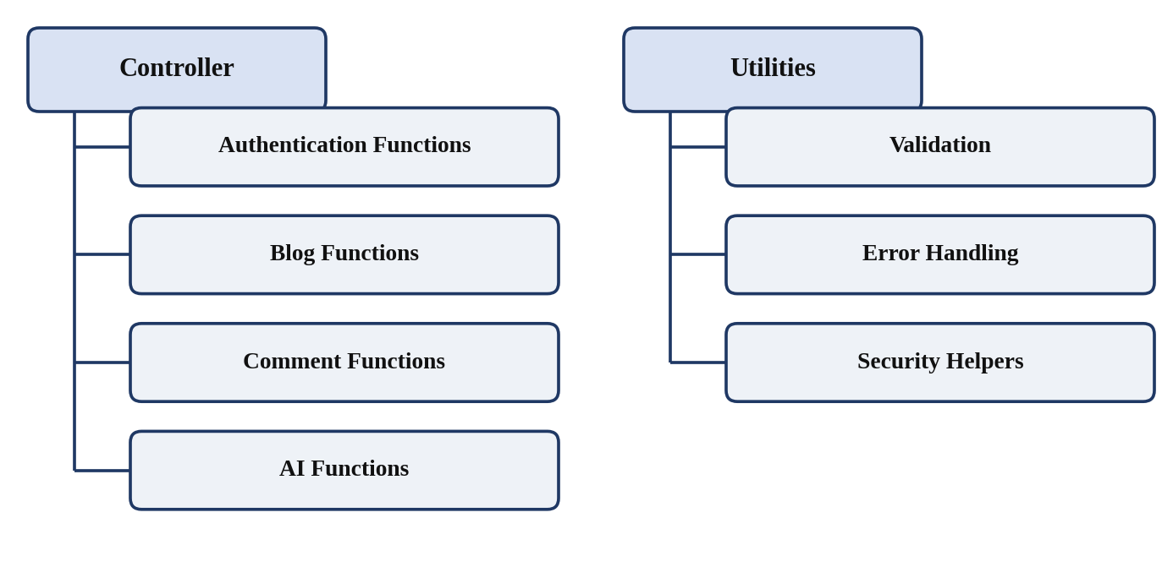
Figure 3: Unit-Level Testing Structure

6.7 API Testing
API testing checks the behavior of the REST interface of ContentGen by sending HTTP requests and examining the responses. Postman or Thunder Client is used to construct each request, send it to the Express.js server and inspect the result. The main elements examined for each request are described below.
- HTTP methods: the method used must match the operation, such as retrieving, creating, updating or deleting data.
- Request body: JSON data sent with requests that create or modify data must be accepted when valid and rejected when invalid.
- Headers: content type and authorization headers must be handled correctly.
- Authorization token: the JWT must be supplied for protected requests and must be verified by the server.
- HTTP status codes: each response must return a status code that matches the outcome.
- JSON responses: the structure and content of response data must be consistent and correct.
- Invalid requests and missing parameters: incomplete or malformed requests must be rejected with a meaningful error.
- Authentication and authorization failures: requests without valid credentials or without sufficient role permission must be denied.
Table 6.3 lists the API categories to be tested. The exact endpoint names must be taken from the project's route definitions and entered during execution.
Table 6.3: API Categories Under Test
API Category | Focus of Testing | Endpoint
Registration API | Valid, incomplete and duplicate registrations | [Enter Endpoint]
Login API | Valid and invalid credentials; token issue | [Enter Endpoint]
Blog CRUD APIs | Create, retrieve, update, delete; authorization | [Enter Endpoint]
AI Generation API | Prompt handling; AI response; failure handling | [Enter Endpoint]
AI Summarization API | Content handling; summary response; failure handling | [Enter Endpoint]
Comment APIs | Adding, retrieving and moderating comments | [Enter Endpoint]
Search APIs | Keyword search; empty and no-match results | [Enter Endpoint]

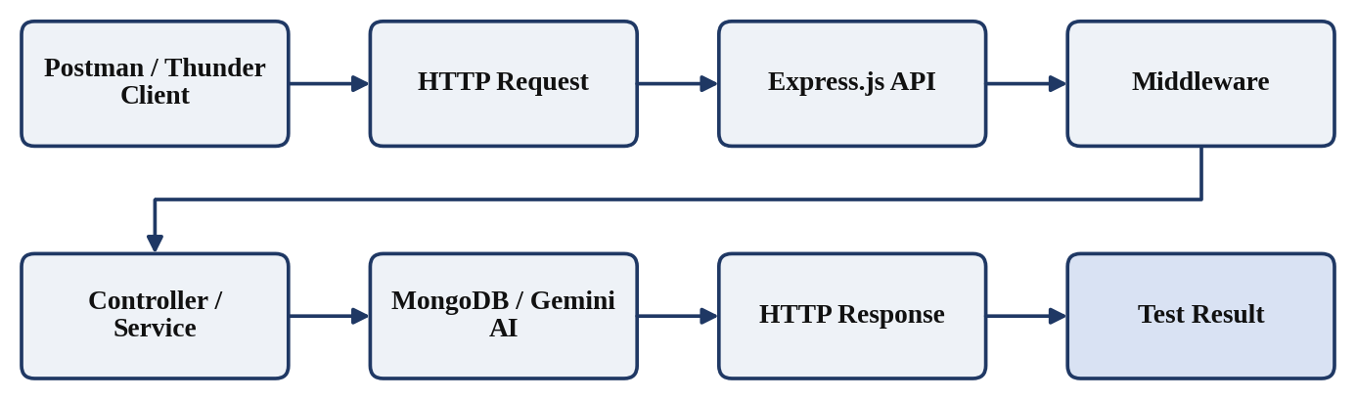
Figure 4: REST API Testing Flow

6.8 Authentication Testing
Authentication testing verifies that the system correctly identifies users and protects restricted resources. The following aspects are tested:
- User registration: valid registration creates a user; invalid or duplicate registration is rejected.
- Password hashing: the stored password in MongoDB must be a hashed value produced by bcrypt.js and not the plain-text password.
- Login: registered users can log in with correct credentials.
- Credential validation: incorrect passwords and unknown users are rejected.
- JWT generation: a token is issued after successful login.
- JWT verification: protected routes accept a valid token.
- Expired or invalid token handling: tampered, malformed or expired tokens are rejected.
- Protected routes: requests without a token or with an invalid token do not reach the controller.
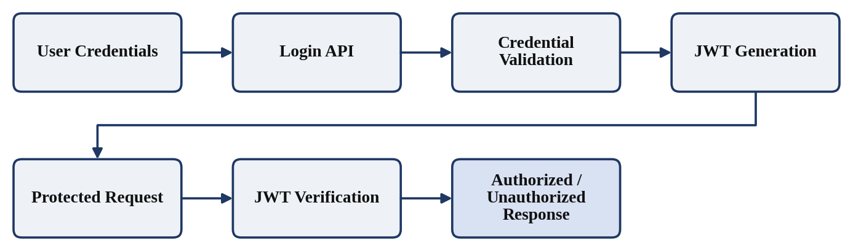
Figure 5: Authentication Testing Flow

6.9 Role-Based Authorization Testing
ContentGen defines four user roles: Admin, Editor, Author and Reader. Authorization testing verifies that each authenticated user can perform only the operations permitted to the assigned role, and that requests outside that permission are denied. For each role, the tester should send permitted requests, which must succeed, and restricted requests, which must be denied. Only the permissions defined in the project are tested.
Table 6.4: Role-Based Authorization Testing
Role | Example Permission | Testing Objective
Admin | User/role/comment management | Verify administrative access
Editor | Review and publishing operations | Verify editorial access
Author | Own blog management | Verify author permissions
Reader | Read published content and comments | Verify reader restrictions

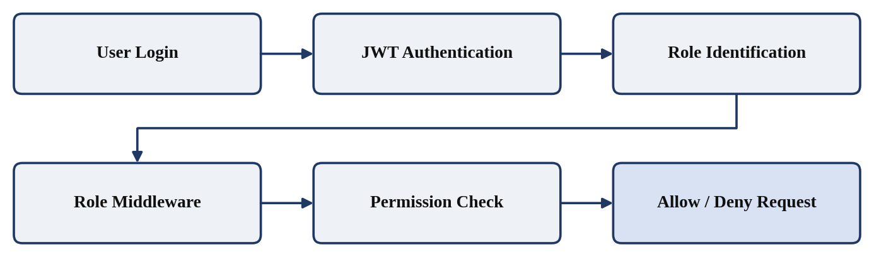
Figure 6: Role-Based Authorization Testing

6.10 Blog Management Testing
Blog management is the core module of ContentGen. A blog moves through the lifecycle Draft, Pending Approval, Scheduled and Published. Testing verifies each operation and each transition of this lifecycle.
- Blog creation: a valid blog is created and saved; missing required fields are rejected.
- Blog editing: permitted users can update a blog and the changes are saved.
- Blog retrieval: stored blogs are returned correctly in JSON format.
- Blog deletion: permitted users can delete a blog, which is then no longer returned.
- Blog status and workflow: status changes follow the lifecycle and are permitted only to the appropriate roles.
- Blog ownership: an author can manage only their own blogs.
- Required fields and invalid data: incomplete or invalid data is rejected with an error.
- Database persistence: the stored blog document reflects each change made through the API.
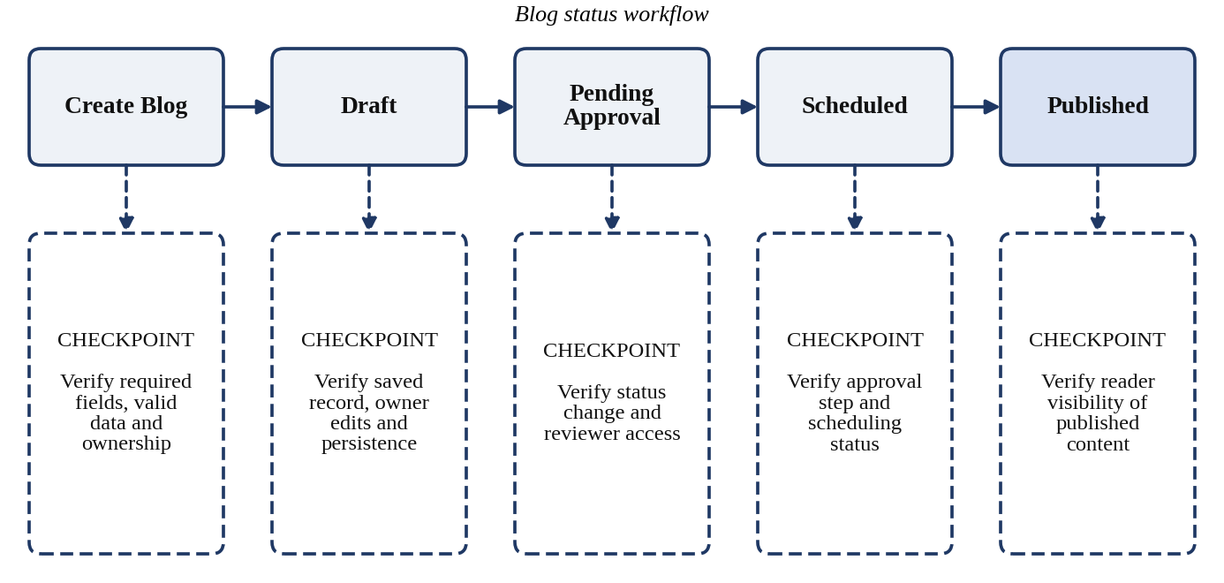
Figure 7: Blog Lifecycle Testing

6.11 AI Feature Testing
ContentGen integrates Google Gemini AI to generate blog content and to summarize content. Because the AI output is produced by an external service, testing focuses on how the backend sends requests, receives responses, handles failures and returns results, rather than on judging the creative quality of the text. AI output should be checked for successful response handling, proper formatting, error handling and integration with the backend.

6.11.1 AI Blog Generation
- Valid prompt: content is generated and returned in a JSON response.
- Empty prompt: request is rejected with a validation error.
- Short prompt: the system handles the request without failure.
- Detailed prompt: the system handles the request and returns a well-formed response.
- Invalid request: malformed or unsupported input is rejected.
- AI service failure: the backend returns a controlled error instead of crashing.
- Unexpected AI response: an empty or improperly formatted response is handled safely.

6.11.2 AI Summarization
- Valid content: a summary is generated and returned.
- Empty content: request is rejected with a validation error.
- Long content: the system handles the input and returns a response or a controlled error.
- Invalid input: unsupported input types are rejected.
- AI service failure: the backend returns a controlled error.
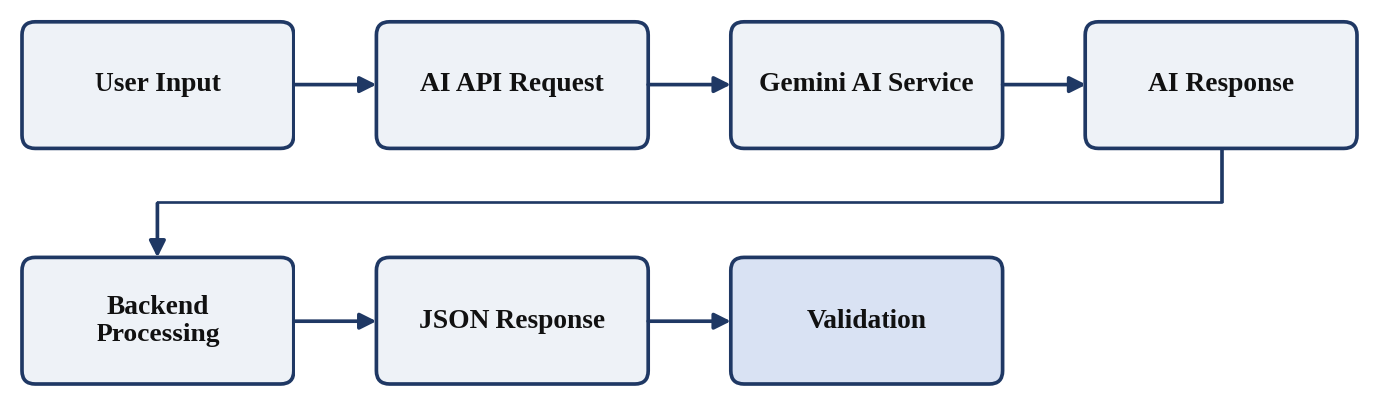
Figure 8: AI Feature Testing Flow

6.12 Database Testing
Database testing verifies that ContentGen stores and retrieves data correctly using MongoDB and Mongoose. The following are tested:
- User document creation.
- Blog (post) document creation.
- Comment document creation.
- Required fields and data validation defined in the Mongoose schemas.
- Relationships and references between documents.
- Updating existing documents.
- Deleting documents.
- Retrieval of stored data.
- Handling of database errors, such as an unavailable connection.
The logical relationships to be validated are: a User can have many Posts (User → Posts), a User can write many Comments (User → Comments), and a Post can have many Comments (Post → Comments). Tests confirm that each Post and Comment correctly references its related documents.
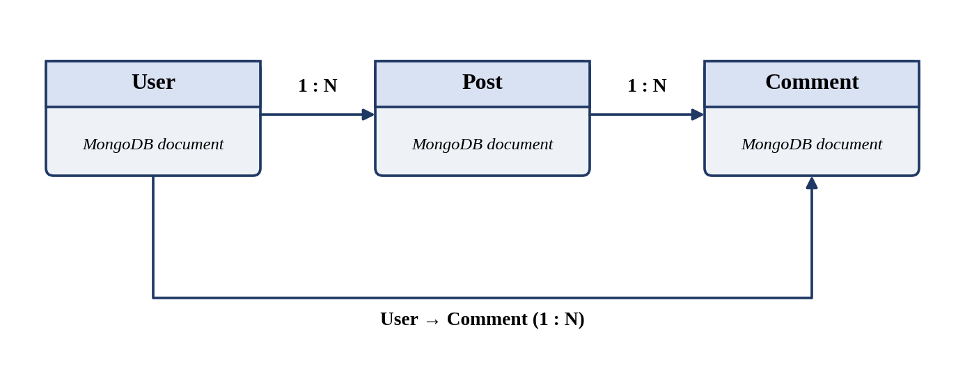
Figure 9: Database Testing and Relationship Validation

6.13 Input Validation Testing
Input validation ensures that only correct and safe data enters the system. Validation testing sends incorrect input deliberately and checks that the API rejects it with an appropriate error while valid input is accepted. The following cases are tested:
- Empty fields.
- Invalid email format.
- Duplicate email.
- Invalid IDs.
- Missing request fields.
- Invalid data types.
- Excessively large input.
- Malformed JSON.
- Invalid query parameters.
Validation prevents incorrect data from being stored in MongoDB, protects the application from unexpected failures, and reduces the risk of improper input reaching the controllers or the AI service.
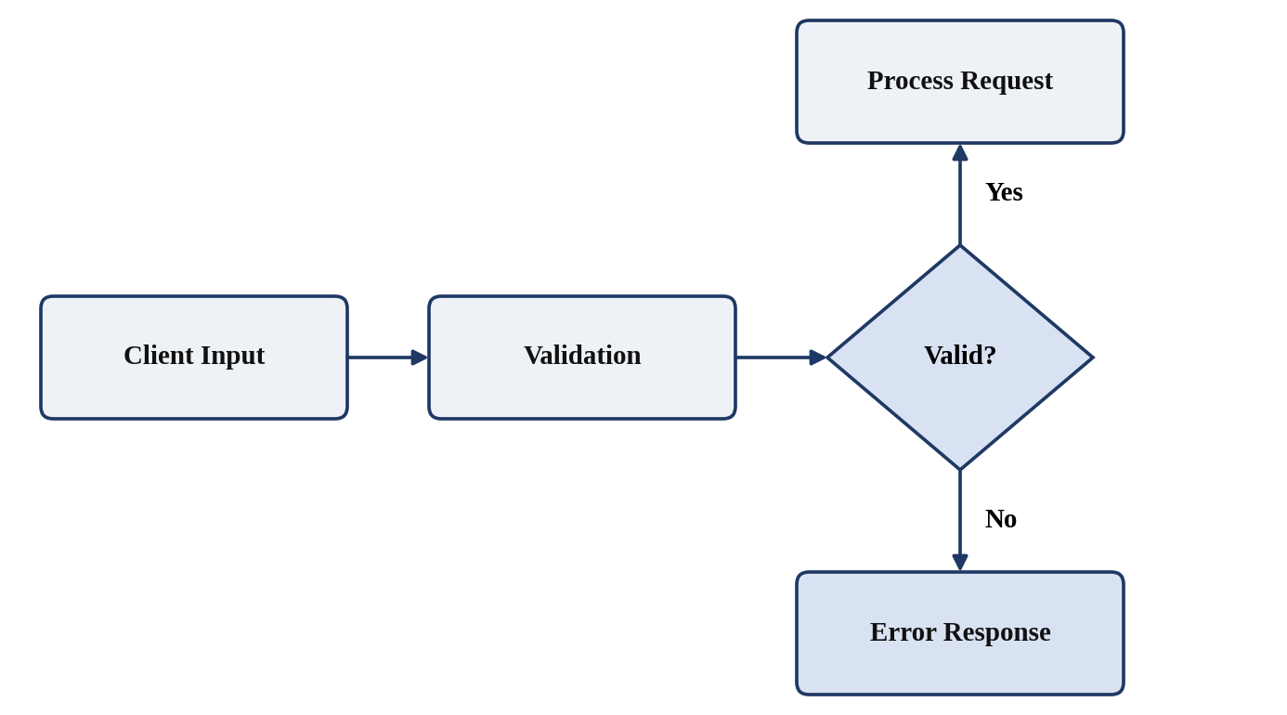
Figure 10: Input Validation Flow

6.14 Error Handling Testing
Error handling testing verifies that the system responds to faults in a controlled and consistent way. Table 6.5 shows the error conditions to be tested. Exact error messages are not specified here; testers should record the actual messages returned by the application.
Table 6.5: Error Conditions Under Test
Error Condition | Situation to Test
400 Bad Request | Invalid or incomplete request data
401 Unauthorized | Missing, invalid or expired authentication token
403 Forbidden | Authenticated user without permission for the operation
404 Not Found | Request for a resource that does not exist
500 Internal Server Error | Unexpected server-side failure
Database connection failure | Database unavailable during a request
AI service failure | Gemini AI request fails or returns no usable response
Invalid JSON | Request body is not valid JSON
Missing authentication token | Protected route called without a token

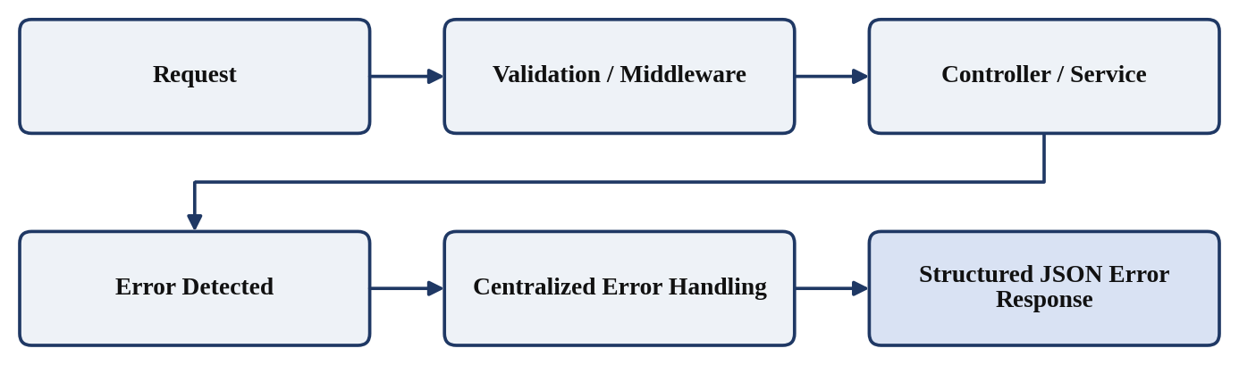
Figure 11: Error Handling Testing Flow

6.15 Security Testing
Security testing checks whether the protective mechanisms in ContentGen work as intended. It does not prove that the application is completely secure; it reduces risk by confirming that known controls behave correctly. The security tests and their purposes are described below.
Table 6.6: Security Tests and Purpose
Security Test | Purpose
Password hashing | Confirm that passwords are stored as bcrypt.js hashes and not in plain text
JWT authentication | Confirm that only valid tokens grant access
Protected routes | Confirm that restricted routes deny unauthenticated requests
Role-based authorization | Confirm that users cannot perform operations outside their role
Input validation | Confirm that invalid input is rejected
Input sanitization | Confirm that unsafe input is handled where sanitization is implemented
Rate limiting | Confirm that excessive requests are limited, where implemented
Secure environment variables | Confirm that secrets are kept in environment configuration and not exposed in source code or responses
Unauthorized access attempts | Confirm that improper requests are denied and do not affect data

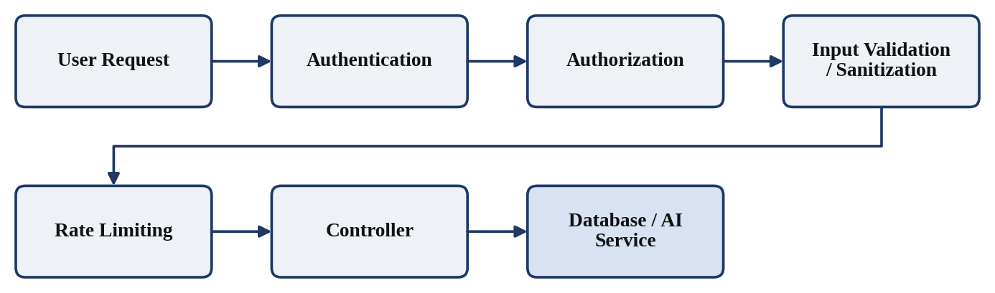
Figure 12: Security Testing Architecture

6.16 Integration Testing
Integration testing verifies that separately developed components work correctly together. The following interactions are tested in ContentGen:
- Express.js and MongoDB.
- Express.js and Mongoose.
- Authentication middleware and routes.
- Controllers and database services.
- Backend and Gemini AI.
- API routes and middleware.
- Blog module and comment module.
Typical integration checks include confirming that a request passes through the middleware before reaching the controller, that data submitted through an API is saved and can be retrieved, and that a comment is correctly linked to its blog and user.
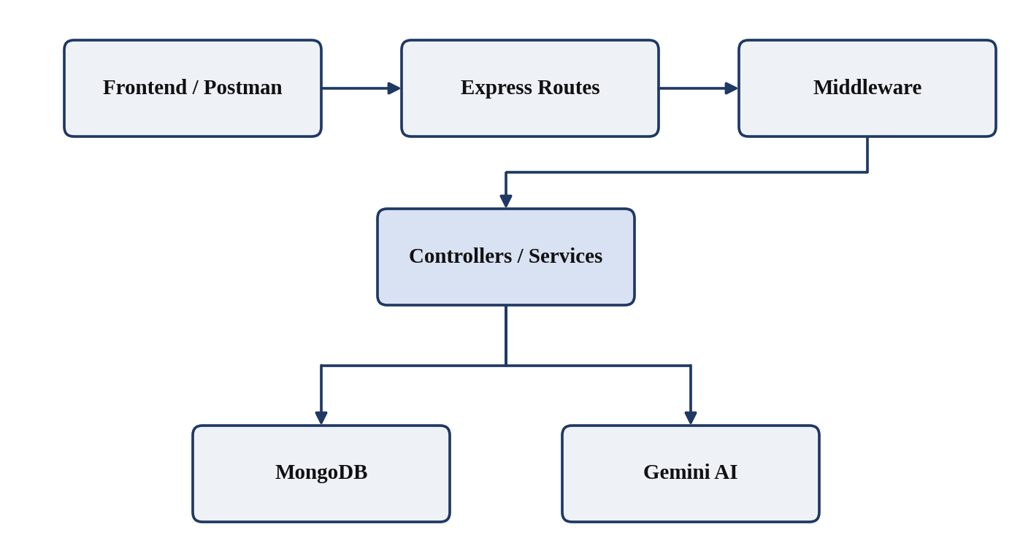
Figure 13: ContentGen Integration Testing

6.17 End-to-End Testing
End-to-end testing validates a complete user workflow across all layers of the system. The following scenario is executed and each response is checked:
- Register a user.
- Log in.
- Receive a JWT.
- Access an authorized API.
- Create a blog.
- Generate AI content.
- Summarize content.
- Store and retrieve blog data.
- Add comments.
- Search content.
- Verify that each step returns an appropriate response.
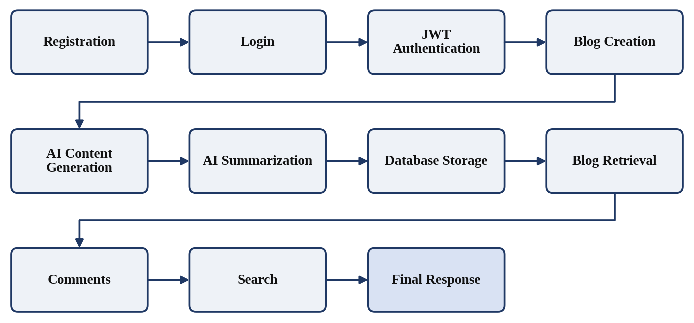
Figure 14: End-to-End Testing Workflow

6.18 Test Case Summary
Table 6.7 summarizes test execution by area. The values must be entered only after actual testing.
Table 6.7: Test Case Summary
Test Area | Test Cases | Result
Registration | To be filled | To be filled
Authentication | To be filled | To be filled
Authorization | To be filled | To be filled
Blog Management | To be filled | To be filled
AI Generation | To be filled | To be filled
AI Summarization | To be filled | To be filled
Comments | To be filled | To be filled
Search | To be filled | To be filled
Database | To be filled | To be filled
Security | To be filled | To be filled
Integration | To be filled | To be filled
End-to-End | To be filled | To be filled

6.19 Defect Identification and Retesting
Defects found during test execution are managed through a defined process. A defect is recorded with its description, the steps to reproduce it and the observed and expected behavior. After the developer fixes the defect, it is retested. Regression testing then confirms that the fix has not affected other working features, after which the defect is closed.
The defect categories relevant to this project are described in Table 6.8.
Table 6.8: Defect Categories
Category | Description
API errors | Incorrect routing, methods or status codes
Authentication errors | Faults in registration, login, password hashing or JWT handling
Authorization errors | Incorrect allowing or denying of role-based operations
Database errors | Faults in saving, retrieving, updating, deleting or relating data
Validation errors | Invalid input accepted or valid input rejected
AI integration errors | Faults in requests to or responses from Gemini AI
JSON/request errors | Failure to handle malformed or incomplete requests
Incorrect response handling | Wrong response structure or content returned

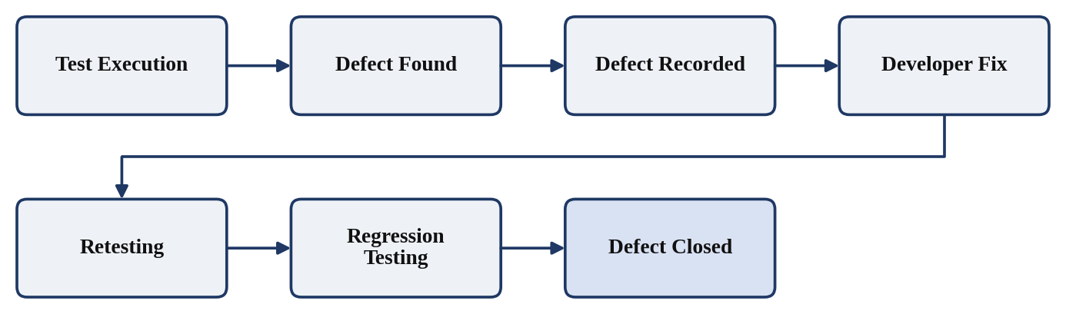
Figure 15: Defect Identification and Retesting Cycle

6.20 Testing Results
This section is reserved for actual evidence collected during test execution. The placeholders below must be replaced with real screenshots and results. No results have been assumed in this document.
Table 6.9: Testing Evidence Placeholders
No. | Evidence | Placeholder | Test Date / Result
1 | Postman screenshots | [Insert Actual Screenshot Here] | [Enter Test Date] / [Enter Actual Test Result]
2 | API response screenshots | [Insert Actual Screenshot Here] | [Enter Test Date] / [Enter Actual Test Result]
3 | MongoDB screenshots | [Insert Actual Screenshot Here] | [Enter Test Date] / [Enter Actual Test Result]
4 | Login/authentication screenshots | [Insert Actual Screenshot Here] | [Enter Test Date] / [Enter Actual Test Result]
5 | AI generation screenshots | [Insert Actual Screenshot Here] | [Enter Test Date] / [Enter Actual Test Result]
6 | AI summarization screenshots | [Insert Actual Screenshot Here] | [Enter Test Date] / [Enter Actual Test Result]
7 | Error response screenshots | [Insert Actual Screenshot Here] | [Enter Test Date] / [Enter Actual Test Result]

6.21 Testing Checklist
The checklist below is to be ticked by the tester as each activity is completed.
Checklist Item | Date / Remarks
☐ Registration tested | [Enter Test Date]
☐ Login tested | [Enter Test Date]
☐ JWT authentication tested | [Enter Test Date]
☐ Role-based authorization tested | [Enter Test Date]
☐ Blog CRUD tested | [Enter Test Date]
☐ AI generation tested | [Enter Test Date]
☐ AI summarization tested | [Enter Test Date]
☐ Categories/tags tested | [Enter Test Date]
☐ Comments tested | [Enter Test Date]
☐ Search tested | [Enter Test Date]
☐ Database operations tested | [Enter Test Date]
☐ Input validation tested | [Enter Test Date]
☐ Error handling tested | [Enter Test Date]
☐ Security controls tested | [Enter Test Date]
☐ Integration tested | [Enter Test Date]
☐ End-to-end workflow tested | [Enter Test Date]
☐ Regression testing completed | [Enter Test Date]

6.22 Conclusion
The testing phase of ContentGen – Generate High-Quality Blog Content Using AI provides a structured method of validating the functional behavior, API communication, authentication, authorization, database operations, AI integration, error handling and overall workflow of the system. By combining functional, API, authentication, authorization, database, AI, integration and end-to-end testing, the plan addresses each layer of the backend built with Node.js, Express.js, MongoDB, Mongoose, JWT, bcrypt.js and Google Gemini AI.
This chapter presents the testing approach, environment, test cases and reporting framework. The actual outcome of testing must be recorded in the placeholders provided once the tests have been executed. Any defects identified are to be fixed, retested and checked through regression testing so that the final system is reliable and secure to the extent verified by the recorded tests.

