Embedded integration
Automatic class attendance on Jetson Nano
What this part is, how the two models fit together, and what is done on the board. Written for the viva. The Jetson Nano has not been issued yet, so measured runs are the laptop baseline. No on-board number in this note is a measured result.

1. What this part is
This part puts the attendance program on a small computer, the Jetson Nano, and makes the pieces run as one system. It does not train the face models. Other people build the face finder and the name matcher. This part takes their code, runs it in the right order, and checks that a camera frame becomes one attendance line.
The finished demo is the board alone. Camera plugged in, face seen, name matched, one line written, no laptop attached. That demo is not done yet, because the board has not been handed over.

2. The whole picture
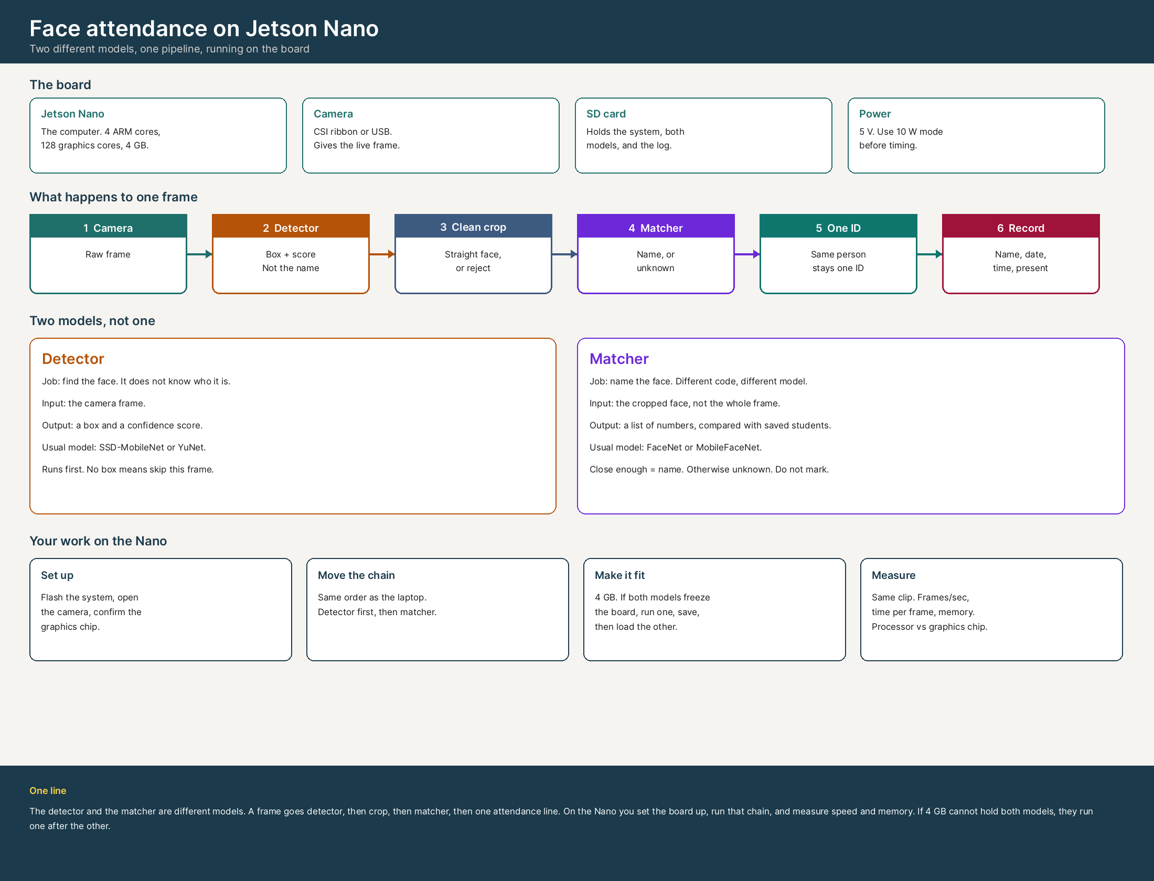
Figure 1. Board, frame path, the two models, and the work on the Nano.

3. The board
The target computer is the original Jetson Nano, not the newer Orin Nano. It is a small board with its own processor and a graphics chip, meant to sit in the room with a camera.
Part | What it is | Why it is there
Processor | 4 ARM Cortex-A57 cores | Opens the camera, compares names, writes the log
Graphics chip | Maxwell, 128 CUDA cores | Runs the detector and the matcher
Memory | 4 GB | The limit. Both models at once can freeze the board
Camera | CSI ribbon port, or USB webcam | Gives the live frame
Storage | microSD card | System, both models, saved students, attendance file
Power | 5 V, 5 W or 10 W mode | Use 10 W mode before any timing
Software | JetPack 4: Ubuntu, CUDA, TensorRT | The stack the models run on
10 W mode is set with sudo nvpmodel -m 0 and sudo jetson_clocks. Timing in 5 W mode makes the board look slower than it is. tegrastats is the command that shows processor use, graphics-chip use, and memory.

4. Two models, not one
Attendance needs two different models and two different pieces of code. They are called one after the other in the same program. They are not the same network.

Detector
- Job: find the face. It does not know the name.
- Input: the whole camera frame.
- Output: a box and a confidence score.
- Usual model on a Nano: SSD-MobileNet or YuNet. Haar cascades are the older non-neural option.
- No box means skip this frame. A low score means ignore that box.

Matcher
- Job: name the face.
- Input: the cropped, straightened face, not the whole frame.
- Output: a list of numbers, called an embedding, usually 128 or 512 values.
- That list is compared with the saved students. Close enough means a name. Not close enough means unknown, and that person is not marked.
- Usual model: FaceNet or MobileFaceNet. MobileFaceNet is the one that fits a Nano better.
Enrollment is done once. A few good photos of each student go through the matcher, and the lists are saved with the name. Later runs only compare. The Nano does not retrain the model.

5. What happens to one frame
- The camera gives a frame.
- The detector returns a box and a score. No box: next frame.
- The face inside the box is cropped and straightened. Blurry or tiny faces are rejected.
- The matcher turns the crop into a list of numbers and compares it with saved students.
- The same person keeps the same ID while they stay in view, so one student is not written five times.
- After enough consistent sightings, one line is written: name, date, time, present.
A photo held up to the camera can still match. A separate liveness check was not part of this stage. That is a known limit, not a feature.

6. How the pieces connect
Each stage has a fixed handoff. Changing it breaks the next stage, so the format stays frozen.
From | To | What is passed
Camera | Detector | A frame
Detector | Crop stage | Box: x, y, width, height, and a score
Crop stage | Matcher | A fixed-size face, or a reject
Matcher | ID stage | A name and a score, or unknown
ID stage | Record | One steady ID for that person
Record | File | Name, date, time, present
If one stage writes a box as x, y, width, height and the next stage expects two corners, a small converter sits in the integration code. The other stage is not rewritten.

7. What is done now
The board has not been issued. The chain was built and timed on a laptop. That laptop run is the baseline. It is not a Jetson result.
- The order of the chain is fixed: frame, find face, clean crop, match name, keep one ID, write one line.
- The handoff between stages is defined, so a later stage can be tested with a saved file if the previous stage is not ready.
- Laptop timing is the comparison point for the later Nano run. It is not quoted as on-board speed.
Do not claim a Nano frames-per-second number, a memory figure, or a tegrastats log. Those do not exist yet.

8. What this part does once the Nano is available
- Flash JetPack onto the SD card, boot, open the camera, and confirm the graphics chip with tegrastats. Set 10 W mode. Write the exact commands in a README so someone else can repeat them.
- Copy the same program onto the board. Run the detector first, on the same short clip used on the laptop. Check that a face still comes out as a box plus a score.
- Time that clip twice. Once on the processor, once on the graphics chip, or with a TensorRT FP16 engine if one is built. Same video, same threshold. Record frames per second, time per frame, and memory.
- Add the matcher. If both models freeze the 4 GB board, run the detector, save the boxes, unload it, then load the matcher. That split is a real result on this board.
- Write a problem list: library would not install, camera number different from the laptop, model file missing, box format changed.
- Leave one script that opens the camera and calls the steps in order, and writes the attendance file with no laptop attached.
TensorRT is the deployment step worth naming. The trained model is exported, then built into an engine in FP16 so the graphics chip does the heavy work. This part does not train the model. It only changes how the model is executed.

9. What to measure
Measure | How | Why
Frames per second | Same clip, counted frames over time | Can it keep up with a classroom camera
Time per frame | Milliseconds for detector, then matcher | Shows which model is the slow part
Memory | tegrastats while both models load | Shows if 4 GB is enough
Processor vs graphics chip | Two runs, same clip, same threshold | Shows what the graphics chip actually buys
Wrong mark / missed mark | Known face, unknown face, bad light | Speed is useless if the name is wrong

10. What to say
My part is embedded integration. The attendance chain is camera, find the face, clean the crop, match the name, keep one ID, write one attendance line. The detector and the matcher are different models. The detector returns a box. The matcher returns a name, or unknown. That chain runs on the laptop, and the output format is fixed. We have not been given a Jetson Nano yet, so there is no on-board measurement. The laptop numbers are the baseline only.
When the Nano is available I flash JetPack, open the camera, run the same face finder on the same clip, and compare the processor against the graphics chip. I record frames per second, time per frame, and memory. The Nano has 4 GB, so if the finder and the matcher do not fit together I run them one after the other. The demo is the board alone, no laptop.

11. Questions they will ask
Question | Answer
Did you train the model? | No. This part runs the models. It does not train them.
Detector or matcher? | Both, in that order. They are different code and different models.
Why a Nano? | So the room terminal does not need a laptop. The graphics chip runs the models.
Why might it not fit? | 4 GB. Two models at once can fill the memory. Then they run one after the other.
What is a threshold? | The matcher score is a number. Below the cutoff the person is unknown and is not marked.
Where are the Nano numbers? | There are none yet. The board has not been issued. Laptop is the baseline.
End of note.

