**Task: 01: Adding new parking slot:**

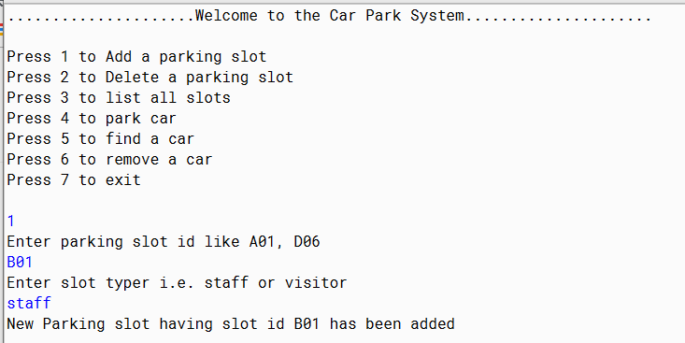

**Task: 02: Remove the parking slot**

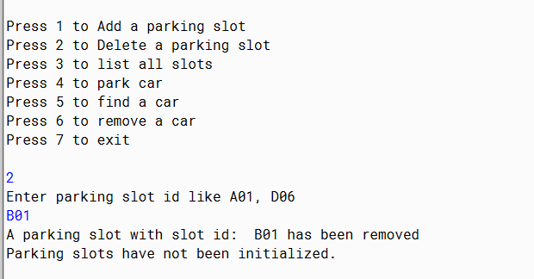

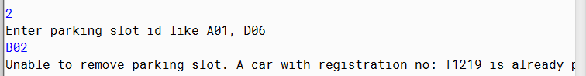

**Task: 03: List all the parking slots**

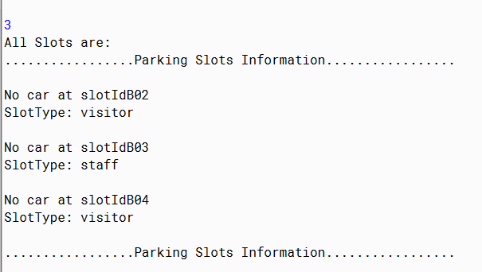

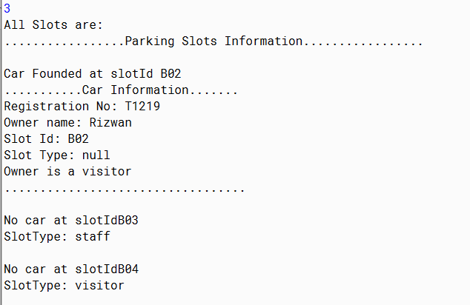

**Task: 04: Park a car:**

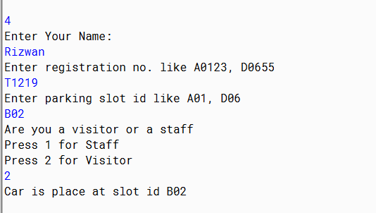

**Task: 05: Find a car by registration no.**

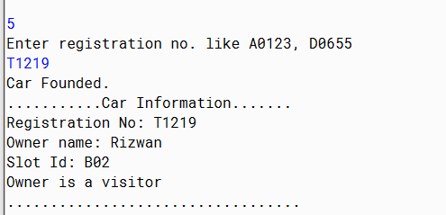

**Task: 06: Remove car from parking slot:**

