# W5: Speech Intro

Jacob Bloom

## Initial sketch

Here’s my initial prototype from class, below it are the problems we found while testing it:

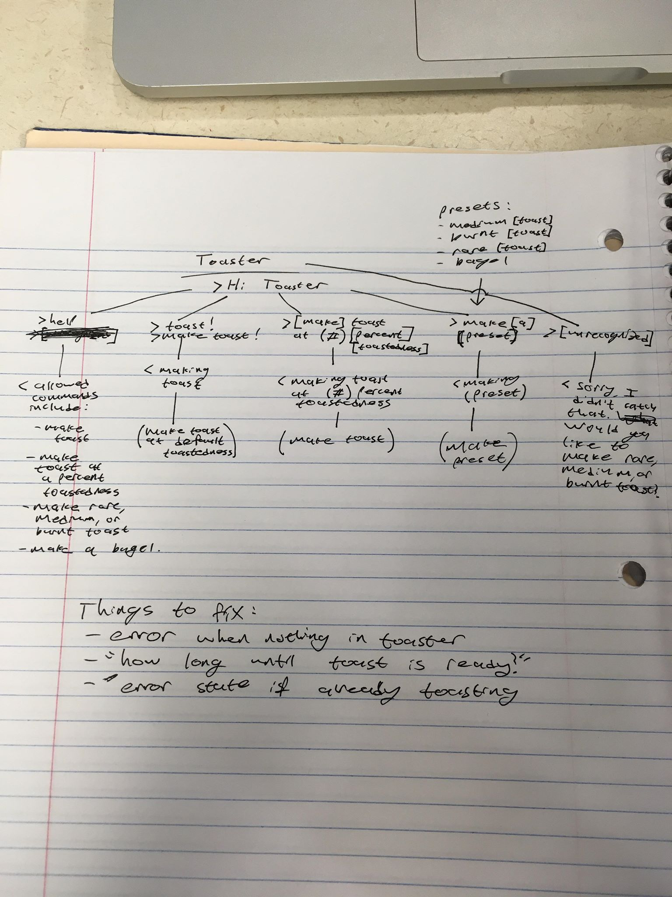

## Updated sketch

An updated sketch appears on the following page.

