

Echolocation

Designed by Jai Kothari - P2566248

For PC, available on Steam and the Epic Games Store.

Rating: E10+

Expected Completion Data – TBD.

Contents

Game Outline 3

Game Story Summary 3

Game Play Summary 3

Characters and Enemies 4

Characters 4

Whale 4

Enemies 4

Mechanics 4

List of Enemies 4

Bosses 4

Controls 5

Mouse and Keyboard 5

Controller 5

Menus 6

Start Menu 6

Pause Menu 6

Gameplay 7

Tutorial 7

The Levels 7

Boss Levels 7

Gameplay Flowchart 8

Game Mechanics 9

The Bell Flowers 9

Interaction Mechanics 9

Walking 9

Stomping 9

Throwing Rocks 9

Environments 9

Hazards 10

Pitfalls 10

Landslides 10

Death Areas 10

Collectibles 11

Cutscenes 11

Major Cutscenes 11

The Starting Cutscene 11

The Ending Cutscene 11

Minor Cutscenes 11

Bonus Materials 11

# Game Outline

## Game Story Summary

Having survived a crippling epidemic that has taken over your small village, you must help those in need by venturing into the dangerous cave system to retrieve a cure, the rare Bell Flower. Trapped in complete darkness, you must use your incredible skill of using visualised sound to guide yourself through the cave system and retrieve the Bell Flower. The sounds you create through moving, stomping and throwing rocks will reveal the shape of the surrounding world but only until they dissipate. It won’t be long until the only way of sensing the cave system alerts and attracts the inhabitants of the cave who are hungry for their next meal.

## Game Play Summary

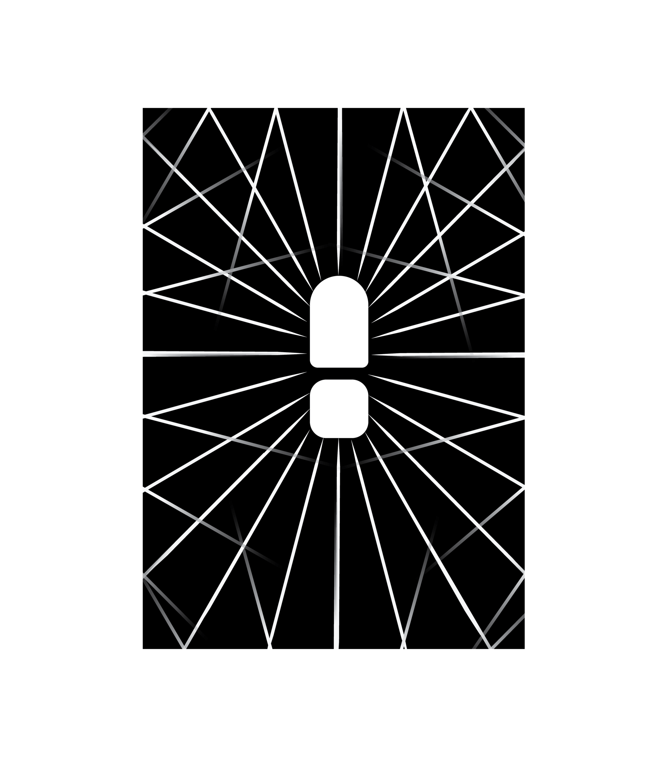Surviving is the main element of this game. Echolocation is a top down 2D puzzle game where the player controls a silent protagonist nicknamed Whale in a completely pitch-black environment and navigates them through a maze-like environment avoiding hazards and monsters. With 100+ different levels in increasing difficulty, and a timer of 10 minutes per level, the player must make their way to the Bell Flowers in each level and back towards their entrance in order to exit the cave and complete the level.

# Characters and Enemies

## Characters

### Whale

As this is a game set in the top down 2D style the only object the player will see is the footsteps of Whale. Whale is the only cured person in the village and has the incredible skill of navigating in the dark.

## Enemies

There are multiple enemies in this game. The footprints for them can be found if the player moves into a sign board. If the player touches any of the enemies, they die instantly, a death splash screen is shown, and the player is asked if they would like to go back to the menu or restart the level.

### Mechanics

All the enemies:

* Appear as their footsteps.
* Are red in colour.
* Resonate sound as they move.
* Sound waves are also red.
* Will move towards the last sound they hear in their radius of detection.
* Will not move towards sounds if they are offscreen. ­
* Can die if wondered into death areas.

### List of Enemies

|  |  |  |
| --- | --- | --- |
| Enemy name | Enemy speed (in relation to player) | Can they be defeated? If so, how? |
| Wolves | 2x | Yes, three rock throws at them will cause them to run away but they can return. |
| Zombies | 0.5x | No, but player can run away from them. |
| Bear | 1x but can swipe at player if player is close | No, but will tire after 30 seconds of movement. |
| Frog | 1.5x | Yes, one rock throw and they will die. |

### 

### Bosses

There are only 2 types of bosses in this game, Ghosts and Dreed. Both have a deeper red colour and leave no footprints. Both move at the same speed as the player.

Ghosts are shown as soundwaves bouncing within a circle. They can always be seen. If they touch the player, the ghost disappears, but the player is stunned for 10 seconds. Usually, ghosts appear when there are other enemies around.

Dreed is shown as soundwaves around a clear circle. They can only be seen when the player stomps but disappears when the sound dissipates. They can only be woken up by stomps, however, and will not wake up even if the player walks on top of them. If they are awake and touch a player, the player dies instantly and are sent back 5 levels.

# Controls

## Mouse and Keyboard

Move up

Move right

Left Click to throw rock

Move down

Move left

## 

Move to aim rock

## Controller

Trigger: Throw rock



Movement

Aim rock

# Menus

## Start Menu

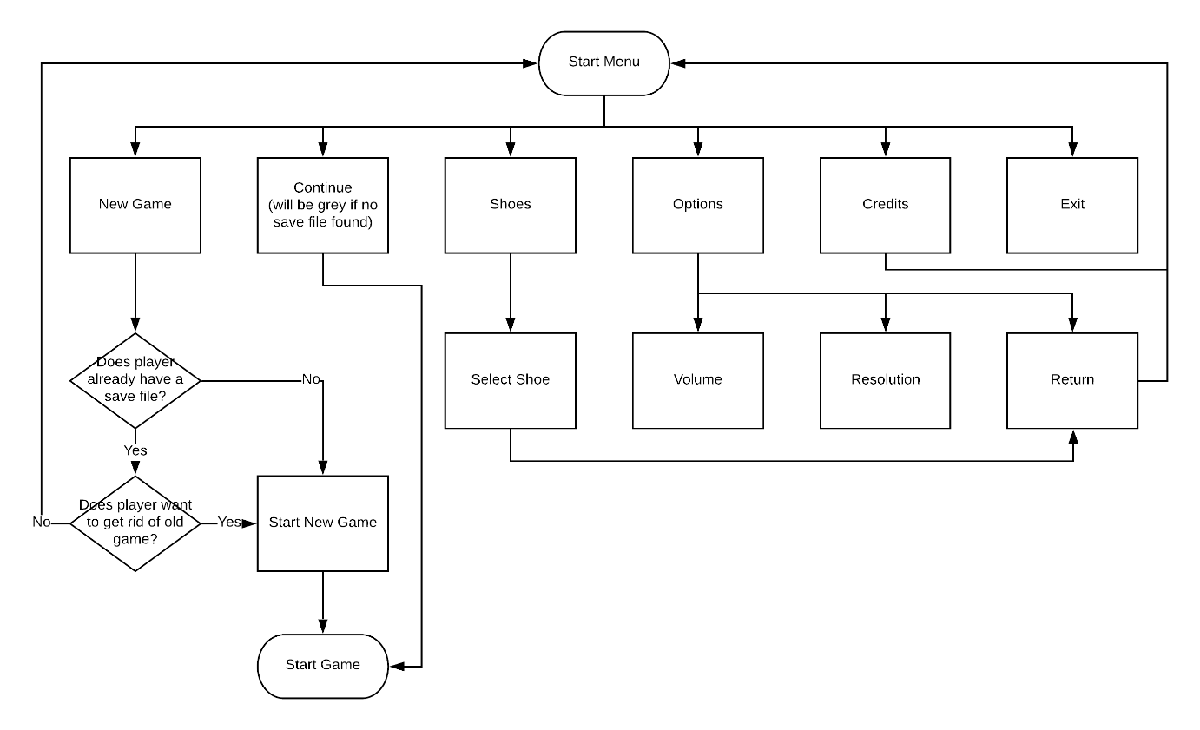

Another option called Extras will appear on the menu once the player has beaten the game once. Extras will contain the hard mode for the game as well as multiplayer.

## Pause Menu

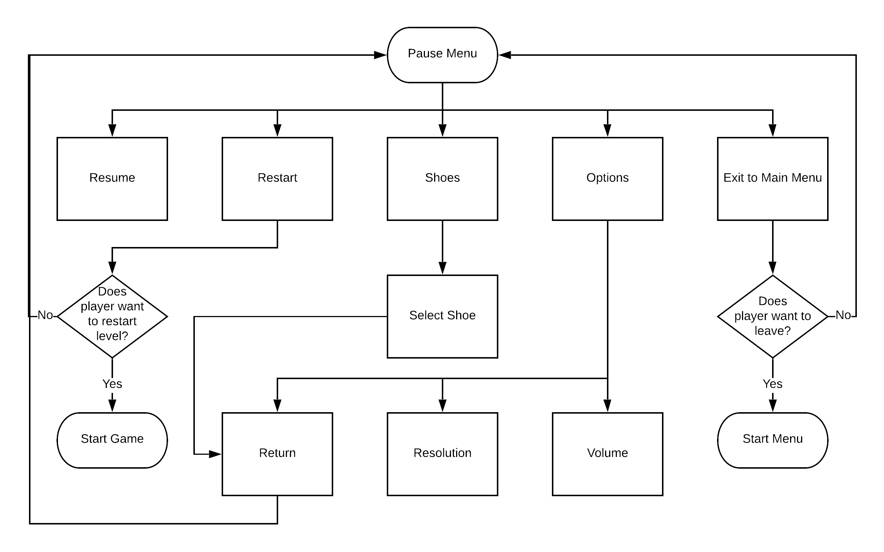

# Gameplay

Gameplay is set into 3 distinct phases. The tutorial, the different levels and boss rooms.

## Tutorial

As the game starts, the player is met with a tutorial. This teaches them the basic mechanics of the game as well as introducing them to the first enemy of the game, zombies. The tutorial will also showcase stage hazards such as pitfalls and landslides as well as danger areas. If the player dies, they are respawned in just before the zombie section. THIS IS NOT THE FIRST LEVEL.

## The Levels

Every level is structured in such a way that they either create a distinct linear path from the start to the Bell Flower and back, or a loop where a new path back to the start must be discovered. The levels increase in difficultly as progression increases. All levels should be done within the 10-minute time limit and be wide enough so that players can escape enemies.

|  |  |  |  |
| --- | --- | --- | --- |
| Level Number | Difficulty | Enemies | Bell Flowers |
| 1 - 19 | Easy | None | 1 |
| 21 - 39 | Medium | 1 - 2 | 1 |
| 41 - 59 | Medium | 3 - 5 | 2 |
| 61 - 79 | Hard | 5 + Ghosts | 2 |
| 81 - 99 | Brutal | Up to 10 + Ghosts + Dreed | 4 |

## 

## Boss Levels

Boss levels happen every 20 levels. These levels still require the player to get Bell Flowers and return to the start however they are faced with hordes of enemies and time sensitive paths. Boss levels do not have a timer and the player can take as long as they want to complete these levels.

|  |  |  |  |  |
| --- | --- | --- | --- | --- |
| Level Number | Difficulty | Enemies | Hazards | Bell Flowers |
| 20 | Easy | 7 Frogs | None | 2 |
| 40 | Medium | 3 Zombies  3 Frogs  1 Wolf | Pitfalls | 3 |
| 60 | Medium | 7 Zombies  5 Frogs  3 Wolves | Pitfalls  1 landslide | 4 |
| 80 | Hard | 10 Zombies  7 Frogs  5 Wolves  2 Bears  5 Ghosts  1 Dreed | Pitfalls  2 landslides  (Player can get trapped) | 5 |
| 100 | Brutal | 10 Zombies  10 Frogs  8 Wolves  5 Bears  10 Ghosts  3 Dreeds | Pitfalls  4 landslides  (player can get trapped in more than one place) | 10 |

## Gameplay Flowchart

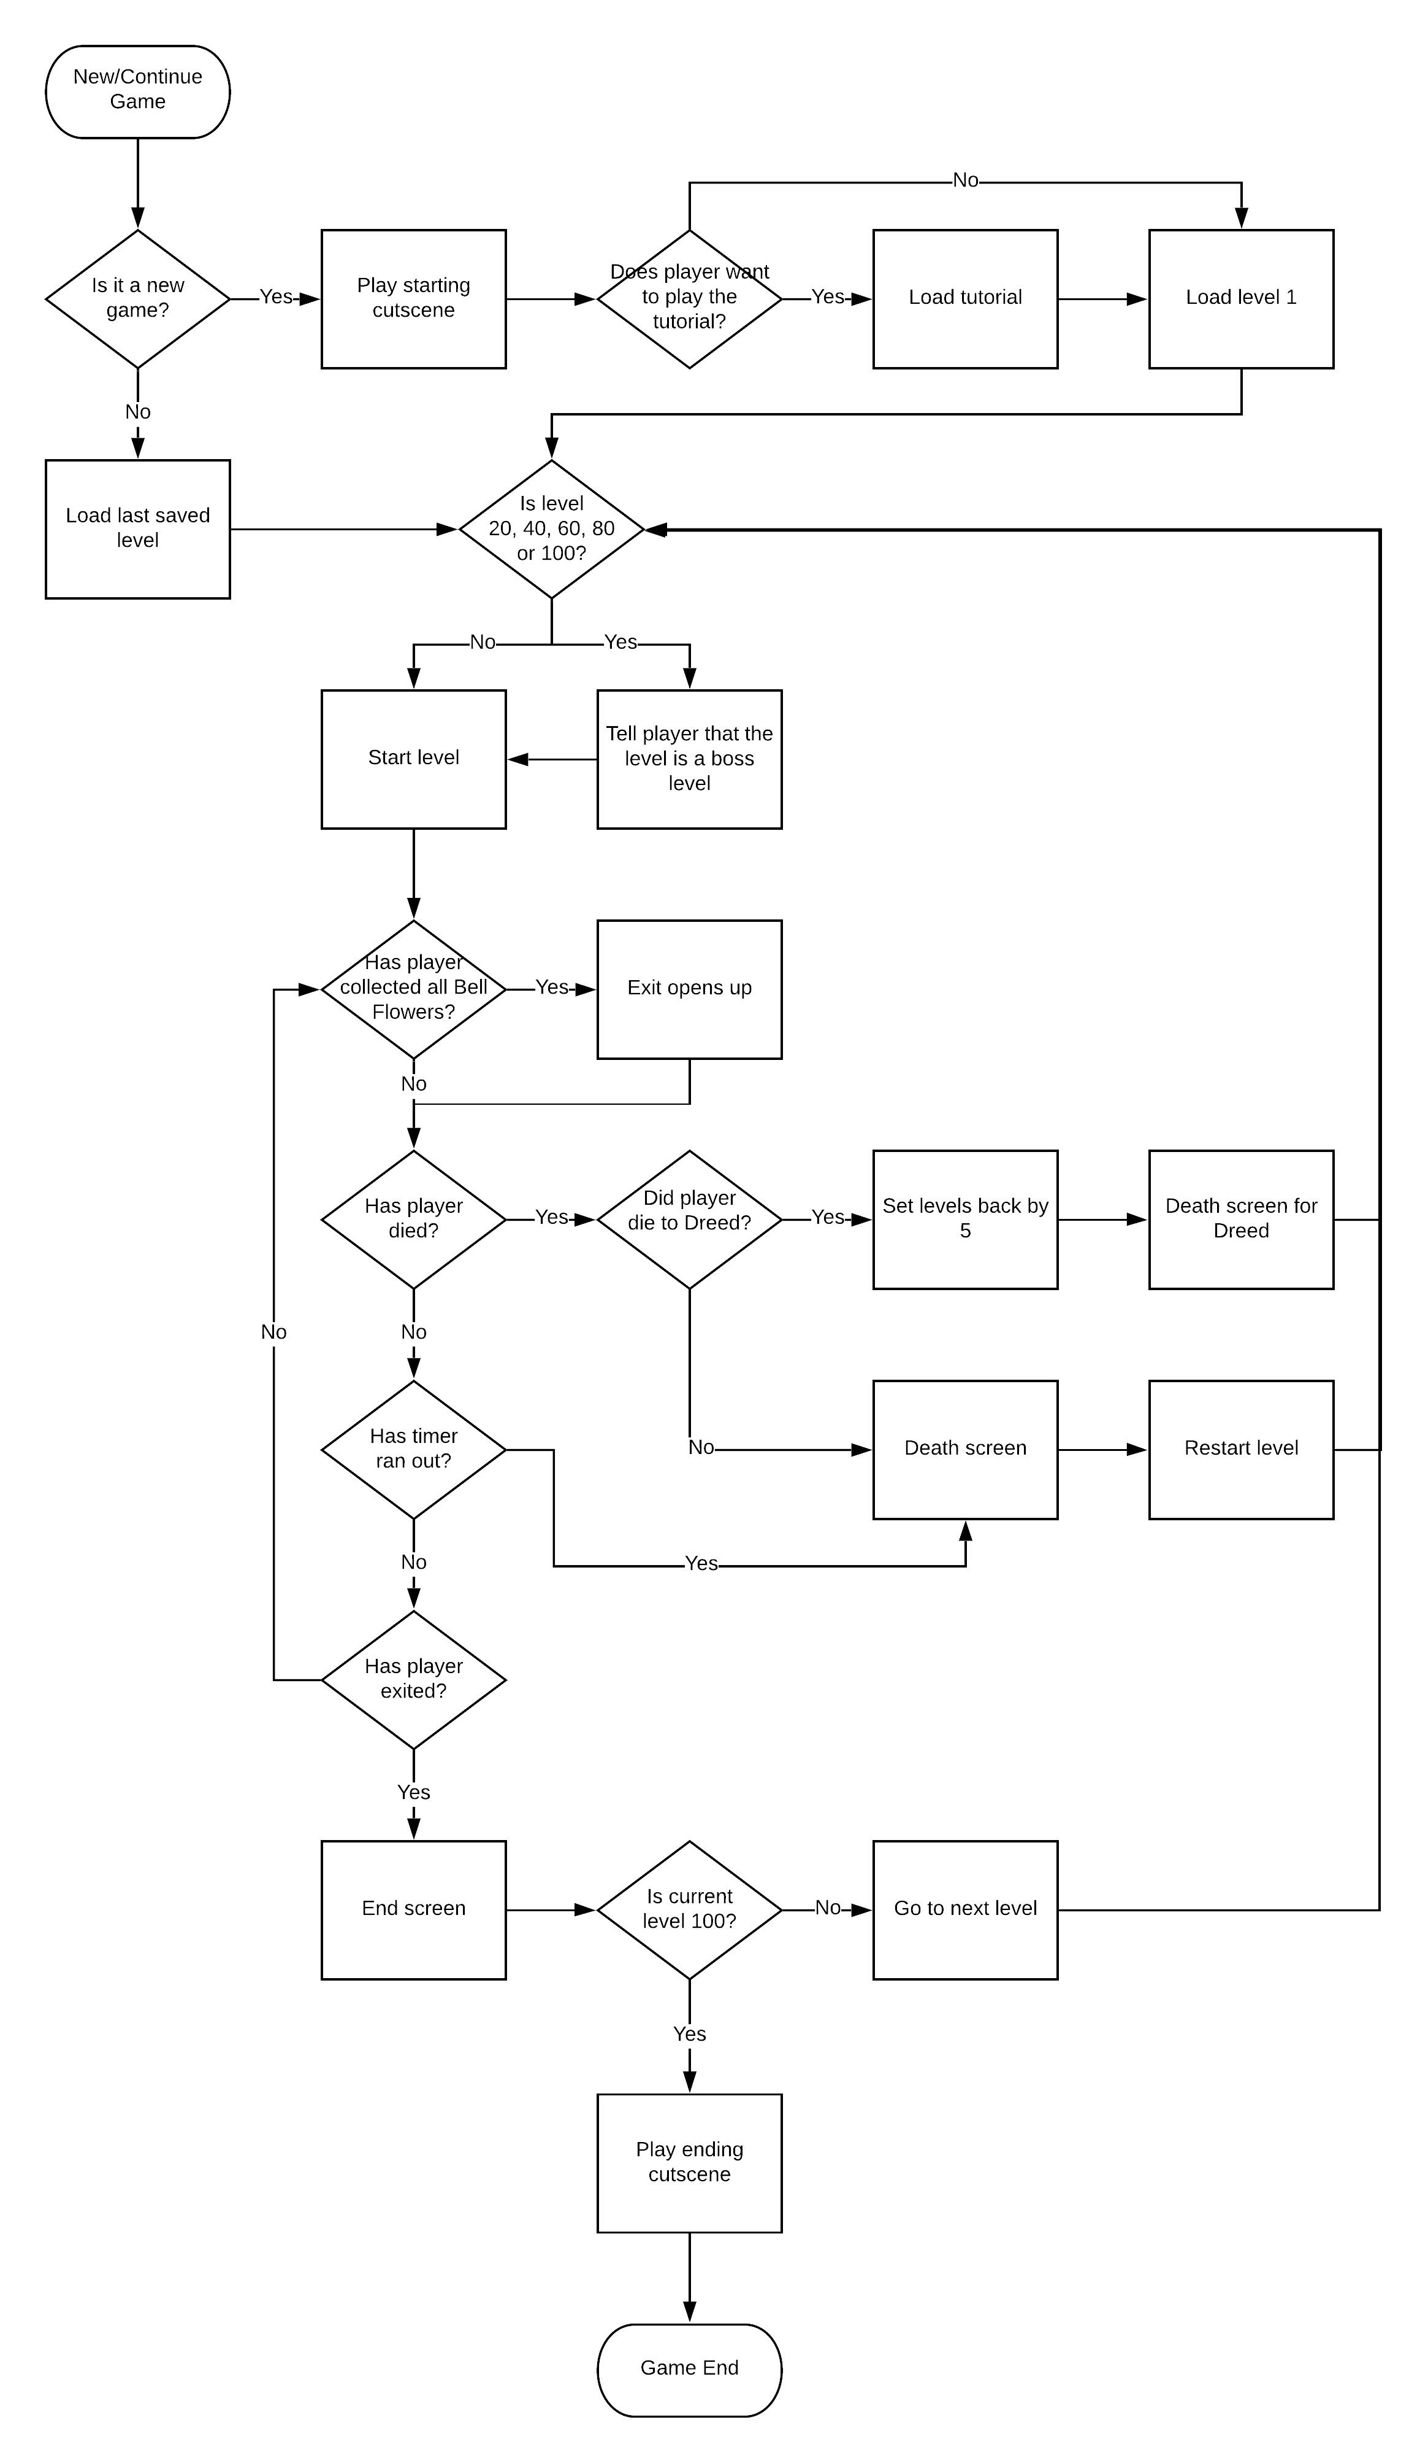

# Game Mechanics

## The Bell Flowers

These are the main objective of the game and must be collected in order to open the exit. They emit a small (Half foot size) green sound wave when they appear on screen. They will ring louder if the player stomps near them and emit a large (2 times foot size) green sound wave.

## Interaction Mechanics

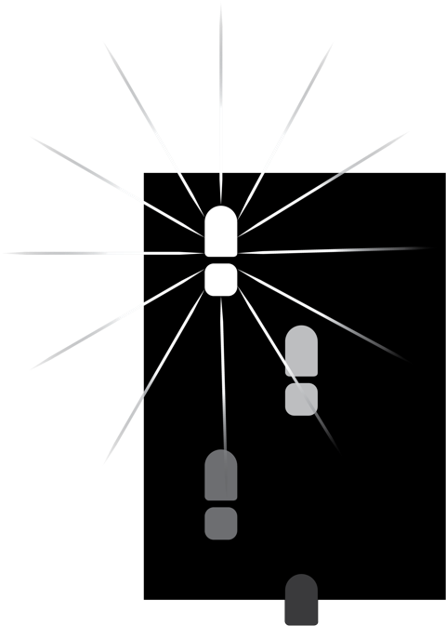The player has 3 main ways for interacting with the world. Walking, stomping and throwing rocks.

### Walking

Walking allows the player to move around the world. This is shown by the footsteps one in front of the other. Sound waves propagate outwards from each step and depending on the environment, the propagation and dissipation can change.

### Stomping

Stomping allows the player to see more of the world. This is shown as a big footstep hitting the floor propagating sound waves further than when walking. The player cannot move whilst stomping.

### Throwing Rocks

Throwing rocks can also help the player sense the world, however only a small part of it and only if the rock hits a wall. It also distracts enemies as they will move towards the sound source. They can also be used on certain enemies to defeat them if the rock hits them.

## Environments

There are 4 main environments within the cave system in Echolocation. Regular ground, water, ice and mud. They all have:

* Different speeds for the player.
* Different physics for sound propagation and dissipation.
* Different colours for the ground type.
* Different sound wave styles.
* Different sounds when stepped on.



|  |  |  |  |  |  |  |
| --- | --- | --- | --- | --- | --- | --- |
| Ground Type | Player Speed | Sound Propagation | Sound Dissipation | What happens when stomped? | Colour | Sound |
| Regular ground | Regular speed | 3 times foot size | Once next footstep is taken | 10 times foot size propagation followed by dissipation | White | Echoey footstep |
| Water | 0.75x | Throughout the whole body of water | 10 seconds after step | Multiple propagations through the body of the water | Deep Blue | Splash |
| Ice | 2x | 4 times foot size | Every 2 steps | Ice can crack and player can plummet to their death if they do not react fast | Aqua | Crunch |
| Mud | 0.5x | 1 times foot size | Once next footstep is taken | No sound propagation but area 4 times the stomp foot is cleared into regular ground. | Brown | Squish |

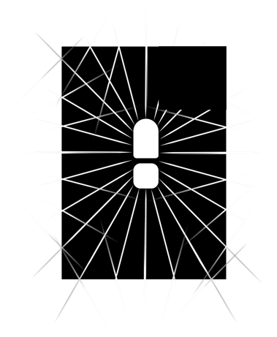

## Hazards

### Pitfalls

These are areas of the world that the player can fall into and die. They absorb all sound, and so will remain black. They also appear under all ice and so if the player stomps, they will fall into a pit.

### Landslides

These are areas that trigger only when the player moves across a trigger point. They cause the path behind the player to be cut off forcing the player to move forward. The player cannot die from these. They also propagate their own sound showing the player the map for 3 seconds but also alert any enemies nearby.

### Death Areas

These are areas that if the player wonders into them, they die instantly. They show up as red sound waves if the player stomps or walks near them. The player can throw rocks into these areas to lore enemies into them and the area will kill all enemies, apart from Ghosts and Dreeds, that wonder into it.

## Collectibles

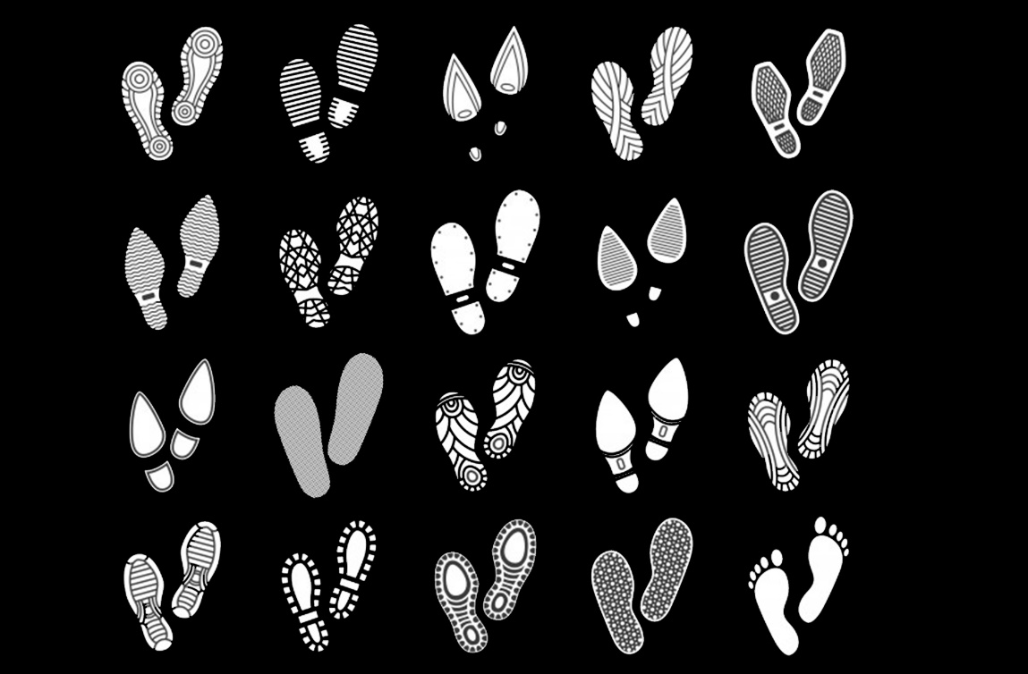The only collectible in the game are additional styles of shoes in the game. These can be found throughout different levels. They do not emit any sound but can deflect sound so are invisible to the player until they walk on near them or stomp close to their proximity. The player can collect them by walking on them and then can use them from the next level.

# 

# Cutscenes

## Major Cutscenes

### The Starting Cutscene

This shows the epidemic in the village and shows the doctor of the village tell Whale to venture into the cave systems to cure the village with the legendary Bell Flower. The doctor explains the dangers of the caves but tells Whale that he is their last hope. We then see Whale set off to the caves.

### The Ending Cutscene

This shows Whale returning with a bag full of Bell Flowers for the village. The doctor grinds these up and make a soup which the whole village drink and they are instantly better. The villagers lift Whale up in the air and chant his name. The screen fades to black and credits roll.

## Minor Cutscenes

There are also 2 minor cutscenes in the game. These happen at the start and end of the level. The first shows a top down view of Whale putting a bag next to the entrance of the cave, entering the cave system and the cave closing off behind him and happens at the start of the level. The other is shown when Whale is exiting the cave system, the cave closing off behind him and Whale putting the collected Bell Flowers in the bag.

# Bonus Materials

After the game is completed, two new options appear on the menu.

First is the option to play the game again, but on an extra hard difficulty. This will cause more enemies to spawn, more hazards, shorter times to complete levels and shorter propagation of sound. If the player completes this, all the shoes they have will turn golden.

Second is the option to build their own levels and submit them to the community for others to play. They can download other users’ levels and play them as well (think Mario Maker). This will allow for an almost infinite play.

Downloadable content may be available in the form of additional map packs, or the introduction of new challenges, objectives or enemies to overcome.

For all images, full detail and their corresponding Ai files are kept in this Google Drive folder: <https://drive.google.com/open?id=1Fj0gFkksXBrRCWfTmQWTXZIC-DFD46Gz>. I created and designed all images in this folder. The flowcharts were made on the web tool lucidchart.com.