Coursera Capstone Project — The Battle of Neighbourhoods

Questions:
What type of resteurants are most popular and attended in Warsaw Capital City?
What Warsaw district has most venues?

Introduction
Warsaw is the capital and largest city in Poland. It’s ethnically diverse. The metropolis stands on the Vistula River in east-central Poland and its population is officially estimated at 1.8 million residents. With a greater metropolitan area of 3.1 million residents, Warsaw is the 5th most-populous urban area in the European Union. Warsaw is major international tourist destination, and a significant cultural, political and economic hub. Warsaw is one of the most beautifull cities in the Europe.
It is an important scientific, cultural, political and economic center. It consists of 18 districts.

With it’s diverse culture , comes diverse food items. There are many restaurants in Warsaw, each belonging to different categories like Chinese , Indian , French etc.

Data
Following data will be used in this project:

- Warsaw data about its districts along with their latitude and longitude. By using this geo space data we will get Visualized Warsaw districts boundaries/
Data Source: https://raw.githubusercontent.com/andilabs/warszawa-dzielnice-geojson/master/warszawa-dzielnice.geojson

- Resteurants in each district of Warsaw. Using this api will give us info about resteurants in each district.
Data Source: Fousquare API

Use of data
Fousquare API will be used to collect info about location data and popularity info about resteurants in Warsaw districts. Then data will be used to find which district has most venues. And what type of resteurant is most popular in Warsaw.
Geolocation data contains Warsaw and its districts borders. It will be used to construct map of Warsaw with addition of district popularity data.

Methodology
1. I used Foursquare api to get venues in each district in Warsaw.
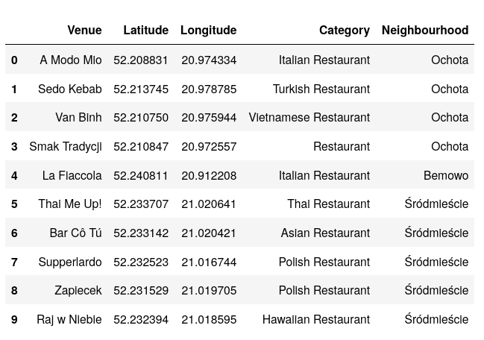

2. Grouped data by district to see what Warsaw district has most venues.
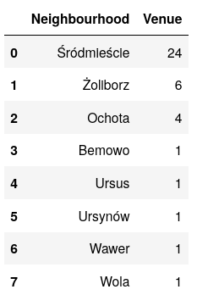
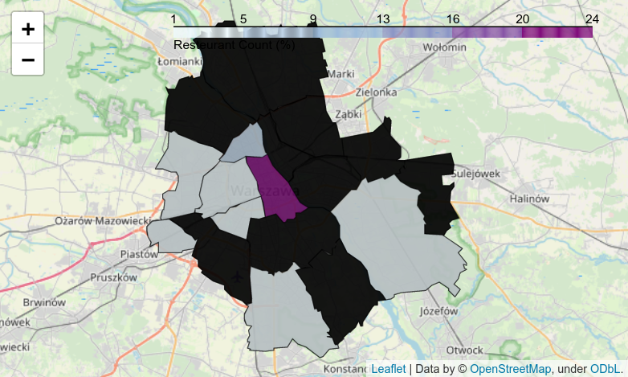
3. I’ve used Choropleth to visualise the data on map.

4. I’ve groupped a data by category to see what type of resteurant is most popular in Warsaw.
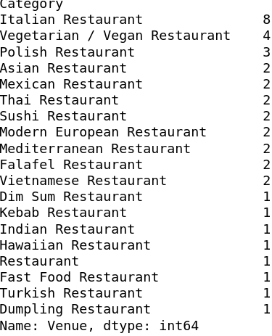

Results
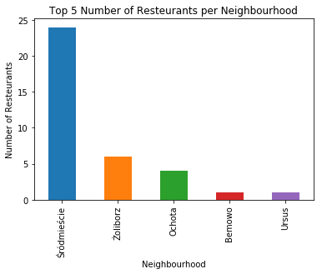
1. Śródmieście district have most resteurants in Warsaw (24). Second is Żoliborz.
2. Most popular type of resteurant is Italian Resteurant. Second is Vegetarian / Vegan Restaurant.
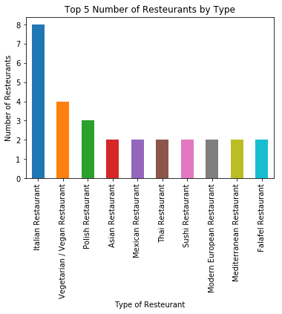
Conclusion
- Most of the resteurants are located in Śródmieście district.
- Best district to recommend with a lot of venues is Śródmieście district.
- Warsaw people prefer Italian Resteurants.

