npx -p @angular/cli ng new multitenant1

<https://www.9lessons.info/2019/07/angular-multi-tenant-project.html> (major reference)

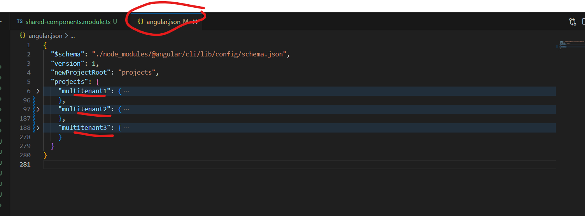

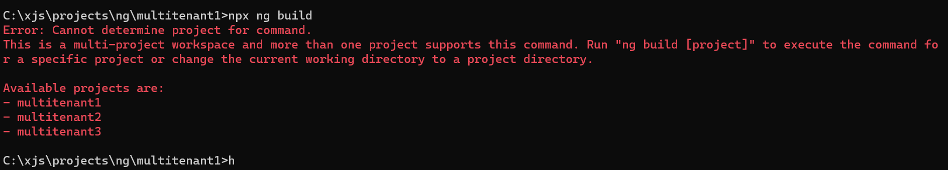

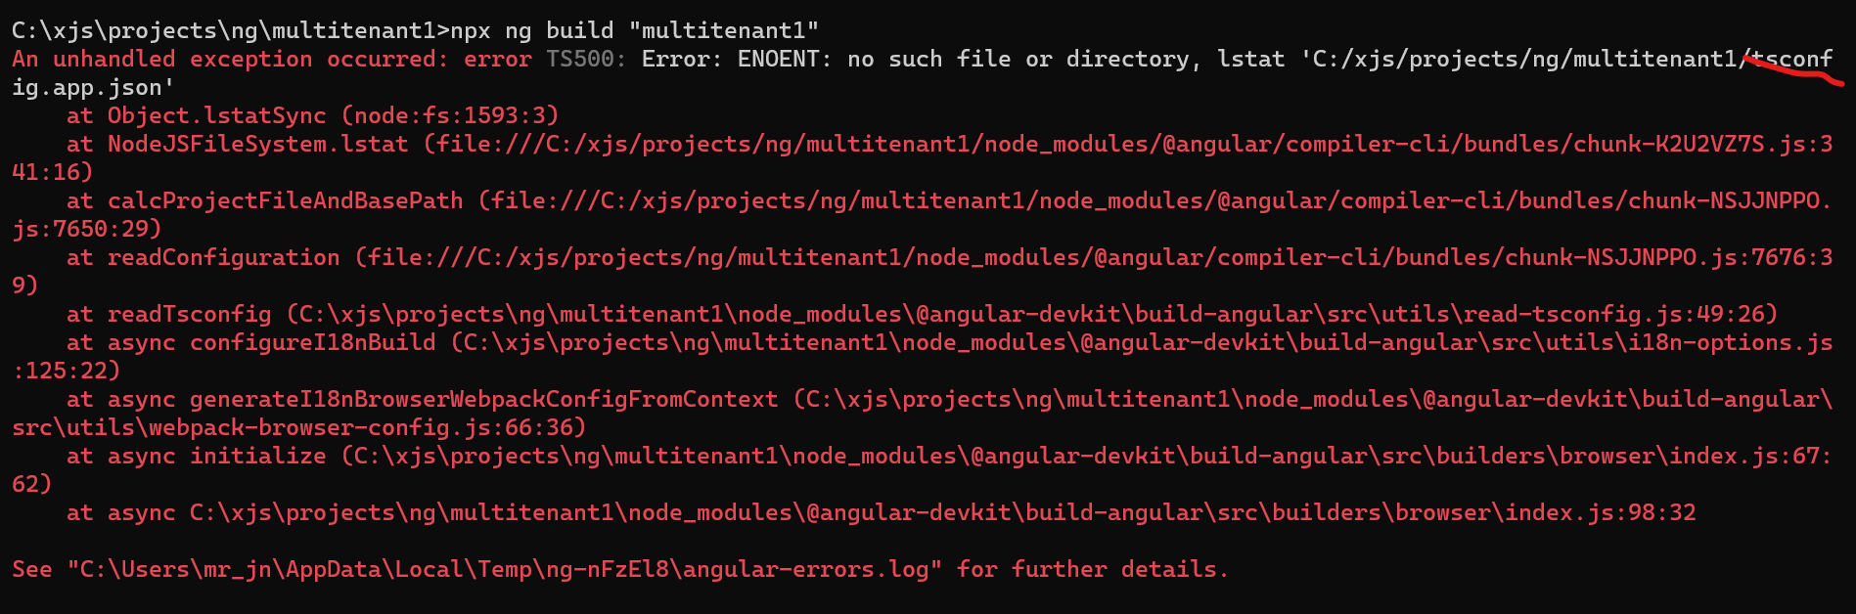

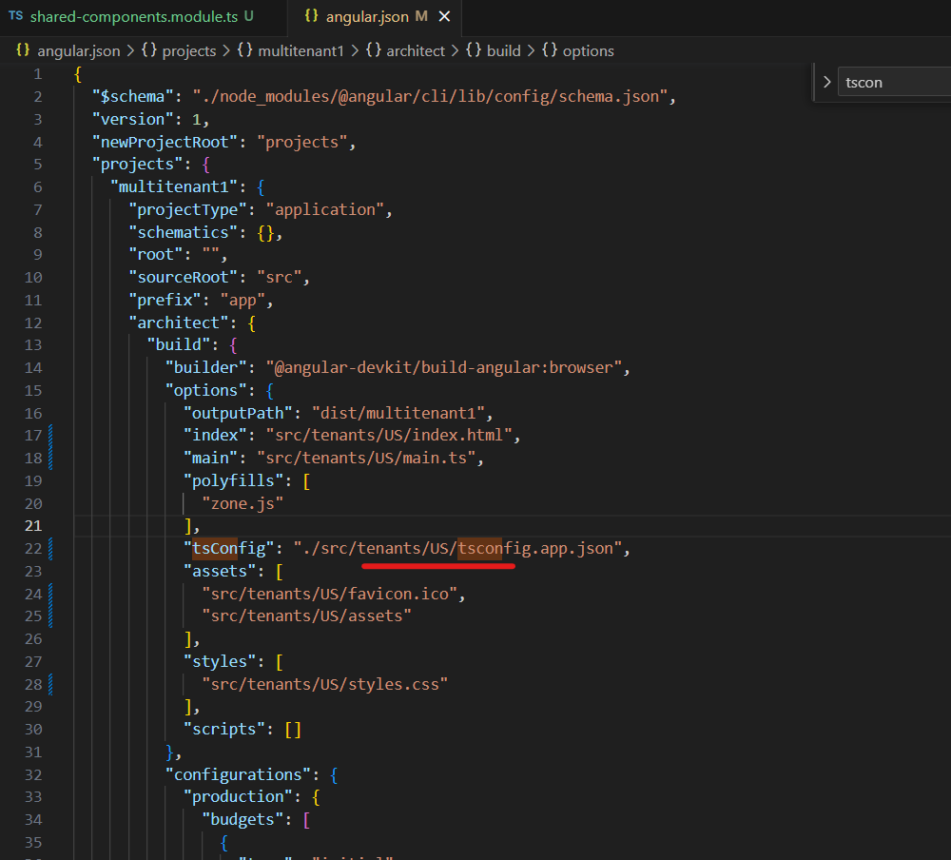

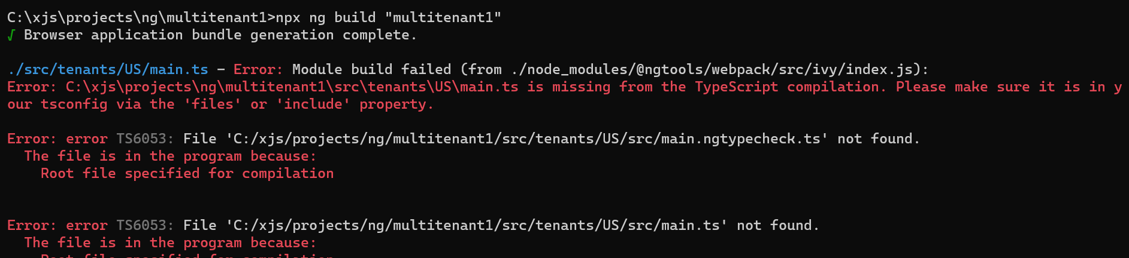

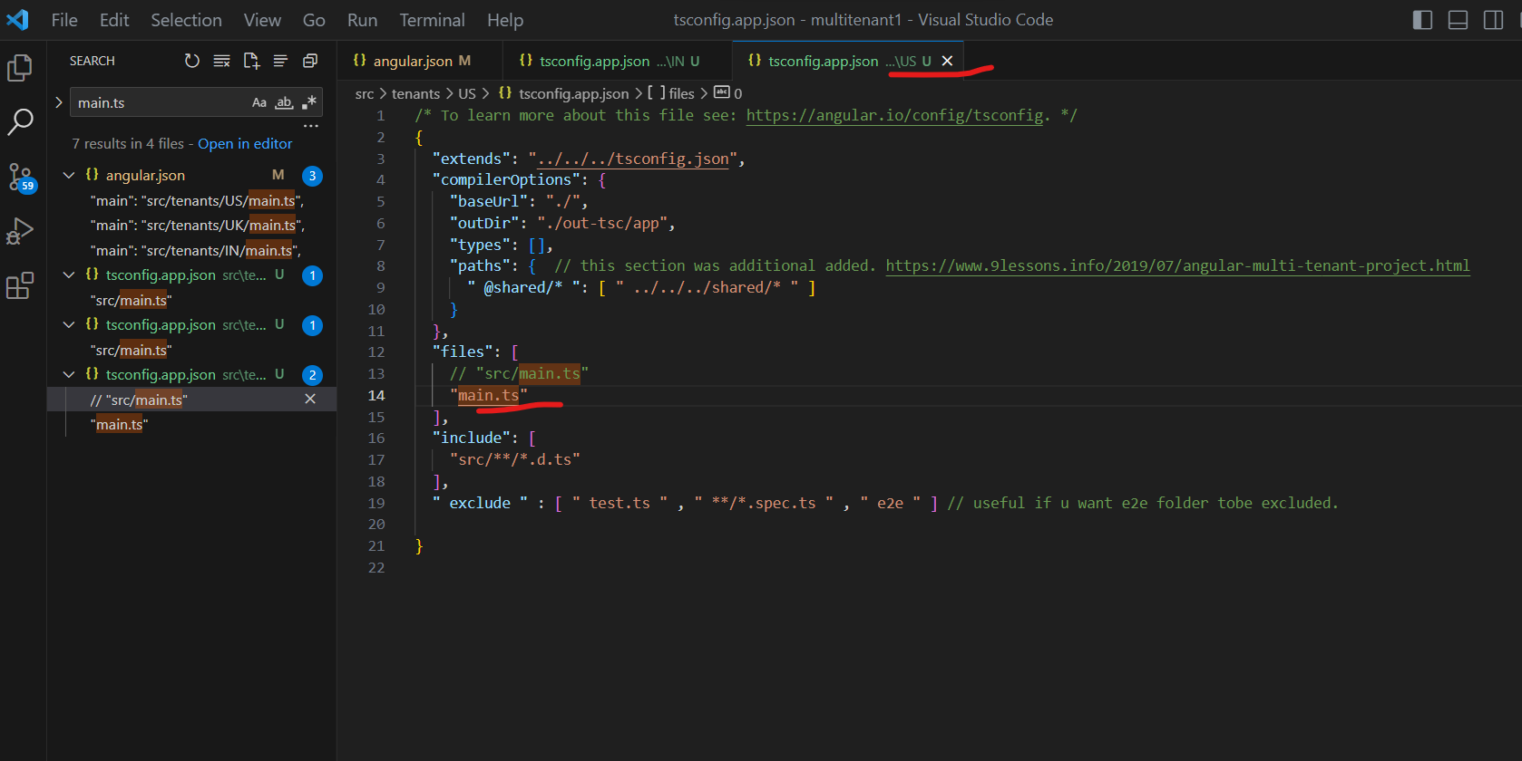

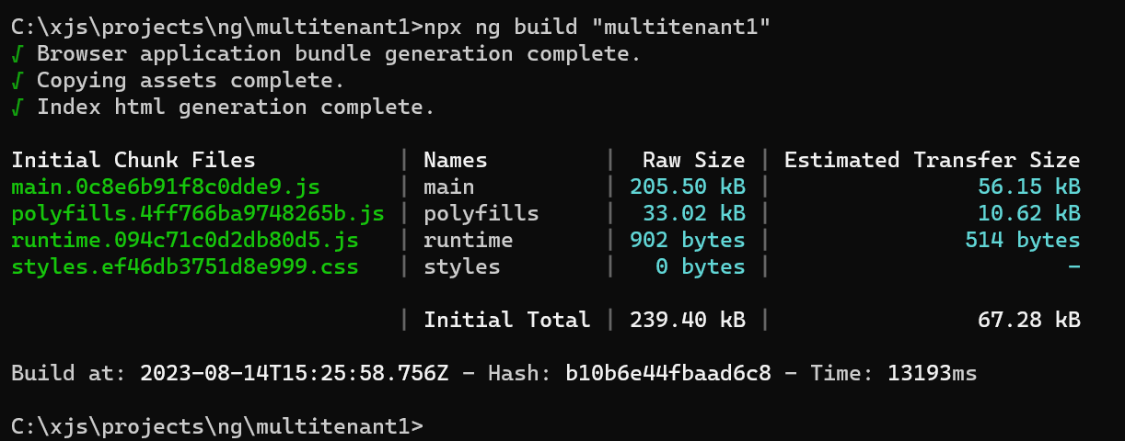

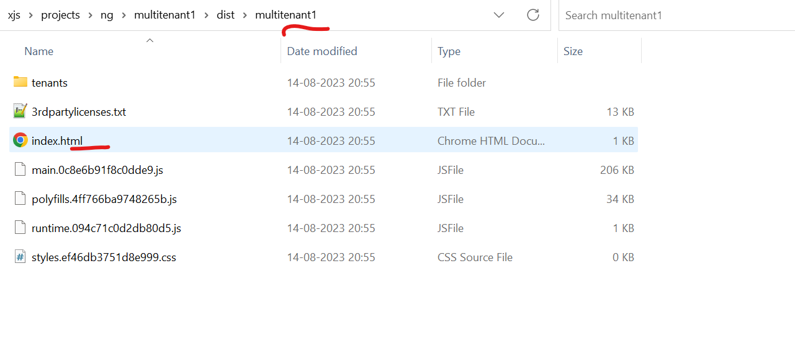

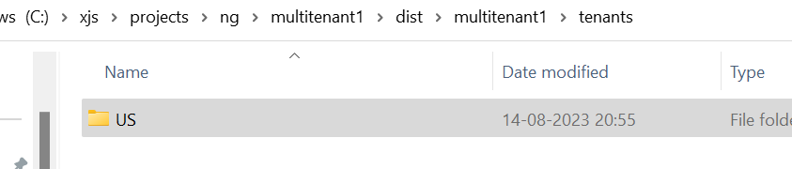

Lets test the US build now:-

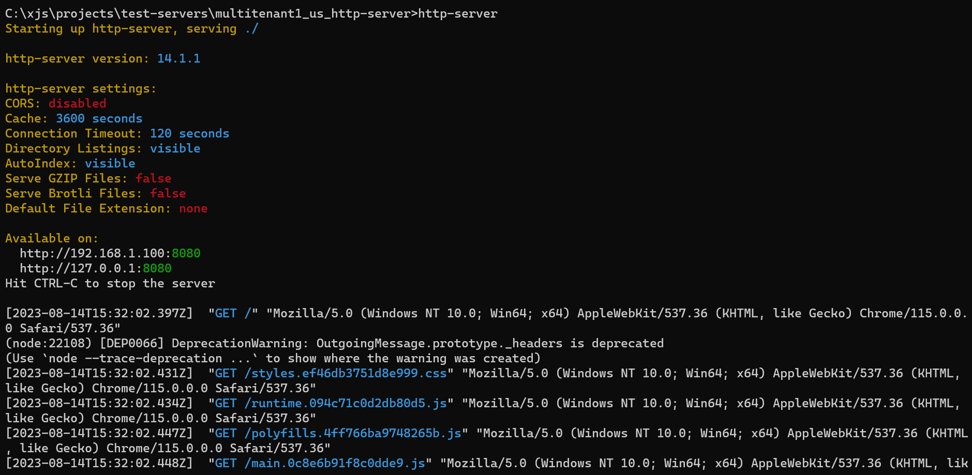

Our build works fine and the dist/multitenant1 files work well even on http-server and hence we have proof if we deploy it on an actual server, it will work fine over the http protocol

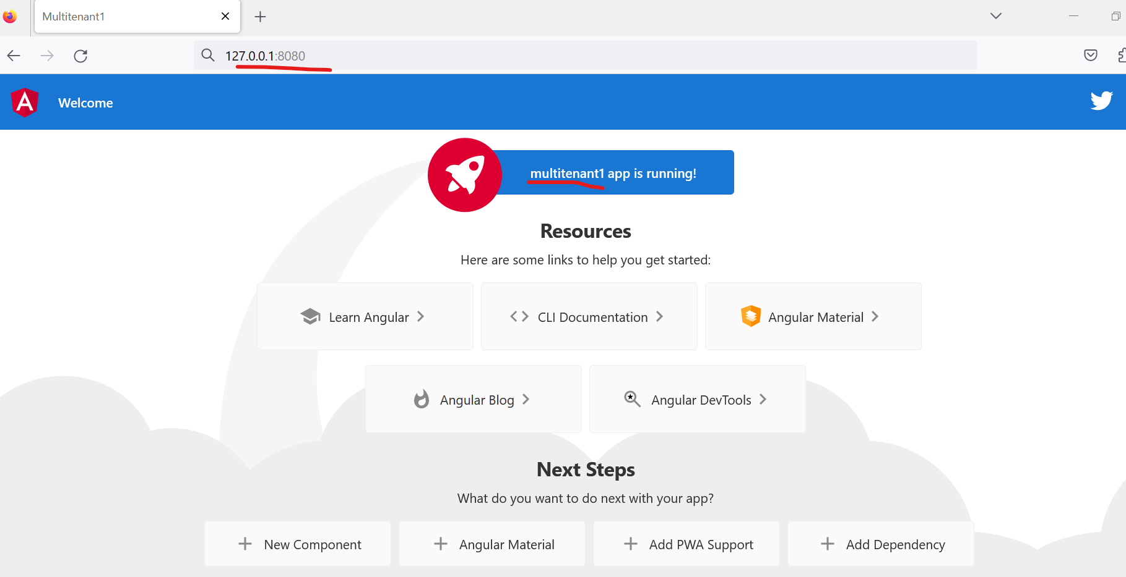

1. Do the below changes in the tsconfig.app.json for IN and UK as well.

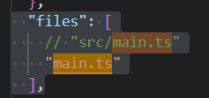

1. Also, lets do it in angular.json under “multitenant2” (UK) and “multitenant3” (IN)

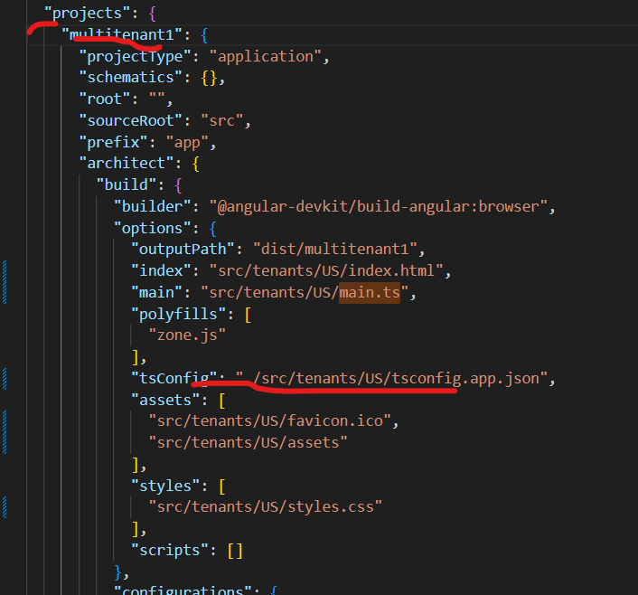

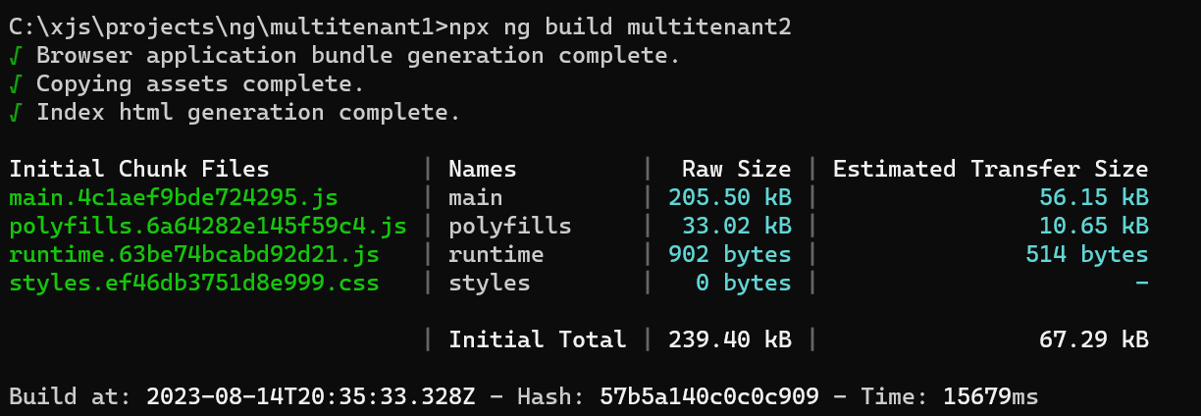

This worked with multitenant2 so, I went along and changed multitenant2 to UK and that worked too.

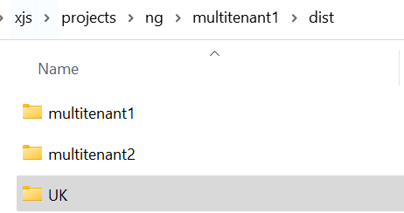

Now, lets do same changes for multitenant3 which is IN. And it worked too.

