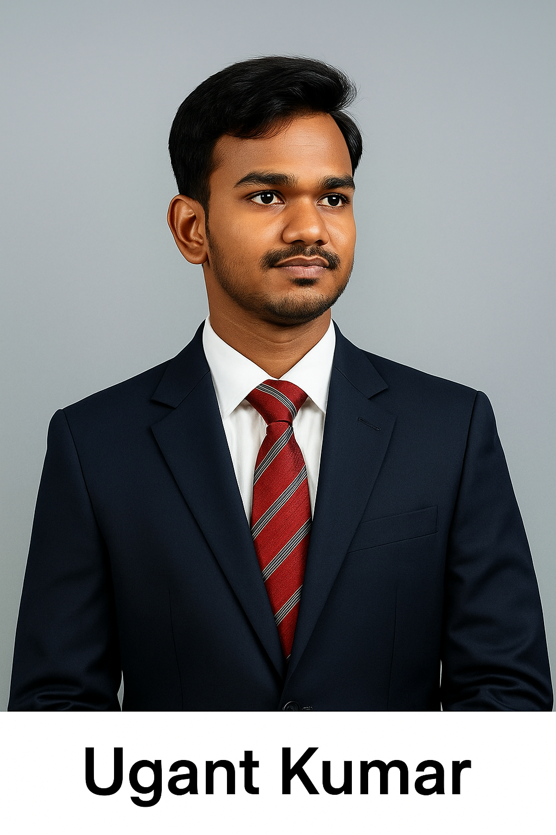

UGANT KUMAR SHARMA (Ugant Kumar)
Email: ugantsharma772@gamil.com | Phone: +91 8825155289
LinkedIn: https://www.linkedin.com/in/ugant-sharma-287590388/ | GitHub: mrjocker89 / King-890

Professional Summary
Passionate Game Developer, Generative AI Specialist, and Prompt Engineer. Skilled in Unity, Python, Blender, and generative AI pipelines.

Objective
Seeking an internship in Game Development or AI Integration focused on procedural generation, intelligent automation, and scalable tooling.

Education
BCA — IGNOU (Pursuing, Expected 2026)
10th — 75% (CBSE), 12th — 64% (CBSE)

Experience
Executive Assistant — SKN Consultancy (1 year): Admin & Finance coordination, documentation, reporting.
Freelance Developer — Lead developer of Frostbound; Blender asset generator; Unity AutoPrefabImporter.

Technical Skills
Languages: C#, Python, JavaScript, HTML, CSS, Java, C, C++
Game/Tools: Unity, Blender, Git, VS Code
AI / Data: Generative AI, Prompt Engineering, GPT4All, Whisper, Data Mining, Advanced Excel
Office: MS Office Suite, Google Workspace, Advanced Excel
Automation: FBX export pipelines, JSON metadata, Unity import automation

Selected Projects
Frostbound: Eternal Awakening — AI-powered mythological survival RPG
Blender Asset Generator — Procedural low-poly generator
Unity AutoPrefabImporter — Automated import automation

Certifications
Ethical Hacking (Cisco); multiple AI, Unity, Python certificates
References available upon request.

