Introduction

This module allows the user to visually assign points to categories before the algorithm is simulated. This is necessary as point cloud data is far too complex to manipulate without an adequate visualization and toolset. This module will provide basic features such as undo/redo, saving on-demand and an adjustable brush size.

Functional Specification

Inputs:
- Input .pcd file
- Output .pcd file
- Brush size adjustments
- Interaction state (assign to a certain category / clear assignments)
- Save to file (Command)
- Undo (Command)
- Redo (Command)

Processes:
- Read input file
- Assign point to a category
- Set interaction type
- Set brush size
- Save to output file
- Handle undo
- Handle redo

Outputs:
- Point cloud data with assigned categories
- Point cloud visualization
- Brush width status
- Interaction state

Design Choices and Rationale

OOP Design Choice

Due to the large amount of state information that needs to be stored (brush size, point cloud state, undo stack, interaction state etc.), a procedural design would be more difficult to implement. Additionally, a subsystem must be created and managed (pcl visualizer). Because of this, it would make more sense to delegate the functions of the program to an object, so that it may manage the pcl viewer system in an encapsulated manner.
In order to implement undo/redo functionality, it would be cleaner to make use of OOP abstraction in order to define how certain actions should be undone/redone.

PointCategories Header File

Since there are several modules working together, two of which heavily rely on the definition of separate point categories and their coding method (RGB representation in .pcd), a header file shared between the modules is the most suitable choice as extended the software and modifying point categories will be easier to do.

Radial Point Clustering – Naive Implementation

In order for more than one point to be categorized at a time, an algorithm which can radially cluster points is required. A Naive implementation was chosen as, in this specific application, the code will never be run in a performance critical situation (eg. repeatedly between time dependent updated), but only on-demand by the user. It is therefore to use a naive approach to solve this problem in the interest of simplicity.

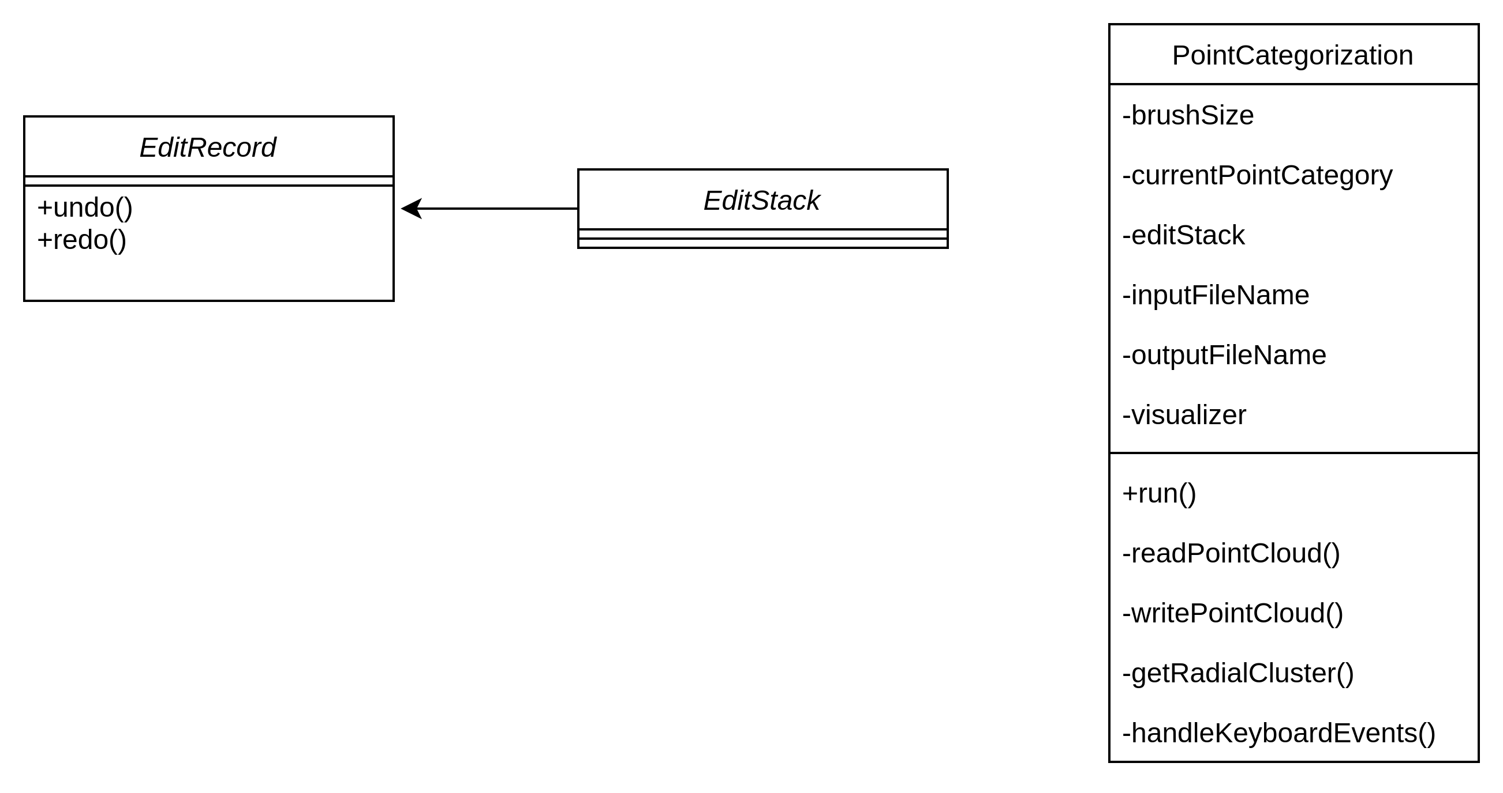
Structural Overview

