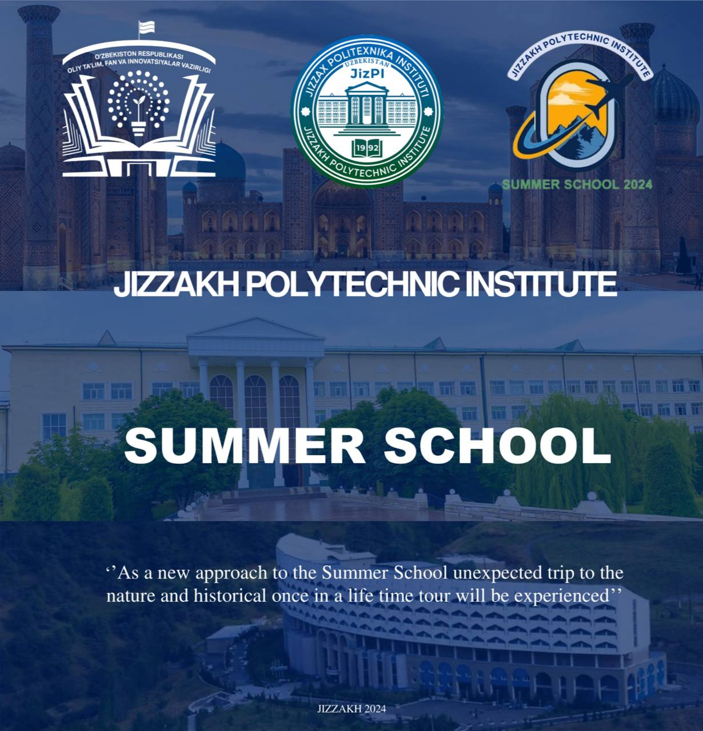

**Министерство высшего образования, науки и инноваций Республики Узбекистан и кафедра «Иностранные языки» Джизакского политехнического института предлагают международную программу «Летняя школа».**

**Всего в программе участвуют 50 иностранных студентов, которые имеют возможность принять участие в летней школе на основе специальных грантов.**

**Единовременная плата за участие в программе «Летняя школа» составляет 220 долларов США (за одного студента и участника):**

**- едино разовый платеж в размере 220 долларов США (без учета расходов на прибытие и возвращение к месту назначения программы)**

**Заявки на участие будут приниматься с 10 июня по 20 июля 2024 года.**

**Полную информацию получите по этой ссылке:** [**https://jizpi.uz/**](https://jizpi.uz/)

**The Ministry of Higher Education, Science and Innovation of the Republic of Uzbekistan and the Department of Foreign Languages of the Jizzakh Polytechnic Institute offer an international Summer School program.**

**A total of 50 international students participate in the program, with the opportunity to attend summer school through special grants.**

**The participation fee in the Summer School program is $220 (per student and participant):**

**- payment of US$220 (excludes costs of round-trip ticket.)**

**Applications for participation will be accepted from June 10 to July 20, 2024.**

**Get complete information via this link:** [**https://jizpi.uz/**](https://jizpi.uz/)

**Workshop: The sparkles of Silk Road: the commons, shrines and wonders**

*10 June-20 July, 2024*

***Date:1-6 August 2024***

***Venue: Jizzakh, Samarkand and Zaamin (in person)***

***About the workshop***

Jizzakh region is an administrative-geographical region located in the heart of Uzbekistan. At the same time, there are certain ethic features in the material and spiritual culture of the region’s population, which are the product of historical and ethno-cultural processes that have taken place in the region for many years.

As in other regions, in the Jizzakh oasis, shrines are formed mainly in connection with saints, sacred objects, natural-geographical objects, the cult of animals and their sanctification, as well as the wonders of nature. Scholar S. Tokarev said, “The advent of Islam brought with it a new religion of Islam. As a result, the local deities in Central Asia changed. The worship of local saints was widespread everywhere”.

The name Jizzakh is derived from the Sogdian word for "small fort" and the present city is built on the site of the Sogdian town of Osru-shana. Others say the name has been described as 'Key', for it controlled the strategic Pass of Jilanuti in the nearby Turkestan range, gateway to the famed riches of the Zerafshan Valley, Samarkand and Bukhara. It was a large settlement in the medieval principality of Usrushana, whose chief town was based on the ancient Sogdian city Bunjikath, present-day Penjikent in Tajikistan.

By the 19th century, the old town was mostly destroyed, its remaining inhabitants evicted, and Russian settlers brought in. Colonialism brought the railway and a slackening of caravan trade. In 1916, Jizzakh was the center of an anti-Russian uprising, which was quickly suppressed. In 1917,

Modern Jizzakh is quietly tree-lined modern city.

Almost nothing is left of Jizzakh's past: what you see is a 20th-century industrial town.

Tree-lined avenues now mark a city devoid of antique appeal, but one which offers a quietly industrial picture of contemporary Uzbek life.

The most admirable place in Jizzakh region is The **Zamin National Park** which is 75km southeast of Jizzakh, along an uninspiring road that traverses a dusty steppe and former collective farms before taking a last minute turn up into the rolling hills and snow-capped mountains that ring Tajikistan. The oldest national park in Uzbekistan (founded in 1926), it covers around 460km2 of apricot orchards, juniper forest and alpine meadow and is crisscrossed by four rivers, the Aldashmansoy, Baikungur, Guralsh and Kulsoy.

There are a number of cafes on and around the mountain, all specialising in the local delicacy - samsa! Jizzakh region counts as the capital of two Uzbek national foods like The role of the “Samsa” and “Pilaf”. The Jizzakh samsa will without any doubt impress you - the size of a small loaf, hard and crispy on the outside, and so juicy inside, it is clearly not intended for eating on the go.

The Silk Road has always been at the center of discussions about what kind of international system we have. The aim of this workshop is to help participants understand international order in the face of this tension between globalization and geopolitics. It wants to explore different issues and challenges where this tension might be more evident. These range from climate change, energy security, food, water, and the managing of borders. The workshop will focus on the policy questions that are raised and some possible scenarios for what they may mean for.

The workshop will explore the different ways in which we can understand the rapidly changing international system. It will do this by looking at a range of cases in Uzbekistan, and more specifically Jizzakh and Samarkand, as well as a range of topics. These can include the following **topics**:

1) Geopolitics of the administrative-geographical region located in the heart of Uzbekistan.

2) Geopolitics of the Environment in a globalised geopolitical world  
3) Geopolitics of modern industrial zones of the former colonial region    
4) Regional integration and geopolitics   
5) Shrines and sightseeing of Silk Road located in Samarkand.

**Trainers and organizers**

**Jizzakh Polytechnic Institute** is the state foundation that promotes regional cooperation, and good governance in wider through postgraduate education, professional training, and intellectual exchange all over the World. Jizzakh Polytechnic Institute offers bachelor’s and master’s degree programs in technical and economic spheres provides export training and conducts demand-driver research. More information: [**fazliddin.yaqubov@mail.ru**](mailto:fazliddin.yaqubov@mail.ru)

**Jizzakh Polytechnic Institute** is located in the center of Jizzakh city which lies between the capital of Uzbekistan and one of the most famous historical cities of the world Samarkand. In addition to offering the full range of academic degree programmes, from undergraduate to doctorate, it has a long tradition of contributing to ongoing policy debates that explore ecologically safe researches.

**Medium of workshop**

English, Russian, Uzbek.

**Eligibility**

* Completed BA or MA degree in Social Sciences or other related fields;
* Researchers, activists, and experts are also eligible to apply;
* Be fluent in English
* Students of bachelor’s and master’s degrees of international universities.

**How to apply**

Please submit the following documents in a single PDF document of no more than 4 pages, all in English, saved as Mr./Ms._ Name_ Surname_ GGW:

* The most recent curriculum vitae of no more than two pages;
* A letter of motivation up to 300 words

Please send your documents by email to: [**fazliddin.yaqubov@mail.ru**](mailto:fazliddin.yaqubov@mail.ru)

**NO LATER** than **20 July 2024 at midnight (Tashkent time).** Please indicate **“The sparkles of Silk Road: the commons, shrines and wonders”** in the subject line of your email. An application that does not follow these instructions will not be reviewed. Please NOTE that **we do not accept applications after the deadline and only selected candidates will be contacted.**

**Deadline**

The deadline for submission of the documents is 20 July 2024 at midnight (Tashkent time).

**Selection**

Invited workshop participants will be required to fully attend the program and complete all workshop activities.