- Based on the data assigned, use the customer data and Python code to identify the characteristics of the segments.
See figure 1 in the appendix for a summary of means by cluster.
Cluster 0
This group stands out to be less knowledgeable about sports equipment compared to the other groups. This translates into the group being more price sensitive than others.
Cluster 1
This group engages in cycling but doesn’t necessarily run or do triathlons. They generally do their own research and are knowledgeable in sports equipment.
Cluster 2
Compared to the other two, this group engages in triathlons. They manage recovery and sleep time, know a lot about sports equipment, and are less price sensitive compared to the other two.
- What are some attributes that are unique to each segment? What differentiates each segment from the other?
Cluster 0
Out of the three groups, this one stands out for the more “casual” responses across the survey. The is best reflected in the response to “I track and use data to measure performance”, where they had the lowest mean score compared to the other groups (figure 2).
Cluster 1
Cycling is what differentiates this group (figure 1) and tends to be older (figure 3).
Cluster 2
This group is differentiated with their investments in technology and equipment, and they’re willing to pay a premium for it all (figure 1).
- What characteristics define these segments based on the means of the questions used to create the segments? What other products do members of these segments own, and what other sports activities are popular among them?
Cluster 0
Cluster 0 skews towards cycling but is less inclined to engage in running or triathlons (figure 4). They own a smart watch, but don’t own cycling computers, heart rate monitors, or recovery trackers. Compared to Cluster 1, which is also cycling inclined, Cluster 0 tends to own indoor equipment such as a spin/exercise bike.
Cluster 1
Cycling is the focus of this group (figure 4). Unlike Cluster 0, they are interested more in outdoor cycling with little ownership of spin/exercise bikes. However, they stand out from the other groups for their ownership of bike trainers and cycling computers with GPS.
Cluster 2
The triathlete group engages in all three sports: triathlons, running, and cycling (figure 4). They also tend to own a lot of equipment compared to the other groups with high mean scores of various equipment categories.
- Are the segments consistent with Wahoo management’s institution? If not, how do they differ?
The clusters 1 and 2 are consistent with Wahoo management’s institution and align the company’s “tip of the spear” mentality. They leverage data to measure performance (figure 2) and Wahoo’s product offerings are positioned to serve that need.
On the hand, cluster 0 is differs with generally “casual” survey responses and doesn’t necessarily use data to measure performance (figure 2). This is more of a spin/exercise group based on their high inclination to own the equipment vs other products.
- What recommendations do you have for Wahoo’s growth strategy based on your segmentation insights?
Based on the segmentation insights, I recommend the company focuses on existing customers and expand their product and service offerings to meet their needs. This where the most value exists.
Cluster 2
This segment offers the most customer lifetime value and represents Wahoo’s target customer with their inclination to use data to track performance. Compared to the other segments, this group is more inclined to invest in a lot of equipment and pay a premium for it. There’s a lot of opportunities to expand offerings to this group.
Cluster 1
As the cycling enthusiast segment that also values data to track performance, there’s also a lot of customer lifetime value with this segment. Expanding services around the equipment they value such as bike trainers and cycling computers is where opportunities exist.
Cluster 0
This is not Wahoo’s target consumer and has a low customer lifetime value compared to the other two. They value data less when measuring performance and don’t invest in equipment outside of spin/exercise bikes and smart watches. In addition, they are more price sensitive to the other two groups.

Appendix
Figure 1 – Summary of Psychographic Responses:
question | 0 | 1 | 2
Q1_1 | 2.38 | 2.52 | 2.81
Q1_2 | 2.81 | 3.38 | 2.65
Q2_1 | 3.9 | 3.47 | 4.41
Q2_2 | 3.84 | 4.1 | 4.35
hqCycle | 1.14 | 1 | 1.06
hqRun | 1.37 | 1.64 | 1.15
hqTri | 1.54 | 1.79 | 1.18

Figure 2 - I track and use data to measure my performance
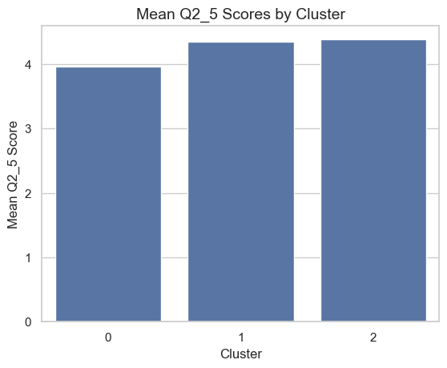
Figure 3 – Average Age by Cluster
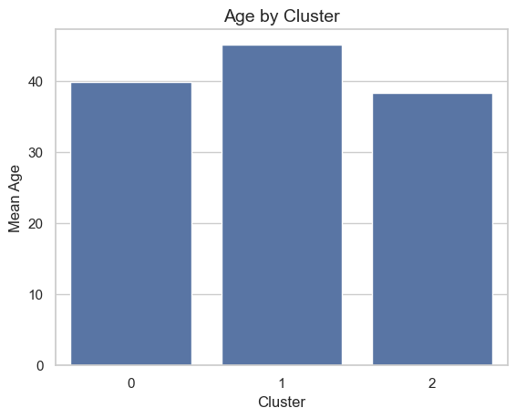
Figure 4 – Sport Preferences by Cluster
