HTML Assignment 2

This is to be done AFTER you have read through Formatting and Lists and played around with some of those concepts! You will be creating another file in the folder called Lastname_Firstname_HTML (from the previous assignment). In that folder you will be creating a file named: HTML2_Lastname_Firstname.htm.

- Create another file in Notepad. Save this new file in your HTML folder with the filename of: HTML2_Lastname_Firstname.htm
- The html used for this page is shown below. Enter this text in notepad. Watch out for the syntax. An example of your final web page is shown on the next page.

<HTML>

<HEAD>
<TITLE>My Second Web Page</TITLE>
</HEAD>

<BODY>
<H1>My Second Web Page</H1>
<H2>My Name is (enter your first and last
name)</H2>

<P style="color:blue">Please notice how this text is blue. Why? (Place your answer here)</P>

<P style="color:black">Back to black again.</P>

<UL>
<LI>Each list must start with the UL tag.
<LI>Each list must end with a /UL tag.
<LI>UL lists mean unordered list (aka. bullets)
<LI>OL lists are ordered (aka. numbers or
letters)
<LI>Each item of list should start with an LI
tag.
<LI>Look at this list and compare to other ex.
in book.
</UL>

</BODY>

- Your instructor will inform you on how he/she would like you to turn in this assignment.

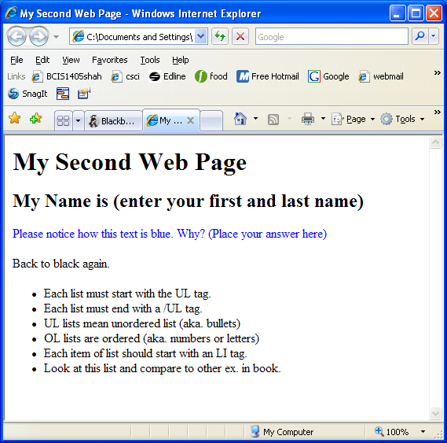

DUE BEFORE CLAS ON FEB 11: Email attachment to jsiekpe@tnstate.edu (DO NOT USE jsiekpe@my.tnstate.edu)

