HTML Assignment 3

This is to be done AFTER you have read through Images, Links, and Lists and played around with some of those concepts! You will be ADDING files to the Lastname_Firstname_HTML. In that folder you will be creating a file named: HTML3_Lastname_Firstname.htm

- Open Notepad (click on Start/All Programs/Accessories/Notepad). In notepad create a webpage using the following step by step guidelines. Make sure and save your file in your HTML folder with the name of: HTML3_Lastname_Firstname.htm :
- Make sure and use indentation and blank lines to keep your HTML easy to read!
- Start your web page with an <html> tag
- Add a heading <head> area with a <title> tag.
  - Your title should be: HTML 3 Lastname Firstname
  - Where Lastname and Firstname is YOUR Lastname and Firstname
  - Make sure and close out the head and title tags
- You can now start the <body> section.
  - Add the following text using <H1> and </H1> tags: This Web page was Designed by (your name)
  - Add the following text using <H2> and </H2> tags: My third HTML assignment
  - Use the <hr> to add a horizontal line
  - Insert an image to your web page.
      - Note: The following is very important. You should save your image in the same folder as your web page.
      - You should then refer to your image with just the filename, and NOT the entire pathname to the file.
      - For example, if you file is on your c: drive in the HTML folder, and it is called mypic.gif you will have a line: <img src="flag.jpg">. Do NOT do: <img src="c:/flag.jpg">. The latter means that I would have to save your flag.jpg on my C: drive for it to work. If you just refer to the filename then I can view the image as long as I save your image with your webpage.
  - Use the <hr> to add another horizontal line.
  - Enter a paragraph of text using the <p> tag.
    - Talk about things you have learned in html.
    - Make sure the text in this paragraph is a color other than black, but something I can see.
    - Add a link that takes you to your favorite webpage.
    - Make sure and close out the <p> tag.
  - Use the <p> tag to start a new paragraph.
  - For review, add a three item ordered list. Make it creative (don’t just say item 1, item 2, etc… and keep it clean)!
  - Use </body> and </html> to close out your body and html tags.

- The following figure is what your web page should look like (see next page). Your image does not have to be a flag. It can be any .jpg file. If you don’t have one, just use one that you used in your assignments.

- Take your time. Look at examples in the book.

- Make sure and turn in your .htm file AND your .jpg file. Without the jpg file, your instructor will not be able to view your image. Both of these files should be in your folder.

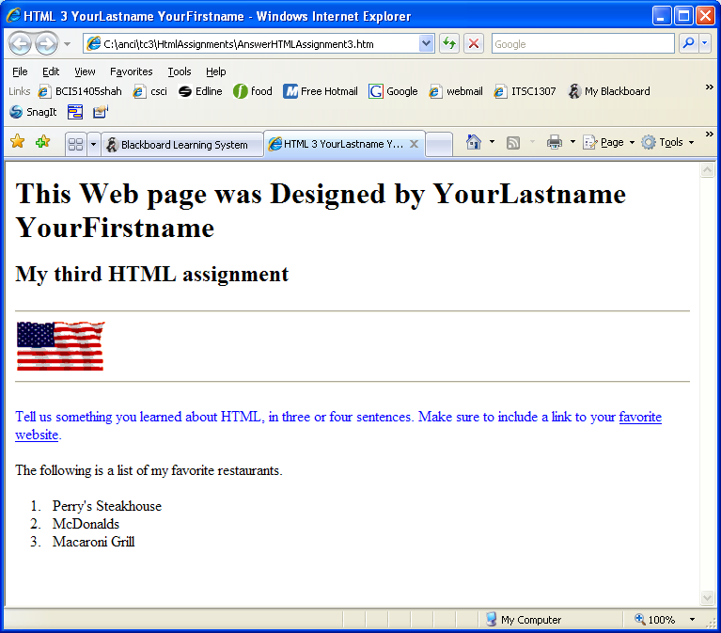

DUE BEFORE CLAS ON FEB 18: Email attachment to jsiekpe@tnstate.edu (DO NOT USE jsiekpe@my.tnstate.edu)

