React Node.js MySQL CRUD Tutorial for Beginners

<https://www.youtube.com/watch?v=fPuLnzSjPLE&list=PLXE2Bj4edhg56h_EB2JbUKPfknkPo_Jyv>

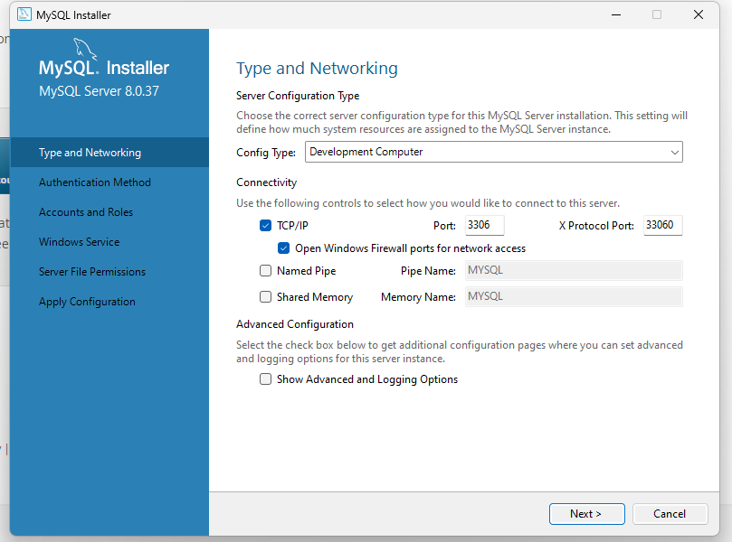

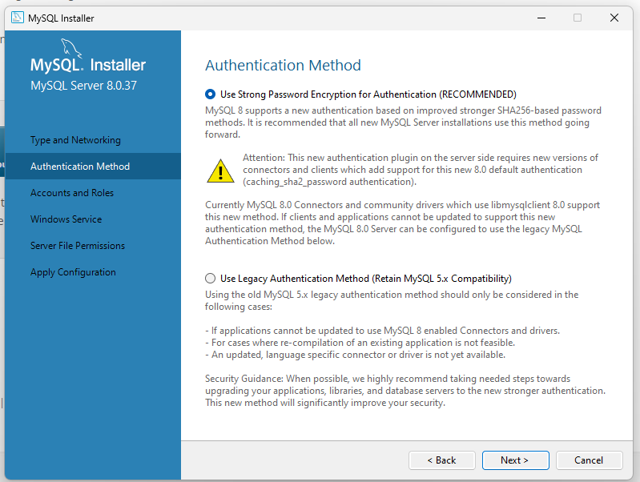

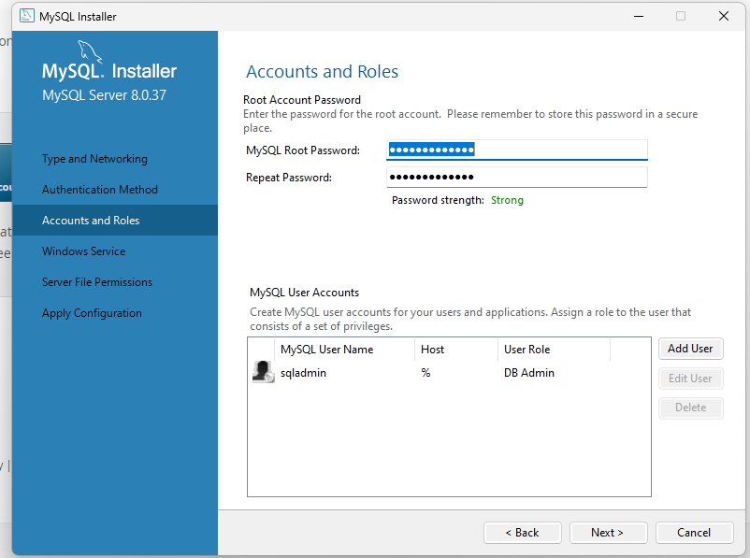

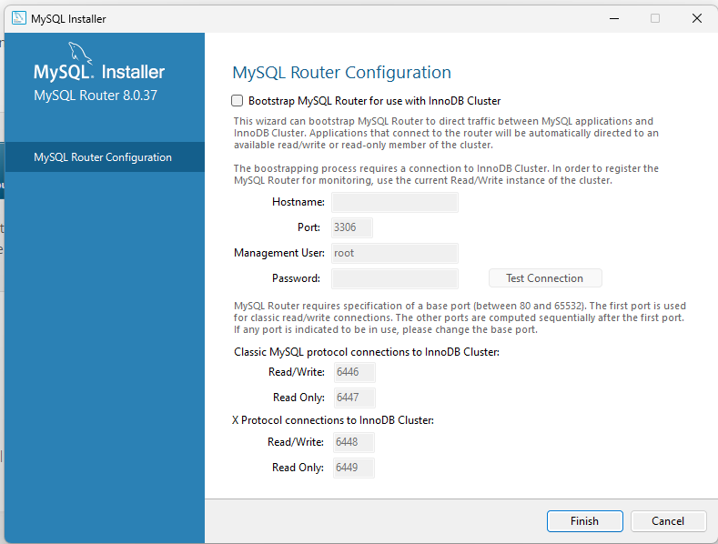

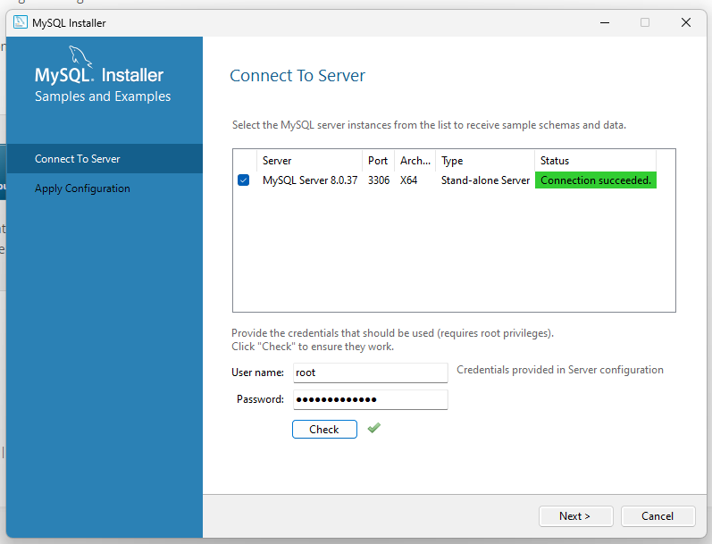

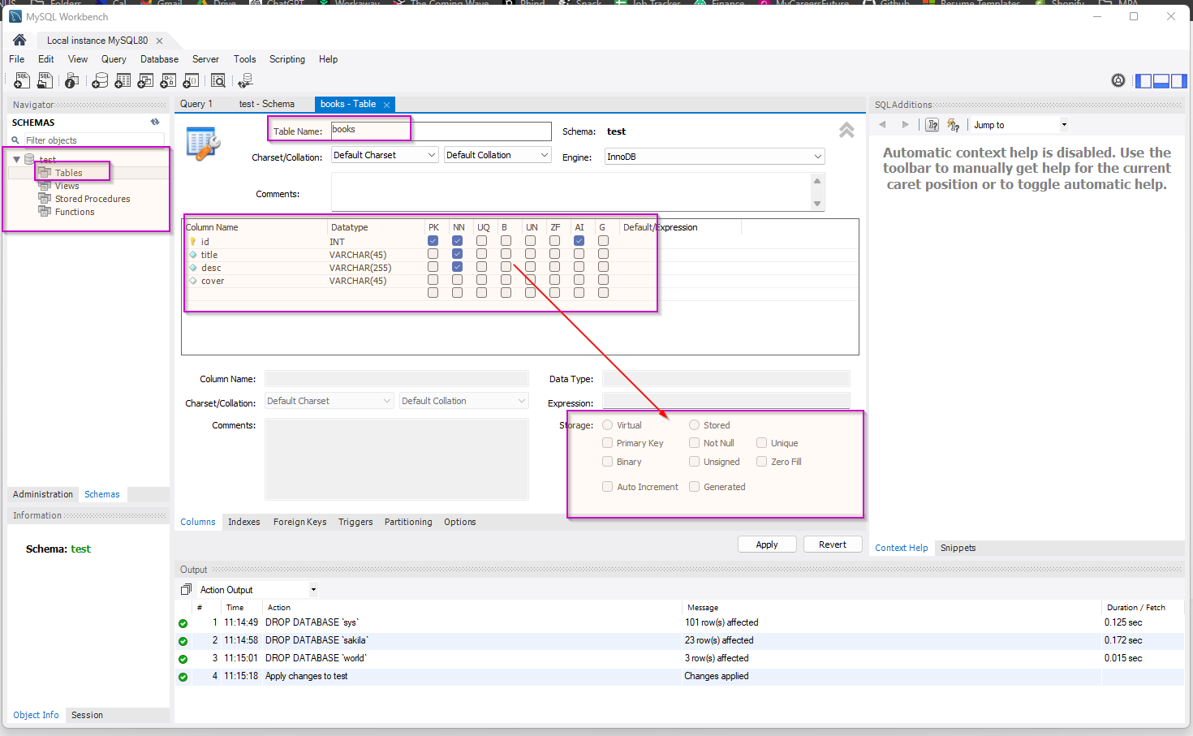

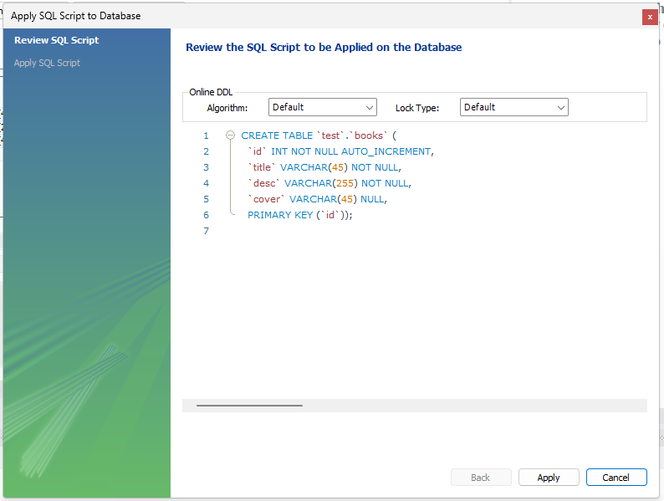

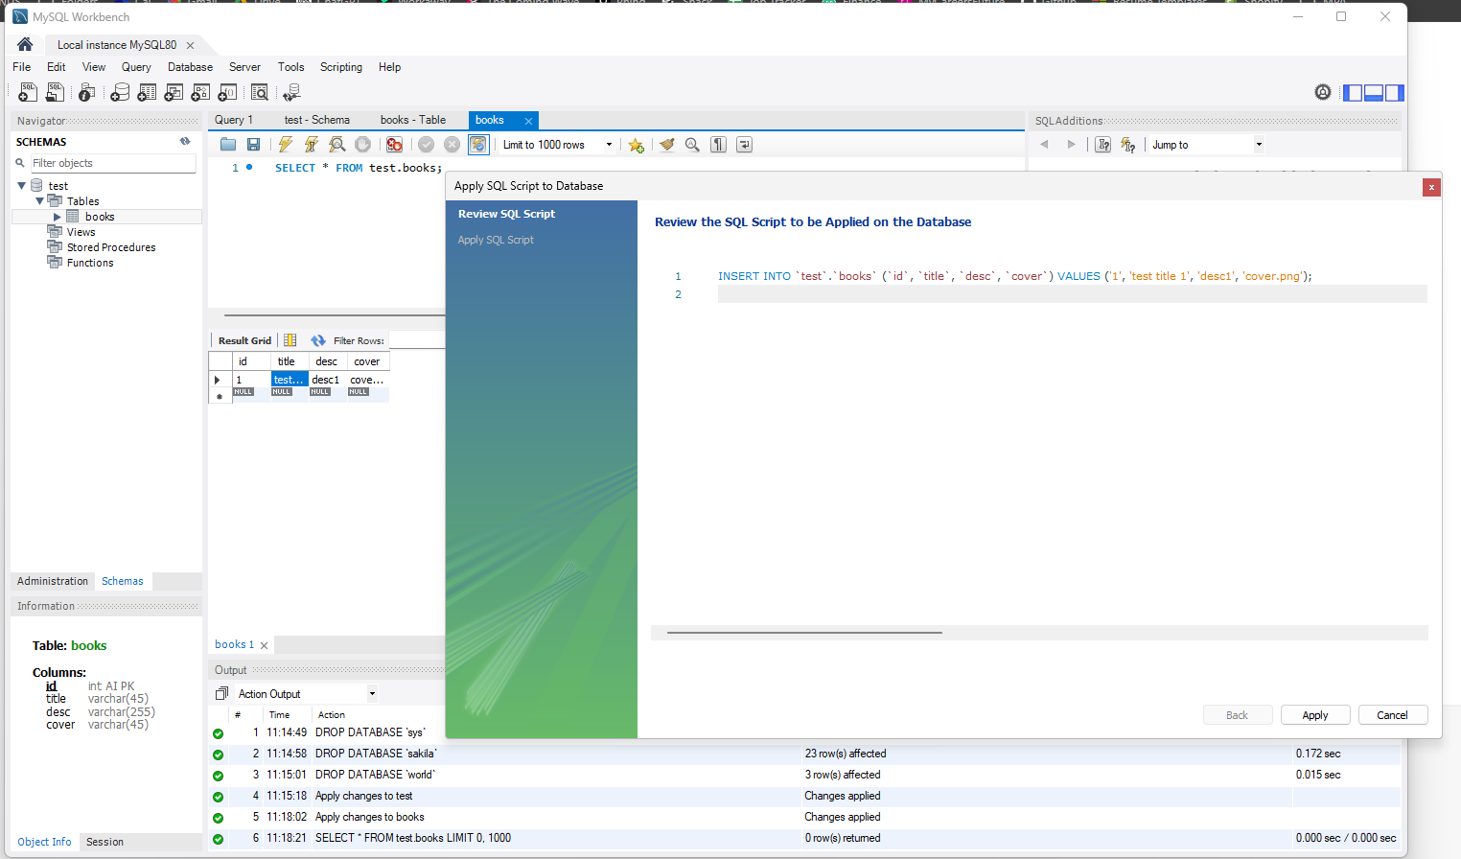

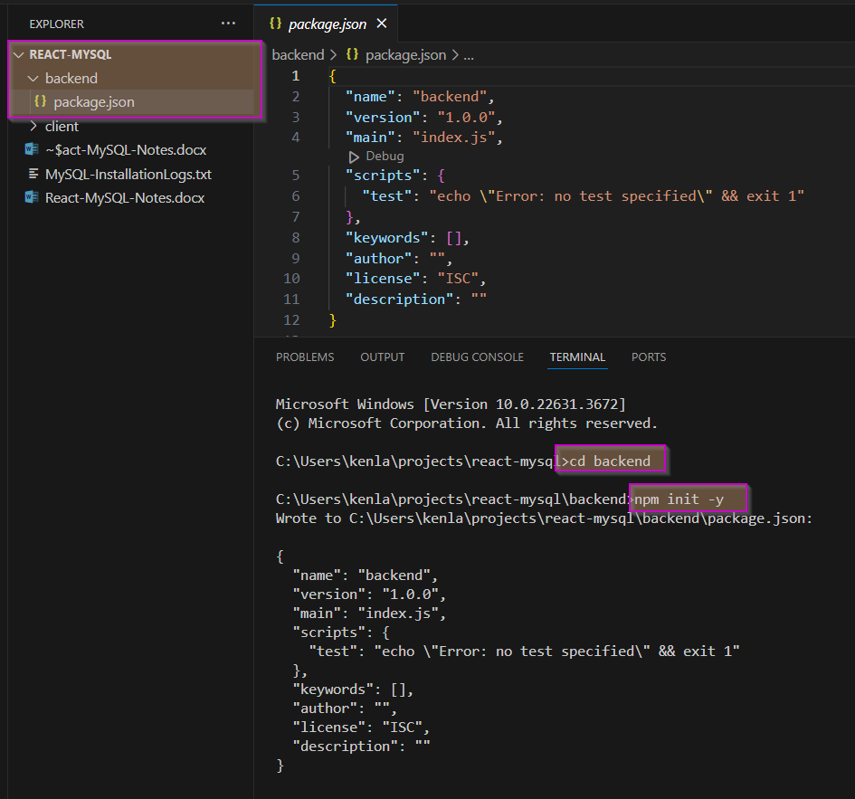

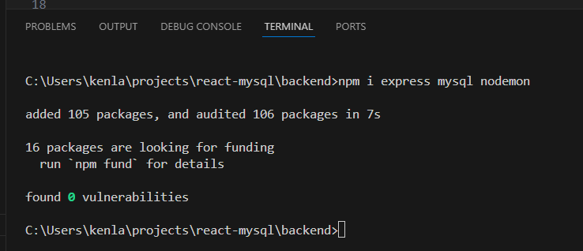

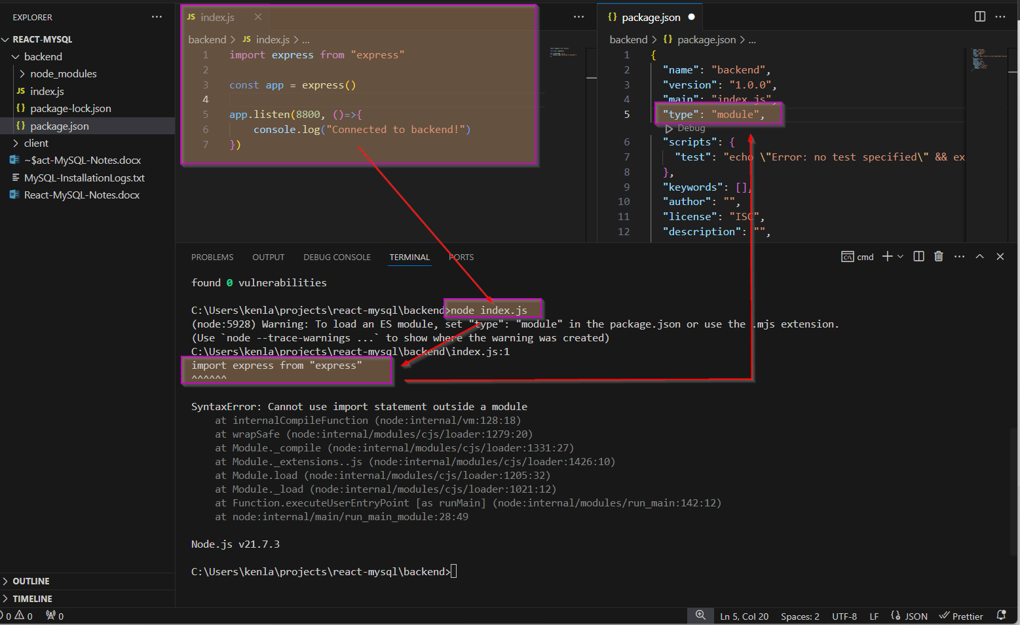

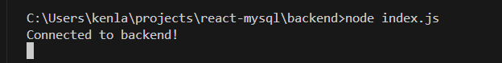

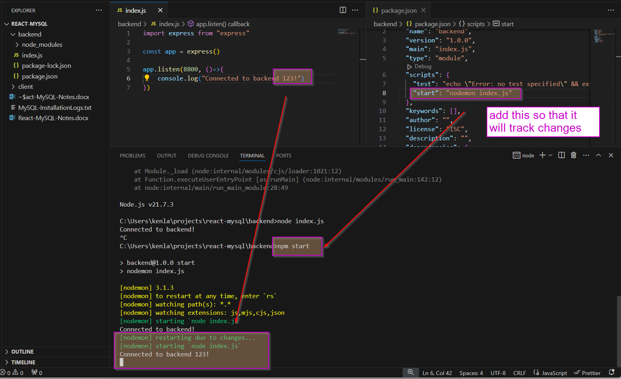

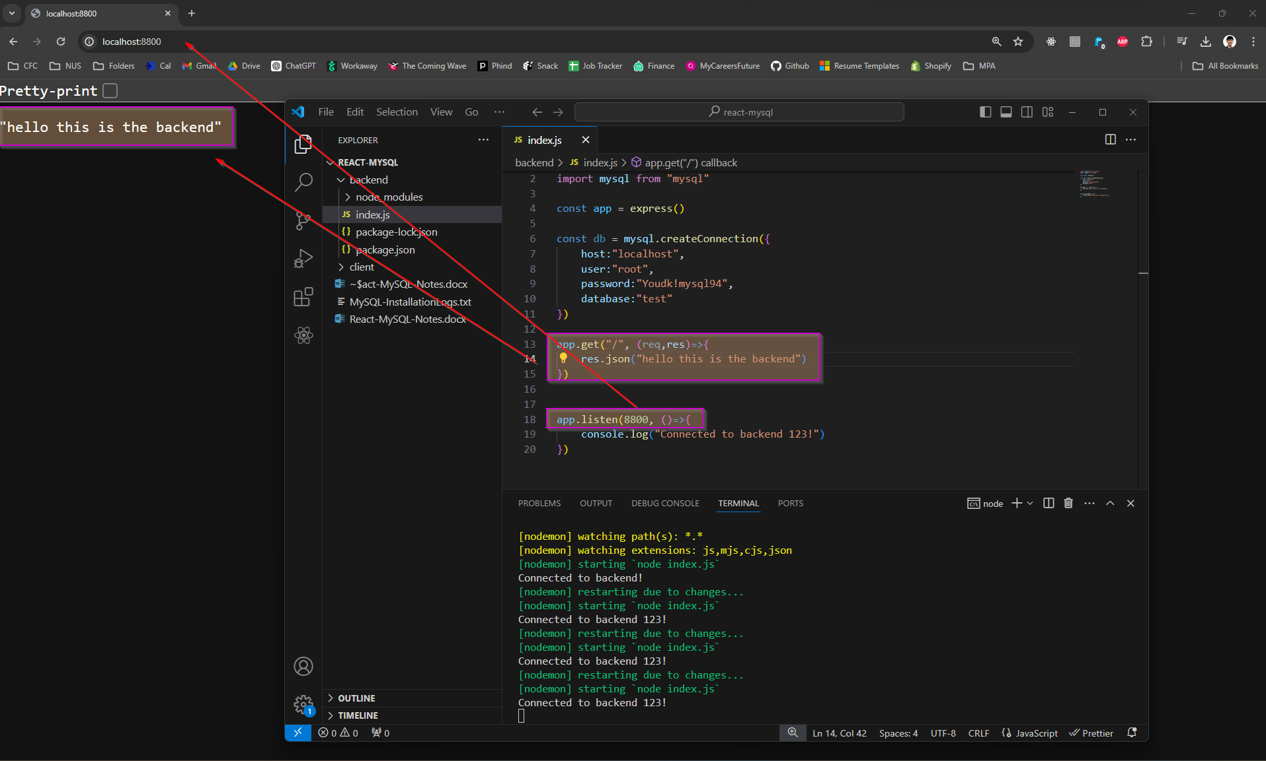

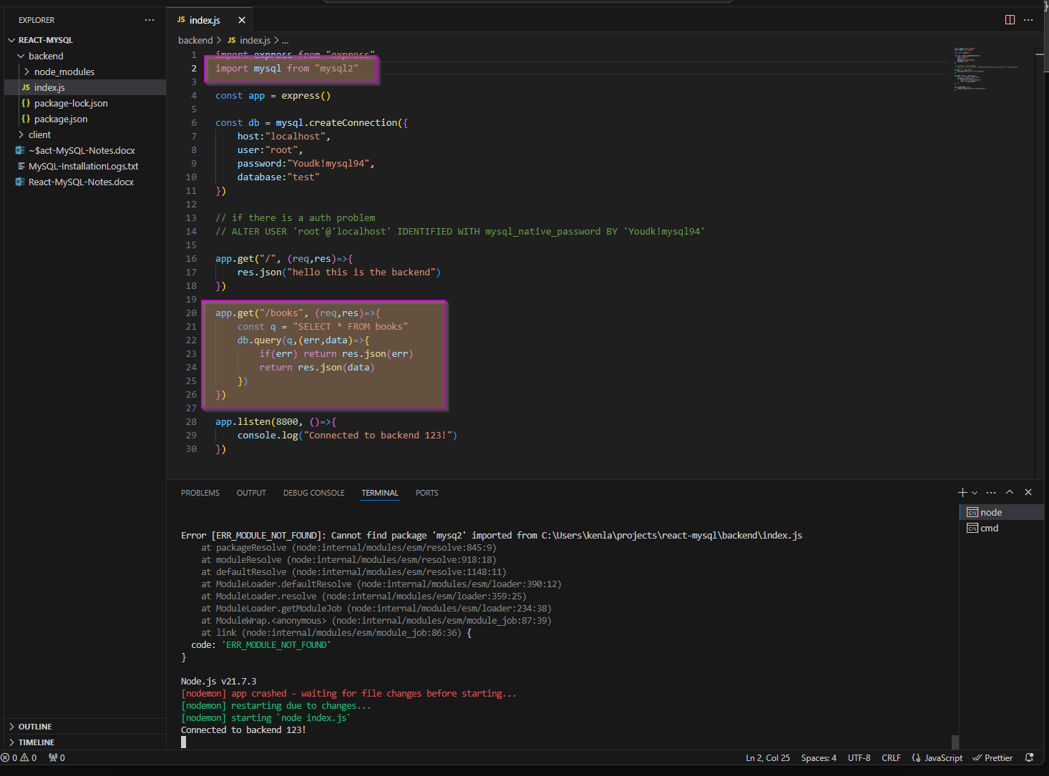

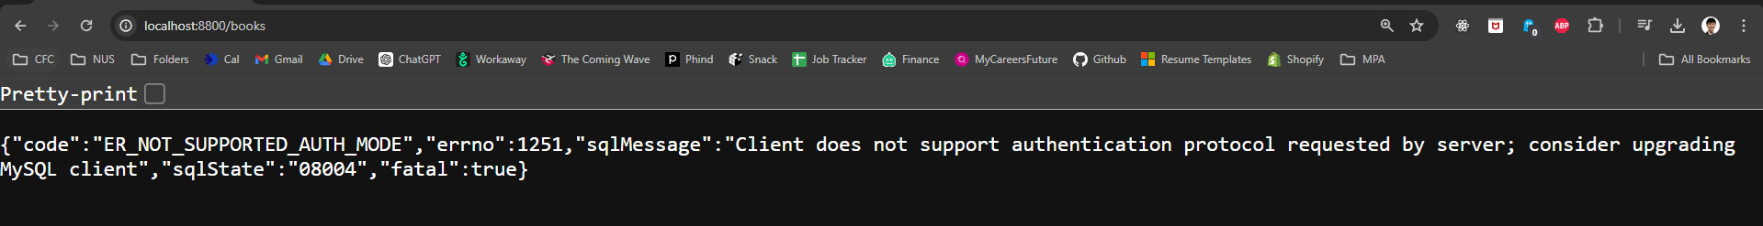

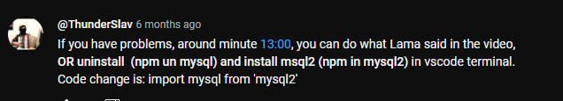

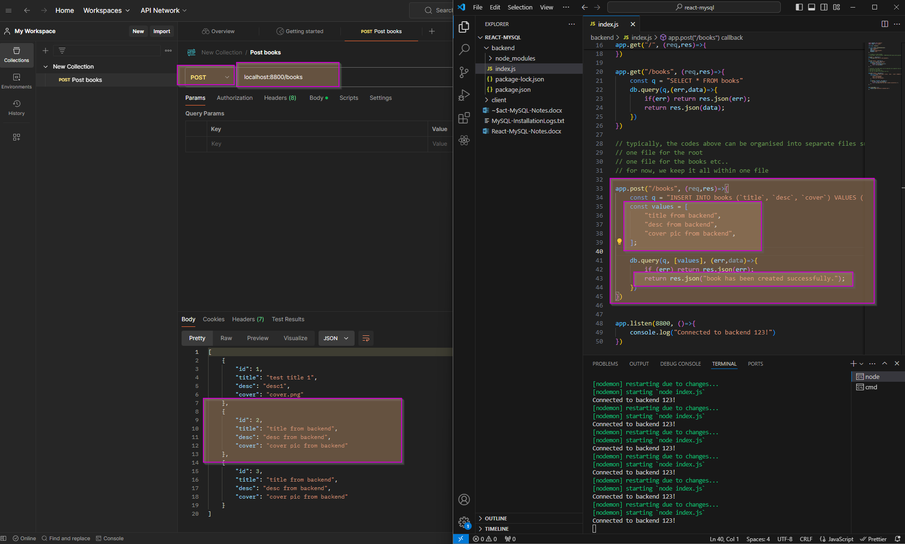

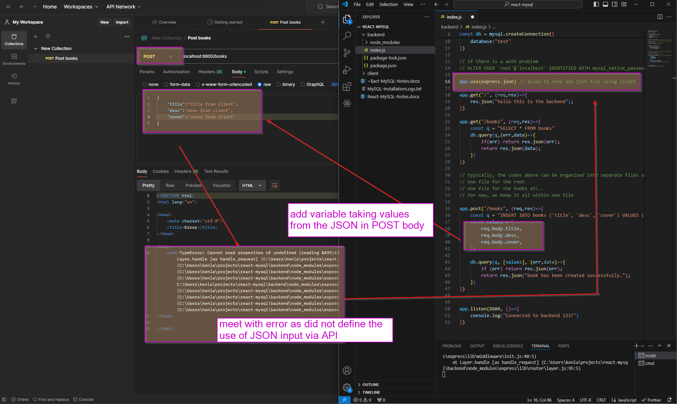



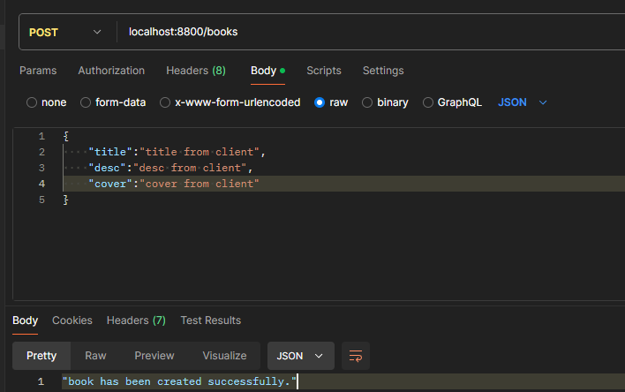

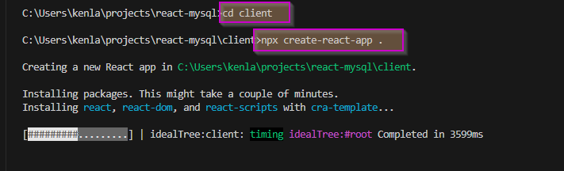

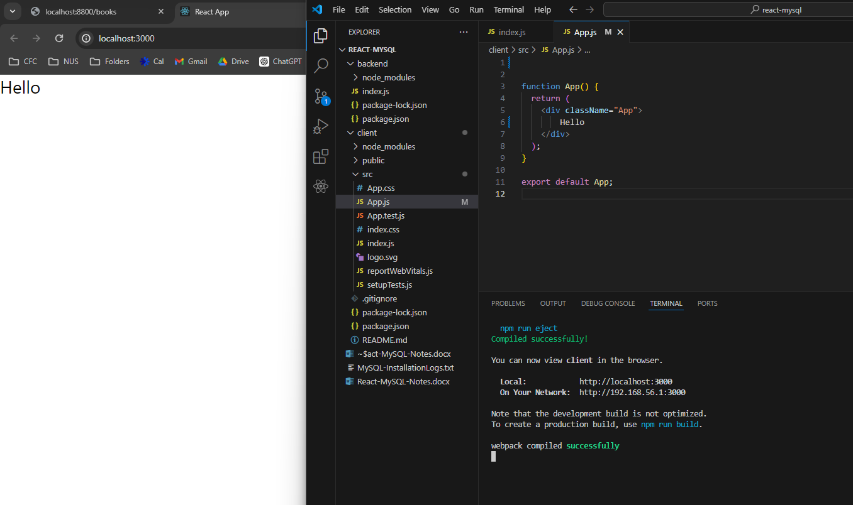

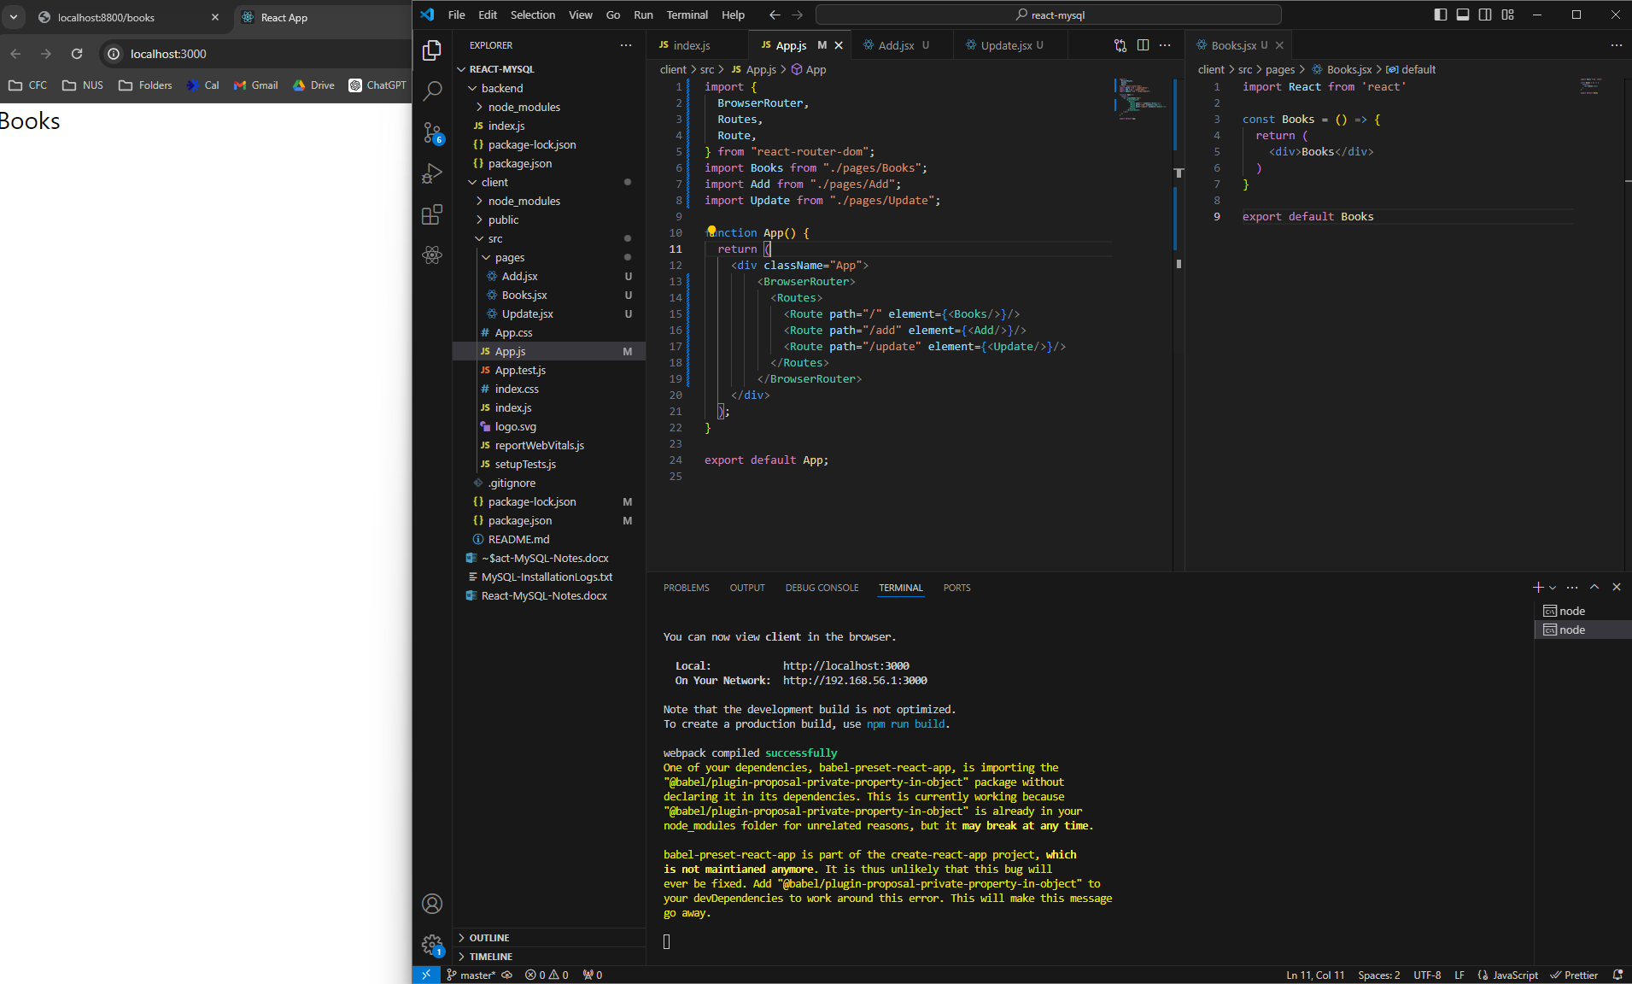

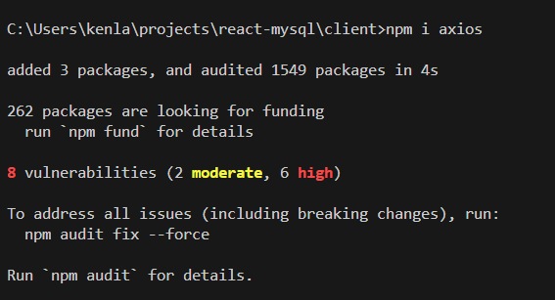

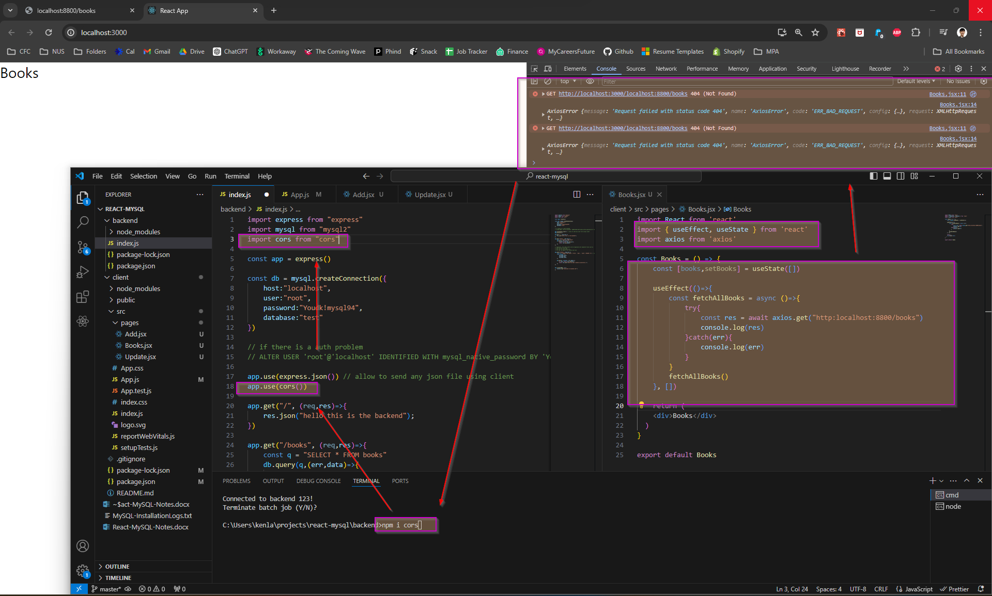



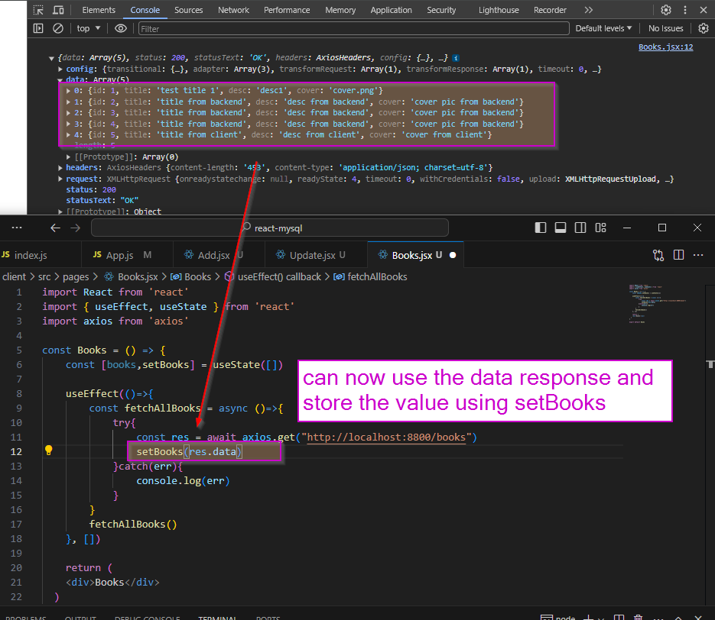

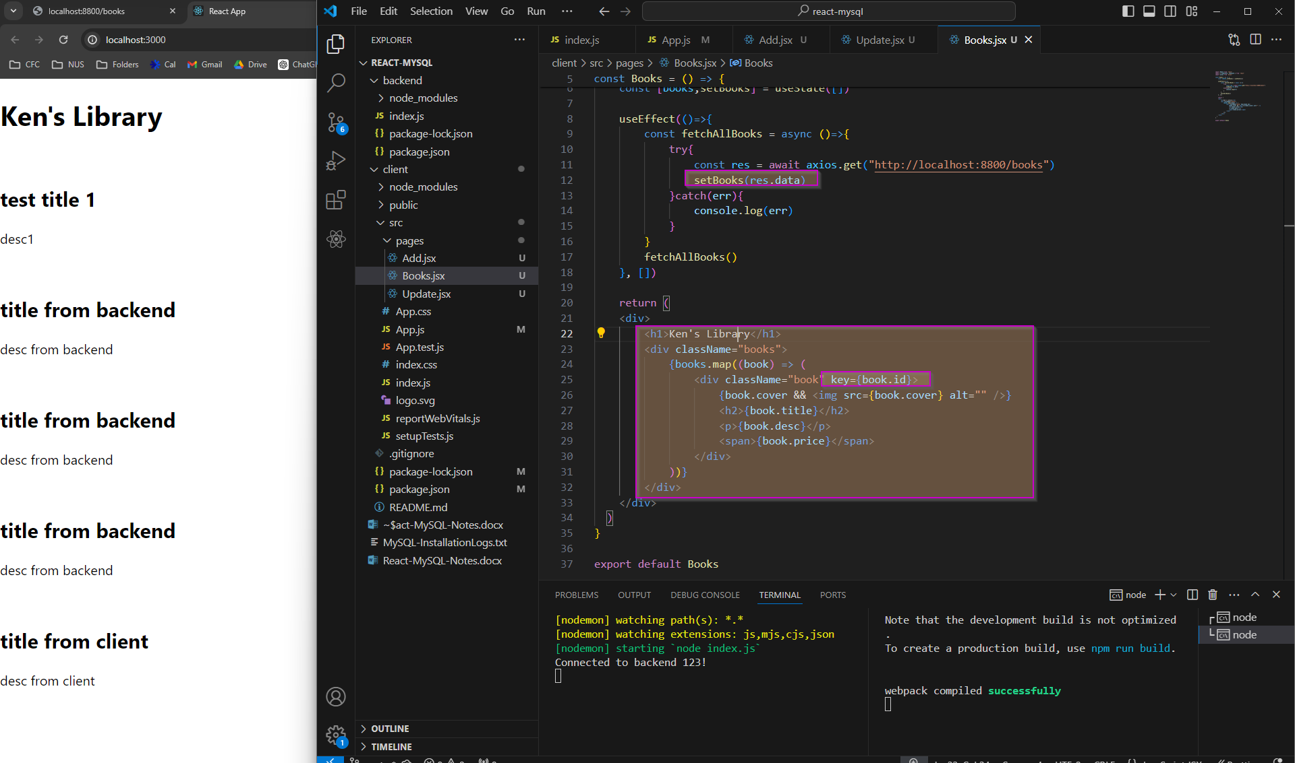



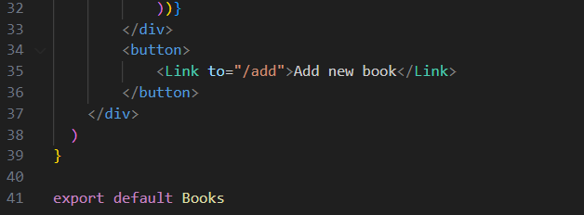

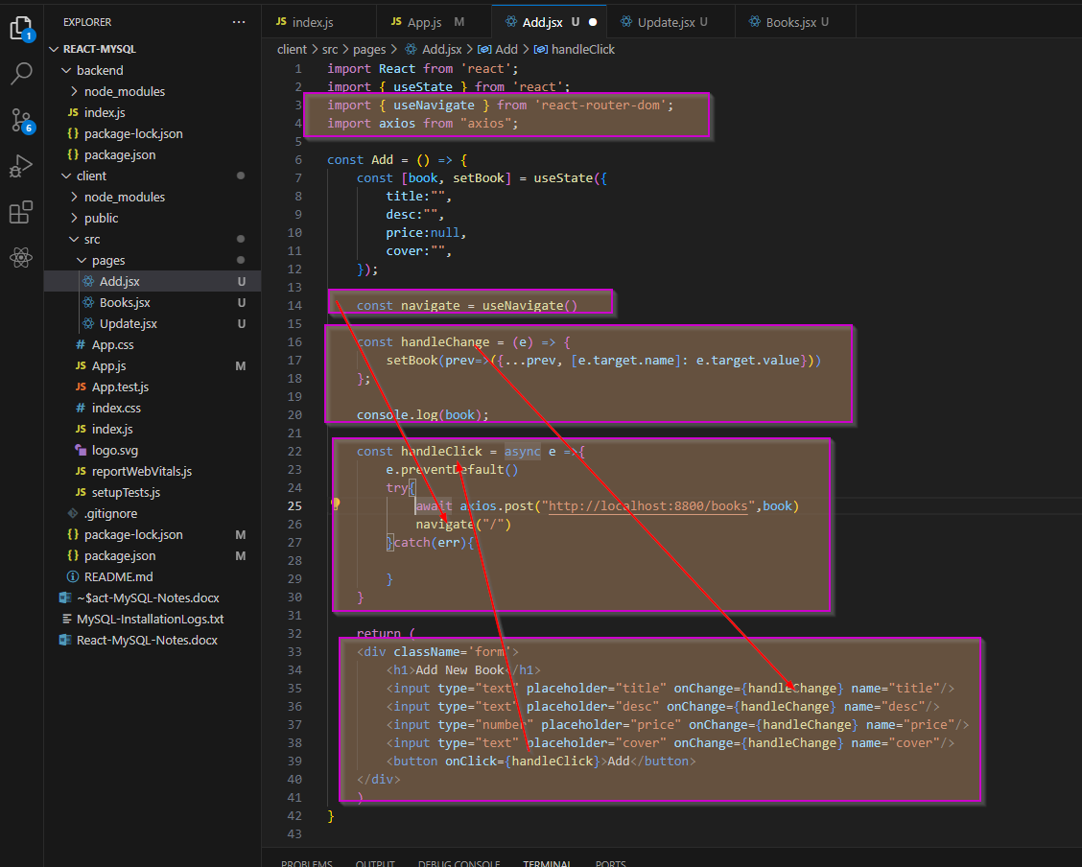

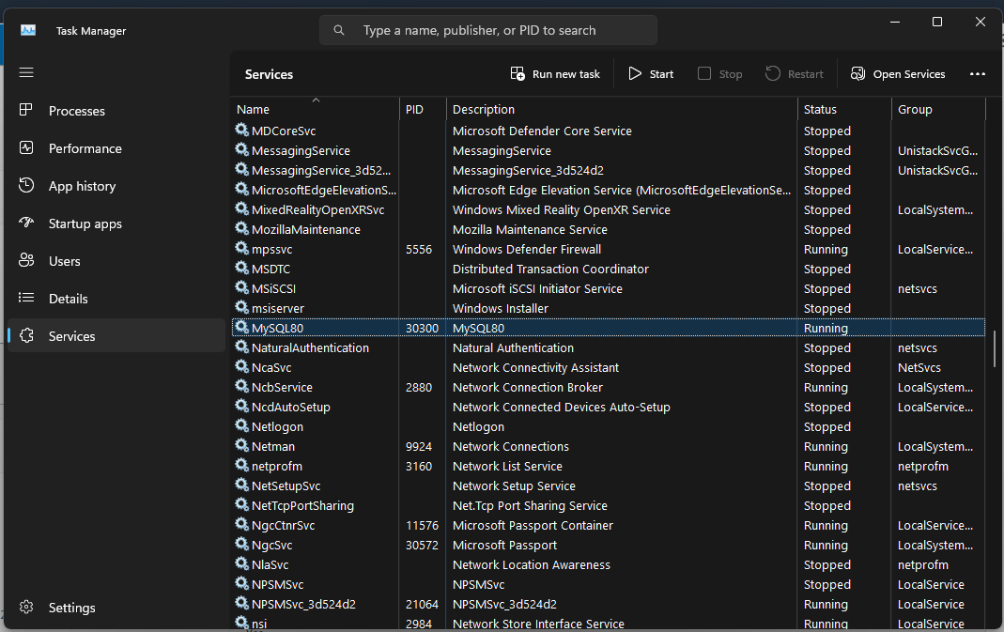

Need to make sure that MySQL80 service is running on localhost

# Deploy onto EC2 instance (without RDS)

<https://towardsdev.com/deploying-a-react-node-mysql-app-to-aws-ec2-2022-1dfc98496acf>

1. Create EC2 instance with Ubuntu OS
   1. SSH into the EC2 instance
   2. Sudo apt update
   3. Sudo apt install git
2. Sudo apt install nginx
   1. Verify if nginx is installed, using http to the AWS EC2 IPv4 DNS address

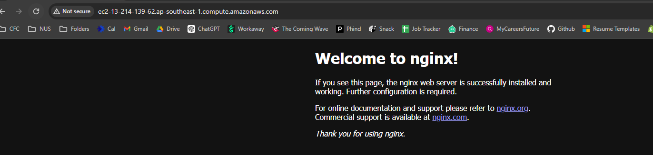

1. Curl -s <https://deb.nodesourcce.com/setup_21.x> | sudo bash
   1. Sudo apt install nodejs -y
   2. Note: seems like need to run with the URL will be more complete, else, hit an error later that npm is not found
2. Push changes to the git repository
   1. Make sure that node_modules or other unnecessary files are excluded in .gitignore file
   2. Make sure the remote repository is correct
      1. git status
      2. git branch
      3. If need to change URL
         1. git remote -v
         2. git remote set-url origin <new-url>
         3. git remote -v
   3. Add, commit and push changes
      1. Git add.
      2. Git commit -m “xxxx”
      3. git push origin main
3. Clone the git repository
   1. git clone xxxx
   2. cd webappdemo/client   
      sudo npm install  
      sudo npm run build
   3. cd ../backend/ && sudo npm install
4. Setup nginx to point to our newly build react app
   1. Sudo cp -R /home/ubuntu/webappdemo/client/build /var/www
   2. sudo vim /etc/nginx/sites-available/default
      1. server {  
          listen 80 default_server;  
          listen [::]:80 default_server; # We want the root folder to point at index.html  
          root /var/www/build;  
          index index.html index.htm index.nginx-debian.html;  
           
          server_name _;  
           
          location / {  
          # First attempt to serve request as file, then  
          # as directory, then fall back to displaying a 404.  
          try_files $uri /index.html $uri/ =404;  
          }  
            
          location /api {  
          proxy_pass http://localhost:8081;  
          }  
         }
   3. ESC + :wq to save and exit
5. Install pm2
   1. Sudo npm install pm2 -g
   2. pm2 start index.js
   3. pm2 status