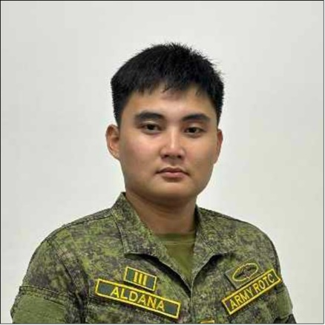

**MARK P. ALDANA**

66 C. Arellano St. San Agustin, Malabon City  
09815098007

To be part of a company that offers good opportunities for growth and development, and allows a room for self-improvement.

**Primary Education: Dr. Celedio A. Salvador Elementary School**

Merced St. Paco, Manila

2008 - 2014

**Secondary Education: Ermita Catholic School**

M.H Del Pilar St. Ermita, Manila

2014 - 2016

**Malabon National High School**

M. Naval St. Hulong Duhat, Malabon City

2016 – 2020

**Vocational Education: City of Malabon Polytechnic Institute**

Gov Pascual Ave. Malabon City

Program - Shielded Metal Art Welding NCII

2021 – 2022

**Tertiary Eduaction: City of Malabon University**

Pampano cor. Maya-maya St. Longos, Malabon City

Program – Bachelor of Science in Information Technology

2022 – Present

* Strong interpersonal communication skills
* Good analytical and troubleshooting abilities.in computer
* Fast Learning abilities towards instructions
* knowledgeable of viruses, application glitches, and hardware **issues** in computer
* Accurate and attentive to details.
* Tolerant and flexible to different situations.

**Achievements:** ROTC Summer Camp Training

Military Science 3

at NCRRCDG Taguig

2023

ARAPT Military Science 41 – 42

NCRRCDG Taguig

2023

ROTC Cadet Officer 2nd Class

2022 - 2024

|  |  |
| --- | --- |
|  |  |

Date of Birth : October 26, 2001

Place of birth : Manila City

Gender : Male

Civil Status : Single

Nationality : Filipino

Height : 5’7’’

|  |  |
| --- | --- |
|  |  |

**Experience:** On-the-job training at Department of Treasury - Municipal of Malabon, Year 2019-2020

Government Internship Program at City of Malabon Polytechnic Institute, Year 2022

______________________________

APPLICANT SIGNATURE