***Javascript Assignment 21***

***1. Select an <h2> tag with id of text and change its inner text to***

***“Hello World”.***

*const h2 = document.querySelector("#text");*

*h2.innerText = "Hello World*

***2. Apply following style to the same h2 using Javascript DOM***

***Method.***

***colour: red,***

***fontWeight: bold,***

***textTransform: uppercase***

*const h2 = document.querySelector("#text");*

*h2.style.color = "red";*

*h2.style.fontWeight = "bold";*

*h2.style.textTransform = "uppercase";*

***3. Create a simple calculator that takes the input from***

***input1, input 2 and add them together.***

***HTML Code:***

<!DOCTYPE html>

<html lang="en">

<head>

    <meta charset="UTF-8">

    <meta http-equiv="X-UA-Compatible" content="IE=edge">

    <meta name="viewport" content="width=device-width, initial-scale=1.0">

    <title>Calculator</title>

</head>

<body>

    <label for="input1">Enter first number:</label>

    <input type="number" id="input1">

    <br><br>

    <label for="input2">Enter second number:</label>

    <input type="number" id="input2">

    <br><br>

    <button onclick="addNumbers()">Add</button>

    <br><br>

    <label for="result">Result:</label>

    <input type="number" id="result" readonly>

</body>

</html>

***Javascript Code:***

function addNumbers() {

    const input1 = Number(document.getElementById("input1").value);

    const input2 = Number(document.getElementById("input2").value);

    const result = input1 + input2;

    document.getElementById("result").value = result;

}

***4. What is the error in the following code?***

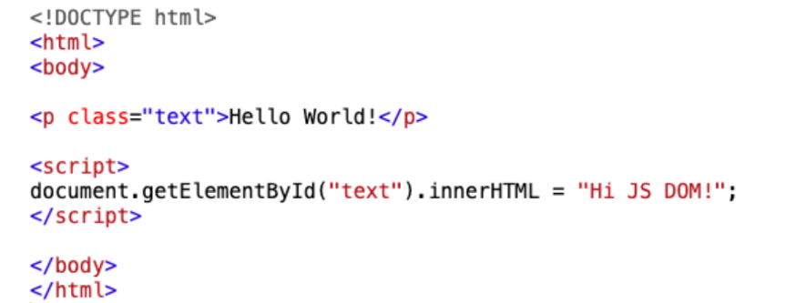

***ANSWER:*** *Here “text” is a class but we are fetching it using “document.getElementById”. It should be using “document.getElementByClassName”*

***5. Using JS Dom select a button and set its onclick event to***

***logging hello in the console.***

***HTML Code:***

<!DOCTYPE html>

<html lang="en">

<head>

    <meta charset="UTF-8">

    <meta http-equiv="X-UA-Compatible" content="IE=edge">

    <meta name="viewport" content="width=device-width, initial-scale=1.0">

    <title>Calculator</title>

</head>

<body>

    <button id="myButton">Click me!</button>

</body>

</html>

***Javascript Code:***

const myButton = document.getElementById("myButton");

myButton.onclick = function () {

    console.log("Hello");

}

***6. Using alert, prevent a person from leaving the screen using JS***

***DOM.***

***Output –***

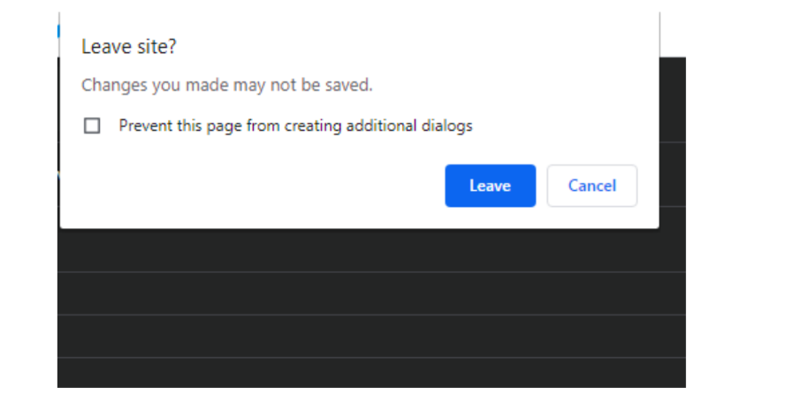

***ANSWER:***

window.addEventListener("beforeunload", function (event) {

    event.preventDefault();

    event.returnValue = "";

    alert("Changes you made may not be saved.");

});

***7. Select all the h2 tags on screen and change their colour to***

***purple.***

const h2Tags = document.querySelectorAll("h2");

h2Tags.forEach(function(h2) {

  h2.style.color = "purple";

});

***8. Create a new <h4> tag on the screen using JS DOM.***

const newH4 = document.createElement("h4");

document.body.appendChild(newH4);

***9. Remove an element from the screen using js dom.***

***Code:***

<!DOCTYPE html>

<html lang="en">

<head>

    <meta charset="UTF-8">

    <meta http-equiv="X-UA-Compatible" content="IE=edge">

    <meta name="viewport" content="width=device-width, initial-scale=1.0">

    <title>Calculator</title>

    <script>

        const myDiv = document.getElementById("myDiv");

        myDiv.remove();

    </script>

</head>

<body>

    <div id="myDiv">This is a div element</div>

</body>

</html>

***10. Get the number of <p> tags on the screen using JS DOM.***

const pTags = document.getElementsByTagName("p");

const numPTags = pTags.length;

console.log(numPTags);

***11. Fetch the value of name from the following form.***

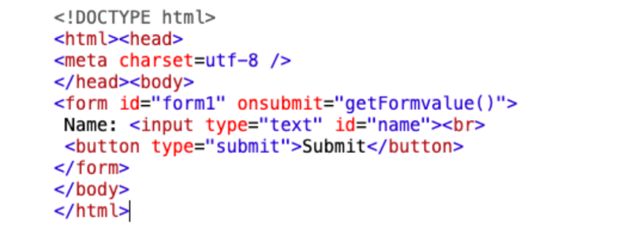

***ANSWER:***

<!DOCTYPE html>

<html lang="en">

<head>

    <meta charset="UTF-8">

    <meta http-equiv="X-UA-Compatible" content="IE=edge">

    <meta name="viewport" content="width=device-width, initial-scale=1.0">

    <title>Calculator</title>

    <script>

        function getFormValue() {

            event.preventDefault();

            const inputName = document.getElementById("name");

            const valueOfName = inputName.value;

            console.log(valueOfName);

        }

    </script>

</head>

<body>

    <form id="form1" onsubmit="getFormValue()">

        Name: <input type="text" id="name" />

        <br />

        <button type="submit">Submit</button>

    </form>

</body>

</html>