ScamShield
Indian Digital Scam Intelligence & Prevention System
Complete Project Documentation — every technology, working flow, program flow, usage guide, and start-to-end development progress, organized.

Version reviewed : 0.3.0 (post final audit)
Audit status : SCAMSHIELD FINAL AUDIT COMPLETE — 472 tests passing
Organisation : Aavishkar College innovation/research prototype (zero-budget)
Mode : 100% local · offline · deterministic · explainable · free (no paid APIs)
Documentation set : this DOCX + PDF + visual PPT in process_threat_detection/

Contents
- 1. Project Overview
- 2. Problem & Motivation
- 3. Proposed System & Key Outputs
- 4. Supported Scam Categories
- 5. Language Support
- 6. Research Direction & Honesty Principles
- 7. Technologies Used
- 8. Repository Structure
- 9. System Architecture
- 10. Working Flow & Program Flow
- 11. Component Deep-Dives
- 12. Flask Web Command Center
- 13. Legacy Streamlit Prototype
- 14. How to Use
- 15. Start-to-End Development Progress
- 16. Evaluation & Research Results
- 17. Security & Privacy Model
- 18. Honest Limitations
- 19. Final Status & Verification
- 20. Appendices (schema, API payloads, project inventory)

1. Project Overview
ScamShield is a research prototype that analyzes suspicious digital content — SMS/chat messages, embedded URLs, QR codes and UPI payment strings — and returns: a 0–100 risk score, a risk level (LOW / MEDIUM / HIGH / CRITICAL), a scam category (for example Fake KYC, UPI payment scam, phishing), human-readable explanations with concrete evidence, and safety recommendations.
It is NOT a black-box binary scam/safe classifier. It explains why something was flagged so a user can take informed action, and it never executes or contacts anything it analyzes. Everything runs locally: no internet, no DNS lookups, no URL opening, no payment execution, no paid APIs.
- Scope: Indian digital-scam patterns (SMS, WhatsApp/Telegram, malicious URLs, QR codes, UPI payment strings).
- Unique focus: multilingual support (English, Hindi, Marathi, Hinglish code-mixing) plus explainable, deterministic risk scoring.
- Delivery: a final Flask web command center + REST API, with a research/evaluation lab and a local ML layer.
- Engineering bar: 472 automated tests passing; security-focused (static only, XSS-safe UI, temp-file cleanup, no stack-trace leakage).

2. Problem & Motivation
Indian users increasingly receive scams through multiple channels at once:
- SMS and messaging platforms (WhatsApp, Telegram, etc.)
- Malicious or suspicious URLs embedded inside messages
- QR codes that redirect to fraudulent payment or credential-harvesting pages
- Social-engineering tactics exploiting urgency, fear or impersonation
These scams span multiple Indian languages and code-mixed Hinglish. Detection tools built primarily for clean English or single-language input struggle with this combination. The gap ScamShield addresses is the combination of: Indian scam patterns + multilingual content + Hinglish code-mixing + explainable, actionable results, all inside a lightweight, zero-budget, fully-local system.

3. Proposed System & Key Outputs
For every input, ScamShield returns a unified result with:
Field | Meaning
risk_score | Continuous 0–100 heuristic score
risk_level | LOW / MEDIUM / HIGH / CRITICAL
is_suspicious | Boolean suspicion flag
scam_type | Specific scam category (e.g. fake_kyc, phishing, upi_payment)
confidence / confidence_type | Heuristic or model probability, always labelled honestly
summary / explanation | Human-readable justification with concrete evidence
indicators | Which signals fired (urgency, brand_impersonation, …)
recommendations | Actionable safety advice
engine_results | The full original per-engine result, preserved for transparency
Errors never crash the system: they are returned as structured results (success=False, error, error_type, status='ERROR', score 0/LOW).

4. Supported Scam Categories
Category | Description
Fake KYC | Messages claiming KYC expiry requiring immediate action
UPI/payment scams | Fraudulent UPI collect requests, fake refund links
Bank impersonation | Messages impersonating banks requesting OTP/PIN
Phishing | Links mimicking legitimate services to steal credentials
Fake customer care | Scammers posing as support staff requesting sensitive info
Job scams | Fake job offers requiring registration fees or personal data
Investment scams | Guaranteed-return or crypto-doubling schemes
Loan scams | Fake pre-approved loans requiring upfront fees
Delivery scams | Fake customs/courier payment demands
Lottery/prize scams | Fake prize notifications requiring processing fees
Social-media impersonation | Impersonating relatives or contacts requesting money
Other social-engineering | Miscellaneous patterns (electricity, SIM, court, etc.)

5. Language Support
Language | Code | Notes
English | en | Full rule coverage
Hindi | hi | Devanagari + Romanized variants
Marathi | mr | Devanagari + Romanized variants
Hinglish | hinglish | Code-mixed English–Hindi handled explicitly

6. Research Direction & Honesty Principles
This is a research investigation — not a claim that the project invented scam detection. The system explicitly documents dataset size, class imbalance, cross-split leakage, and every engine limitation. Risk scores are labelled as heuristic (not calibrated). The ML confidence is the model's raw predicted-class probability, never presented as a certified probability.

7. Technologies Used
Technology | Version / Role | Where it is used
Python | 3.14.6 (dev) — core language | Everywhere (engines, ML, web, research, docs)
Flask | 3.x — final web frontend / REST API | web/app.py, web/templates, web/static
Streamlit | 1.32.x — LEGACY prototype UI (not final) | app/ui.py, app/ui_helpers.py
scikit-learn | 1.3.x — TF-IDF vectoriser + Logistic Regression | src/scamshield/ml
joblib | 1.3.x — model persistence | models/scamshield_tfidf.joblib
OpenCV (headless) | 4.8.x — local QR decoding (cv2.QRCodeDetector) | src/scamshield/qr/decode.py
qrcode | 7.3.x — QR fixture generation (tests/demo only) | scripts/generate_qr_fixtures.py
numpy | 1.24.x — QR fixture/tests | scripts, tests
pytest | latest — 472 tests across 10 suites | tests/
Vanilla JS / HTML / CSS | Frontend rendering (no framework) | web/static
matplotlib / PIL | Documentation visuals only | this process_threat_detection/ build
python-docx / python-pptx / reportlab | This documentation generation | process_threat_detection/
Python stdlib | urllib.parse, csv, json, re, tempfile, pathlib | engines + web
Note: during the final audit, pandas >=2.0 and matplotlib >=3.7 were removed from requirements.txt because they were imported nowhere; numpy is kept (used by QR tests/scripts).

8. Repository Structure
Threat-links-detection/
├─ data/ Labelled datasets (raw, processed, train, validation, test)
├─ src/scamshield/ Analysis engine
│ ├─ ingest/ Input normalization
│ ├─ nlp/ Message/text scam classification (WORKING engine)
│ ├─ url/ Static URL risk engine (WORKING engine)
│ ├─ qr/ Local QR decode + URL/UPI/text routing (WORKING engine)
│ ├─ ml/ Local ML: TF-IDF + Logistic Regression (WORKING)
│ ├─ chain/ Multi-stage scam-chain correlation (WORKING)
│ ├─ research/ Research & Evaluation Lab (WORKING)
│ ├─ risk/ + explain/ Folded into nlp/ (dead nodes kept for clarity)
│ └─ analyzer.py Unified ScamShield Analyzer (one schema, all inputs)
├─ models/ Trained ML artifact + metrics + research/ artifacts
├─ web/ FINAL frontend: Flask app + template + static JS/CSS
├─ app/ Legacy CLI demos + legacy Streamlit prototype (Step 9)
├─ tests/ 10 test suites (472 tests)
├─ scripts/ Dataset building, ML training, QR fixtures
├─ research/ Notes, gap analysis
└─ process_threat_detection/ THIS documentation (DOCX + PDF + PPT + assets)

9. System Architecture
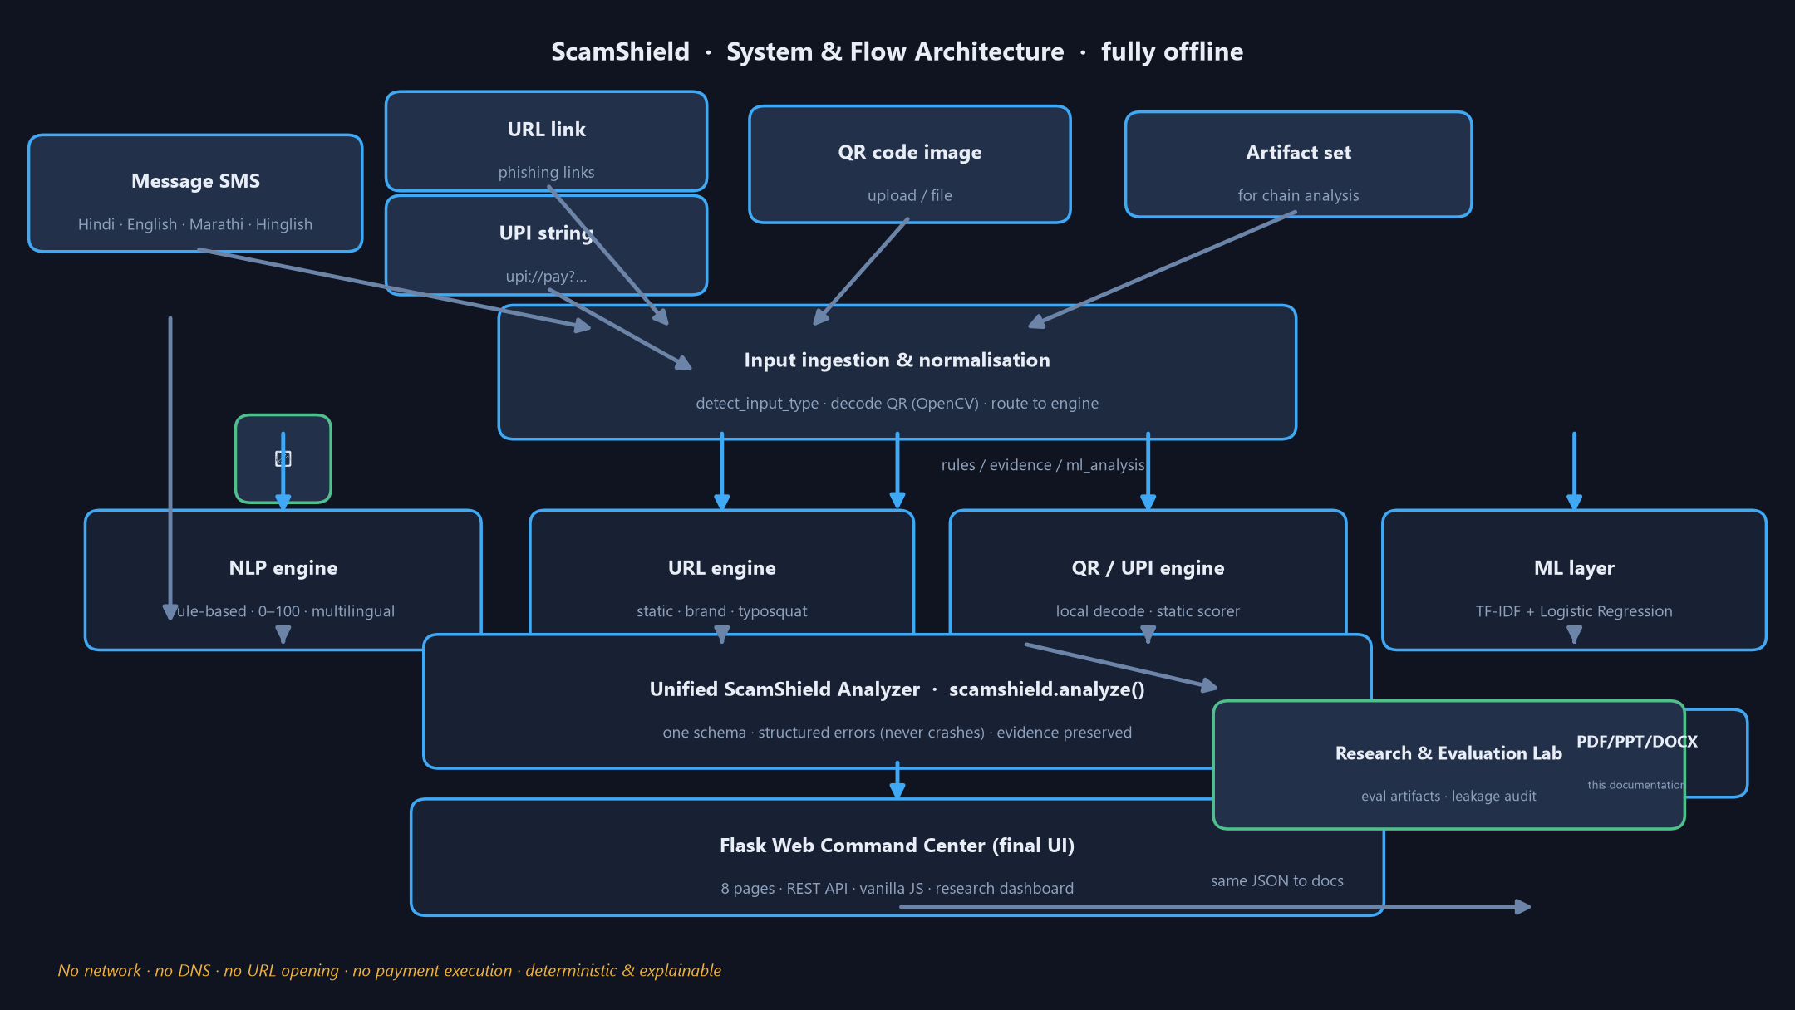
Figure 1 — End-to-end system architecture and data flow (fully offline).
Layers: user inputs (message / URL / UPI / QR / artifact set) -> ingestion & normalisation (detect_input_type, QR decode) -> component engines (NLP, URL, QR/UPI, plus the ML layer) -> unified analyzer -> optional chain correlation -> unified result -> Flask web command center / API. The Research & Evaluation Lab reads the same JSON artifacts used by the dashboard.

10. Working Flow & Program Flow
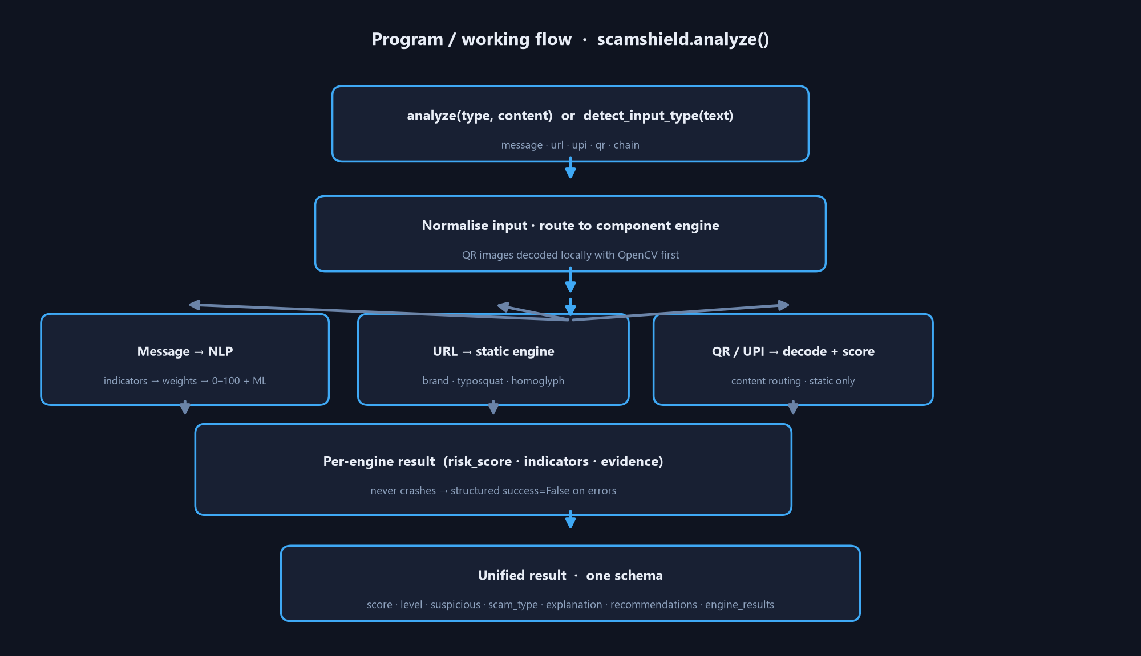
Figure 2 — Program/wiring flow inside scamshield.analyze().
Step-by-step program flow for a single analyze() call:
- 1. The caller supplies (type, content) explicitly, or detect_input_type() guesses url / upi / message from the prefix (only ^https?:// and ^upi: are auto-detected; otherwise message).
- 2. Input is normalised (strip, type-check, decode for QR images).
- 3. Routing: message -> NLP engine; url -> URL engine; upi -> UPI static scorer; qr -> OpenCV decode then route decoded payload (url/upi/text) to the matching engine; chain -> correlation layer over already-analyzed artifacts.
- 4. For messages, the NLP result is augmented with per-URL url_analysis plus combined_risk (always >= strongest single signal), and the local ML prediction is attached as engine_results['ml_analysis'] — kept SEPARATE so a weak ML signal can never hide a real rule signal.
- 5. QR images with multiple codes combine every code's risk using the same documented 70% strongest+weaker rule.
- 6. Everything is normalized into ONE unified schema; the full original engine result is preserved under engine_results.
- 7. Any failure returns a structured success=False result (score 0, LOW) — the analyzer never crashes.
Chain program flow (analyze_chain / analyze('chain', stages)):
- normalize_stage() converts each supplied artifact (raw engine result, unified result, or structured stage dict) into a Stage.
- correlate() matches pairs by exact URL, registrable root-domain, UPI payee, QR content continuation, or scam-category family.
- score_chain() combines stage scores + capped relationship bonuses (never a plain average; never below the strongest stage).
- detect_pattern() recognizes kyc_phishing, payment_scam, prize_refund, fake_customer_care, job_scam, investment_scam, loan_scam; otherwise multi_stage_scam or none.
- Classification levels: none | potential_chain | multi_stage_scam — a single artifact is never a multi-stage scam.

11. Component Deep-Dives

11.1 NLP message engine (src/scamshield/nlp)
Rule-based, fully local, deterministic. Pipeline: preprocess (lowercase, normalize, URL/token placeholders) -> indicator detection from curated multilingual dictionaries -> weighted scoring (each indicator has a strength; severity multiplier LOW 1.0 / MEDIUM 1.6 / HIGH 2.2) -> family bonuses (e.g. family-money +18, transaction/credential guards) -> caps so size alone can never force a verdict -> 0–100 score + level + scam type + evidence + recommendations.
Strong signal examples | Weight context
kyc_request | KYC-category requests score heavily (threshold reaches risky band ~10)
otp_request | OTP/PIN requests, weight 12
credential_request | Password/OTP sharing request, weight 14
suspicious_link | Embedded suspicious URL, weight 9
urgency | Urgency/intimidation words (now, immediate, block, expire)
family_money_request | Family/friend money + bonus ~18
transactional_guard | -40 drain: ordinary bank transaction wording keeps real receipts LOW

11.2 URL intelligence engine (src/scamshield/url)
Static, structural analysis only — never opens, resolves, follows, downloads or phones home. Detectors include: raw IP hosts (+54 with keyword), embedded credentials, punycode/IDN, registrable-domain awareness (root_domain/subdomains/tld), brand impersonation with sub-domain placement, typosquatting/look-alike domains, Unicode/mixed-script homoglyphs (e.g. Cyrillic p in paypal), suspicious query parameters (password, otp, card), nested/encoded URLs, hex hosts, cheap TLDs, hyphen/numeric-host abuse, unusual schemes — with complexity caps. Also exposes analyze_attachment_filename() and assess_sender() for message metadata.

11.3 QR security analyzer (src/scamshield/qr)
Local decode via OpenCV. Each decoded payload is content-routed: url -> URL engine, text -> NLP engine, upi -> static UPI scorer, unknown (mailto:/geo:/…) never auto-malicious. Multi-QR images combine risks with the 70% strongest+weaker rule. Full transparency in explanations (every point is listed with its indicator, severity, reason and evidence).

11.4 UPI analyzer (src/scamshield/qr/upi.py)
Static parser + scorer for upi:// URIs: payment_destination_detected +8, embedded_payment_amount +10, amount thresholds at 10k/50k/100k, urgency/refund/KYC/OTP note-language. A normal merchant-pay QR stays LOW; refund/prize/urgent notes with high amounts reach HIGH/CRITICAL. The analyzer never claims a specific UPI ID is fraudulent — it always says verify the recipient.

11.5 Unified ScamShield Analyzer (src/scamshield/analyzer.py)
One schema over message/URL/QR/UPI/chain/ML. Functions: analyze(), analyze_batch(), detect_input_type(), analyze_chain() exposed at top level. Structured errors, deterministic ordering, full evidence preservation.

11.6 Local ML intelligence (src/scamshield/ml)
TF-IDF (word+char n-grams) + Logistic Regression, trained fully offline on data/train/messages.csv. predict_message() returns prediction, score (predicted-class probability 0–100), confidence (labelled model_probability, explicitly not calibrated), features_used, model metadata. Missing model -> graceful 'ML model unavailable' result. The authoritative top-level verdict stays driven by the deterministic rule engine; the ML signal is attached separately as ml_analysis.

11.7 Multi-stage chain correlation (src/scamshield/chain)
Research/prototype layer that correlates already-analyzed artifacts. Scoring is transparent: stage_bonus decays geometrically, rel_bonus squared + capped at 40, category-consistency bonus caps at 8, progress +8, pattern +6; score is never below the strongest stage. Recognized pattern families: kyc_phishing, payment_scam, prize_refund, fake_customer_care, job_scam, investment_scam, loan_scam. Honest caveats: correlation of independent detections is not proof of intent; a lone artifact is never a chain; unflagged stages never gain suspicion.

11.8 Research & Evaluation Lab (src/scamshield/research)
python -m app.research_eval measures dataset profile, rule/ML/combined metrics, per-language and per-category metrics, FP/FN examples (sanitised), detection latency, and a cross-split leakage audit with a leakage-clean subset. Artifacts written to models/research/ (JSON/CSV/Markdown) and read at runtime by the web dashboard.

12. Flask Web Command Center (final frontend)
web/ is a thin HTTP layer: every response comes from the real analyze()/analyze_chain() results. No duplicated detection or scoring in Flask or the browser. WSGI-ready (web.app:app).
- 8 pages: Overview, Message Intelligence, URL Intelligence, QR Analyzer, UPI Analyzer, Attack Chain, Research/Evaluation, System Status.
- Risk scores/levels come from the backend only; the local ML signal is shown separately from the rule verdict.
- Responsive (off-canvas sidebar, stacked mobile panels), reduced-motion respected, all injected data HTML-escaped (no XSS).
Endpoint | Purpose
GET / | Single-page command center (research payload injected server-side)
GET /api/health | Service, version, offline + ML availability
POST /api/analyze/message | {"message": "..."} → rule + local ML
POST /api/analyze/url | {"url": "..."} → static URL analysis (never opened)
POST /api/analyze/upi | {"upi": "..."} → static UPI URI analysis (never executed)
POST /api/analyze/qr | multipart qr_image → local decode; temp file always cleaned up in finally
POST /api/analyze/chain | {"stages": [...]} → multi-stage chain analysis
QR upload handling: 5 MiB limit, allowed extensions PNG/JPG/JPEG/WebP/GIF/BMP; resized/validated before temp-file write; decoded payloads analysed statically; the temp file is unlinked in a finally block (verified by test_qr_temp_file_cleaned_up).

13. Legacy Streamlit Prototype (kept, NOT final)
app/ui.py was the original prototype frontend (dark cybersecurity theme, SVG gauges, session history in st.session_state storing metadata only). It is retained in the repo for reference and labelled LEGACY — the Flask web app is the final frontend.

14. How to Use

14.1 Setup (local, free)
python -m venv .venv
.venv\Scripts\activate # Windows
pip install -r requirements.txt

14.2 Run the web app
python web/app.py # http://127.0.0.1:5000
# SCAMSHIELD_HOST / SCAMSHIELD_PORT / SCAMSHIELD_DEBUG env vars optional
# or serve behind any WSGI server: web.app:app
Use it to: paste a suspicious SMS, check a link, upload a QR image, inspect a UPI string, build a multi-stage attack chain, browse the research dashboard, and check system status.

14.3 API usage (curl-style)
curl -X POST http://127.0.0.1:5000/api/analyze/message -H "Content-Type: application/json" \
-d '{"message": "Your KYC has expired. Click the link now."}'
curl -X POST http://127.0.0.1:5000/api/analyze/url -H "Content-Type: application/json" \
-d '{"url": "https://secure-sbi-verify.example.com/login"}'
curl -X POST http://127.0.0.1:5000/api/analyze/upi -H "Content-Type: application/json" \
-d '{"upi": "upi://pay?pa=refund-center@hdfcbank&am=500000&tn=reward"}'
curl -X POST http://127.0.0.1:5000/api/analyze/qr -F "qr_image=@tests/fixtures/qr/url_suspicious.png"
curl -X POST http://127.0.0.1:5000/api/analyze/chain -H "Content-Type: application/json" \
-d '{"stages": [<full analyzed result>, ...]}'

14.4 CLI
python -m app.scan "Your KYC has expired. Verify immediately at this link."
python -m app.url_scan "https://secure-sbi-verify.example.com/login"
python -m app.qr_scan "tests/fixtures/qr/upi_refund_scan.png"
python -m app.analyze --type message --input "Your KYC has expired..." --json
python -m app.ml_scan "Your account will be blocked. Verify KYC immediately..."

14.5 Python library
from scamshield import analyze, analyze_batch, detect_input_type, analyze_chain
analyze("message", "Your KYC has expired. Click the link now.")
analyze("url", "https://secure-sbi-verify.example.com/login")
analyze("qr", "tests/fixtures/qr/url_suspicious.png")
from scamshield.ml import predict_message
predict_message("Your KYC has expired. Click the link now.")

14.6 Training & research
python -m src.scamshield.ml.train # retrain local ML (offline, reproducible)
python -m app.research_eval # full evaluation lab -> models/research/
python -m app.research_eval --json # machine-readable output
python scripts/build_dataset.py # regenerate labelled dataset splits

14.7 Testing
python -m pytest tests/ -q # 472 passed (see test coverage below)
Test coverage: URL engine 95, Unified analyzer 84, QR engine 56, Message engine 50, Chain analysis 49, Local ML 40, Research lab 30, Flask API 28, Web scenarios 24, Frontend 16.

15. Start-to-End Development Progress
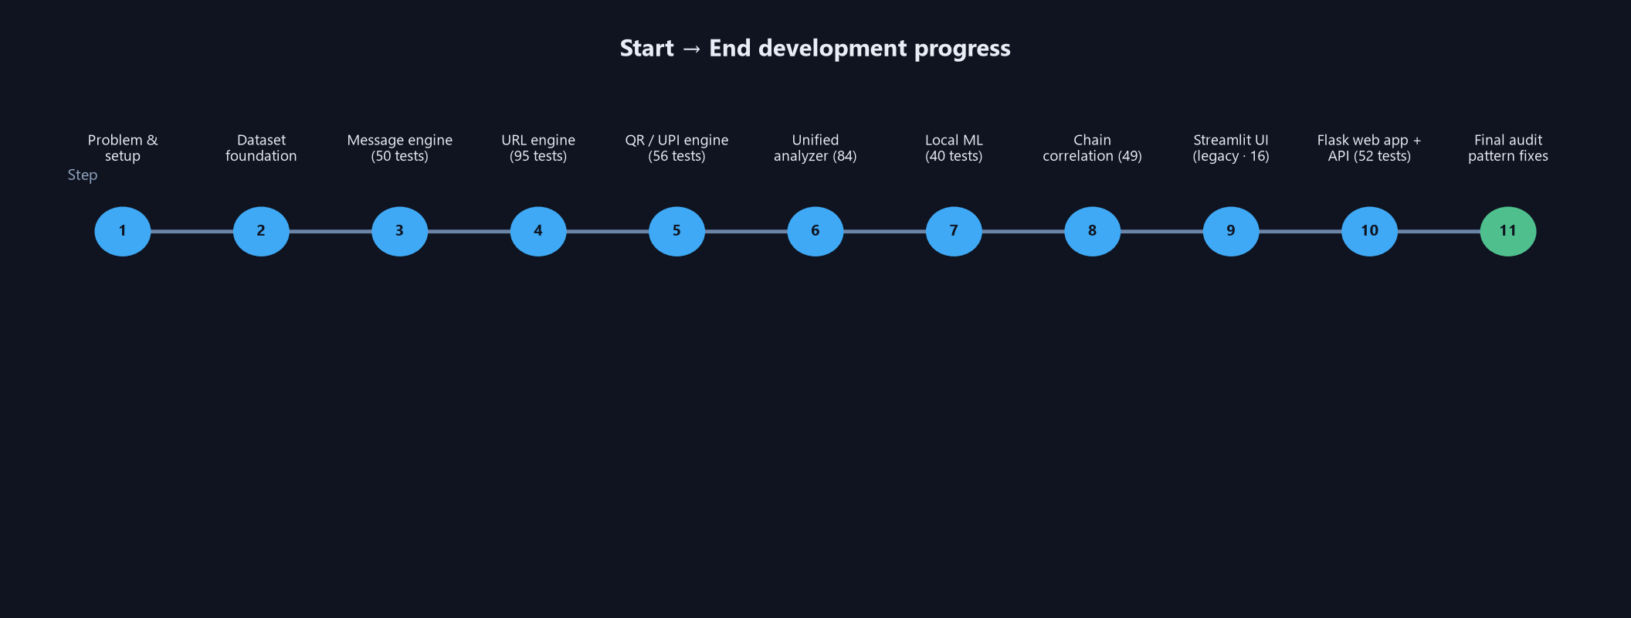
Figure 3 — Milestone timeline (Steps 1–10 + final audit).
Milestone | Delivered | Tests
Step 1 — Problem, setup, dataset schema | Repo skeleton + schema + privacy rules | —
Step 2 — Dataset foundation | Synthetic + public labelled splits via scripts/build_dataset.py (placeholders for OTP/phone/etc.) | —
Step 3 — Message intelligence engine | Rule-based multilingual scanner (en/hi/mr/hinglish), weights, caps, explainability | 50
Step 4 — URL intelligence engine | Static advanced analysis: brand impersonation, typosquat, homoglyph, caps | 95
Step 5 — QR / UPI analyzer | OpenCV decode + content routing + static UPI scorer + multi-QR rule | 56
Step 6 — Unified analyzer | One schema; structured errors; detect_input_type; analyze_batch | 84
Step 7 — Local ML | TF-IDF + Logistic Regression, offline train/predict, leakage audit | 40
Step 8 — Chain correlation | Multi-stage scam-chain layer (never invents suspicion) | 49
Step 9 — Streamlit prototype UI | Legacy command center (superseded by Flask) | 16
Step 10 — Flask web command center | Final frontend: 8 pages + REST API + research dashboard | 52 (API+E2E)
Research & Evaluation Lab | Full eval pipeline + models/research artifacts | 30
Final audit (Prompt 3) | Pattern fixes (job/loan/UPI), dependency cleanup, research re-run, docs corrected, security+API+E2E verification | 472 total
Audit highlights: added high-precision patterns (register fee, no experience needed, processing charges, loan, pre-approved) turning paraphrased job scams from 11 to 51 HIGH; removed unused pandas/matplotlib; re-ran the research lab (Rule Acc 0.7736); corrected stale README counts; verified 22 live API checks and a full E2E demo over real HTTP with no stack-trace leakage.

16. Evaluation & Research Results
Frozen deduplicated test set, n=106 (cross-split leakage reported honestly; a separate leakage-clean subset is re-evaluated at runtime).
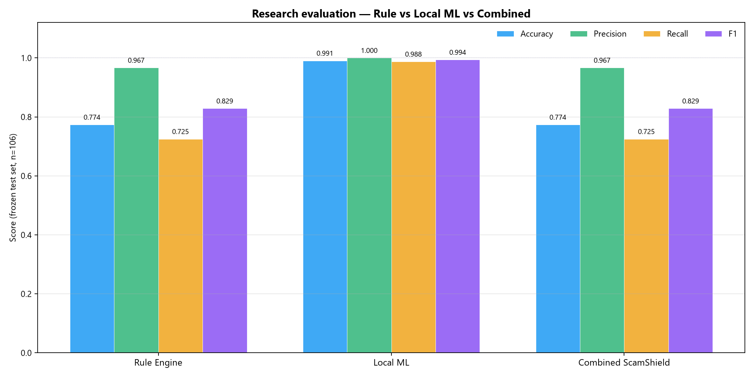
Figure 4 — Accuracy / Precision / Recall / F1 across systems.
System | Accuracy | Precision | Recall | F1
Rule Engine | 0.7736 | 0.9667 | 0.7250 | 0.8286
Local ML | 0.9906 | 1.0000 | 0.9875 | 0.9937
Combined ScamShield | 0.7736 | 0.9667 | 0.7250 | 0.8286
Combined equals Rule on message inputs by design: the deterministic rule engine is authoritative; the ML signal is shown separately as ml_analysis and never averaged in (a weak/missing ML prediction can never hide a real signal).
Rule-engine misclassification: 22 false negatives (missed scams — the higher-risk error) and 2 false positives; representative examples are persisted sanitised in fp_fn_examples.json.
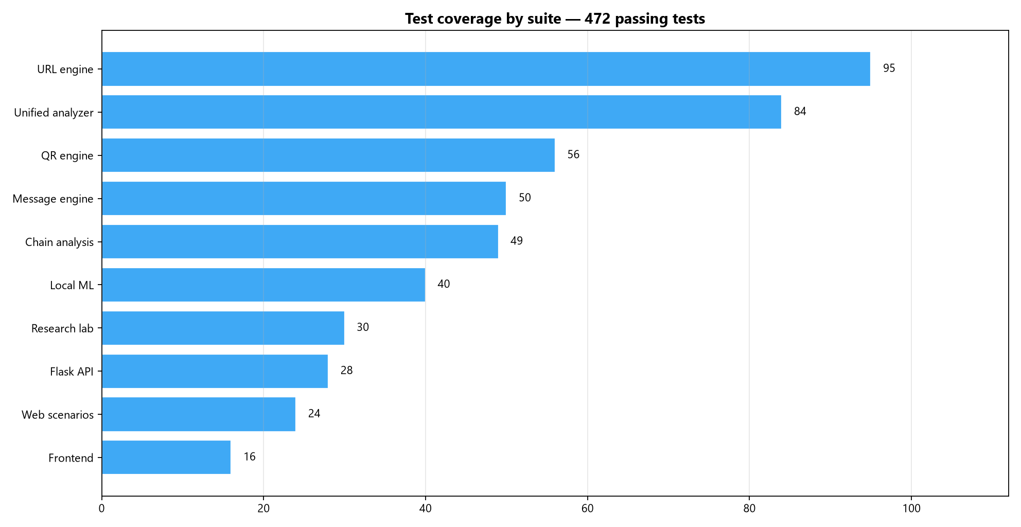
Figure 5 — Test coverage by suite (472 tests).
Latency (20 iterations) | Mean | Median | Max
message | ≈ 28 ms | ≈ 28 ms | ≈ 31 ms
url | ≈ 1.8 ms | ≈ 1.6 ms | ≈ 4.3 ms
upi | ≈ 0.25 ms | ≈ 0.15 ms | ≈ 2.4 ms
qr | ≈ 23 ms | ≈ 23 ms | ≈ 27 ms
Research artifacts: evaluation_summary.json, model_comparison.csv, confusion_matrices.json, language_results.json, category_results.json, latency_results.json, leakage_report.json, fp_fn_examples.json, evaluation_report.md.

17. Security & Privacy Model
- Fully offline: verified no sockets / DNS / HTTP / urlopen anywhere in the engines (only urllib.parse + Path.resolve).
- URLs and UPI strings are analysed statically — never opened, resolved, followed, fetched, or executed.
- QR uploads: size (5 MiB) + extension validated, written to a temp file, deleted in a finally block (tested).
- No stack traces leaked to clients: 400/404/405/413/500 handlers return structured JSON; debug mode off by default.
- Web UI HTML-escapes every injected value (esc()) before innerHTML — no XSS (verified by audit).
- No secrets, API keys, credentials, or private data stored or logged anywhere.
- Dataset privacy: placeholders ([OTP], [PHONE], [ACCOUNT], XX12, *.example.in, RFC 5737 IPs); no real PII.
- No database, no authentication, no cookies — stateless, local-first, WSGI-hostable.

18. Honest Limitations
- The rule engine is exact-phrase based: heavily paraphrased scam variants (investment, bank-warning, some govt/Hinglish rewordings) can score LOW/MEDIUM and are documented conservative misses.
- A small known false-positive pair: protective 'do not share UPI PIN'-style receipts can be flagged (precision conservatism), documented as FPs in the research lab.
- Chain layer requires already-analyzed artifacts (the UI does this for you); it is correlation, not proof of intent.
- Local ML is a binary classifier on a small synthetic dataset with class imbalance and cross-split leakage — accuracy numbers are NOT production claims.
- URL/UPI analysis is static: no live reputation, no DNS, no threat-intel — by design (offline, no paid APIs).
- Latency/accuracy figures are from the local research lab, not calibrated against production traffic.

19. Final Status & Verification
Area | Status
Full test suite | 472 passed (10 suites) — compileall clean
Flask API (live) | 22/22 checks pass incl. malformed/oversized/no trace leakage
E2E demo (real HTTP) | safe msg LOW · fake-KYC HIGH+ML scam 82% · phishing URL HIGH 72 · refund-UPI HIGH 68 · suspicious QR HIGH 60 · KYC chain CRITICAL 100 · research payload inline
Engines | message/URL/QR/UPI/unified/chain/ML all verified (engine_verify + scenario sweeps)
Security | no network/DNS, static-only, temp cleanup, XSS-escaped UI, no secrets
Research artifacts | regenerated & internally consistent with the shipped engine
Docs | READMEs corrected (472, Web UI final, framework note); stale counts removed
Dependencies | unused pandas/matplotlib removed; numpy annotated
The project is ready for demonstration as a local, offline, explainable Indian scam & threat-link detection prototype.

20. Appendices

Appendix A — unified result (message example, trimmed)
{
"success": true, "input_type": "message", "status": "ANALYSED",
"risk_score": 56, "risk_level": "HIGH", "is_suspicious": true,
"scam_type": "fake_kyc", "confidence": 66.0, "confidence_type": "heuristic",
"summary": "High-risk message classified as a fake kyc scam. Evidence: urgency pressure.",
"indicators": ["urgency", "kyc_request", "suspicious_link"],
"explanation": [{"indicator": "urgency", "severity": "low", "score": 0.0, ...}],
"recommendations": [...], "evidence": {...},
"engine_results": {"message": {...}, "url_analysis": {...}, "ml_analysis": {...}}
}

Appendix B — API error contract
Validation failures return HTTP 400 with body {success:false, error_type:'validation', error: <message>, risk_score:0, risk_level:'LOW'}. Unknown routes 404, wrong methods 405, oversized uploads 413, unexpected exceptions 500 (generic, no traceback).

Appendix C — project inventory (key files)
File | Purpose
src/scamshield/nlp/patterns.py | Multilingual indicator dictionaries (edited in final audit)
src/scamshield/nlp/scoring.py | Weighted 0–100 scoring + caps
src/scamshield/url/indicators.py | Phishing signal detectors
src/scamshield/qr/decode.py | OpenCV QR decoding
src/scamshield/qr/upi.py | Static UPI URI parser + scorer
src/scamshield/analyzer.py | Unified analyzer (analyze / analyze_batch / detect_input_type / analyze_chain)
src/scamshield/ml/train.py + predict.py | Offline ML training + prediction
src/scamshield/chain/* | Chain correlation + scoring + explanation
src/scamshield/research/* | Evaluation lab + artefact writers
web/app.py | Flask application (final frontend)
web/templates/index.html + static/* | Single-page UI
tests/* | 10 test suites (472 tests)
scripts/* | Dataset builder, QR fixtures, training helpers
data/* | Labelled multilingual dataset (privacy-safe)
models/research/* | Research evaluation artifacts

Documentation generated for the ScamShield project — every technology, working flow, program flow, usage guide and start-to-end progress, in one organised document.

