1. **Boxplot for all 5885 workers:**

|  |  |
| --- | --- |
| **Group** | **Sample size** |
| 0-24 | 57 |
| 24-48 | 98 |
| 48+ | 5670 |

While generating Earn and Learn scores, our algorithm looked back upto M=6 months prior to the day when the scores were computed. A lot of the workers from the 48+ month group did not have any registrations within the 6 months prior to 31st March 2017, even though they had registrations within the 12 months prior to that date. So, when the Earn and Learn scores were generated for those workers, for most of the months, the Earn scores for these workers ended up with 0 values, which affected the average Earn score values for the 48+ month group.

Below we show the boxplot for all the 5885 workers. We also show the average value for each group in each box plot. **It is evident from the figure that workers from all groups spend time on learning and exploration. Moreover, there is a decreasing trend in the average learning scores.**

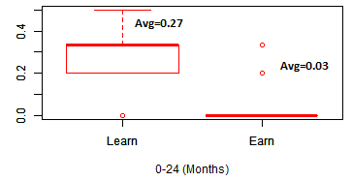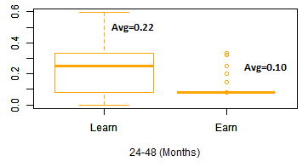

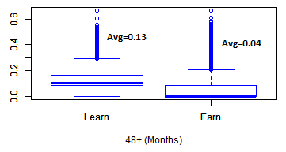

1. **Boxplot for 2566 workers with at least one transaction in any one month of the six months prior to 31 March, 2017 (2566 workers further filtered from 5885 workers):**

|  |  |
| --- | --- |
| **Group** | **Sample size** |
| 0-24 | 57 |
| 24-48 | 98 |
| 48+ | 2396 |

Below we show the boxplot for all the 2566 workers. **It is evident from the figure that workers from all groups spend time on learning and exploration. Moreover, there is a decreasing trend in the average learning scores.**

