Simulation of cooling of heated metal parts for quenching in heat treatment of metal.

Three different approaches:

1. Part only surrounding medium is not included heat radiates out of the parts boundary to an external temperature
2. Part in fluid, no flow, simulates hot part placed in a water tank. Heat transfers from part to fluid and out of fluid boundary
3. Same as 2 but flow of water into and out of the tank is simulated.



Figure 1 Metal Part
In the three simulations the part starts at 900 degrees. The surrounding medium is 25 degrees. In the flow simulation the incoming fluid is 25 degrees.

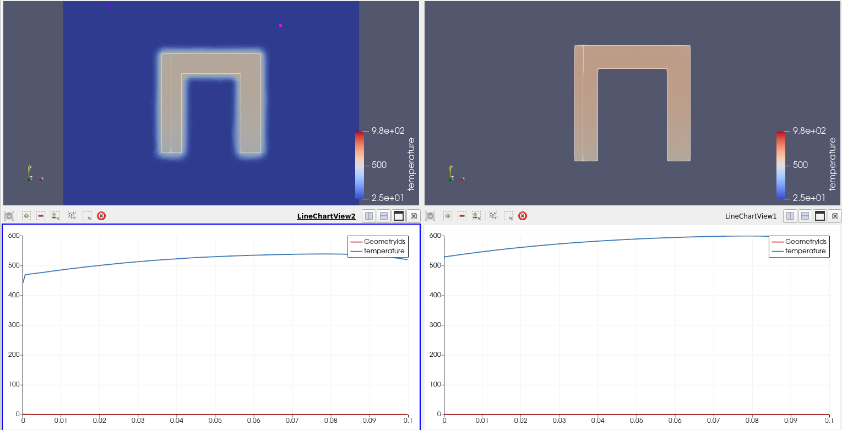
Figure 2 Part on left in water tank, part on right is the part only. Both the water and external temperatures on boundary are 25 degrees. The cooling is plotted as a line along the left leg. The results vary slightly.

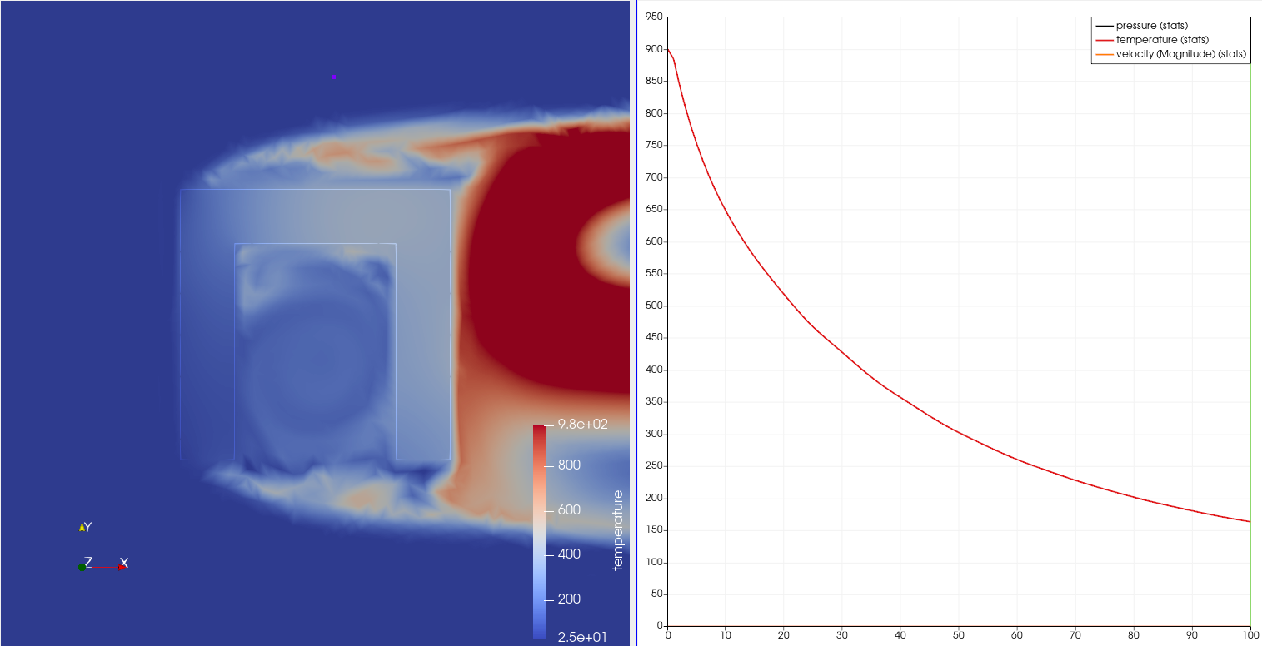
Figure 3 25 degree water flows in from the left and out to the right, cooling is significantly more rapid.

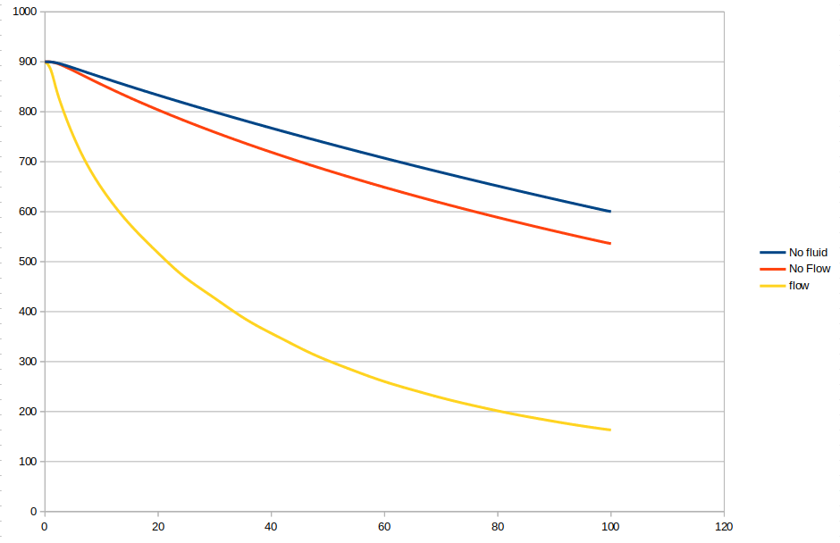
The Temperature time history in the middle of the upper corner of the part

Animation, click to play

Files are located

https://github.com/mrkearden/Heat-Treatment-Simulations

