

**Middle East Technical University**

**Electrical & Electronics Engineering Department**

**EE463 – Static Power Conversion I**

**Hardware Project**

**Complete Simulation Report**

“Drive & Survive”

Sefer İDACI - 2575421

Orkun Bera GEDİK - 2516185

Mustafa Berkay KEBABCI - 2575595

# **Introduction**

In this project a DC Motor Drive application will be designed, simulated and implemented. Available topologies are discussed in this simulation report and decided to choose one of them according to the aimed bonuses. The topology includes rectifier and converter circuits, which are explained in detail in this report and simulation results are given. The components are chosen by searching the available components taking into consideration their limits and prices. Moreover, PWM signal is obtained using Arduino and the result is provided.

# **Problem Definition**

The requirement to drive a DC motor is a controlled rectifier in which some bonuses are aimed at achieving. As input voltage variable AC source (Variac) is employed.

Constraints:

· Input: Adjustable three phase AC grid voltage

· Output: DC output < 180 V

Motor Specifications:

· Armature Winding: 0.8 Ω, 12.5 mH

· Shunt Winding: 210 Ω, 23 H

· Interpoles Winding: 0.27 Ω, 12 mH

## **Targeted Bonuses**

### **1-** **Tea Bonus**

It is aimed to boil water to make a glass of hot tea by applying 2kW power to kettle for 5 minutes.

### **2-** **Industrial Design Bonus**

It is aimed to enclose the system for protection and professional use.

### **3-** **Single Supply Bonus**

Using only one AC source is intended and to obtain other voltage levels benefiting from converters.

### **4-** **Two-Quadrant Bonus**

It is aimed to both accelerate and brake the DC motor by applying positive and negative output current.

# **Topology Selection**

There were 3 basic topologies that we thought as reasonable:

* 3 Phase Thyristor Rectifier + Buck Converter
* Single Phase Diode Rectifier + Buck Converter
* 3 Phase Diode Rectifier + Buck Converter

## **3 Phase Thyristor Rectifier + Buck Converter**

This is a robust solution that combines the versatility of thyristor-based rectification with the efficiency of a buck converter for DC voltage regulation. The rectifier stage uses thyristors to convert AC to DC, with the firing angle of the thyristors allowing precise control over the output voltage. This makes the topology suitable for applications requiring dynamic adjustment of the output voltage, such as industrial drives or variable-speed motor controls. The buck converter further steps down and regulates the voltage to the desired level with high efficiency. However, the complexity of the thyristor firing circuit and the harmonic distortion introduced into the AC supply are significant drawbacks. The need for harmonic mitigation measures, such as filters, adds to the cost and size of the system. Despite these challenges, the topology excels in high-power applications due to its ability to handle substantial power levels efficiently.

## **Single Phase Diode Rectifier + Buck Converter**

This is a simpler and more cost-effective solution. The single-phase diode rectifier converts AC to a fixed DC voltage, which the buck converter subsequently regulates. This topology is widely used in low to medium power applications, such as small power supplies or household appliances. Its simplicity and low cost make it appealing for less demanding applications. However, the single-phase design inherently results in higher ripple in the rectified DC output, which increases the demand on the buck converter's filtering stage. Furthermore, its power-handling capability is limited compared to three-phase systems, making it unsuitable for high-power industrial applications.

## **3 Phase Diode Rectifier + Buck Converter**

This topology combines the benefits of three-phase rectification with the simplicity of diode-based rectifiers. The three-phase diode rectifier provides a relatively smooth DC output with lower ripple compared to single-phase rectification, thanks to the three-phase input. This minimizes the filtering requirements and enhances the efficiency of the buck converter stage. The absence of thyristors simplifies the circuit, reducing both cost and maintenance. This topology is particularly well-suited for high-power applications where voltage control is not critical or can be managed by the buck converter. Additionally, its lower harmonic distortion compared to thyristor-based rectifiers makes it more grid-friendly and easier to integrate into existing power systems.

## **Comparison and Conclusion**

When comparing the three topologies, the “3-Phase Thyristor Rectifier + Buck Converter” stands out for its flexibility and power-handling capabilities, but its complexity and harmonic issues make it less attractive for general use, also our application does not need that much power requirement. The Single-Phase Diode Rectifier + Buck Converter is cost-effective and simple, but its performance limitations and higher ripple restrict its suitability to low-power applications. The 3-Phase Diode Rectifier + Buck Converter, on the other hand, strikes an optimal balance between performance, simplicity, and efficiency. It offers lower ripple, higher power-handling capacity, and easier integration with power systems compared to the other two topologies. Thus, for applications requiring high power and efficiency without the need for dynamic voltage control, the 3-Phase Diode Rectifier + Buck Converter is the most reasonable choice.

# **Simulations of Selected Topology Without Control and Soft Start**

Since we are using ideal components in our simulation. We need to think of the worst case scenario regarding our component selection. Hence, we have used the maximum value of our duty cycle value for worst case scenarios. In this simulation we have not used maximum power load for the tea bonus but we chose our components suitable for the bonus.

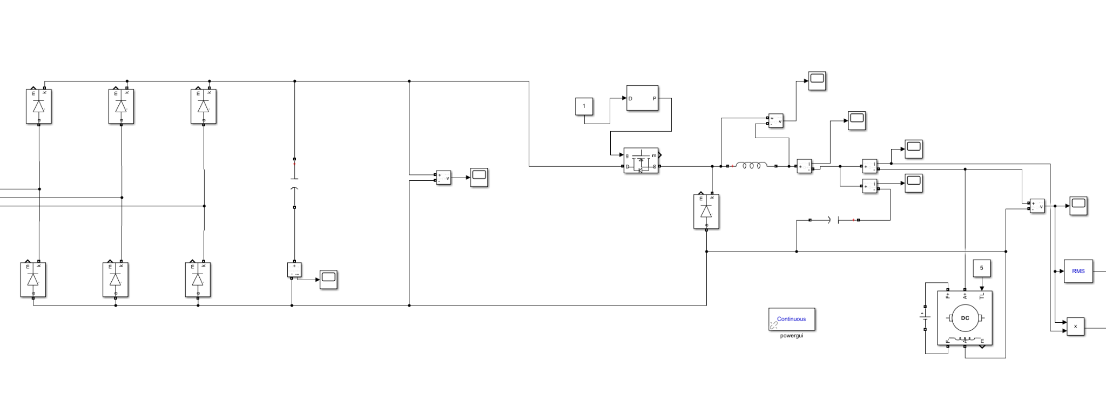

**Figure 1:** Simulink Topology

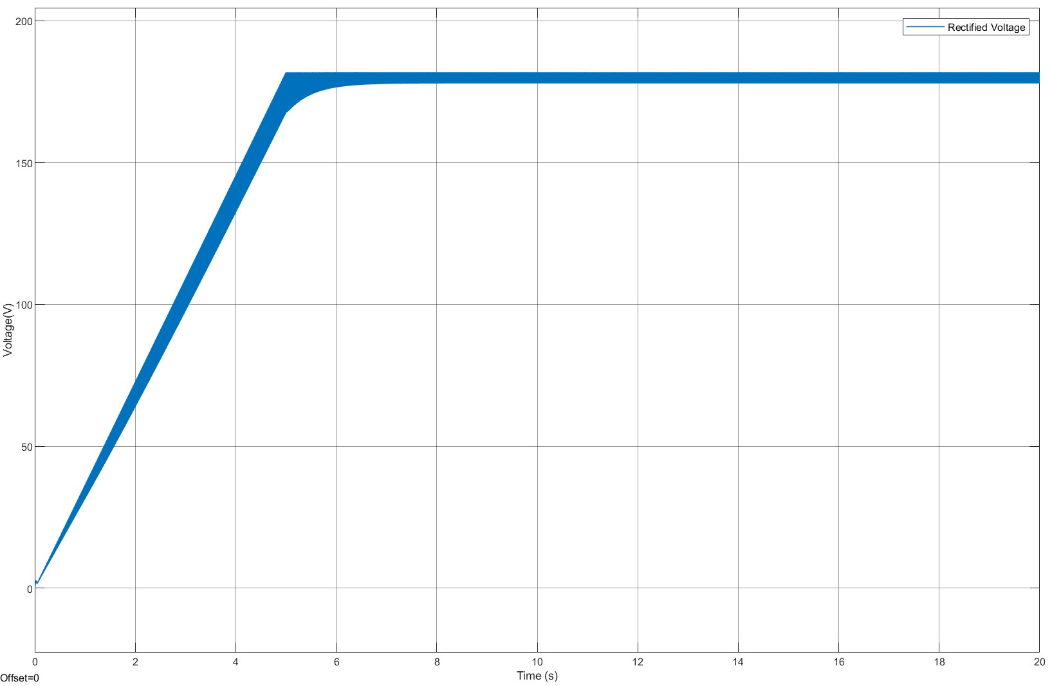

**Figure 2:** 3-Phase Diode Rectifier Output Voltage

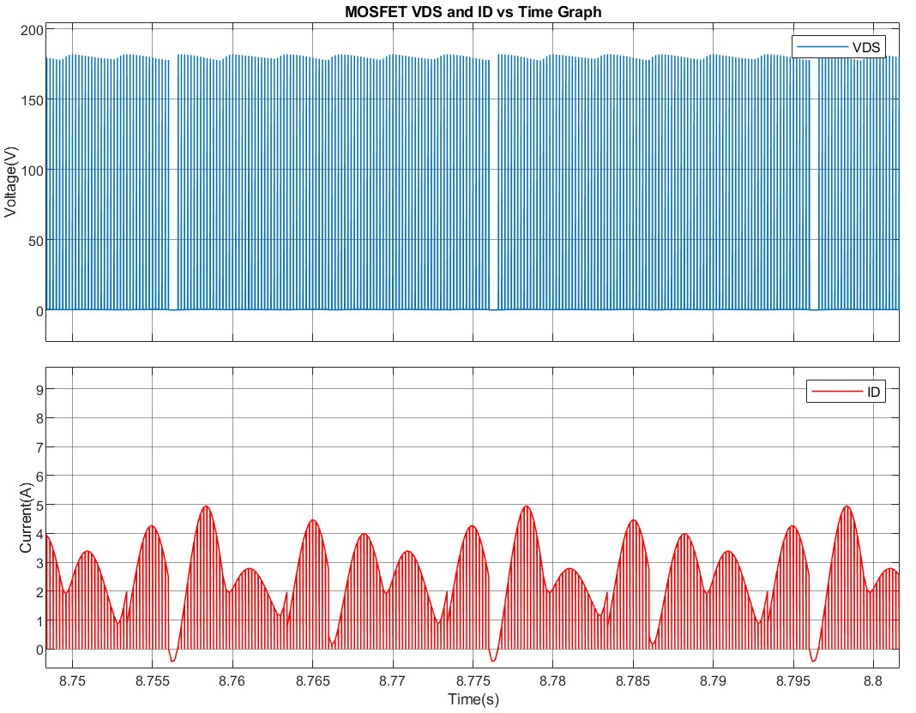

**Figure 3:** MOSFET VDS and ID vs Time Graph

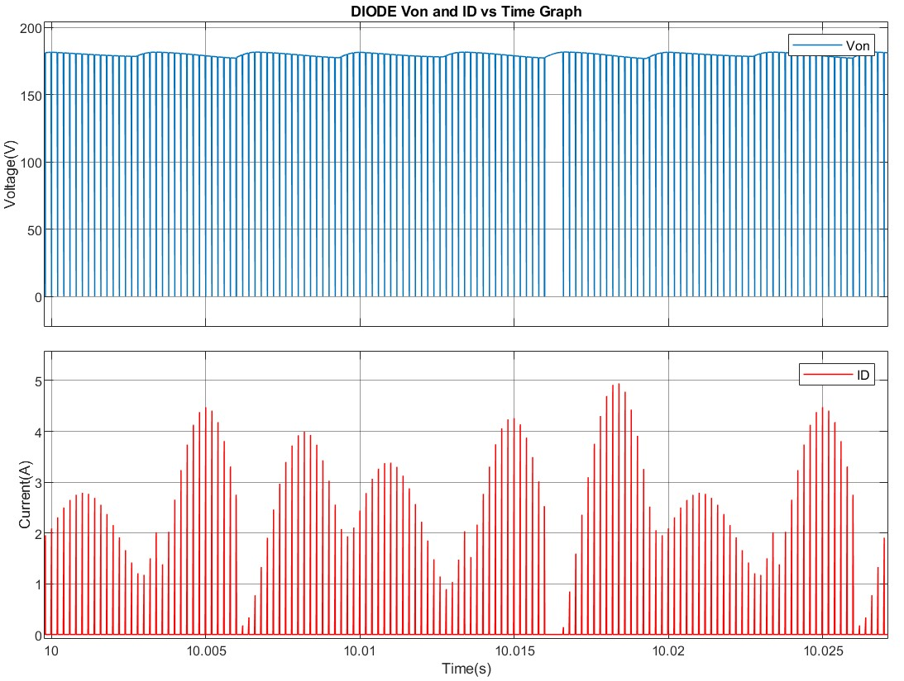

**Figure 4:** Buck Converter Diode Von and ID vs Time Graph

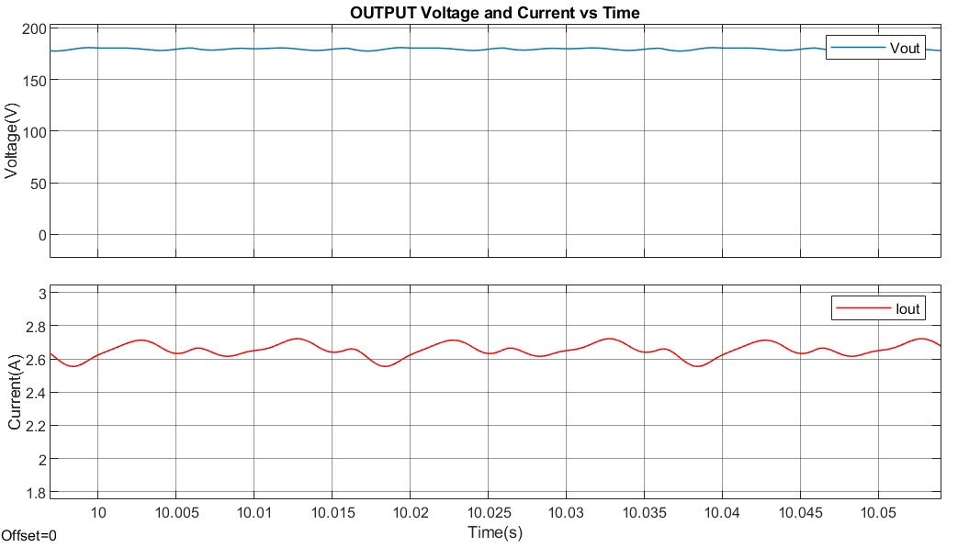

**Figure 5:** Output Voltage and Current vs Time Graph

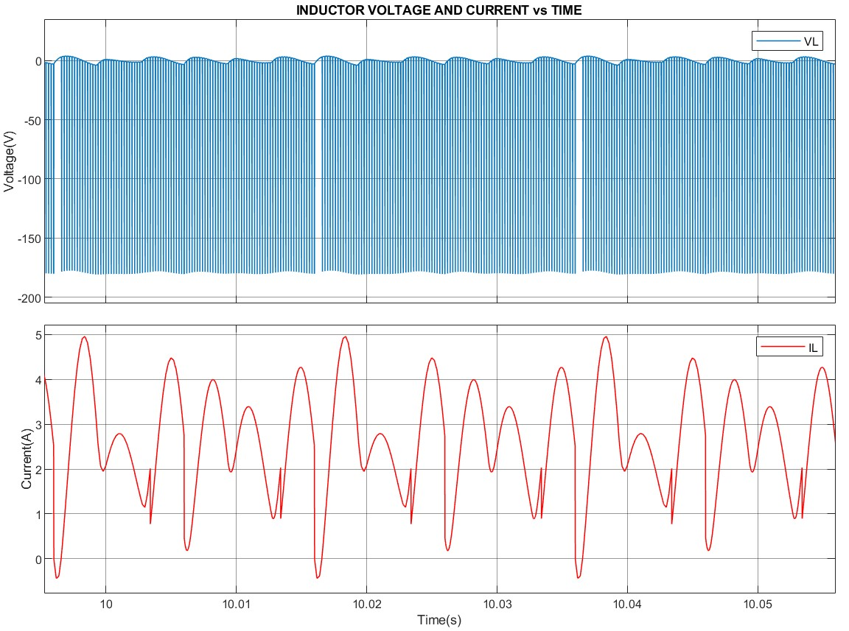

**Figure 6:** Inductor Voltage and Current vs Time Graph

# **Control Method**

In this project we wanted to implement a closed loop control algorithm to keep motor speed constant when variable loads are attached to the DC motor. We will sample motor speed by the means of an encoder. Encoders are electromechanical devices that generates a PWM signal based on rotation speed of the shaft they attached to. In general encoders come with their own shaft and the encoder with shaft is inserted to the rotationary part. In this project the DC motor under study has a large enough shaft so it is better to choose a hollow type encoder because of the listed reasons.

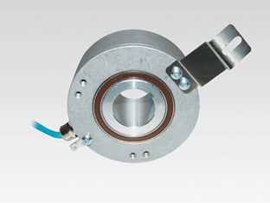

**Figure 7:** Hollow Type Encoder Example.

(Especially) During startup, high current spikes will be observed so for the control loop, we wanted to control both current and speed of the motor. In this way, a simple speed and current control loop is constructed in Figure 8 and results of constructed control loops are shown on Figure 9. In the simulation, machine parameters are inserted directly but rectification plus Buck converter cannot be inserted directly. MATLAB’s PID tuner application is used to determine PID parameters in order to give a rough behavior and before tuning, system is linearized by the application itself. When the controller is inserted to rectifier-Buck converter cascaded system, PID app cannot linearize the system(due to MOSFET- diode model highly nonlinear behaviors) and hence the parameters cannot be determined. Instead a constant voltage supply is assumed (220V in this case) and control simulation is shaped around this assumption.

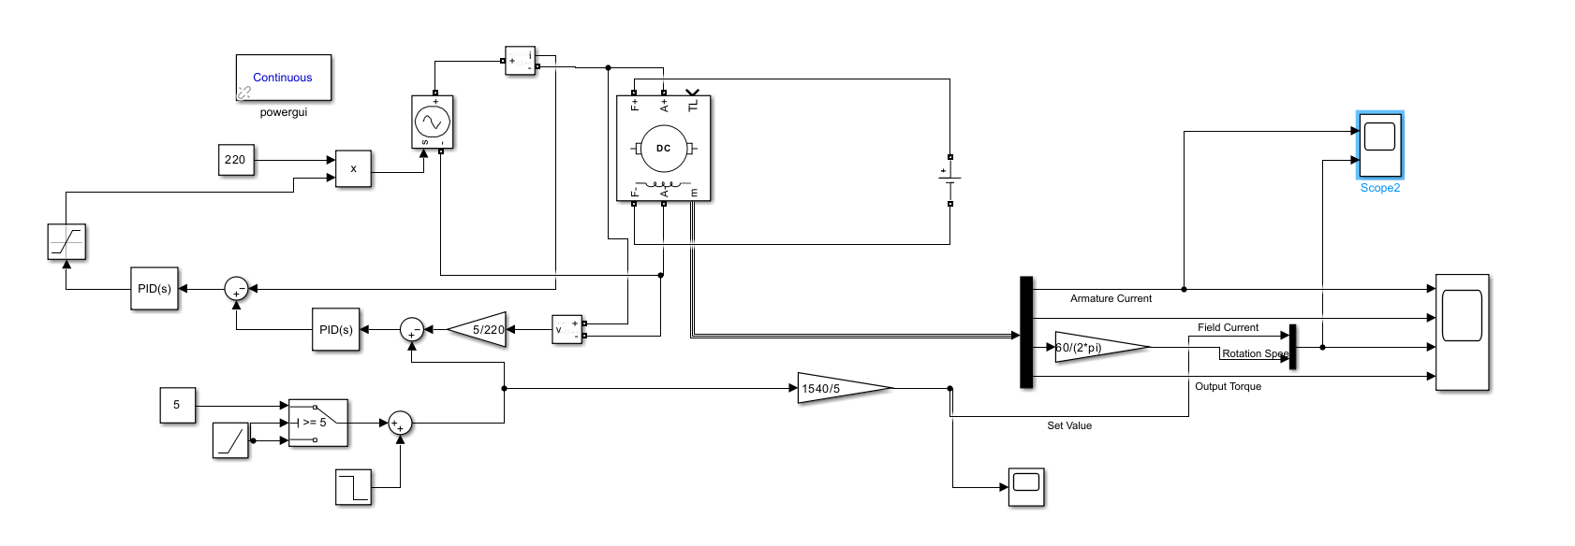

**Figure 8:** Closed Loop Control Simulation

In the simulation, two “set point” cases are studied: a ramp input from startup to rated speed and a step input to observe the plant response. Outputs of both behaviors are present in Figure 9. In the figure, a robust enough speed control can be observed easily: during ramp input maximum 400rpm error is present (which is expected from a zero order system when a first order ramp input is given) but at steady state the error converges to zero thanks to integral control. Lesser errors can be achieved by increasing P parameters but that will make the motor behave more aggressively (and hence most probably drawing currents with high amplitude spikes). In the same figure, when a step speed set input is applied, DC motor currents with high spikes can be observed. This behavior is inevitable but it can be regulated up to a point but for the time being, weight is given on speed control parameters and understanding system behavior. Depending on encoder choice and depending on controller choice (analog or digital) simulation parameters need an update and final current smoothening behavior is left to later steps.

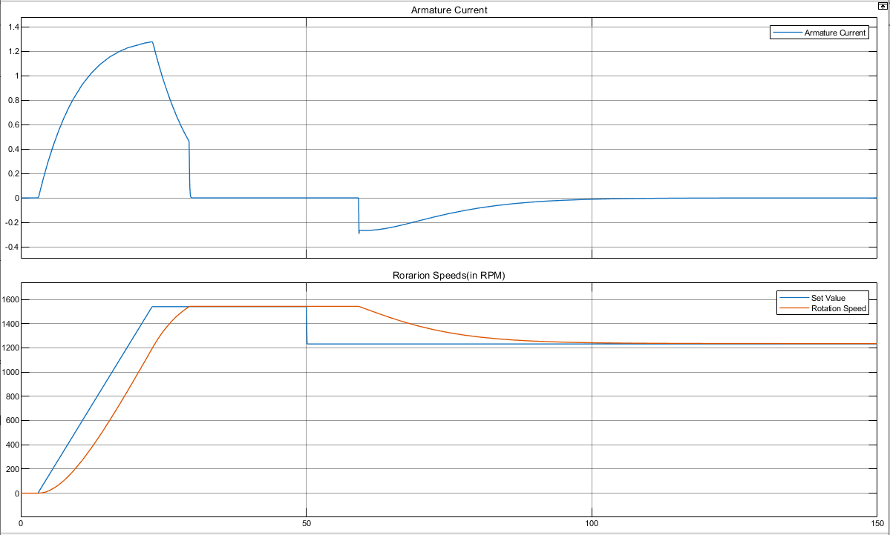

**Figure 9:** Closed Loop Control Simulation Results.

On the choice of controllers, we have two alternatives. For the analog controllers we have TL494 which is an analog PWM generator with two integrated error amplifiers to control duty cycle. [1] We could also use simple 555 timers to create the desired frequency signal but it requires additional comparators, op-amps to process feedback signals, hence 555 timer choice is discarded. If a digital controller will be employed, an Arduino Uno or STM32F103(Blue Pill) will be chosen. Arduino Uno is present on our personal inventories and it is a simple card to use but it has problems when generating high frequency signals (above 30kHz).

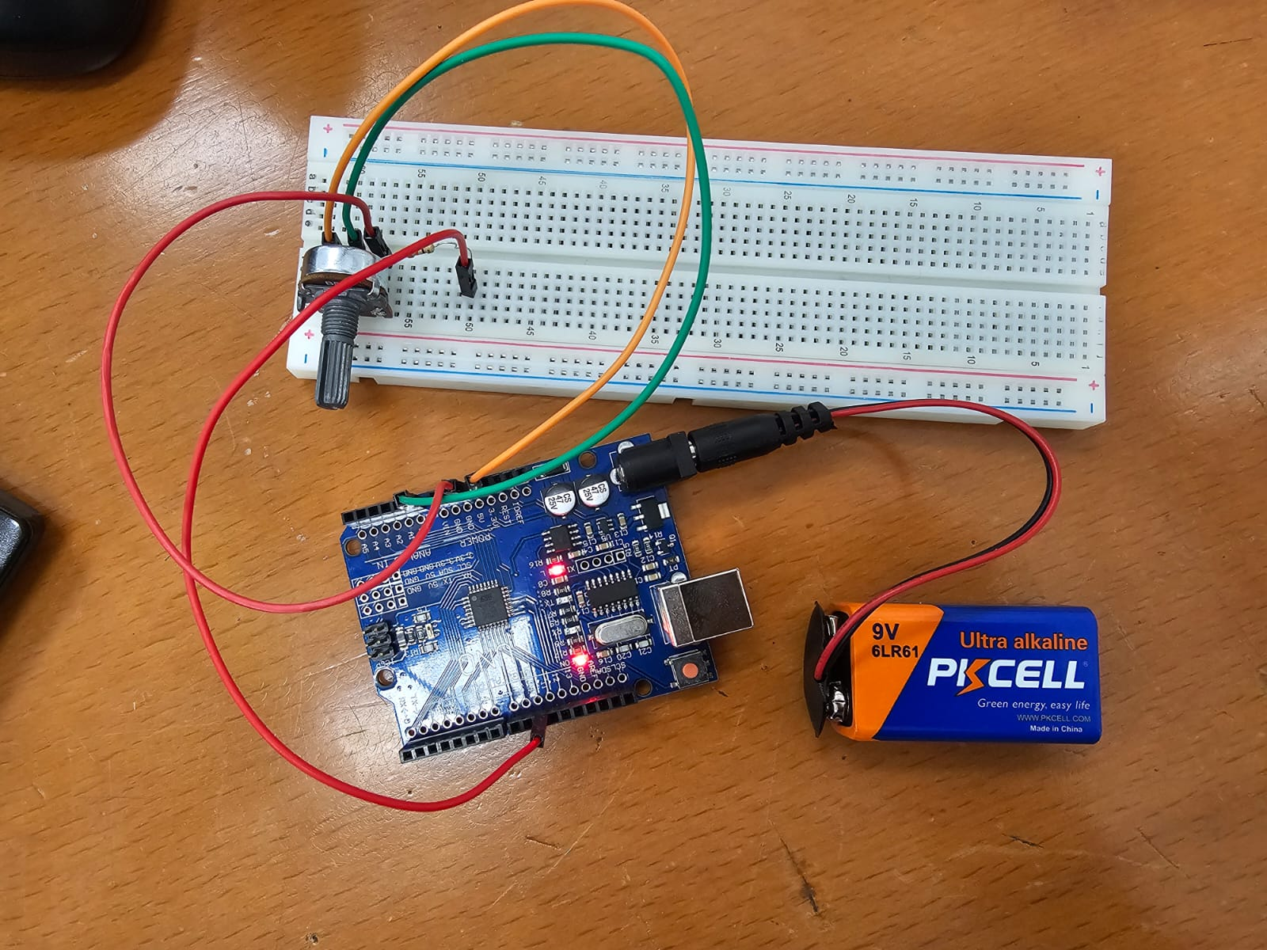

**Figure 10:** Arduino Generated PWM Test Setup

In order to test capabilities of Arduino Uno, an experimental circuit is constructed as seen on Figure x+2. Recorded output PWM signal, generated by Arduino Uno is present in Figure X+3. Arduino code is written to generate a 40kHz signal with 0.005 steps to duty cycle however observing the oscilloscope screen, generated signal is around 5kHz even though the code is written otherwise. 4.92V signal is expected to drive power MOSFET’s and IGBT’s when gate drivers are employed in between. Further tests will be conducted on the card and it is expected to fit the job however, depending on the situation it may be replaced by an STM card.

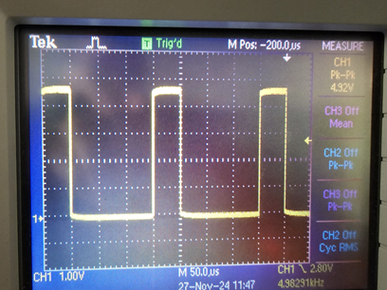

**Figure 11:** Arduino Generated Experimental PWM Signal Recorded on Oscilloscope.

# **Component Selection**

**IXGH24N60C4D1 N IGBT**

For higher voltages IGBTs are used. Although IGBTs switching loss are generally higher than MOSFETs, their conduction losses are lower as voltage drop is fixed. IXGH24N60C4D1 is a good choice for switching applications.

**1000 μF 400V Capacitor**

In order to reduce the output voltage ripple of buck converter, high capacitance is required and 1000 μF 400V is a good choice both for voltage rating and safe ripple margin.

**2200 μF 400V Capacitor**

In order to reduce the output voltage ripple of three phase full bridge rectifier, higher capacitance is required and 2200 μF satisfies desired smoothness.

**Arduino Uno**

Arduino Uno provides the required PWM signal for gate drives, i.e. for switching operations.

**LM2596 Voltage Regulator**

In order to supply low voltage to Arduino, a DC voltage regulator is needed. LM2596 is a suitable and cheap option.

**TLP250 Optocoupler**

To drive IGBT with an isolated circuit, using TLP250 Optocoupler is decided.

**ROE-0512 DC/DC Converter**

12V DC is required to apply drive circuit, so ROE-0512 DC/DC Converter 12V DC supply is a good choice.

**DSEI30-06A Power Diode**

To use Buck Converter a power diode is required. As DSEI30-06A is a proper selection as its current limit is 37A and can withstand 600V.

**Current Sensor - ACS712**

In order to measure the current for control the motor, a current sensor is needed.

**Fuses**

In order to protect the system from overcurrent, fuses will be connected at the beginning.

**Heatsink / Fan**

The system needs to be cooled while working as higher temperatures alters the effect of components.

**1 mH Inductor**

A human made inductor will be used for Buck Converter by wrapping cable around the core.

**Conclusion**

# **References**

[1] Tl494 Analog Fixed Frequency PWM Signal Generator: https://www.alldatasheet.com/view.jsp?Searchword=Tl494&gad_source=1&gclid=Cj0KCQiAo5u6BhDJARIsAAVoDWtLRLNEs_e6o1kucrSWyM9ZrsqDa7a9zjaRP_92KMw0wz2SAJ0VUSAaAmuJEALw_wcB