**Program Structure & Algorithms**

**INFO6205**

**Assignment 6**

**Name:** Mayur Kenkre

**NUID:** 002771727

**Task:**

• Determine for sorting algorithms--what is the best predictor of total execution time: comparisons, swaps/copies, hits (array accesses), or something else.

**Relationship Conclusion:**

**Evidence:**

Console output of mergesort:  
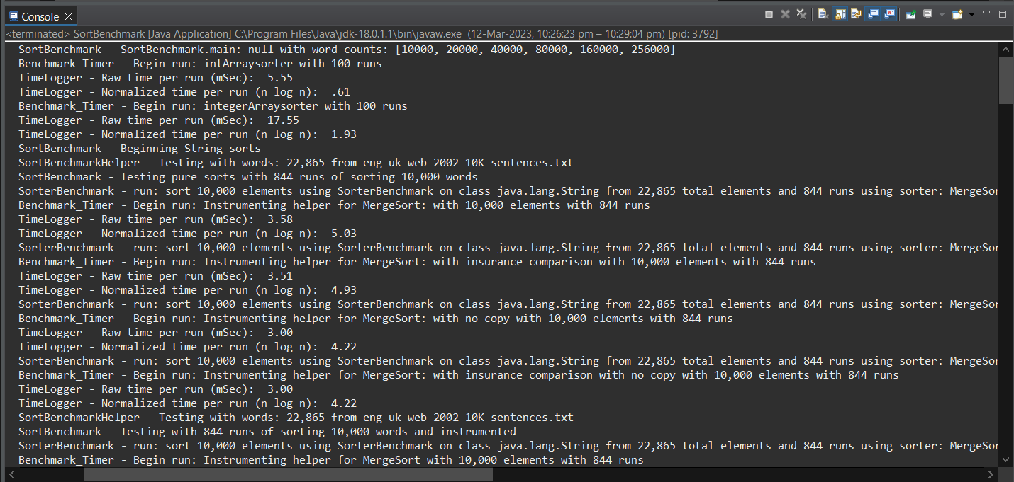

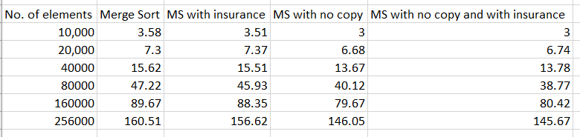

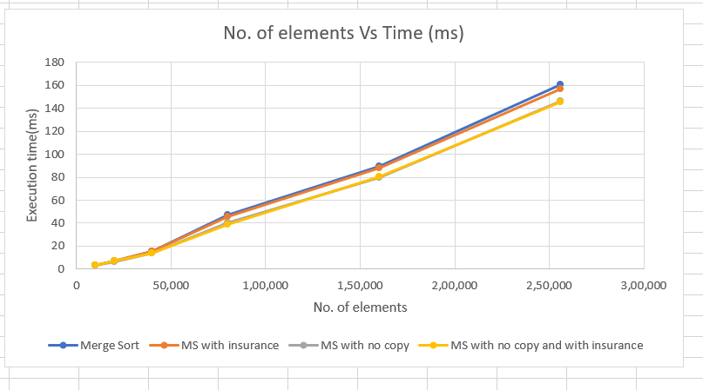

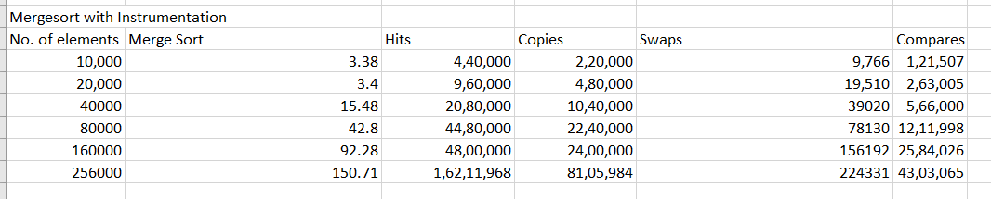

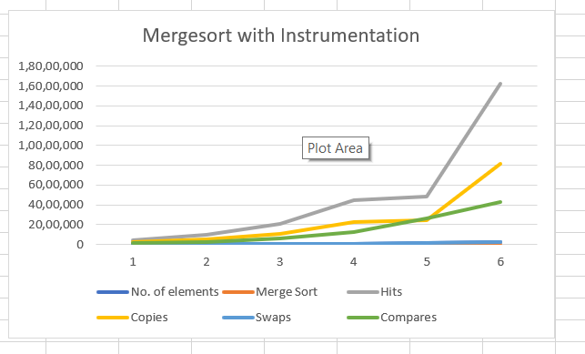

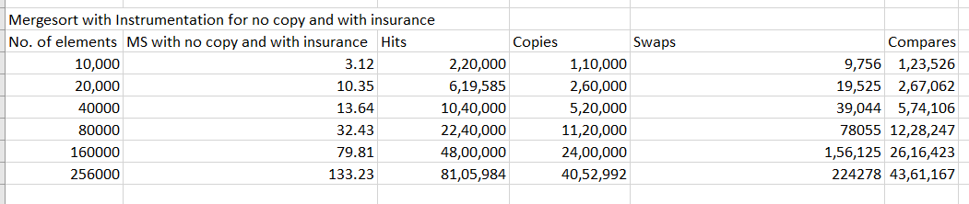

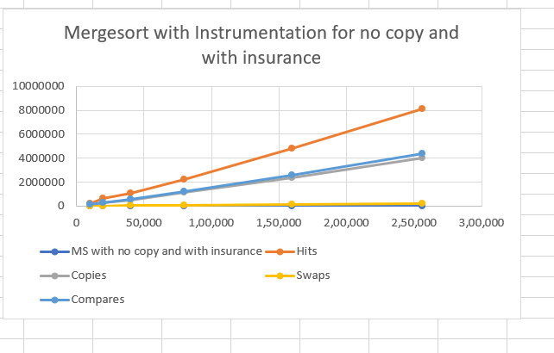

On a log-log graph, the correlation between the number of Hits, Copies, and Compares and the quantity of elements is linear. In Merge Sort, the time complexity is O(n log n), signifying that the number of Compares is the key factor in determining the algorithm's overall execution time. Although the number of Hits, Copies, and Swaps also rise as the number of elements increases, they have a lesser influence on the total time complexity compared to the number of Compares.