

August 25, 2021



Grand Prize Drawing

Wednesday, Oct. 13, 2021

*100% of all proceeds benefit local nonprofits*

*Over* ***$6.6 Million***

*raised since 2006*

GVHomeofHope.com

Dear Granville Homeowner,

We value your time, and we apologize for adding to your mail if you are already familiar with this drill; however, we want to make sure you are aware of actions currently being taken that can negatively impact your home’s value. We have been informed by several folks in your neighborhood that another out-of-town law firm, Lattie Malanga Libertino, LLP, is sending out unsolicited and unfounded letters claiming construction defects in your home. This is a common practice among certain unscrupulous law firms to stoke fear among homeowners in order to persuade them to join a frivolous lawsuit.

**Don’t be fooled!** Those of you who attended our GV101 homeowner meeting were made aware of this practice, which has been going on for decades in California. Many people who receive these letters are unaware of the repercussions of joining such a lawsuit.

If you have already educated yourself about construction defect litigation, we thank you, and we apologize for taking up more of your time with this matter. If not, we would like to provide you with the resources to learn about fabricated construction-defect lawsuits and to protect your investment. We cannot stress enough the importance of educating yourself so you don’t make the mistake of permanently labeling your home as “defective” for a settlement that never comes or is offered at pennies on the dollar.

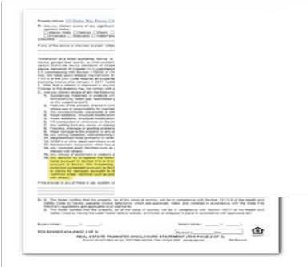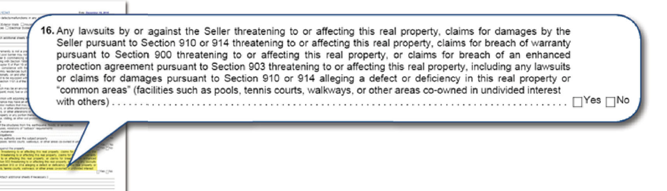

*Many participants in frivolous class-action lawsuits are unaware that they are required to disclose that their home is “defective” when re.financing or selling their home.*

*(Form shown: California Association of Realtors Real Estate Transfer Disclosure Statement)*

**This law firm has never contacted us to tell us about any homeowner concerns.** We believe their goal is to quietly send mass mailers to initiate lawsuits in order to line their own pockets at your expense and without regard to the damage they will do to your home, your property value and our good reputation.

*(continued)*

*(continued)*

Here are some facts that you need to know:

* **Simply filling out a Homeowner Profile Summary or Free Inspection form has, in the past, led homeowners who only wanted more information to be named as a plaintiff in the lawsuit. *Read the flne print!***
* **If you wish to sell or refinance their home after participating in a lawsuit, you will be required to disclose that every element of your home is “defective,” which could negatively impact your home’s value.**
* **Properties that have participated in construction-defect lawsuits are publicly listed as a “lemon” at fresnodefectcheck.com.**
* **If you do have a legitimate workmanship issue with your home, please contact our Customer Care team**.
* **Granville Homes stands behind every home we build, and will vigorously defend our reputation against these types of frivolous claims.**

In addition, when joining lawsuits such as this, you are likely agreeing that you will not be able to file any future construc- tion-related claims, as stated in this letter that one of our homeowners received from another soliciting law firm.

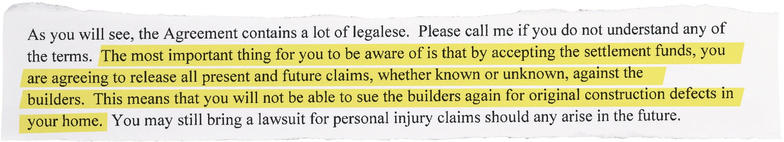

We have included a fact sheet prepared by local attorney Marisa Balch so you can be fully informed of the repercussions of participating in these types of lawsuits. In addition, we have provided some reviews from homeowners who have worked with these attorneys in the past. You can also visit [**www.fresnodefectcheck.com**](http://www.fresnodefectcheck.com/) and click “Links” for articles and infor- mation. Additional homeowner resources can be found at **GVHomes.com/know-your-rights.**

Our customers and our homes are our highest priority. Granville proudly stands behind our products, and if you ever have any questions or concerns about the condition of your home, whether you purchased

it new from Granville Homes or bought it on the resale market from a prior Granville homeowner, please do not hesitate to call. You can reach our Customer Care team at (559) 268-2000 or via email at [CustomerCare@GVHomes.com.](mailto:CustomerCare@GVHomes.com)

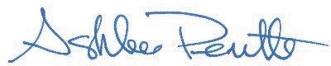Thank you again for your continued support. Best regards,

Ashlee Perritte Customer Care Manager

cc: Darius Assemi President