**Exception**

An **exception** is an event, which occurs during the execution of a program, that disrupts the normal flow of the program's instructions.

**Exception handling**

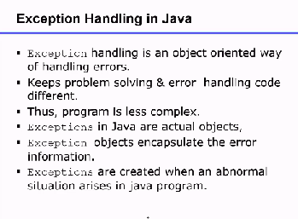

**Hierarchy of exception Class**

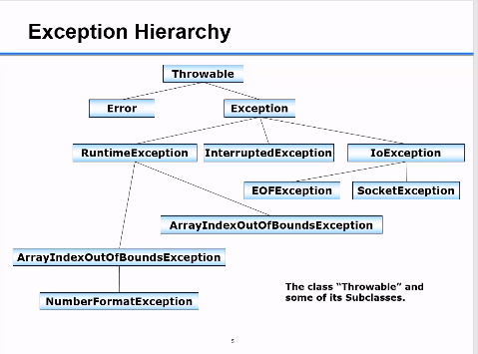

**Exception vs Error**

Exception can be recovered While Error cannot be recovered.

**Handling Exception with Try-Catch-Finally**

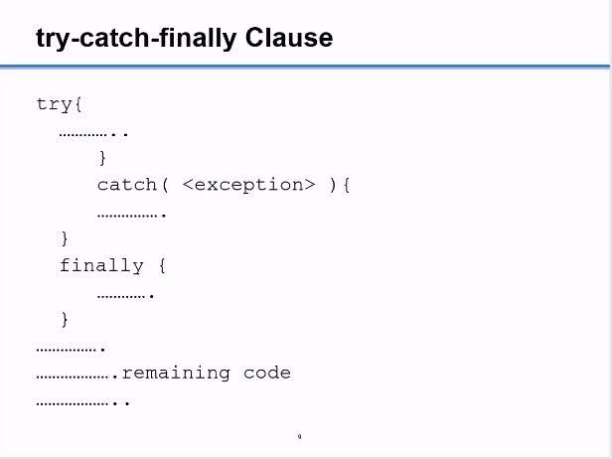

**Important methods of Java Exception Class**

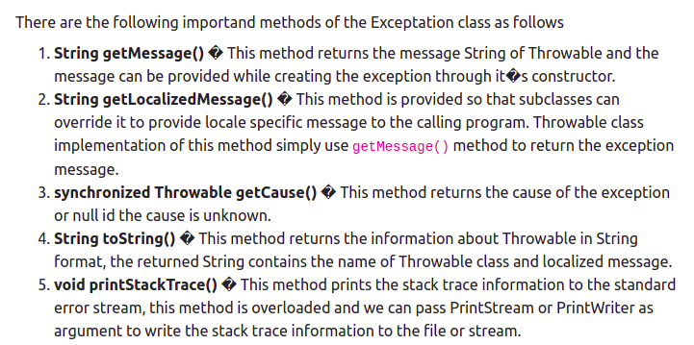

**Difference between Checked and Unchecked Exceptions in Java**

**Checked Unchecked**

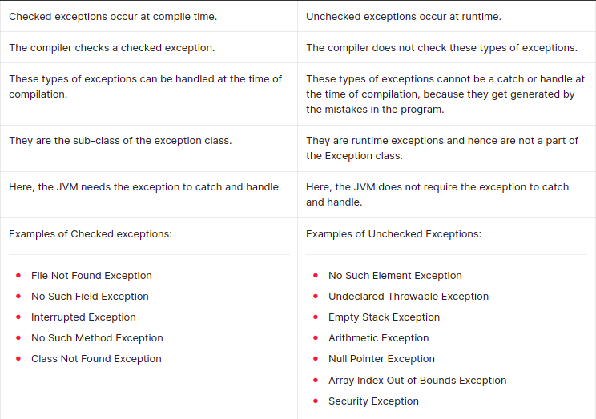

**Difference between the throw and throws keyword in Java**

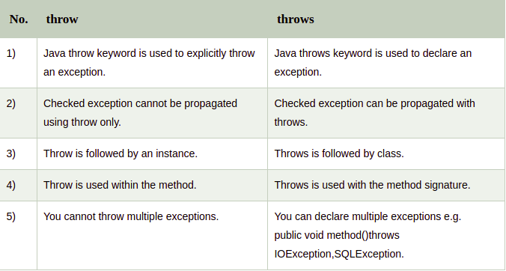

**Creating Custom Exception in Java**

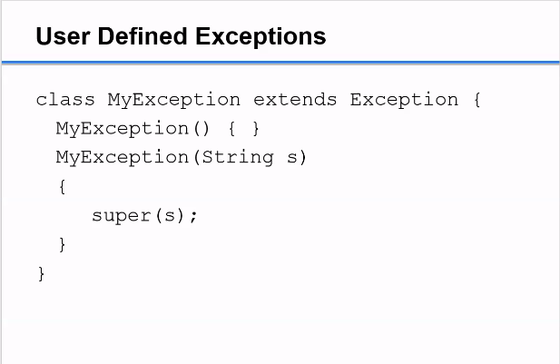

**Invalid age exception Example(Custom Exception)**

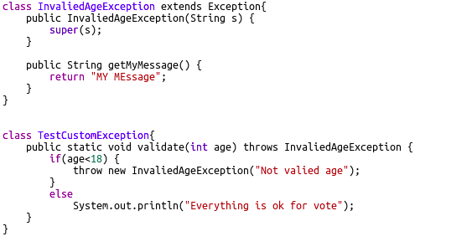

**Output**

Not Valid age

**Q. What is OutOfMemoryError in Java?**

OutOfMemoryError exception. Usually, this error is thrown when there is insufficient space to allocate an object in the Java heap. In this case, The garbage collector cannot make space available to accommodate a new object, and the heap cannot be expanded further.

**Important points**

