Python Programming | Lab02
First Python Program | 80 & 100 Point Versions
Assignment Purpose:

The purpose of this lab assignment is to demonstrate knowledge of creating and running a Python program.

This is your first lab assignment. You are not yet expected to figure out any complicated program logic. As a matter of fact you will be provided with the source code of the 80-point version below. Your mission is to demonstrate that you can use a text editor to enter the source code and then run it. Python is an interpreted language: there is no separate compile step to type. When you run a program, the Python interpreter checks your source code, translates it to bytecode behind the scenes, and executes it for you.

Remember that Python source files are saved with the .py extension. The file you were given is named Lab02st.py, but the program is the 80-point version. You need to save the file as Lab02v80.py before you begin. Also be careful with spelling and capitalization: Python is case-sensitive, so print will work but Print will not.

When you are finished, your instructor will grade your assignment. Start by displaying the execution on the monitor, which shows that the program runs and produces the required output correctly. After your instructor has seen the execution, show the source code file.

Copy the program exactly as shown below:

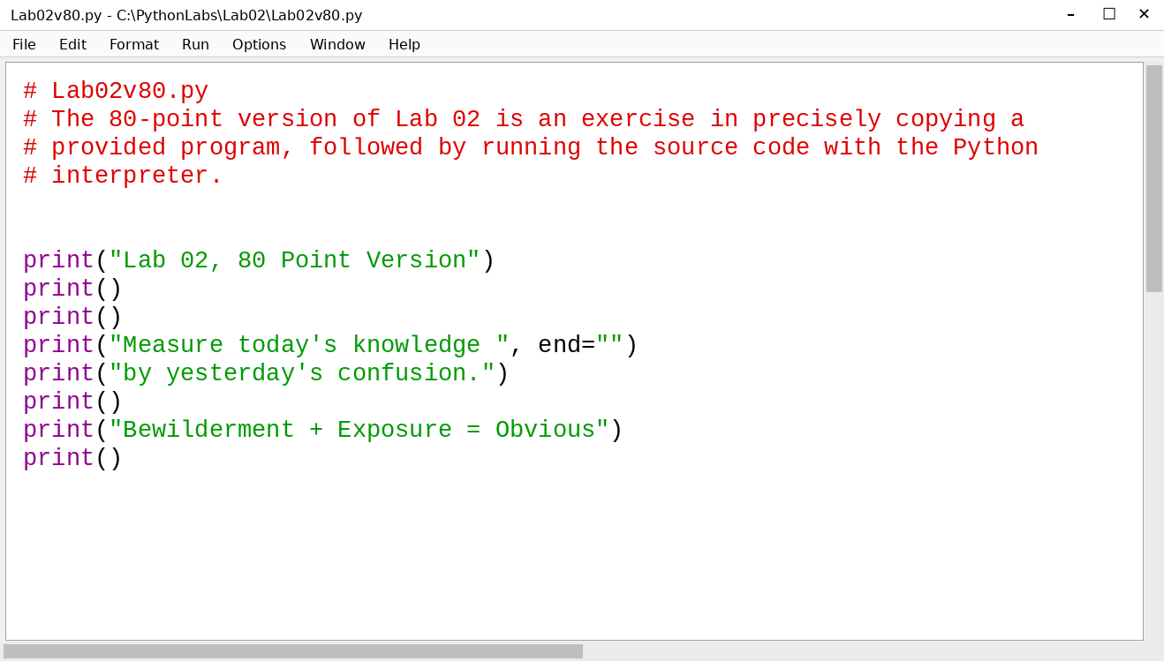
80 Point Version Output

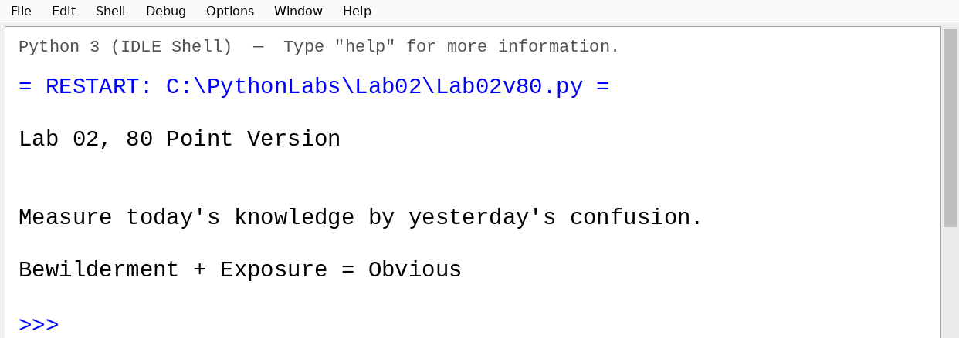

100 Point Version Specifics

Make sure that you first save your 80-point version, in the event that you are not able to complete the 100-point version in time. Rename the lab, Lab02v100.py and then continue with the instructions below. For the 100-point version you need to add additional program statements that are not provided. Show your understanding of creating Python text output by exactly creating the output that is shown below.

100 Point Version Output

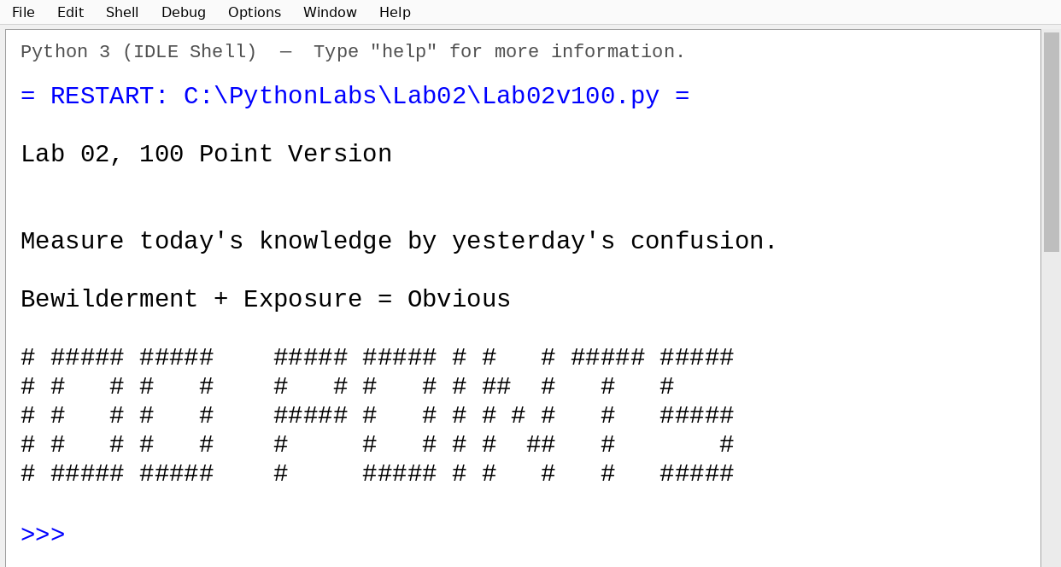

NOTE: This assignment is simpler when you use a monospaced font, like Courier, in the editor window.
ALSO: DO NOT PUT EXTRA SPACES OR <TAB> CHARACTERS AT THE START OF A LINE! In Python, indentation matters, and it will cause an IndentationError or mess up your output!

