

Cake Girls

Business Proposal

By:

Mary Dominique S. Bilgera

1. **Rationale and Background**
2. Business Title

The passionate and creative twin sisters, Monique and Manel Bilgera, are the Cake Girls. They do believe that personalized cakes make every occasion extra special and passionate bakers make the difference!

1. Brief History (futuristic)

Cake Girls started in 2017. With a meagre staff of 3 at the onset, the vision started to unfold before their very eyes when orders started to pile-up. From a partnership, it turned into a Corporation in 2022. And now they have branches situated in key cities of the metropolis.

1. Major and Specific Objectives

**Major Objective**

The Cake Girls core goal is to provide their clients with a cake masterpiece that is intricately handcrafted to suit clients’ specific needs.

**Specific Objectives**

* To provide quality cakes
* To expand the business nationwide
* To provide employment

1. Mission and Vision

**Mission**

Cake Girls is committed to serve consumers with the best quality assortment of cakes

**Vision**

Cake Girls’ vision is to become the premier company in the cake baking industry in the Philippines

1. Logo



Figure 1: Logo of Cake Girls Bakeshop

1. **Factors of Production**
2. Capital

Table 1: Estimated costs for the first year of operation of Cake Girls.

|  |  |  |  |
| --- | --- | --- | --- |
| EXPENSES | QUANTITY | PRICE | TOTAL |
| Rent | 12 months | ₱ 5 000 | ₱ 60 000 |
| Renovation and Decorations | 1 | ₱ 10 000 | ₱ 10 000 |
| Permits, Licenses, and Business Certificates | 1 | ₱ 5 000 | ₱ 5 000 |
| Equipment | 1 | ₱ 20 000 | ₱ 20 000 |
| Supplies including Ingredients and Packaging | 12 months | ₱ 7 000 | ₱ 84 000 |
| Labor (1 helper) | 12 months | ₱ 3 500 | ₱ 42 000 |
| Advertising | 12 months | ₱ 416 | ₱ 5 000 |
| Utilities | 12 months | ₱ 5 000 | ₱ 60 000 |
| Emergency Reserve | 1 | ₱ 14 000 | ₱ 14 000 |
| TOTAL | | | ₱ 300 000 |

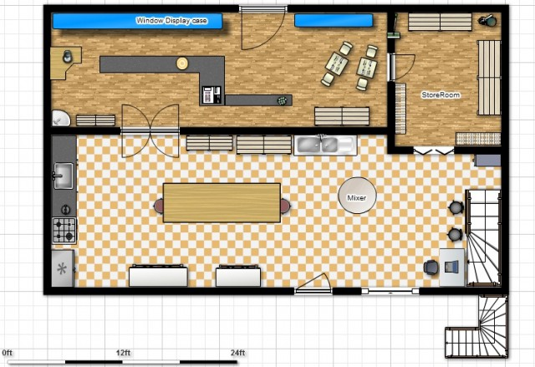

Fire Exit

Figure 2: Floor Plan of Cake Girls Bakeshop

1. Entrepreneurs

Cake Girls will be managed by its owners, Monique and Manel Bilgera. Monique is going to be the operational manager of the business and Manel would be the financial manager.

1. Land

The store is located at a very strategic location on the ground floor of 168 Mall at Divisoria, Manila. This place has a wide displays of gowns and suits and is the go-to of debutantes and wedding couples which gives them easy access to their target market. This is also good for the business as the owners will only pay a small portion of the rent because they know the proprietor of the mall.

1. Labor

* Personnel Plan

The owners or the entrepreneurs of the business will not just finance the business but will also play major roles in the bakeshop. Cake Girls will only hire one (1) helper during the first year of operation. All of the activities of the bakeshop will be handled by the owners and the helper. Since the staff are only 3, the bakeshop will limit the acceptance of orders to make sure they are providing quality and satisfactory cakes. In instance that there are enough money circulating the business, Cake Girls will hire more bakers to help them in the business.

Table 2: Personnel Plan

|  |  |
| --- | --- |
| Job | Employee/s |
| Operational Manager | Monique |
| Financial Manager | Manel |
| Cashier | Monique |
| Sales Clerk | Monique |
| Accountant | Manel |
| Utility | Monique, Manel, and Helper |

1. **Products / Services Offered**
2. Product / Service Description

Personalized cakes are the key product of Cake Girls, and product quality is essential for the success of the business. In order to ensure product quality, the bakeshop will emphasize cleanliness and sanitation, use quality ingredients, and will always be sure all cakes are properly baked.

1. Raw Materials / Components

The following are the primary ingredients and supplies used by the bakeshop:

* Flour
* Eggs
* Baking Soda
* Vanilla Extract
* Butter
* Sugar
* Baking Powder
* Condensed Milk
* Yeast
* Food Colouring
* Food Flavouring
* Salt

1. Unique or Distinct Characteristics

At Cake Girls, they want people to support their company and gain loyal patronage not because they design one-of-a-kind custom-made cakes but because the cakes that they produce are delicious, original and imaginative. Their designs are limitless and the possibilities, endless.

1. Target Market / Consumers

The primary target market of the bakeshop are large events like weddings and debuts, or even bigger parties. An interesting cake isn’t just part of the food or refreshments, it is a part of the atmosphere or great surprise.

1. **Sales and Marketing Strategy**
2. How to Market the Product?

Based on the mission of the bakeshop, Cake Girls’ product strategy is to provide best quality and unique cake for the clients. Prices of the products would be ensured to be affordable without compensating the quality of the cakes. Discounted price will be offered to volume purchase orders and loyalty cards will be given to regular customers. Apart from that, the bakeshop will also provide free delivery of orders if within Metro Manila.

1. Advertisement

Customer awareness is the first step in promoting a new business. Cake Girls will achieve this through grand opening. The event will be promoted through flyers, posts in social networking sites, and hopefully through word of mouth. At the grand opening, Cake Girls will have a display of their different personalized cakes and offer free taste of the cakes.

1. Partnership

The bakeshop will network with wedding planners, event planners and caterers. They will also offer discounts for referrals and will reward them with similar recommendations to the clients of the business.

1. **Future of the Business**
2. Expansion Strategy

In order for the business to grow and expand, Cake Girls will start by adding new products and services to its clients when there are already adequate funds to support the expansion efforts. The bakeshop will open a themed café where they will not only offer cakes but also different kinds of pastries and drinks that is consistent with the business mission to provide fun, imaginative & beautifully-crafted delicious work of art.

1. Increase of Production

The bakeshop will start increasing their production as soon as they start to expand the business. Since Cake Girls started with only 3 staffs, they will hire new bakers and helpers to help them in making the products and in serving their clients. Equipment will also be bought to aid the production of cakes and pastries.

1. Franchising (futuristic)

They chose franchising as another vehicle for expansion. Cake Girls waited for 4 years to begin franchising their bakeshop. Marketing in nearby cities helped the twins bring in their first few franchises.

1. Contingency Measures / Strategies

The bakeshop will have a reserved money that can be used in case of risks and exposures should occurs. The business will also get an insurance program for the protection of the company and its employees.