PRICE TRUTH
  - Code Review and Lab Work Report
Focused demonstration: historical price assessment with real SHAP explanations. Supporting demonstration: unit-price comparison.
Field | Submission details
Module | S3 Lab Work — 40-mark rubric
Institution | NMIMS • M.Sc. Data Science
Faculty | Dr. Yogesh Naik
Team | Swagata Bhowmik (B053)  Charvi Rathod (B049)  Yashwi Shah (B036)
Review execution | 19 September 2026; exact timestamp in review_manifest.json
Environment | Python 3.12.0 • macOS 26.5.2 • ARM64
Application | http://localhost:8501 — local Python application
Reference design | https://price-truth.netlify.app/dashboard — simulated visual prototype

Rubric area | Marks | Included evidence
Codebase | 10 | Architecture, source files, data audit and working flow
Frameworks | 10 | Installed versions and implementation justifications
Code quality | 10 | Actual Ruff, PyTest, Mutmut and Radon outputs
NFRs | 10 | Nine target-versus-evidence rows, including unverified targets

Recorded check | Result
PyTest | 98 passed; 0 failed; 0 skipped
Ruff | 0 configured-rule violations
Mutmut | 305 / 375 killed (81.33%); scoped to 3 modules

This report is finalized for the supplied code snapshot. It is not a claim that every product feature, NFR or rubric mark has been achieved. Tool measurements cover the scopes stated on the following pages.

1. Codebase and demonstration scope
The submitted application accepts an actual catalogue listing and a user quote, validates prices, estimates an observed selling-price range and computes Tree SHAP. It also provides a deterministic comparison of pack value.
Catalogue selection + user quote
-> input validation -> trained preprocessing -> price model
-> calibrated interval + real SHAP -> displayed result / JSON

Raw Amazon + Flipkart CSVs -> cleaning + exclusion audit
-> grouped train / validation / calibration / test partitions
-> model selection -> saved model + held-out evaluation

app.py # navigation, cached resources
src/price_truth/
data.py # cleaning and catalogue audit
model.py # training, calibration, SHAP
calculations.py # discount/unit/shrink arithmetic
external.py # official API clients and caches
history.py # comparable price observations
catalogue.py # search, safe links and export
ui.py, paths.py, __init__.py
scripts/ # acquisition, browser and review
tests/ # six behavior/integration suites
datasets/, artifacts/ # real inputs and trained model
reports/ # original tool outputs and hashes

Layer | Files | SLOC
Data | 1 | 107
ML | 1 | 149
Domain / services | 4 | 174
Interface | 2 | 279
Infrastructure / scripts | 5 | 308
Tests | 6 | 361
TOTAL | 19 | 1378

Source scope is the existing application, scripts and tests, not just the demonstrated module. Document assembly utilities and packaging are outside these code metrics. Supporting pages exist; unified product search and live equivalent-offer aggregation are not claimed complete.

2. Real data and reproducible preparation
Source | Raw rows | Retained | Excluded
Amazon | 1465 | 1347 | 118
Flipkart | 20000 | 19920 | 80
TOTAL | 21465 | 21267 | 198

Decision | Observed evidence / implementation
Amazon exclusions | 109 repeated rows; 9 rows from four price-conflict product IDs
Flipkart exclusions | 78 missing-price rows; 2 repeated rows
Dates | Amazon: unknown. Flipkart: December 2015–June 2016.
Missing ratings | Retained as missing; model imputation fitted on training data
Sensitive source fields | Reviewer identifiers and text excluded from processed catalogue
Integrity | Original CSV SHA-256 checks; exclusion CSV and audit JSON
Synthetic data | No generated training observations, prices, histories or authenticity labels

Partition | Rows | Purpose
Train | 10777 | Initial fitting
Validation | 2708 | Model selection
Calibration | 3513 | Interval calibration
Test | 4269 | Final held-out evaluation

Related normalized titles are grouped before splitting. Groups do not overlap across partitions. This reduces, but does not eliminate, variant leakage. Preprocessing learns only from fitting data; the final estimator is refitted on train + validation.
Evidence: reports/data_audit.json, excluded.csv, evaluation_split.csv, tests/test_data.py. Raw source licensing must be confirmed before public redistribution.

Source records
Amazon: kaggle.com/datasets/karkavelrajaj/amazon-sales-dataset
Flipkart: kaggle.com/datasets/PromptCloudHQ/flipkart-products
Additional Open Food Facts / Open Prices caches and cited shrink cases serve supporting pages. They are not merged into the price model. See docs/DATA-SOURCES.md for provenance and limitations.

3. Model evaluation and actual explanation
Validation candidate | Mean absolute log error
baseline | 0.279389
random_forest | 0.265184
hist_gradient_boosting | 0.261744

Histogram gradient boosting was selected by validation log error. An ensemble was not added because the available evaluation did not establish a need. The model target is log(1 + observed selling price in INR).
Held-out measure | Selected model | Baseline
Rows | 4269 | 4269
MAE (INR) | 356.82 | 373.27
Median absolute percentage error | 20.16% | 23.39%
Mean absolute log error | 0.273049 | 0.305961
R-squared | 0.957552 | 0.958382
90% interval empirical coverage | 89.76% | Not calibrated

Platform | Combined log MAE | Separate log MAE | Baseline
amazon | 0.292458 | 0.311104 | 0.300071
flipkart | 0.271619 | 0.26827 | 0.306395

# Actual model inputs; selling price is never a predictor.
out = frame[CATEGORICAL +
["listed_price", "rating", "rating_count"]].copy()
out["log_listed_price"] = np.log1p(out.listed_price)
out["log_rating_count"] = np.log1p(out.rating_count)

# Actual explanation computed at assessment time.
explanation = shap.TreeExplainer(estimator)(transformed)
contributions = explanation.values[0]

Excerpts: src/price_truth/model.py. SHAP describes the estimated log selling price; tests check additive agreement for held-out examples from both platforms.

Interpretation limits
R-squared is not fraud-classification accuracy. Listed price can bias the estimate; old snapshots do not establish today’s fair price. The combined model does not beat every separate-platform metric. Conformal coverage is empirical and depends on comparable data. No verified fraud labels are available.

4. Frameworks and static review
Library | Version | Role / justification
pandas | 2.3.3 | CSV ingestion and cleaning
numpy | 2.3.5 | Arrays, transforms and numerical metrics
scikit-learn | 1.8.0 | Grouped splitting, preprocessing and tree models
shap | 0.52.0 | Computed Tree SHAP; no hardcoded contributions
streamlit | 1.57.0 | Interactive Python application and cached resources
plotly | 6.6.0 | Interactive price and explanation charts
requests | 2.33.1 | Official API requests with bounded timeouts
pytest | 9.0.3 | Behavior, integration and UI tests
pytest-cov | 7.1.0 | Statement and branch coverage
ruff | 0.16.8 | Configured syntax, imports and lint rules
mutmut | 3.8.0 | Executable mutation testing
radon | 6.0.1 | Four code-metric families
playwright | 1.63.0 | Isolated Chrome flow checks

Ruff result
.venv/bin/python -m ruff check src app.py scripts tests \
--output-format json

Scope / rule families | Violations | Outcome
src, app.py, scripts, tests  E4 / E7 / E9 / F / I / B / UP | 0 | Passed configured checks

Evidence: reports/ruff.json (empty result list) and review_manifest.json (command, version, exit code). This is not a claim that every possible style/security rule was enabled. Runtime versions here are the application/review environment, not the separate document renderer.

5. PyTest and coverage
Test module | Cases | Verified area
app | 11 | Page navigation, quote and unit workflows, offline UI
calculations | 43 | Finite values, discounts, units, currencies, multipacks
data | 10 | Raw hashes, exclusions, splits and feature leakage
model | 5 | Full training path, held-out SHAP, invalid inputs
search | 5 | Real cached query, bounds and API failure behavior
services | 24 | Cache fallback, exports and history isolation

Measure | Actual result
Executed cases | 98
Failures / errors / skipped | 0 / 0 / 0
Elapsed seconds | 14.223
Statement coverage | 462 / 526 = 87.83%
Branch coverage | 74 / 98 = 75.51%

Package module | Covered statements | Statements | Missing branches
__init__.py | 0 | 0 | 0
calculations.py | 35 | 35 | 0
catalogue.py | 19 | 19 | 0
data.py | 66 | 82 | 3
external.py | 56 | 65 | 5
history.py | 31 | 31 | 0
model.py | 103 | 104 | 1
paths.py | 7 | 7 | 0
ui.py | 145 | 183 | 15

Coverage measures the price_truth package. app.py is exercised by AppTest but excluded from this coverage denominator. Scripts are linted and measured by Radon. Boundary fixtures are test-only; they never become displayed source evidence or model training data.
Two warnings were recorded in the full run: the Flipkart-only comparison has an entirely missing rating-count feature, which SimpleImputer skips. The combined model and tests completed. See pytest-run.txt for the unabridged warnings.

6. Mutation testing: tests of the tests
Outcome | Actual count
Killed | 305
Survived | 70
Total | 375
Timeout / no tests / skipped | 0 / 0 / 0
Kill rate | 81.33%

Mutmut ran natively against calculations.py, catalogue.py and history.py. Model training, API integration and interface code are outside mutation scope. Explicit mutant selection forced a fresh run after stronger tests; cached old outcomes were not presented as new evidence.
Actual mutation | Result | Mechanism / remaining gap
positive #1: conversion replaced by None | Killed | Valid numeric inputs must work
compare_packs #28: pack count omitted | Killed | Ranking must use total multipack quantity
positive #8: error message replaced by None | Survived | Exception type checked; wording not asserted
series_for #1: default UNIT changed | Survived | UI/tests pass units explicitly; default remains a test gap

# Killed: calculations.x_compare_packs__mutmut_28
- unit_price(p["price"], p["quantity"], p["unit"],
- p.get("packs", 1))
+ unit_price(p["price"], p["quantity"], p["unit"])

# Survived: calculations.x_positive__mutmut_8
- raise ValueError("Enter a finite value greater than zero.")
+ raise ValueError(None)

Diff excerpts abbreviated only for page width; complete original diffs and all mutant IDs are included in reports/. Outcome count is not adjusted to remove cosmetic mutants.
Review finding | Action / status
Multipack ranking not sufficiently tested | Added real arithmetic assertions; omission now killed
History isolation tests too weak | Added store/currency/unit/date/proof/duplicate checks
70 surviving mutants | Disclosed; remaining test gaps and message mutations
Mutation scope limited to 3 files | No whole-project mutation-score claim

7. Radon: complexity and maintainability
Module | Blocks | Mean CC | Max CC | Rank
ui.py | 6 | 6.67 | 13 | C
calculations.py | 5 | 4.0 | 8 | B
model.py | 8 | 2.12 | 5 | A
external.py | 4 | 5.75 | 10 | B
data.py | 7 | 3.0 | 9 | B
catalogue.py | 3 | 3.33 | 4 | A
history.py | 3 | 4.0 | 7 | B
app.py | 3 | 4.67 | 12 | C
scripts/fetch_real_data.py | 2 | 5.5 | 6 | B
scripts/review.py | 5 | 9.6 | 40 | E
scripts/browser_check.py | 1 | 3.0 | 3 | A

47 production/script blocks; mean CC 4.66. Rank E / CC 40 in scripts/review.py is the report-assembly routine. It remains a disclosed refactoring opportunity. UI and app routing also contain rank C functions.
Module | Maintainability index | Rank
ui.py | 25.01 | A
scripts/review.py | 34.05 | A
model.py | 34.07 | A
external.py | 38.76 | A
calculations.py | 42.83 | A
data.py | 43.12 | A
history.py | 44.55 | A
app.py | 45.59 | A
scripts/fetch_real_data.py | 47.48 | A
catalogue.py | 55.75 | A
scripts/browser_check.py | 58.84 | A
paths.py | 67.73 | A
__init__.py | 100.0 | A

Radon rank A starts above MI 19; these are not percentage quality scores. Test-file metrics are preserved in raw JSON but excluded from the production/script tables above.

8. Radon: raw and Halstead metrics
Metric | Production + scripts | Tests
loc | 1219 | 537
lloc | 892 | 408
sloc | 1017 | 361
comments | 4 | 0
multi | 0 | 0
blank | 138 | 117

LOC = physical lines; LLOC = logical lines; SLOC = source lines; multi = multiline string lines. Single-line docstrings are not included in the multi total. The report retains raw numbers rather than treating comment counts as quality guarantees.
Module | Vocabulary | Volume | Difficulty | Effort | Est. bugs
paths.py | 10 | 59.79 | 0.67 | 39.86 | 0.02
ui.py | 74 | 664.41 | 6.87 | 4565.15 | 0.22
__init__.py | 0 | 0 | 0 | 0 | 0.0
calculations.py | 61 | 510.04 | 6.98 | 3559.89 | 0.17
model.py | 56 | 493.63 | 6.09 | 3004.67 | 0.16
external.py | 35 | 251.33 | 3.1 | 780.0 | 0.08
data.py | 57 | 548.29 | 8.27 | 4532.54 | 0.18
catalogue.py | 17 | 73.57 | 2.5 | 183.94 | 0.02
history.py | 63 | 543.93 | 6.35 | 3451.88 | 0.18

Halstead bugs are formula-derived estimates, not discovered defects. Full Halstead function metrics and raw metrics are in reports/radon-hal.json and reports/radon-raw.json.

Source traceability
Check | Evidence
Application source | SHA-256 for all 19 reviewed Python files in review_manifest.json
Original datasets | Hash checks in test_data.py and data_audit.json
Review commands | Exact executable paths, arguments and exit codes retained
Packaging check | Reviewed Python files matched their recorded hashes before document assembly

This document summarizes actual saved results. It does not substitute hand-calculated or estimated test outcomes for tool execution. Presentation utilities are separate from the reviewed application.

9. Non-functional requirements
Informal ISO 25010 category mapping. Targets are inherited from the project requirements; partial and unmeasured results remain visible.
NFR / category | Target | Observed result / evidence
Performance / efficiency | Page <3s; prediction <2s | First browser 3.044s: missed. Repeat 1.029s. First assessment + SHAP 0.926s; warm p95 0.035s across 29 warm calls. performance.json; browser JSON.
Scalability / capacity | 100 concurrent users | Not measured. Sequential inference timings do not demonstrate concurrency.
Usability / interaction | No manual needed | Functional flows checked. No user study; usability target not established. test_app.py.
Security | HTTPS; no PII storage | Local HTTP only; hosted HTTPS unverified. No account/quote persistence; source reviewer fields excluded from processed data. Raw files retain original fields.
Reliability | 99% evaluation uptime | Not measured over an evaluation window. Tests are not uptime evidence.
Portability / flexibility | Desktop, tablet, mobile | 1440px desktop and 390px mobile Chrome emulation; no horizontal page overflow. Physical devices/tablet not checked.
Maintainability | Modular code | 13 production/script Python files; CC/MI and surviving mutations disclosed. Radon JSON.
Availability / reliability | Accessible 24/7 | Not established: local application, no public deployment.
Compatibility | Chrome, Firefox, Safari, Edge | Chrome 153.0.8010.52 checked. Other browsers untested. browser_check.json.

NFR conclusion
Local inference meets the recorded latency target; the first page load narrowly missed its target. Functional browser checks and modularity have evidence. Public reliability, availability, capacity and broader compatibility remain unverified. No certification or complete NFR compliance is claimed.

10. Reproduce and present the results
The tools have already been executed. Re-running is optional for the unchanged code and required if implementation changes. The complete raw results are included in the submission archive.
# Existing environment: launch the working application
.venv/bin/python -m streamlit run app.py

# Fresh environment (macOS/Linux, Python 3.12)
python3 -m venv .venv
.venv/bin/python -m pip install -r requirements-dev.txt

# Reproduce the complete automated review
.venv/bin/python scripts/review.py

# Browser evidence: app must be running; Chrome installed
.venv/bin/python scripts/browser_check.py

# Individual professor-recommended tools
.venv/bin/python -m ruff check src app.py scripts tests
.venv/bin/python -m pytest --cov=price_truth --cov-branch
.venv/bin/mutmut run 'price_truth.*'
.venv/bin/python -m radon cc src app.py scripts tests -j
.venv/bin/python -m radon mi src app.py scripts tests -j
.venv/bin/python -m radon raw src app.py scripts tests -j
.venv/bin/python -m radon hal src app.py scripts tests -j

Exact previously executed commands are in review_manifest.json. Windows uses .venv\Scripts\python.exe; Mutmut requires a suitable Unix/WSL environment. The browser script uses the standard macOS Chrome path. The archive contains real data and the locally generated trusted model.
Demo step | Action | Explain
1 | Open Discount Checker; assess initial catalogue listing | Actual quote -> trained model -> historical estimate
2 | Inspect interval and SHAP; download assessment JSON | Contributions explain the model, not seller honesty
3 | Compare pack options in Unit Price Compare | Check price per standard unit and pack counts
4 | Show audit, held-out evaluation and test results | Real inputs, independent partitions, 98 passes
5 | Show one killed and one surviving mutation | Tests catch important defects; gaps are disclosed
6 | Show the NFR table | Measured outcomes and unverified targets are separate

11. Browser evidence and final scope
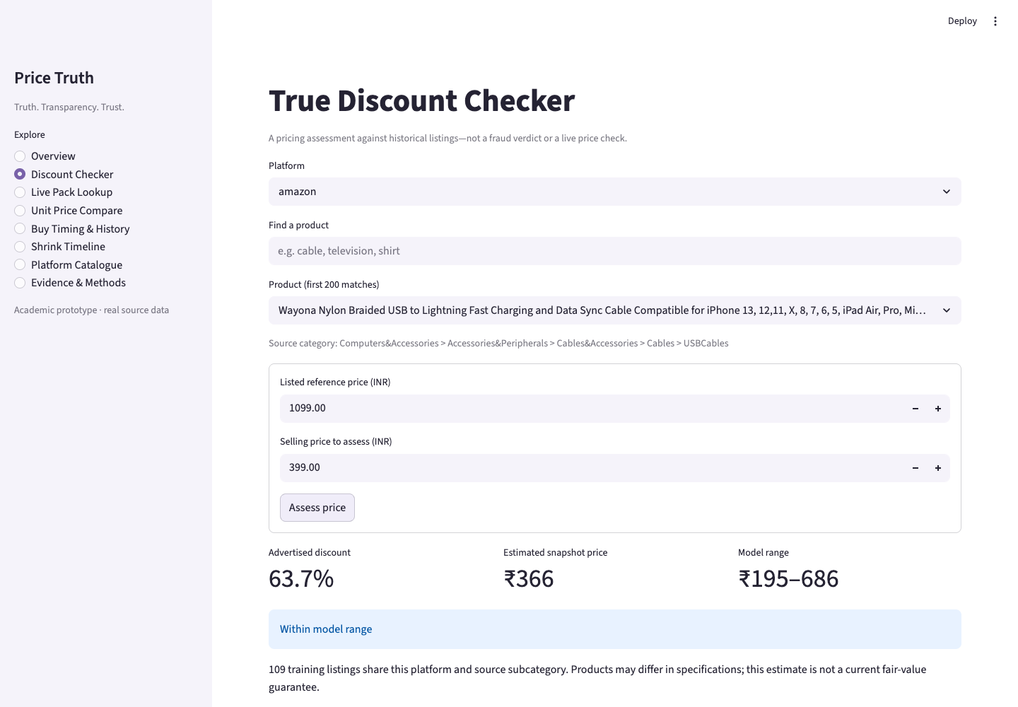
Figure 1. Actual local Chrome price-assessment screen. Original screenshot: reports/checker-desktop.png. Browser checks also waited for the SHAP explanation heading; chart inputs are computed by the model.
Included in this submission | Outside completed scope
Working historical price-assessment workflow | Verified fake-discount classification
Real trained model and Tree SHAP | Validated current-price or seasonal forecasts
Working unit arithmetic and supporting pages | Unified live same-product retailer dashboard
Actual code-review results and known findings | Public uptime, 100-user capacity and final redesign

The chosen workflow is implemented and the code review is complete for this snapshot. The broader consumer-product vision remains a future extension. This distinction is part of the submitted engineering evidence.

