Cypher Reference Document

Creating Your Character
A Cypher character is defined by a descriptive sentence like a Charming Wizard who Rides the Lightning or a Stealthy Tech who Talks to Machines. But before you get to looking at the parts of that sentence, you start with the core of a character, which gives you your basic stats, a couple of skills, and a few other game bits that every character needs (like how many wounds you can take). A core character is an entirely playable (if slightly uninteresting) character. As a core character, you know how to perform common actions and interact with the world the GM presents.

Tier
Tier is a measure of your accumulated experience. A core character starts at tier 1. A tier 1 character is more than just a novice; you’re reasonably accomplished and capable, on par with a college student or person in a typical job that requires some experience or training.
Over the course of the game, as you travel, experience things, and accomplish goals, you will advance to higher tiers and unlock new capabilities. Very experienced characters will reach tier 6, and perhaps even higher. A tier 6 character can accomplish a lot more than a tier 1 character.

Your Three Stats
Your character has three defining characteristics, which are typically called statistics or “stats.” These stats are Might, Speed, and Intellect. Each of the three stats has two components: Pool and Edge, so you have a Might Pool and Might Edge, a Speed Pool and Speed Edge, and an Intellect Pool and Intellect Edge.
Your Pools represent your raw, innate ability. You spend points from your Pools to activate your abilities and improve your actions.
A core character’s Pools all start at 8. In addition, you get 6 additional points to add to the three Pools as you wish.

Edge
Edge reduces the point cost when you spend Pool points (it’s like a discount). A core character has an Edge of 0 for all three stats.

Wounds
Your character starts the game hale and healthy. But you’re likely to encounter threats at some point and risk becoming wounded. Wounds can come from such varied sources as the attack of a predatory beast, a fall from a great height, or a supernatural effect like an explosion of magical fire. Anything that hurts you gives you a wound.
Wounds come in three severities: minor, moderate, and major.
A core character can take up to three minor wounds, three moderate wounds, and three major wounds. When you’re wounded, record the wound on your character sheet—there’s a box for each of them. Each kind of wound has a different effect on your character.
Minor Wounds: These are nicks, scratches, bruises, and other inconsequential injuries that no longer hurt after a few hours. Individual minor wounds don’t negatively affect your character in any way. When you’re out of minor wounds, any new minor wounds you take become moderate wounds.
Moderate Wounds: These are open cuts, weapon grazes, sprains, minor fractures, and other injuries that no longer hurt after a few days.
When you take your last moderate wound, all of your actions are hindered, and any new moderate wounds you take become major wounds.
Major Wounds: These are fractures, large open cuts, gunshot wounds, and other significant injuries that generally take anywhere from days to weeks to recover from.
Each major wound you take hinders all of your actions.
When you take your last major wound, you die.

Skills
A skill is any kind of knowledge or ability that you can get better at through practice and training. Athletics, perception, computers, and history are examples of skills. Having a skill makes tasks relating to that skill easier.
Your core character starts with two skills. The skills you can choose from depend on the genre of the game the GM is running (such as sci-fi, fantasy, or postapocalypse).
You have the option of starting with a third skill, but in exchange you have to pick a meaningful skill that you’re bad at (called an inability). Having an inability in a skill makes tasks relating to that skill harder. For example, you could choose athletics as your third skill, but you’d have to pick another skill (like perception or stealth) to be bad at.
When you pick a skill for your inability, it has to be something meaningful that could significantly impact your character from time to time, such as athletics, perception, or charm, not a skill like farming or philosophy.

Effort
When you really need to accomplish a task, you can try harder. In game terms, this is called applying Effort. Applying Effort costs 3 points from the appropriate stat Pool. Effort makes a task easier, just as a skill does.
A core character has an Effort of 1, meaning you can only use Effort to ease a task by one step. A character with a higher Effort score can apply more Effort to a task, easing it by additional steps.

Asset
An asset is any object, situation, or assistance that helps you with a task. If you’re trying to force open a door, a crowbar is an asset. If you’re trying to put out a fire, a rainstorm is an asset. If you’re trying to climb over a fence, your friend giving you a boost (in other words, helping) is an asset. If you’re fighting a monster, the monster being distracted by strong winds is an asset.
An asset usually eases a task by one step. A really good asset (or two regular assets) can ease a task by two steps. Assets can never ease a task by more than two steps—any more than two steps doesn’t count.

Cyphers
Cyphers are one-use abilities that your character has. They change from session to session, and you’ll always be getting more of them, so use them when you need them (don’t hoard them). A cypher might be a bit of luck that helps you out, a moment of inspiration about the answer to a problem, or a surge of adrenaline that pushes you beyond your normal limits. The GM will tell you what cyphers you have and will decide when you get replacements for the ones you’ve used.
You can have up to two cyphers at one time; this is your cypher limit.

Recoveries
To recover points used from your Pools, you rest and take a recovery. A core character’s recovery is equal to a 1d6 roll plus their tier, so 1d6 + 1. The result of the roll is how many points you get back; you can add them into your Pools in any combination you like, up to your normal maximum for each Pool.

Healing Wounds
You can heal wounds by rallying (spending an action and a few Might points), treatment (requiring some time and simple first aid), or resting (either on its own or as part of a recovery).

Weapons and Armor
Weapons are divided into categories of light, medium, and heavy (light weapons are things like punches and small knives, medium weapons are baseball bats and broadswords, heavy weapons are rifles and big axes, and so on). A core character can freely use light weapons (“freely use” means your attacks with light weapons don’t have a penalty). You can’t freely use medium or heavy weapons, so if you attack with one, your attack is hindered.
Armor is divided into categories of light, medium, and heavy (light armor is stuff like thick leather, medium is chainmail, and heavy is plate mail). A core character can’t freely use any kind of armor, so if you wear armor, it hinders some of your physical tasks. Any character can use a shield.

Equipment
Your core character begins with one set of appropriate clothing and enough extra cash to pay for something that’s moderately priced like a nice backpack or a hunting knife. (Cypher uses abstract price categories instead of specific amounts of dollars, gold pieces, and so on.) Most characters have better equipment options depending on what genre the GM is running.

What’s Next?
A core character is just the skeleton of a character; there’s more you can do to make your character fun and interesting. You have two possibilities: make a real-world character, or make a character for a specific genre such as fantasy or science fiction (sci‑fi). Ask your GM what sort of game they’re running and what sort of character you need to make.
Real-World Character: If you are playing in a campaign set in the “real world” and are playing a normal person, you also get a descriptor (which gives you another skill and more points to add to your Pools) and get to pick another skill based on your profession. More information about turning your core character into a real-world character is explained later on..
Genre Character: For most other games (such as fantasy or science fiction), you’ll need to pick a type, focus, and descriptor; together with what you chose as a core character, this means you’re an extraordinary person (and probably live in an extraordinary setting). You can choose your type, focus, and descriptor in any order, but many people like to start with a type because it includes a lot of important stuff related to the game genre. The types you can choose from depend on what genre the GM is running—fantasy, science fiction, superhero, and so on. As you continue building your character, it’s okay to go back and make changes to things you decided earlier. For example, if you put most of your core character’s Pool points into Might but the abilities from your type or focus mostly use Intellect, it’s okay to move some points around so your final character’s Intellect Pool is bigger than how you set up your core character.
Whether you’re making a real-world character or a genre character, the information in the other sections will remind you what a core character gets and how the new parts of your character add to that.

The Core Character

Core Character Quick Summary
Your core character starts with the following.
- 8 Might / 8 Speed / 8 Intellect
- 6 additional points to allocate in Might, Speed, and/or Intellect
- Capacity to take three minor / three moderate / three major wounds
- Effort: 1
- Cypher limit: 2
- Freely use light weapons
- Cannot freely use any armor
- Two genre skills
- Optional: One additional genre skill in exchange for an inability in a genre skill
- One set of appropriate clothing, enough extra cash to pay for a moderately expensive item, and a set of basic equipment (from the genre you’re playing in)
Core characters begin with either two or three skills; each must be different. And if you are a real-world character with a profession and get another skill choice, that must be different as well. The upshot is that you can’t become trained twice (specialized) in the same skill at tier 1.

Skills
A skill is a category of knowledge, an ability, or an activity relating to a task, such as athletics, navigation, or charm. A character who has a skill is better at completing related tasks than a character who lacks the skill, but even an unskilled character can attempt nearly any task.
A character’s level of skill is either trained (reasonably skilled) or specialized (very skilled).
Training in a skill eases attempts to accomplish that task.
Specialization in a skill eases attempts to accomplish that task by two steps. (If you get trained twice in the same skill, or are already trained and get training in the same skill again later, you become specialized.)
Being an expert in a skill allows you to ease a task by three steps, but becoming an expert usually requires that you have a special ability that specifically grants you that option, such as with Expert Combatant.
Inability in a specific task or skill is also possible. An inability is a task your character isn’t good at. You can think of inabilities as negative skills—instead of those tasks being eased, they’re hindered.
If you have neither training nor an inability, you can freely attempt a task. This is something you can do, but you do it neither better nor worse than the average person. Most people (in The Real World Genre, anyway) can freely drive their vehicle, driving every day to get places, but they would be seriously challenged to come out of a spin after going much too fast on an icy road.
To carry on with the example of driving, a person who’s never been behind the wheel might have an inability in driving. A professional driver, like a bus or truck driver or an auto aficionado, might be trained in driving. A race car driver, stunt driver, or criminal getaway driver might be specialized in driving.
Genre Skills: When you are given the opportunity to choose skills, select them from the appropriate genre. You can pick any skill listed for your game’s genre that isn’t restricted by your tier. For example, if the GM is running a swords & sorcery or dungeon fantasy game, pick your genre skills from the Fantasy Skills list. You’ll find the description of the skill in this section, though.
Each genre defines several skills. Many more skills are possible, especially in science fiction genres, but the same is true in real-world genres and fantastic games. If you’d prefer your character have an avocation or background that isn’t on the skills list for your genre, work with your GM to add that skill to your game.
In most campaigns, fluency in a language is considered a skill. So if you want to speak French, that’s the same as being trained in biology or athletics.
Background Skills: One of the two skill choices you are given when creating a core character is your background skill. Your choice of background skill reveals something about where your character came from and an element of their backstory. When you choose (or randomly determine, if you prefer) a background skill, you can use it as a seed to create a narrative about your past.
For instance, if you choose crafting (with a focus on cooking) as your background skill, your character may have been a small-town baker who grew dissatisfied, a commissary cook for a military group that has since disbanded (or was decimated), or just someone who learned everything your grandmother was able to teach about her cooking traditions before everything changed.
If you choose performance as your background skill, your character may have been a dancer in a seedy inn at the edge of town, a member of a troupe of actors who’ve all moved on to different trades, someone in a traveling circus that fell afoul of the law, or maybe someone who was once a celebrated performer but fell from grace so completely that few now recognize you.
Alternately, come up with your background first, then select a background skill that suits it.
Tier-Restricted Skills: When you have the option to learn a skill, choose one appropriate for your genre and tier.
You have to be tier 2 or higher before you can become specialized in a noncombat skill (such as charm, athletics, and gathering information).
For combat skills—such as attacking with a broadsword, or defending, like dodging to avoid an attack—you have to be tier 2 or higher to become trained, and tier 4 or higher to become specialized (some character abilities like Expert Combatant can let you become trained or specialized earlier than this).
Tier-Restricted Skillls
Tier Skill
2 You can become specialized in noncombat skills.
2 You can become trained in a combat skill (attacking or defending).
4 You can become specialized in a combat skill (attacking or defending).

Master Skill List
The skills presented here are intentionally somewhat broad and high-level so you can choose a skill that best fits the kind of character you’re creating. For instance, if you want to play a character good at preparing and tanning hides, cutting and stitching what results to create a garment or leather object, and repairing the same, crafting (with a focus on leatherworking) is the skill for you. If you’re in a real‑world game, maybe you’d prefer hacking, especially if you want to hack electronic systems, write code, or try your hand at prompt engineering.

Animal care
Astronomy
Athletics
Attacking (tier-restricted)
Biology
Charm
Chemistry
Crafting
Cybernetics
Deception
Defending (tier-restricted)
Disarming traps
Disguise
Driving
Engineering
Escaping
Farming
Firefighting
Forensics
Gathering information
Geology
Gunnery (tier-restricted)
Gymnastics
Hacking
Healing
Heavy equipment operation
History
Identifying
Initiative
Intimidation
Lockpicking
Magic lore
Mathematics
Mechanics
Mining
Navigation
Outdoor survival
Perception
Performance
Philosophy
Physics
Pickpocketing
Piloting
Piloting spacecraft
Psychic lore
Psychology
Publishing
Recognizing motive
Religious lore
Riding
Scavenging
Scribing
Skilled trade
Stealth
Systems operation
Tracking
Woodcutting
Zero-G fluency

Animal care: Your experience with animals allows you to understand their needs and intentions, calm distressed animals, and attempt to influence them peacefully.
Astronomy: You are well-versed in the study of the stars, planets, and cosmology in general.
Athletics: Regular training has improved your physical fitness, making you better at climbing, jumping, running long distances, and swimming tasks.
Athletics and gymnastics are similar skills, but athletics focuses on tasks related to using your Might Pool, while gymnastics focuses on tasks requiring your Speed Pool.
Attacking (tier restricted): Choose one kind of attack action per training you gain in this skill: light bashing, light bladed, light ranged, medium bashing, medium bladed, medium ranged, heavy bashing, heavy bladed, heavy ranged, or your unarmed attacks. Alternatively, you’re better at attacking with one of your special abilities (like Blast or Onslaught) or one kind of weapon you can freely use (such as swords or rifles).
Biology: You have a deep working knowledge of living systems, including animals, plants, and insects appropriate to your game’s setting.
Charm: You know how to interact with people to get them to react to you positively. In a disagreement, you’re adept at getting them to agree with your position.
Any truthful positive social interaction is covered by charm.
Chemistry: You’re knowledgeable about the composition and properties of physical substances, allowing you to predict and study chemical reactions, analyze substances to detect chemicals of interest, and—with sufficient time and experiments—attempt to develop novel materials.
Crafting: You’re well-versed in one aspect of crafting, as appropriate to your game’s setting. Options include cooking; weaving; metalworking or blacksmithing; leatherworking; brewing, vinting, and/or distilling; woodworking; pottery; gun and ammunition smithing; or something else available for the genre.
Crafting training allows you to craft (and, if appropriate, repair) related items using your resources.

Cybernetics: You’re knowledgeable about cybernetic prosthetics, enhancements, and related machine-body and machine-mind devices, with some practice in installing, maintaining, repairing, and removing them.
Deception: You are a capable liar, able to use speech and the written word to deceive and misinform others.
Any untruthful positive social interaction is covered by deception.
Defending (tier restricted): Choose one kind of defense per training you gain in this skill: blocking an attack (a Might task), dodging an attack (a Speed task), a Might defense roll to endure an unwanted physical effect, or an Intellect defense roll to resist an unwanted mental effect.
Disarming traps: You have a knack for figuring out how devious mechanisms and traps function, giving you better odds in your attempt to defuse them, if not permanently then at least long enough to bypass them.
Disguise: You’re adept at disguising your identity with a false appearance using minimal accoutrements, usually with whatever’s at hand.
Disguise
Applying a disguise usually requires a disguise kit or access to similar materials and at least a minute (or many minutes) to complete. A disguise may allow you to pass as someone else of roughly your size and shape. Besides appearing as someone else, a disguise may require impersonating a different voice and different mannerisms. A disguise usually routinely (no rolls required) convinces casual observers, especially those who don’t already know you, though if the disguise comes under direct scrutiny or challenge, you must succeed on a disguise task against the level of whoever’s studying you to maintain the deception.
Disguise kit contents vary by genre, but all contain setting-appropriate materials a character can use to change their features, hair, and other distinguishing elements, possibly even including alternate clothing.
If attempting to disguise yourself as a particular person, you must have previously interacted with them or studied them, their specific voice, and their mannerisms, and the disguise task to maintain the deception under direct scrutiny is hindered.

Driving: You can keep a car or truck (or land vehicle appropriate to your game’s setting) on the road even under difficult conditions.
Engineering: You can analyze, repair, and create innovative solutions for complex problems, such as tracing power outages and making new devices appropriate to your game’s setting.
Engineering, Hacking, and Systems Operation
The differences between engineering, hacking, and systems operation are that training in engineering eases your tasks to create, repurpose, and repair complex items (and requires making physical alterations in the real world). Hacking, on the other hand, eases your tasks to warp, distort, or otherwise use software embedded in a device or network in ways that were never intended (and do not involve making physical alterations). Finally, systems operation eases your tasks to use complex items and systems as intended, including computers and regular computer programming (but, like hacking, do not require physical alterations to devices).
Engineering training could potentially require resources to make or repair complex systems. In a sci-fi setting, the engineering skill includes any task related to the mechanics skill.
Regular computer usage and programming—as opposed to hacking—is a systems operation task.

Escaping: You’re talented at slipping restraints, squeezing through bars, breaking the grip of a creature holding you, pulling free from sucking quicksand, or some similar circumstance.
Farming: You are knowledgeable when it comes to cultivating land, raising crops, and harvesting what you’ve grown to provide food and resources at the end of the growing seasons. (Tending to livestock in any but the most general way requires training in animal care.)
Firefighting: You are proficient in methods to contain fires and know the best ways to use axes, hoses, fire extinguishers, and other tools to directly suppress fire.
Forensics: You know how to interpret physical evidence to figure out what happened at a location, such as at a crime scene, or what may have led to an object’s current condition, such as the cause of death for a body.
Gathering information: You’re adroit at gathering rumors, stories, and other information from locals to discover the news of the day; doing so requires several hours of effort.
Gathering information in a real-world or science fiction setting—also known as researching—includes using sources like databases, physical archives, discussion platforms, and experts who agree to message you.

Geology: You’re knowledgeable about planetary structure, composition, and processes (including working knowledge of earthquakes, volcanoes, and the formation of natural resources).
Gunnery (tier restricted): You are proficient in attacking with all large mounted weapons appropriate to the setting, including tank cannons, battleship guns, turrets, or spacecraft weaponry such as torpedoes, railguns, phasers, and so on.
Gymnastics: Regular training has improved your balance, easing your tasks to avoid losing your footing, as well as attempts to roll, dive, flip, and pull off similar feats that require grace and agility, such as precision jumping, sprints, swinging from ropes or handholds, dancing, skiing, or ice skating.
If you are trained in gymnastics, it might provide the same benefit in zero-G environments as zero-G fluency. But not the other way around.
Hacking: You can exploit weaknesses in a computer or computerized machine to gain unauthorized access, manipulate its intended function, damage it, and/or otherwise contravene its regular operation. Hacking requires a connection and some way to manipulate the system, such as with a keyboard or more advanced interface, and requires at least a few rounds or even minutes of effort, and perhaps much longer, depending on the hack desired.
Attempting to exploit, break, or warp a computerized system—as opposed to operating a system as intended—is a hacking task.
Healing: You’re experienced in diagnosing and dealing with sickness, bruises, cuts, breaks, and other injuries, and are proficient with healing tasks.
Healing might be called “medicine” in real-world or science fiction settings, suggesting the possibility that the character previously pursued a medical specialty, nursing, dentistry, optometry, audiology, or something similar.
Training in healing eases your task to treat a wound.
Heavy equipment operation: You’re proficient in operating various heavy machinery used in construction projects, such as bulldozers, cranes, excavators, pavers, rollers, and other equipment appropriate to your game’s setting.
History: You’re well-versed in the study of past events, societies, and cultures, and you have related knowledge about what’s led to current nations and populations.
Identifying: Your analytical mind allows you to venture a guess regarding the origin of unfamiliar objects, texts, sounds, and so on.
Initiative: Your reactions are honed, giving you skill in initiative tasks during combat.
Intimidation: You’re good at swaying others with threatening words and/or a fearsome presence.
Any negative social interaction is covered by intimidation.
Lockpicking: You are proficient at unlocking a locked mechanism without the key.
Magic lore: You’ve studied magical traditions of many different sorts and know something about the different organizations and schools, leading magical practitioners, sources of power, fabled artifacts, and more. Your lore helps you identify magic items, the potential purpose of a strange ritual, or how an active spell is working, or gain some similar insight. By spending a minute concentrating on an object or area, you can determine if there is any magic present; by examining a magical object or area and making a magic lore roll against the target’s level, you can determine the magic’s general purpose or function.
Magic lore might be called “occultism” in real-world or science fiction settings where magic isn’t real (or, at least, is generally believed not to be real).
Mathematics: You’re a whiz with numbers, calculations, and pattern analysis.
Mechanics: You can diagnose, repair, maintain, and (with the right tools and parts) build engines and various machines appropriate to your game’s setting.
Mechanics training often requires resources to build and repair engines.
Mining: You have experience with methods for extracting valuable geological materials and minerals from the ground, including the use of mining tools appropriate to the genre.
Mining techniques vary widely by genre. For example, in a fantasy or real-world historical genre, pickaxes feature prominently. In more modern real-world and horror settings, dynamite comes into the picture. In science fiction settings, a miner might know how to use laser boring devices.
Navigation: Your sense of direction is well honed, and you are familiar with using maps, cues from the environment, and/or tools appropriate to the setting to find your way through an unfamiliar or confusing landscape.
Outdoor survival: You know the basics of hunting, trapping, fishing, and other ways to find (and prepare) game and vegetation for food, as well as locating drinkable water and shelter in wilderness areas.
Perception: You have a better chance to notice what others miss in a physical environment when searching an area, listening closely, or using some other sense to discover what’s hidden or not obvious.
Performance: You’re adept at one kind of performance or art, whether that’s singing, comedy, playing an instrument, acting on a stage or in front of a camera, composing, painting, or something else.
Philosophy: You’re conversant with critically analyzing questions regarding existence, knowledge, ethics, and similar fundamental issues.
Physics: You’re knowledgeable about scientifically derived laws of the physical universe and can use that knowledge to devise experiments to probe natural phenomena.
Pickpocketing: You’re adept at separating a target from belongings they carry on their person without being detected. You’re also trained with sleight-of-hand tricks, like making a coin seemingly disappear, hiding something in your own clothing, or planting something on someone else.
Piloting: You’re adept at piloting planes, boats, submersibles, or craft appropriate to your game’s setting.
Piloting spacecraft: You’re adept at piloting a spaceship, including in tasks related to navigating to other locations in space, as appropriate to your vessel’s capabilities and the game’s setting.
Psychic lore: You’re cognizant of the many varieties of psychic talent; of the leagues, agencies, and other groups that employ entities with psionic power; and of other related topics. Your lore helps you identify psychic activity, objects, or the purpose of a particular psychic working, or gain some similar insight.
Psychology: You’re conversant with the study of behavior and therapies developed to address mental health.
Publishing: You’re well-versed in one aspect of publishing, such as writing, editing, copywriting, proofing, marketing, or something else. (Publishing is a modern real-world or science fiction skill. Someone interested in this skill in a historical real-world or fantasy setting might choose scribing instead.)
Recognizing motive: You’re practiced at determining someone else’s lies, motives, and disposition.
Religious lore: You know about the gods and pantheons of the world; their cults, temples, and priesthoods; and their doctrines, holy artifacts, methods of worship, and religious holidays. Your lore helps you identify holy items if any exist in your setting, the potential purpose of a religious ceremony, or how divine influence might be affecting an area, or gain some similar insight.
Religious lore might simply be called “religion” in real-world or science fiction settings where a constellation of different pantheons doesn’t exist (or, at least, not obviously).
Riding: You know how to ride and care for a horse, camel, or similar mount. Alternatively, you know how to ride and care for a motorcycle, bicycle, or similar mechanical device appropriate to your game’s setting.
Scavenging: You’re experienced in scavenging for food, water, shelter, and when you’re especially lucky, a random piece of postapocalyptic equipment. A scavenging task attempt usually requires a minimum of ten minutes but could stretch to two to four hours spent searching through the rubble and ruins.
Scavenging and Related Tasks
Level | Task
5 | Find enough food and clean water for a group of five characters to eat and drink for one day
5 | Find a place of relative safety to regroup, take shelter from the elements, and hide from other dangerous groups or creatures
– | The task is hindered by one step for every two more people (above five) a scavenger tries to find resources or a refuge for
+ | The task is eased by one step for every two fewer people (below five) a scavenger tries to find resources or a refuge for
Scavenging is most appropriate for postapocalypse settings with easy access to the ruins of a fallen civilization that still contain potentially useful things, including preserved food and potable water. In other genres, or if attempting to find useful things in the wilderness, use outdoor survival.
Scribing: You are adroit at copying texts, illustrating manuscripts, and preparing official documents by hand. (Scribing is usually an option in any setting except modern real world and science fiction. Someone interested in scribing in a modern real-world or sci-fi setting might choose publishing instead.)
Skilled trade: You’re experienced in one skilled trade, potentially allowing you to earn a wage as a carpenter, a bricklayer, a drywall installer, a plumber, a mechanic, a roofer, an electrician, or a similar trade, as appropriate for your setting.
Stealth: You’re adept at sneaking and hiding, staying out of sight, and keeping all noise of your presence to a minimum.
Systems operation: You can operate a variety of different complex systems—including computers, robots, spacecraft drives, environmental systems, communication systems, scanning systems, and so on—to achieve their intended functions. This operation could extend to generating simple code for legitimate programming purposes.
Tracking: You are better able to follow a target through all sorts of landscapes and environments and in identifying tracks.
Woodcutting: You’re adept at felling trees, splitting logs, and preparing timber for fuel, construction, and other uses. (Woodcutting is usually an option in any setting except modern real world and science fiction. Someone interested in woodcutting in a sci-fi setting might choose systems operation, allowing them to direct automated woodcutting machinery.)
Zero-G fluency: You’re adept at moving through zero-gravity and low-gravity environments.

Descriptors
The first part of your character sentence “I am an adjective noun who verbs” is the descriptor. It’s the adjective part of the sentence. It’s the most general, easily encapsulated means of describing any character—Resilient, Cautious, Strong, and so on.
Choose one of the descriptors in this section for your character. You can pick any descriptor you wish regardless of your type or focus (if any). Descriptors offer a one‑time package of characteristics, usually training in one skill of your choice and a boost to one of your stat Pools.
Remember that every character has the option of gaining an extra skill in exchange for an inability. You can emphasize your descriptor more by choosing a skill and inability that are thematically appropriate for your descriptor. For example, if your descriptor is Compassionate, you might choose recognizing motive as your extra skill and intimidation as your inability. If your descriptor is Jovial, you might choose gathering information as your extra skill and deception as your inability.
Your descriptor influences how your character reacts to each new situation and challenge. For instance, the differences between a Cautious Ranger and a Brash Ranger are considerable, as are the differences between a Charming Starpilot and a Skeptical Starpilot.
Your descriptor matters most when you’re a beginning character. The mechanical benefits that come from your descriptor will eventually be overshadowed by the growing importance of your type and focus (assuming you’re not playing a game strictly set in the real world). However, the influence of your descriptor will remain at least somewhat important throughout your character’s life.
Your GM may allow you to choose a different skill for your descriptor if it makes sense for the genre and suits the descriptor’s theme.
Many descriptors have similar combinations of stat Pool increases and skill training. Remember that you can further customize your character by choosing an inability and a third skill.
Descriptors List

Appealing
Bookish
Brash
Calm
Cautious
Chaotic
Charming
Clever
Compassionate
Creative
Empathic
Fast
Gloomy
Graceful
Guarded
Honorable
Inquisitive
Intelligent
Intuitive
Jovial
Kind
Mechanical
Mysterious
Mystical
Perceptive
Resilient
Rugged
Skeptical
Stealthy
Strong
Strong-Willed
Tough
Virtuous

Appealing
You’re attractive to others, but perhaps more important, you are likeable and charismatic. You’ve got that “special something” that draws others to you. You often know just the right thing to say to make someone laugh, put them at ease, or spur them to action. People like you, want to help you, and want to be your friend.
You gain the following characteristics:
- +2 to your Intellect Pool
- Trained in charm or recognizing motive

Bookish
You’ve spent most of your life in sedentary pursuits—reading books, watching the stars, writing poetry, and so on—rather than active ones. You’re well-versed in all manner of academia or other intellectual pursuits. You’re not necessarily weak or feeble (although this is a good descriptor for characters who are elderly), but you have no experience in more physical activities.
You gain the following characteristics:
- +2 to your Intellect Pool
- Trained in history, philosophy, psychology, or similar

Brash
You’re a self-assertive sort, confident in your abilities, energetic, and perhaps a bit irreverent toward ideas that you don’t agree with. Some people call you bold and brave, but those you’ve put in their place might call you puffed up and arrogant. Whatever. It’s not in your nature to care what other people think about you, unless those people are your friends or family. Even someone as brash as you knows that friends sometimes have to come first.
You gain the following characteristics:
- +2 to your Speed Pool
- Trained in hacking or initiative

Calm
You’re steady and not easily excited when facing stress or adversity. You try to focus on an inner stillness so you can react thoughtfully rather than impulsively. Likewise, your presence can ground others around who see your unruffled disposition and listen to your patient advice.
You gain the following characteristics:
- +2 to your Intellect Pool
- Trained in charm or skilled trade

Cautious
You don’t charge into new situations without due consideration. You’re afraid of what will happen if you don’t carefully study the particulars of a new job, opportunity, or investigation. Those burdened with less vigilance than you might call you timid, but you suspect bravery is just another word for foolhardiness.
You gain the following characteristics:
- +2 to your Speed Pool
- Trained in gathering information or perception

Chaotic
Danger doesn’t mean much to you, mainly because you don’t think much about repercussions. In fact, you enjoy sowing surprises, just to see what will happen. The more unexpected the result, the happier you are. Sometimes you are particularly manic, and for the sake of your companions, you restrain yourself from taking actions that you know will lead to disaster.
You gain the following characteristics:
- +2 to your Speed Pool
- Trained in initiative or performance

Charming
You’re a smooth talker and a charmer. Whether through seemingly supernatural means or just a way with words, you can convince others to do as you wish. Most likely, you’re physically attractive or at least highly charismatic, and others enjoy listening to your voice. You probably pay attention to your appearance, keeping yourself well groomed. You make friends easily. You play up the personality facet of your Intellect stat; intelligence is not your strong suit. You’re personable.
You gain the following characteristics:
- +2 to your Intellect Pool
- Trained in charm or deception

Clever
You’re quick-witted, thinking well on your feet. You understand people, so you can fool them but are rarely fooled. Because you easily see things for what they are, you get the lay of the land swiftly, size up threats and allies, and assess situations with accuracy. Perhaps you’re physically attractive, maybe you use your wit to overcome any physical or mental imperfections, or perhaps you have turned your mind to compromising digital devices because you’re just that clever.
You gain the following characteristics:
- +2 to your Intellect Pool
- Trained in deception or recognizing motive

Compassionate
Helping others is your calling. It’s why you’re here. Others delight in your outgoing and charitable nature, and you delight in their happiness. You’re at your best when you’re aiding others, whether by treating their injuries, helping them with a task, or putting the best face on a bad situation for the sake of morale.
You gain the following characteristics:
- +2 to your Intellect Pool
- Trained in animal care or healing

Creative
Maybe you have a notebook where you write down ideas so you can develop them later. Perhaps you email yourself ideas that strike you out of the blue so you can sort them in an electronic document. Or maybe you just sit down, stare at the blank page or screen, and, by indomitable force of will, produce something from nothing. However your gift works, you’re creative—you write, compose, sculpt, design, direct, code, or otherwise create narratives that enthrall other people with your vision.
You gain the following characteristics:
- +2 to your Intellect Pool
- Trained in performance or publishing

Empathic
Other people are open books to you. You may have a knack for reading a person’s tells, those subtle movements that convey an individual’s mood and disposition. Or you may receive information in a more direct way, feeling a person’s emotions as if they were tangible things, sensations that lightly brush against your mind. Your gift for empathy helps you navigate social situations and control them to avoid misunderstandings and prevent useless conflicts from erupting.
You gain the following characteristics:
- +2 to your Intellect Pool
- Trained in gathering information or recognizing motive

Fast
You’re fleet of foot. Because you’re quick, you can accomplish tasks more rapidly than others can. You’re not just quick on your feet, however—you’re quick with your hands, and you think and react quickly. You even talk quickly.
You gain the following characteristics:
- +2 to your Speed Pool
- Trained in deception or initiative

Gloomy
You suspect that fate is, if not actively leading you to a terrible end, at least determined to show you the world’s underbelly through a series of unfortunate events. Maybe you alone feel targeted, or maybe it’s the entire world. It’s easier to expect the worst and be surprised when things don’t turn out terribly than the other way around.
You gain the following characteristics:
- +2 to your Speed or Might Pool
- Trained in history or recognizing motive

Graceful
You have a perfect sense of balance, moving and speaking with grace and beauty. You’re quick, lithe, flexible, and dexterous. Your body is perfectly suited to dance, and you use that advantage in combat to dodge blows. You might wear garments that enhance your agile movement and sense of style.
You gain the following characteristics:
- +2 to your Speed Pool
- Trained in gymnastics or initiative

Guarded
You conceal your true nature behind a mask and are loath to let anyone see who you really are. Protecting yourself, physically and emotionally, is what you care about most, and you prefer to keep everyone else at a safe distance. You may be suspicious of everyone you meet, expecting the worst from people so you won’t be surprised when they prove you right. Or you might just be a bit reserved, careful about letting people through your gruff exterior to the person you really are.
You gain the following characteristics:
- +2 to your Intellect Pool
- Trained in deception or disguise

Honorable
You are trustworthy, fair, and forthright. You try to do what is right, to help others, and to treat them well. Lying and cheating are no way to get ahead—these things are for the weak, the lazy, or the despicable. You probably spend a lot of time thinking about your personal honor, how best to maintain it, and how to defend it if challenged. In combat, you are straightforward and offer quarter to any foe.
You gain the following characteristics:
- +2 to your Might Pool
- Trained in charm or philosophy

Inquisitive
The world is vast and mysterious, with wonders and secrets to keep you amazed for several lifetimes. You feel the tugging on your heart, the call to explore the wreckage of past civilizations, to discover new peoples, new places, and whatever bizarre wonders you might find along the way. However, as strongly as you feel the pull to roam the world, you know there is danger aplenty, and you take precautions to ensure that you are prepared for any eventuality. Research, preparation, and readiness will help you live long enough to see everything you want to see and do everything you want to do.
You gain the following characteristics:
- +2 to your Intellect Pool
- Trained in gathering information or identifying

Intelligent
You’re quite smart. Your memory is sharp, and you easily grasp concepts that others might struggle with. This aptitude doesn’t necessarily mean that you’ve had years of formal education, but you have learned a great deal in your life, primarily because you pick things up quickly and retain so much.
You gain the following characteristics:
- +2 to your Intellect Pool
- Trained in chemistry, engineering, mathematics, or similar

Intuitive
You are often tickled by a sense of knowing what someone will say, how they will react, or how events might unfold. Maybe you have a mutant sense, maybe you can see a few moments ahead through time, or maybe you’re just good at reading people and extrapolating a situation. Whatever the case, many who look into your eyes immediately glance away, as if afraid of what you might see in their expression.
You gain the following characteristics:
- +2 to your Intellect Pool
- Trained in psychology or recognizing motive

Jovial
You’re cheerful, friendly, and outgoing. You put others at ease with a big smile and a joke, possibly one at your own expense, though lightly ribbing your companions who can take it is also one of your favorite pastimes. Sometimes people say you never take anything seriously. That’s not true, of course, but you have learned that to dwell on the bad too long quickly robs the world of joy. You’ve always got a new joke in your back pocket because you collect them like some people collect bottles of wine.
You gain the following characteristics:
- +2 to your Intellect Pool
- Trained in charm or performance

Kind
It’s always been easy for you to see things from the point of view of other people. That ability has made you sympathetic to what they really want or need. From your perspective, you’re just applying the old proverb that “it’s easier to catch flies with honey than with vinegar,” but others see your behavior as kindness. Of course, being kind takes time, and yours is limited. You’ve learned that a small fraction of people don’t deserve your time or kindness—true sadists, narcissists, and similar folk will only waste your energy. So you deal with them swiftly, saving your kindness for those who deserve it and can benefit from your attention.
You gain the following characteristics:
- +2 to your Intellect Pool
- Trained in charm or healing

Mechanical
You have a special talent with machines of all kinds, and you’re adept at understanding and, if need be, repairing them. Perhaps you’re a bit of an inventor, creating new machines from time to time. You get called “techie,” “tech,” “mech,” “gearhead,” “motorhead,” or any of a number of other nicknames. Mechanics usually wear practical work clothes and carry around a lot of tools.
You gain the following characteristics:
- +2 to your Intellect Pool
- Trained in engineering, heavy equipment operation, or systems operation

Mysterious
The dark figure lurking silently in the corner? That’s you. No one really knows where you came from or what your motives are—you play things close to the vest. Your manner perplexes and confounds others, but that doesn’t make you a poor friend or ally. You’re just good at keeping things to yourself, moving about unseen, and concealing your presence and identity.
You gain the following characteristics:
- +2 to your Intellect or Speed Pool
- Trained in deception or stealth

Mystical
You think of yourself as mystical, attuned with the mysterious and the paranormal. Your true talents lie with the supernatural. You likely have experience with ancient lore, and you can sense and wield the supernatural—though whether that means “magic,” “psychic phenomena,” or something else is up to you (and probably up to those around you as well). Mystical characters often wear jewelry, such as a ring or an amulet, or have tattoos or other marks that show their interests.
You gain the following characteristics:
- +2 to your Intellect Pool
- Trained in magic lore, psychic lore, or religious lore

Perceptive
You miss little. You pick out the small details in the world around you and are skilled at making deductions from the information you find. Your talents make you an exceptional sleuth or a talented scout.
You gain the following characteristics:
- +2 to your Intellect Pool
- Trained in perception or recognizing motive

Resilient
You’re tougher than most, which means you can take some punishment and come back for more. But if events do overtake you, you don’t panic—you just concentrate on getting out of whatever’s constraining you. Being resilient is at least partly about knowing how to get out of a bad situation.
You gain the following characteristics:
- +2 to your Might Pool
- Trained in athletics or escaping

Rugged
You’re a nature lover accustomed to living rough, pitting your wits against the elements. Most likely, you’re a skilled hunter, gatherer, or naturalist. Years of living in the wild have left their mark with a worn countenance, wild hair, or scars. Your clothing is probably much less refined than the garments worn by city dwellers.
You gain the following characteristics:
- +2 to your Might Pool
- Trained in animal care or outdoor survival

Skeptical
You have a questioning attitude regarding claims that are often taken for granted by others. You’re not necessarily a “doubting Thomas” (a skeptic who refuses to believe anything without direct personal experience), but you’ve often benefited from questioning the statements, opinions, and received knowledge presented to you by others.
You gain the following characteristics:
- +2 to your Intellect Pool
- Trained in identifying or recognizing motive

Stealthy
You’re sneaky, slippery, and fast. These talents help you hide, move quietly, and stay unseen. It might be that you’re wiry and small. What’s more important is that you understand how to use shadows, cover, and distraction to remain unseen and unheard, and how to make movements fluid and deliberate. Whatever the case, your expertise gives you better odds when you wish to sneakily observe, infiltrate, or ambush. Or maybe just to attempt sleight of hand and relieve someone of their valuables.
You gain the following characteristics:
- +2 to your Speed Pool
- Trained in pickpocketing or stealth

Strong
You’re extremely strong and physically powerful, and you use these qualities well, whether through violence, athletic feats of prowess, or enduring abuse. You probably have a brawny build and impressive muscles, though you might instead be strong and wiry.
You gain the following characteristics:
- +2 to your Might Pool
- Trained in athletics or intimidation

Strong-Willed
You’re tough-minded, willful, and independent. No one can talk you into anything or change your mind when you don’t want it changed. This quality doesn’t necessarily make you smart, but it does make you a bastion of willpower and resolve. You likely dress and act with unique style and flair, not caring what others think.
You gain the following characteristics:
- +2 to your Intellect Pool
- Trained in charm or intimidation

Tough
You’re strong and can take extra physical punishment—you keep going, shrugging off hurts and injuries that might slow or incapacitate a lesser person. You might have a large frame and a square jaw. Tough characters frequently have visible scars.
You gain the following characteristics:
- +2 to your Might Pool
- Trained in athletics or outdoor survival

Virtuous
Doing the right thing is a way of life. You live by a code, and that code is something you attend to every day. Whenever you slip, you reproach yourself for your weakness and then get right back on track. Your code probably includes moderation, respect for others, cleanliness, and other characteristics that most people would agree are virtues, while you eschew their opposites: sloth, greed, gluttony, and so on.
You gain the following characteristics:
- +2 to your Might Pool
- Trained in philosophy or religious lore

The Real World Genre
Authorities gather outside a bank where a robbery has gone wrong and the criminals are trying to negotiate a hostage swap. Movers are hired by an agency to clear out a mansion after the eccentric owner dies without heirs. Friends rent a cabin near a wilderness lake, hoping to do some fishing, relaxing, and maybe a hike to the old fire lookout tower. Protesters gather outside a building where they believe injustices occur. A team of firefighters responds to flames blazing through a skyscraper and must identify which floors require the most immediate attention.
All these situations are normal enough in the real world. Putting out a fire with a team, dealing with a hostage situation with negotiation and rescue operations, doing espionage in hopes of finding the truth, and many other real-world scenarios are exciting enough without the addition of fantastic elements. Then again, who knows—the GM might have plans to take the scenario in an unexpected direction once you’ve established your characters.
As a player, you understand the context of The Real World Genre, at least contemporarily—you’re familiar with cities, cars, smartphones, the internet, and so on. For that reason, it might even be easier for you to get into character—you could even choose to model your character on someone you pass in the street or see regularly on the internet or TV. All of which is to say, you can develop your character and help advance the initial encounters and situation with relative ease.

Real-World Subgenres
Your real-world game’s theme—or subgenre, such as espionage, crime thriller, or action—that your GM chooses to pursue influences the kinds of events you’re likely to encounter during a scenario, and more importantly for you, the kinds of characters you’ll play. For other specifics such as appropriate skills, foci, and so on, you can jump directly to Creating a Real-World Character.

Espionage
An espionage-themed setting is a game where you might play a secret agent sent on a series of missions in exotic locales under an assumed identity allowing you to engage in spying. You could also travel openly in your role as an entertainer or author, but have a covert agenda that requires you to infiltrate someplace under the control of a foreign power, corporation, multinational, or billionaire’s personal empire.
Your GM will let you know whether you’re agents of a special department of a national government intelligence agency such as the FBI, SIS (MI6), FSB, CIA, and so on. Of course, not all spying is sponsored by nation-states. There are many semi-secret organizations that sell their services to both governments and corporations.
Shows like Leverage, Burn Notice, Alias, and The Blacklist, as well as movies like any of the James Bond films, the Mission Impossible movies (and older shows), the Jason Bourne movies, the 2015 Man from U.N.C.L.E. movie (and older shows), and so on all provide a sense of the kinds of things you can expect in a real-world espionage game.
Tradecraft: “Tradecraft” came to be a term associated with working as a spy during World War II. That association was cemented during the Cold War. As a character playing in an espionage game, you’ll want to develop your tradecraft through your selection of initial skills and skills you can gain as you advance.
Tradecraft includes several skills such as perception, deception, charm, the ability to maintain a false cover identity with disguise, ferreting information out of files or computer networks, and methods of hiding one’s intrusion after the fact.

Crime Thriller
In a crime thriller game, you’ll likely find your character trying to solve one or more crimes, possibly a series of connected crimes, especially murder. Your character may be involved in some or all aspects of the initial crime scene investigation, interviews with witnesses and others implicated by evidence, evidence analysis, and probably some follow-up footwork to chase down loose ends, gather more evidence, and interview more witnesses and other people of interest.
As such, your character could be a detective, a forensic specialist, a journalist, a true crime podcaster or author, a police consultant, or someone who works for or runs their own private investigation agency.
Detective dramas like Bones, Law & Order, Castle, Person of Interest, Mare of Easttown, and many similar shows feature the sorts of activities and investigations your character is likely to become involved with. On the other hand, the GM could turn the theme on its head and ask that you create characters that are part of a criminal gang, the mob, or another group on the wrong side of the law.
Good detectives and crime investigators are adroit with a similar skill set as those practicing spy tradecraft. Finding clues through keen perception and by gathering information with as wide a net as possible is just as important as analyzing the evidence and putting the pieces together to solve the crime. Good interview skills are also useful, whether you want to charm, deceive, and/or intimidate the witness to learn whatever it is they don’t want to tell you.

Action
Real-world action and adventure RPG scenarios often delve into situations like those encountered by secret service or other authorities (or just someone in the wrong place at the wrong time) facing off against kidnappers who’ve taken a loved one or other person of interest, or radicals attacking or hijacking a skyscraper, a jetliner in mid‑flight, a political capitol, a high‑security prison, or some other high-value location. Action adventures also famously delve into pulpy scenarios, such as when archaeologists and explorers travel to foreign lands to unearth secrets guarded by traps and mazes built by ancient civilizations. Further, there are all sorts of examples of those living on the edge who plan and attempt to execute a heist of some well-guarded treasure secured by modern, high-tech means. And so on.
Action-centric games benefit from characters with a diverse group of specialties, each contributing an important skill to the team. Think about a character like a tracker, a lockpicking professional, a surveillance expert, someone with a military background, an archaeologist, an animal handler, a con artist, a demolitions expert, a mechanic, or a driver, among others.
Movies like Die Hard, Raiders of the Lost Ark (and other Indiana Jones movies), Fountain of Youth, Ocean’s 11, Romancing the Stone, Air Force One, Olympus Has Fallen, Speed, and many more provide a pretty good sense of the kinds of challenges your character may be up against.
Your character in a real-world adventure game should lean into their profession and any surrounding skills. For instance, if you play an archaeologist, you’ll probably want to be trained in identifying and history, at minimum. If you play someone with a military background, you’ll want to take advantage of the special rules restriction exception to train away your inability in using heavier weapons such as rifles. If you play a con artist, deception, disguise, and stealth are probably skills you’ll want. Generally speaking, think of a situation that might arise in an action adventure story, and create a character who has at least some familiarity with that circumstance.
Optional Rules for Real-World Action Games
In real-world action games (and perhaps in rescue games or other real-world subgenres your GM deems appropriate), GMs may implement the following optional rules that directly affect your character during play.
Action Wounds: Your real-world action character can take two more minor wounds and one more moderate wound than normal for a core character.
Wound Treatment: Even though it’s The Real World Genre, action is usually a heroic genre, at least for the PCs. Using treatment to remove a wound takes a Last action for a minor wound, one minute for a moderate wound, and ten minutes for a major wound.
Desperate Actions: The idea is that when the situation becomes desperate, your character rises to the occasion, as is expected of an action hero. The GM might trigger Desperate Actions for a particular encounter, or it might just be a staple of their action game, like the additional number of wounds your character can take and the amount of time it takes to rally.
Under Desperate Actions, while you have at least two moderate wounds or at least one major wound, you get a free reroll on one action each round (as if you had spent 1 XP).

Rescue
A rescue scenario has a lot in common with an action RPG scenario, in that dangerous things are happening, and it’s your job to deal with them and the immediate aftermath. Usually, that means keeping other people safe from the devastation resulting from natural disasters like floods, tsunamis, fires, earthquakes, volcanoes, and maybe even meteor strikes, as well as from human-caused calamities like nuclear meltdowns, highly contagious disease vectors seeping from biological weapons facilities, massive oil spills, colossal cruise ships sinking, and many other situations.
In a rescue scenario, you’ll likely play a first responder character such as a firefighter, EMT or paramedic, pilot, dispatcher, hazmat technician, civil or nuclear engineer, or someone else with expertise related to the particular disaster unfolding. Movies like Backdraft and TV dramas like Emergency!, Chicago Fire, 9-1-1, Station 19, Rescue Me, and many similar shows demonstrate the sorts of scenarios you might get involved with.
If you’re playing a first responder, skills to focus on probably include healing and heavy equipment operation; however, your specific role may suggest additional skills. For instance, as a firefighter, training in firefighting will be important. Emergency rescue pilots should be skilled in piloting a helicopter or other aircraft. Hazmat technicians should be skilled in perception and identifying. And so on. Overall, your concerns as a character in a rescue scenario likely revolve around helping other people. Though mitigation of a particular disaster might be important—for instance, having a vulcanologist on hand during a volcano eruption would be incredibly useful—having a character with a capacity to help those who would otherwise succumb is also central.

Historical
History is wide, and if your GM is running a historical game, they have endless options to choose from. They might set their game during World War II, the Renaissance, the 1930s, ancient Greece, feudal Japan, ancient Egypt, a period in a Mayan city-state, or literally thousands of other settings across human existence and culture. Your GM probably has access to a good history book on the time period in question, one that details what life was like in that era.
Your GM likely has an interest in exploring a particular historical incident or time period with their game to give you the thrill of “being there” when something important happens. Thus, instead of a campaign, your historical game might be a short-term experience where you get to try something new, or at least something you don’t normally do. Your GM will give you details on the sort of characters that are appropriate to whatever situation or conflict arises.
For example, if you’re playing a game set in medieval Europe, maybe your GM tells you to create a character that evokes a knight, courtier, noble, minstrel, or scofflaw of the period. If you’re playing a game set in ancient Greece, perhaps your GM asks you to create a character such as an artisan, merchant, soldier (sometimes called a hoplite), scholar, philosopher, or athlete of the era. And so on.
Adapting Alternate Types: For some settings, a subset of fantasy types like Sword Fighter, Archer, Axe Fighter, and so on may be appropriate for a particular historical game. If so, many of the purely non-magical types could be adapted to all sorts of historical periods where fighting, raiding, and/or soldiering were important parts of the experience. Your GM will let you know if adding such a type (instead of a profession) is appropriate to their game.
Unless the GM has decided to mix a little “ . . . and There’s Magic” into the historical setting, any type you gain can’t choose fantasy genre abilities that are tagged as magic at tier 3 or 6, regardless of what the type might otherwise indicate.

Real-World Horror
Of all the real-world subgenres, horror is traditionally one of the most popular in movies, shows, and games. Horror RPG scenarios set in the modern real world often begin with your character unaware that their normal life will soon be compromised in a terrifying way. You may ultimately learn some terrible things—like maybe that monsters are real. But, usually, you begin play confident that supernatural elements are just stories, even as a new opportunity arises. For instance, play might begin when you and the other players inherit a run-down home or antique; are hired to house-sit, clean, or otherwise visit an out-of-the-way cabin or mansion; decide it would be fun to be an urban explorer in an abandoned psychiatric hospital; discover a part of your old house that hasn’t been opened in over fifty years; receive samples from an ice core thousands of years old that contain weird spores; or are presented with some other interesting situation that requires more investigation.
Movies and shows like The Ring, It Follows, Poltergeist, Supernatural, A Nightmare on Elm Street, Hereditary, It, The Exorcist, The Babadook, and hundreds more illustrate the various sorts of situations real-world people might discover when horror descends.
Even if real-world characters don’t know what they’re getting into, you as a player might have some inkling. But even if you don’t, the same sorts of characters that would be interesting to play in a real-world action, crime thriller, or rescue game are appropriate for a game that dips into horror. A party where each character brings something to the table is useful, but simply surviving might be the point, so skills related to stealth, perception, and recognizing motive could be important. Maybe the horror is something that can actually be faced and defeated, in which case gathering information and magic lore might be appropriate, if offered by the GM.

Modern Magic
A modern magic scenario is one where magic exists in what otherwise seems like the real world. Unlike many other real-world subgenres, magic’s existence in the world usually isn’t the point. Instead, magic is more of an adjunct to whatever else is going on—literally “ . . . and there’s magic.” The only potential exception to this is if magic’s existence is secret, but even then, that revelation probably is only in service to a greater revelation. For instance, the big reveal might be that not only is magic real, but there’s an entire magical shadow society—a “half world”—containing practitioners, mythical entities, monsters, schools where magic is taught, and other supernatural elements that secretly exist beneath the surface of the modern world.
In a modern magic scenario, you may face threats that also arise from the same quarter—a practitioner who has gone bad, monsters, ghosts, gods and demigods, and so on. Non‑supernatural challenges might also come your way, which means your character, who presumably has some access to magic, would have an interesting advantage.
Shows like Buffy the Vampire Slayer and Supernatural are excellent examples of stories where magic exists and the protagonists must use their abilities—sometimes magical—to deal with the problems that arise from the underlying premise.
Competent characters are useful in any real-world scenario. Detectives trained in perception, people with a military background who know their way around weapons, journalists experienced with gathering information, folks who know how to stay out of sight using stealth—all these and more would pair well with possible magical abilities that your GM might eventually let your real‑world character access. Being competent in your own right becomes all the more important if magic options are not immediately forthcoming.

Creating a Real-World Character
Create your real-world character as indicated below.
Core Character: Begin with a core character.
In game terms, the main thing that makes a character a real-world character is you don’t start with a focus. Because real-world characters also don’t have a type, they don’t get additional type-granted Pool points, Edge, or special abilities that types and foci normally grant. Starting real-world characters also don’t gain additional weapon or armor familiarity other than the free use of light weapons that all core characters gain—in fact, starting real-world characters have an inability in using a medium or heavy weapon.
Descriptor: Choose a descriptor, which grants you a few additional points to a particular Pool and training in a related skill.
Profession: As a real-world character, you have a profession, expressed as an additional skill choice. What job, hobby, or interest is central to your character’s identity? Call that your profession. Then choose your training in a skill related to that. For instance, if lawyer is your profession, you might choose charm for your skill training. If you’re a doctor, you might be trained in healing. If you’re a security consultant, you might be trained in gathering information. Someone whose profession lies outside the law might be trained in stealth.
Skills: Refer to the Real-World Skills list for skills you can choose from when creating and advancing your character. However, depending on the game, your GM might give you choices from the fantasy skills list and/or the science fiction skills list. Your choice of background skill, and possibly the extra skill you might get if you choose a meaningful inability, also come from the same list of genre skills.
Special Skill Restriction Exception: Normally, you can’t become trained in an attack skill until tier 2. And if playing using the core character as your basis, you can freely use only light weapons (and you have an inability in using medium and heavy weapons).
However, you can choose to apply one of the skills you gain as a starting real-world character toward the inability you would otherwise have in using a specific class of medium or heavy weapons. For instance, if your character has a background in the military, as a hunter, as a martial arts practitioner that uses a blade (such as in kendo), or with similar weapon-using experience, you could choose your background skill in medium rifles, heavy shotguns, or medium blades. This training doesn’t ease your roll for attacks with that class of weapon, but it does cancel out the inability that otherwise would have hindered your rolls with the weapon.

Real-World Skills
These skills are appropriate for games set in the real world. When you have the option to choose skills, choose from the following.

Animal care
Astronomy
Athletics
Attacking (tier restricted)
Biology
Charm
Chemistry
Crafting
Deception
Defending (tier restricted)
Disguise
Driving
Engineering
Escaping
Farming
Firefighting
Forensics
Gathering information
Geology
Gunnery (tier restricted)
Gymnastics
Hacking
Healing
Heavy equipment operatio
History
Identifying
Initiative
Intimidation
Lockpicking
Magic lore
Mathematics
Mechanics
Mining
Navigation
Outdoor survival
Perception
Performance
Philosophy
Physics
Pickpocketing
Piloting
Psychology
Publishing
Recognizing motive
Religious lore
Riding
Scavenging
Skilled trade
Stealth
Systems operation
Tracking

Character Species: Real-world characters are usually Humans.
Genre Abilities: At tier 3, your real-world character gains an additional skill to be trained in or (if already trained in a skill) to be specialized in, assuming it’s not a tier-restricted skill.
At tier 6: You gain yet another skill to be trained in (or specialized in, if already trained).
Equipment: Refer to the Real-World Equipment table for equipment you can choose from when creating your character and for options that might be available when you have more currency to spend. Or refer to the Real-World Equipment Bundle options.
Manifest Cyphers: Usually none.
Wound Treatment: Games set in the real world tend to be realistic. Using treatment to remove a wound takes ten minutes for a minor wound, one hour for a moderate wound, and one week for a major wound.
Currency: Currency underlying price categories in a real-world setting is whatever currency is in use in the real-world backdrop. In some games, that will be dollars; in other games, euros, pounds, or pesos.
Type and Focus: A type and focus are important parts of fantasy, science fiction, and superhero characters. But not of real-world characters. Instead of being a foundation, the initial core character you create is your character, along with your descriptor and profession.
In fact, your descriptor plus your profession becomes your character sentence. For example, you could be a Clever lawyer, an Honorable journalist, a Brash doctor, a Strong stunt driver, and so on.
Advancement: You can advance your real-world character like a character from other genres, and thus increase Effort limit, gain training in a new skill, gain Edge, gain additional Pool points, and eventually increase your tier.
At higher tiers, you can become trained in attacks with medium or heavy weapons, which would initially counteract your inability when attempting to use such weapons.
And there’s always a chance that your GM’s real-world game is merely the introduction to something stranger, which means they may direct you to choose a focus and/or a type after all.

Real-World Background Options
These options presume a modern real-world game. Adapt one of these or work with your GM to develop a historical real-world background.
- Life has been good to you for the most part. Now you feel like it’s time to give back in some way—to volunteer, work for a charity, or take on some other new role that has a positive social component.
- You finally landed your dream job after years of hard work, only to have it eliminated. Now you’re not sure what to do—though you do need to pay the bills.
- You’ve been working in your profession for years and had some success. But now you’re feeling burned out and are looking for something different, or at least a break.
- You were raised in a loving family and were quite close to your siblings. However, one of them disappeared without a trace a few years ago, and you promised yourself you’d find them one day.
- Your spouse died five years ago, and only now do you feel like you’re up for restarting your life.
- Your research partner and friend stole your research and published it as if they’d done the work. Nothing you can do about that, but now you’re looking for validation and recognition elsewhere.
- A relative left you a large inheritance, but you’ve always abhorred how they made their money. You’ve sworn to give it all away to a charity or other group doing prosocial work.
- As the child of missionaries, you spent your young life traveling. As an adult, you haven’t decided if you share your parents’ faith, but you’ve definitely got their penchant for travel.
- One of your parents was a famous entertainer, but you never saw that as a plus. You spend most of your time trying to evade the notice of others, especially as it relates to fame.
- When you were young, you were positive magic was real. As you’ve grown older and wiser, you’ve come to realize you were probably wrong, and the sadness of that realization remains.
- Your medical practice was too small to go it alone in the face of all the consolidation and insurance overheads, so you shuttered it and are considering your options.
- You served in the military. You saw things during that time that left you questioning your choices and decided to go into business for yourself—but doing what?

Historiness
“Historiness” is the quality of seeming historical or evoking a historical feeling, even if it’s not necessarily historical. If your GM is going for a strictly historical game, replicating events from historical fiction may not be to their liking. That said, fiction set in historical time has a gold mine of interesting options. Consider the works of Jane Austen, Charles Dickens, or even William Shakespeare. Imagine a game weaving in and out of Pride and Prejudice, A Tale of Two Cities, or Macbeth.
Your GM might go even further afield and mix fiction set in historical times with elements of horror or science fiction. Examples of this kind of fiction include Pride and Prejudice and Zombies by Seth Grahame-Smith, Penny Dreadful (the TV series), The League of Extraordinary Gentlemen comic series, and Shades of Milk and Honey by Mary Robinette Kowal.
Optional Types for Historical Settings
Archer
Axe Fighter
Barbarian
Bard
Burglar
Knife Fighter
Noble Warrior
Ranger
Swashbuckler
Sword Fighter
Thief
Two-Weapon Fighter
Warrior

Real-World Equipment Bundle
Choose the following equipment bundle to quickly outfit your real-world character, or assemble your own starting equipment.
- Bundle: Appropriate clothing, a raincoat, a used vehicle, a smartphone, a smartwatch or wireless earbuds, a laptop or tablet computer, a basic purse or wallet, a sticky notes pad and pen, a tin of breath fresheners, a bottle of painkillers, and a penknife. Your character also starts with currency equivalent to a moderately priced item.
- Select your own equipment: You gain appropriate clothing, one expensive item, five moderately priced items, and up to six inexpensive items. Your character also starts with currency equivalent to a moderately priced item.

Many characters in other genres gain a weapon as an additional piece of equipment. As a real-world character without a type, you usually don’t. However, you can still choose one as one of your other items, or gain one later during the game.

Genre Character Abilities from Types and Foci
Your type and focus give you abilities—unique things your character can do. For instance, if you’re a Barbarian, you have Wounded Fury, which improves one of your attacks each round if you’re hurt.
An ability has a simple description and statistics. Here’s how to understand what it’s telling you.
Name and Cost: Every ability has a unique name, like “Frenzy” or “Wounded Fury.” This is just a game term so you and the GM know what abilities you have. Your character might have a different name for it, or not have a name for it at all.
Sometimes your type and focus might give you the same ability, such as Wounded Fury from the Barbarian type and from the Howls at the Moon focus. Taking both of those abilities (or two abilities with different names that provide the same effect) doesn’t give you any extra benefit, so don’t choose an ability that’s a duplicate of something you already have.
If you must spend Pool points to activate an ability, the number of points and the Pool name appear after the ability name, such as “1+ Intellect” after Frenzy. This part is omitted if the ability has no cost.
Whenever an ability grants a choice between two Pools, each time you use that ability you can decide which of those two Pools to spend your points from. You can’t split the cost between both Pools.

If an ability has a + sign after the Pool point cost, it means you can spend additional points or levels of Effort in a special way, such as affecting additional targets or increasing the duration. The exact benefit is explained later in the ability in a separate Effort section.
Effect: This is what the ability does. If the ability has more than one effect or option, each is listed as a new paragraph. Some abilities have improved effects if a character using the ability is tier 3 or higher, as noted at the end.
In general, to affect an unwilling target with an ability, you have to make some kind of attack roll against them.
You can always end one of your abilities (including effects provided by cyphers) with an ongoing effect as an extra action on your turn, at no cost.
Effort: Each option in this section costs one level of Effort. Unless indicated otherwise, at higher tiers you can apply more than one level of Effort to further increase the base benefit. For example, if one level of Effort allows you to increase the maximum level of the foe you can affect by 1, two levels of Effort would increase the level of the foe you can affect by 2, and so on.
Even if an ability doesn’t have a + in the cost, you can usually still apply Effort to ease the ability’s attack roll or skill roll, or to deal extra damage with an attack roll.
If there are multiple options, you have to use separate levels of Effort for each. For example, if the ability says “additional target” and “increase range,” affecting an additional target costs one level of Effort, increasing the range costs one level of Effort, and doing both for the same activation costs a total of two levels of Effort. If the option costs points instead of a level of Effort, the point cost is listed in parentheses after the option, like “additional target (2 Intellect).”
Action or Enabler: The last part of the ability description tells you how much time it takes to activate the ability.
Action. You use your action to gain the effect.
First action. You can use the ability as a First action or an action.
Last action. You can only use the ability as a Last action.
Enabler. The ability works whenever you want it to without using an action.
Hours or Minutes. Similar to an “action” ability, but activating it takes the listed number of minutes or hours instead of just an action.
Perpetual. Similar to an enabler ability, but it constantly affects you (such as letting you breathe water) or permanently modifies you (such as adding +1 to your crossbow damage). If an ability doesn’t state that it’s an action or enabler, it’s perpetual.
Abilities whose effects persist until you take a recovery end immediately, not when the benefits of the recovery are gained after ten minutes, an hour, and so on.
You can always end one of your abilities with an ongoing effect as an extra action on your turn, at no cost.

Fantasy Genre
A mage flinging lightning and death spells faces off against an ancient dragon whose fiery breath has seared whole armies. A knight bedecked in bright armor rides forth with the sunrise and the kingdom’s acclaim, sworn to a worthy quest that might last years. A party of travelers, swords sheathed and bows unstrung, enters a firelit inn just before the evening rain hits, drawn by the smell of roast beast and delicate notes from a song performed by an elven bard. A band of explorers descends into a sprawling, buried ruin left behind by vanished forerunners, eager to find treasure and magic.
The fantasy genre is an exploration of worlds where magic exists side by side with untamed forests and expansive mountain ranges that are home to elves, dwarves, and other mythical creatures. The mostly preindustrial settlements dotted across the landscape often feature newer, human societies, while much older humanoid species (and monsters of every sort) are everywhere else, save those that are long vanished, leaving behind their mysterious ruins to lure the curious.
Which means you can expect your character to embark on quests, confront supernatural threats, and grapple with themes of destiny, power, and good versus evil. And you’ll do so wielding magic, enchanted tools and weapons, and extraordinary special abilities of your own.

Fantasy Subgenres
Many fantasy subgenres exist, including fusions with other genres. This book focuses on three subgenres: dungeon fantasy, swords & sorcery, and epic fantasy.
A major distinguishing factor between these subgenres is the character types available for each. For instance, in a dungeon fantasy, you might play as a Paladin, Mage, Bard, or several others. In a swords & sorcery game, your options include Witch, Axe Fighter, Knife Fighter, and similar kinds of warriors. In an epic fantasy game, you might play a Noble Warrior, Burglar, Wizard, Swashbuckler, and similar.
Fantasy Skills
These skills are appropriate for dungeon fantasy, swords & sorcery, and epic fantasy games. Some of these skills are tier restricted, meaning there’s a minimum tier requirement before you can become trained or specialized in them. When you have the option to choose skills, choose from the following.
Animal care
Athletics
Attacking (tier-restricted)
Charm
Crafting
Deception
Defending (tier-restricted)
Disarming traps
Disguise
Escaping
Farming
Gathering information
Gymnastics
Healing
History
Initiative
Intimidation
Lockpicking
Magic lore
Mining
Navigation
Outdoor survival
Perception
Performance
Pickpocketing
Psychic lore
Recognizing motive
Religious lore
Riding
Scribing
Stealth
Tracking
Woodcutting

Dungeon Fantasy
A character in a dungeon fantasy adventuring party can expect to be challenged by a host of bizarre monsters and life-draining undead, traps and curses, and eventually, maybe even dragons or gods. Many of these challenges will come as you explore perilous places like dungeons, caverns, and ancient ruins. But the rewards are well worth the threats, because often they include treasures of gold, gems, jewelry, and—sometimes best of all—magic.
If you’ve played Dungeons & Dragons as it’s normally presented, you’ve played in a dungeon fantasy setting.

Creating Dungeon Fantasy Characters
Core Character: Begin with your core character and then select a type.
Skills: Refer to the Fantasy Skills list for skills you can choose from when creating and advancing your character. Your choice of background skill, and possibly the extra skill you might get if you also choose a meaningful inability, also come from the same list of genre skills.
Character Species: Nearly any of the (optional) fantasy species you can imagine are commonly part of a dungeon fantasy setting.
Dungeon Fantasy Character Species Options
Dragonfolk
Dwarf
Elf
Gnome
Halfling
Hellborn
Human
Orc
Foci: Any focus that has at least some possibility of being something a mighty hero or magic user might accomplish could be appropriate for your character. Which means weird foci like Rides the Lightning and Blazes With Fire that might seem a perfect fit for the superhero genre are also perfectly suitable for a dungeon fantasy game. For your character, it’s a kind of magic you pursue, a birthright of your extradimensional parentage, magic channeled from your god, or something similar.
Suggested Foci for a Dungeon Fantasy Game
Abides in Stone
Blazes With Fire
Casts Spells
Commands Mental Powers
Consorts With the Dead
Controls Beasts
Crafts Illusions
Doesn’t Do Much
Entertains
Explores
Fights Dirty
Fights Unarmed
Fights With Panache
Howls at the Moon
Hunts
Infiltrates
Leads
Masters Telekinesis
Masters Weaponry
Moves Like the Wind
Never Says Die
Performs Feats of Strength
Quells Evil
Reveres a Supernatural Force
Rides the Lightning
Sneaks Through the Shadows
Speaks for the Land
Strikes With Mystic Might
Tends to the Wounded
Wears a Sheen of Ice
Equipment: In addition to one set of clothing, you get to choose items from the Fantasy Equipment table; you start with six inexpensive items, five moderately priced items, one expensive item, and enough extra currency to buy a moderately priced item. Instead of picking your own equipment, you can just choose the equipment bundle described in your character type, which has items already picked out for you.
Manifest Cyphers: These cyphers are usually in the form of potions, scrolls, runes, and charms.
Wound Treatment: Treatment to remove a wound in a dungeon fantasy setting takes one minute for a minor wound, ten minutes for a moderate wound, and one hour for a major wound.
Currency: The currency underlying price categories in a dungeon fantasy setting usually features several coinages minted from valuable metals, including copper, silver, gold, and platinum.
Background Options: Each type includes suggestions for your character’s background. Choose one or create your own.
Genre Abilities for Your Fantasy Character: At tier 3, your fantasy character gains a mid-tier ability from the list of Fantasy Genre Abilities at the end of this section. At tier 6, you gain a high-tier ability from the same list. In addition, at tier 6, you can replace one of your mid-tier genre abilities with a different mid-tier genre ability. See that section for additional stipulations that might affect your fantasy genre ability choice.

Dungeon Fantasy Types
Barbarian
Bard
Cleric
Druid
Fighter
Mage
Monk
Necromancer
Paladin
Ranger
Rogue

Barbarian
For you, every day is another chance to spill blood, drink ale, or both—and pick up a scar or two to commemorate the day. Born an outlander and a wanderer at heart, you’ve become an adventurer more by accident than design. They say you’re savage, but only behind your back, lest they face your fury.
Out of everyone in your group, you tend to draw the most attention from foes because you give up trepidation for rage. Fears fall away when your blood is up; all you see is red. Frenzy gives you strength, battle-minded purpose, and, more times than not, a path to victory. But when your battle fever passes, your lore of the wild places helps guide you and your allies through uncivilized lands where monsters, bandits, and other barbarians roam.

Background Options
- Your nomadic tribe hunted in the icy wastes, but the chief’s son humiliated you in ritual combat, and now you seek to redeem yourself.
- You were the leader of a barbarian host for a while, but gave it up a year ago to wander.
- You’ve sworn to kill every dark wizard in a demonic cabal, but a few remain hidden.
- Two years ago you failed to protect a princess from a serpent cult and their snakes.
- Your folk dwelled in the rolling hills until they were slaughtered by treacherous devils from the city. You thirst for revenge.
- You taught yourself how to survive in the deep jungle and spent most of your life alone. Today, you seek companionship and the strength found in numbers.
- A friend of yours went their own way a few years ago. Rumors are they’re now a bandit.
- You’ve come into great wealth a few times but always lost it—most recently a year ago.

Barbarian Abilities
You gain all of the following benefits:
- Able to take three more minor wounds and one more moderate wound
- Add +3 to Might Pool
- Add +1 to Speed Pool
- Add +1 Edge in Pool of your choice
- Freely use all weapons
- Freely use light and medium armor
- Gain one weapon of your choice (or accept the equipment bundle weapon)
- At tier 3 and tier 6, choose an ability from the Fantasy Genre Abilities list
- At tier 1, you gain the following abilities:
Frenzy (1+ Intellect): While in combat, you can enter a state of frenzy. While in this state, you can’t use Intellect points, but you add +1 to your Might Edge and your Speed Edge. This effect lasts as long as you wish, but it ends if no combat is taking place within range of your senses.
Effort: Ease your allies’ attacks against one foe of your choice for the rest of the combat.
Enabler.
Wilderness Survival: You know how to survive in unpeopled lands. After spending at least ten minutes in the wilderness and succeeding on a difficulty 2 outdoor survival task (or a difficulty your GM determines is appropriate to the area), you find something useful you were seeking. The useful thing might be shelter in the form of a cave or tree hollow, all the makings necessary to start a fire, a game animal you bring down with ease, or berries, mushrooms, root vegetables, or other food. You know how to best prepare any game or vegetation you find and are able to feed yourself and up to five allies.
Wounded Fury: While you have at least three moderate wounds or at least one major wound, you gain one free level of Effort you can apply to one of your attacks each round. Enabler.
At tier 3: The benefit increases to two free levels of Effort.

Barbarian Equipment Bundle
Choose the following equipment bundle to quickly outfit your character, or assemble your own starting equipment.
A greatsword, appropriate clothing, chainmail armor, a backpack, a bedroll, 50 feet (16 m) of rope, a crowbar, a wineskin (full), three torches, rations and water for three days, a tinderbox, and enough extra currency to buy a moderately priced item.

Bard
You’re an entertainer: a singer, dancer, poet, storyteller, or something similar. Naturally charismatic and talented, your diligence and study have only improved your art. You know old poems, songs, jokes, and stories, and you’re skilled at creating new ones, too. Your seemingly beneficent nature puts others at their ease, and your performances lift spirits, ease mental burdens, and may even inspire.
Most characters on your team probably look to you for help, advice, and, if nothing else, a rousing performance to spark courage. Those same talents are useful when your group tries diplomacy. Whether you’re relying on the truth or attempting a deception, your ability to flatter, smile, and delight others may open places that swords and spells can’t.
As a Bard, who is focused more on Speed than Might, you probably prefer to make dodge defense rolls in combat; if so, you probably don’t wear armor because that would hinder your Speed defense rolls to dodge.

Background Options
- You spent years as a wandering minstrel collecting epic tales, but some still elude you.
- Your younger sibling asked to apprentice with you last week.
- You were a court entertainer and courtier until a jealous noble slandered you.
- The theater your uncle runs was struck and destroyed by a falling star last month.
- You wrote a song to galvanize the rebellion, but now the king’s assassins hunt you.
- You’ve been getting gigs at an inn right outside the palace walls for almost a year.
- You received a rare book of poems as a gift from your lover, but it was stolen last week.
- Your instrument broke; you’ve been using a shoddy replacement since then.

Bard Abilities
You gain all of the following benefits:
- Able to take two more minor wounds and one more moderate wound
- Add +1 to Might Pool
- Add +1 to Speed Pool
- Add +2 to Intellect Pool
- Add +1 Edge in Pool of your choice
- Freely use light and medium weapons
- Freely use light armor
- Gain one weapon of your choice (or accept the equipment bundle weapon)
- At tier 3 and tier 6, choose an ability from the Fantasy Genre Abilities list
- At tier 1, you gain the following abilities:
Expert Interlocuter: You are trained in your choice of charm, deception, or intimidation.
At tier 6: You can become an expert in that same skill if you are already specialized, but you must gain the skill normally (such as from a character advancement).
Inspiring Performance (2+ Intellect): With a rousing speech or inspiring music, you lift the spirits of and inspire three allies who can hear and see you. While you continue to speak or perform each round as your action, affected allies gain an asset in a task you choose (combat or noncombat) related to your performance.
Even after the effect ends, affected allies are so inspired that they add +1 to their next recovery.
Effort: Affect three additional allies.
Action.
At tier 3: Affected allies add +2 to their next recovery.
A Smile and a Word: When you successfully interact with a creature by succeeding on a charm, deception, or intimidation task—even those having to do with calming animals or communicating with someone or something whose language you do not speak—you also learn one small useful or at least interesting bit of information. For instance, if you convince the guard to let you pass, you might also learn that their supervisor is due back in ten minutes. Action.

Bard Equipment Bundle
Choose the following equipment bundle to quickly outfit your character, or assemble your own starting equipment.
A rapier, a gittern (a musical instrument also known as a guitar) and pick, a shield, a backpack, a bedroll, 50 feet (16 m) of rope, a stage makeup kit, three torches, three days of rations and water, a tinderbox, and enough extra currency to buy a moderately priced item.

Cleric
You follow a divine being and serve as their representative among mortals. The power of your deity (or deities) allows you to perform minor “miracles” on their behalf. How well or poorly you follow the teachings of your deity is up to you, but their main area of interest greatly influences how you see the world. For instance, a Cleric serving a god of fire may have different priorities than one who serves a goddess of the sea. But almost all deities agree on one thing: healing and blessing others is a good way to extend their influence in the world.
Your allies may see you as a vital support with your ability to bless their actions and heal their wounds after (or during!) a fight. But the truth is that you’re a capable warrior in your own right, armed and armored nearly as well as front-rank fighters, and with the added capability of being able to turn away your god’s most hated foes—usually the reanimated dead.

Background Options
- In a moment of doubt a decade ago, you lost your faith. You’ve spent all these years since making up for your sin.
- Your temple burned to the ground last year, and you still don’t know how or why.
- One month ago, you killed a demon-possessed fellow cleric of your order to save a child.
- Raised in a devout temple order, you’re driven by a compassion to heal those in need.
- Six months ago, you recovered a gilt-edged holy book, but it remains magically sealed.
- The only survivor of a foray into a ruin two years ago, you still rarely speak of it.
- Hand-selected by a deity to wander, your holy task is to root out forces of evil and unlife.
- You were recently released from lockup following a drunken brawl in a tavern.

Cleric Abilities
You gain all of the following benefits:
- Able to take two more minor wounds and one more moderate wound
- Add +1 to Might Pool
- Add +1 to Speed Pool
- Add +2 to Intellect Pool
- Add +1 Edge in Pool of your choice
- Freely use light and medium weapons
- Freely use all armor
- Gain one weapon of your choice (or accept the equipment bundle weapon)
- At tier 3 and tier 6, choose an ability from the Fantasy Genre Abilities list
- At tier 1, you gain the following abilities:
Combat Prowess: You add +1 damage to one type of weapon attack of your choice: melee weapon attacks or ranged weapon attacks.
Divine Radiance (1+ Intellect): You channel divine influence to gain one of the following effects.
- Blessing: A target within short range is charged with benevolent divine grace. At any point before they’ve taken their next ten-minute or longer recovery, they gain an asset to one action.
Effort: Affect two additional targets.
Action.
- Turn Undead: Up to five undead creatures of level 2 or less within short range are blasted by divine radiance (make separate Intellect attack rolls against each target). Affected targets are repulsed and must spend their next turn fleeing your presence.
Depending on the game, your GM may decide Turn Undead works on demons or creatures of similar ilk instead of (or in addition to) undead.
Effort: Affect two additional targets. Increase the maximum level of undead you can affect by 1.
Action.
At tier 3: Instead of causing affected targets to flee, you can make them unable to take actions for one turn.
When an ability or effect lets you attack multiple creatures on your turn, each attack after the first one is an extra action on your turn. An attack made as an extra action on your turn counts as a separate action for the purposes of modifying the task with Effort.
Healing Hand (1+ Intellect): With a touch, you reduce one wound’s severity. A healed minor wound is gone completely, one moderate wound becomes a minor wound, or one major wound becomes a moderate wound. (If the character is at their limit of lower-severity wounds, you can’t use this ability to reduce the severity of their wounds.)
Each time you use Healing Hand, the Intellect cost increases by 1. The cost returns to 1 after you take a recovery.
Last action.
An NPC recipient of Healing Hand regains 5 health.

Cleric Equipment Bundle
Choose the following equipment bundle to quickly outfit your character, or assemble your own starting equipment.
A mace or hammer, appropriate clothing, chainmail armor, a backpack, a bedroll, 50 feet (16 m) of rope, extra bandages (eases four healing tasks before being used up), a book of prayers, two torches, three days of rations and water, a tinderbox, and enough extra currency to buy a moderately priced item.

Druid
You have a magical affinity for animals and the landscapes they inhabit. Sometimes you serve as a protector of forests, grasslands, seas, or some other region natural creatures need to survive and thrive; other times you rely on your connection to such places to protect and empower yourself. You might be part of an ancient, far-flung priesthood or a self-taught celebrant channeling the magic of the forest, moon, storm, and beast.
Your expertise provides your group both offensive might and more discreet or tactful possibilities when you’re traveling through or exploring wild environments. Your beast companion aids you and your allies in combat, and it also performs other tasks such as surveillance, distraction, tracking, reaching a location large creatures can’t, and so on.

Background Options
- You were a solitary hermit tending a sacred grove until raiders burned it. You still hunt them and the seeds they stole.
- News has it that a noble in the next town over is hunting a rare magical stag.
- A wanderer raised by animals, your integration into intelligent society has been rocky.
- For the last year, your recurring nightmare features an aggressive, reddish fungal blight.
- Your people tended a desert oasis until a mage’s curse dried its waters. You hope to one day discover the curse-giver’s identity.
- You found and returned the queen’s runaway dog; now you wonder if you should’ve kept it.
- Rumors suggest that a long-vanished society of druids has become active again.

Druid Abilities
You gain all of the following benefits:
- Able to take two more minor wounds and one more moderate wound
- Add +1 to Might Pool
- Add +3 to Intellect Pool
- Add +1 Edge in Pool of your choice
- Freely use light and medium weapons
- Freely use light armor
- Gain one weapon of your choice (or accept the equipment bundle weapons)
- At tier 3 and tier 6, choose an ability from the Fantasy Genre Abilities list
- At tier 1, you gain the following abilities:
Beast Companion: You gain a follower that is a level 2 beast of your size or smaller that accompanies you and follows your instructions. You and your GM must work out the appearance and personality of your beast. Its movement is based on its creature type (avian, swimmer, and so on).
If your beast companion dies, you can use your resource points to revive them or (by hunting in the wild for a few days) locate and befriend a new one.
When working out the details of your follower, you might decide you’d like an animated plant companion rather than an animal.
Friend to Small Creatures (1+ Intellect): A type of small creature you name that exists in the surrounding environment (such as insects, rats, bats, or birds) comes under your influence if you succeed on a difficulty 2 Intellect task for outdoor survival. Affected creatures within short range will not harm you or those you designate as allies until you use a ten-minute or longer recovery.
This ability doesn’t work against hostile swarms of creatures of level 3 or higher.
Your creatures—even common insects (level 0)—can swarm in large-enough numbers to hinder the attacks or defenses of a single target, or take some other action.
You can use this ability to calm or command vines, grass blades, creepers, roots, or branches of nearby plants instead of animals.
Effort: Your creatures collectively respond to your commands as an NPC ally.
Action.
An NPC ally can provide an asset to one task each round, like perception or defense, unless your GM decides the ally isn’t capable of providing that kind of asset.
Seeds of Fury (1 Intellect): You throw a handful of seeds in the air that ignite and speed toward a target within long range, scorching the air with twisting smoke trails. A successful attack deals 3 damage and catches the target on fire, inflicting +1 damage per round until the target uses an action to douse the flames or until you’ve taken your next recovery. Action.

Druid Equipment Bundle
Choose the following equipment bundle to quickly outfit your character, or assemble your own starting equipment.
A quarterstaff, a bow and quiver of 12 arrows, appropriate clothing, leather armor, a backpack, a bedroll, 50 feet (16 m) of rope, a tent, a candle, three days of rations and water, a tinderbox, and enough extra currency to buy a moderately priced item.

Fighter
Weapon tightly gripped, you charge your monstrous foes. Anyone willing to hold a sword might be called a “fighter,” but you’re a cut above most. Less well-trained warriors may serve as soldiers, guards, and muscle in a tavern, but a Fighter truly understands conflict and battlefield control. You’ve trained in specific weapons and methods of defense, have scars from past fights, and probably look forward to your next descent into an ancient ruin or enemy’s outpost, if only so you can match your weapon against a foe’s blade or spell.
In your group, you’re usually the most physically capable, the most durable, and the most ready to meet danger head-on. This attribute probably leads to a role as a protector of your friends—particularly the least sturdy among them. If someone has to take the lead when entering the monster’s den, you’re among the first to charge in.

Background Options
- You lost your childhood home in war and only survived because you fought. Now, years later, you still seek out the last remnants of the enemy army.
- You’ve only recently recovered from a major wound after a giant ambushed you.
- People still occasionally recognize you as the winner of a local combat tournament.
- You were a captain during the war, but after the kingdom lost, you kept a low profile.
- Your sibling died exploring a haunted keep. Their sword passed to you three days ago.
- The constabulary discharged you a few months ago, and you’re still not sure why.
- The war was long and bloody, but now it’s finally over, and you need work.
- You came up as a city guard—until the city was sacked. Now you seek to redeem yourself by safeguarding those less sturdy than you.

Fighter Abilities
You gain all of the following benefits:
- Able to take three more minor wounds and one more moderate wound
- Add +3 to Might Pool
- Add +1 to Speed Pool
- Add +1 Edge in Pool of your choice
- Freely use all weapons
- Freely use all armor
- Gain one weapon of your choice (or accept the equipment bundle weapon)
- At tier 3 and tier 6, choose an ability from the Fantasy Genre Abilities list
- At tier 1, you gain the following abilities:
Expert Combatant: You are trained in a specific weapon attack of your choice, such as swords, axes, or bows; or in a broader category of attacks, such as light bashing weapons, light bladed weapons, light ranged weapons, medium bashing weapons, medium bladed weapons, medium ranged weapons, and so on.
At tier 2: You can choose to become specialized in the same attack method you chose at tier 1, but you must gain the skill normally (such as from a character advancement).
At tier 6: You can become an expert in a specific attack method (either the one you chose at tier 1 or another weapon skill you’re already specialized in), but you must gain the skill normally.
Press Advantage: When your damage‑dealing attack roll is 17 or higher, you deal +1 damage with the attack. If you roll a 19 or 20, you inflict the extra damage regardless of whether you choose to deal additional damage or take a special minor or major effect.
Successive Attack (2 Speed or Might): Once per turn if you take down a foe, you can immediately make another attack on that same turn against a new foe within your reach as an extra action on your turn. You can use this ability with melee attacks and ranged attacks. Enabler.

Fighter Equipment Bundle
Choose the following equipment bundle to quickly outfit your character, or assemble your own starting equipment.
A sword, appropriate clothing, chainmail armor, a shield, a backpack, a bedroll, 50 feet (16 m) of rope, spikes and hammer set, two torches, three days of rations and water, a tinderbox, and enough extra currency to buy a moderately priced item.

Mage
You cast spells of blasting fire, magical protection, and force at a distance. As a spellcaster, you’re always on the lookout for new arcane secrets, magic lore, and spells you can add to your repertoire. You understand that the most powerful spells—those that can alter a creature’s form, open pathways to other worlds, or kill with a single word—are jealously guarded secrets even among friendly spellcasters, including between master and apprentice. But that only makes you willing to brave nearly any threat to search for such things, even in dangerous locations far below ground.
You’re happy to rely on the physical protection provided by others in your group who are more armed and armored, leaving more esoteric threats and puzzles to your elevated talents. And any time potentially enchanted loot or treasure is discovered, others in the group are likely hoping you, with your intelligence and experience, can explain their function. That’s not to say you’re not a threat in your own right—you know at least one spell capable of magically blasting foes, and if you survive, you hope to learn even more.

Background Options
- You spent your early years studying in a magical academy, until a covetous god sent her followers to sack it.
- A few days ago, the spellcaster you apprenticed under was murdered.
- You apprenticed under a cruel teacher who you barely managed to escape—but he still seeks you after all these years.
- You bid on a rare book of arcane lore at last week’s auction but lost to a masked wizard.
- A trinket your sister called her lucky charm was delivered to you yesterday with no note.
- You learned your spells from an old book left to you by your uncle who disappeared mysteriously, and you still keep an eye out for news about him.
- More by accident than choice, you saved the life of the mayor’s adventure-seeking son.
- A demon who taught you one of your spells showed up last week to call in a favor.

Mage Abilities
You gain all of the following benefits:
- Able to take two more minor wounds and one more moderate wound
- Add +1 to Speed Pool
- Add +3 to Intellect Pool
- Add +1 Edge in Pool of your choice
- Cannot freely use any armor
- Gain one weapon of your choice (or accept the equipment bundle weapon)
- At tier 3 and tier 6, choose an ability from the Fantasy Genre Abilities list
- At tier 1, you gain the following abilities:
Blast (1+ Intellect): You emit a short-range blast of energy inflicting 4 damage on a target with a successful attack roll. Work with the GM to determine the type of energy comprising your blast.
You can tune the effect to make it hot enough to slice through material of up to level 5 that’s no more than 1 foot (30 cm) thick if given a few rounds to concentrate on doing so.
If you have another damaging attack ability (from your focus or your type), you can use Blast to augment that ability, increasing its damage by 1.
Effort: Gain fine control over the effect until you use a ten-minute or longer recovery, varying the intensity as you wish within immediate range; for instance, you could use it to warm the area, cook food without burning it, provide bright light in the area, and so on. Increase the maximum level of material that you can cut through by 1.
Action to attack; Last action to initiate fine control; enabler to augment another attack ability.
The type of energy you release could be fire, in which case you might call this ability Blast of Fire. Alternatively, your focus might suggest the energy type. For instance, this ability could produce a ray of electricity—especially if your focus is Rides the Lightning—and be called Blast of Lightning.
Mage Armor (1 Intellect): An invisible field of energy surrounds you until you use a ten-hour recovery. This allows you to try blocking attacks with an eased Intellect defense roll instead of a Might defense roll; if you succeed, you reduce the severity of the wound by one step. Action.
At tier 3: Your Intellect defense roll to block an attack is eased by two steps total.
Prepare Spell: Each day you can pick a different magical effect and cast it as a spell. Choose a low-power manifest cypher. After spending ten minutes preparing, you gain that cypher’s effect as a spell (a character special ability). You can cast that spell as an action, costing 2 Intellect. This spell does not count toward your cypher limit. Unlike when using a cypher, you do not lose this spell after casting it.
As part of making a ten-hour recovery, you can change which cypher you’ve taken as a spell. Changing which cypher you have prepared as a spell ends all of your durations of the previous prepared spell.
You can select this ability up to three times (as a character advancement or in place of a new focus ability), allowing you to choose one, two, or three cyphers each day as spells.
Ten minutes to prepare a cypher as a spell; action to cast a cypher as a spell.
At tier 3: You can use this ability to choose a low- or medium-power cypher as a spell. You can cast a medium-power cypher spell as an action, costing 4 Intellect.
At tier 6: You can use this ability to choose a low-, mid-, or advanced-power cypher as a spell. You can cast an advanced-power cypher spell as an action, costing 6 Intellect.

Mage Equipment Bundle
Choose the following equipment bundle to quickly outfit your character, or assemble your own starting equipment.
A dagger, appropriate clothing, a spellbook (which also serves as a field journal for taking arcane notes), pen, ink, a backpack, a bedroll, 50 feet (16 m) of rope, matchsticks (10), a magnifying glass, three torches, three days of rations and water, two flasks of oil, and enough extra currency to buy a moderately priced item.

Monk
You don’t use weapons—you are a weapon. With powerful punches, kicks, and full-body moves, you inflict incredible damage on your foes. By focusing your energy (sometimes called chi, ki, or just “grit”), you magnify your power and speed. You probably gained your skills through intense training, fighting in real-world tournaments against your peers and betters, and, more recently, putting your unique skills to use in adventuring.
Weaponless martial artists are both feared and revered, which means your role in your group is likely unique in one sense. However, you join any other frontline warriors on your team, using your weapons of hand, foot, knee, and elbow far more nimbly than someone swinging around a bulky slab of metal.

Background Options
- Brought up in a secluded monastery, you left before you completed your training and still regret it after all these years.
- The master you were training under was called to the capital two weeks ago.
- Your old rival appeared in town a few months ago and apparently wants a rematch.
- Your entire family was killed when a volcano erupted. Since then you’ve dedicated yourself to destroying primordial and elemental beings, especially those related to fire and earth.
- A document you found in a library a year ago claims your family descends from dragons.
- Growing up, you never lost a competitive bout in the monthly games in your community, except once. You still search for the one who beat you in hopes of a rematch.
- Your close friend disappeared a few months ago, and their debts became your debts.
- In off hours, you’ve been studying artful flower arrangement for the last couple of weeks.

Monk Abilities
You gain all of the following benefits:
- Able to take three more minor wounds and one more moderate wound
- Add +2 to Might Pool
- Add +2 to Speed Pool
- Add +1 Edge in Pool of your choice
- Cannot freely use any armor
- At tier 3 and tier 6, choose an ability from the Fantasy Genre Abilities list
- At tier 1, you gain the following abilities:
Flurry (2 Speed): After making a light unarmed attack, as an extra action on your turn you make another light unarmed attack against the same target or a different one. Action.
At tier 3: You can make a third light unarmed attack as a third action on your turn.
A few character abilities allow you to treat your unarmed attack as a medium weapon instead of a light weapon. You can’t use Flurry with a medium unarmed attack.
Nimble (2 Speed): As a First action, you move up to a short distance and then can take another First action, such as attacking with a light weapon or opening a door (the movement happens before the First action, not the other way around). Unlike a normal situation of taking an action and moving a short distance, this movement doesn’t hinder your tasks. Enabler.
No Need for Weapons: Your unarmed attacks (such as punches, kicks, elbows, or knees) inflict an additional 2 damage.

Monk Equipment Bundle
Choose the following equipment bundle to quickly outfit your character, or assemble your own starting equipment.
Appropriate clothing, a backpack, a bedroll, 50 feet (16 m) of rope, a meditation mat, three torches, three days of rations and water, a tinderbox, and enough extra currency to buy an expensive item.

Necromancer
Decomposing flesh radiates fading life force. You know how to siphon that power, twist and shape it, then reinfuse the dead with it to return them to ambulatory service. You can also draw that energy directly from them to heal your own rent flesh or anyone near you. In fact, your necromantic prowess gives you a degree of control over undead of all sorts, allowing you to daze and repel them, or even briefly command their service. Because your abilities are so directly tethered to death, many people fear and hate you regardless of your deeds and true motivation.
Your animated helpers can aid whoever you command, including any allies willing to accept help from a corpse. Likewise, your ability to drain life from your foes to heal your flesh can also provide balm to allies willing to accept it. And should your group face an external necromantic threat, you have the knowledge and power to help confront it.

Background Options
- When your spouse died, you dedicated your life to bringing them back, if not to life, then at least to a lifelike animated facsimile. But so far, it’s been failure upon failure.
- About six months ago you animated a corpse that whispered your name before turning to dust.
- You recently discovered there’s a bounty on you because you reportedly disturbed a graveyard.
- After nearly dying as a young person, you decided that seeking immortality through unlife was your goal.
- The dark school where you learned your craft was destroyed by lightning a few months ago.
- Your sibling was found dead a year ago, apparently killed by an undead host.
- You learned your craft from sigils scribed in the walls of ancient tombs, but now all the things buried there continually seek you out to “reclaim” what you stole.
- Your friend remains angry that you failed to turn up for an important ceremony three months ago.

Necromancer Abilities
You gain all of the following benefits:
- Able to take two more minor wounds and one more moderate wound
- Add +4 to Intellect Pool
- Add +1 Edge in Pool of your choice
- Freely use light and medium weapons
- Freely use light armor
- Gain one weapon of your choice (or accept the equipment bundle weapon)
- At tier 3 and tier 6, choose an ability from the Fantasy Genre Abilities list
- At tier 1, you gain the following abilities:
Basic Necromancy (3 Intellect): You animate the body of a dead creature of approximately your size or smaller within immediate range, creating a level 1 follower that is an undead creature. It has none of the intelligence, memories, or special abilities that it had in life. The creature follows your verbal commands until you use a one-hour or longer recovery, after which it becomes an inert corpse. Unless the creature is killed by damage, you can reanimate it again when its time expires, but any damage it had when it became inert applies to its newly reanimated state.
If you use Basic Necromancy to animate a second body, any body you’ve already animated with this ability becomes an inert corpse again.
Action to animate.
Drain Life (1+ Intellect): You send forth an ashy tendril reaching up to short range, inflicting 2 damage to a living target with a successful Intellect attack roll. You benefit from their drained life, healing a minor wound from yourself or an ally within immediate range. Action.
At tier 3: If you apply two levels of Effort, a successful attack inflicts 5 damage and heals a moderate or minor wound from yourself or an ally within immediate range.
Tribulation (1+ Intellect): You conjure pure spiritual energy to blast up to five undead, demons, and creatures of similar ilk of level 2 or less within short range. If you succeed on a separate Intellect attack against each foe, you choose whether they spend their next turn fleeing or lose their next turn.
Effort: Increase the maximum level of the foe you can affect by 1. Specify some other action for the creatures to perform for one round, such as attacking a foe of your choice.
Last action.

Necromancer Equipment Bundle
Choose the following equipment bundle to quickly outfit your character, or assemble your own starting equipment.
A quarterstaff, appropriate clothing, a book of necrotic lore, a backpack, a bedroll, incense (10 sticks), matchsticks (10), a lantern, three days of rations and water, three flasks of oil, and enough extra currency to buy a moderately priced item.

Paladin
By the power granted to you through righteous divine will, you protect and heal the innocent, drive out and destroy the servants of evil, and strive to live up to your oaths of honor and service. As witnessed before your god, you stand for justice and against the forces of corruption—usually delivered by the holy power you channel through your weapon.
You’re among the first in your group to face your foes, seemingly fearless. You’re most effective in situations where your presence can draw the attention of your foes away from your allies, especially as your gods-given power can serve as a proactive defense.

Background Options
- You were first called to service by a divine vision of a coming world-ending disaster. If you gather enough power in your god’s name, you believe you can avert it.
- You served for years in a holy war in a faraway land, but returned home last month.
- A few weeks ago, a seer claimed a demon was secretly attempting to corrupt you.
- After your parents were slain by evil dragons, you took up their path to honor their lives (and slay evil dragons).
- Last week you woke up with no memory at all of the preceding year.
- You were discharged from the temple a year ago under a cloud of suspicion.
- You were a simple priest until your temple was sacked. Then you took up the sword, driven by a zealous commitment to smite evil.
- You triumphantly drove a nest of ghouls from the local graveyard a few weeks ago.

Paladin Abilities
You gain all of the following benefits:
- Able to take three more minor wounds and one more moderate wound
- Add +3 to Might Pool
- Add +1 to Intellect Pool
- Add +1 Edge in Pool of your choice
- Freely use all weapons
- Freely use all armor
- Gain one weapon of your choice (or accept the equipment bundle weapon)
- At tier 3 and tier 6, choose an ability from the Fantasy Genre Abilities list
- At tier 1, you gain the following abilities:
Combat Prowess: You add +1 damage to one type of weapon attack of your choice: melee weapon attacks or ranged weapon attacks.
Holy Succor (1+ Intellect): While an ally within immediate range of you has at least three moderate wounds or at least one major wound, you can extend your divine grace, granting them one free level of Effort they can apply each round to an attack or defense roll. The divine grace they are afforded lasts until the wounds are healed or they use a ten-minute or longer recovery.
Each time you use Holy Succor, the Intellect cost increases by 1. The cost returns to 1 after you take a recovery.
Enabler.
Sacred Smite (2 Intellect): Choose one creature you can see that you want to be punished for their transgressions. Until you attack a different creature, your attacks against that creature deal +1 damage from divine energy coursing through your melee or ranged weapon. If the target is an undead creature, a demon, or of similar ilk as designated by your GM, you choose whether your successful attack inflicts +2 damage or your foe must flee from you for one turn. Enabler.
At tier 3: The bonus damage against undead, demons, and similar ilk increases to +3.

Paladin Equipment Bundle
Choose the following equipment bundle to quickly outfit your character, or assemble your own starting equipment.
A greatsword, appropriate clothing, chainmail armor, a holy symbol or portable shrine depicting the higher power you serve, a backpack, a bedroll, 50 feet (16 m) of rope, three torches, rations and water for three days, a tinderbox, and enough extra currency to buy a moderately priced item.

Ranger
You’re adept at traveling through perilous places. Hard experience has taught you that trust is something to be offered only rarely, and even then, might have to be traded for enmity. You know how to think like, track, and, if need be, bring down your prey, whether your quarry is wild game or someone you’ve determined must be hunted.
Your ability to navigate is important in any group where travel to distant unknown regions and/or through mazelike tunnels under the earth happens with any sort of regularity. Your skill in finding the right path makes you invaluable anytime your group needs to track a foe who’s fled the scene and, once found, quickly dispatch them.

Background Options
- Raised in the deepest wilds, your training was passed to you, and your duty is to one day pass that same training on to a worthy heir.
- An old friend asked you to help someone in need, but you were never able to find them.
- An enemy from your past recently tracked you down, but you lost them again.
- You served as a scout for a frontier settlement. One day upon your return, it was gone as if it had never been. You still search, as possible, for what might have happened.
- While serving as a bodyguard for a crime lord, you killed a city watch officer.
- Your sibling was devoured by a monster when you were young. To this day, you’re motivated to hunt down and eliminate such creatures.
- You still trade on the baroness’s gratitude for locating her missing son a few years ago.
- You gained your strange scar exploring a dungeon, but you don’t remember how.

Ranger Abilities
You gain all of the following benefits:
- Able to take three more minor wounds and one more moderate wound
- Add +1 to Might Pool
- Add +2 to Speed Pool
- Add +1 to Intellect Pool
- Add +1 Edge in Pool of your choice
- Freely use light and medium weapons
- Freely use light and medium armor
- Gain one weapon of your choice (or accept the equipment bundle weapon)
- At tier 3 and tier 6, choose an ability from the Fantasy Genre Abilities list
- At tier 1, you gain the following abilities:
Expert Tracker: You are trained in tracking.
At tier 6: You can become an expert in tracking if you are already specialized, but you must gain the skill normally (such as from a character advancement).
Find the Way: When you are tracking a creature, have gotten lost, don’t know the first step to take to begin a journey, or are attempting to choose between two or more routes to take, you can ask your GM one question about the task and get a very short, helpful answer. Once you use this ability, you can’t use it again until after your next recovery. Action.
Quarry (2 Intellect): Choose one creature you can see to be your quarry. You gain an asset on all tasks involving following, understanding, interacting with, attacking, or defending against your quarry. Your attacks against your quarry deal +1 damage. This benefit encompasses hunting-related tasks, if appropriate, such as skinning, dressing, the best way to prepare and preserve any resulting game meat, and so on. You can have only one quarry at a time. Action.
At tier 3: You can have two quarries at a time.

Ranger Equipment Bundle
Choose the following equipment bundle to quickly outfit your character, or assemble your own starting equipment.
A sword or bow (plus a quiver of 12 arrows), appropriate clothing, a compass, a backpack, a bedroll, 50 feet (16 m) of rope, a wineskin (full), three torches, rations and water for three days, a tinderbox, and enough extra currency to buy a moderately priced item.

Rogue
You’re crafty; some might even say shady. That’s because you survive risky endeavors with stealth, skill, and the grace that comes with quick reflexes. You size up the vulnerabilities of others with a glance, and when it’s in your best interest, exploit opportunities to their fullest. What you lack in brawn you more than make up for in guile, furtiveness, and maybe a little bit of luck.
You prefer letting someone else in your group charge head-first into conflict, allowing you to slip past unnoticed, possibly so you can stick a dagger in an enemy’s back. When danger isn’t imminent, you’re among the best suited to carefully examine a new location and, if necessary, remediate traps and unlock vaults.

Background Options
- You got your start by working for a criminal guild and still retain an insatiable hunger for coin.
- Last week you “helped” the city watch unlock a safe found in an abandoned wagon.
- Your salvage of a sunken vessel in the harbor last month was interrupted by pirates.
- Your father disappeared two weeks ago with no explanation.
- You grew up on the streets, surviving on your wits, your nimble fingers, and the aid of a friend who later betrayed you nearly to your death. You still look for them.
- You built up a small retail business. That ended when it burned down three months ago.
- Raised a noble, you took up theft as an illicit “hobby” that grew out of control, and now lead something of a double life.
- Your acquaintance the duke invited you to a grand party scheduled for next month.

Rogue Abilities
You gain all of the following benefits:
- Able to take two more minor wounds and one more moderate wound
- Add +3 to Speed Pool
- Add +1 to Intellect Pool
- Add +1 Edge in Pool of your choice
- Freely use light and medium weapons
- Freely use light armor
- Gain one weapon of your choice (or accept the equipment bundle weapons)
- At tier 3 and tier 6, choose an ability from the Fantasy Genre Abilities list
- At tier 1, you gain the following abilities:
Detect Traps (2+ Speed or Intellect): When you roll to find a trap and your roll is less than a 9, treat the roll as a 9. (This means you don’t get a GM intrusion if you roll a 1.) You retain your increased trap sensitivity until you use a ten‑minute or longer recovery.
Effort: Increase the minimum number rolled for this ability by 3.
Action.
At tier 3: The minimum number rolled for this ability increases to 12.
Expert Sneak: You are trained in stealth.
At tier 6: You can become an expert in stealth if you are already specialized, but you must gain the skill normally (such as from a character advancement).
Sneak Attack (1 Speed): If you use a light weapon to attack a foe under one of the following conditions, your attack inflicts +5 damage. (This ability doesn’t work with medium or heavy weapons.)
- You attack with surprise.
- An ally uses their action to ease your attack.
- Your foe’s defenses are hindered due to some other ongoing direct distraction.
- Your foe is unable to take their next turn due to some disabling attack or situation.
First action.

Rogue Equipment Bundle
Choose the following equipment bundle to quickly outfit your character, or assemble your own starting equipment.
Two daggers, appropriate clothing, a bag of light tools (including lockpicks), a backpack, a bedroll, 50 feet (16 m) of rope, a hand mirror, three torches, rations and water for three days, a tinderbox, and enough extra currency to buy a moderately priced item.

Swords & Sorcery
As a swords & sorcery player, expect a somewhat rawer “low fantasy” feel to the game. You and your fellow PCs are probably some variety of warrior, and magic (“sorcery”) is usually a corrupting force generally in the hands of NPCs, especially sinister villains—it’s more of a threat than a reliable tool for heroes. If you do choose to explore magic, you can expect it to take longer to pull off and for its effects to be less overt.
You’ll face the aforementioned evil sorcerers and dark cults made up mostly of other humans, but with the occasional monstrous creature and sorcery-summoned demon thrown in. In a swords & sorcery adventure, you may have to rely more on yourself than on the goodwill of gods (who are mostly immoral, with little regard for humans). Rewards can include treasures like those found in dungeon fantasy games, but often include the simple satisfaction of saving the day and perhaps the adoration of those you liberated.
If you’ve read or watched Conan novels or movies or are familiar with Elric of Melniboné, you have a sense of the swords & sorcery genre.
Swords & sorcery is a heroic genre reflected not only in the kinds of adventures your character will experience, but also in how magic in the hands of your character is more difficult to wield; however, your ability to recover from wounds is equal to or better than characters in any other genre. Your character’s ability to withstand wounds directly reinforces the theme that individual toughness and resilience, rather than powerful spells, are your best weapons against dark forces.

Creating Swords & Sorcery Characters
Core Character: Begin with your core character and then select a type.
Skills: Refer to the Fantasy Skills list for skills you can choose from when creating and advancing your character. Your choice of background skill, and possibly the extra skill you might get if you also choose a meaningful inability, also come from the same list of genre skills.
Character Species: Swords & sorcery settings usually feature mostly Humans in the role of heroes.
Foci: The list of suggested swords & sorcery foci is more restricted than the larger list of dungeon fantasy foci given that “low fantasy” settings are ones where magic is typically less pervasive. Perhaps other foci are also available in your game, but possibly only after your character has somehow proven themselves or unlocked a more overtly magical possibility through gameplay.
Suggested Foci for a Swords & Sorcery Game
Controls Beasts
Doesn’t Do Much
Entertains
Explores
Fights Dirty
Fights Unarmed
Fights With Panache
Howls at the Moon
Hunts
Infiltrates
Leads
Masters Weaponry
Moves Like the Wind
Never Says Die
Performs Feats of Strength
Sneaks Through the Shadows
Tends to the Wounded
Equipment: In addition to one set of clothing, you get to choose items from the Fantasy Equipment table; you start with six inexpensive items, five moderately priced items, one expensive item, and enough extra currency to buy a moderately priced item. Instead of picking your own equipment, you can just choose the equipment bundle described in your character type, which has items already picked out for you.
Manifest Cyphers: These cyphers are usually in the form of herbs, charms, and tattoos.
Wound Treatment: Treatment to remove a wound in a swords & sorcery setting takes one minute for a minor wound, ten minutes for a moderate wound, and one hour for a major wound.
Currency: The currency underlying price categories in a swords & sorcery setting usually features coinages minted from various valuable metals, including silver, copper, and gold.
Background Options: Each type includes suggestions for your character’s background. Choose one or create your own.
Genre Abilities for Your Fantasy Character: At tier 3, your fantasy character gains a mid-tier ability from the list of Fantasy Genre Abilities at the end of this section, and at tier 6 you gain a high-tier ability from the same list. In addition, at tier 6, you can replace one of your mid-tier genre abilities with a different mid-tier ability. See that section for additional stipulations that might affect your fantasy genre ability choice.

Swords & Sorcery Types
Archer
Axe Fighter
Barbarian (from dungeon fantasy)
Knife Fighter
Priest
Sorcerer
Sword Fighter
Thief
Two-Weapon Fighter
Witch
.

Archer
You’re a War Arrow, a Hawkeye, a Death Whisper—or, as they sometimes call those like you, an Archer. You down your foes from afar with whistling bolts, one shot after another, before they have a chance to close. Even when foes bite, hew, and curse you in turn, your steady hand and long experience wielding a bow in combat allow your aim to remain true.
You excel at ranged support for your allies, or sometimes downing foes from afar before hostilities have a chance to truly begin. You’re also adept at watching over an area for your next target, protecting others in your band with the threat of your nocked arrow.

Background Options
- You bow-hunted as a child to feed your family when your single parent was hurt by raiders—raiders who later burned your family’s home to the ground, killing all but you.
- You won an archery contest a month ago despite allegations of cheating.
- You were stranded in a forlorn desert keep for years until rescued two months ago.
- You poached game from the royal forest to feed the starving (including yourself) until you were caught and served years in the dungeon. Recently, you escaped.
- You were part of an expedition to retrieve a sacred artifact that went missing here a year ago.
- A barbarian host saved your homeland from a dragon about six months earlier.
- Every year a famed archery contest is held. One day you hope to enter and win it.
- You found a weird arrow in a swamp-choked ruin a couple of weeks ago.

Archer Abilities
You gain all of the following benefits:
- Able to take two more minor wounds and one more moderate wound
- Add +4 to Speed Pool
- Add +1 Edge in Pool of your choice
- Freely use light and medium weapons
- Freely use light armor
- Gain one weapon of your choice (or accept the equipment bundle weapon)
- At tier 3 and tier 6, choose an ability from the Fantasy Genre Abilities list
- At tier 1, you gain the following abilities:
Expert Combatant: You are trained in a specific weapon attack of your choice, such as swords, axes, or bows; or in a broader category of attacks such as light bashing weapons, light bladed weapons, light ranged weapons, medium bashing weapons, medium bladed weapons, medium ranged weapons, and so on.
At tier 2: You can choose to become specialized in the same attack method you chose at tier 1, but you must gain the skill normally (such as from a character advancement).
At tier 6: You can become an expert in a specific attack method (either the one you chose at tier 1 or another weapon skill you’re already specialized in), but you must gain the skill normally.
Overwatch (2 Speed): You use a ranged weapon to target a limited area (such as a doorway, a hallway, or the eastern side of the clearing you’re in); as soon as a viable target enters the area, you can attack them. This works like delaying, but you also negate any benefit the target would have from cover, position, surprise, range, illumination, or visibility. Your attack inflicts +1 damage. You can remain on overwatch as long as you wish, within reason. Alternatively, you can use this ability against a target already in the limited area on your turn. Action.
Quick Draw (2 Speed): Once per turn if you take down a foe with your medium or heavy ranged attack, you can immediately make another attack on that same turn against a new foe within short range as an extra action on your turn. Enabler.

Archer Equipment Bundle
Choose the following equipment bundle to quickly outfit your character, or assemble your own starting equipment.
A bow and quiver of 24 arrows, appropriate clothing, a bag of light tools (which include tools for fletching arrows and extra bowstrings), a backpack, a bedroll, 50 feet (16 m) of rope, a tent, a hand mirror, three torches, rations and water for three days, a tinderbox, and enough extra currency to buy a moderately priced item.

Axe Fighter
When combat calls, your chosen weapon is a sturdy axe—maybe a handaxe, a battleaxe, or even a greataxe. Thus, they name you Deathhew, Axe Reaver, or maybe just what you are: an Axe Fighter. You’ve split many skulls with your axe, and if the gods continue to watch over you, many more will fall before you in the years ahead.
Like others in your band, you’re ready for combat. You don’t mind if an ally gets in the first blow against cursed creatures you often face, because you know you’re more than capable of finishing the job with a final, sundering swing of your blade.

Background Options
- Raised in a forest-bound village, you took up your axe to fight encroaching dire wolves.
- Six months ago in a miasmic jungle, you acquired a jade pommel for your axe.
- Last week you returned to a merchant’s home for payment but found them dead.
- A clan warrior, you were exiled from your mountainous homeland at age 16 for killing (or at least being accused of killing) your best friend.
- A shrine to ancient, prehuman evils was discovered under your village a month ago.
- Your axe is scratched from countless skirmishes during your years as a mercenary, but now you wish to pursue a new goal. You’re just not quite sure what.
- The monstrous troll head you mounted as a trophy disappeared last week.
- Your mother, who taught you the ways of the axe, went blind mysteriously a year ago.

Axe Fighter Abilities
You gain all of the following benefits:
- Able to take three more minor wounds and one more moderate wound
- Add +4 to Might Pool
- Add +1 Edge in Pool of your choice
- Freely use all axes
- Freely use all armor
- Gain one weapon of your choice (or accept the equipment bundle weapons)
- At tier 3 and tier 6, choose an ability from the Fantasy Genre Abilities list
- At tier 1, you gain the following abilities:
Axe Hook (1 Might): This is an axe attack that relies on your axe’s “beard” (the portion of the blade directly below the axe’s cutting edge) to hook a target’s weapon or shield. A successful attack deals 2 less damage than normal but causes them to drop one or the other. To retrieve their weapon or shield, the target must use an action.
Alternatively, you can hook a limb to pull your target off balance. This attack deals 1 less damage than normal but hinders your target’s tasks until your next turn.
Action.
Expert Combatant: You are trained in a specific weapon attack of your choice, such as swords, axes, or bows; or in a broader category of attacks such as light bashing weapons, light bladed weapons, light ranged weapons, medium bashing weapons, medium bladed weapons, medium ranged weapons, and so on.
At tier 2: You can choose to become specialized in the same attack method you chose at tier 1, but you must gain the skill normally (such as from a character advancement).
At tier 6: You can become an expert in a specific attack method (either the one you chose at tier 1 or another weapon skill you’re already specialized in), but you must gain the skill normally.
Split Skull (1 Might): You attack with an axe in a way that has a greater risk of making an error but gains an additional benefit. Your GM intrusion range for this attack increases by 2 (from 1 on a d20 to 1–3 on a d20), but if you hit you can choose one of the following additional effects:
Brute Force: The foe takes +2 damage.
Head Trauma: The attack inflicts 1 less damage, but the foe’s actions are hindered until they use an action to recover.
Action.
Split Skull GM intrusions: Your axe flies out of your hand, landing a short distance away. Your axe head becomes stuck in the foe and pulls free of your grasp. Your axe haft splinters or breaks, making it unusable until repaired. Your axe ricochets and you inflict a moderate wound on yourself.

Axe Fighter Equipment Bundle
Choose the following equipment bundle to quickly outfit your character, or assemble your own starting equipment.
A greataxe and a handaxe, appropriate clothing, chainmail armor, a backpack, a bedroll, 50 feet (16 m) of rope, a signal horn, three torches, rations and water for three days, a tinderbox, and enough extra currency to buy a moderately priced item.

Barbarian (Swords & Sorcery)
The stats for a swords & sorcery Barbarian are the same as those for a dungeon fantasy Barbarian.

Knife Fighter
Adversaries (especially those who are sword trained) often underestimate someone armed only with daggers. If they challenge you, they learn their error when you flick a knife into their eye before they can even draw their oversized weapons. Maybe you prefer to be called a Quicksteel or a Shank, like some of your fellow students of the dagger, but in the end, Knife Fighter describes what you are as expeditiously as a knife thrust.
You’re probably one more combatant in your group, though your ability to be among the first in a conflict to draw blood gives your comrades cover as they make their own attacks. It’s especially useful if you can pin a foe to the wall or floor for a moment, because that could signal to your allies who they should attack next.

Background Options
- You first picked up a knife as a street urchin in a sprawling city. You learned to be motivated by simple survival.
- You were muscle on a job to con a wealthy merchant two weeks ago but never got paid.
- A horrific extradimensional entity started whispering to you a year ago, but you mostly ignore it.
- When your parents’ caravan was overrun, you spent years wandering treacherous wildlands with only a pet bear as your companion, until a hunter killed it.
- You and your sister joined a bandit gang; after she was killed a year ago, you left the life behind.
- Recently, the priest who took you in when you were orphaned died of a mysterious illness.
- You recovered an inlaid metal chest from the old ruins weeks ago but still can’t get it open.
- You were trained as an enforcer for a cutthroat gang and now want to retire from violence. However, the world leaves you no choice but to use your knife to survive.

Knife Fighter Abilities
You gain all of the following benefits:
- Able to take three more minor wounds and one more moderate wound
- Add +4 to Speed Pool
- Add +1 Edge in Pool of your choice
- Freely use all knives
- Freely use light armor
- Gain one weapon of your choice (or accept the equipment bundle weapons)
- At tier 3 and tier 6, choose an ability from the Fantasy Genre Abilities list
- At tier 1, you gain the following abilities:
Expert Combatant: You are trained in a specific weapon attack of your choice, such as swords, axes, or bows; or in a broader category of attacks such as light bashing weapons, light bladed weapons, light ranged weapons, medium bashing weapons, medium bladed weapons, medium ranged weapons, and so on.
At tier 2: You can choose to become specialized in the same attack method you chose at tier 1, but you must gain the skill normally (such as from a character advancement).
At tier 6: You can become an expert in a specific attack method (either the one you chose at tier 1 or another weapon skill you’re already specialized in), but you must gain the skill normally.
Gut Ripper (1 Speed): You attack with a knife in a way that has a greater risk of making an error but gains an additional benefit. Your GM intrusion range for this attack increases by 2 (from 1 on a d20 to 1–3 on a d20), but if you hit you can choose one of the following additional effects:
Deep Slice: The foe takes +2 damage.
Let Them Bleed: The wound bleeds; on your next turn, the foe takes 2 damage that ignores armor.
Action.
Gut Ripper GM intrusions: Your knife gets stuck in your foe and slips from your grasp. Instead of hurting your foe, you accidentally inflict a minor wound on yourself. Your knife sheath is empty and you can’t complete the attack.
Hindering Throw (3 Speed): Your successful ranged knife attack sticks in the target, catching in their clothing, their flesh, the floor, or another adjacent surface in a way that deals normal damage and hinders their tasks on their next turn.
Action.

Knife Fighter Equipment Bundle
Choose the following equipment bundle to quickly outfit your character, or assemble your own starting equipment.
Five daggers, appropriate clothing, a backpack, a bedroll, 50 feet (16 m) of rope, a knife belt, three torches, rations and water for three days, a tinderbox, and enough extra currency to buy a moderately priced item.

Priest
You propitiate the dark ones, ancient entities, or possibly a very real and present god who will punish you if you fail to continue singing their praises and offering sacrifices. But in return for your worship and idolatry, you can call upon their antediluvian aid, allowing you to manifest inexplicable powers to heal, enhance, cleanse, or punish.
Your allies count on you to interpret strange dreams, identify lost gods and their works, heal and ward them against malign influences, and, when it matters most, step into a fight with your magic or weapon. You’ve journeyed long and far enough to know that the capacity to strike a foe down with an axe or sword is just as much a blessing as magic, as long as thanks are given afterward.

Background Options
- Your natural carving talent was so advanced that the gods noticed you even as a child.
- A year ago another priest predicted you would soon die in a bloody, surprising manner.
- An idol you gave to a barbarian warlord was returned to you recently, bloodstained and hewn.
- A message from your father arrived a few weeks ago, demanding that you return to your homeland.
- Missionaries in an obscure faith raised you. Now you hope to spread the good word as far and wide as possible to grow your faith’s reach.
- You woke in a tomb this morning. You got out but don’t remember how you got there.
- Last month you cast out a demon that was possessing a bandit. Their promised reward is still pending.
- You believe the gods keep claiming credit for your innate magical abilities. One day you hope to cut them out entirely, but until then, you repeat their dogmas to the gullible.

Priest Abilities
You gain all of the following benefits:
- Able to take two more minor wounds and one more moderate wound
- Add +3 to Intellect Pool
- Add +1 to Might Pool
- Add +1 Edge in Pool of your choice
- Freely use light and medium weapons
- Freely use light and medium armor
- Gain one weapon of your choice (or accept the equipment bundle weapon)
- At tier 3 and tier 6, choose an ability from the Fantasy Genre Abilities list
- At tier 1, you gain the following abilities:
Cypher Use: You can bear one additional cypher at a time.
Idol (3+ Intellect): At the conclusion of a ten-minute ritual, you create an idol that persists until its magic is exhausted. The idol could be a symbol etched in stone, a figurine woven from twigs, a small carving, or something similar. The idol must be set on a solid surface with a nod toward being protected from the elements, such as being set in a tree hollow, at the base of a wall, or inside a structure.
The idol’s holy connection to the ineffable provides your choice of one of the following fixed benefits. Whoever prays to the idol as their action gains this benefit whether you are present or not. The idol has a depletion of 1–2 in 1d6; roll each time it grants its benefit to someone.
Bestial Fury: The supplicant is infused with a latent spirit of bestial fury. The fury activates when the supplicant loses their temper or they choose to rouse it as an extra action on their turn.
When the fury emerges, the character visibly changes into a swollen, rage-filled version of themselves. While furious, they can’t spend Intellect points for any reason other than to try to regain their composure. They attack any and every living creature within short range, rolling twice for each attack and taking the better result. The fury lasts until they use a ten-minute or longer recovery or they use an action to succeed on a difficulty 2 Intellect task. When the supplicant reverts to normal, the physical toll of the change deals two moderate wounds. (A furious NPC supplicant is effectively one level higher and takes 6 damage when the fury ends.)
Healing: The severity of one of the supplicant’s wounds is reduced by one step.
Spiritual Cleanse: The supplicant is freed from one curse, demonic possession, or similar spiritual affliction of level 5 or less.
Effort: You can carry the idol with you.
Ten minutes to initiate.
Retribution (1 Intellect): You call forth the powers of a deity to assail a foe within short range that you can see. If your Intellect attack hits, the target takes 3 damage; they are also marked with an obvious sign relating to that deity until you take a ten-minute or longer recovery. For example, if you call for the retribution of Thesk the Serpent Lord, the attack looks like ephemeral snakes twining around and biting your foe, and they are marked on their forehead or another obvious location with glowing fangs or a snake’s head.
Last action.
At tier 3: The retribution increases to 5 damage.

Priest Equipment Bundle
Choose the following equipment bundle to quickly outfit your character, or assemble your own starting equipment.
A battleaxe, appropriate clothing, chainmail armor, a shield, a backpack, a bedroll, 50 feet (16 m) of rope, a book of prayers, three torches, rations and water for three days, a tinderbox, and enough extra currency to buy a moderately priced item.

Sorcerer
You’re one of the rare few. You have the aptitude, inborn talent, and capacity to confer with dark entities without losing your mind, allowing you to unlock and command magic. Most people gaze upon you with fear when they realize your abilities are not mere pageantry, but instead the secrets of a forgotten age reborn in you. When you open your inner eye, your mind expands, allowing you to see the unseen, bend others to your will, and lash their minds directly.
Your magic is useful in a fight, especially since you don’t need to physically strike your foes to harm or sway them; however, you lean on others in your group to provide physical security lest you be overrun by mere force before you have a chance to shine. Outside a conflict, your deeper knowledge of ancient, sorcerous lore may spell the difference between a successful foray and an early grave.

Background Options
- When you woke from a ten-year coma as a young adult, you had your abilities but no memories of your past. Now you hope to recover them if possible.
- Rumors suggest the small kingdom where you were born fell to shadows a year ago.
- You changed your name and look six months ago after being accused of necromancy.
- The thieves’ guild sometimes contracts your services during interrogations.
- Your grandmother had the sight too, until assassins of the crown killed her. So you try to keep your abilities hidden, biding your time until you can claim your revenge.
- You sometimes dream of a “smiling man” whose whispers threaten madness.
- A monstrous alien species kidnapped you and performed strange tests on you, and when they released you, you had your abilities. You’re afraid they also may have changed you in other ways that are still not apparent.
- You had a child who grew to adulthood, joined a war, and died three years ago.

Sorcerer Abilities
You gain all of the following benefits:
- Able to take two more minor wounds and one more moderate wound
- Add +4 to Intellect Pool
- Add +1 Edge in Pool of your choice
- Freely use light and medium weapons
- Freely use light armor
- Gain one weapon of your choice (or accept the equipment bundle weapon)
- At tier 3 and tier 6, choose an ability from the Fantasy Genre Abilities list
- At tier 1, you gain the following abilities:
Cypher Use: You can bear one additional cypher at a time.
Open Inner Eye (2+ Intellect plus 1 minor wound): After a ten-minute ritual that concludes by you or an ally puncturing your forehead with a blade (inflicting a minor wound), you can peer into the spiritual realm until you use a ten-hour recovery. While your inner eye is open, your perception tasks in physical reality are hindered, but you gain additional abilities.
While your inner eye is open, you can use any of the following abilities, paying the Pool point cost for each use.
- Detect Spirit (2+ Intellect): Make an Intellect roll to scan for mental presences of living creatures and undead spirits within short range. You detect any such creature whose level is equal to or less than the level of your result. Barriers of higher level than the level of your result block this sense.
Effort: Until your next turn you can pinpoint those presences in physical space.
Action.
- Mindslice (1 Intellect): You mentally attack a target you can see within short range, focusing your mind to blast their thoughts for 2 damage (ignores armor). Creatures without minds (such as relatively mindless undead) might be immune. Action.
- Sorcerous Suggestion (2 Intellect): If you succeed on an Intellect attack against a creature with a mind, on their next turn they attempt one of the following actions that you specify: identify themself, say why they are present, close or open a door or container, drop something or pick something up, move an immediate distance, pass something they’re holding to you, or just stand quietly and do nothing. Action.
Ten minutes to activate (one minute to activate at tier 3 and higher).
At tier 3: The time you need to activate the ritual is reduced to one minute and your perception tasks in the real world are no longer hindered.
Most types give you three abilities. Sorcerer only gives you two, but Cypher Use gives you additional options and Open Inner Eye is like three abilities wrapped in one.

Sorcerer Equipment Bundle
Choose the following equipment bundle to quickly outfit your character, or assemble your own starting equipment.
A dagger, appropriate clothing, a book of lore, a backpack, a bedroll, incense (ten sticks), matchsticks (ten), a magnifying glass, three torches, two flasks of oil, rations and water for three days, and enough extra currency to buy a moderately priced item.

Sword Fighter
In some lands, you’re known as a Swordsworn, a Steelhand, or a Blade Master. You don’t care about a showy name—you just prefer to fight with a sword. You’ve fought with your sword for thousands of hours while training, in war, on expeditions, and during desperate battles in forgotten places of the world. Maybe you fight as a mercenary, for yourself, or as part of a group of adventurers. As long as you’ve got your sword, nothing can withstand you.
You are up for a fight anytime, even when startled directly from sleep. Sword held high, you’re ready to protect your allies, even if that means drawing your foes’ attention. So be it; they’ll meet you at your sword’s edge.

Background Options
- You grew to adulthood as a pit fighter who lived by your sword until you escaped, but your former “employers” still hunt for you.
- Some weeks back you rescued an ally from a sorcerer’s enchanted tower.
- You racked up a considerable gambling debt a few months ago, still unpaid.
- Born into a royal house, you were disowned after too many reckless duels, but you hope to return one day and seize your birthright.
- Your sibling was on a ship that disappeared on a journey across the misted sea last year.
- You fled the war, not because you were afraid to fight, but because you were press-ganged into service by the enemy force when you were young.
- The one who hired you to recover an artifact died last month before the mission started.
- A cult of rat worshipers tried to kidnap your family last year, but you burned out their den.

Sword Fighter Abilities
You gain all of the following benefits:
- Able to take three more minor wounds and one more moderate wound
- Add +2 to Might Pool
- Add +2 to Speed Pool
- Add +1 Edge in Pool of your choice
- Freely use all swords
- Freely use all armor
- Gain one weapon of your choice (or accept the equipment bundle weapon)
- At tier 3 and tier 6, choose an ability from the Fantasy Genre Abilities list
- At tier 1, you gain the following abilities:
Combat Prowess: You add +1 damage to one type of weapon attack of your choice: melee weapon attacks or ranged weapon attacks.
Expert Combatant: You are trained in a specific weapon attack of your choice, such as swords, axes, or bows; or in a broader category of attacks such as light bashing weapons, light bladed weapons, light ranged weapons, medium bashing weapons, medium bladed weapons, medium ranged weapons, and so on.
At tier 2: You can choose to become specialized in the same attack method you chose at tier 1, but you must gain the skill normally (such as from a character advancement).
At tier 6: You can become an expert in a specific attack method (either the one you chose at tier 1 or another weapon skill you’re already specialized in), but you must gain the skill normally.
Swing Through (1 Speed): You attack with a sword in a way that has a greater risk of making an error but gains an additional benefit. Your GM intrusion range for this attack increases by 2 (from 1 on a d20 to 1–3 on a d20), but if you hit you can choose one of the following additional effects:
Eat Steel: The foe takes +2 damage.
Slice and Step: You reposition your foe or yourself an immediate distance away, easing your attack on your next turn (whether against that foe or a different one).
Action.
Swing Through GM intrusions: Your sword chips or bends, reducing its damage by 1 until repaired. Your sword goes flying, landing a short distance away. Your foe deflects your attack, and you inflict a moderate wound on yourself.

Sword Fighter Equipment Bundle
Choose the following equipment bundle to quickly outfit your character, or assemble your own starting equipment.
A sword, appropriate clothing, chainmail armor, a shield, a backpack, a bedroll, 50 feet (16 m) of rope, a crowbar, three torches, rations and water for three days, a tinderbox, and enough extra currency to buy a moderately priced item.

Thief
You’ll cop to Thief, but you’re also a finagler, a swindler, and someone able to perform tricks that go beyond mere sleight of hand (or so you tell everyone). More importantly, you’re deadly with a blade when your tricks go wrong, but especially if you gain the drop on someone. You’re no hulking warrior—rather, your feline grace allows you to slip into and out of danger with nary a scratch. The same can’t be said of your foes.
You prefer to let others in your band jump headlong into a fight, allowing you to bypass the threat altogether, or perhaps deliver a decisive blow from behind. You’re a natural when it comes to checking out new areas, disarming traps, and cracking open secure containers.

Background Options
- Your parents sold you to the thieves’ guild to pay off debts, but you hope to find them one day and get the story from them.
- You’ve been living under a false identity for a year since a disastrous night of thievery.
- Two months ago you stole a fabulous jewel but have since discovered it’s too hot to fence.
- Pursued by vengeful cultists six months ago, you discovered a strange ruin in the forest.
- You came from a distant land and, unable to speak the language at first, learned to steal to live. You’re in a better place now but have some scores to settle.
- You killed a vile sorcerer two years ago, but now their child seeks vengeance.
- Your patron has an amazing, uplifting plan, but it requires a large fortune to get off the ground, and thieving is how you’ve been helping to contribute.
- Lured by the promise of riches, you were lost in a labyrinth for months, only recently escaping.

Thief Abilities
You gain all of the following benefits:
- Able to take two more minor wounds and one more moderate wound
- Add +3 to Speed Pool
- Add +1 to Intellect Pool
- Add +1 Edge in Pool of your choice
- Freely use light and medium weapons
- Freely use light armor
- Gain one weapon of your choice (or accept the equipment bundle weapon)
- At tier 3 and tier 6, choose an ability from the Fantasy Genre Abilities list
- At tier 1, you gain the following abilities:
Detect Traps (2+ Speed or Intellect): When you roll to find a trap and your roll is less than a 9, treat the roll as a 9. (This means you don’t get a GM intrusion if you roll a 1.) You retain your increased trap sensitivity until you use a ten‑minute or longer recovery.
Effort: Increase the minimum number rolled for this ability by 3.
Action.
At tier 3: The minimum number rolled for this ability increases to 12.
Ferocious When Cornered: While you have at least three minor wounds, at least two moderate wounds, or at least one major wound, you gain one free level of Effort you can apply to one of your attacks each round. Enabler.
At tier 3: The benefit increases to two free levels of Effort.
Sneak Attack (1 Speed): If you use a light weapon to attack a foe under one of the following conditions, your attack inflicts +5 damage. (This ability doesn’t work with medium or heavy weapons.)
- You attack with surprise.
- An ally uses their action to ease your attack.
- Your foe’s defenses are hindered due to some other ongoing direct distraction.
- Your foe is unable to take their next turn due to some disabling attack or situation.
First action.

Thief Equipment Bundle
Choose the following equipment bundle to quickly outfit your character, or assemble your own starting equipment.
A rapier, appropriate clothing, a bag of light tools (including lockpicks), a backpack, a bedroll, 50 feet (16 m) of rope, an oilcan for quieting squeaky hinges, three torches, rations and water for three days, a tinderbox, and enough extra currency to buy a moderately priced item.

Two-Weapon Fighter
In some lands they call you a Twin Fang; in others, a Blade Dancer. These and other names illustrate your fighting style. A weapon clutched in each hand, you crash into your foes, attacking as if two people in one body. You deal out death to monsters of the wild lands and dark places, enemies, and whoever chooses to match themselves against you. So far, you’ve been the victor.
Your weaponplay is among the most conspicuous in your group, so foes may be drawn to you over the other warriors in your band. That’s how you like it. You’re a bit more specialized than they are, but that sacrifice in versatility means you’re doubly armed and ready to meet whatever the fates throw your way.

Background Options
- You learned your deadly skills guarding a ruthless crime lord. When they were slain anyway, their lover put a price on your head that you’re still running from.
- You were hired to steal a fabled jewel a year ago but never found a map to its crypt.
- Chained against your will on a trader’s galley, you escaped, reaching land a month ago.
- Your clan taught you the dance of two weapons, but they expect you to return one day to teach it to another aspirant.
- A year ago a frost giant killed your band of adventurers, leaving you the only survivor.
- You rescued the prince from bandits a month ago, and people now recognize you in the street.
- You were raised as an indentured miner until you and your gang fought your way to freedom. You’re still hunting down remnants of your former “employers” as you can.
- Almost a year ago you learned that one of your parents, a general, was part of a secret conspiracy.

Two-Weapon Fighter Abilities
You gain all of the following benefits:
- Able to take three more minor wounds and one more moderate wound
- Add +2 to Might Pool
- Add +2 to Speed Pool
- Add +1 Edge in Pool of your choice
- Freely use light and medium weapons
- Freely use light and medium armor
- Gain two weapons of your choice (or accept the equipment bundle weapons)
- At tier 3 and tier 6, choose an ability from the Fantasy Genre Abilities list
- At tier 1, you gain the following abilities:
Dual Wield: You can use two light melee weapons at the same time or one light melee weapon and one medium melee weapon at the same time. You can make an attack with either one as your action, then attack with the other weapon as an extra action on your turn. Enabler.
At tier 3: You can choose to use two medium melee weapons at the same time.
When using Dual Wield to attack twice on your turn, you can’t use a First action to attack with a light melee weapon and then attack again with your other weapon as an action; instead, your two actions take place in regular initiative order.
Expert Combatant: You are trained in a specific weapon attack of your choice, such as swords, axes, or bows; or in a broader category of attacks such as light bashing weapons, light bladed weapons, light ranged weapons, medium bashing weapons, medium bladed weapons, medium ranged weapons, and so on.
At tier 2: You can choose to become specialized in the same attack method you chose at tier 1, but you must gain the skill normally (such as from a character advancement).
At tier 6: You can become an expert in a specific attack method (either the one you chose at tier 1 or another weapon skill you’re already specialized in), but you must gain the skill normally.
Weapon Switch: As an extra action on your turn, you change which weapons you’re holding in each hand. This might entail swapping your left and right weapons, sheathing them and drawing new ones, flipping and catching one or both of them, dropping one to switch to a two-handed grip, or something similar. This maneuver is so startling, unexpected, and impressive that your next attack is eased by two steps. Once you use this ability, you can’t use it again until after your next recovery. Enabler.

Two-Weapon Fighter Equipment Bundle
Choose the following equipment bundle to quickly outfit your character, or assemble your own starting equipment.
A sword, a saber, a dagger, appropriate clothing, chainmail armor, a backpack, a bedroll, 50 feet (16 m) of rope, three torches, rations and water for three days, a tinderbox, and enough extra currency to buy a moderately priced item.

Witch
You are a master of potions, using herbs, minerals, and even bits and pieces such as frog eyes and dragon scales as your metaphorical canvas and paint. When you work with these materials to brew potions, you imagine and create new substances imbued with wondrous and magical effects. But your magical talents extend beyond potioncraft—you can call down curses on your foes with very real effects and, depending on your choices as you continue to study and explore, eventually learn all manner of other spells.
You are one of the most versatile members of your group, given that you can brew a potion for almost any need—healing, hiding, empowering, or straight-up blasting. When facing conflict, you prefer to let others take the brunt, but you’re not inexperienced when it comes to weapons, and can give as good as you get if the need arises.

Background Options
- You suffered demonic possession for years but finally cast them out, and now you do what you can to fix all the harms you wrought.
- A reclusive crone raised you, claiming she found you alone in the woods as a babe, though you’ve always been suspicious that there was more to the story.
- Weird glyphs appeared etched on the cliffs last week; you’ve seen them before in your dreams.
- When enemies overran your homeland, you swore dark oaths to obtain your witchcraft. Eventually, however, the soul debt you owe will come due.
- You cursed a noble after their carriage splashed you last week, and now they’re dead.
- Creatures from a distant star seeped down and destroyed a nearby village three months ago.
- Raised by healers, you’ve always tried to further your parents’ craft, though sometimes what you can do surprises even you.
- Unexpectedly, a potion you brewed last week transformed into an albino bat and flew away.

Witch Abilities
You gain all of the following benefits:
- Able to take two more minor wounds and one more moderate wound
- Add +3 to Intellect Pool
- Add +1 to Speed Pool
- Add +1 Edge in Pool of your choice
- Freely use light and medium weapons
- Freely use light armor
- Gain one weapon of your choice (or accept the equipment bundle weapons)
- At tier 3 and tier 6, choose an ability from the Fantasy Genre Abilities list
- At tier 1, you gain the following abilities:
Brew Potion: You brew a potion. You can choose its effect from the Low-Power Manifest Cyphers table. Your brewed potion cypher counts toward your cypher limit (or to the limit of anyone you give the potion to), plus the allowance granted by Potion Cyphers. If you are already at your cypher limit, your choice of one of your current cyphers loses its magic so you can have the new potion cypher.
Ten minutes to brew.
At tier 3: You can choose a low or medium‑power manifest cypher as your brewed potion.
At tier 6: You can choose a low, medium-, or advanced-power manifest cypher as your brewed potion.
Evil Eye (1+ Intellect): You make the sign of the evil eye, targeting a creature within short range with your Intellect attack. On a success, they are afflicted by a spirit of misfortune until you use a one-hour recovery. During this period, the GM afflicts them by introducing (or intruding, if against a PC) inconvenient events such as tripping, losing an item, missing an appointment, and so on.
Effort: Increase the misfortune duration so it lasts until you use a ten-hour recovery. Inflict 2 Intellect damage per level of Effort on a successful attack (in addition to the misfortune aspect of the ability).
Last action.
At tier 3: You can use two levels of Effort to make the misfortune permanent; it is a level 4 curse for the purpose of abilities that remove afflictions.
Potion Cyphers: You can bear two additional cyphers at a time as long as they are cyphers you created with Brew Potion.

Witch Equipment Bundle
Choose the following equipment bundle to quickly outfit your character, or assemble your own starting equipment.
A quarterstaff, a dagger, appropriate clothing, a bag of light tools (including basic potion ingredients and brewing tools), a backpack, a bedroll, a book of lore, three torches, rations and water for three days, a tinderbox, and enough extra currency to buy a moderately priced item.

Epic Fantasy
In an epic fantasy game, you can expect a grand scale and a sweeping narrative that propels your (perhaps unlikely) character into a wider world where the struggle between good and evil is undecided. Prophecy, destiny, and ancient evils are common themes. The initial threats you face may seem more mundane, though still dangerous enough to toughen and prepare you and your comrades for what lies ahead: epic final struggles, potentially pitting you against shadow kings, dragons, evil gods, and/or demon lords.
If you’ve read or watched any Lord of the Rings novels or movies, or are familiar with various stories, myths, and movies regarding King Arthur, you already have some familiarity with epic fantasy.
Epic fantasy is a genre demonstrated not only by the narratives explored, but also by how magic in the hands of characters tends to be slower to access but, when fully realized, more powerful. On the other hand, healing can take longer than in typical dungeon fantasy, which also helps tell a tale of the genre. Your character can take severe wounds and survive, but maybe only after getting direct and prolonged attention from a healer.

Creating Epic Fantasy Characters
Core Character: Begin with your core character and then select a type.
Skills: Refer to the Fantasy Skills list for skills you can choose from when creating and advancing your character. Your choice of background skill, and possibly the extra skill you might get if you also choose a meaningful inability, also come from the same list of genre skills.
Character Species: Epic fantasy settings often feature Humans but could also include additional fantasy species.
Epic Fantasy Character Species Options
Species
Dwarf
Elf
Halfling
Human
Orc
Foci: The suggested foci for an epic fantasy setting lie somewhere between the wide-open options of a dungeon fantasy and the severely magic-restricted choices of a swords & sorcery game. Viable prospects for your character include magical foci, but not some of the most extreme options.
Suggested Foci for an Epic Fantasy Game
Foci
Casts Spells
Consorts With the Dead
Controls Beasts
Crafts Illusions
Doesn’t Do Much
Entertains
Explores
Fights Dirty
Fights Unarmed
Fights With Panache
Howls at the Moon
Hunts
Infiltrates
Leads
Masters Weaponry
Moves Like the Wind
Never Says Die
Performs Feats of Strength
Quells Evil
Reveres a Supernatural Force
Sneaks Through the Shadows
Speaks for the Land
Strikes With Mystic Might
Tends to the Wounded
Equipment: In addition to one set of clothing, you get to choose items from the Fantasy Equipment table; you start with six inexpensive items, five moderately priced items, one expensive item, and enough extra currency to buy a moderately priced item. Instead of picking your own equipment, you can just choose the equipment bundle described in your character type, which has items already picked out for you.
Manifest Cyphers: Manifest cyphers are rare in this setting because magic is rare, profound, and powerful, not fleeting or easily used.
Wound Treatment: Treatment to remove a wound in an epic fantasy setting takes ten minutes for a minor wound, one hour for a moderate wound, and one week for a major wound.
Currency: The currency underlying price categories in an epic fantasy setting is usually silver and copper coins. Coins of other metals (gold, chiefly) exist but are not in common circulation.
Background Options: Each type includes suggestions for your character’s background. Choose one or create your own.
Genre Abilities for Your Fantasy Character: At tier 3, your fantasy character gains a mid-tier ability from the list of Fantasy Genre Abilities at the end of this section, and at tier 6 you gain a high-tier ability from the same list. In addition, at tier 6, you can replace one of your mid-tier genre abilities with a different mid-tier ability. See that section for additional stipulations that might affect your fantasy genre ability choice.

Epic Fantasy Types
Archer (from swords & sorcery)
Burglar
Noble Warrior
Swashbuckler
Warrior
Wizard

Archer (Epic Fantasy)
The stats for an epic fantasy Archer are the same as those for an Archer making their way through a swords & sorcery setting.

Burglar
Who would’ve thought that you’d one day be capably sneaking through goblin warrens and escaping dragons? Certainly not you. But necessity is the best teacher, and you’ve learned that shadows are your friends when you need somewhere to hide, sneaking is more than its own reward if you need to accomplish something quickly when no one’s watching, and escaping a foe is almost always the right choice, even if it’s so you can circle around and attack them by surprise.
You prefer letting someone else in your group begin conflicts, allowing you to slip past unnoticed, possibly so you can avoid the combat altogether. When danger isn’t imminent, you’re among the best suited to carefully examine a new location and, when possible, steal whatever isn’t spiked down.

Background Options
- Raised in a small village, you learned to hide as a way to stay alive when orcs, goblins, and evil men started to appear.
- Your former company of six disbanded a month ago after another member disappeared.
- You recently burgled a group of trolls, though you’ve already run through most of the gold.
- A map of a nearby barrow’s surprisingly large interior found its way to you two weeks ago.
- Your parents were sick and lame, so you learned to supplement the household with quick hands. Then, one terrible day, they paid the price for your pilfering.
- You won a drinking contest at a nearby inn and now get one free drink a night if you wish.
- Everything was taken from you. Now you seek to reclaim your stolen heritage, one pilfered valuable at a time.
- A keepsake and good luck charm you found on your very first adventure was stolen last week.

Burglar Abilities
You gain all of the following benefits:
- Able to take two more minor wounds and one more moderate wound
- Add +2 to Speed Pool
- Add +2 to Intellect Pool
- Add +1 Edge in Pool of your choice
- Freely use light weapons
- Freely use light armor
- Gain one weapon of your choice (or accept the equipment bundle weapons)
- At tier 3 and tier 6, choose an ability from the Fantasy Genre Abilities list
- At tier 1, you gain the following abilities:
Burgle (2 Speed): When you succeed on a stealth task, you can also undertake one of the following tasks as an extra action on your turn, even if the task is usually a Last action: attempt to pick a lock, grab a loose object up to a fifth of your size and conceal it on your person, move up to a long distance, or attack a target in immediate range with a light weapon. Enabler.
Escape (2+ Speed): When you roll to escape (such as slipping your restraints, squeezing through the bars, breaking the grip of a creature holding you, or pulling free from sucking quicksand) and your roll is less than a 9, treat the roll as a 9. (This means you don’t get a GM intrusion if you roll a 1.) Action.
Effort: Increase the minimum number rolled for this ability by 3.
At tier 3: The minimum number rolled for this ability increases to 12.
Slip Into Shadow: Even if in full view of a creature, your successful stealth task allows you to slip away from that creature and hide from view in a nearby shadow, behind a tree or furnishing, or in the next room as your action.
Effort: Attempt to slip away from one additional target looking directly at you (attempt a separate stealth task against each).
Enabler.
At tier 3: You can attempt to hide from two additional creatures, whether or not you use Effort.

Burglar Equipment Bundle
Choose the following equipment bundle to quickly outfit your character, or assemble your own starting equipment.
Two daggers, appropriate clothing, a bag of light tools (including lockpicks), a backpack, a bedroll, 50 feet (16 m) of rope, a pipe and tobacco pouch, three torches, rations and water for three days, a tinderbox, and enough extra currency to buy a moderately priced item.

Noble Warrior
A life well-lived, you believe, is a life in service to others. Should glory and elevated status one day find you, you’re confident you’ll use that office to bring peace and aid to all who are in need of a protector. Until then, you’re satisfied defending one ally at a time, pledging your weapon to their defense if their need be true.
You’re excellent in a fight but equally concerned with aiding your allies. You have on several previous occasions even interceded, taking an attack that would’ve otherwise brought one of your fellows low. You’re also adept at using the confusion such a sacrifice elicits in foes, returning the favor with the edge of your swift blade.

Background Options
- One of the last direct descendants of a fallen kingdom, you hope to one day revive it.
- You tracked down a monstrous creature last year, but lost them in a cursed swamp.
- You grew up in a knightly order, advancing from squire to full knight, and now you are sustained by the oaths you swear.
- You successfully delivered important information last week, despite being hunted by undead.
- Last week you returned from one of your patrols protecting the area from encroaching shadows.
- Your sibling hopes to reclaim the throne from the rebels, and you pledged to help them so their claim can one day be made.
- Last year you learned you are heir to a kingdom lost and mostly forgotten during a previous age.
- You agreed to lead a company on a quest a month ago, but they still haven’t departed.

Noble Warrior Abilities
You gain all of the following benefits:
- Able to take three more minor wounds and one more moderate wound
- Add +2 to Might Pool
- Add +2 to Speed Pool
- Add +1 Edge in Pool of your choice
- Freely use light and medium weapons
- Freely use light and medium armor
- Gain one weapon of your choice (or accept the equipment bundle weapon)
- At tier 3 and tier 6, choose an ability from the Fantasy Genre Abilities list
- At tier 1, you gain the following abilities:
Expert Combatant: You are trained in a specific weapon attack of your choice, such as swords, axes, or bows; or in a broader category of attacks such as light bashing weapons, light bladed weapons, light ranged weapons, medium bashing weapons, medium bladed weapons, medium ranged weapons, and so on.
At tier 2: You can choose to become specialized in the same attack method you chose at tier 1, but you must gain the skill normally (such as from a character advancement).
At tier 6: You can become an expert in a specific attack method (either the one you chose at tier 1 or another weapon skill you’re already specialized in), but you must gain the skill normally.
Noble Defender (2 Might or Speed): Choose one character you can see. That character comes under your protection. You gain an asset on all tasks involving finding, healing, interacting with, and protecting them. When you use the help action to aid their block or dodge, you give them two assets instead of one. You can use the help action to aid their Intellect defense (including direct attacks like fear and mind control and subtle influences like charm and intimidation) and give them two assets when you do so. You can only protect one character at a time.
First action.
At tier 3: Two characters at a time can be under your protection.
Noble Sacrifice (2 Might or Speed): When you take the attack meant for another character, you gain a benefit for your selflessness. The attack automatically hits you and inflicts its normal damage (plus the additional minor wound for taking the attack). You can immediately retaliate with an attack against a foe within range. If you took the attack for a person you are protecting with Noble Defender, this attack is eased. Enabler.

Noble Warrior Equipment Bundle
Choose the following equipment bundle to quickly outfit your character, or assemble your own starting equipment.
A sword, appropriate clothing plus an extra set of refined clothing, chainmail armor, a backpack, a bedroll, 50 feet (16 m) of rope, a field journal (including pen and ink), three torches, rations and water for three days, a tinderbox, and enough extra currency to buy a moderately priced item.

Swashbuckler
Your skill, daring, and flamboyant style outshine most others. When battle beckons, you rely on agile swordplay rather than brute force. You’re not afraid to leap onto tables, slide down bannisters, and otherwise gamble on using the environment to your advantage. That same reckless confidence imbues your dashing grin, your witty banter, and your almost-theatrical charisma, allowing you to charm and beguile as you please.
Among those in your company, you’re probably one of the most ostentatious. If a fight is in the offing, foes are likely to focus on you for as long as you wish, thereby providing your allies a measure of protection. Of course, your fencing skills are amazing, so that’s no sacrifice on your part. In fact, combat is just another stage on which you can show off your style and wit, aiding in your efforts to negotiate or woo.

Background Options
- Forsworn and ignored as a child, you are motivated by gaining the admiration and love of others (perhaps many others) through demonstrating your worthiness and skills.
- You wooed a lover with tales of stolen jewels, but last month they made off with your valuables.
- After fleeing a vast gambling debt last year, you took another name and changed your look.
- You picked up your skills while touring as part of a troupe of entertainers and thieves. That troupe splintered due to a mysterious murder, and you still seek answers as you can.
- You briefly captained a privateer ship, but only long enough to gain passage to where you are now.
- You were part of a spectacular prison escape last week that’s still the talk of the town.
- Wanting to reinvent yourself, you continue to make changes through hard personal work and constant training.
- You found a treasure map stitched into a coat, though deciphering it still lies beyond your skill.

Swashbuckler Abilities
You gain all of the following benefits:
- Able to take three more minor wounds and one more moderate wound
- Add +3 to Speed Pool
- Add +1 to Intellect Pool
- Add +1 Edge in Pool of your choice
- Freely use light and medium weapons
- Freely use light armor
- Gain one weapon of your choice (or accept the equipment bundle weapon)
- At tier 3 and tier 6, choose an ability from the Fantasy Genre Abilities list
- At tier 1, you gain the following abilities:
Attack Flourish: When you attack, you add stylish moves, entertaining quips, or a certain something that entertains or impresses others. One creature you choose within short range who can see you gains an asset to their next task if taken within a round or two. Enabler.
Flamboyant Swordplay (1 Speed): You attack in a way that has a greater risk of making an error but gains an additional benefit. Your GM intrusion range for this attack increases by 2 (from 1 on a d20 to 1–3 on a d20), but if you hit you can choose one of the following additional effects:
Daring Lunge: The foe takes +2 damage.
Disarming Agility: The attack inflicts 1 less damage, but your foe drops something they are holding in one hand (such as a weapon or shield). To retrieve the dropped item, the foe must use an action.
Action.
Flamboyant Swordplay GM intrusions: Your foe’s disarmed object strikes your ally for a minor wound. The tip of your weapon gets embedded in the floor or wall, requiring an action to free it. The attack impact jars you, hindering tasks with that hand until you use an action to shake it off.
A few abilities in this book include suggested GM intrusions because you’re more likely to trigger an intrusion when using those abilities, and having some options here makes it easier for the GM.

Romantic Flair (2+ Intellect): Your accompanying exuberant charm, bold confidence, perfectly timed bow, or suggestive wink means if your roll to charm or impress is less than a 9, treat the roll as a 9. (This means you don’t get a GM intrusion if you roll a 1.)
Effort: Increase the minimum number rolled for this ability by 3.
Action.
At tier 3: The minimum number rolled for this ability increases to 12.

Swashbuckler Equipment Bundle
Choose the following equipment bundle to quickly outfit your character, or assemble your own starting equipment.
A rapier, flamboyant clothing (for example, a ruffled shirt, a feathered hat, a long cape, ornate boots, fine gloves, and an elaborate belt, often vibrant in color), a backpack, a bedroll, a hand mirror, a writing set (quill, ink, and parchment paper), gaming dice, five candles, rations and water for three days, a tinderbox, and enough extra currency to buy a moderately priced item.

Warrior
Strength. That’s what you have. The familiar, comforting ache in your muscles is the echo of countless training bouts and bloody skirmishes. You have made yourself into someone that stories are told about; you are a Warrior of the realm, a slayer of those who would bring it down, and someone who would do anything to achieve your goals.
Strong and tough, you’re usually among the first in your company to bring weapons to bear. Doing so means those with less strength of arms will survive to fight another day. Of course, you’d probably fight regardless; for you, it’s as much about projecting power and building a legacy.

Background Options
- You apprenticed as a royal guard, and that training remains—you still want to protect others.
- You were part of a larger force that took back a city overrun by monsters last year.
- Your sibling always scraped through life with your help, but six months ago they died mysteriously.
- You survived a war, coming away with your scars, your weapons, and a need to fight.
- You received word of a powerful weapon having been found, but not where or by who.
- You descend from a long line of warriors, and everyone expects the same of you. You’re not so sure that’s your destiny, but for now, you fight.
- Though you have little use for it, you protected a library from burning two weeks ago.
- You personally trained a soldier who recently was promoted to captain of the guard.

Warrior Abilities
You gain all of the following benefits:
- Able to take three more minor wounds and one more moderate wound
- Add +3 to Might Pool
- Add +1 to Speed Pool
- Add +1 Edge in Pool of your choice
- Freely use all weapons
- Freely use all armor
- Gain one weapon of your choice (or accept the equipment bundle weapon)
- At tier 3 and tier 6, choose an ability from the Fantasy Genre Abilities list
- At tier 1, you gain the following abilities:
Combat Prowess: You add +1 damage to one type of weapon attack of your choice: melee weapon attacks or ranged weapon attacks.
Despite My Wounds: While you have two or more moderate wounds or one major wound, you get a free reroll on one action each round (as if you had spent 1 XP). Enabler.
Expert Combatant: You are trained in a specific weapon attack of your choice, such as swords, axes, or bows; or in a broader category of attacks such as light bashing weapons, light bladed weapons, light ranged weapons, medium bashing weapons, medium bladed weapons, medium ranged weapons, and so on.
At tier 2: You can choose to become specialized in the same attack method you chose at tier 1, but you must gain the skill normally (such as from a character advancement).
At tier 6: You can become an expert in a specific attack method (either the one you chose at tier 1 or another weapon skill you’re already specialized in), but you must gain the skill normally.

Warrior Equipment Bundle
Choose the following equipment bundle to quickly outfit your character, or assemble your own starting equipment.
A sword, appropriate clothing, chainmail armor, a shield, a backpack, a bedroll, 50 feet (16 m) of rope, spikes (six) and a hammer, three torches, rations and water for three days, a tinderbox, and enough extra currency to buy a moderately priced item.

Wizard
Your conjured lightning, flashing displays, and wizardly spells are just part of what makes you a wizard. With your wisdom and knowledge, you have the opportunity to guide others to a larger goal, to learn ancient secrets, discover new truths, and maybe even become a major figure as history unfolds.
You may see your role as the voice of wisdom and reason in your company. More tactically, your spells aren’t as quick as a flashing sword or swift-flying arrow, so you appreciate others in your fellowship who have the physical presence to keep aggressors away from you a few extra moments while you prepare one of your magical effects. And anytime enemy magic is found, you have the best chance to deal with and perhaps even counter it.

Background Options
- As a child you were paid to clean the library of lore. You also snuck books to read, which awakened your gift for magic. Now you seek to find and preserve books of lore wherever you go.
- You provided magical displays to entertain guests at a friend’s party last week to good reviews.
- A powerful magical artifact bequeathed to you was stolen years ago, and you seek to find the identity of the thief as your other duties allow.
- When you went to consult with a fellow wizard last month, they were mysteriously gone.
- You number among a few chosen who were granted magic by celestial beings, and they have charged you with keeping the world safe from evil.
- Rumors suggest that the evil that once resided in the old ruins has crept back in the last year.
- You’ve spent the last three months poring over ancient scrolls, seeking important magic lore.
- You recently received an invitation to visit allies who reside in a secret underground fortress.

Wizard Abilities
You gain all of the following benefits:
- Able to take two more minor wounds and one more moderate wound
- Add +1 to Might Pool
- Add +3 to Intellect Pool
- Add +1 Edge in Pool of your choice
- Freely use all light and medium weapons
- Cannot freely use armor
- Gain one weapon of your choice (or accept the equipment bundle weapon)
- At tier 3 and tier 6, choose an ability from the Fantasy Genre Abilities list
- At tier 1, you gain the following abilities:
Lightning Bolt (1 Intellect): You unleash a bolt of lightning at a target within long range, inflicting 6 damage with a successful attack roll. Alternatively, work with your GM if you want your bolt to be composed of a different kind of energy or use the same energy type as that suggested by your focus. For instance, if your focus is Blazes With Fire, this ability could produce a ray of fire and be called Fiery Bolt. Last action.
At tier 3: The bolt branches and also attacks a second target in short range of the first target (make separate attack rolls for each).
Prepare Spell: Each day you can pick a different magical effect and cast it as a spell. Choose a low-power manifest cypher. After spending ten minutes preparing, you gain that cypher’s effect as a spell (a character special ability). You can cast that spell as an action, costing 2 Intellect. This spell does not count toward your cypher limit. Unlike when using a cypher, you do not lose this spell after casting it.
As part of making a ten-hour recovery, you can change which cypher you’ve taken as a spell. Changing which cypher you have prepared as a spell ends all of your durations of the previous prepared spell.
You can select this ability up to three times (as a character advancement or in place of a new focus ability), allowing you to choose one, two, or three cyphers each day as spells.
Ten minutes to prepare a cypher as a spell; action to cast a cypher as a spell.
At tier 3: You can use this ability to choose a low- or medium-power cypher as a spell. You can cast a medium-power cypher spell as an action, costing 4 Intellect.
At tier 6: You can use this ability to choose a low-, mid-, or advanced-power cypher as a spell. You can cast an advanced-power cypher spell as an action, costing 6 Intellect.
Wizard’s Cunning (2 Intellect): When you succeed on an Intellect roll for magic lore against a difficulty set by your GM, you identify and understand the purpose of something magical within short range (if any). In addition, you can attempt to immediately dispel one magical effect (such as an effect created by a character, creature, or item) within the same area by succeeding on another magic lore task against its level.
Alternatively, you can attempt to create a small magical effect within short range. The effect might be to create a firework-like display of light and sound, permanently change the color or basic appearance of a small mundane object, cause small objects to float through the air, ask a moth or other small creature to carry a message for you, mend a broken object, urge a little more alacrity from a mount (lasting until you use a one-hour or longer recovery), and so on. Using this ability offensively is possible with some ingenuity, but it can’t inflict more than 1 or 2 damage.
Last action.

Wizard Equipment Bundle
Choose the following equipment bundle to quickly outfit your character, or assemble your own starting equipment.
A quarterstaff, appropriate clothing, a spellbook (which also serves as a field journal for taking arcane notes), pen and ink, a backpack, a bedroll, 50 feet (16 m) of rope, matchsticks (ten), a pipe and tobacco pouch, three torches, rations and water for three days, a tinderbox, and enough extra currency to buy a moderately priced item.

Fantasy Genre Abilities
At tier 3, your fantasy character gains a mid-tier genre ability from those described below, and at tier 6 you gain a high-tier genre ability. In addition, at tier 6, you can replace one of your mid-tier genre abilities with a different mid-tier ability.
However, the following stipulations apply:
- Check with your GM to make sure all the genre abilities fit their campaign—for instance, your GM may decide that in their game, the hunter-gatherers of the northern steppes (where your people come from) eschew magic. Or perhaps in your GM’s swords & sorcery game, magic is almost entirely in the hands of NPCs. In other words, your character might not be able to choose genre abilities tagged as explicitly magic.
- When it is time to choose a genre ability at tier 3 and tier 6 but you’re not finding one below that seems like a natural fit for your character, work with your GM, who might grant you the option to pick an ability from elsewhere—such as from foci.

Mid-Tier Fantasy Abilities
A Bit of Magic (Magic): Each day you can pick a different magical effect and cast it as a spell. Choose a low-power or medium-power manifest cypher. You can cast that spell as an action, costing 3 Intellect for a low-power cypher or 5 Intellect for a medium-power cypher. This spell does not count toward your cypher limit. Unlike when using a cypher, you do not lose this spell after casting it.
As part of making a ten-hour recovery, you can change which cypher you’ve taken as a spell.
Ten minutes to prepare a cypher as a spell; action to cast a cypher as a spell.
At tier 6: You can use this ability to choose a low-, mid-, or advanced-power cypher as a spell. You can cast an advanced-power cypher spell as an action, costing 7 Intellect.
Cypher Use: You can bear one additional cypher at a time. You can gain this ability multiple times (as a character advancement or in place of a new focus ability). Each time you do, you can bear one additional cypher at a time.
Danger Instinct (3 Speed): If you are attacked by surprise, whether by a creature, a device, or simply an environmental hazard (such as a tree falling on you), you move an immediate distance before the attack occurs. If moving prevents the attack, you are safe. If the attack can still potentially affect you—if the attacking creature can move to keep pace, if the attack fills an area too big to escape, and so on—your defense against it is eased. Enabler.
Disappear Into Shadow: Even if in full view of up to three creatures, your successful stealth task allows you to slip away from them and hide from view in a nearby shadow, behind a tree or furnishing, or in the next room as your action.
Effort: Attempt to slip away from one additional target looking directly at you (attempt a separate stealth task against each).
Enabler.
Discerning Mind (2 Intellect): Your mind resists injury from one mental attack, psychic trauma, or similar effect, reducing its wound severity by one step (major to moderate, moderate to minor, minor to none). Enabler.
Elemental Protection (4+ Intellect) (Magic): You and every creature you designate within immediate range gains protection against one kind of energy damage (such as fire, electricity, or cold). The creatures reduce the severity of wounds from that energy by one step (major to moderate, moderate to minor, minor to none). This protection lasts for a creature until they use a one-hour or longer recovery; one individual ending the ability doesn’t affect the duration for other creatures.
Effort: Reduce the wound severity by another step.
Action.
Enhanced Stat: You gain 4 points to one Pool of your choice.
Exceptional Follower: You gain a level 3 follower.
From the Shadows: Your successful attack against a creature that was previously unaware of your presence deals +3 damage. Enabler.
Fury (3 Might): Your melee attacks inflict +2 damage. This ability lasts until you use a ten-minute or longer recovery. Action.
Pry Open Defense (4 Intellect) (Magic): With a successful Intellect attack, you tear apart the defenses of a creature within long range. Any magic-based defenses they have (such as a warding spell) are negated. If the creature has no magical defenses, its armor is reduced by 2. If it has no magic-based defenses or armor, its defense tasks are hindered. This lasts until you use a ten-minute or longer recovery. Action.
Puncturing Attack: Your attacks ignore 2 points of your opponent’s armor.
Snipe (2 Speed): You spend one action aiming at a foe. If you attack that foe on your next turn, your attack is eased, and if you hit you inflict an additional 5 damage. First action.
Strategize (4 Intellect): Having an action plan in place before facing a challenge improves the odds of success, even if that plan is eventually changed or discarded once it’s put into play. If you and your allies spend at least ten minutes going over a plan of action and you try to enact the plan before you use a ten-hour recovery, your GM provides a useful piece of information about the situation, either immediately if you’ve missed something or as it comes up sometime during the execution of the plan. The plan of action must be something concrete and executable in order to gain this benefit. Ten minutes to activate.
Tough: You can take an additional minor wound.
Winning Smile (2+ Intellect): When you roll to charm or influence someone and your roll is less than a 9, treat the roll as a 9. (This means you don’t get a GM intrusion if you roll a 1.) Your increased influence persists until your next ten-minute or longer recovery.
Effort: Increase the minimum number rolled for this ability by 3.
Action.

High-Tier Fantasy Abilities
Assassin Strike (5 Speed): If you successfully attack a creature that was previously unaware of your presence, you deal +6 damage. (If you also have From the Shadows, add the extra damage from both abilities.) Enabler.
Concussive Force (7 Intellect) (Magic): You cause a pulse of force to explode out from a point you choose within long range. The pulse extends up to short range in all directions, dealing 5 damage to everything in the area (make separate attack rolls against each). Even if you fail the attack roll against a creature in the area, it still takes 1 damage. Action.
Inspire Action (4 Intellect): If one ally can see and easily understand you, you can instruct that ally to take an action. If the ally chooses to take that exact action, they can do so as an additional action immediately. Doing so doesn’t interfere with the ally taking a normal action on their turn. Action.
Invisibility (4+ Intellect) (Magic): You become invisible. This effect ends if you do something to reveal your presence or position—attacking, using an ability, moving a large object, and so on—or you use a ten-minute or longer recovery.
An invisible character’s attack is eased by two steps. Attacks on an invisible character are hindered by four steps or are nearly impossible if the attacker has no idea where they might be.
An NPC’s invisibility lasts until you use a ten-minute or longer recovery.

Effort: Use this ability on a creature you touch; that creature becomes invisible (instead of yourself), lasting until they use a ten-minute or longer recovery.
Action.
Jump Attack (5+ Might): You jump up to 4 feet (1 m) into the air and make a melee attack against a foe on the way up or down. If you hit, you inflict damage and can attempt a difficulty 4 Might roll to inflict an additional 4 damage and knock them prone.
Effort: Add 2 feet to the jump height and +2 damage to the attack (whether or not you knock the target prone).
Action.
Magic Portal (6 Intellect) (Magic): You create a tunnel through space that allows transportation to a location within long range. You must be able to see this location or know that it exists (such as beyond a closed door or an open space underground beneath you). This hole in reality is large enough to accommodate you and creatures of your size or smaller. Anything moving into the hole immediately emerges from the other side. The hole remains open until you use a ten-minute or longer recovery. Action.
Mask (5 Intellect) (Magic): You transform your body to become someone else. You can change any physical characteristic you wish, including coloration, height, weight, gender, and distinguishing markings. You can also change the appearance of whatever you are wearing or carrying. Your stats, as well as the stats of your items, do not change. You remain in this form for up to a day or until you use an action to resume your normal appearance. If using this ability as a disguise that comes under direct scrutiny or challenge, your disguise task is eased by three steps. Action.
Resilience: You can take one more moderate wound than normal.
Spellbreaker (4+ Intellect) (Magic): You immediately end one ongoing magical effect (such as an effect created by a character ability, cypher, or magical device) within immediate range if you succeed on an Intellect attack against it. If you target a cypher or magical device and succeed on your Intellect attack, it doesn’t function until you use a ten-minute or longer recovery.
Effort: Use this ability as an enabler, allowing you to use it in response to an attack when it isn’t your turn.
Action (enabler if used defensively).
Spin Attack (5+ Speed): You stand in one place and attack up to five foes, each as an extra action on your turn. All of the attacks have to be the same sort of attack (melee or ranged attacks). Make a separate attack roll for each foe.
Effort: Attack one additional creature with this ability.
Action.
Will of a Leader (9 Intellect): You harden your allies’ dedication and capabilities with an inspiring speech that lasts at least a minute. All allies within immediate range (including yourself) add +1 Edge to one stat (chosen by each individual). This lasts until they use a one-hour or longer recovery; one individual ending the ability doesn’t affect the duration for other allies. One minute to complete.

Fantasy Species
In some fantasy games, one might encounter elves, orcs, and similar species. Maybe a player character could even be a member of such a species. The GM may decide to handle them with narrative description (and maybe advice on how to adapt the type and focus you already have) rather than introduce additional mechanics. For example, if you’re a dwarf, that might not change your stats or skills—though it may have interesting roleplaying challenges and benefits.
However, the GM might decide to offer species choices that do grant mechanical benefits. In this case, choosing Dwarf as your species would change your stats.
If the GM uses species, they become the fourth element in the sentence “I am an adjective species noun who verbs.” For instance, your sentence might be “I am a Jovial Dwarf Barbarian who Never Says Die” or “I am a Charming Human Cleric who Blazes With Fire.”
If the GM decides that species with mechanical benefits are appropriate for their game, they may give you the choice to gain one described in this section and/or a species they’ve created to suit their setting.
Species offer a one-time package of characteristics for your character, much like a descriptor.
Fantasy Species
Dragonfolk
Dwarf
Elf
Gnome
Halfling
Hellborn
Human
Orc

Dragonfolk
Scaled and descended from dragons, you share a kinship with some of the mightiest creatures that ever winged their way across the world. You might have been born of dragonfolk parents, willingly transformed in a magical ceremony, or chosen by a dragon to be their agent or champion—or you might have no idea why you are the way you are. Some claim you have a great destiny, but whether you believe that is up to you.
You gain the following characteristics:
- You don’t get a GM intrusion if you roll a 1 on a block task.
- You are trained in intimidation (except against other dragonfolk and dragons).
- Choose an energy (acid, cold, fire, and so on); you inflict +1 damage when you attack with this energy.
Work with your GM if you want your dragonfolk character to have a breath weapon. You can easily adapt one of your type or focus abilities, such as Blast, Shroud of Flame, Lightning Hand, or something similar, so the effect is produced from your breath instead of as presented in the ability description.

Dwarf
You’re a stocky, broad-shouldered, bearded native of the mountains and hills. You’re also as stubborn as the stone in which the dwarves carve their homes under the mountains. Tradition, honor, pride in smithcraft and warcraft, and a keen appreciation of the wealth buried under the roots of the world are all part of your heritage. Those who wish you ill should be wary of your temper. When dwarves are wronged, they never forget.
You gain the following characteristics:
- You add +1 on recoveries.
- You are trained in navigation (if underground or in mountainous areas).
- You inflict +1 damage with axes.

Elf
You haunt the woodlands and deep, natural realms, as your people have for millennia. You are the arrow in the night, the shadow in the glade, and the laughter on the wind. As an elf, you are slender, quick, graceful, and long lived. You manage the sorrows of living much longer than most others with song, wine, and an appreciation for the deep beauties of growing things, especially trees, which can live even longer than you do.
You gain the following characteristics:
- You don’t get a GM intrusion if you roll a 1 on an Intellect defense roll.
- You are trained in stealth (if in forested areas).
- You inflict +1 damage with bows.
Half-elves gain either the Elf species characteristics or the Human species characteristics, whichever you decide when creating your half-elf character.

Gnome
Standing about three and a half feet (100 cm) tall, you are curious and love discovering ways to turn found things into art, tools, or weapons. You might be a sculptor, smith, artist, chef, storyteller, or inventor. Alchemy, magic, and engineering fascinate you. Other beings may see you as a strange mix of a nature-loving elf and a craft-obsessed dwarf, but you and your kind are unique people with a passion for life, exploration, and creation.
You gain the following characteristics:
- You don’t get a GM intrusion if you roll a 1 on a dodge roll.
- You are trained in crafting.
- You inflict +1 damage with light melee weapons.

Halfling
Three feet (1 m) tall and proud of every inch, you are fond of the comforts of home but itching for a little adventure now and then. Small and quick, you have a way of getting along with everyone. You might have been raised in a halfling village, a mixed community where humans and the small folk work and eat side by side as friends, or a less welcoming environment where your people get things done using deception and criminal activity. You and humans have a lot in common—you’re just more compact and efficient about it.
You gain the following characteristics:
- You don’t get a GM intrusion if you roll a 1 on a stealth task.
- You are trained in escaping.
- You inflict +1 damage with light thrown weapons.

Hellborn
Part human and part something from another dimension, you might be the orphan of a supernatural dalliance, the result of a magical ritual gone wrong, a scion of a long-established bloodline, or just someone who spiritually “ingested” the demon that tried to possess you. Some of your kind have horns, tails, and pointed teeth. Others are more subtle or more obvious in their differences—a shadow of a knife edge in their face and a touch that withers normal plants, a little too much fire in their eyes and a scent of ash in the air, a forked tongue, goatlike legs, or the inability to cast a shadow. Work with the GM on your particular hellborn appearance.
You gain the following characteristics:
- Reduce the severity of wounds you receive from fire and heat by one step.
- You are trained in magic lore.
- You inflict +1 damage with unarmed attacks.
Work with your GM if you want your hellborn character to have an inherently magical ability related to your alternate-dimensional heritage. You can easily adapt one of your type or focus abilities, such as Seeds of Fury, Sacred Smite, Tribulation, or something similar, so the effect is something you personally manifest instead of as presented in the ability description.

Human
Humans are among the youngest species, and perhaps that’s why—when considered as a whole—they’re more given to explore, conquer, and expand their communities, even if that means taking from other species or other humans. Individually, humans couldn’t be more diverse. Which means you could be under 5 feet (150 cm) tall and barely 100 pounds (45 kg), or well over 6 feet (180 cm) tall and weigh in at 250 pounds (113 kg); have blue eyes or brown, black, green, or some other variation; have no hair, flowing golden locks, amazing dreads, a mohawk, or some other rakish cut; be all about your faith, exploring ancient places, keeping evil at bay, enriching yourself, or some other disposition; and so on. What’s definitely true is that you are not afraid to strive for what you want and believe in.
You gain the following characteristics:
- Choose a second descriptor and add its benefits to your regular descriptor.
If you choose Human as your species, your character sentence “I am an adjective species noun who verbs” gains another element: your second descriptor. For example, your sentence might be “I am a Brash and Rugged Human Fighter who Masters Weaponry.”
In a game where everyone’s human, using the Human species option may not make sense. Your GM might grant you the option to choose Human as a species only if other species are also part of the game.

Orc
Other species are sometimes prejudiced against orcs, viewing them as misbegotten creatures destined to serve as fodder for more powerful evil overlords. Perhaps that’s true of some; however, you know orcs are a proud (if aggressive) people with a sense of honor. Though they can be deadly enemies, especially to humans and elves, they have been known to ally with others against a larger threat. Whatever your particular upbringing, you’ve ventured out into the wider world looking for new opportunities. How much your heritage affects your outlook is up to you—it might color everything, or it might only come up when someone flinches from your visage.
You gain the following characteristics:
- You can take one more minor wound than normal.
- You are trained in intimidation (except against other orcs).
- You inflict +1 damage with heavy melee weapons.
Half-orcs gain either the Orc species characteristics or the Human species characteristics, whichever you decide when creating your half-orc character.

Adapting Alternate Types
If you want more type options than those presented in one fantasy subgenre, you can choose a type from another fantasy subgenre with little to no change to the characters as written. Work with your GM if you want to play a Witch, Priest, or Sorcerer in a dungeon fantasy game—those characters’ access to magic is slower than in a dungeon fantasy game and less powerful than in an epic fantasy game. Perhaps your GM will give you access to a version of A Bit of Magic (one that lets you pick only low-power manifest cypher effects) in addition to your regular abilities to make your character more on par with a Mage or Druid, for instance.
It might also be possible to choose types from other genres completely. As usual, you’ll want to work with your GM, though you may have to adapt or reskin the type a bit more comprehensibly. For instance, a Scoundrel or Noble from a space opera game might make an interesting fantasy character, but their possessions, background, and general description would obviously require an update.

Spellcasting
Most abilities that a Cleric, Mage, Sorcerer, Druid, Wizard, and similar types learn could be described as “spells” or “rituals.” In terms of game mechanics, these are identical to abilities from other types; however, calling them spells or rituals gives them a specific narrative feel appropriate to the fantasy genre. For instance, spellcasters might incant strange syllables and/or use accompanying hand gestures when using their spells. Alternatively, they could consult a grimoire; brandish a holy symbol; and/or rely on pack pouches or other containers filled with a variety of odd dusts, scales of strange beasts, or oils of suspicious origin.

Seeing in the Dark
Generally speaking, player characters—regardless of their species—can’t see in complete darkness. The GM will let you know if they’re handling things differently for their game.

Science Fiction Genre
A spacesuit-clad tech struggles to repair the warcraft’s sensors, field generators, and torpedo magazines, even as the vessel suffers another barrage from enemy starfighters. Propelled by a flickering fusion drive, a pilot plunges the spacecraft deep into Jupiter’s gravity well, attempting a slingshot maneuver even as the gas giant’s atmosphere attempts to drag down another victim. The freighter’s weary crew shambles into a neon-drenched spaceport bar, eager for some R&R after their recent escapades on an interdicted moon. The exploration team descends into the lightless chasms of a derelict megastructure, the spotlights of their antigravity harnesses playing across inscrutable machines left behind by a long-dead species of galactic architects.
Science fiction explores imaginative and futuristic concepts such as advanced technology, space exploration, artificial intelligence, genetic engineering, parallel universes, the possibility of extraterrestrial life, possible aftermaths of postapocalyptic annihilation, and much more. This means a near-future setting where aliens attack Earth and a setting on a megastructure halfway across the universe set a few billion years in the future are both science fiction even though the Venn diagram for what’s shared between these two games is probably slim.
Despite science fiction’s wide-open space, the genre usually focuses on how the situation affects society and especially the characters caught up in the setting. In our case, that means the characters you’ll play as you delve into your GM’s sci-fi game. You’ll face themes related to transhumanism, dystopian societies, extinction, and probably a lot of exploring the unknown, likely using tools and other equipment that lie far beyond modern technology (or tools you’ve scavenged from a devastated modern world).

Science Fiction Subgenres
Though science fiction is rife with unreal things, it’s often grounded in some kind of real-world framework of potential technological advancement and shared history. In any case, science fiction can attempt to be predictive while providing a compelling game, narrative, or, in some cases, a warning of what might happen if we don’t change our ways. There are literally dozens of popular sci-fi subgenres. The Cypher Character Rulebook focuses on three: hard science fiction, space opera, and postapocalypse.
Beyond all the setting details, types help distinguish the setting. For instance, in a hard science fiction setting, you might play an Engineer, Diplomat, Soldier, and so on. But in a postapocalypse game, you have the option to play as a Survivor, Heavy, or Tender—people just trying to stay alive after the world has ended.

Science Fiction Skills
These skills are appropriate for hard science fiction and space opera games. Some of these skills are tier restricted, meaning there’s a minimum tier requirement before you can become trained or specialized in them.
Astronomy
Athletics
Attacking (tier restricted)
Biology
Charm
Chemistry
Crafting
Cybernetics
Deception
Defending (tier restricted)
Disguise
Driving
Engineering
Escaping
Forensics
Gathering information
Geology
Gunnery (tier restricted)
Gymnastics
Hacking
Healing
Heavy equipment operation
History
Identifying
Initiative
Intimidation
Lockpicking
Magic lore
Mathematics
Mining
Navigation
Outdoor survival
Perception
Performance
Philosophy
Physics
Pickpocketing
Piloting
Piloting spacecraft
Psychic lore
Psychology
Publishing
Recognizing motive
Religious lore
Riding
Scavenging
Stealth
Systems operation
Tracking
Zero-G fluency

Hard Science Fiction
As a PC in a hard science fiction game, you can expect a setting that is potentially years in the future—maybe even a few hundred, after humans managed not to wipe themselves out, but instead colonized the solar system. In such a scenario, colonies stretch to the moon, a variety of space stations and orbitals, Mars, cloud cities in Venus’s upper atmosphere, hollowed-out asteroids in the asteroid belt, and many other outposts farther out on the moons of various supergiant planets. Your challenges come in dealing with the limitations of real-world science (vacuum, the effects of low gravity and acceleration, long ship travel times, and so on) even as you work with and against various factions, new technologies, and maybe the implications of brand-new discoveries that threaten to set what everyone has long accepted as the standard limits of science on their head.
If you’ve read or watched the Expanse series, you’re familiar with a particular type of hard science fiction setting. Other examples might have a contemporary setting where some new element threatens to upend society, such as in The Three-Body Problem by Liu Cixin and The Power by Naomi Alderman, to name just a very few.
Hard science fiction scenarios are so potentially numerous it’s hard to specify any one setting. For instance, an entire hard science fiction game could occur in and around a generation ship hurtling between the solar system and the nearest star system, Alpha Centauri.

Creating Hard Science Fiction Characters
Core Character: Before choosing a type, create your core character.
Skills: Refer to the Science Fiction Skills list for skills you can choose from when creating and advancing your character. Your choice of background skill, and possibly the extra skill you might get if you also choose a meaningful inability, also come from the same list of genre skills.
Character Species: Hard science fiction settings usually center on Humans (in the absence of any real-world evidence of aliens), whether or not your GM is using the optional species rules.
Foci: The list of suggested hard science fiction foci is more restricted than the larger list of space opera foci because some technologies (and many environments) commonly portrayed in space opera are not likely to ever be developed or found. Perhaps other foci are available in your game, but possibly only after the discovery of some previously unknown alien supertech.
Suggested Foci for a Hard Science Fiction Game
Builds Allies
Carries a Gun
Controls Beasts
Doesn’t Do Much
Entertains
Explores
Fights Dirty
Fights Unarmed
Fights With Panache
Fuses Flesh and Steel
Fuses Mind and Machine
Hunts
Infiltrates
Leads
Masters Weaponry
Never Says Die
Performs Feats of Strength
Sneaks Through the Shadows
Solves Mysteries
Stands Like a Bastion
Talks to Machines
Tends to the Wounded
Works for a Living
Equipment: In addition to one set of clothing, you get to choose items from the Science Fiction Equipment table; you start with six inexpensive items, five moderately priced items, one expensive item, and enough extra currency to buy a moderately priced item. Instead of picking your own equipment, you can just choose the equipment bundle described in your character type, which has items already picked out for you.
Manifest Cyphers: These cyphers are available only in settings where weird prototypes or mysterious alien tech exist.
Wound Treatment: Hard science fiction tends to be a realistic genre. Using treatment to remove a wound takes ten minutes for a minor wound, one hour for a moderate wound, and one week for a major wound.
Currency: The currency underlying price categories in a hard science fiction setting usually are nonphysical credits controlled by a hidden financial network, accessible by a variety of different machines, including your character’s smart device.
Background Options: Each type includes suggestions for your character’s background. Choose one or create your own.
Genre Abilities for Your Science Fiction Character: At tier 3, your character gains a mid‑tier ability from the list of Science Fiction Genre Abilities at the end of this section, and at tier 6 you gain a high-tier ability from the same list. In addition, at tier 6, you can replace one of your mid-tier genre abilities with a different mid-tier ability. See that section for additional stipulations that might affect your science fiction genre ability choice.

Hard Science Fiction Types
Diplomat
Engineer
Medic
Noble
Operative
Pilot

SoldierDiplomat
You play the long game while everyone else is reacting to the latest provocation. You know how to smile, flatter, and offer gifts to your potential new ally, even when you’d prefer to jump across the table and strangle them. Sometimes less obvious means are required for negotiation. When possible, you try to discover as much as you can about who you’ll be talking to. If they won’t do as you ask initially, perhaps they’ll make a deal in light of something they need that you can help arrange—or, if you’re not above making veiled threats, because you know something they’d prefer not come out.
You understand others, so you’re probably someone who can advise and assist teammates and serve as an intermediary between your allies and strangers. Many times, a bit of diplomacy—or a bit of distraction through verbal diversion—is what allows the rest of the team to reach a sensitive location, talk your way out of the same, or, when the stakes are really high, avoid escalating tensions.

Background Options
- Your family was part of an asteroid co-op, but your big mouth got you voted out and now you seek to better yourself.
- You brokered a deal between two multiplanetary corps last month, ending years of hostility.
- You, your parents, and your siblings went down in a moon shuttle crash when you were young. You’ve always suspected a conspiracy was behind it but haven’t found any hard evidence. Yet.
- You were recently fired by the new head of the government bureau that employed you.
- One of your colleagues, a fellow analyst in a spy agency, was recently charged with treason.
- You were last in your graduating class, roundly reviled by your classmates, yet here you are, determined to make a difference and prove them all wrong.
- You can’t say anything about your biggest diplomatic success lest you risk renewed war.
- Your grandchild helps keep you doing what you do—they deserve a better future.

Diplomat Abilities
You gain all of the following benefits:
- Able to take two more minor wounds and one more moderate wound
- Add +1 to Speed Pool
- Add +3 to Intellect Pool
- Add +1 Edge in Pool of your choice
- Freely use light and medium weapons
- Freely use light armor
- At tier 3 and tier 6, choose an ability from the Science Fiction Genre Abilities list
- At tier 1, you gain the following abilities:
Connected (2+ Intellect): You know people who get things done—not just respected people in positions of authority, but also a variety of online hackers and regular street criminals. These people are not necessarily your friends and might not be trustworthy, but they owe you a favor or two. When you use this ability, you remember or otherwise establish a level 2 contact you can reach out to in a specific location. You and your GM can work out the specifics.
Effort: Increase the level of the new contact by 1.
This ability renews when you access a new location or when at least a month has elapsed in the same location where you last used this ability.
Enabler.
At tier 3: You can establish two contacts in a specific location simultaneously.
Fast Talk (1 Intellect): When speaking with an intelligent creature who can understand you and isn’t hostile, you convince them to take one reasonable action in the next round. A reasonable action must be agreed upon by your GM; it should not put the creature or its allies in obvious danger or be wildly out of character. Action.
Inspiring Suggestion (2 Intellect): Choose an ally who can see and easily understand you. Suggest a specific action for them to take, such as “attack the leader” or “climb the wall.” If the ally chooses to take that exact action on their next turn, they gain two assets on that task. First action.

Diplomat Equipment Bundle
Choose the following equipment bundle to quickly outfit your character, or assemble your own starting equipment.
A briefcase (vacuum-proof), a surelock (to keep others out of your briefcase), appropriate clothing, an extra set of very fine clothing, a smart device (glasses, badge, ring, or the like), a breather, an environmental tent, an everlight, two days of rations and water, a grooming and toiletry kit, and eyeshades. Your character also starts with currency equivalent to a moderately priced item.

Engineer
Listen to those engines hum! Wait, are those harmonics in spec? For you, every machine is a potential opportunity to learn something, to fix something, or maybe even to make something new—however temporary—from its parts. If you don’t know something, you know what archives are most likely to contain the blueprints or other answers you need, even if that knowledge is encoded in restricted databases.
You’re a maker, a fixer, and a hard-edged knowledge worker with real-world experience in all kinds of scenarios. Because of your presence, your team’s mission is more likely to succeed, rather than fail for want of a turbo encabulator.

Background Options
- Having barely survived a system failure in your childhood asteroid habitat, you’ve dedicated yourself to technical pursuits to prevent similar disasters in the future.
- Last week, the news reported that an engineering professor you studied under was murdered.
- When the dissidents attacked, they cut the main power, resulting in your parents’ deaths. You’ve sworn to one day find their leadership and return the favor.
- Your paper on an ion drive refinement means you’re still recognized in narrow circles.
- You woke up from a medically induced coma ten years ago with no memory of your past and no identifying documents. After all these years, you still have no answers.
- Last month, the engines on a tramp freighter you were trying to repair exploded.
- You recently returned from a three-year tour of the outer planet deuterium refineries.
- When the colony radiation scrubber broke a month ago, you were able to make a quick fix.

Engineer Abilities
You gain all of the following benefits:
- Able to take two more minor wounds and one more moderate wound
- Add +1 to Speed Pool
- Add +3 to Intellect Pool
- Add +1 Edge in Pool of your choice
- Freely use light and medium weapons
- Freely use light and medium armor
- At tier 3 and tier 6, choose an ability from the Science Fiction Genre Abilities list
- At tier 1, you gain the following abilities:
Connected Knowledge (1 Intellect): You can connect to restricted data (via an implant, a handheld device, a robotic drone assistant, or the like) that isn’t publicly accessible. Ask your GM a question and get a short but accurate answer if you succeed on an Intellect task. The difficulty is routine if it’s something anyone could learn via their own method of access, level 3 if the sensitive or secret knowledge is primarily an engineering or scientific topic, and level 5 or higher if your GM decides the information is particularly sensitive or secret, whether scientific in nature or not. Last action.
Expert Engineer: You are trained in engineering.
At tier 6: You can become an expert in engineering if you are already specialized, but you must gain the skill normally (such as from a character advancement).
Modify Device (3 Intellect): You quickly jury-rig a piece of equipment or a power source in order to repair or upgrade it. This requires access to appropriate parts and tools.
Repair: If you succeed on an engineering task (difficulty equal to the device’s level + 1), you temporarily repair a piece of broken equipment or an inactive power source to get a few more uses out of it.
Fully repairing a device—as opposed to the jury-rigged repair of Modify Device—is often possible, but usually requires at least a few days, specialized tools and parts, and the application of resource points ).
Upgrade: If you succeed at a difficulty 3 engineering task, you make the device function about 25 percent above its rated specifications. When you take a ten-hour recovery, the device breaks, requiring a full repair (as opposed to another Modify Device task) to regain its original, unmodified function. For example, you could overclock a medium blaster so that it deals 1 additional damage, modify a food printer so that each cup of coffee made with it tastes better, modify a spacecraft’s engine so that its acceleration is improved by 25 percent, and so on.
Whether you repair or upgrade the device, it now has a depletion of 1–6 on a d20 (check each use).
Ten minutes to complete.
At tier 3: The modified device’s depletion improves to 1–2 on a d20.

Engineer Equipment Bundle
Choose the following equipment bundle to quickly outfit your character, or assemble your own starting equipment.
A set of tools specialized for engineering, appropriate clothing, a backpack, a smart device (glasses, badge, ring, or the like), a breather, an environmental tent, a bolt cutter, an everlight, two days of rations and water, a grooming and toiletry kit, and eyeshades. Your character also starts with currency equivalent to a moderately priced item.

Medic
You fix people, reknitting their flesh, patching their ruptured organs, and coaxing their shattered bones back together. Your bedside manner doesn’t really matter, especially when your skills are called on during disaster or war. And your comportment matters even less in situations when you use your medical knowledge and supplies to disable foes—sometimes, no one expects a medic to fight back.
Your role on a team that routinely encounters challenging environments or conflict is crucial. Without your expertise and care, the group’s next job could prove its last. Luckily, you can also handle yourself in a fight. In fact, either hard experience or professional training means you’re not someone who needs protection when the situation sours.

Background Options
- Rebel anarchists spaced your small mining community and forcibly inducted you into their ranks. You escaped but still seek revenge on their remnants.
- You served as a doctor in an orbital surgical hospital (OSH) until it was recently destroyed.
- Your spacefaring clade hunted icy bodies in the Kuiper Belt, but a mistake you made led to the death of the administrator’s child, and now you seek absolution.
- A doctor you worked under was charged with illegal organ sales last week.
- Your family helped found a Mars hab, but a criminal gang cracked it and killed almost everyone. You still dream of payback.
- Every so often, your expertise in an area of medical knowledge is requested by the military.
- You recently finished a refresher course on space medicine at the new lunar hospital.
- Your medical intervention saved someone who turned out to be a corrupt government official.

Medic Abilities
You gain all of the following benefits:
- Able to take two more minor wounds and one more moderate wound
- Add +1 to Speed Pool
- Add +3 to Intellect Pool
- Add +1 Edge in Pool of your choice
- Freely use light and medium weapons
- Freely use light and medium armor
- At tier 3 and tier 6, choose an ability from the Science Fiction Genre Abilities list
- At tier 1, you gain the following abilities:
Bad Medicine (2+ Intellect or Speed): With access to a medical field kit (or similar equipment), you deliberately misuse a medication normally meant to heal, such as a skin spray, injector, or similar device. Make an attack against a creature in immediate range; the medical device is a light weapon (the attack is eased). If you succeed, they can’t take any actions on their next turn.
Effort: Instead make the creature unconscious until you use a recovery (requires two levels of Effort).
Action to prepare medicine; action to attack.
Bad Medicine doesn’t allow you to exceed your normal Effort limit.
Expert Doctor: You are trained in healing.
At tier 6: You can become an expert in healing if you are already specialized, but you must gain the skill normally (such as from a character advancement).
Prepared Medic (2+ Intellect): With access to a medical field kit (or similar equipment), you can use treatment in half the normal amount of time or treat twice as many wounds for one character in the normal time. Enabler.

Medic Equipment Bundle
Choose the following equipment bundle to quickly outfit your character, or assemble your own starting equipment.
A medical field kit, appropriate clothing, an armored bodysuit, a smart device (glasses, badge, ring, or the like), a breather, an environmental tent, a single-use vacuum suit, an everlight, two days of rations and water, a grooming and toiletry kit, and eyeshades. Your character also starts with currency equivalent to a moderately priced item.
A medical field kit allows you to treat patients quickly and efficiently. Depending on the setting (and the GM’s approval), you might instead have different technology that functions the same way as a medical field kit, such as artificial organelles in your cells, subcutaneous equipment in your hands, or targeted gene editing that creates microtools and medication as needed.

Noble (Hard Science Fiction)
The stats for a hard science fiction Noble are the same as those for a Noble in a space opera.

Operative
You imagine yourself as the glitch in the system, or the “ghost in the machine” that gets in and then out without alerting automated surveillance until you’re already elsewhere. As far as your foes are concerned, you’re one of them, blending in with everyone else so that no one suspects you’re an operative working for the enemy. But if you are caught out, you don’t hesitate—you eliminate those who recognize you so quickly that they can’t raise the alarm.
Some situations would benefit from having someone on your team already on the inside, which is perfect for you. Or at least someone who doesn’t draw enemy fire until you can slip past perimeter security to shut down surveillance and/or take out guards who don’t realize you’re a foe.

Background Options
- Orphaned, you survived in the hidden places of the spinning space habitat and spent most of your life alone. Today, you try to break out of that life and mindset, hoping to find friends despite how everything you’ve learned fights against that.
- On your last job, you discovered the corporation was into explicitly illegal activities.
- Your parents’ belief that you’re a musician who plays various gigs was recently shaken.
- Your family’s moon mine was illegally seized by a megacorp. Now you work to expose and dismantle megacorps whenever you can.
- The stray data modules you grabbed on your last job turned out to contain classified info.
- They hired you to be a body double, but you fled after they told you to assassinate your target first.
- Raised from childhood to be an assassin, you escaped the daily tortures to make a new life for yourself. One day you hope to find and punish those who hurt you.
- Last month you discovered that your employers in turn work for a mysterious secret group.

Operative Abilities
You gain all of the following benefits:
- Able to take two more minor wounds and one more moderate wound
- Add +2 to Speed Pool
- Add +2 to Intellect Pool
- Add +1 Edge in Pool of your choice
- Freely use light and medium weapons
- Freely use light and medium armor
- Gain one weapon of your choice (or accept the equipment bundle weapon)
- At tier 3 and tier 6, choose an ability from the Science Fiction Genre Abilities list
- At tier 1, you gain the following abilities:
Escape (2+ Speed): When you roll to escape (such as slipping your restraints, squeezing through the bars, breaking the grip of a creature holding you, or pulling free from sucking quicksand) and your roll is less than a 9, treat the roll as a 9. (This means you don’t get a GM intrusion if you roll a 1.)
Effort: Increase the minimum number rolled for this ability by 3.
Action.
At tier 3: The minimum number rolled for this ability increases to 12.
Sneak Attack (1 Speed): If you use a light weapon to attack a foe under one of the following conditions, your attack inflicts +5 damage. (This ability doesn’t work with medium or heavy weapons.)
- You attack with surprise.
- An ally uses their action to ease your attack.
- Your foe’s defenses are hindered due to some other ongoing direct distraction.
- Your foe is unable to take their next turn due to some disabling attack or situation.
First action.
Spin Identity (2+ Intellect): When you roll to convince an intelligent creature (including computers and surveillance systems) that you are someone or something other than who you actually are, and your roll is less than a 6, treat the roll as a 6. (This means you don’t get a GM intrusion if you roll a 1.)
This ability doesn’t let you impersonate a specific individual. Instead, you convince onlookers that you are someone they do not know belonging to a certain category of people. “I’m with the government.” “I’m just a simple traveler going about my business.” “Your commander sent me.”
Successful uses of Spin Identity persist until you use a ten-minute or longer recovery, unless your actions or other circumstances reveal your true identity earlier.
Effort: Increase the minimum number rolled for this ability by 3.
Action.
At tier 3: The minimum number rolled for this ability increases to 12.

Operative Equipment Bundle
Choose the following equipment bundle to quickly outfit your character, or assemble your own starting equipment.
A molecular blade, appropriate clothing, spray-on impact armor (ten uses), extra clothes and accessories for disguise, a smart device (glasses, badge, ring, or the like), a backpack, a breather, an environmental tent, a single-use vacuum suit, an everlight, two days of rations and water, a grooming and toiletry kit, and eyeshades. Your character also starts with currency equivalent to a moderately priced item.

Pilot
You’re sensitive to the slightest vibration and yaw of ion, nuclear, and chemical rocket-propelled spacecraft, honed during many hundreds of hours of test flights, combat missions, and your personal zeal for piloting interplanetary craft between moons and planets. Your job combines sophisticated course plotting, long periods of gradual acceleration and deceleration, and, sometimes, intense moments of action where your reaction times make the difference between arriving at your destination and your spacecraft becoming one more drifting hulk in a decaying orbit.
If the team’s mission requires an interplanetary trip, it’s your job to get everyone there. Should enemy craft threaten the trip, your superior piloting skills help keep everyone alive, up to and including the Soldiers who, scary as they may be, probably couldn’t last ten seconds piloting through an interplanetary naval engagement.

Background Options
- You grew up in a floating city above Venus, until a crack in the dome required evacuation. Fancy shuttle piloting saved you, but most people died. Ever since, you’ve tried to improve your own piloting skills.
- After mustering out of service three years ago, you’ve been taking odd jobs piloting cargo craft.
- Raised in an experimental AI creche later deemed unethical and illegal, you’ve taken pains to hide your past, but secretly feel that persecution of artificial people is unjust.
- Your niece recently contacted you, asking you to teach her how to pilot spacecraft.
- You and your family were selected to be part of the first crew in a generation ship, but rebels seized it, killing almost everyone. You still harbor thoughts of vengeance.
- Crashing an experimental warcraft four months ago ended your test pilot career.
- Not long ago you returned from a years-long outer-planet survey; only you survived.
- Due at least in part to your long absences, your marriage fractured last month.

Pilot Abilities
You gain all of the following benefits:
- Able to take two more minor wounds and one more moderate wound
- Add +1 to Speed Pool
- Add +3 to Intellect Pool
- Add +1 Edge in Pool of your choice
- Freely use light and medium weapons
- Freely use light armor
- Gain one weapon of your choice (or accept the equipment bundle weapon)
- At tier 3 and tier 6, choose an ability from the Science Fiction Genre Abilities list
- At tier 1, you gain the following abilities:
Born to Pilot (2+ Intellect): When you roll to pilot a spacecraft and your roll is less than a 9, treat the roll as a 9. (This means you don’t get a GM intrusion if you roll a 1.) Spacecraft piloting tasks include specific maneuvers like safely docking the craft, turning or accelerating the ship gradually enough to avoid dangerously high gravity for sustained periods, noticing something unusual come up on the sensors, and so on.
Effort: Increase the minimum number rolled for this ability by 3.
This ability renews when you take a recovery.
Action.
At tier 3: The minimum number rolled for this ability increases to 12.
Expert Space Pilot: You are trained in piloting spacecraft.
At tier 6: You can become an expert in piloting spacecraft if you are already specialized, but you must gain the skill normally (such as from a character advancement).
Piloting Flourish: When you handle a spacecraft, your impressive piloting chops, your diverting quips, and/or a certain something in the way you accomplish a maneuver entertains or impresses others. One creature you choose on or near the spacecraft who can see you or is otherwise aware of your maneuver gains an asset to their next task if taken within a round or two.
At tier 3: You can impress up to three chosen creatures simultaneously.
Enabler.

Pilot Equipment Bundle
Choose the following equipment bundle to quickly outfit your character, or assemble your own starting equipment.
A vacuum pistol and a weapon energy pack (50 shots), appropriate clothing, spray-on impact armor (ten uses), a smart device (glasses, badge, ring, or the like), a backpack, a breather, an environmental tent, a single-use vacuum suit, a first aid kit, an everlight, two days of rations and water, a grooming and toiletry kit, and eyeshades. Your character also starts with currency equivalent to a moderately priced item.

Soldier
You’ve seen things civilians wouldn’t believe: attack ships shattering Mars domes with mini-nukes; fellow soldiers disintegrated by stray linear accelerator fire, floating ashes their only grave marker; gravity-dropping through the silent void, praying your lidar warns you quickly enough to pop your brake rockets before you slam into the unlit enemy asteroid. The adrenaline kick of a firefight is like nothing else, but better yet is the fizzy exhilaration of another mission survived.
Made for combat, you’re probably among the first on your team to confront armed foes. Your allies with other specialties are probably happy to let you; not everyone can rely on combat enhancements when adversaries begin firing kinetic weapons.

Background Options
- You came of age in a megalopolis slum, doing what was necessary to survive. You left it all behind, but sometimes you still wish you’d taken a couple of your friends with you.
- You witnessed a peace accord almost being signed two weeks ago, but an envoy vanished.
- You grew up in a farming collective that was ultimately killed by the climate cataclysm. You’ll take corporate gigs, but you keep an eye out for the sorts of execs that put profit ahead of normal people’s lives.
- A comrade in arms sent you a note to look them up a few months ago because they had “news.”
- You and your sister were raised by pirates operating in the belt. You got out but she didn’t. You always wonder what happened to her but are afraid to find out.
- You mustered out of service about a year ago, and you’ve mostly spent through your payout.
- Last week you were offered a job training an ACI (artificial combat intelligence) from your brain.
- You completed a job serving as a diplomat’s bodyguard six months ago, but now they’re dead.

Soldier Abilities
You gain all of the following benefits:
- Able to take three more minor wounds and one more moderate wound
- Add +2 to Might Pool
- Add +2 to Speed Pool
- Add +1 Edge in Pool of your choice
- Freely use all weapons
- Freely use all armor
- Gain one weapon of your choice (or accept the equipment bundle weapon)
- At tier 3 and tier 6, choose an ability from the Science Fiction Genre Abilities list
- At tier 1, you gain the following abilities:
Combat Enhancement (2+ Speed or Intellect): Your military combat enhancement—likely some kind of nerve implant, subdermal hardware, or genetic modification—lowers your reaction time in response to unexpected threats so that you’re rarely surprised. Roll initiative as normal, but if your roll is less than a 15, treat the roll as a 15. (This means you don’t get a GM intrusion if you roll a 1.)
Effort: Increase the minimum number rolled for this ability by 3.
Enabler.
At tier 3: The minimum number rolled for this ability increases to 18.
Expert Combatant: You are trained in a specific weapon attack of your choice, such as swords, axes, or bows; or in a broader category of attacks such as light bashing weapons, light bladed weapons, light ranged weapons, medium bashing weapons, medium bladed weapons, medium ranged weapons, and so on.
At tier 2: You can choose to become specialized in the same attack method you chose at tier 1, but you must gain the skill normally (such as from a character advancement).
At tier 6: You can become an expert in a specific attack method (either the one you chose at tier 1 or another weapon skill you’re already specialized in), but you must gain the skill normally.
For a Soldier, Expert Combatant means choosing training in weapons appropriate to the genre, such as laser pistols or rail guns (if available), or firing specific spacecraft weapons, such as point defense cannons, torpedo tubes, plasma casters, or something similar.
Push Implant: After attacking, you can activate a combat implant to make an additional attack as an extra action on your turn. Doing this inflicts a moderate wound on yourself. Enabler.
If you want a combat-capable character but don’t want implants like those described under Combat Enhancement, you might prefer to use the Fighter type from the dungeon fantasy genre as the basis for your character, translating between the genres but otherwise using those abilities instead of the Soldier’s.

Soldier Equipment Bundle
Choose the following equipment bundle to quickly outfit your character, or assemble your own starting equipment.
A vacuum rifle and a weapon energy pack (50 shots), appropriate clothing, an armored bodysuit, a smart device (glasses, badge, ring, or the like), a backpack, a breather, an environmental tent, a single-use vacuum suit, a restraint (binds subject’s wrists together), an everlight, two days of rations and water, a grooming and toiletry kit, and eyeshades. Your character also starts with currency equivalent to a moderately priced item.

Space Opera
If you’re playing in a space opera game, you can probably expect faster-than-light (FTL) starships, and perhaps instantaneous transportation/teleportation technology that can beam or “portal” people planetary distances or farther—travel times may not even be important. Psychic abilities might be prevalent. Each planet could have a single biome and probably at least one place on it you can visit. Alien creatures across the galaxy (and beyond) might be monsters to fight, while alien beings are often very humanlike (if not entirely so), likely differing only in appearance, or perhaps the entire species stresses a singular trait. In fact, you might even decide to play an alien character if your GM uses them in the game.
Most space opera is likely closer to fantasy than hard science fiction. Thus, space opera themes sometimes feature the role of destiny and perhaps a struggle against evil like in many fantasy games. Others explore deeper themes, such as the fight against a much more intractable force: the underlying rules of reality itself.
If you’ve watched the various Star Wars and Star Trek movies and shows, you’re familiar with space opera. Other examples include the Culture series by Iain M. Banks, the Known Space series by Larry Niven, and the Foundation books by Isaac Asimov (along with the 2021 television show). However, all these are on the “we’re trying to seem real” end of space opera. Space opera also includes older pulp sci-fi stories and movies, such as Flash Gordon, Ray Bradbury’s The Martian Chronicles, Edgar Rice Burroughs’s John Carter of Mars series, and Andre Norton’s many science fiction books like Sargasso of Space and The Time Traders.
Space operas could encompass so many different scenarios that it’s hard to specify any one setting. For instance, an entire space opera game could occur inside a megastructure orbiting just beyond the event horizon of Sagittarius A, the supermassive black hole at the center of the Milky Way galaxy.

Creating Space Opera Characters
Core Character: Before choosing a type, create your core character.
Skills: Refer to the Science Fiction Skills list for skills you can choose from when creating and advancing your character. Your choice of background skill, and possibly the extra skill you might get if you also choose a meaningful inability, also come from the same list of genre skills.
Character Species: Nearly any science fiction species you can imagine might be part of your GM’s space opera setting.
Space Opera Character Species Options
Aarak
Cyborg
Delph
D’nec
Drakain
Human
Mutant
Naron
Prota
Rigellian
Stelan
Vendeer
Zantari
Foci: The suggested space opera foci are less restricted than the smaller list of hard science fiction foci due to the more fantastic tone of the genre, including (if your GM allows it) the possibility of psionic abilities and alien supertech.

Suggested Foci for a Space Opera Game
Abides in Stone
Blazes With Fire
Builds Allies
Carries a Gun
Changes Shape
Commands Mental Powers
Crafts Illusions
Doesn’t Do Much
Employs Magnetism
Entertains
Explores
Fights Dirty
Fights Unarmed
Fights With Panache
Fuses Flesh and Steel
Fuses Mind and Machine
Hunts
Infiltrates
Leads
Masters Telekinesis
Masters Weaponry
Moves Like the Wind
Never Says Die
Performs Feats of Strength
Reveres a Supernatural Force
Rides the Lightning
Sneaks Through the Shadows
Solves Mysteries
Stands Like a Bastion
Strikes With Mystic Might
Talks to Machines
Tends to the Wounded
Walks Through Walls
Wears a Sheen of Ice
Works for a Living
Equipment: In addition to one set of clothing, you get to choose items from the Science Fiction Equipment table; you start with six inexpensive items, five moderately priced items, one expensive item, and enough extra currency to buy a moderately priced item. Instead of picking your own equipment, you can just choose the equipment bundle described in your character type, which has items already picked out for you.
Manifest Cyphers: These cyphers are present only in settings where weird prototypes or mysterious alien tech exists.
Wound Treatment: Space opera is usually a heroic genre. Using treatment to remove a wound takes a Last action for a minor wound, one minute for a moderate wound, and ten minutes for a major wound.
Currency: The currency underlying price categories in a science fiction setting usually are nonphysical credits controlled by a hidden financial network, accessible by a variety of different machines, including your character’s smart device.
Background Options: Each type includes suggestions for your character’s background. Choose one or create your own.
Genre Abilities for Your Science Fiction Character: At tier 3, your space opera character gains a mid‑tier ability from the list of Science Fiction Genre Abilities at the end of this section, and at tier 6 you gain a high-tier ability from the same list. In addition, at tier 6, you can replace one of your mid-tier genre abilities with a different mid-tier ability. See that section for additional stipulations that might affect your science fiction genre ability choice.

Space Opera Types
Android
Diplomat (from hard science fiction)
Medic (from hard science fiction)
Noble
Psion
Scoundrel
Soldier (from hard science fiction)
Starpilot
Tech
Trader

Android
You were manufactured, not born. Some might say that makes you superior to living people, especially those born without the benefit of strict genetic oversight. And even people who have used genetic engineering lack your ability to upgrade yourself as needed to deal with new situations, new jobs, and wherever your curiosity might lead. Your integument and frame are tougher than skin and bones, and you have a way with other machines that most living things never will.
As adaptable as you are, you can take multiple different roles on your team over time, including serving as a frontline combatant. You’re equally useful in other situations, especially when interfacing with nearby machines. But even that pales in comparison to your android capacity to dump old skills and take on new training in something important to an emerging situation or upcoming mission.

Background Options
- You just discovered you are an android, built to mimic humans, and now you want to find your maker and ask them some tough questions.
- You were sold as a “nanny bot” to a family to watch their children, which you excelled at until the dissident bomb. Now repurposed, you hope to one day bring retribution to the offenders.
- You had an earlier existence, but as you learned a few weeks ago, your memories were erased to give you your current identity.
- One of thousands of military androids that fought in the planetary wars, you ran away.
- Raised by the institute, your life has been protected and serene. Now you’re looking for adventure farther away from the civilized worlds.
- You toiled for years to pay off your manufacture bond and were finally emancipated a few months ago.
- You’ve always loved space travel. One day you hope to upgrade yourself to become a shipmind capable of faster-than-light travel yourself.
- You were the target of a crime against artificial people a few years ago.

Android Abilities
You gain all of the following benefits:
- Able to take two more minor wounds and one more moderate wound
- Add +1 to Might Pool
- Add +1 to Speed Pool
- Add +2 to Intellect Pool
- Add +1 Edge in Pool of your choice
- Freely use all weapons
- Freely use all armor
- Gain one weapon of your choice (or accept the equipment bundle weapon)
- At tier 3 and tier 6, choose an ability from the Science Fiction Genre Abilities list
- At tier 1, you gain the following abilities:
Built to Hack (2+ Intellect): When you roll to hack an unintelligent computer or machine and your roll is less than a 9, treat the roll as a 9. (This means you don’t get a GM intrusion if you roll a 1.) Hacking tasks—which you can initiate using your ability to wirelessly network or by directly connecting to the target machine—include breaking into secure databases, taking temporary control of remote turrets, unlocking electronically secured entrances, and so on.
Effort: Increase the minimum number rolled for this ability by 3.
Enabler.
At tier 3: The minimum number rolled for this ability increases to 12.
Flex Skill: Choose one task (other than an attack or defense skill) on which you will concentrate. For the rest of the day, you’re trained in that task. You can’t use this ability with a skill in which you’re already trained to become specialized. This ability refreshes when you use a ten-hour recovery. Enabler.
Androids using Flex Skill usually accomplish the training by expanding data they already downloaded, compressed, and stored in their system, though in some cases accessing a specialized skill might require connecting to an external data hub.

Machine Not Flesh: You are a sophisticated, intelligent machine with a generally humanoid shape; work with your GM to determine specifics. This gives you the following benefits:
- You gain an additional +4 points to permanently distribute among your Pools.
- You gain an additional +1 Edge in one Pool of your choice.
- Your nonbiological body is immune to standard poisons, diseases, and the vacuum of space, and you do not need to eat, drink, or breathe (though you must still rest and take recoveries).
- If you can connect to an electrical conduit, charging station, or similar location that can provide you with power, you can take an extra one-action recovery each day.
- You ease any hacking tasks you attempt.
Your machine nature also comes with some downsides.
- Instead of using healing, treatment of your wounds requires engineering. Accelerated healing methods developed for biological creatures (such as the Prepared Medic ability from the Medic type) don’t work on you at all.
Repair tasks to successfully treat (remove) your minor, moderate, and major wounds are level 1, level 3, and level 5, respectively.
- If you cannot connect to a suitable power supply during your ten-hour recovery, you lose your normal one-action recovery and your bonus (connected to power) recovery until you do so.
- Some biologicals look down on androids. At the GM’s discretion, your positive interaction tasks with such individuals are hindered.

Android Equipment Bundle
Choose the following equipment bundle to quickly outfit your character, or assemble your own starting equipment.
A heavy blaster, five weapon energy packs (50 shots each), appropriate clothing, spray-on impact armor (ten uses), a smart device (glasses, badge, ring, or the like), a backpack, binoculars, a crowbar, digital intoxicant (works with Androids), a bag of light tools, an everlight, and eyeshades. Your character also starts with currency equivalent to a moderately priced item.

Diplomat (Space Opera)
The stats for a space opera Diplomat are the same as those for a Diplomat in a hard science fiction setting.

Medic (Space Opera)
The stats for a space opera Medic are the same as those for a Medic in a hard science fiction setting.

Noble
You descend from privilege, wealth, and power. Your family owns significant property, wields political control, and/or has vast wealth—or once did. You’ve stepped away from that somewhat, though you still carry a noble title, whether you want to or not. People recognize you in certain circles, especially those who’ve had dealings with your family.
With access to the privileges your title can command, you might be able and willing to pay for your group’s passage on a starship, or even provide them with passage outright if your family’s resources are extensive enough (assuming you are on good terms with your siblings and parents). But even if your title is more of an honorific handed down from better times, your nobility still grants access that you and your friends might not otherwise be able to attain.
Different cultures have different titles for nobility. Examples include duke/duchess, marquis/marchioness, earl/countess, viscount/viscountess, and baron/baroness. Work with your GM to determine your title.

Background Options
- You were adopted into the family and your siblings never let you forget it. Now your eldest is set to inherit, and you suspect they had something to do with your adopted parents’ death.
- Some look down on you because your family only gained a noble title a few years ago.
- Your mother died a few months ago, and you’ve been under pressure to assume her role.
- Growing up, your only friend was the nanny’s child, until the nanny and her child were cast out on allegations of theft. You’ve always wanted to find them again and make it right.
- You recently received a threat from a long-lost sibling who wasn’t granted a noble’s title.
- Orbital weapons recently destroyed another noble house; rumors say it wasn’t an accident.
- Tales of derring-do in the border worlds kept you sane growing up, and now that you have funds of your own, you’re keen to find adventure.
- You poured considerable family wealth into a project whose founder recently disappeared.

Noble Abilities
You gain all of the following benefits:
- Able to take two more minor wounds and one more moderate wound
- Add +1 to Might Pool
- Add +1 to Speed Pool
- Add +2 to Intellect Pool
- Add +1 Edge in Pool of your choice
- Freely use light and medium weapons
- Freely use light and medium armor
- Gain one weapon of your choice (or accept the equipment bundle weapon)
- At tier 3 and tier 6, choose an ability from the Science Fiction Genre Abilities list
- At tier 1, you gain the following abilities:
Exorbitant Reach: You have an exorbitant item of your choice, such as a personal force field or a small spaceship. Work with your GM to determine something appropriate for the setting.
At tier 3: You gain another exorbitant item.
Noble Bearing (2 Intellect): You are adept at claiming the rewards that a noble background can generate. When you use this ability, strangers who are not already attacking give you at least a round to have your say. Alternatively, you can secure a place to stay somewhere that provides accommodations (even if that means others are turned out), get into a restricted area, ignore rules (minor ones, anyway), get in to see and speak with an important person, or gain some similar benefit without needing to succeed on an interaction task (unless your GM determines special circumstances apply, in which case you gain an asset to the task). Enabler.
Retainer: You enjoy the services of a loyal level 2 follower who looks after your affairs, accounts, meals, clothing, and other trivial needs so you don’t have to. Work with your GM to flesh out the details of your retainer.
By spending 2 Intellect, you can have your retainer take the attack meant for you. If the attack brings them to 0 health, they are unconscious but not dead and can be restored by using your resource points and arranging or providing for a few days of care.
At higher tiers: Your follower improves when you reach tier 3 and again at tier 5 (this is explained in the section about followers).
Your retainer could be a robot or alien pet if you prefer.

Noble Equipment Bundle
Choose the following equipment bundle to quickly outfit your character, or assemble your own starting equipment.
A medium blaster and a weapon energy pack (50 shots), appropriate clothing, spray-on impact armor (ten uses), a smart device (glasses, badge, ring, or the like), a backpack, a breather, an environmental tent, a single-use vacuum suit, an auton, an everlight, two days of rations and water, a grooming and toiletry kit, and eyeshades. Your character also starts with currency equivalent to a moderately priced item, as well as something exorbitant; see Exorbitant Reach.

Psion
Your latent psychic talents were coaxed forth via study, specialized training, and perhaps even genetic manipulation and/or cranial implants. Now you routinely tap into another fundamental force of the universe, possibly an extradimensional energy field that gives you a mental connection to both the physical world and the minds of other creatures. How you choose to use your somewhat rare abilities depends on your circumstances and ambitions.
With your ability to peer into the minds of others, you can help your team avoid conflict. Your allies benefit from letting you help mediate situations, since you might gain an insight into the secret hearts of the other negotiators. But should you fail to read their thoughts (or dislike what you find), you’re also a capable combatant, able to veil yourself in mental distortion while peppering foes with psychic violence.

Background Options
- Raised in the border worlds, you and your parents were always on the run because of some terrible secret related to your birth. Now that you’re older, you hope to learn the truth.
- Recently, you were thrown out of the quasi‑governmental psychic police force that trained you.
- Your sibling, also a psychic but more powerful than you, joined the military last year.
- Your parents went into debt to buy an experimental drug to save your life. The drug worked (and maybe gave you your abilities), but the debt got them killed and you on a wanted list.
- About six months ago, psychics from all around the system began turning up murdered.
- You were raised in idyllic surroundings by a caring clade. Now that you’re grown, you want to bring similar peace to others with psi abilities that haven’t been so lucky.
- You keep your psychic abilities hidden. Recently, you received a blackmail threat on the topic.
- Roughly a year ago, you started having unsettling dreams about a man with no face.

Psion Abilities
You gain all of the following benefits:
- Able to take two more minor wounds and one more moderate wound
- Add +4 to Intellect Pool
- Add +1 Edge in Pool of your choice
- Freely use light and medium weapons
- Cannot freely use armor
- At tier 3 and tier 6, choose an ability from the Science Fiction Genre Abilities list
- At tier 1, you gain the following abilities:
Mind Reading (2 Intellect): You can read the surface thoughts of a creature you can see within short range. If the creature is unwilling, you must make an Intellect attack against them to read their thoughts. Once you have established contact, you can read the target’s thoughts until you use a ten-minute or longer recovery. Action.
Onslaught (1 Intellect): You attack a foe using energies that assail either their physical form or their mind. In either case, you must be able to see your target. If the attack is physical, you emit a short-range ray of force that inflicts 4 damage. If the attack is mental, you focus your mental energy to blast their thought processes with a mindslice that inflicts 2 Intellect damage (ignores armor). Some creatures without minds (such as robots) might be immune to your mindslice. Action.
At tier 3: You deal 1 additional damage with Onslaught.
Psychic Veil (1 Intellect): Your appearance is distorted as if viewed through the visual aura of a migraine until you take a ten-minute or longer recovery. The distortion doesn’t interfere with your actions, but your dodge and Intellect defense rolls are eased.
While active, the distortion protects you from mental attacks, reducing their wound severity by one step (major to moderate, moderate to minor, minor to none). For example, if you are hit by a psychic blast attack that causes a moderate wound, you instead take a minor wound.
Enabler.

Psion Equipment Bundle
Choose the following equipment bundle to quickly outfit your character, or assemble your own starting equipment.
A carryall pack, appropriate clothing, a dose of space-fit serum good for a month, a smart device (glasses, badge, ring, or the like), a backpack, a breather, an environmental tent, a single-use vacuum suit, an everlight, two days of rations and water, a grooming and toiletry kit, and eyeshades. Your character also starts with currency equivalent to a moderately priced item.

Scoundrel
You find that shading the truth, more often than not, benefits your endeavors. You’ve even pulled off one or more lucrative confidence games during your career, bilking the gullible of their resources for your own benefit. This kind of behavior tends to catch up with a person, so you probably move around a lot, hoping to stay ahead of unfortunate realizations and subsequent reprisal.
Your group might lean on you when it comes to breaking into places without proper authorization or for distracting guards, officials, or foes with your capacity to make almost anything sound plausible even if it’s a complete web of lies. If you’re forced into armed conflict, you’ll fight, but you’re also remarkably good at seeing to your own welfare first.

Background Options
- A happy childhood ended when a world ship collided with your planet. Since then you’ve grown up as best you could, but you’ve never stopped looking into who or what was responsible.
- You were the lieutenant of a crime boss until they were killed last year in a violent hit.
- Born into a well-to-do merchant family, you embezzled, were found out, and were banished. Now you’re trying to figure out how to make it up and apologize.
- You recently finished blowing through the funds from your last successful con job.
- You hired a pilot to haul illegal cargo a few weeks ago, but they dumped it to avoid authorities.
- Your parents were traders, but you always wanted to do something else. To please them, you took up the trade but have never been very good at it. Maybe it’s time to find a different life.
- Your sibling entered the government. After years of no contact, they want to talk.
- About three months ago, you finally kicked a serious drug habit.

Scoundrel Abilities
You gain all of the following benefits:
- Able to take two more minor wounds and one more moderate wound
- Add +2 to Speed Pool
- Add +2 to Intellect Pool
- Add +1 Edge in Pool of your choice
- Freely use light and medium weapons
- Freely use light armor
- Gain one weapon of your choice (or accept the equipment bundle weapon)
- At tier 3 and tier 6, choose an ability from the Science Fiction Genre Abilities list
- At tier 1, you gain the following abilities:
Desperate Defense: While you have at least one moderate or one major wound, you can choose to enter a state of heightened awareness against threats. While in this state, you can’t use points from your Intellect Pool, but you add +1 to your Speed Edge and gain two assets to block and dodge tasks. If you choose to end the heightened state while you remain wounded, you can’t resume it again until after you use a recovery. Enabler.
Fast Talk (1 Intellect): When speaking with an intelligent creature who can understand you and isn’t hostile, you convince them to take one reasonable action in the next round. A reasonable action must be agreed upon by your GM; it should not put the creature or its allies in obvious danger or be wildly out of character. Action.
Hand to Eye (2 Speed or Intellect): When you roll to accomplish a task involving manual dexterity or mental agility—pickpocketing, lockpicking, games involving agility, and so on—and your roll is less than a 9, treat the roll as a 9. (This means you don’t get a GM intrusion if you roll a 1.)
Effort: Increase the minimum number rolled for this ability by 3.
Enabler.
At tier 3: The minimum number rolled for this ability increases to 12.

Scoundrel Equipment Bundle
Choose the following equipment bundle to quickly outfit your character, or assemble your own starting equipment.
A medium blaster and a weapon energy pack (50 shots), appropriate clothing, a false ID, an interface module, a smart device (glasses, badge, ring, or the like), a backpack, a breather, an environmental tent, a single-use vacuum suit, an everlight, two days of rations and water, a grooming and toiletry kit, and eyeshades. Your character also starts with currency equivalent to a moderately priced item.

Soldier (Space Opera)
The stats for a space opera Soldier are the same as those for a Soldier in a hard science fiction setting.

Starpilot
To you, the way the ship trembles right before you engage faster-than-light (FTL) speed communicates the stardrive’s health. How the cockpit screens stutter expresses how much damage the ship has just suffered after that last enemy torpedo. And how much the deckplates buzz indicates how much more you can push your starship as you fly a looping, spinning trajectory past enemy starcraft.
When you’re not conveying your allies between distant stars or outmaneuvering enemy fighters, you’re reasonably competent in a hand-to-hand firefight. It seems like you’ve always got a little extra on your side—call it luck, audacity, or maybe just being too stubborn to know when to quit—potentially allowing you to defeat a larger force, or at least startle them long enough for you and your allies to get away.
Talk to your GM before choosing Starpilot as your type to see whether they expect a scenario where you’ll have reasonable access to a starcraft.

Background Options
- You were born thousands of years ago but were frozen in a freak accident. Though you have a new life, you’re always on the lookout for an explanation or even a way to visit the distant past.
- You hot-wired a crime lord’s personal starship to escape their wrath a year ago.
- Aliens raised you after they found your parents’ crashed starship. Why they crashed, where they came from, and other details are mostly lost, but sometimes your dreams reveal more.
- Your sibling was executed by the establishment six months ago, but you still don’t know why.
- Your copilot and comrade left your employ a few weeks ago to start a family on a colony world.
- You were born a lordling of a moon destroyed in the interstellar war. Most of your people were incinerated, but you’ve made a life. Still, you keep an eye out for ways to make the perpetrators pay.
- Recently, you learned of a potential location for a “starship graveyard” from a passing traveler.
- You successfully delivered a cargo hold full of rare goods to a distant world last month.

Starpilot Abilities
You gain all of the following benefits:
- Able to take two more minor wounds and one more moderate wound
- Add +2 to Speed Pool
- Add +2 to Intellect Pool
- Add +1 Edge in Pool of your choice
- Freely use light and medium weapons
- Freely use light and medium armor
- Gain one weapon of your choice (or accept the equipment bundle weapon)
- At tier 3 and tier 6, choose an ability from the Science Fiction Genre Abilities list
- At tier 1, you gain the following abilities:
Audacious Blast (1 Speed): You attack with a blaster (or other genre-appropriate ranged weapon) in a way that has a greater risk of making an error but gains an additional benefit. Your GM intrusion range for this attack increases by 2 (from 1 on a d20 to 1–3 on a d20), but if you hit you can choose one of the following additional effects:
Disarming Shot: The attack inflicts 1 less damage, but your foe drops something they are holding in one hand (such as a weapon or shield). To retrieve the object, the foe must use an action.
Piercing Accuracy: The foe takes +2 damage.
Action.
Audacious Blast GM intrusions: Your blaster runs out of power. Your blaster shot ricochets, hitting you or an ally for a moderate wound. The attack draws the attention of other hostiles.

Cypher Use: You can bear one additional cypher at a time.
Redline Maneuver (1 Speed or Intellect): You attempt a risky maneuver piloting the starcraft, increasing the GM intrusion range by 2 on your task, and “redlining” the craft beyond its regular operating envelope.
If you succeed on a difficulty 2 (or potentially higher, depending on your GM’s assessment of the situation) task, you can accomplish something normally ill-advised when flying a starcraft. For instance, you could fire its weapons as you put the entire ship into an accelerating spiral, possibly directly into the swarm of fighters as opposed to fleeing, hoping to shatter their coordination and maybe cause a couple of crashes in the process. You could try to graze a star’s corona (or even chromosphere) to lose pursuing ships. You could jump the starcraft to FTL more quickly than is usually possible, or closer to a gravitational source than is normally thinkable. Or you could move much farther or faster through FTL than normally works out well for the craft.
Action.
Redline Maneuver GM intrusions: The FTL engines fail. The ship takes significant damage. Someone’s console within the ship explodes, inflicting a moderate wound.

Starpilot Equipment Bundle
Choose the following equipment bundle to quickly outfit your character, or assemble your own starting equipment.
A medium blaster and a weapon energy pack (50 shots), appropriate clothing, an impact cloak, a smart device (glasses, badge, ring, or the like), a backpack, a breather, an environmental tent, a “sidekick sphere” (use auton stats), an everlight, two days of rations and water, a grooming and toiletry kit, and eyeshades. Your character also starts with currency equivalent to a moderately priced item.

Tech
You’re not simply good with machines; you’re a galactic-level genius. Where others see a pile of junk, a boring appliance, or a simple device, you see potential—circuits, energy conduits, and power cells enabling you to build an explosive, repair a weapon, fashion a new custom-built device, or keep a starship limping along when by all rights that last enemy disintegration beam should have spelled the end.
Others on your team probably celebrate your technical know-how, especially as it usually falls to you to bypass dumb devices like surveillance monitors and force screens. And if they can protect you from direct enemy action, you can produce a gadget that might just be the key to accomplishing the overall objective.

Background Options
- You grew up in a hollowed-out asteroid away from all dangers, learning the secrets of technology from your clade. Now you’re ready to step out and share your skills with the universe.
- Until you recently paid off your bond, you spent several years laboring for a megacorporation.
- You barely escaped your homeworld’s destruction when the planet mind AI went rogue and converted all mass to computronium. Now you seek out and destroy malignant AI wherever you travel.
- You were paid to produce an explosive device, but recently discovered it was used as a weapon.
- A close friend of yours was murdered a year ago, but by who or why is still unknown.
- Your parents grew and assembled you from a biological printer. Tests say you’re normal, but you’re always concerned that someone will find out you’re not “real.”
- The habitat air purification machine you built ten years ago still works, against all odds.
- You were part of a team of bounty hunters until six months ago, when the group disbanded.

Tech Abilities
You gain all of the following benefits:
- Able to take two more minor wounds and one more moderate wound
- Add +1 to Speed Pool
- Add +3 to Intellect Pool
- Add +1 Edge in Pool of your choice
- Freely use light and medium weapons
- Freely use light armor
- Gain one weapon of your choice (or accept the equipment bundle weapon)
- At tier 3 and tier 6, choose an ability from the Science Fiction Genre Abilities list
- At tier 1, you gain the following abilities:
Always Tinkering: You build a single-use technological device. You can choose its effect from the Low-Power Manifest Cyphers table. Your device counts toward your cypher limit (or the limit of anyone you give the device to). If you are already at your cypher limit, your choice of one of your current cyphers shorts out, had to be salvaged for parts to create the new device, or something similar, and the new device takes its place.
Ten minutes to build.
At tier 3: You can choose a low or medium-power manifest cypher as a single-use device.
At tier 6: You can choose a low, medium-, or advanced-power manifest cypher as a single-use device.
Each time you use Always Tinkering, you can choose a different manifest cypher you want to build.

Craft Device (5+ Intellect): You build a new—but somewhat fragile—device if you succeed at a difficulty 3 engineering task. You can choose its effect from the Low-Power Manifest Cyphers table. The resulting device is not a cypher, doesn’t count toward your cypher limit, and usually isn’t limited to one use; instead, it has a depletion of 1 in 1d6. The device is small enough that you can carry it.
One hour to build.
At tier 3: If you apply a level of Effort to this ability you can choose a medium-power manifest cypher as your device.
At tier 6: If you apply two levels of Effort to this ability you can choose an advanced-power manifest cypher as your device.
Cypher Use: You can bear one additional cypher at a time.

Tech Equipment Bundle
Choose the following equipment bundle to quickly outfit your character, or assemble your own starting equipment.
A medium blaster and a weapon energy pack (50 shots), appropriate clothing, a set of tools specialized for building your devices, a smart device (glasses, badge, ring, or the like), a backpack, a breather, a bolt cutter, an environmental tent, a single-use vacuum suit, a first aid kit, an everlight, two days of rations and water, a grooming and toiletry kit, and eyeshades. Your character also starts with currency equivalent to a moderately priced item.

Trader
You know commerce, which means you know people. Your ability to both charm strangers and talk your way around unfortunate facts, combined with your knowledge of the best trade routes and berth rates, gives you a leg up when acquiring goods at a steep discount, only to sell them at a profit on some other moon or planet. You try to make your clients at least feel like they’ve just struck the deal of their life, even when nothing could be further from the truth.
You’re someone who can open doors to new opportunities for the whole team. Your talent applies both broadly speaking, when it comes to finding new jobs and maybe more chances for a payout, but also simply when it comes to negotiating with potential foes, talking your way out of trouble, or, if there’s nothing else for it, shooting your way out.

Background Options
- Colliding black holes destroyed your childhood star system. Now you’re always on the lookout for surviving relics of your obliterated past.
- Last year, you survived a starship crash, but your uninsured trade cargo did not.
- Your parents raised you to be a trader, and one day you hope to take over their business, or merge what you build in the meantime with theirs.
- Two weeks ago a merchant undercut you on a deal that would have been highly profitable.
- You are descended from a family of artists and your first trade was a treasured sculpture made by an ancestor. Devastated, your family disowned you, and now you’re always on the lookout for that damned sculpture so you can get it back and atone.
- You parted ways with your trading partner of seven years a few months ago.
- You safeguarded illicit cargo recently, hiding it from the officials, and your client is grateful.
- You’re storing some trade cargo for later, no questions asked, but there’s something odd about it.

Trader Abilities
You gain all of the following benefits:
- Able to take two more minor wounds and one more moderate wound
- Add +1 to Speed Pool
- Add +3 to Intellect Pool
- Add +1 Edge in Pool of your choice
- Freely use light and medium weapons
- Freely use light armor
- Gain one weapon of your choice (or accept the equipment bundle weapons)
- At tier 3 and tier 6, choose an ability from the Science Fiction Genre Abilities list
- At tier 1, you gain the following abilities:
Fast Talk (1 Intellect): When speaking with an intelligent creature who can understand you and isn’t hostile, you convince them to take one reasonable action in the next round. A reasonable action must be agreed upon by your GM; it should not put the creature or its allies in obvious danger or be wildly out of character. Action.
A Smile and a Word: When you successfully interact with a creature by succeeding on a charm, deception, or intimidation task—even those having to do with calming animals or communicating with someone or something whose language you do not speak—you also learn one small useful or at least interesting bit of information. For instance, if you convince the guard to let you pass, you might also learn that their supervisor is due back in ten minutes. Action.
Smooth Operator (2+ Intellect): You purchase an expensive item for the cost of a moderately priced item. You can only use this ability in a location where services and items are routinely bought and sold.
Effort: Purchase a very expensive item for the cost of an expensive item (this requires two levels of Effort). Purchase an exorbitant item for the cost of a very expensive item (this requires four levels of Effort).
This ability renews when you access a new market or when at least a month has elapsed at the same market where you last used this ability.
Enabler.
At tier 3: You can use this ability twice before it must be renewed by going somewhere else or letting enough time pass.

Trader Equipment Bundle
Choose the following equipment bundle to quickly outfit your character, or assemble your own starting equipment.
A medium blaster and a weapon energy pack (50 shots), an apex edge knife, appropriate clothing, an armored bodysuit, a smart device (glasses, badge, ring, or the like), a backpack, a breather, an environmental tent, a single-use vacuum suit, an everlight, two days of rations and water, a grooming and toiletry kit, and eyeshades. Your character also starts with currency equivalent to a moderately priced item.

Postapocalypse
After civilization falls, the world is transformed into a harsh place where your character’s very survival is in question. The only answer is constant scavenging for food and water in a ruinscape of collapsing buildings, rotting food stores, radiation, crazed animals, and desperate bands of raiders willing to take everything you have without shedding a tear. Postapocalypse games are grounded in a (somewhat) realistic portrayal of what life would be like in the aftermath of a world-ending sequence of events. Mere survival may be one of the primary themes of your GM’s game.
If you’re familiar with books or movies like The Road, Children of Men, and even the Mad Max series, you know what postapocalypse settings are like. The Walking Dead comics and TV show are very much a postapocalypse setting as well, aside from the fantastic element of the zombies that caused the world to end.
Skills: Use the Postapocalypse Skills list for skills you can choose from when creating and advancing your character. Your choice of background skill, and possibly the extra skill you might get if you also choose a meaningful inability, also come from the same list of genre skills.

Creating Postapocalypse Characters
Core Character: Before choosing a type, create your core character.
Postapocalypse Skills: These skills are appropriate for games in a modern postapocalypse setting. When you have the option to choose skills, choose from the following.
Postapocalypse Skills
Animal care
Astronomy
Athletics
Attacking (tier-restricted)
Biology
Charm
Chemistry
Crafting
Deception
Defending (tier-restricted)
Disguise
Driving
Engineering
Escaping
Firefighting
Forensics
Gathering information
Geology
Gymnastics
Hacking
Healing
Heavy equipment operation
History
Identifying
Initiative
Intimidation
Lockpicking
Magic lore
Mathematics
Mechanics
Mining
Navigation
Outdoor survival
Perception
Performance
Philosophy
Physics
Pickpocketin
Piloting
Psychology
Publishing
Recognizing motive
Religious lore
Riding
Scavenging
Stealth
Tracking
The postapocalypse skills listed here are appropriate for games where the world ended in modern times. If your game is set in a different time, adjust the skills as needed.
Character Species: Postapocalypse settings usually feature mostly Humans.
Foci: The list of suggested foci for a postapocalypse game doesn’t generally include foci with magical, science fiction, or other fantastic elements.
Suggested Foci for a Postapocalypse Game
Carries a Gun
Controls Beasts
Doesn’t Do Much
Entertains
Explores
Fights Dirty
Fights Unarmed
Fights With Panache
Hunts
Infiltrates
Leads
Masters Weaponry
Never Says Die
Performs Feats of Strength
Sneaks Through the Shadows
Solves Mysteries
Stands Like a Bastion
Talks to Machines
Tends to the Wounded
Equipment: In addition to one set of clothing, you get to choose items from the Postapocalypse Equipment table; you start with six inexpensive items, five moderately priced items, one expensive item, and enough extra currency to buy a moderately priced item. Instead of picking your own equipment, you can just choose the equipment bundle described in your character type, which has items already picked out for you.
Manifest Cyphers: This setting usually has no manifest cyphers.
Wound Treatment: The postapocalypse tends to be a realistic genre. Using treatment to remove a wound takes ten minutes for a minor wound, one hour for a moderate wound, and one week for a major wound.
Currency: The currency underlying price categories in a postapocalypse setting is most likely barter. An especially organized and resource-rich group of survivors might develop scrip or something similar as usable currency within their own region of influence.
Background Options: Each type includes suggestions for your character’s background. Choose one or create your own.
Genre Abilities for Your Postapocalypse Character: At tier 3, your postapocalypse character gains a mid-tier ability from the list of Science Fiction Genre Abilities at the end of this section, and at tier 6 you gain a high-tier ability from the same list. In addition, at tier 6, you can replace one of your mid-tier genre abilities with a different mid-tier ability. See that section for additional stipulations that might affect your science fiction genre ability choice.

Postapocalypse Types
Dealer
Heavy
Survivor
Tender

Dealer
You make your way through civilization’s ruins as best you know how, trading for supplies with your natural talent for bullshit. When things go south, you run away, or maybe plant a knife in your would-be trading partner’s back. You have a way of connecting people to the things they want—or at least promising to do so—and folks sometimes call you a Fixer or Supplier. And though you might be moved to help others with their needs, if we’re being honest, your own skin is your most important commodity.
You’re adept at talking, so you’re probably one of the people your band relies on to deal with strangers, allies, and potential foes for as long as words serve the situation. Others in your band also benefit from your trading prowess, such as it is. But when the situation turns ugly, you’re ready to dance away from a double-cross, or maybe instigate the same yourself.

Background Options
- You raised a family before the apocalypse, but lost them in the interim. Now you’re always looking for news about them despite the odds being stacked against their survival after all this time.
- You hid a stash of psychedelic drugs somewhere around here six months ago, but you forget where.
- The warlord you stabbed and left for dead a year ago is still alive, according to recent rumors.
- You got into a vehicle accident, and when you woke up from a coma months later, the apocalypse had happened. You’re still not quite sure what caused it but are determined to find out one day.
- A few weeks ago you learned that one of the teenagers in the community is probably your child.
- The raider band that made camp nearby a month ago didn’t attack your group because of your verbal skills.
- You managed a superstore before the apocalypse, but got separated from it. You believe that if you can get back to it, you’ll be set up for decades.
- Last year you negotiated a deal that should’ve saved everyone, but you were double-crossed.

Dealer Abilities
You gain all of the following benefits:
- Able to take two more minor wounds and one more moderate wound
- Add +2 to Speed Pool
- Add +2 to Intellect Pool
- Add +1 Edge in Pool of your choice
- Freely use light and medium weapons
- Freely use light armor
- Gain one weapon of your choice (or accept the equipment bundle weapon)
- At tier 3 and tier 6, choose an ability from the Science Fiction Genre Abilities list
- At tier 1, you gain the following abilities:
Fast Talk (1 Intellect): When speaking with an intelligent creature who can understand you and isn’t hostile, you convince them to take one reasonable action in the next round. A reasonable action must be agreed upon by your GM; it should not put the creature or its allies in obvious danger or be wildly out of character. Action.
Sneak Attack (1 Speed): If you use a light weapon to attack a foe under one of the following conditions, your attack inflicts +5 damage. (This ability doesn’t work with medium or heavy weapons.)
- You attack with surprise.
- An ally uses their action to ease your attack.
- Your foe’s defenses are hindered due to some other ongoing direct distraction.
- Your foe is unable to take their next turn due to some disabling attack or situation.
First action.
When the Deal Bombs: There’s always a risk that someone you deal with will try to turn on you. After successfully charming, deceiving, interacting positively with, or using Fast Talk or a similar ability on a creature, if they become hostile to you within a day or so, you automatically reduce the wound severity of their first successful attack against you by one step. Enabler.
At tier 3: Instead of reducing the wound’s severity, you ignore it completely (no damage).

Dealer Equipment Bundle
Choose the following equipment bundle to quickly outfit your character, or assemble your own starting equipment.
A medium handgun (with 10 bullets), appropriate clothing, a bag of trade goods (which include a few pieces of candy, a couple of batteries, a few lighters, and so on), a handaxe, a backpack, a sleeping bag, binoculars, a fishing rod and tackle, a cast-iron pot, a book of matches, two candles, a hammer, and a rusted knife. Your character also starts with currency or barter equivalent to a moderately priced item.

Heavy
War never changes—it only changes people like you who have to fight in it or, after the war is lost, battle for survival in a world broken by conflict. For you, the only way forward is to crush even potential enemies so quickly and violently that they’ll never threaten you or that which you cherish again.
In an often violent postapocalyptic world, your allies appreciate your protection and, when necessary, your aggressive nature when you must force your way into a location that may contain the resources required to survive another day.

Background Options
- You lost your children in the apocalypse. Now your goal is to help and preserve children whenever you can.
- You recently learned that you have a condition that will require before-times medical care.
- You were new to the army when the apocalypse happened before dawn. Since then, you’ve been determined to survive to honor your friends and family who died while still asleep.
- Three weeks ago, your ex-spouse rose to a position of power in your community of survivors.
- You raised a mountain lion from cub to adult, but the creature went missing a few months ago.
- You were given a cocktail of drugs to fight in the war, but the war was what precipitated the apocalypse. Now you try to find any remnants of the generals behind it so you can end them.
- According to new rumors, a community to the west can still manufacture ammunition.
- Last month you and your allies successfully defeated one of the warlords ravaging the area.
- You have a scar on your head from a bullet wound and sometimes experience headaches and blackouts.

Heavy Abilities
You gain all of the following benefits:
- Able to take three more minor wounds and one more moderate wound
- Add +2 to Might Pool
- Add +2 to Speed Pool
- Add +1 Edge in Pool of your choice
- Freely use all weapons
- Freely use all armor
- Gain one weapon of your choice (or accept the equipment bundle weapons)
- At tier 3 and tier 6, choose an ability from the Science Fiction Genre Abilities list
- At tier 1, you gain the following abilities:
Combat Prowess: You add +1 damage to one type of weapon attack of your choice: melee weapon attacks or ranged weapon attacks.
Desperate Feat: While you have at least one moderate or major wound, you add +1 Edge to the Pool of your choice. Enabler.
Expert Combatant: You are trained in a specific weapon attack of your choice, such as swords, axes, or bows; or in a broader category of attacks such as light bashing weapons, light bladed weapons, light ranged weapons, medium bashing weapons, medium bladed weapons, medium ranged weapons, and so on.
At tier 2: You can choose to become specialized in the same attack method you chose at tier 1, but you must gain the skill normally (such as from a character advancement).
At tier 6: You can become an expert in a specific attack method (either the one you chose at tier 1 or another weapon skill you’re already specialized in), but you must gain the skill normally.
For a Heavy, Expert Combatant also means choosing training in weapons appropriate to the genre, such as pistols and rifles.

Heavy Equipment Bundle
Choose the following equipment bundle to quickly outfit your character, or assemble your own starting equipment.
A heavy handgun (with 10 bullets) and machete, appropriate clothing, a Kevlar vest, a backpack, a sleeping bag, a gas mask, 50 feet (16 m) of nylon rope, a teakettle, a book of matches, two candles, a hammer, and a rusted knife. Your character also starts with currency or barter equivalent to a moderately priced item.

Survivor
You get by, but sometimes only just. Surviving means enduring situations that may seem unbearable. Sustaining yourself could mean you’ve had to harden your heart; with limited resources, even others who initially survived the apocalypse might have only put off the inevitable. But not you—you know how to find needful things among the remains of the past, you have the reflexes to avoid danger, and you have the flexibility required to prevail during the most difficult times.
You help your team survive, mainly through your expertise in scavenging for food, shelter, and useful things. You’re also reasonably good in a fight, though running away (at least a little bit) from immediate danger always gives you an edge in what happens next, which could be to help an ally.

Background Options
- Your small-town life was placid until the apocalypse, but in the immediate aftermath, you were forced to make some horrifying decisions. Now you seek to atone.
- You were pressed into a raider gang until you were able to flee two months ago.
- You heard rumors of a refuge around here, but when you arrived recently, you found only bones.
- You survived the collapse holed up in a big-box store, but that’s all gone because of a comrade’s betrayal. Now, you hoard anything useful and find it hard to trust others.
- You emerged from a fallout shelter about a week ago when it ran out of resources.
- You were invited to join a community a few months ago, but you stole from them and fled the area instead.
- You were a before-times sheriff, but your decisions in the immediate aftermath of the disaster led to unnecessary deaths. Ashamed, you’re driven to protect strangers to redeem your past failures.
- You kept a child alive for years, and they recently grew up and went their own way.

Survivor Abilities
You gain all of the following benefits:
- Able to take three more minor wounds and one more moderate wound
- Add +1 to Might Pool
- Add +2 to Speed Pool
- Add +1 to Intellect Pool
- Add +1 Edge in Pool of your choice
- Freely use light and medium weapons
- Freely use light armor
- Gain one weapon of your choice (or accept the equipment bundle weapon)
- At tier 3 and tier 6, choose an ability from the Science Fiction Genre Abilities list
- At tier 1, you gain the following abilities:
Despite My Wounds: While you have two or more moderate wounds or one major wound, you get a free reroll on one action each round (as if you had spent 1 XP). Enabler.
Enhanced Scavenging (2+ Intellect): When you roll to scavenge the postapocalyptic landscape for something useful and your roll is less than a 9, treat the roll as a 9. (This means you don’t get a GM intrusion if you roll a 1.) Your enhanced effect persists until you take a ten-minute or longer recovery.
Effort: Increase the minimum number rolled for this ability by 3.
Enabler.
At tier 3: The minimum number rolled for this ability increases to 12.
Get Out: If you move at least an immediate distance away from the most obvious threat or toward what promises to offer safety, one task you attempt next round is eased. Enabler.

Survivor Equipment Bundle
Choose the following equipment bundle to quickly outfit your character, or assemble your own starting equipment.
A medium rifle (with 10 bullets), appropriate clothing, a flashlight (rechargeable with crank), a backpack, a sleeping bag, a bolt cutter, a first aid kit, a water filter straw, a cast-iron frying pan, a roll of duct tape, a book of matches, a manual hand drill, a crowbar, and a rusted knife. Your character also starts with currency or barter equivalent to a moderately priced item.

Tender
Even under the worst possible circumstances, you usually feel that your life—whatever remains of it—is best lived in service to others. Depending on how you tend to others’ needs, they might know you as a Sage, Doctor, Responder, or Minister. But names don’t matter. You just want to help others survive, heal their hurts, and, if nothing else can be done for them, see that their ends are humane and painless.
Everyone probably welcomes your presence, or at least your skills, especially those in your group. Without your care and knowledge, their lives could come to a brutal, painful end. If conflict kicks off, you can handle a weapon, but you prefer trying to counteract the threat so you and your allies aren’t hurt in the first place.

Background Options
- You watched your family succumb to radiation sickness. You now scavenge relentlessly for before-times knowledge, determined that no one else should suffer a similar fate if you can help it.
- You saved a family from a virulent sickness a few months ago, and they still regularly thank you.
- You relied on a rare medicine to tend to many of your patients; a few weeks ago you used it up.
- A medical student before the apocalypse, you were ill-prepared to care for others when the bombs fell—you had to abandon countless dying strangers. You’ve found that icy dispassion hard to break free of and still rarely help those you don’t know or trust.
- You were part of a survivor community until it was destroyed by advancing radiation a year ago.
- According to dealers that wander through occasionally, a working hospital operates nearby.
- In the immediate aftermath of the catastrophe, you were nursed back to health by a nameless wanderer who vanished afterward. You now feel obligated to pay that kindness forward, healing others as you were helped.
- Bad luck and a bad reaction caused a friend you were treating to die a few months ago.

Tender Abilities
You gain all of the following benefits:
- Able to take two more minor wounds and one more moderate wound
- Add +1 to Might Pool
- Add +1 to Speed Pool
- Add +2 to Intellect Pool
- Add +1 Edge in Pool of your choice
- Freely use light and medium weapons
- Freely use light armor
- Gain one weapon of your choice (or accept the equipment bundle weapon)
- At tier 3 and tier 6, choose an ability from the Science Fiction Genre Abilities list
- At tier 1, you gain the following abilities:
Foil Danger (2 Intellect): If you are aware of a danger within immediate distance and succeed on an Intellect roll against its level, you negate that danger for one round. For instance, the danger could be a feature of the landscape like a mud or acid pit, a trap triggered by a wire, or a creature’s natural ability (like a snake’s venom or a radiation blast from a glowing roach). It could even be a foe’s mundane attack or action (such as a weapon attack or their attempt to flip a switch), in which case this ability means they can’t take that action on their next turn. Action.
Inspiring Suggestion (2 Intellect): When you make a helpful suggestion to an ally, they have a better chance of succeeding at what they’re doing. Choose an ally who can see and understand you, then suggest a specific action for them to take, such as “attack the leader” or “climb the wall.” If the ally chooses to take that exact action, they gain two assets on that task. First action.
Wasteland Healer (2 Intellect): With access to a scavenged doctor’s bag (or similar equipment), you can use treatment in half the normal amount of time or treat twice as many wounds for one character in the normal time. Enabler.

Tender Equipment Bundle
Choose the following equipment bundle to quickly outfit your character, or assemble your own starting equipment.
A light handgun (with 10 bullets), appropriate clothing, a scavenged doctor’s bag, a backpack, a sleeping bag, a medical “how to” book, a bottle of aspirin (depletion of 1 in 1d20), a water filter straw, a water kettle, a book of matches, three candles, and a rusted knife. Your character also starts with currency or barter equivalent to a moderately priced item.
A scavenged doctor’s bag is a collection of bandages, stitches, medicines, and similar supplies you’ve scavenged from the wasteland. It has a depletion of 1 in 1d10. If the bag is depleted, a Tender can restock it after spending at least an hour picking through ruins where people once lived and spending 1 resource point.

Science Fiction Genre Abilities
At tier 3, your science fiction or postapocalypse character gains a mid-tier ability from the following list of Science Fiction Genre Abilities, and at tier 6 you gain a high-tier ability from the same list. In addition, at tier 6, you can replace one of your mid-tier genre abilities with a different mid-tier ability.
However, the following stipulations apply:
- Check with your GM to make sure all the genre abilities fit their campaign—for instance, your GM may decide that in their postapocalypse game, the capacity required to achieve certain technological marvels is long gone. In other words, your character might not be able to choose certain genre abilities like Machine Companion, Mind Reading, or others that grant exceptional effects.
- When it is time to choose a genre ability at tier 3 and tier 6 but you’re not finding one below that seems like a natural fit for your character, work with your GM, who might grant you the option to pick an ability from elsewhere—such as from foci.

Mid-Tier Science Fiction Abilities
Black Thumb: When repairing, modifying, or building machines or devices of any kind, your task takes you half as long as normal.
Cypher Use: You can bear one additional cypher at a time. You can gain this ability multiple times (as a character advancement or in place of a new focus ability). Each time you do, you can bear one additional cypher at a time.
Disable Mechanism (3+ Intellect): With a successful Intellect attack to hack a machine, robot, or device (intelligent or not) within immediate range, you disrupt it in one of the following ways:
- All the machine’s tasks are hindered until you use a ten-minute or longer recovery.
- The machine’s speed is halved.
- The machine can take no action for one round.
- The severity of the machine’s attacks are reduced by one step (minimum of a minor wound) until you use a ten-minute or longer recovery.
You must touch the machine, robot, or device to disrupt it (if you are making an attack, it inflicts no damage).
Effort: Increase the range to as far as you can directly see (through your own eyes, not through a remote camera or other interface). Target a mechanism through a network interface you have unrestricted access to (this requires two levels of Effort).
Action.
Enhanced Stat: You gain 4 points in one Pool of your choice.
Exceptional Follower: You gain a level 3 follower.
Hands on the Wheel (2+ Intellect): When you pilot or drive a mechanical craft and your roll is less than a 9, treat the roll as a 9. (This means you don’t get a GM intrusion if you roll a 1.) This ability’s benefit persists until you take a ten-minute or longer recovery.
Effort: Increase the minimum number rolled for this ability by 3.
Enabler.
At tier 3: The minimum number rolled for this ability increases to 12.
Incredible Health: Due to some unusual circumstances—alien physiology, injection of nanobots, exposure to strange radiation, your natural immune system coming into its own, or something else—you are now immune to diseases (and, if youwish, mutations) of any kind.
Machine Companion: A level 3 robot of your size or smaller (purchased or built by you) accompanies you and follows your instructions as an intelligent follower. You and your GM must work out the details of your robot. If the robot is destroyed, it can be restored using your resources and a few days of tinkering.
If you already have a robot assistant, machine companion, or similar device, you either gain a new one or upgrade the current one by 1 level, whichever you choose.
Mind Reading (2 Intellect): You can read the surface thoughts of a creature you can see within short range. If the creature is unwilling, you must make an Intellect attack against them to read their thoughts. Once you have established contact, you can read the target’s thoughts until you use a ten-minute or longer recovery. Action.
Snipe (2 Speed): You spend one action aiming at a foe. If you attack that foe on your next turn, your attack is eased, and if you hit you inflict an additional 5 damage. First action.
Spray (2 Speed): If a weapon has the ability to fire rapid shots without reloading (usually called a rapid-fire weapon, such as a crank crossbow or submachine gun), you can spray multiple shots around your target to increase the chance of hitting, gaining an asset to the attack. This ability uses 1d6 + 1 attacks’ worth of ammunition or power (or all of the weapon’s stores, if it has less ammo or power than the number rolled). If the attack is successful, it deals 1 less damage than normal. You can also use this ability on multiple thrown weapons (such as stones, shuriken, daggers, and so on) if you’re carrying them on your person or they are all within reach. Action.

High-Tier Science Fiction Abilities
Arc Spray (3 Speed): If a weapon has the ability to fire rapid shots without reloading (usually called a rapid-fire weapon, such as a crank crossbow or submachine gun), you can fire your weapon at three targets (all next to one another) at once. Make a separate hindered attack roll against each target. Action.
Improved Machine Companion: You create, find, or otherwise acquire a level 5 intelligent machine companion follower that accompanies you and acts as you direct. If it’s destroyed, it can be restored using your resources after a few days of labor. If you already have a lower-level machine companion, you choose whether it is upgraded to level 5 or you retain it as is and gain a new level 5 companion.
Inspire Action (4 Intellect): If one ally can see and easily understand you, you can instruct that ally to take an action. If the ally chooses to take that exact action, they can do so as an additional action immediately. Doing so doesn’t interfere with the ally taking a normal action on their turn. Action.
Knowledge Expert: You are trained as an expert in two broad science and/or knowledge skills (such as mathematics, physics, engineering, geology, history, hacking, and the like) that you are already specialized in. Alternatively, you can increase your skill in two science or knowledge skills (from no skill to trained, or from trained to specialized). Enabler.
Lethal Capability: You’ve mastered how to kill with a particular attack. You inflict an additional 5 damage with attacks of one specific type, such as a thrown knife, a shot with a firearm, a swing of an axe, unarmed attacks, or some other specific attack you prefer.
You can gain this ability more than once. Each time you do, choose a different specific attack.
Severe Machine Disruption (5+ Intellect): With a successful Intellect attack to hack a machine, robot, mechanism, or device (intelligent or not) within immediate range, you disrupt it in all the following ways simultaneously:
- All the machine’s tasks are hindered until you use a ten-minute or longer recovery.
- The machine’s speed is halved.
- The machine can take no action for one round.
- The severity of the machine’s attacks are reduced by one step (minimum of a minor wound) until you use a ten-minute or longer recovery.
You must touch the machine to disrupt it (if you are making an attack, it inflicts no damage).
Effort: Increase the range to as far as you can directly see (through your own eyes, not through a remote camera or other interface). Target a machine through a network interface you have unrestricted access to (this requires two levels of Effort).
Action.
Technology Expert: When you roll to use any kind of mechanical device (other than a weapon) and your roll is less than a 9, treat the roll as a 9. (This means you don’t get a GM intrusion if you roll a 1.)
Effort: Increase the minimum number rolled for this ability by 3.
At tier 3: The minimum number rolled for this ability increases to 12.
Telepathic Network (0+ Intellect): You create a telepathic network between yourself and up to ten willing creatures you know, no matter where they are. All creatures in the network are linked and can communicate telepathically with one another. They can also “overhear” anything said in the network. Activating or using this ability doesn’t require an action and doesn’t cost Intellect points; to you, it’s as easy as speaking out loud. The network lasts until you choose to end it.
Effort: Increase the base number of people in the network to twenty (5 Intellect), lasting until you use a ten-minute or longer recovery; each additional ten people costs 1 Intellect.
Enabler to create a network; action to create an expanded network (twenty or more people).

Science Fiction Species
Intelligent species other than humans are often encountered in science fiction settings, particularly space opera.
For example, it’s possible PCs could run into mutants in a postapocalypse game, cyborgs in a hard science fiction setting, or either one plus any number of alien species in a space opera game. Or the player characters might be of such a species themselves.
The GM may decide to handle species with narrative description (and maybe advice on how to adapt the type and focus you already have) rather than introduce additional mechanics. For example, if you’re a 7-foot-tall furry rigellian, it might not change your stats or skills—though it may have interesting roleplaying challenges and benefits.
However, the GM might decide to offer species choices that do grant mechanical benefits. In this case, choosing the Rigellian species would change your stats.
If the GM decides that species with mechanical benefits are appropriate for their game, they may give you the choice to gain one described here and/or a species they’ve created to suit their setting.
Species offer a one-time package of characteristics for your character, much like a descriptor.

Science Fiction Species
Aarak
Cyborg
Delph
D’nec
Drakain
Human
Mutant
Naron
Prota
Rigellian
Stelan
Vendeer
Zantari

Aarak
Aaraks like you hail from a canyon-carved volcanic world that enjoys an embarrassment of thermals, updrafts from when the wind streams over mountains and ridges, and “cloud streets” of aligned lanes of cumulus clouds running parallel to the wind. Feathered, light-boned, and described as “avian” by certain other species, you’ve left your homeworld, looking for adventures (and thermals!) on other planets and habitats.
You gain the following characteristics:
- If jumping from a height elevated by at least 30 feet (9 m) from your surroundings, you can glide a long distance before landing at some lower point in range.
- You reduce your falling damage from a fall by one wound severity.
- You don’t get a GM intrusion if you roll a 1 on a dodge roll.
Aarak: You can extend your glide duration and perhaps distance if you find a thermal, a series of thermals, or a low-gravity environment that can keep you aloft longer. Work with your GM to determine what local conditions are like.

Cyborg
You sport a variety of cybernetic implants, some of which replace missing organs you would have had if you were a human, with others designed to enhance whatever biology you still possess. You might have been born of a birthing process all the people of your colony undergo, willingly augmented as part of a stint of military service, or assimilated into a cybernetic collective against your will (from which you later escaped)—or you might be ignorant of why you’re half machine. Most days, you figure it doesn’t matter. It’s not what you’re made of that counts; it’s your actions.
You gain the following characteristics:
- You don’t get a GM intrusion if you roll a 1 on a Might defense task.
- You are trained in hacking.
- You inflict +1 damage with melee attacks via conducted electricity.

Delph
Delphs are welcome almost anywhere, usually because of their skin artistry—your people’s metachrotic ability to create colorful, unique designs and patterns across your entire body, including your luxurious head tendrils. When you really apply yourself, you can make amazingly beautiful patterns (or help camouflage yourself in some environments if you have about ten minutes to create a new design on your skin). What’s less well known is your people’s capacity to produce intraspecies pheromones (usually whether you want to or not) that almost anyone—delphs and other species—find alluring, or at least pleasant.
You gain the following characteristics:
- You can apply an asset to positive social interactions (whether you’re using charm or deception) if your pheromone affects whoever you’re talking to.
- When you take ten minutes to update your skin design for a certain environment, you gain an asset to stealth tasks in that environment.
Delph: Your pheromones don’t affect machines and may not affect all alien species. Work with your GM to see who might find your presence pleasant.

D’nec
Like your fellows, you are a 4-foot (1 m) tall humanoid with glowing eyes. The d’nec are a nomadic species capable of repairing broken or scavenged electronics, engines, robots, and other devices, and then find a market for the reconditioned results. Though raised with the same disciplines as other d’nec, you struck out on your own, hoping to find new opportunities and new experiences the average d’nec can’t even imagine.
You gain the following characteristics:
- You gain 1 extra point to your Intellect Pool each time you use a recovery.
- You trained in systems operation.
- You inflict +1 damage with light ranged energy weapons.

Drakain
Your skin is ridged with lines of bone and you likely stand at least 6 feet (2 m) tall. Some might compare drakain to humans, but only the foolish would do so aloud. You and other drakain deeply value combat and honor, believing that death in battle is among the most glorious of ends. After all, yours is a proud warrior people, and drakain have parlayed their prowess into great empires in the past. You cherish your birthright, but that doesn’t keep you from befriending beings of other species and exploring opportunities that come your way.
You gain the following characteristics:
- You can take one more minor wound than normal.
- You are trained in intimidation (except against other drakain).
- You inflict +1 damage with bladed weapons (or high-tech versions of the same).

Human
Humans are among the youngest species, and perhaps that’s why—when considered as a whole—they’re more given to explore, conquer, and expand their communities, even if that means taking from other species or other humans. Individually, Hhumans couldn’t be more diverse. Which means you could be under 5 feet (150 cm) tall and barely 100 pounds (45 kg), or well over 6 feet (180 cm) tall and weigh in at 250 pounds (113 kg); have blue eyes or brown, black, green, or some other variation; have no hair, flowing golden locks, amazing dreads, a mohawk, or some other rakish cut; be all about your faith, exploring ancient places, keeping evil at bay, enriching yourself, or some other disposition; and so on. What’s definitely true is that you are not afraid to strive for what you want and believe in.
You gain the following characteristics:
- Choose a second descriptor and add its benefits to your regular descriptor.
In a game where everyone’s human, using the Human species option may not make sense. Your GM might grant you the option to choose Human as a species only if other species are also part of the game.
If you choose Human as your species, your character sentence “I am an adjective species noun who verbs” gains another element: your second descriptor. For example, your sentence might be “I am a Brash and Rugged Human Fighter who Masters Weaponry.”

Mutant
Savage forces strong enough to destroy a world left you transformed. Perhaps through latent mutations passed down from ancestors that survived the apocalypse, or because something about you reacts when exposed to radiation or some other mutagenic source, you’ve gained mutations. You might look relatively similar to others of your species, or you might have one or more obvious physical differences that make it hard to disguise your nature—work with your GM to decide your specific features. Not that you necessarily want to hide what you are; you might wish to proudly display what makes you different and, to your mind, better.
You gain the following characteristics:
- You don’t get a GM intrusion if you roll a 1 on a Might defense task.
- Choose any tier 1 ability from any focus; work with your GM to adapt that ability as your mutation.

Naron
You are descended from a species of natural telepaths that communicate mind to mind, not via spoken language. Standing about 5 feet (1.5 m) tall, your prominence—usually a subtle glow that faintly silhouettes your bald head—moves in slow waves when you’re relaxed, or flashes and pulses when you’re excited or stressed (unless you consciously suppress it). The naron are generally a peaceful people, but some of you have found the wider galaxy offers interesting opportunities in all walks of society among creatures where psi is a rare to vanishing trait.
You gain the following characteristics:
- You can’t produce vocal sounds but instead telepathically communicate with one, some, or all intelligent creatures within short range as easily as if you were talking back and forth out loud.
- You are trained in charm or deception.
- You are trained in recognizing motive.

Naron telepathy doesn’t allow you to read others’ thoughts or even talk with them if they want to shut you out. But if you are a naron who wants to explore your latent telepathic gifts, choose Psion as your type and/or a psi-heavy focus such as Commands Mental Powers. However, other foci could be adapted or reskinned so the abilities granted are considered to be generated by your latent psi.

Prota
Your flesh is akin to stretchy clay in that you can change your overall shape between a basic sluglike blob (or circular sphere) to a being with up to several pseudopods useful as your arms and legs. Your control over your shape is limited; you’re unable to exactly replicate other creatures or objects, but you can evoke their shapes, though it takes you about ten minutes to achieve a new shape. Prota are rare—your homeworld was destroyed by war long before you were born. You rarely encounter others of your kind, so you’ve learned to get along with other beings, some of whom you’ve come to regard as your friends or found family.
You gain the following characteristics:
- You can take one more minor wound than normal.
- You are trained in charm.
- You gain an asset to a specific task that you’ve shaped your body for.
Examples of tasks a prota can gain an asset for after spending ten minutes reshaping themselves include hiding in a distinct spot, squeezing through an explicit small aperture, climbing a particular wall, aiming at a specified location, carrying an especially heavy load, and so on.

Rigellian
As a rigellian, you are a 7-foot (2 m) tall humanoid covered in thick fur. Rigellians are renowned for their strength, loyalty, and roaring language. Most rigellians are peaceful and enjoy life on a technologically advanced homeworld orbiting a distant blue supergiant star. While you may share the sense of honor most of your kind possess, you’ve probably left home behind to pursue adventure in the wider galaxy.
You gain the following characteristics:
- You don’t get a GM intrusion if you roll a 1 on an athletics task.
- You are trained in systems operation.
- You inflict +1 damage with ranged projectile weapons.

Stelan
If not for the angularity of your features compared with humans, outsiders would be hard-pressed to tell you apart. However, your difference in temperament is more obvious. It only takes a few minutes in your presence to understand that stelans prize rational thought above everything, having little use for gut feelings, emotions that cloud sound judgment, and the value of anecdote in the face of compiled data.
You gain the following characteristics:
- You don’t get a GM intrusion if you roll a 1 on an Intellect defense task.
- You are trained in gathering information.
- You can choose to force your target to lose its next turn instead of dealing damage with a successful unarmed attack.

Vendeer
You are a vendeer, which means that you are 9 feet (2.5 m) tall, slender, and purple-skinned. Your mane-like “hair” makes you slightly more sensitive to psychic phenomena, especially the thoughts and emotions of other creatures, intelligent or not. Vendeer are native to a lush forest moon, and though not technically advanced, your kin enjoy rich cultural and spiritual lives. But the lure of other planets and stars pulled you far from home, and now you pursue a life far different than that of the hunter-gatherers you left behind.
You gain the following characteristics:
- You don’t get a GM intrusion if you roll a 1 on a recognizing motive task.
- You are trained in perception.
- You inflict +1 damage with spears (or high-tech versions of the same).

Zantari
Your antennae give you improved senses and your thick skin helps insulate you against the cold of the icy moon your people call home, but otherwise you appear humanoid. However, appearances can be deceptive, as zantari have five genders, which outsiders find difficult to distinguish. As a zantari, you value honor, ritual combat, and military service, but also artistry. Others sometimes describe you as emotional, but for you that’s a compliment—without intensity of feeling, how could life be worth living?
You gain the following characteristics:
- Reduce the severity of wounds you receive from ice and cold by one step.
- You are trained in perception.
- You inflict +1 damage with ranged energy weapons.

Species or Type?
In some science fiction settings, certain species can be so advanced or so different that type might be a better option for characters than species as presented here. The most obvious example is in the space opera setting, with its Android type.
Alternatively, a type from another genre could serve as the basis of your preferred alien species, once adapted or reskinned to make it fit the sci-fi genre. For example, if you want to emulate a Predator-style species, the fantasy Ranger would make a reasonable foundation for your character. In any event, work with your GM to see what’s possible.
In such cases where your type describes your species, but other PCs are choosing standard species from this section, you instead gain the benefit of two descriptors.

Adapting Types From Other Genres
If you want more type options than those presented in one science fiction subgenre, your GM may allow you to choose a type from another subgenre (especially between hard science fiction and space opera) and convert it with just a little work. Types from the postapocalypse genre may require more customization—possibly a slight boost because they’re a little less capable in certain ways. Work with your GM to see what’s possible.
It might also be possible to choose types from other genres. You’ll want to work with your GM, and will need to adapt or reskin the type a bit more comprehensibly. For instance, a Paladin or Mage from the dungeon fantasy genre might make an interesting science fiction character, but their equipment, background, general description, and basis for their abilities would all require a rework. Any magic these types do would have to be reimagined for science fiction as energies generated by devices they carry or some other in-world source.

Hard Science Fiction or Space Opera?
The difference between a hard science fiction game and a space opera game is not especially large. Both operate with a nod toward scientific principles, even if one takes more liberties with what might eventually be possible. Scientific rigor between settings lies on a spectrum, and what one GM considers a fundamental scientific “sin” in their hard sci-fi game, another GM might view as a necessary narrative abstraction. Often, the deciding factor is the existence of faster-than-light (FTL) technology, which usually exists only in space opera games. Exceptions, of course, can always be made.
Space opera is revealed by the fantastic technologies beyond those normally found in hard science fiction and postapocalypse games. And just as the technology is probably beyond what may ever come to pass, the genre is also partially defined by how a character can recover from their wounds. In a hard science fiction or postapocalypse game, a character who survives a battle with a warbot might have to spend considerable time in the med bay. But a space opera character might be back in the fight in an hour or even less.

Superheroes Genre
The superteam known as the Justice Rangers gathers in their hidden base to discuss their old foe Doctor Righteous, whose latest escapades threaten to blow up the moon. The radioactive superhero Curie blazes across the cityscape to confront Nine Legs, a colossal insectoid mutant who’s taken an entire skyscraper hostage. The vigilante Roundhouse slinks through the shadows, on the trail of a group of toughs employed by the Oppenheimer crime syndicate. Galaxiar, glowing with cosmic energy, ventures into uncharted space to prevent an interdimensional invasion from the alien beings whose name translates simply to “Eaters.”
The superhero genre puts extraordinary powers in the hands of relatively few heroes and villains in a world that otherwise looks much like our own. Depending on the setting, superheroes sometimes operate openly, other times in the shadows. Either way, heroes try to save the day, whether the public appreciates it or not.
As a superheroic character, you’ll probably take on dangerous missions, confront superpowered threats, and perhaps grapple with whether the justice you seek to preserve is legitimate in the face of the rule of law. Regardless, you’ll have superhuman strength, flight, energy manipulation, or some other extraordinary power that gives you a leg up on regular people.
If you’ve read Marvel or DC comics featuring Iron Man, Thor, Superman, the Flash, and a whole host of others, or watched MCU or DCU movies, you’re familiar with the superhero genre.

Playing a Superhero Character
As usual, superhero PCs gain access to special abilities. However, character creation involves several additional facets that characters in other genres don’t usually have access to, including power shifts and origin superhero abilities. In addition, you may face really impossible tasks (challenges that go from 1 to 15 instead of 1 to 10).
Superhero types are different than types in other genres, as they are ranked from 1 to 5. Each rank indicates a higher power level than the one before. Only superheroes have ranks. Thus, a rank 1 Vigilante is basically a well-trained, well-equipped human, but a rank 3 Superhuman is far capable than a normal mortal.

Creating Superhero Characters
Before choosing a type, create your core character.
Skills: Refer to the Superhero Skills list for skills you can choose from when creating and advancing your character. However, depending on the game, your GM might give you choices from the Fantasy Skills list and/Science Fiction Skills list. Your choice of background skill, and possibly the extra skill you might get if you also choose a meaningful inability, also come from the same list of genre skills.
Some of these skills are tier restricted, meaning there’s a minimum tier requirement before you can become trained or specialized in them.
Superhero Skills
These skills are appropriate for games in superhero settings. When you have the option to choose skills, choose from the following.
Animal care
Astronomy
Athletics
Attacking (tier-restricted)
Biology
Charm
Chemistry
Crafting
Deception
Defending (tier-restricted)
Disguise
Driving
Engineering
Escaping
Farming
Firefighting
Forensics
Gathering information
Geology
Gunnery
Gymnastics
Hacking
Healing
Heavy equipment operation
History
Identifying
Initiative
Intimidation
Lockpicking
Magic lore
Mathematics
Mechanics
Mining
Navigation
Outdoor survival
Perception
Performance
Philosophy
Physics
Pickpocketing
Piloting
Psychic lore
Psychology
Publishing
Recognizing motive
Religious lore
Riding
Scavenging
Skilled trade
Stealth
Systems operation
Tracking

Character Species: Superhero settings usually feature Humans, whether or not your GM is using the optional species rules. Alternatively, your superpowers might come from being an alien, in which case it’s not really your species that is important, but your type and focus. But given how the genre tends to draw in elements from fantasy and science fiction, alternate species may be something your GM also wants to explore.
Foci: The list of suggested superhero foci effectively includes every focus in the game, given the rambunctious, wide-open nature of the genre.
Suggested Foci for a Superhero Game
Abides in Stone
Blazes With Fire
Builds Allies
Carries a Gun
Casts Spells
Changes Shape
Commands Mental Powers
Consorts With the Dead
Controls Beasts
Crafts Illusions
Doesn’t Do Much
Employs Magnetism
Entertains
Explores
Fights Dirty
Fights Unarmed
Fights With Panache
Fuses Flesh and Steel
Fuses Mind and Machine
Grows to Towering Heights
Howls at the Moon
Hunts
Infiltrates
Leads
Masters Telekinesis
Masters Weaponry
Moves Like the Wind
Never Says Die
Performs Feats of Strength
Quells Evil
Reveres a Supernatural Force
Rides the Lightning
Sneaks Through the Shadows
Solves Mysteries
Speaks for the Land
Stands Like a Bastion
Strikes With Mystic Might
Talks to Machines
Tends to the Wounded
Walks Through Walls
Wears a Sheen of Ice
Works for a Living
Equipment: Many superheroes don’t worry about mundane equipment. If characters have devices that they regularly use as weapons or that are the source of their power—such as an advanced suit of armor or a utility belt filled with gimmicks—these should be represented by abilities as if they were inherent powers. Thus, a gadget-using hero might be a Crimefighter who has the Amazing Tools origin superhero ability. Or they could emulate the effect by adapting the Casts Spells focus, with each “spell” represented by a gadget.
Superhero types do not get a mundane weapon as additional equipment; your super abilities usually provide you with a way to attack foes. However, you can still choose a weapon as one of your other items, or gain one later during the game.
In other words, from a story point of view, your character might be all about equipment, but from a game mechanics point of view, it’s not equipment at all—it’s part of your character. If an armored hero is ever caught without their suit of armor, they have no special powers other than their skills, but that’s entirely true to the genre, so it works.
However, you may care what equipment you have as part of your secret identity; if so, see Secret Identity Equipment Bundle.

Secret Identity Equipment Bundle
You might have standard equipment as part of a secret identity. If so, choose the following equipment bundle to quickly outfit your character, or assemble your own starting equipment.
Appropriate clothing, a raincoat, a used vehicle, a smartphone, a smartwatch or wireless earbuds, a laptop or tablet computer, a basic purse or wallet, a sticky notes pad and pen, a tin of breath fresheners, a bottle of painkillers, and a penknife. Your character also starts with currency equivalent to a moderately priced item.
Manifest Cyphers: These are possible, in the form of high-tech gadgets, strange serums, power jewels, and alien technology.
Wound Rallying: Unlike in other genres, a superhero character can rally a major wound by using an action and spending 10 Might.
Wound Treatment: The superhero genre is usually heroic in the sense that fantastic things can and do happen. Using treatment to remove a wound takes a Last action for a minor wound, one minute for a moderate wound, and ten minutes for a major wound.
Currency: The currency underlying price categories in a superhero setting is whatever currency is in use in the real-world backdrop. In some games, that will be dollars; in other games, euros, pounds, or pesos.
Background Options: Each type includes suggestions for your character’s background. Choose one or create your own.
Rank: Every superhero type has a rank from 1 to 5 measuring its general power level. Starting rank 1 types are close to the power level of regular starting Cypher characters; higher-rank types are significantly more powerful. Your GM will let you know which rank to use as a basis for your superhero character.
Power Shifts: Your character gains a number of power shifts depending on their rank.
Origin Superhero Ability: You gain an origin superhero ability at tier 1, in addition to any other ability choices you have as a tier 1 character.
This ability choice is intended to supplement your superhero character concept in case you are missing an ability you can’t get from your descriptor, type, and focus. It’s not meant to augment abilities you already have, but to ensure your superhero’s theme or starting power suite is complete. Rather than choosing an origin ability that doubles down on the powers you’ve already gained from your type and focus, choose an ability that complements your character concept or makes that concept possible.
Example: Teri wants to make a speedster character. If she chooses the Moves Like the Wind focus (which gives her various speed powers), she shouldn’t also take the Incredible Velocity origin ability (which increases movement speed). She could take the Intangible origin ability (allowing her to pass through physical barriers), with the idea that her character is vibrating through walls like the Flash. Another way to build that sort of character is to take the Walks Through Walls focus and the Incredible Velocity origin ability.
Example: Bear wants to create a superhero who’d be an effective team leader. He could choose the Leads focus and the Powerful Blast origin ability to make a hero like Cyclops, or take the Unyielding Shield ability if he wants a character like Captain America.
Your character’s type and focus might already cover all the powers you want. In this case, consider an origin ability like Power Cypher Use, Superhero Versatility, or Team-Up Ally.
Genre Abilities for Your Superhero Character: At tier 3: Your character gains a mid-tier ability from the list of Fantasy Genre Abilities or Science Fiction Genre Abilities, and at tier 6 you gain a high-tier ability from the same lists. In addition, at tier 6, you can replace one of your mid-tier genre abilities with a different mid-tier ability.

Power Shifts
Superheroes can do things that other people cannot. As a superhero, you might be able to throw a car, blast through a brick wall, leap onto a speeding train, or cobble together an interdimensional gateway device. A power shift is one way to enable these incredible effects. A power shift might mean you’re incredibly strong, durable, agile, or smart, or it might improve some other aspect of your character beyond the norm for a tier 1 character.
In most cases, a power shift is like a permanent free level of Effort that is always active for certain tasks. It doesn’t count toward your maximum Effort use. For example, for a power shift that affects an attack, each shift eases the attack roll. For a power shift that affects an ability’s damage, each shift adds +3 damage.
The following are some example power shift categories. Shifts marked with an asterisk (*) have special rules and don’t act like a free level of Effort.
- Accuracy: All attack rolls.
- Dexterity: Dodging, Speed defense rolls, movement, acrobatics, gymnastics, initiative.
- Flight*: Can fly as fast as a regular human’s ground speed; not particularly maneuverable; can carry a creature of your size or smaller.
- Healing*: One extra one-action recovery each day.
- Increased Range*: Increases the range of one ability; touch or immediate becomes short, short becomes long, long becomes very long.
- Intelligence: Intellect defense; all knowledge skills, science skills, and crafting skills.
- Power: Effects and damage of one of your character abilities, but not attack rolls with it.
- Prodigy*: Trade one of your tier 1 abilities for a tier 2 focus ability, or trade two tier 1 abilities for a tier 3 focus ability. (This skips earlier abilities in your focus flowchart.)
- Resilience: Blocking, Might defense rolls, tasks requiring hardiness and endurance.
- Savant: Two specific skills (other than an attack skill, a defense skill, or a character ability that requires an attack roll), such as history, perception, or charm. You can assign this shift to an ability that treats your roll as a minimum number, such as Incredible Instinct.
- Single Attack: Attack rolls and damage for one specific kind of attack, such as pistols, punches, swords, or an attack special ability like laser eyes or a psychic blast.
- Strength: Athletics, noncombat strength rolls, melee damage, thrown weapon damage.
Every superhero type includes at least two power shifts. When you create your character, assign your power shifts however you want, but place no more than three in any one category.
For example, if you’re playing a superstrong Powerhouse character, you might put three of your shifts in Strength. Whenever you lift something heavy, smash through a wall, or throw an object, you ease the task by three steps before applying Effort, skill, or assets. Therefore, any strength‑based task of difficulty 3 or lower becomes routine for you. If you put your other two shifts into Resilience, you ease blocking tasks by two steps.
As another example, if you’re playing a masked Enhanced Hero with great acrobatic skills and a utility belt full of gadgets, you might put one shift in Accuracy and two in Dexterity. Whether you’re actually superpowered or just tough and well trained is up to you.

Power Shift Advice
When it comes to enhancing attack combat abilities, assigning your power shifts is usually a “pick any two” situation: attack roll, effect, or damage. Which choice makes sense for you depends on your idea for your character.
- If you want to ease your attack roll and improve your damage with one specific attack (such as guns), choose Single Attack. Think of this as your character being one of the best at this kind of attack overall.
- If you want to be strong and improve all your strength-based damage but not attack rolls for strength-based attacks, choose Strength. Think of this as your character being strong, but not necessarily someone who is skilled at fighting.
- If you want to improve the effect of a special ability and its damage, choose Power. Think of this as your character having an ability that’s especially powerful but still figuring out how to be accurate with it.
You also can assign your power shifts among these three options so they overlap and give you the exact result you want. For example, if your character is a brawler with a very big punch, put a shift in Single Attack for your punches and another shift in Strength; you’ll ease your punch attack roll and get bonus damage from Single Attack and also from Strength (for a total of +6 damage). If you have a psychic blast that can add an extra effect when you use Effort (like a stun or knockback), put one shift in Single Attack and one in Power; you’ll ease the attack roll with your blast, get the special effect on every attack, and get extra damage from both shifts.

Superhero Types
Type | Rank | Power Shifts
Crimefighter | 1 | 2
Vigilante | 1 | 2
Enhanced Hero | 2 | 3
Powerstar | 2 | 3
Superhuman | 3 | 4
Powerhouse | 4 | 5
Living God | 5 | 6

Crimefighter (Rank 1)
You apply your keen intelligence to outwit the dark forces, reveal corruption, and put a stop to illegal activities. Though some see you as a super-detective able to piece together fragmented clues and unravel complex mysteries that stump the police, you can also hold your own in a fight. You might be skilled in various martial arts, tactical combat, and/or strategic use of nonlethal gadgets, ensuring you can subdue opponents of all kinds.
You often work alone in the shadows, but sometimes you join other heroes, especially when they are looking for a way forward against a particularly cunning villain. You being part of the team means they gain something of your reputation—a terrifying enigma who will pursue criminals wherever they might lead.

Background
- Your parent was a proud, long-serving member of a superhero group. You’ve dedicated yourself to taking up their role (if not their mantle).
- Busy fighting crime, you recently missed an engagement important to your secret identity.
- You’ve never had much. You’ve decided to fight crime, but you’re also open to endorsements.
- A few months ago you learned your efforts to put down one villain helped give rise to another.
- You noticed some bad behavior but figured it wasn’t your problem. But then someone you love was murdered. Now you never look the other way.
- The police sometimes take a dim view of your efforts, as happened last week, ruining your case.
- Your protégé of many years struck out on their own a few weeks ago.
- Despite what you’ve always thought, you recently learned you may have some living relatives.

Crimefighter Abilities
You gain all of the following benefits:
- Able to take three more minor wounds and one more moderate wound
- Add +2 to Might Pool
- Add +3 to Speed Pool
- Add +5 to Intellect Pool
- Add +1 Edge in Pool of your choice
- Freely use all weapons
- Freely use all armor
- Two power shifts
- One ability from the Origin Superhero Abilities list
- At tier 3 and tier 6, choose an appropriate ability from the Science Fiction Genre Abilities list or the Fantasy Genre Abilities list
- At tier 1, you gain the following abilities:
Always Tinkering: You build a single-use technological device. You can choose its effect from the Low-Power Manifest Cyphers table. Your device cypher counts toward your cypher limit (or to the limit of anyone you give the device to). If you are already at your cypher limit, your choice of one of your current cyphers shorts out, had to be salvaged for parts to create the new device, or something similar, and the new device takes its place. Ten minutes to build.
At tier 3: You can choose a low or medium-power manifest cypher as a single-use device.
At tier 6: You can choose a low, medium-, or advanced-power manifest cypher as a single-use device.
Each time you use Always Tinkering, you can choose a different manifest cypher you want to build.
Sleuthing (3 Intellect): When you’re tracking a target, looking for anything out of the ordinary (such as a clue or a single piece of evidence) at the scene of interest, or otherwise attempting to learn something about a mystery, you can ask your GM one question about the task and get a very short, helpful answer that might be obvious to your character, but not to the player who doesn’t have their character’s experience. Action.
Super Combatant: You are trained in a specific attack of your choice, such as eye lasers, punches, or guns; or in a broader category of attacks such as light bashing weapons, light bladed weapons, light ranged weapons, medium bashing weapons, medium bladed weapons, medium ranged weapons, and so on.
At tier 2: You can choose to become specialized in the same attack method you chose at tier 1, but you must gain the skill normally (such as from a character advancement).
At tier 6: You can become an expert in a specific attack method (either the one you chose at tier 1 or another weapon skill you’re already specialized in), but you must gain the skill normally.
Superheroics: Choose one Pool: Might, Speed, or Intellect. For tasks using your chosen Pool, add your rank to the amount of Effort you can apply, allowing you to apply additional levels of Effort to tasks in that Pool.
In addition, you can choose to push yourself so hard that you take a moderate wound in exchange for two free levels of Effort you can apply to tasks in your chosen Pool (as long as this doesn’t push you past your Effort limit for that Pool).
Finally, add your rank as a bonus to your recovery, with those points going only into the Pool you have chosen.

Vigilante (Rank 1)
You use your fists, your agility, and your speed to bring justice to the streets, even if that means operating outside the law. You’re driven by a personal code, and maybe a tragedy from your past that yet lingers. You probably have no inherent superpowers, but instead rely on extensive conditioning, relentless martial arts training, and an unwavering desire to eliminate corruption and protect the innocent.
When you team up with other heroes for jobs that are too big for you to tackle alone, you make an ideal choice for scouting, getting in and out of places before anyone even realizes you’re there. But if your foes do notice you, you’re usually the first to react. And if a stand-up fight against villains is unavoidable, well, your entire body is a honed instrument of justice.

Background
- Your grandfather was a victim of a criminal gang. You’ve sworn never to rest until they’re all dealt with.
- Last week your old crimefighting partner disappeared. Maybe they went undercover?
- The villain you unmasked two months ago was a prominent philanthropist beloved by many.
- The bomb killed everyone you loved. Now you track down terrorists and other lowlifes and stop them before they can hurt others.
- You recently discovered an ancient ninja order is establishing new influence in the area.
- When you nearly lost your life due to corrupt business dealings by your former employer, you swore to take matters into your own hands, and you haven’t stopped since.
- You saved another hero from captivity last year, and they still seem angry about it.
- A crime boss you helped put behind bars a few years ago is back in business.

Vigilante Abilities
You gain all of the following benefits:
- Able to take three more minor wounds and one more moderate wound
- Add +5 to Might Pool
- Add +3 to Speed Pool
- Add +2 to Intellect Pool
- Add +1 Edge in Pool of your choice
- Freely use all weapons
- Freely use all armor
- Two power shifts
- One ability from the Origin Superhero Abilities list
- At tier 3 and tier 6, choose an appropriate ability from the Science Fiction Genre Abilities list or the Fantasy Genre Abilities list
- At tier 1, you gain the following abilities:
Nimble (2 Speed): As a First action, you move up to a short distance and then can take another First action, such as attacking with a light weapon or opening a door (the movement happens before the First action, not the other way around). Unlike a normal situation of taking an action and moving a short distance, this movement doesn’t hinder your tasks. Enabler.
Sneak Attack (1 Speed): If you use a light weapon to attack a foe under one of the following conditions, your attack inflicts +5 damage. (This ability doesn’t work with medium or heavy weapons.)
- You attack with surprise.
- An ally uses their action to ease your attack.
- Your foe’s defenses are hindered due to some other ongoing direct distraction.
- Your foe is unable to take their next turn due to some disabling attack or situation.
First action.
Super Combatant: You are trained in a specific weapon attack of your choice, such as swords, axes, or bows; or in a broader category of attacks such as light bashing weapons, light bladed weapons, light ranged weapons, medium bashing weapons, medium bladed weapons, medium ranged weapons, and so on.
At tier 2: You can choose to become specialized in the same attack method you chose at tier 1, but you must gain the skill normally (such as from a character advancement).
At tier 6: You can become an expert in a specific attack method (either the one you chose at tier 1 or another weapon skill you’re already specialized in), but you must gain the skill normally.
As a Vigilante, you probably choose unarmed attacks as your Super Combatant training.
Superheroics: Choose one Pool: Might, Speed, or Intellect. For tasks using your chosen Pool, add your rank to the amount of Effort you can apply, allowing you to apply additional levels of Effort to tasks in that Pool.
In addition, you can choose to push yourself so hard that you take a moderate wound in exchange for two free levels of Effort you can apply to tasks in your chosen Pool (as long as this doesn’t push you past your Effort limit for that Pool).
Finally, add your rank as a bonus to your recovery, with those points going only into the Pool you have chosen.

Enhanced Hero (Rank 2)
You’re more than human. Something made you that way—your abilities might be due to cutting-edge cybernetics; a freak accident, such as exposure to exotic energies or chemicals; an experimental serum or genetic therapy, unlocking latent potential or rewriting your very DNA; an alien artifact or mystical ancient relic; or something else. Whatever the source of your enhancement, your abilities allow you to perform feats that are impossible for normal people.
Your abilities include those that lend themselves to combat, which means that a team-up with others usually has you among those taking the brunt of any hostilities, protecting allies whose enhancements aren’t quite as fearsome as your own.

Background
- After you and your friends crashed into a truck illegally hauling toxic waste, you were enhanced. They died. Now you use your abilities to protect others in their name.
- Recently your enhancement briefly flared with power, but erratically, without your control.
- They attacked you, trying to extract what made you special. Now you’re dedicated to not only defending yourself, but going after everyone with similar selfish, criminal motives.
- A scientist who studied your abilities when they first appeared died three weeks ago.
- Your estranged sibling, who couldn’t stand the sight of your enhancement, recently reached out.
- You’ve seen too many people suffer. You took on your role to show everyone that it’s possible to fight for something better.
- You accidentally killed a villain you were bringing to justice about a year ago.
- It turns out there may be someone else with a duplicate of your enhancement—but that person is a villain.

Enhanced Hero Abilities
You gain all of the following benefits:
- Able to take three more minor wounds and one more moderate wound
- Add +6 to Might Pool
- Add +6 to Speed Pool
- Add +2 to Intellect Pool
- Add +2 to the Pool you choose for your Superheroics ability
- Add +1 Edge in Pool of your choice
- Freely use all weapons
- Freely use all armor
- Three power shifts
- One ability from the Origin Superhero Abilities list
- At tier 3 and tier 6, choose an appropriate ability from the Science Fiction Genre Abilities list or the Fantasy Genre Abilities list
- At tier 1, you gain the following abilities:
No Need for Weapons: Your unarmed attacks (such as punches, kicks, elbows, or knees) inflict an additional 2 damage.
Press Advantage: When your damage-dealing attack roll is 17 or higher, you deal +1 damage with the attack. If you roll a 19 or 20, you inflict the extra damage regardless of whether you choose to deal additional damage or take a special minor or major effect.
Successive Attack (2 Speed or Might): Once per turn if you take down a foe, you can immediately make another attack on that same turn against a new foe within your reach as an extra action on your turn. You can use this ability with melee attacks and ranged attacks. Enabler.
Superheroics: Choose one Pool: Might, Speed, or Intellect. For tasks using your chosen Pool, add your rank to the amount of Effort you can apply, allowing you to apply additional levels of Effort to tasks in that Pool.
In addition, you can choose to push yourself so hard that you take a moderate wound in exchange for two free levels of Effort you can apply to tasks in your chosen Pool (as long as this doesn’t push you past your Effort limit for that Pool).
Finally, add your rank as a bonus to your recovery, with those points going only into the Pool you have chosen.

Powerstar (Rank 2)
You have a single, often spectacular, core superpower. Beams of energy shoot from your eyes, the power of magnetism is yours to command, your flesh can burst into flames, you can generate lightning, or something equally amazing. This ability forms the backbone of your heroic identity, allowing you to attempt incredible feats, though sometimes posing unique challenges in controlling your gift in all circumstances.
With a Powerstar on the team, the obstacles villains throw your way are easier to break, burn, or otherwise demolish. Most heroes welcome you into their ranks (or in a temporary team-up), as long as you can keep your volatile abilities leashed.

Background
- Thinking it was your patriotic duty to help round up unregistered superhumans, you did your part. Then you discovered you were probably on the wrong side of history, and now you work against the agencies targeting those with abilities.
- Your secret identity was discovered by a journalist a month ago, but they’ve kept quiet so far.
- When the war broke out, it was your patriotic duty to serve. The war’s long over, but you still feel a duty to protect.
- A year ago your power flared out of control and you nearly hurt innocent bystanders.
- After almost losing your abilities through disuse, you swore to yourself to get out there, make a difference, and, most importantly, use your power well (and often).
- The only way to stop a villain you fought recently was to kill them. But you never found the body.
- You were part of a superteam that disbanded after a series of setbacks six months earlier.
- Your sibling’s child is showing signs of manifesting powers akin to your own.

Powerstar Abilities
You gain all of the following benefits:
- Able to take three more minor wounds and one more moderate wound
- Add +4 to Might Pool
- Add +4 to Speed Pool
- Add +6 to Intellect Pool
- Add +2 to the Pool you choose for your Superheroics ability
- Add +1 Edge in Pool of your choice
- Freely use light weapons
- Freely use all armor
- Three power shifts
- One ability from the Origin Superhero Abilities list
- At tier 3 and tier 6, choose an appropriate ability from the Science Fiction Genre Abilities list or the Fantasy Genre Abilities list
- At tier 1, you gain the following abilities:
Enhanced Energy: When you succeed on an important task using your powers as determined by your GM, you regain 4 points to your Intellect Pool. Each time you do, you regain 1 less point. This ability renews after you take a ten-hour recovery. Enabler.
Power Prowess: You inflict +1 damage with any attack you make involving your powers.
Superheroics: Choose one Pool: Might, Speed, or Intellect. For tasks using your chosen Pool, add your rank to the amount of Effort you can apply, allowing you to apply additional levels of Effort to tasks in that Pool.
In addition, you can choose to push yourself so hard that you take a moderate wound in exchange for two free levels of Effort you can apply to tasks in your chosen Pool (as long as this doesn’t push you past your Effort limit for that Pool).
Finally, add your rank as a bonus to your recovery, with those points going only into the Pool you have chosen.
Wider Use: When you pick your focus, in addition to choosing two tier 1 abilities, you also choose one tier 2 ability.

Superhuman (Rank 3)
Your suite of extraordinary powers elevates you far beyond human capabilities. You might have a versatile combination of special attributes, possibly including enhanced strength and durability that allow you to withstand immense impacts and lift incredible weights, or super-speed for rapid movement and reaction, or even more exotic abilities like flight, energy manipulation, or advanced telepathy.
Superhumans are capable in a variety of different situations, though your particular specialty will determine how many ways you can benefit your group or allies during a team-up.

Background
- You learned when you were young that if you didn’t regularly use your special abilities, they would build up until they flared out of control. So becoming a “superhero” was more necessity than decision—doing anything less risks everyone around you.
- Your old college friend is running for senator on an anti-superhuman platform.
- You’ve decided the city or larger state is corrupt, and it’s up to you to make it right.
- You recently saved hundreds by stabilizing a falling building long enough for everyone to flee.
- When the rampaging kaiju came ashore last week, you were one of the city’s defenders.
- You were raised in a lab under harsh conditions. One day the researchers let you go and went into hiding. You’ve been trying to find them—and whoever was behind them—ever since.
- A few weeks ago, you got a message from a parent who you were told died when you were young.
- A villain with insect-control powers vowed to destroy you, but that was months ago.

Superhuman Abilities
You gain all of the following benefits:
- Able to take three more minor wounds and one more moderate wound
- Add +6 to Might Pool
- Add +6 to Speed Pool
- Add +6 to Intellect Pool
- Add +4 to the Pool you choose for your Superheroics ability
- Add +1 Edge in Pool of your choice
- Freely use all weapons
- Freely use all armor
- Four power shifts
- One ability from the Origin Superhero Abilities list
- At tier 3 and tier 6, choose an appropriate ability from the Science Fiction Genre Abilities list or the Fantasy Genre Abilities list
- At tier 1, you gain the following abilities:
Inspiring Suggestion (2 Intellect): Choose an ally who can see and easily understand you. Suggest a specific action for them to take, such as “attack the leader” or “climb the wall.” If the ally chooses to take that exact action, they gain two assets on that task. First action.
Push on Through: Instead of a ten-minute recovery, you have a second one-action recovery. Thus, your first two recoveries are one action, the third is one hour, and the fourth is ten hours.
You can take one more moderate wound than normal.
You can use one of your one-action recoveries to allow an ally to use one of their ten-minute recoveries as an action.
Successive Attack (2 Speed or Might): Once per turn if you take down a foe, you can immediately make another attack on that same turn against a new foe within your reach as an extra action on your turn. You can use this ability with melee attacks and ranged attacks. Enabler.
Super Combatant: You are trained in a specific weapon attack of your choice, such as swords, axes, or bows; or in a broader category of attacks such as light bashing weapons, light bladed weapons, light ranged weapons, medium bashing weapons, medium bladed weapons, medium ranged weapons, and so on.
At tier 2: You can choose to become specialized in the same attack method you chose at tier 1, but you must gain the skill normally (such as from a character advancement).
At tier 6: You can become an expert in a specific attack method (either the one you chose at tier 1 or another weapon skill you’re already specialized in), but you must gain the skill normally.
Superheroics: Choose one Pool: Might, Speed, or Intellect. For tasks using your chosen Pool, add your rank to the amount of Effort you can apply, allowing you to apply additional levels of Effort to tasks in that Pool.
In addition, you can choose to push yourself so hard that you take a moderate wound in exchange for two free levels of Effort you can apply to tasks in your chosen Pool (as long as this doesn’t push you past your Effort limit for that Pool).
Finally, add your rank as a bonus to your recovery, with those points going only into the Pool you have chosen.

Powerhouse (Rank 4)
You embody raw, overwhelming power, making you a one-person force to be reckoned with. You have a formidable array of abilities, starting with amazing stamina, fluid dexterity, and a cutting intellect. But that’s the least amazing thing about you—few can stand against you unless they are literal gods. And even those may fear your wrath.
Powerhouses are effective in almost every situation, though your particular suite of abilities could provide even more amazing aid to your allies, depending on the circumstances.

Background
- Although you almost never get involved when trouble strikes, something came along that was too important to ignore. When this is all done, you intend to permanently return to your “civilian” secret identity life.
- Your mentor survived a supervillain attack two years ago but remains bedridden to this day.
- You were bequeathed this power for a reason, so you’ve dedicated yourself to making things better however you can.
- Your job as a national hero endorsed by the government ended three years ago.
- The first time you publicly used your abilities to help, the crowds lauded and celebrated your name. That’s a feeling you’ll chase to your grave.
- Recently, your ugly breakup with another superhero was dissected by all the gossip sites.
- You used your abilities to save an entire bridge from collapsing during a villain conflict.
- Last month you were offered a spot on an up‑and-coming superteam, but you declined.

Powerhouse Abilities
You gain all of the following benefits:
- Able to take three more minor wounds and one more moderate wound
- Add +8 to Might Pool
- Add +8 to Speed Pool
- Add +8 to Intellect Pool
- Add +6 to the Pool you choose for your Superheroics ability
- Add +1 Edge in Pool of your choice
- Freely use all weapons
- Freely use all armor
- Five power shifts
- One ability from the Origin Superhero Abilities list
- At tier 3 and tier 6, choose an appropriate ability from the Science Fiction Genre Abilities list or the Fantasy Genre Abilities list
- At tier 1, you gain the following abilities:
Always Mighty: Every time you use a recovery, if your Might Pool isn’t already full, you get 1 extra point to restore to your Might Pool. You can select this ability up to three times.
One way you could choose Always Mighty again is if your focus is Performs Feats of Strength, which includes this ability as an option.
Enhanced Energy: When you succeed on an important task using your powers as determined by your GM, you regain 4 points to your Intellect Pool. Each time you do, you regain 1 less point. This ability renews after you take a ten-hour recovery.
Push on Through: Instead of a ten-minute recovery, you have a second one-action recovery. Thus, your first two recoveries are one action, the third is one hour, and the fourth is ten hours.
You can take one more moderate wound than normal.
You can use one of your one-action recoveries to allow an ally to use one of their ten-minute recoveries as an action.
Super Combatant: You are trained in a specific weapon attack of your choice, such as swords, axes, or bows; or in a broader category of attacks such as light bashing weapons, light bladed weapons, light ranged weapons, medium bashing weapons, medium bladed weapons, medium ranged weapons, and so on.
At tier 2: You can choose to become specialized in the same attack method you chose at tier 1, but you must gain the skill normally (such as from a character advancement).
At tier 6: You can become an expert in a specific attack method (either the one you chose at tier 1 or another weapon skill you’re already specialized in), but you must gain the skill normally.
Superheroics: Choose one Pool: Might, Speed, or Intellect. For tasks using your chosen Pool, add your rank to the amount of Effort you can apply, allowing you to apply additional levels of Effort to tasks in that Pool.
In addition, you can choose to push yourself so hard that you take a moderate wound in exchange for two free levels of Effort you can apply to tasks in your chosen Pool (as long as this doesn’t push you past your Effort limit for that Pool).
Finally, add your rank as a bonus to your recovery, with those points going only into the Pool you have chosen.

Living God (Rank 5)
Literally a divine being and part of a divine pantheon (or this powerful for some other reason), you use your amazing abilities to end injustice and defeat evil. Whether you’re a child of Mount Olympus, Asgard, or some other mythology; from a distant dimension or star; or the result of an experiment or process that bequeathed you unbelievable power, you’ve thrown in your lot with regular people, at least for now.
What can’t a living god do, or at least credibly attempt? Your presence on a team almost ensures its eventual success, assuming the foes you face aren’t also gods.
The rank 5 Living God type is extremely powerful, allowing PCs who emulate superheroes along the lines of Thor, Superman, and similar ultrapowerful beings.

Background
- Some time ago, your powers were stripped from you because of your selfish, cruel ways. Over the subsequent years, you matured and dedicated yourself to being a better, kinder person who helps others. Eventually, your powers returned. You hope your selfish ways never do.
- Three months ago you learned you might not be the only member of your family still alive.
- You’re an alien raised by humans, and despite your differences (and amazing abilities), you see humans as your people and you’ll do anything to protect them.
- The head of your pantheon called you back to the realm a year ago but you refused.
- Born of humans and another, stranger realm, you’ve dedicated yourself to protecting both, even though both humans and those of the other realm sometimes treat you unfairly.
- The anniversary of the alien invasion you helped defeat last year is coming up.
- You recently learned of a (luckily rare) substance that severely weakens you when it’s nearby.
- Your secret identity was the target of identity theft, threatening your finances and, more importantly, your friends and found family among normal people.

Living God Abilities
You gain all of the following benefits:
- Able to take three more minor wounds and one more moderate wound
- Add +10 to Might Pool
- Add +10 to Speed Pool
- Add +10 to Intellect Pool
- Add +8 to the Pool you choose for your Superheroics ability
- Add +1 Edge in Pool of your choice
- Freely use all weapons
- Freely use all armor
- Six power shifts
- One ability from the Origin Superhero Abilities list
- At tier 3 and tier 6, choose an appropriate ability from the Science Fiction Genre Abilities list or the Fantasy Genre Abilities list
- At tier 1, you gain the following abilities:
Hover (2 Intellect): You float slowly into the air. If you concentrate, you can control your movement to remain motionless in the air or float up to a short distance as your action; otherwise, you drift with the wind or with any momentum you have gained. This effect lasts until you use a ten‑minute or longer recovery. Action.
Push on Through: Instead of a ten-minute recovery, you have a second one-action recovery. Thus, your first two recoveries are one action, the third is one hour, and the fourth is ten hours.
You can take one more moderate wound than normal.
You can use one of your one-action recoveries to allow an ally to use one of their ten-minute recoveries as an action.
Second Focus: You have two foci instead of one. At tier 1 you gain two abilities from each of them. When you advance to a new tier, you gain a new ability from each focus.
Super Combatant: You are trained in a specific weapon attack of your choice, such as swords, axes, or bows; or in a broader category of attacks such as light bashing weapons, light bladed weapons, light ranged weapons, medium bashing weapons, medium bladed weapons, medium ranged weapons, and so on.
At tier 2: You can choose to become specialized in the same attack method you chose at tier 1, but you must gain the skill normally (such as from a character advancement).
At tier 6: You can become an expert in a specific attack method (either the one you chose at tier 1 or another weapon skill you’re already specialized in), but you must gain the skill normally.
Superheroics: Choose one Pool: Might, Speed, or Intellect. For tasks using your chosen Pool, add your rank to the amount of Effort you can apply, allowing you to apply additional levels of Effort to tasks in that Pool.
In addition, you can choose to push yourself so hard that you take a moderate wound in exchange for two free levels of Effort you can apply to tasks in your chosen Pool (as long as this doesn’t push you past your Effort limit for that Pool).
Finally, add your rank as a bonus to your recovery, with those points going only into the Pool you have chosen.

Really Impossible Tasks
In superhero games, due to conventions of the genre, difficulty caps at 15 instead of 10. In a regular Cypher game, difficulty 10 is labeled “impossible,” but that label is for regular folks. For superpowered characters, “impossible” means something different, thanks to power shifts.
Think of each difficulty above 10 as being one more step beyond impossible. Although a GM in another genre would say there’s no chance that you could leap 100 feet (30 m) from one rooftop to another, in a superhero game, that might just be difficulty 11. Picking up a city bus isn’t something normal characters could do, but for a strong superhero, it might be difficulty 12.
In theory, NPCs in such a game can go up to level 15 as well. Levels above 10 represent opponents that only a superhero would consider taking on: a robot that’s 1,000 feet (300 m) tall (level 11); Galashal, Empress of Twelve Dimensions (level 14); or a space monster the size of the moon (level 15).
Normally, characters are limited to six levels of Effort on any task (from spending Pool points and using free levels of Effort). Superheroes have an ability called Superheroics that allows them to exceed that limit and reach for really high difficulties.
More guidance on this topic can be found in the Cypher GM’s Guide.

Origin Superhero Abilities
Adhesive Mobility: You can effortlessly adhere to most physical objects and surfaces nimbly enough that you can effectively walk or run up walls and ceilings as if they were level ground, using as much or as little of your body surface as makes sense. For example, you could simply hang from a surface with one hand or lie across a wall for maximum surface contact. In addition, you rarely drop objects, and others can’t easily take objects away from you; your tasks related to retaining your grip on an object are eased.
Amazing Invulnerability: Choose one kind of energy, such as cold, electricity, fire, psychic, radiation, and so on. You reduce the severity of wounds you take from this energy by three steps (major, moderate, and minor to none). You can’t become invulnerable to kinetic energy using this ability. You can use this ability to become invulnerable to damaging magical blasts (but not magical effects that aren’t based on damage, such as mind control or telekinesis).
Amazing Tools: You have a utility belt, supersuit, or other device that provides you with a useful effect when you need it. Pick a low-power manifest cypher accessed through this device. You can activate the device as an action, costing 2 Intellect. The chosen ability does not count toward your cypher limit. Unlike when using a cypher, you do not lose this ability after activating it.
Whenever you take a ten-hour recovery, you can change which cypher you’ve incorporated into this device.
If you lose your device, you can (depending on your skill) craft a replacement or arrange for one to be made for you, requiring 1d6 days of concerted effort.
Armored Body (rank 2+): You are very resistant to damage due to your body being composed of rock or metal, your incredible toughness, or a similar reason.
You ignore minor wounds.
You can take an additional moderate wound and major wound.
Astonishing Teleport: You can instantly teleport anywhere you can see or that you know exists.
You can instantly teleport to a location within immediate range and then take a First action, such as attacking with a light weapon or opening a door (the teleportation happens before your First action, not the other way around).
You can take an action, then teleport within short range as an extra action on your turn.
As a Last action, you can teleport to a location within long range.
First action, action, or Last action.
Awesome Force Field: An invisible force field surrounds you, lasting until you take a ten‑minute or longer recovery. This allows you to try blocking attacks with an eased Intellect defense roll instead of a Might defense roll; if you succeed, you reduce the severity of the wound by one step. If the blocked attack would still inflict a wound, you can spend 5 Intellect to completely negate it, shattering your force field until your next turn.
Effort: Create a level 6 force field up to a short distance away that is identical to a force field cypher, lasting until you take a ten-minute or longer recovery. You can have more than one such force field active at a time, but each one beyond the first requires you to use an additional level of Effort to activate it (two levels for a second force field, and so on). Your personal force field doesn’t count toward this total.
Action.
Duplicate (2+ Might): You cause a temporary instance of yourself to appear at any point you can see within short range. It persists until you use a ten-minute or longer recovery. The instance is a level 2 follower that appears with copies of your clothing and equipment (minus any cyphers and artifacts) and has all your memories. The instance obeys your commands and does as you direct. The instance dissipates earlier if you dismiss it as an extra action on your turn, if you use this ability again, or if it is killed. When the instance disappears, any clothing or equipment it appeared with also vanishes, and any new equipment it acquired remains behind. Each time an instance is killed, you take a moderate wound.
Normally, you can only have one instance at a time; creating a second makes the first one disappear.
Effort: Spawn one additional duplicate of yourself, which is simultaneously active with the normal duplicate from this ability; each duplicate can be individually dismissed as an extra action on your turn. Increase the level of one of your duplicates by 1.
Action to initiate.
Extraordinary Leap: When you move, instead of walking or running you can jump up, down, or across to anywhere you choose within long range if you have a clear and unobstructed path to that location. For example, you could jump to the top of a ten-story building or down to the ground from the top of that building.
If you do nothing but jump for three actions in a row, you can go farther with each leap until you’re jumping a very long distance each round, effectively moving at around 55 miles per hour (88 kph) for up to about ten minutes.
Fantastic Armament: You have a weapon, either mystical or technological in nature. You can freely use this weapon. Work with your GM to determine its origin, its history, and whether it’s a ranged or melee weapon.
You wield this weapon as a medium weapon that inflicts an additional +2 damage.
Your weapon also has one power of its own. Choose an ability from the Low‑Power Manifest Cyphers or Medium‑Power Manifest Cyphers table. You can use that power as your action, costing 3 Intellect if it’s a low-power ability or 5 Intellect if it’s a medium-power ability.
If you lose your weapon, you can (depending on your skill) craft a replacement or arrange for one to be made for you, requiring 1d6 days of concerted effort.
Fantastic Vehicle: You have a vehicle, either mystical or technological in nature, that you can freely use. Work with your GM to determine whether it’s a flying vehicle, a burrowing vehicle, a land vehicle, a watercraft, or something else.
Your vehicle can comfortably carry you and up to six other creatures of your size.
Your vehicle also has one power of its own. Choose an ability from the Low‑Power or Medium‑Power Manifest Cyphers table. You can use that power as your action, costing 3 Intellect if it’s a low-power ability or 5 Intellect if it’s a medium‑power ability.
If you lose your vehicle, you can (depending on your skill) craft a replacement or arrange for one to be made for you, requiring 1d6 days of concerted effort.
Incredible Instinct: If you are attacked by surprise, whether by a creature, a device, or simply an environmental hazard (such as poison gas from a vent), you move an immediate distance before the attack occurs. If moving prevents the attack, you are safe. If the attack can still potentially affect you (the attacking creature can move to keep pace, the attack fills an area too big to escape, and so on), your defense against it is eased.
When you roll for initiative and your roll is less than a 9, treat the roll as a 9. (This means you don’t get a GM intrusion if you roll a 1.)
Effort: Increase the minimum number rolled for this ability by 3.
At tier 3: The minimum number rolled for this ability increases to 12.
Incredible Velocity: You can move a long distance as a First action (instead of moving only an immediate distance as a First action), but your tasks are hindered by two steps until the end of your next turn.
Alternatively, you can take an action, then move a short distance as part of your turn (instead of only an immediate distance), without your tasks being hindered until the end of your next turn.
If you do nothing but move for three actions in a row, you accelerate greatly and can move up to 700 miles per hour (1,100 kph) for up to about ten minutes.
Intangible: You (including your clothing and equipment) can pass through physical barriers of up to level 5 at a rate of 3 feet (1 m) per round as your action. You can perceive while phased within a barrier or object, which allows you to peek through walls. You can’t pass through energy barriers.
In addition, you could take an action, and instead of moving up to an immediate distance afterward, you can phase through a physical barrier. (You can’t use this ability as a First action.)
Effort: Increase the maximum level of the barrier you can pass through by 1. Use the ability as an enabler to ease your dodge defense roll against an attack by one step.
Action; enabler if used defensively.
Invisible Knack: When you wish, you (including your clothing and equipment) becomes invisible. The effect ends if you do something to reveal your presence or position—attacking, using an ability, moving a large object, and so on—but you can become invisible again on your next turn.
If you use an action, you can confer the invisibility effect on a creature or object you touch instead of, or in addition to, yourself. This invisibility lasts until the affected target does something to reveal their presence, the object is struck or forcibly moved, or they or you use a ten‑minute or longer recovery.
Effort: Affect a creature or object within long range instead of touch range.
Enabler for yourself; action for another creature or object.
An invisible character’s attack is eased by two steps. Attacks on an invisible character are hindered by four steps or are nearly impossible if the attacker has no idea where they might be.
Power Cypher Use: You can bear one additional cypher or power boost cypher at a time.
Powerful Blast: You can emit a long-range blast of energy inflicting 4 damage with a successful attack roll, or 6 points if you use a Last action to attack. Work with your GM to determine the type of energy comprising your blast (cold, electricity, fire, and so on). Action or Last action.
Regenerative Healing: Your healing factor is constantly at work, healing your wounds automatically without requiring your will or actions.
You automatically heal one minor wound each round.
If you have no minor wounds, you can heal one moderate wound each round if you spend 2 Might to do so.
If you have no minor or moderate wounds, you can heal one major wound each minute if you spend 5 Might to do so.
If you would be killed by wounds but spend 5 Might to heal a major wound, your regeneration keeps you alive but unconscious while it’s healing that wound.
You decide whether or not to spend Might to heal a wound, even if you are unconscious or unable to take actions. (In other words, you don’t have to spend Might to heal if you don’t want to.)
Shrink (1+ Might): Your size proportionally decreases to a height of 1 inch (3 cm) until you use a ten-minute or longer recovery. Your clothing and equipment changes size with you. While small, you add 7 points to your Speed Pool and add +2 to your Speed Edge. While you are this small, your dodge and stealth tasks are eased by two steps and your movement speed is one-tenth normal; your melee attacks still inflict normal damage because the force is concentrated in a very small area.
Each time you use Shrink, the Might cost increases by 1. The cost returns to 1 after you take a recovery.
First action; enabler to use again to remain shrunken.
Skill Exemplar: You are among the best of the best when it comes to your area of expertise. Choose one skill that you are trained or specialized in (other than an attack skill or defense skill), such as healing, athletics, stealth, physics, pickpocketing, hacking, gymnastics, and so on. When you roll for this skill and your roll is less than a 15, treat the roll as a 15. (This means you don’t get a GM intrusion if you roll a 1.)
Effort: Increase the minimum number rolled for this ability by 3.
At tier 3: The minimum number rolled for this ability increases to 18.
Stretchy: Your body is elastic and rubbery, granting you the following benefits.
You can take an extra moderate wound.
As your action, you can stretch and reshape your body and limbs thin enough to easily pull free from mundane bindings, or squeeze through a tight spot as small as half an inch (1 cm) in diameter.
You can stretch your arms up to a long distance, allowing you to touch, grab, or interact with anything you can see as if you were standing next to it and could use your hands normally.
You can attempt to grab a creature as an eased attack by enveloping yourself around them or wrapping them in extra lengths of your stretchy limbs. If you hit, you prevent them from moving on their turn, and their physical attacks are hindered. If they try to escape, you must succeed at a Might task to maintain your grip. As your action, you can automatically inflict 4 damage to a grabbed target by squeezing them.
Superhero Versatility: Gain 12 Pool points, dividing them among your Pools as you wish.
Team-Up Ally: You have an NPC ally who is a level 4 superhero. They have one ability from the Origin Superhero Abilities list (other than Team-Up Ally) and the modifications of a level 4 follower. You and your GM must work out their name, appearance, and personality, and how their superhero ability works as an NPC ability. (Alternatively, your ally could be an unusual super-powered pet, such as a tiny dragon from an alternate dimension, a strange alien techno‑organic being, or something else unexpected.)
Anytime you wish to have your ally accompany you on an outing, your GM decides if they’re available, depending on circumstances, and you must succeed at a difficulty 2 charm task.
If your ally is supposedly killed, they were actually only knocked unconscious or severely hurt. They can be restored using your resource points plus several weeks of care you arrange or provide.
Telepathic Prodigy: You can speak telepathically with a creature within long range. Communication is two-way, but the other party must be willing and able to communicate. You don’t have to see the target, but you must know that they are within range.
Effort: Read an unwilling creature’s surface thoughts if you succeed at an Intellect task against them; this also allows you to telepathically speak to them even if they don’t want to listen, and lasts until you use a ten-minute or longer recovery. Enabler.
Unbelievable Transformation: Your body physically changes from its base state, allowing you to alter your posture, voice, hair, skin, features, and size (up or down by an apparent 50 percent). You can even change the clothing and equipment you appear to wear or carry; however, these are actually part of you and, as such, have limited functionality.
You can choose random features or adopt the appearance of a specific individual you’ve spent at least one minute carefully studying within short range. Effectively, you don’t need a disguise kit to attempt a disguise, nor do you require the minute or more it normally takes to apply a mundane disguise. If this disguise comes under direct scrutiny or challenge, you gain two additional assets to your disguise task to maintain the deception.
Last action.
Uncanny Flight: You can fly. You can move a short distance and take an action, or move a long distance as your action. You have fine control over your flight, can hover in place, and can attempt complicated flight maneuvers. You can carry one creature of your size or smaller (or possibly much more, depending on your strength).
Unyielding Shield: You carry a nearly unbreakable shield. If it takes a major wound for you, instead of it being destroyed, you lose your next turn from the force traveling through the shield (or the GM may instead trigger a GM intrusion).
Whenever you take a recovery, remove all minor and moderate wounds from the shield.
You can freely use the shield in one hand as a light melee weapon. You can throw your shield as a short-range light weapon. Whether the thrown shield hits or misses, you can attempt a difficulty 2 Speed task for it to bounce back to your grasp.
Effort: A successful hit with the shield also hinders the target for one round.
If you lose your shield, you can (depending on your skill) craft a replacement or arrange for one to be made for you, requiring 1d6 days of concerted effort.

Adapting Alternate Types
If you want more type options than those presented in the superhero genre, you can adapt or reskin a type from another genre, such as a dungeon fantasy Monk or a space opera Psion. When translating the alternate types to the superhero genre, your character also gains the following:
- Replace the additional Pool points benefit of the original type with the additional Pool points benefit of a type of the appropriate rank (such as Crimefighter or Vigilante for a rank 1 superhero)
- One choice from the Origin Superhero Abilities list
- A number of power shifts indicated for a superhero of the appropriate rank (such as three power shifts for a rank 2 superhero)
- The Superheroics ability, and additional points to the Pool you choose for that ability (+2 for rank 2, +4 for rank 3, +6 for rank 4, or +8 for rank 5)
For example, adapting a Monk into a rank 2 superhero gives you the additional Pool points benefit of an Enhanced Hero or Powerstar (instead of the Monk’s +2 to Might and +2 to Speed), one origin superhero ability, the Superheroics ability and three power shifts, plus all of the Monk’s special abilities and other benefits.

Foci
Two spellcasters are attacked by a demon assassin—one reflexively raises a shield of fire; the other sows confusion with an illusion. The first of the group converging at the spaceport bar looking for rumors tries learning information directly from the patrons with their mental powers, another attempts to befriend everyone, and a third dares to intimidate a target in the corner by revealing the horrifying shape they can take. The warriors face off—one never quits a fight, always coming back for more, while the other holds nothing but their clenched and deadly fists.
Your focus helps make your character unique, differentiating you from the other PCs whether you have the same or different types. Your focus provides you with associated special abilities. It’s the verb of the sentence “I am an adjective noun who verbs.”

Choosing a Focus
This chapter contains over forty foci, such as Blazes With Fire and Works for a Living. Each genre in this book includes a list of foci appropriate for that setting, but work with your GM if you have an idea for how a focus not on that list could be adapted to fit the genre and your character’s theme.
When choosing your focus for a game, coordinate with the other players and the GM about what you’re all thinking of selecting. Ideally, none of you should have the same focus, because your character’s distinctiveness is part of the reason you’re choosing a focus in the first place.

The Story Behind Your Focus
How your character came to have the focus you do is yours to define, as long as it fits within the setting. For example, if your character Entertains, maybe you grew up as part of a traveling troupe, or perhaps you found yourself in the role accidentally in order to make ends meet. If you choose Employs Magnetism, maybe it’s because you’re secretly a mutant, you stole an experimental device that confers the ability, or you don’t know where your gifts come from and you want to find out. (It’s okay for you, the player, to know the answer even if your character doesn’t.)
Giving a little thought to the origin of your character’s focus helps flesh out your background, ties you to other places and people, and connects to other parts of your character.

Understanding Your Focus
The foci descriptions in this book are purposely stripped down to basics so they have the widest possible application across multiple genres. A single descriptive sentence or two summarizes each one.
Each focus offers one or more genre theme suggestions. These help conceptualize how that focus might fit your character in a particular genre. For instance, the Builds Allies focus might mean that, in a science fiction genre, the allies you build are robots. But in a fantasy genre, you might be crafting golems and similar magically animated entities.
Each focus also offers one or more GM intrusion suggestions for possible ways the GM might complicate the situation, or as a consequence of a bad roll on your part.
Sometimes, a focus grants you additional equipment: one or two starting items you gain, in addition to whatever you already have from other sources, that might be required for you to use your ability or that might pair well with the focus. For instance, a character that can build things needs a set of tools. That said, many foci don’t require additional equipment.

Focus Abilities
At tier 1, choose two tier 1 special abilities from your chosen focus. It’s not in your best interest to choose an ability identical—or effectively identical—to one you already have, such as one granted by your type. Doing so doesn’t provide any benefit unless it’s an ability that specifically indicates it can be taken more than once or an ability that improves something you already have.
At tier 2 and each new tier after that, refer to your focus flowchart and pick one special ability. It shows how the focus’s early abilities connect to and unlock its later abilities. Your new focus ability can be anything on the flowchart as long as it’s your current tier or lower and connected by a line to an ability you already have. You can always go back and take a lower or equal tier ability, as long as you’ve taken any preceding ability in the flowchart. And you can always take another tier 1 ability (if any remain) for your focus.
If an ability specifically indicates it can be taken more than once, you can choose it again instead of advancing elsewhere along the flowchart.
Finally, you can’t choose a higher-tier focus ability if it modifies a lower-tier ability you don’t have yet.

Foci List
Abides in Stone
Blazes With Fire
Builds Allies
Carries a Gun
Casts Spells
Changes Shape
Commands Mental Powers
Consorts With the Dead
Controls Beasts
Crafts Illusions
Doesn’t Do Much
Employs Magnetism
Entertains
Explores
Fights Dirty
Fights Unarmed
Fights With Panache
Fuses Flesh and Steel
Fuses Mind and Machine
Grows to Towering Heights
Howls at the Moon
Hunts
Infiltrates
Leads
Masters Telekinesis
Masters Weaponry
Moves Like the Wind
Never Says Die
Performs Feats of Strength
Quells Evil
Reveres a Supernatural Force
Rides the Lightning
Sneaks Through the Shadows
Solves Mysteries
Speaks for the Land
Stands Like a Bastion
Strikes With Mystic Might
Talks to Machines
Tends to the Wounded
Walks Through Walls
Wears a Sheen of Ice
Works for a Living

Abides in Stone

Your flesh is made of hard mineral, making you a hulking, difficult-to-harm humanoid.
- Genre themes: golem (fantasy), crystal alien (science fiction), rock monster (superhero)
- GM intrusions: Creatures of stone sometimes forget their own strength or weight. A walking statue can terrify common folk.

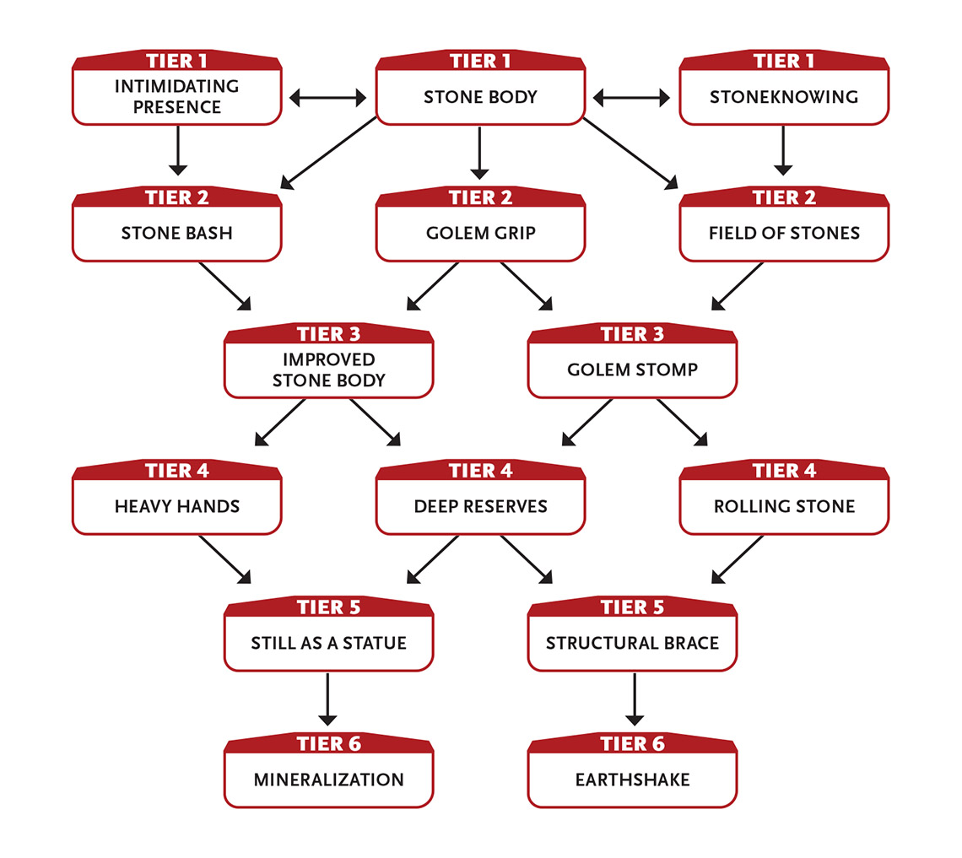Tier 1
Intimidating Presence: Because of your stony presence, you gain an asset on all attempts to intimidate.
Stone Body: Your body is made of a hard substance like stone or crystal. Work with your GM to decide your exact form, though it is likely about the shape and size of a humanoid. You do not need to eat, drink, or breathe (though you do need rest and sleep).
As a being of mineral, you can take two more minor wounds than normal and ease block rolls, and your unarmed attacks deal an additional 2 damage.
Due to your relative mineral inflexibility, you have an inability in dodge tasks.
Stoneknowing (1 Intellect): You are trained in working any kind of stone.
In addition, if you touch a crystal or stone object or structure and concentrate, you learn its level and perhaps some relevant facts about its materials and structure. For example, you could learn that a brick wall is level 3 and conceals a hidden space behind it or that a boulder is level 5 and contains iron ore. Your GM may require an Intellect task for you to learn something especially subtle or secret. Last action.

Tier 2
Field of Stones: You can attempt to hide in natural terrain, appearing as a natural rock formation. If the terrain is rocky and your stealth roll is a 15 or less, you can treat the roll as a 15. (This means you don’t get a GM intrusion if you roll a 1.) In other terrain, your stealth task to blend in as rocks is eased by two steps.
At tier 3: The minimum number rolled for this ability increases to 18.
Golem Grip (3 Might): You can easily grab foes with your stone fists. Make an eased attack against a foe. If you succeed, you restrict their movement, preventing them from moving away and hindering their physical attacks and attempts to break free.
If the target attempts to break free as their action, you must make a Might roll to continue holding them.
If you are holding a target, you can squeeze them automatically on your turn (no roll required), inflicting 4 damage.
Action.
Stone Bash: Your unarmed attack this round inflicts an additional 2 damage if you make it as a Last action.

Tier 3
Golem Stomp (4 Might): You stomp on the ground with all of your strength, creating a shock wave. Make separate attacks against three creatures in immediate range. Each creature you hit takes 3 damage and you choose if they are pushed out of immediate range or are knocked prone. Action.
Improved Stone Body: You can take one more moderate wound than normal.

Tier 4
Deep Reserves: When others are exhausted, you can push through. You can transfer up to 6 points among your Pools in any combination, at a rate of 1 point per round. For example, you could transfer 3 points of Speed to Might and 3 points of Intellect to Might, which would take a total of six rounds. This ability renews when you take a ten‑hour recovery. Action.
Heavy Hands: Your unarmed attacks deal an additional 2 damage.
Rolling Stone (5 Might): You can dive forward and contract your limbs, becoming a careening boulder moving up to a long distance. During this movement you can attack three foes by colliding with them. Make separate attack rolls for each; success means you inflict 6 damage. Last action.

Tier 5
Still As a Statue (5 Might): You freeze in place, burying your essence deep in your stone core. During this time, you lose all mobility as well as the ability to take physical actions. You cannot sense what’s happening around you, and no time seems to pass for you. While using this ability, any wounds you take are reduced in severity by two steps. You rouse to normal wakefulness and mobility 24 hours later, removing three wounds of any severity. If an ally shakes you hard enough (with a minimum cost of 2 Might on their part), you rouse earlier, but no wounds (if you have any) are removed. Action to initiate.
Structural Brace (5+ Might): You serve as a structural brace, additional pillar, or other support buttress for a structure in danger of collapsing. If you need to roll to prevent the structure from collapsing and your roll is 18 or less, treat the roll as an 18. (This means you don’t get a GM intrusion if you roll a 1.) While serving as a brace, you cannot move from where you are and you automatically fail dodge tasks. You can take an extra action on your turn to end the effect early; otherwise it ends when you take a ten-hour recovery.
Alternatively, you can simply hold up a mighty weight of up to 50 tons (45 tonnes) or use this ability to hold a door or gate shut (treating a roll of 18 or less as an 18, or higher with Effort).
Effort: Increase the minimum number rolled for this ability by 3. Increase the weight you can hold by 10 tons (9 tonnes).
Action to initiate.

Tier 6
Earthshake (7 Might or Intellect): You trigger a violent earth movement in a short area within very long range. Buildings and terrain features are damaged, reducing their levels by 1 to 3, shedding debris and rubble. Creatures in the area take 6 damage from shaking and/or falling debris (roll a separate attack roll against each). Even on a failed attack, creatures in the area still take 3 damage. Action.
Mineralization: You can take one more major wound than normal.

Blazes With Fire
You can sheathe your body in flames, which protect you and harm your foes.
- Genre themes: fire wizard (fantasy), lava world alien (science fiction), fiery super (superhero)
- GM intrusions: Fire burns flammable material. Fire spreads out of control. Primitive creatures fear fire and often attack what they fear.

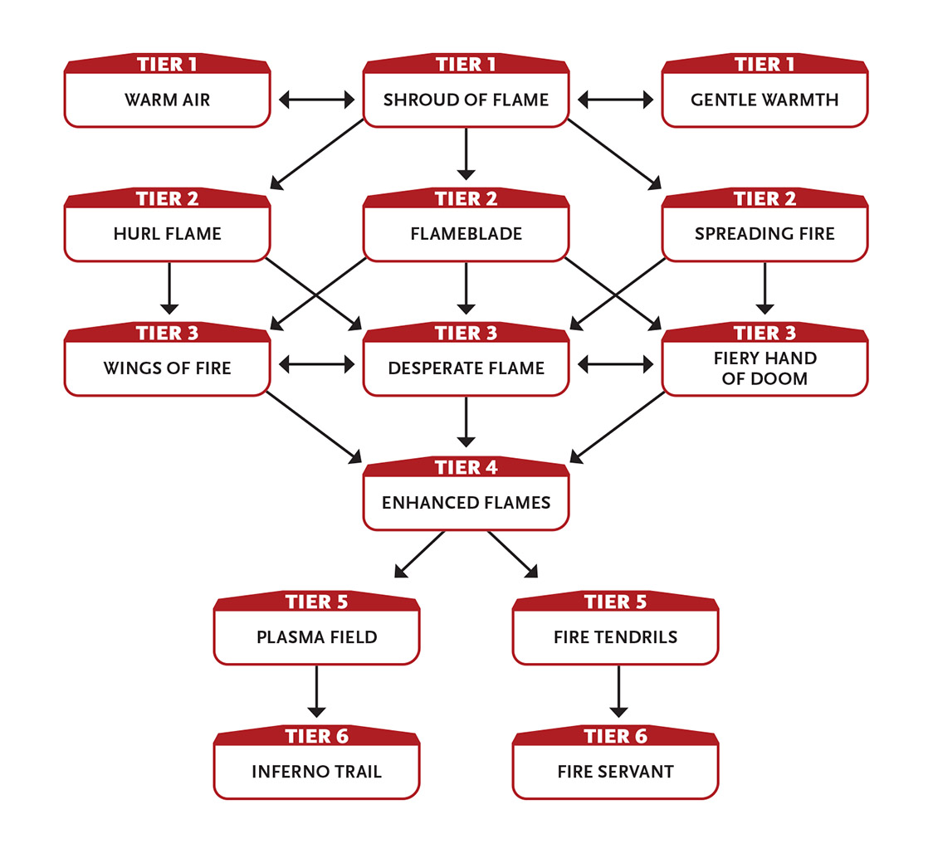Tier 1
Gentle Warmth (1 Intellect): You make it up to 30˚ F (15˚ C) warmer in an immediate area until you take a ten-minute or longer recovery (this reduces wound severity from cold temperature environments by two steps). This effect is centered on you and moves with you. Action.
Shroud of Flame (1 Intellect): At your command, your entire body becomes shrouded in flames until you use a ten-minute or longer recovery. The fire doesn’t burn you or your equipment, but it inflicts 2 damage on anyone who tries to touch you or strike you with a melee attack (no roll required).
While you are shrouded in flame, reduce the severity of wounds from heat and flames used against you by one step (major to moderate, moderate to minor, minor to none). For example, if you are hit by a fire attack that causes a moderate wound, you instead take a minor wound.
While shrouded in flame, you can touch a foe as a light unarmed attack, inflicting 2 fire damage.
Enabler.
Warm Air: While your Shroud of Flame is active, you heat the air beneath you, allowing you to fall up to 10 feet (3.5 m) safely. Falls of greater than 10 feet are treated as 10 feet less. Enabler.

Tier 2
Flameblade (2 Intellect): Your Shroud of Flame covers one weapon you wield in flame, such as a manufactured weapon like a sword or bow. (You could also intensify the flame already shrouding your hand, improving your unarmed attacks.) Any attack you make with the flaming weapon inflicts an additional 1 damage from fire (if the weapon fires projectiles, such as arrows from a bow, this damage applies to the projectiles). The flame ends if you stop holding or carrying the weapon, but as an extra action on your turn you can cover a different weapon you wield with flames. This ability ends automatically when you use a ten‑minute or longer recovery. Enabler.
Hurl Flame (2 Intellect): While your Shroud of Flame is active, you can reach into your halo and hurl a handful of fire at a target within short range, inflicting 4 fire damage if you succeed on an Intellect attack. Action.
Spreading Fire (2 Intellect): Once per turn if you take down a foe with an attack that inflicted fire damage, you can immediately make another fire‑based attack on that same turn against a new foe within short range as an extra action on your turn. Enabler.

Tier 3
Desperate Flame: While you have at least three moderate wounds or at least one major wound, you gain two free levels of Effort you can apply to one fire attack each round. This benefit lasts until you take your next ten-minute or longer recovery or you no longer have the qualifying wounds. Enabler.
Fiery Hand of Doom (3 Intellect): While your Shroud of Flame is active, you can reach into your halo and produce a hand composed of animate flame with a handspan of up to 3 feet (1 m), lasting until you use a ten-minute or longer recovery. The hand is a level 3 creature that inflicts 1 extra fire damage when it attacks (4 damage total). The hand acts as you direct, floating in the air. Directing the hand is an action. Without a command, the hand does nothing but follow you. It can move a long distance in a round, but it never moves farther away from you than long range. The hand can attack, grab, move, and carry things. It inflicts 3 damage each round to any flammable object it holds. Action to create; action to direct.
Wings of Fire (4 Intellect): While your Shroud of Flame is active, you can spread wings of fire and fly until you use a ten-minute or longer recovery, moving at a rate of up to 20 feet (6 m) per round in any direction. You can also take one other non‑movement action as an extra action on your turn. Action to initiate.

Tier 4
Enhanced Flames: Fire damage you deal using special abilities increases by 2 damage per attack.

Tier 5
Fire Tendrils (5 Intellect): Your Shroud of Flame sprouts three tendrils of flame that last until you use a ten-minute or longer recovery. You can attack with each tendril as an extra action on your turn. Each tendril inflicts 3 damage (5 damage with Enhanced Flames). If you don’t use the tendrils to attack, they remain but do nothing. Action to initiate.
Following the round in which you initiate Fire Tendrils, attacking with them—as extra actions on your turn—counts as your overall action for that round.

Plasma Field (5 Intellect): A selected portion of your fire shroud spikes to a temperature hot enough to incinerate incoming ranged attacks (such as arrows, bullets, a thrown metal knife, and so on), instantly turning them to ash. You are immune to such attacks for one round. You must be aware of an attack to incinerate it. Enabler.

Tier 6
Fire Servant (6 Intellect): You use your Shroud of Flame to create an automaton of fire that is your general shape and size, lasting until you use a ten-minute or longer recovery. This NPC ally acts as you direct each round. Directing the automaton is an action, and you can command it only when you are within long range of it. Without a command, the automaton continues to follow your previous command. You can also give it a simple programmed action, such as “Wait here and attack anyone who comes within short range until they’re dead.” Action to create; action to direct.
Fire automaton: level 5; Armor 1; bash attacks deal 6 damage (1 from fire)
Inferno Trail (6 Intellect): Your Shroud of Flame leaves a trail of fire in your wake. The trail matches your path, creating a wall of flame about 6 feet (2 m) high that inflicts 5 damage on any creature that passes through it. If targets are flammable, they also catch on fire for an additional 1 damage each round until they spend a round putting out the fire. You can suppress the trail of fire when you wish as an extra action on your turn (and restart it the same way) or end the overall effect early. Otherwise, the effect ends after you use a ten‑minute or longer recovery. Action.

Builds Allies
You create automatons, robots, constructs, or other artificial creatures that do as you command.
- Genre themes: golem crafter (fantasy), robot builder (real world, science fiction, superhero)
- GM intrusions: The automaton gains a mind of its own. The automaton becomes controlled by someone else. The automaton unexpectedly fails in a spectacular way.
- Additional equipment: You have a set of tools, or access to the same, that allows you to build your allies.
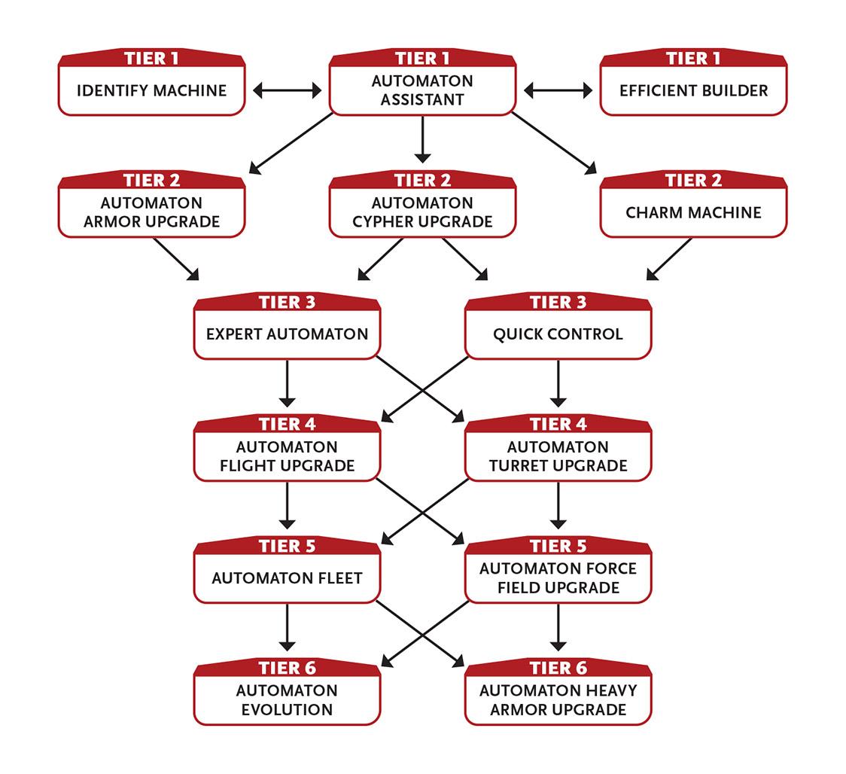

Tier 1
Automaton Assistant: You have built a level 2 automaton follower of your size or smaller that accompanies you and follows your instructions. You and the GM must work out the details of your automaton’s appearance and personality.
If the automaton is damaged, a few minutes of your attention mends it—the automaton regains 2 health.
If the automaton is destroyed, it can be restored using your resources if you spend a few days tinkering.
Depending on the genre, your automatons might be metallic robots, animated objects, organic androids, magical golems, steampunk constructs, awakened statues, or something else entirely.

Efficient Builder: Anytime you gain resource points, you gain 1 additional point, but that point can be spent only on repairing or crafting.
Identify Machine (1 Intellect): You understand the purpose, function, level, and status of a single robot or powered device within immediate range. Last action.

Tier 2
Automaton Armor Upgrade (3 Intellect): You’ve built a new capability into one of your automatons—it can use its action to transform into an armored suit that you wear until you use a one-hour or longer recovery. If you are within an immediate distance when it transforms, it automatically forms itself around you. The transformed automaton acts as light armor; because it anticipates and reacts to your movements, you can freely use this armor. Enabler.
Automaton Cypher Upgrade (3 Intellect): You’ve built a new capability into one of your automatons—for one day, the automaton increases your cypher limit by one. Enabler.
Charm Machine (2 Intellect): You convince an unintelligent machine or automaton within immediate range to “like” you with a successful Intellect attack roll. A machine that likes you is 50 percent less likely to function if said function would cause you harm. For example, if a foe attempts to detonate a bomb near you controlled by a detonator that likes you, there is a 50 percent chance that it won’t explode. The target likes you until you use a ten-minute or longer recovery. Action to initiate.

Tier 3
Expert Automaton: You’ve built a level 3 automaton follower. It otherwise functions much like your level 2 automaton from Automaton Assistant.
Instead of gaining a new level 3 automaton, you can upgrade an existing level 2 or 3 automaton follower (increasing its level by 1) and gain a new level 2 automaton.
You can take this ability multiple times, each time gaining another automaton.
Quick Control (4 Intellect): A successful Intellect attack allows you to command a machine or automaton (intelligent or not) within short range to take one action within its capabilities on its next turn, regardless of its normal programming or attitudes. If this action would cause the machine or automaton direct harm to itself or its allies, your Intellect attack against it is hindered. (If you use this ability to command an intelligent machine or automaton, it likely becomes hostile to you afterward.) Action.

Tier 4
Automaton Flight Upgrade: You’ve built a new capability into one of your automatons—as its normal movement, it can fly up to a long distance. If you wish, it can carry you but can only move at a rate of up to 20 feet (6 m) per round in any direction while doing so.
Automaton Turret Upgrade: You’ve built a new capability into one of your automatons—it can reconfigure itself and become an immobile energy weapon on a gimbal mount. The turret is a heavy weapon with very long range that inflicts 7 damage. If you have the automaton act on its own, it makes one hindered attack per round. If you or an ally use the turret as a weapon, attacks with it are eased. Action to change the automaton’s configuration; Last action to attack with turret.
In a fantasy setting, the automaton turret probably shoots fire or lightning. In a science fiction setting, it probably shoots lasers.

Tier 5
Automaton Fleet: You’ve built four level 2 automaton followers, each no larger than yourself. You and the GM must work out the details of each automaton’s appearance and personality.
If one of these automatons is destroyed, it can be restored using your resources after a few days of labor.
Automaton Force Field Upgrade: You’ve built a new capability into one of your automatons—it can erect a translucent level 5 force field around itself and anyone within immediate range of it until you use a ten-minute or longer recovery. Any creature protected by the field reduces incoming wounds by one severity (NPCs take 3 less damage). Enabler.

Tier 6
Automaton Evolution: One of your automaton followers is upgraded, increasing its level by 1. You can select this ability multiple times. Each time, the level of one of your automatons increases by 1.
Automaton Heavy Armor Upgrade (6 Intellect): You’ve built a new capability into one of your automatons—the robot can use its action to transform into an armored suit that you wear until you use a one-hour or longer recovery. If you are within an immediate distance when it transforms, it automatically forms itself around you. The transformed automaton acts as heavy armor; because it anticipates and reacts to your movements, you can freely use this armor. Enabler.

Carries a Gun
You carry a firearm (whether a conventional gunpowder pistol or some kind of blaster or energy weapon) and you know how to use it in a fight.
- Genre themes: musketeer (fantasy), soldier (historical, real world, science fiction)
- GM intrusions: Weapons misfire or jam; the attack fails and the action is lost, plus an additional action is needed to fix the problem. An attack strikes sensitive equipment or an unintended target.
- Additional equipment: You have a medium or small firearm.
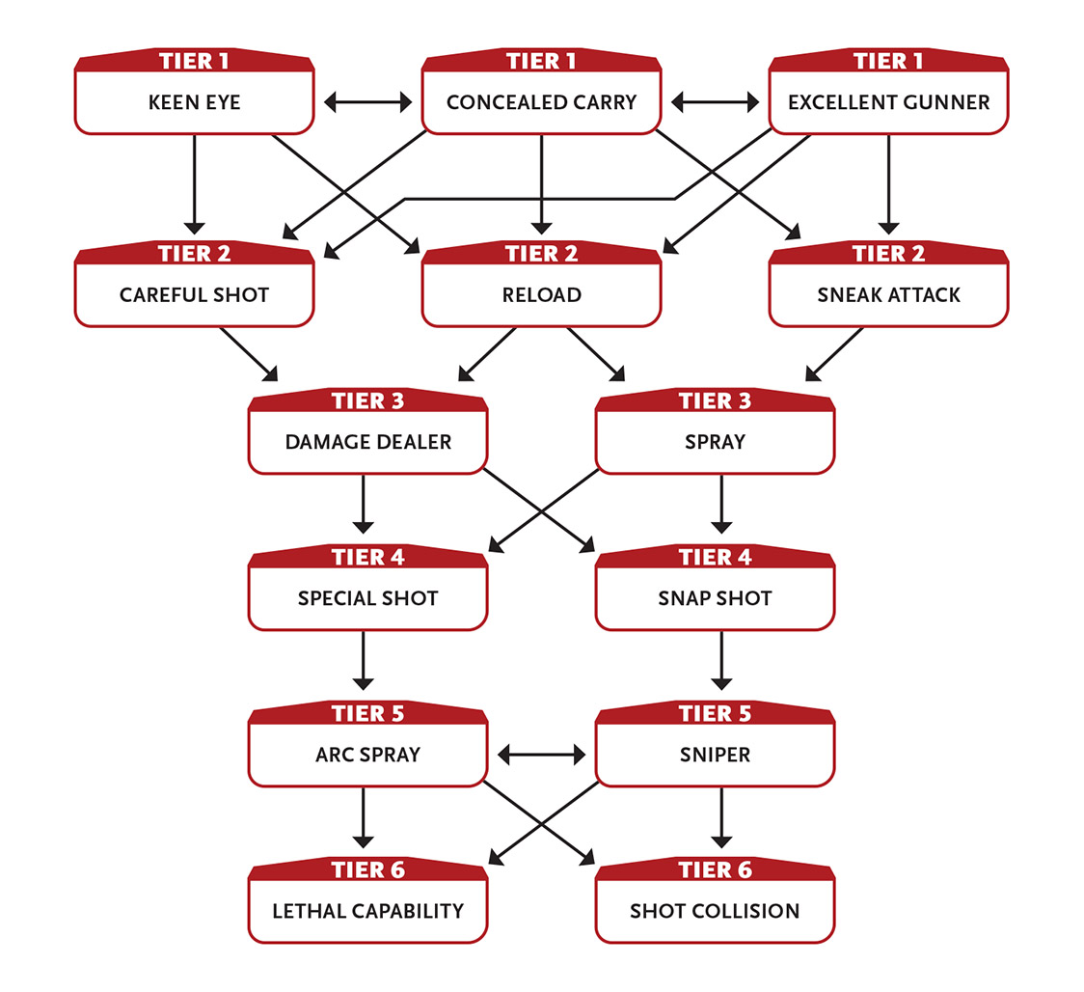

Tier 1
Concealed Carry: You can easily hide a one‑handed firearm on your person, drawing or holstering it as an extra action (a First action) on your turn. Tasks to hide this weapon (whether from someone looking at you or actually searching you) are eased by two steps.
You gain an asset on any task to spin, twirl, quick draw, or do another trick task involving your firearm and its holster.
You can perform skillful manipulations with your firearm, including gunspinning (twirling it around one finger), shooting an icon from a playing card at long range, shooting an object held in someone’s hand at long range, shooting a coin tossed skyward at long range, and so on, after which you can reholster your firearm in the blink of an eye. These acts can’t hurt or affect a creature (or their equipment); however, if you do this to impress or intimidate a foe, that task is eased.
Excellent Gunner: You can freely use firearms and suffer no penalty when using one.
You inflict an additional 1 damage with firearms.
For one attack you make with a firearm, you can roll twice and use the better result. This ability renews when you make a ten-minute or longer recovery. Enabler.
Keen Eye: You can see perfectly well half again as far as normal. You ignore attack and perception penalties for fog, smoke, mist, dim light, and very dim light.

Tier 2
Careful Shot: You can use Speed Effort or Intellect Effort to increase your ranged weapon damage.
In addition, if you use an action to line up your shot, the attack on your next turn inflicts 2 additional damage per level of Effort applied to increase damage (5 damage total per level of Effort). Enabler.
Reload (1 Speed): You can reload a firearm as an extra action on your turn. Enabler.
Sneak Attack (1 Speed): If you attack a foe under one of the following conditions, your light melee or light ranged weapon attack inflicts an additional 5 damage on a successful hit. (This ability doesn’t work with medium or heavy weapons.)
- You attack with surprise.
- An ally uses their action to ease your attack.
- Your foe’s defenses are hindered due to some other ongoing direct distraction.
- Your foe is unable to take their next turn due to some disabling attack or situation.
First action.

Tier 3
Damage Dealer: You’ve become better at killing with firearms, inflicting an additional 3 damage with them.
Spray (2 Speed): If a weapon has the ability to fire rapid shots without reloading (usually called a rapid-fire weapon, such as a crank crossbow or submachine gun), you can spray multiple shots around your target to increase the chance of hitting, gaining an asset to the attack. This ability uses 1d6 + 1 attacks’ worth of ammunition or power (or all of the weapon’s stores, if it has less ammo or power than the number rolled). If the attack is successful, it deals 1 less damage than normal. You can also use this ability on multiple thrown weapons (such as stones, shuriken, daggers, and so on) if you’re carrying them on your person or they are all within reach. Action.

Tier 4
Snap Shot: You can attack with your firearm and then attack again as an extra action on your turn. The second attack is hindered by two steps. Enabler.
Special Shot: When you hit a target with a firearm attack, you can choose to reduce the damage by 1 point but hit the target in a precise spot. Some of the possible effects include (but are not limited to) the following:
- Shoot an object out of someone’s hand.
- Shoot the target’s leg, wing, or other limb they use to move, reducing their maximum movement speed to immediate for a few days or until they receive expert medical care.
- Shoot a strap holding a backpack, armor, or a similarly strapped-on item so that it falls off.
Enabler.

Tier 5
Arc Spray (3 Speed): If a weapon has the ability to fire rapid shots without reloading (usually called a rapid-fire weapon, such as a crank crossbow or submachine gun), you can fire your weapon at three targets (all next to one another) at once. Make a separate hindered attack roll against each target. Action.
Sniper: You are effective at much longer range than normal. Double the range of any firearm in your hands. If making a shot at very long range (or longer), you inflict an additional 1 damage.

Tier 6
Lethal Capability: You’ve mastered how to kill with a particular attack. You inflict an additional 5 damage with attacks of one specific type, such as your firearm, or some other specific attack you prefer.
You can gain this ability more than once. Each time you do, choose a different specific attack.
Shot Collision (4+ Speed): Once per round, if someone attacks you with a firearm, thrown weapon, or other physical projectile (such as an arrow, bullet, or crossbow bolt), instead of attempting a defense task, you can attempt to shoot the projectile out of the air. Make an attack against the projectile at the same difficulty as the defense task. If you hit, your shot deflects, destroys, or otherwise prevents the projectile from hitting you.
If you wish, the successfully deflected object explosively shatters in an immediate radius you select between you and the attacker, dealing 2 damage to all creatures and objects in the area (roll a separate attack against each). If you apply Effort to increase the damage, you deal 2 additional damage per level of Effort (instead of 3); targets in the area take 1 damage even if you fail the attack roll.
Enabler.

Casts Spells
You have a book of various spells and can change which ones you have ready to cast each day—blasts of energy, summoning monsters, magical flight, teleportation, and copying cyphers can all be part of your repertoire.
Character abilities from the Casts Spells focus are magical spells or rituals. Your character has to use specific magic words and gestures to activate them, and they may require tiny amounts of strange ingredients like spider eyes and powdered gemstones. These are just story and flavor requirements; in terms of game mechanics, these abilities work just like abilities from other foci and from various types.
- Genre themes: sorcerer or wizard (fantasy), magician (real world with magic and/or horror), master of the mystic arts (superhero)
- GM intrusions: A spell goes wrong. A summoned creature turns on the caster. A rival spellcaster is drawn to the magic use.
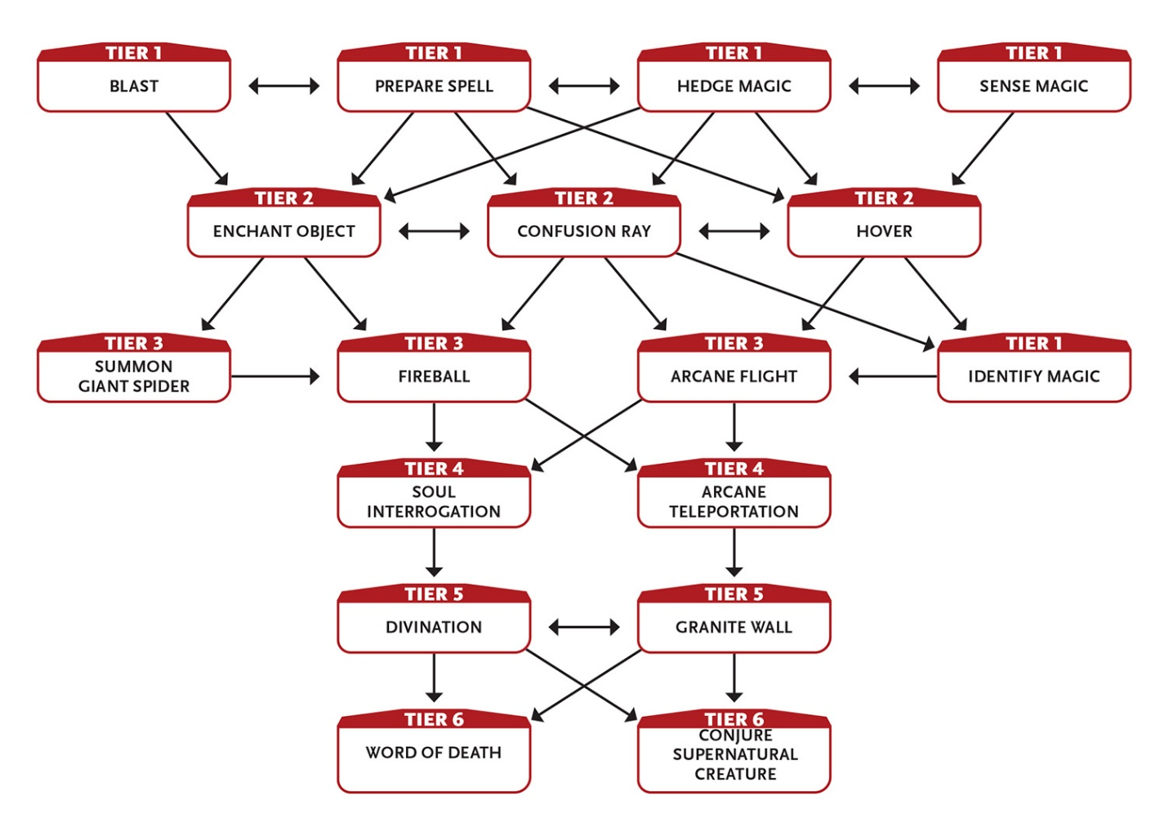

Tier 1
Blast (1+ Intellect): You emit a short-range blast of energy inflicting 4 damage on a target with a successful attack roll. Work with the GM to determine the type of energy comprising your blast.
You can tune the effect to make it hot enough to slice through material of up to level 5 that’s no more than 1 foot (30 cm) thick if given a few rounds to concentrate on doing so.
If you have another damaging attack ability (from this focus or your type), you can use Blast to augment that ability, increasing its damage by 1.
You can change the name of the Blast ability so it relates to the kind of energy you create, such as Blast of Fire, or something more evocative suggesting the name of the spellcaster who created it, such as Malhavoc’s Destructive Blast.

Effort: Gain fine control over the effect until you use a ten-minute or longer recovery, varying the intensity as you wish within immediate range; for instance, you could use it to warm the area, cook food without burning it, provide bright light in the area, and so on. Increase the maximum level of material that you can cut through by 1.
Action to attack; Last action to initiate fine control; enabler to augment another attack ability.
Hedge Magic (1 Intellect): You can perform small tricks: temporarily change the color or basic appearance of a small object, cause small objects to float through the air, clean a small area, mend a broken object, prepare (but not create) food, and so on. You can’t use Hedge Magic to harm another creature or object. Action.
Prepare Spell: Each day you can pick a different magical effect and cast it as a spell. Choose a low-power manifest cypher. You gain that cypher’s effect as a spell (a character special ability) after spending ten minutes preparing. You can cast that spell as an action, costing 2 Intellect. This spell does not count toward your cypher limit. Unlike when using a cypher, you do not lose this spell after casting it.
Whenever you take a ten-hour recovery, you can change which cypher you’ve taken as a spell. Changing which cypher you have prepared as a spell ends all of your durations of the previous prepared spell.
You can select this ability up to three times, allowing you to choose one, two, or three cyphers each day as spells.
Ten minutes to complete preparing a cypher as a spell; action to cast a cypher as a spell.
At tier 3: You can use this ability to choose a low- or medium-power cypher as a spell. You can cast a medium-power cypher spell as an action, costing 4 Intellect.
At tier 6: You can use this ability to choose a low-, medium-, or advanced-power cypher as a spell. You can cast an advanced-power cypher spell as an action, costing 6 Intellect.
Sense Magic (1 Intellect): If there is magic of any kind at work within short range, you are aware of that fact (but not the specifics). Last action.

Tier 2
Confusion Ray (2 Intellect): You project a grey beam of disruptive mental energy at a creature within short range. Make an Intellect attack against your foe; success means you deal 1 damage (ignores armor) and their tasks are hindered until your next turn. Action.
Enchant Object (2 Intellect): You imbue a weapon, tool, or other usable item with magic that enhances its performance, lasting until you (or the user of the object) use a ten-minute or longer recovery. At any point while the ability is active, the creature using the object gains an asset to one action requiring the object. You decide if the object looks the same, glows like a candle, or gains a magical rune for the duration of the spell. Action.
Hover (2 Intellect): You float slowly into the air. If you concentrate, you can control your movement to remain motionless in the air or float up to a short distance as your action; otherwise, you drift with the wind or with any momentum you have gained. This effect lasts until you use a ten‑minute or longer recovery. Action to initiate.

Tier 3
Arcane Flight (3+ Intellect): You can float and fly through the air at your normal land speed until you use a ten-minute or longer recovery. In terms of overland movement, a flying creature moves about 20 miles (32 km) per hour and is not affected by terrain.
Effort: Affect one additional touched creature of your size or smaller; you direct their movement and they must remain within sight of you or they fall.
Action to initiate.
Arcane Flight is better than Hover, so if you have both, you can exchange Hover for another tier 2 or lower ability from the Casts Spells focus.

Fireball (4+ Intellect): You create a burst of fire within long range, filling an immediate area. Roll against each creature in the area; you inflict 3 damage on a success, or 1 damage on a failure. Flammable objects may catch fire. Each level of Effort applied to increase damage adds 2 damage to each target (instead of 3). Action.
Identify Magic (3 Intellect): If you have sensed magic using the tier 1 ability, you can gain more specifics about what you sense: the level of the magic, the source of the magic (a spellcaster, a magical creature, an ongoing magical effect, or an enchanted object), and the general effects of the magic at play. Last action.
Summon Giant Spider (4+ Intellect): You conjure a giant spider, which appears within immediate range. The spider acts according to its nature, attacking a nearby creature that looks like suitable prey. The spider remains until you use a ten-minute or longer recovery, then fades away.
Effort: Make the spider understand you and obey your verbal instructions.
Action to initiate.
Giant spider: level 3, perception as level 5, Speed defense as level 4 due to quickness; health 12; bite inflicts 3 damage plus 1 Speed damage from poison (ignores armor); moves a long distance each round when on webs

Tier 4
Arcane Teleportation (4+ Intellect): You instantly teleport to any location within a short distance that you can see.
Effort: Increase your range by a short distance. Teleport to a location you can’t see. Bring one creature (of your size or smaller) with you.
At tier 5: If you spend 5 Intellect, your base distance and distance increment for Effort increase to long range, and each level of Effort applied lets you bring two people with you.
At tier 6: If you spend 6 Intellect, your base distance increases to anywhere on the same planet, and each level of Effort used lets you bring three people with you.
Action.
Soul Interrogation (5 Intellect): You attempt to learn secret information about a foe that you can use against them. Make an Intellect attack against a creature within long range. Success means you learn their level, basic abilities, and obvious weaknesses (such as a vulnerability to fire or silver), as well as their mannerisms and personal qualities that you could discover by conversing with them for an extended time. For the next few months, your actions against them are eased. Action.

Tier 5
Divination (6 Intellect): You contact a powerful entity (such as a deity, demon lord, or creature from a dimension of knowledge), ask one question, and get a general answer. The GM assigns a level to the question, so the more obscure the answer, the more difficult the task. Generally, knowledge that you could find by looking somewhere other than your current location is level 1, obscure knowledge of the past is level 7, and specific knowledge of future events beyond the next few minutes is impossible. Action.
Granite Wall (5+ Intellect): You create a level 5 granite wall within short range. The wall is four 10-foot by 10-foot (3.5 m by 3.5 m) squares, each 1 inch (2.5 cm) thick, arranged as you wish. The wall lasts until you use a one-hour or longer recovery, after which it crumbles to dust.
Effort: Increase the duration to until you use a ten-hour recovery. Make the duration permanent (this requires three levels of Effort).
Action.

Tier 6
Conjure Supernatural Creature (7+ Intellect): A supernatural creature from another dimension such as an angel, demon, or elemental manifests in a physical form within immediate range. The creature acts according to its nature, usually by attacking a nearby foe that is opposed to its own ethos (an angel would attack a demon or necromancer, a demon would attack an innocent or a holy priest, and an elemental would attack a creature of the opposing element). The creature remains until you use a ten-minute or longer recovery, then fades away (although a demon or elemental might remain for a while to cause trouble).
Effort: Make the supernatural creature understand you and obey your verbal instructions.
Action to initiate.
Angel: level 5; health 15; physical, magical, or energy attack inflicts 6 damage; flies a short distance each round
Demon: level 5; health 25; physical, magical, or energy attack inflicts 6 damage; flies a short distance each round
Elemental: level 5; health 25; physical or energy attack inflicts 5 damage; amorphous form can pass through spaces as small as 1 foot (30 cm); air elemental flies a long distance each round; earth elemental has Armor 3; fire elemental has Armor 10 against fire; water elemental swims a long distance each round

Word of Death (6 Intellect): You speak a magic word so potent that it can instantly kill a foe. Make an Intellect attack against a foe within short range. If you succeed, you inflict 10 damage. Action.

Changes Shape
You can transform into various animals, gaining their natural abilities as if you were born with them.
- Genre themes: animal druid (fantasy), shapeshifter (science fiction, superhero)
- GM intrusions: Something triggers an involuntary transformation. An NPC is frightened by or aggressive toward the shapeshifter. The transformation takes longer than expected.
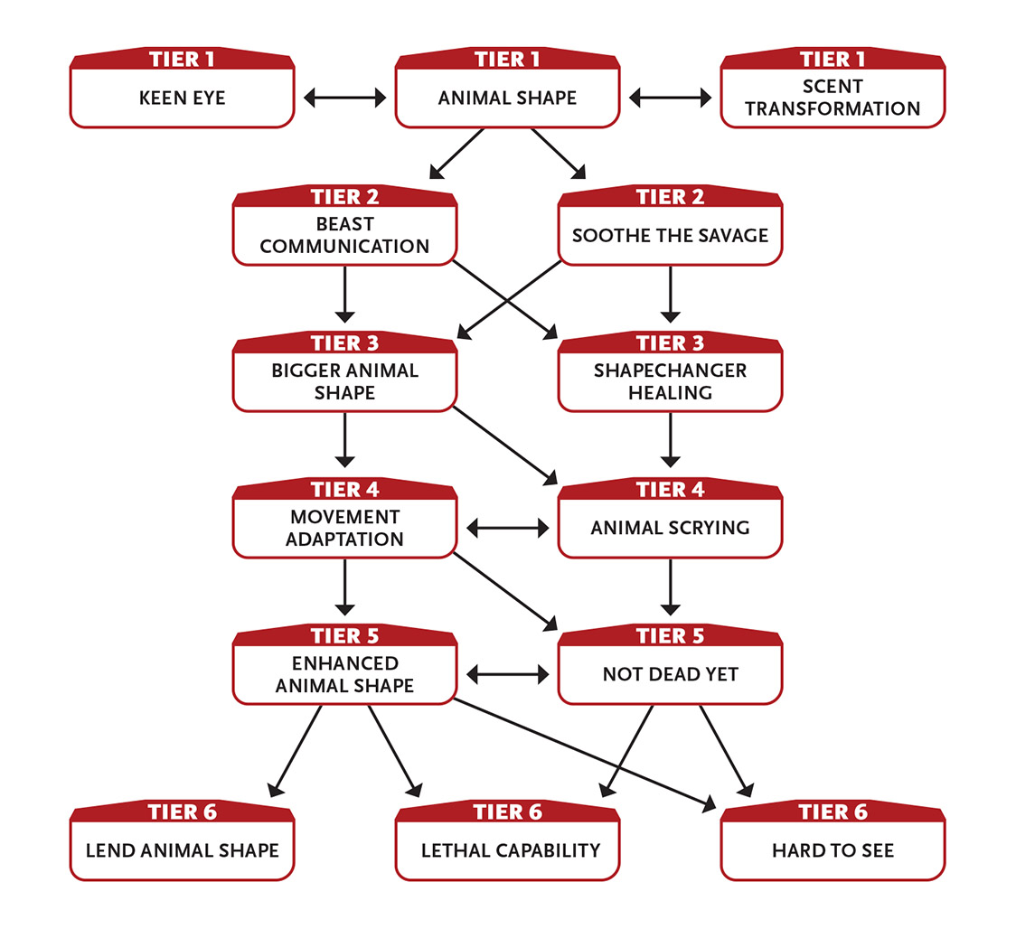

Tier 1
Animal Shape (3+ Intellect): You change into an animal as small as a rat or up to your own size (such as a large dog or small bear) until you use a recovery. Each time you transform, you can take a different animal shape. Your equipment becomes part of the transformation, rendering it unusable unless it has a passive effect, such as armor. In this form your stats remain the same as your normal form, but you can move and attack according to your animal shape (attacks from most human-sized animals inflict 4 damage; attacks from smaller animals inflict 2 damage) without penalty. Tasks requiring hands (such as using door handles or pushing buttons) are hindered when in animal form. You cannot speak but can still use abilities that don’t rely on human speech. You gain a minor ability associated with the creature you become (see the Animal Form Minor Abilities box). For example, if you transform into a bat, you can fly up to a long distance each round. If you transform into an octopus, you can breathe underwater.
Effort: Gain an asset to one skill associated with the creature you become (see the Animal Form Minor Abilities box).
Effort: Become a talking animal; this looks exactly like a normal animal, but you can still talk and use any abilities that rely on human speech.
Effort: Take a hybrid shape; this is like your normal form but with animalistic features, even if that animal is something much smaller than you (such as a bat or rat). In hybrid form you can speak, use all of your abilities, make attacks like an animal, and perform tasks using hands without being hindered. Anyone who sees you clearly in hybrid form would never mistake you for a mere animal.
Action to change or revert.
Keen Eye: You can see perfectly well half again as far as normal. You ignore attack and perception penalties for fog, smoke, mist, dim light, and very dim light.
Scent Transformation (1 Intellect): You alter your scent so that you smell like an animal of your choosing until your next ten-minute or longer recovery. This can foil tracking attempts that are based on smell, and when attempting to interact with animals of your chosen type that rely heavily on smell, your tasks are eased by two steps. You can use this ability no matter what your shape is. Action to initiate.

Tier 2
Beast Communication (2 Intellect): You can convey a basic concept to a creature that normally can’t speak or understand speech. The creature can also give you a very basic answer to a simple question. Action.
Soothe the Savage (2 Intellect): Make an Intellect attack roll to calm a nonhuman beast within short range that can see you. You must speak to them (although they don’t need to understand your words). They remain calm until you use a ten‑minute or longer recovery or for as long as you keep using your action to calm them. Action.

Tier 3
Bigger Animal Shape: When you use Animal Shape, you can grow to about twice your normal size. Being so large, your animal shape gains the following additional benefits: you can ignore the first moderate wound you take, your unarmed attacks inflict an additional 4 damage, and you gain an asset on your unarmed attack rolls. However, your dodge tasks are hindered.
While using Bigger Animal Shape, you also gain an asset to tasks that are easier for a larger creature to perform, like climbing, intimidating, wading rivers, and so on.

Shapechanger Healing: When you change into an animal form, you are healed of one wound of any severity. This ability renews after you take a ten-hour recovery. Enabler.

Tier 4
Animal Scrying (4+ Intellect): If you know the general location of an animal that is friendly toward you and within 1 mile (1.6 km) of your location, you can sense through its senses until you use a ten-minute or longer recovery. You must be in animal form or a form similar to that animal to activate this ability.
Effort: Activate this ability even if you are not in animal form or a form similar to that animal.
Action to establish.
Movement Adaptation (4 Might): You can modify your animal shape, either growing wings so you can fly or becoming aquatic with fins and gills (for example, if you are in the form of a gorilla, you could become a winged gorilla or a fishlike gorilla). If you choose flight, you can fly a long distance each round. If you choose aquatic, you can breathe water and swim at your normal land speed. You can carry a creature of your size or smaller, or if affected by Bigger Animal Shape, three creatures of your regular size or smaller. If you use Animal Shape, you gain the benefit of this ability without having to spend an action to trigger it. Action; enabler when using Animal Shape.

Tier 5
Enhanced Animal Shape: When you use Animal Shape, your animal form gains the following additional bonuses: +3 to your Might Pool, +2 to your Speed Pool, and you can ignore minor wounds from physical attacks. Enabler.
Not Dead Yet: When you would normally be dead, you instead fall unconscious for one round and then awaken.
When you awaken this way, you immediately gain 1d6 + 6 points to restore your stat Pools, and you remove one moderate wound and one major wound.
Once you use this ability, your tasks are hindered until you use a ten-hour recovery.
If you die again before you use your ten-hour recovery, you are truly dead.
You can select this ability twice. The second time you select it, the healing increases to 1d6 + 12 and you remove double the number of wounds.
Enabler.

Tier 6
Hard to See: When you move, you are a blur. It is impossible to make out your identity as you pass by someone at speed.
In addition, if you do nothing but move on your turn, your dodge and stealth tasks are eased by three steps until your next turn.
Lend Animal Shape (6+ Intellect): You change into an animal as if using Animal Shape, and one willing creature within immediate range also transforms into an animal of that type (bear, tiger, wolf, and so on) until you use a ten-minute or longer recovery, as if they were using your Animal Shape ability. All creatures transforming with you must be your size or smaller. A creature can revert to its normal form as an action, but it cannot then change back into the animal form. One creature (whether you or someone else) changing form does not affect any other creature affected by this ability.
Effort: Affect an additional creature.
Action.
Lethal Capability: You’ve mastered how to kill with a particular attack. You inflict an additional 5 damage with attacks of one specific type, such as a claw, a bite, a tail slap, or some other specific attack you prefer.
You can gain this ability more than once. Each time you do, choose a different specific attack.

Animal Form Minor Abilities
“Animals” and “beasts” are intentionally not rigorously defined, because it depends on the setting. The terms are, in fact, interchangeable synonyms. In an Earth-like setting, badgers, wolves, and eagles are animals and beasts. In a very different fantasy world, in a very different time period, or on a science fiction planet, a warg, a triceratops, and a rigellian stinkpig are beasts and animals, while a basilisk, a robot dog, and a Saturnian silicon spider probably are not. Basically, if it’s more or less an animal, it is one. If it’s supernatural or has some kind of special powers, it is not.

Use the following as examples or suggestions of what a character gains when in the shape of an animal. If an animal shape lists two skills, the character chooses which one they want to have an asset in each time they take that shape.
Animal | Minor Ability | Skill Asset
Ape | Hands | Climbing
Badger | Scent | Climbing
Bat | Flying | Perception
Bear | Scent | Climbing
Bird | Flying | Perception
Boar | Scent | Might defense
Cat | Small | Climbing or stealth
Constrictor snake | Constrict | Climbing
Crocodile | Constrict | Stealth or swimming
Deinonychus | Fast | Perception
Dolphin | Fast | Perception
Fish | Aquatic | Stealth or swimming
Frog | Aquatic | Jumping or stealth
Horse | Fast | Perception
Leopard | Fast | Climbing or stealth
Lizard | Small | Climbing or stealth
Octopus | Aquatic | Stealth
Shark | Aquatic | Swimming
Turtle | Armor | Might defense
Venomous snake | Venom | Climbing
Wolf | Scent | Perception
The GM can mix up the combinations of skills and other abilities for these animal shapes to create other Earth animals, or create animals in the campaign setting that don’t exist on Earth.
Aquatic: The animal either breathes water instead of air or is able to breathe water in addition to breathing air.
Armor: The animal has a thick hide or shell that functions like light armor (but never hinders the character’s tasks).
Constrict: The animal can grip its opponent fast after making a melee attack (usually with a bite or claw), easing attack rolls against that foe on later turns until the animal releases the foe.
Fast: The animal can move a long distance on its turn instead of a short distance.
Flying: The animal can fly, which (depending on the type of animal) may be up to a short or long distance on its turn.
Hands: The animal has paws or hands that are nearly as agile as those of a human. Unlike with most animal shapes, tasks that require hands are not hindered (although the GM may decide that some tasks requiring human agility, such as playing a flute, are still hindered).
Scent: The animal has a strong sense of smell, gaining an asset on tracking and dealing with darkness or blindness.
Small: The animal is considerably smaller than a human, easing its dodge tasks but hindering tasks to move heavy things.
Venom: The animal is venomous (usually through a bite), inflicting an additional 1 poison damage

Commands Mental Powers
You can send and receive thoughts as easily as communicating by voice.
- Genre themes: enchanter (fantasy), telepath (real world, science fiction, superhero)
- GM intrusions: Something glimpsed in the target’s mind is horrifying. A feedback loop allows the target to read the character’s mind.
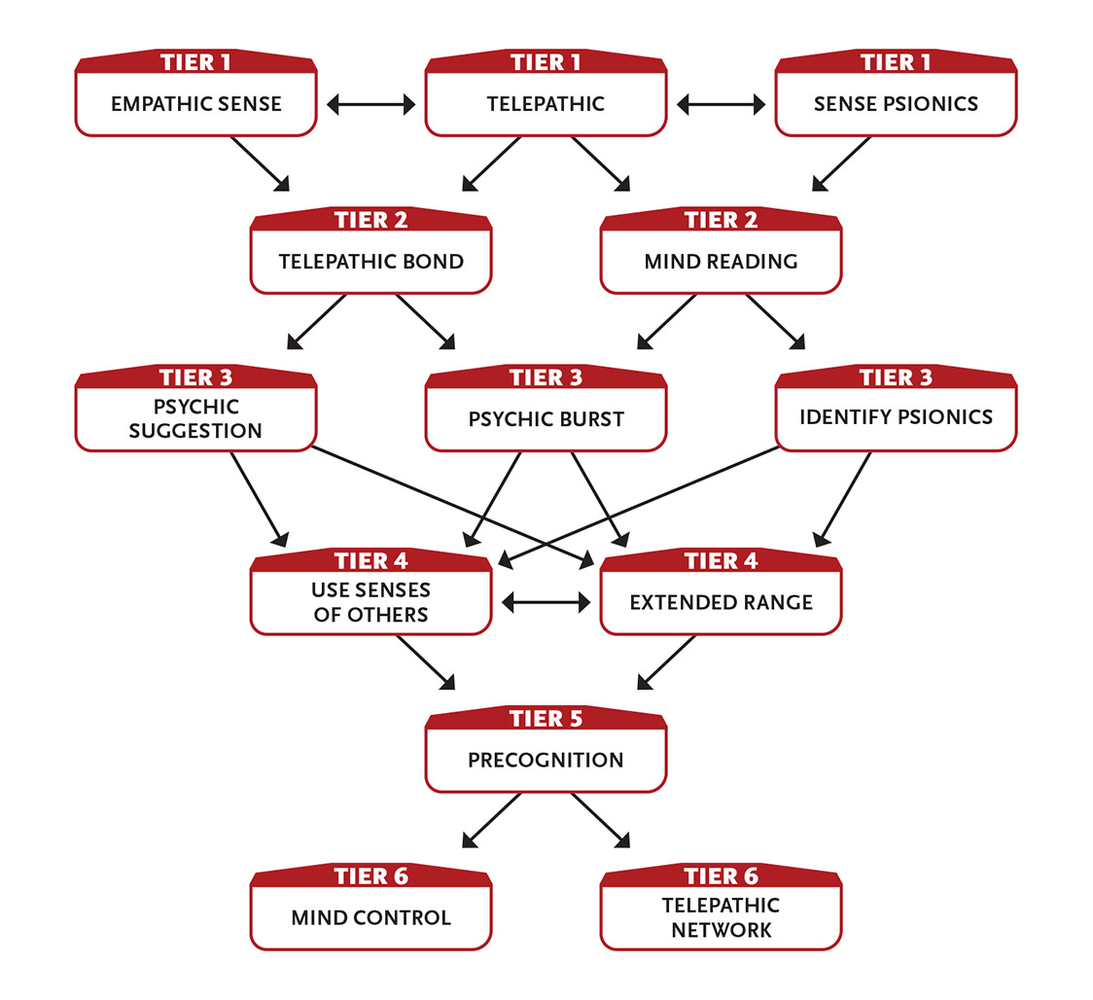

Tier 1
Empathic Sense: You sense the general mental state of a being within short range. You can sense their general emotion, and in particular how they feel about you. Last action.
Sense Psionics (1 Intellect): If there are mental powers, psionic abilities, or other psychic phenomena at work within short range, you are aware of that fact (but not the specifics). Last action.
Telepathic (1+ Intellect): You can speak telepathically with others who are within long range. Communication is two-way, but the other party must be willing and able to communicate. You don’t have to see the target, but you must know that they’re within range. You can have more than one active contact at once, but you must establish contact with each target individually. Each contact lasts until you use a ten-minute or longer recovery.
Effort: Increase the duration so it lasts until you use a ten-hour recovery.
Action to establish contact.

Tier 2
Mind Reading (2 Intellect): You can read the surface thoughts of a creature you can see within short range. If the creature is unwilling, you must make an Intellect attack against them to read their thoughts. Once you have established contact, you can read the target’s thoughts until you use a ten‑minute or longer recovery. Action to initiate.
Telepathic Bond (2 Intellect): You create a bond between yourself and another creature, allowing the two of you to communicate mentally at will. You must touch the creature to activate this and they must be willing. Either of you can dissolve the bond as a Last action. You two can speak telepathically with each other at any time as long as you are both willing and are within 100 miles (160 km) of each other. You can have only one telepathic bond at a time. Last action to form bond or dissolve it.

Tier 3
Identify Psionics (3 Intellect): If you have sensed psionics using the tier 1 ability, you can gain more specifics about what you sense: the level of the effect, the source of the effect (a creature or an ongoing psychic effect), and the general effects of the psionics at play. Last action.
Psychic Burst (3+ Intellect): You blast waves of mental force into the minds of three targets within short range (make an Intellect roll against each target). This burst inflicts 3 Intellect damage (ignores armor).
Effort: Attack an additional target.
Action.
Psychic Suggestion (4 Intellect): You attempt to make a foe within short range take the action you indicate on their next turn. Make an Intellect attack against the foe. If the action would cause direct harm to themself or their allies, the mental attack is hindered. Action.

Tier 4
Extended Range: You increase how far one of your mental abilities can reach. Choose one of your focus abilities that affects another creature. Your range for this ability increases by one range category (touch to immediate, then short, long, very long, 1 mile, 100 miles, and finally anywhere on the same planet). You can choose this ability multiple times, each time increasing the range of that ability or another ability by an additional range category.
Use Senses of Others (4 Intellect): You can see, hear, smell, touch, and taste through the senses of another creature within long range. You don’t need to see the creature, but you must know that they are within range, and if they are intelligent and unwilling, you must succeed on an Intellect attack to begin sensing through their senses. Your shared senses last until you use a ten-minute or longer recovery. Action to establish.

Tier 5
Precognition (6 Intellect): You dimly sense the future. Until you use a ten-minute or longer recovery, you gain the following benefits:
- You gain an asset on defense tasks.
- You can predict the actions of those around you. You gain an asset to seeing through deceptions and attempts to betray you as well as avoiding traps and ambushes.
- You know what people are probably thinking and what they will say before they say it. You gain an asset to all interaction tasks.
Enabler.

Tier 6
Mind Control (6+ Intellect): You control the actions of another creature you touch. The creature must be level 2 or lower and you must succeed at an Intellect attack against them. Control lasts until you use a ten-minute or longer recovery. While you have control, you maintain mental contact with the target and sense what they sense. You decide on a case-by-case basis if they follow your orders or if they can act freely.
When the duration ends, the creature doesn’t remember being controlled or anything it did while under your command.
Effort: Increase the maximum level of the target you can affect by 1.
Action to initiate.
Telepathic Network (0+ Intellect): You create a telepathic network between yourself and ten willing creatures you know, no matter where they are. All creatures in the network are linked and can communicate telepathically with one another. They can also “overhear” anything said in the network. Activating or using this ability doesn’t require an action and doesn’t cost Intellect points; to you, it’s as easy as speaking out loud. The network lasts until you choose to end it.
Effort: Increase the base number of people in the network to twenty (5 Intellect), lasting until you use a ten-minute or longer recovery; each additional ten people costs 1 Intellect.
Enabler to create a network; action to create an expanded network (twenty or more people).

Consorts With the Dead
The dead answer your questions, and their reanimated corpses serve you.
- Genre themes: necromancer (fantasy), mad scientist (real world, superhero)
- GM intrusions: The character’s necromantic reputation precedes them. A corpse seeks revenge for being reanimated.
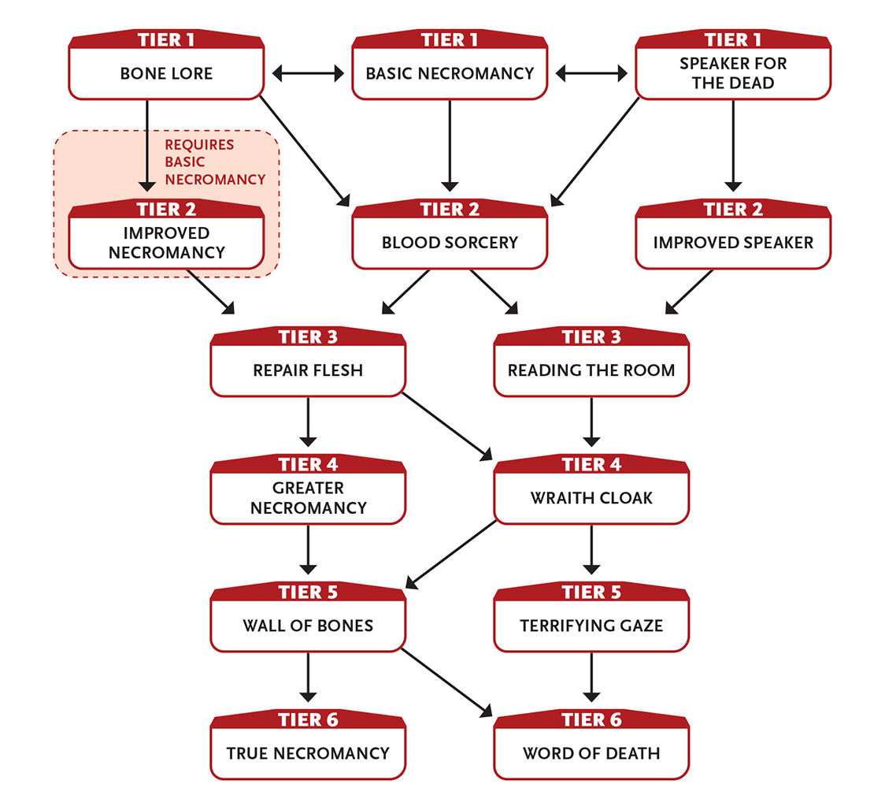

Tier 1
Basic Necromancy (3 Intellect): You animate the body of a dead creature of approximately your size or smaller within immediate range, creating a level 1 follower that is an undead creature. It has none of the intelligence, memories, or special abilities that it had in life. The creature follows your verbal commands until you use a one-hour or longer recovery, at which point it becomes an inert corpse. You can reanimate it again when it becomes inert or if it is “killed” by damage (though you may have to spend a few minutes with a needle and thread to reattach detached or loose parts).
Last action to animate.
Bone Lore (1 Intellect): With a touch, you ascertain the cause of death of a corpse, how long since its death, and its species when it was alive. Last action.
Speaker for the Dead (2 Intellect): You touch a corpse of a dead being and ask it a question. It can’t answer questions that it wouldn’t have understood in life, and it can’t provide answers that it wouldn’t have known in life.
The dead being is not compelled to answer you at all, so you might need to interact with it in a way that would have convinced it to answer while it was alive. For example, you might promise to give the corpse a proper burial, avenge their death, or carry a message to someone they knew when they were alive. This probably requires an interaction roll (typically charm or intimidation).
Action.

Tier 2
Blood Sorcery: You draw upon your own blood, spirit, or life energy to power your abilities. You take a moderate wound and add +1 Edge to the Pool of your choice while you retain that wound. Enabler.
Only one +1 Edge can be gained at a time using Blood Sorcery.
Improved Necromancy: You can use Basic Necromancy to animate multiple bodies at the same time. Each animated creature beyond the first costs 1 additional Intellect point (so 4 points for two bodies, 5 points for three, and so on).
Your range for Basic Necromancy (including when animating multiple bodies) increases to short.
Improved Speaker: When using Speaker for the Dead, for each additional Intellect point you spend beyond the initial ability cost, you can ask one additional question. Enabler.

Tier 3
Reading the Room (3 Intellect): You gain knowledge about an area by speaking with dead spirits or their residual energies.
You may ask the GM one question, which must be simple and matter-of-fact. You must succeed at an Intellect roll against the difficulty of the question, as set by the GM. “What killed the cattle in this barn?” is a good example of a simple question. “Why were these cattle killed?” is not an appropriate question because it has more to do with the mindset of the killer than the barn. Simple questions usually have a difficulty of 2, but extremely technical questions or those that involve facts meant to be kept secret can have a much higher difficulty.
Action.
Repair Flesh (3 Intellect): You can knit back together damaged flesh with a touch.
You can reduce a wound by one severity: major to moderate, moderate to minor, or minor to none.
Instead of curing a wound, you can enhance a character’s next recovery by +2 Pool points.
If used on a living or undead NPC, you restore 3 health.
Action.

Tier 4
Greater Necromancy (5+ Intellect): You animate the body of a dead creature up to twice your size within short range, creating a level 3 follower that is an undead creature. It has none of the intelligence, memories, or special abilities that it had in life. The creature follows your verbal commands until you use a one-hour or longer recovery, at which time it becomes an inert corpse. You can reanimate it again when it becomes inert, or if it is “killed” by damage (though you may have to spend some time with a needle and thread to reattach detached or loose parts).
Each animated creature beyond the first costs 2 additional Intellect points (so 7 points for two bodies, 9 points for three, and so on).
Action to animate.
Wraith Cloak (4 Intellect): At your command, a nearby undead spirit wraps itself around you until you use a ten-minute or longer recovery. The spirit is empowered during this period, automatically inflicting 4 damage (no roll required) to anyone who tries to touch you or strike you with a melee attack. While the wraith cloak is active, all your stealth tasks are eased. Enabler.

Tier 5
Terrifying Gaze (6 Intellect): You project a fearsome gaze at up to five living creatures within short range who can see you. Make a separate Intellect attack roll for each creature. Success means that the creature is frozen in fear, not moving or taking actions until you use a ten‑minute or longer recovery, they are attacked, or you leave their field of view. Some creatures without minds (such as slime monsters or animated statues) might be immune to Terrifying Gaze. Action.
Wall of Bones (5 Intellect): You create a barrier of bones tainted with undeath composed of four 10-foot by 10-foot (3.5 m by 3.5 m) squares, each 1 inch (2.5 cm) thick, arranged as you wish. The wall is a level 5 barrier. One or both sides emanate necrotic energy; anyone within immediate distance of such a side takes 5 damage (no rolls required) or double that if they pass through. The wall lasts until you use a ten-minute or longer recovery. Action to create.

Tier 6
True Necromancy (8+ Intellect): You animate the body of a dead creature up to twice your size within short range, creating a level 5 follower that is an undead creature. It has none of the intelligence, memories, or special abilities that it had in life. The creature follows your verbal commands until you use a one-hour or longer recovery, at which time it becomes an inert corpse. You can reanimate it again when it becomes inert or if it is “killed” by damage (though you may have to spend some time with a needle and thread to reattach detached or loose parts).
Each animated creature beyond the first costs 3 additional Intellect points (so 11 points for two bodies, 14 points for three, and so on).
Action to animate.
Word of Death (6 Intellect): You speak a magic word so potent that it can instantly kill a foe. Make an Intellect attack against a foe within short range. If you succeed, you inflict 10 damage. Action.

Controls Beasts
Your ability to communicate and lead beasts is uncanny.
- Genre themes: druid or ranger (fantasy), animal telepath (real world, science fiction, superhero)
- GM intrusions: The community is reluctant to welcome dangerous animals. Out-of-control beasts become a hazard.
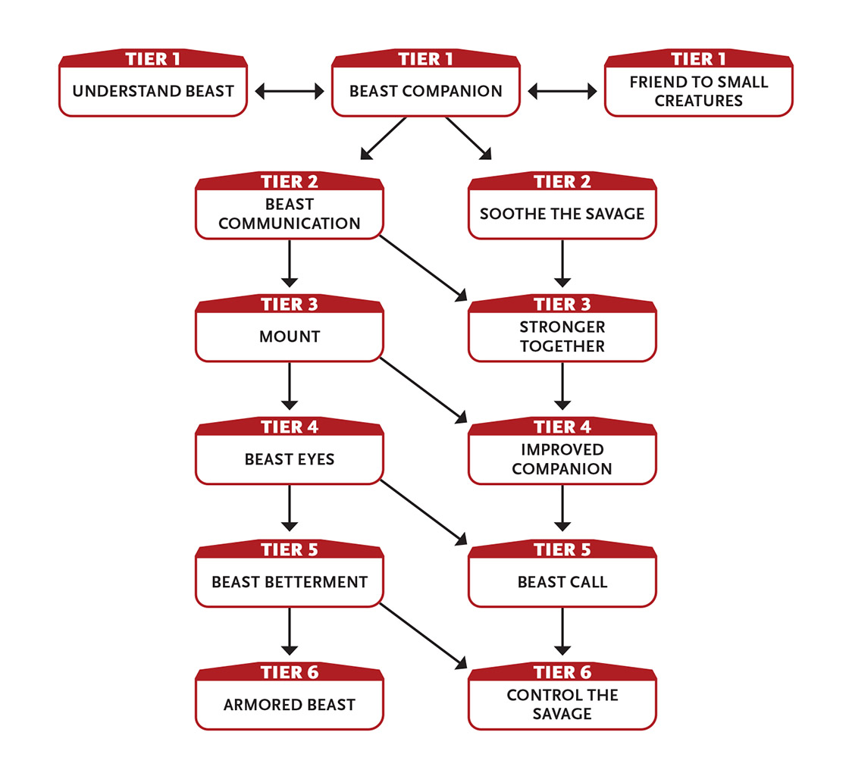

Tier 1
Beast Companion: You gain a follower that is a level 2 beast of your size or smaller that accompanies you and follows your instructions. You and the GM must work out the appearance and personality of your beast. Its movement is based on its creature type (avian, swimmer, and so on).
If your beast companion dies, you can use your resources hunting in the wild for a few days to locate and befriend a new one.
Beast Companion, as part of the Controls Beasts focus, can be taken multiple times. Each time, you gain another level 2 beast follower.
Friend to Small Creatures (1+ Intellect): A broad type of small creature you name that exists in the surrounding environment (such as insects, rats, bats, or birds) comes under your influence if you succeed on a difficulty 2 Intellect task for outdoor survival. Affected creatures within short range will not harm you or those you designate as allies until you use a ten-minute or longer recovery.
This ability doesn’t work against hostile swarms of creatures of level 3 or higher. Your creatures—even common insects (level 0)—can swarm in large-enough numbers to hinder the attacks or defenses of a single target, or take some other action.
This ability could instead be used to calm or command vines, grass blades, creepers, roots, or branches of nearby plants rather than animals or insects.
Effort: Your creatures respond to your commands as NPC allies.
Action to initiate.
Understand Beast (2 Intellect): You sense the level, the nature, and any special abilities of a nonhuman creature within immediate range. Last action.
The GM has final say over what counts as a nonhuman beast. Unless some kind of deception is at work, you should know whether you can affect a creature before you attempt to use Soothe the Savage on them. Aliens, extradimensional entities, very intelligent creatures, and robots never count.

Tier 2
Beast Communication (2 Intellect): You can convey a basic concept to a creature that normally can’t speak or understand speech. The creature can also give you a very basic answer to a simple question. Action.
Soothe the Savage (2 Intellect): Make an Intellect attack roll to calm a nonhuman beast within short range that can see you. You must speak to them (although they don’t need to understand your words). They remain calm until you use a ten-minute or longer recovery or for as long as you keep using your action to calm them. Action.

Tier 3
Mount: You gain a follower that is a level 3 beast who serves you as a mount. You and the GM must work out the appearance and personality of your beast. Its movement is based on its creature type (avian, swimmer, and so on).
Instead of gaining a new creature as your mount, your beast companion can become your mount (this may involve a growth spurt), increasing their level to 3, in which case you gain a different level 2 beast companion.
While riding your mount, on your turn they can move and you can make an attack, and you gain an asset on the attack. (This is a special exception to how followers normally can aid your attack.)
Any focus ability you have that affects your beast companion (such as Beast Eyes or Improved Companion) can instead affect your mount (your choice).
If your mount dies, you can use your resources hunting in the wild for about a week to locate and train a new one.
Stronger Together: When you and your beast companion (or a beast you’ve calmed with Soothe the Savage) are within immediate distance of each other, you inflict an additional 2 damage when you attack and both of you gain an asset to defense tasks. Enabler.

Tier 4
Beast Eyes (3 Intellect): You link your mind to your beast companion (or a beast you’ve calmed with Soothe the Savage, if they remain well disposed toward you), perceiving through their senses if they are within 1 mile (1.6 km) of you. This ability lasts until you use a ten-minute or longer recovery. Action to initiate.
Improved Companion: Increase the level of your beast companion (and their modifiers, if any) by 1. You can select this ability up to three times. Each additional time you select it, increase your beast’s level by 1.

Tier 5
Beast Betterment: When you take a recovery within immediate range of your beast companion, you gain an additional 3 Pool points. Enabler.
Beast Call (5 Intellect): You temporarily summon one level 4 beast or a horde of small beasts (who together function as a level 4 creature) to help you. The beast or beasts do your bidding for as long as you focus your attention, but you must use your action each turn to direct them. The beasts are native to the area and arrive under their own power, so if you’re in an unreachable place, this ability won’t work. Action.

Tier 6
Armored Beast: Your beast’s Armor increases by 2.
Control the Savage (6 Intellect): Make an Intellect attack roll to control a calm nonhuman beast within short range. You control it as long as you use your action each round to concentrate on the target. Action.

Crafts Illusions
You fashion images from light that are so perfect they seem real.
- Genre themes: illusionist (fantasy), hologram artist (science fiction, superhero)
- GM intrusions: The illusion isn’t believable. The illusion is pierced at just the wrong moment.
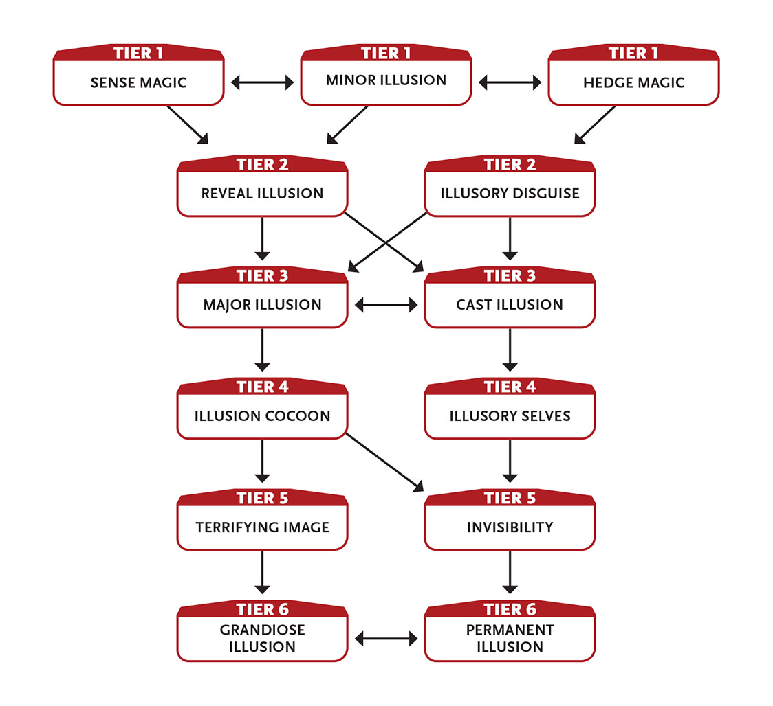

Tier 1
Hedge Magic (1 Intellect): You can perform small tricks: temporarily change the color or basic appearance of a small object, cause small objects to float through the air, clean a small area, mend a broken object, prepare (but not create) food, and so on. You can’t use Hedge Magic to harm another creature or object. Action.
Minor Illusion (1 Intellect): You create a single image of a creature or object within immediate range. The image must fit within an immediate area. The image can move (for example, you could make the illusion of a person walk or attack), but it can’t leave the area. The illusion includes sound but not smell. It lasts until you use a ten-minute or longer recovery, but if you want to change the original illusion significantly—such as making a creature appear to be wounded—you must use an action to concentrate on it again. If you move out of range, the illusion vanishes.
Instead of a realistic illusion, you can create a confusing pattern of images around a creature within short range. As long as you use your action to change this pattern, you hinder the creature’s attacks and defenses (no attack roll needed to affect them).
Action to create; action to modify.
You usually don’t have to make a roll against a casual observer to get them to believe your illusion is real, but you probably do if they’re doubtful or searching for unusual details. An observer who recognizes something as an illusion can ignore it, but it can still distract them and interfere with what they can see.
Sense Magic (1 Intellect): If there is magic of any kind at work within short range, you are aware of that fact (but not the specifics). Last action.

Tier 2
Illusory Disguise (2+ Intellect): You appear to be someone or something else, roughly of your size and shape, until you use a one-hour or longer recovery. Once created, the disguise requires no concentration.
Effort: Disguise one additional creature (1 Intellect); if you lose sight of a disguised creature, they lose their disguise.
Action.
Reveal Illusion (2+ Intellect): When you roll to find an illusion or invisible target within short range and your roll is less than a 12, treat the roll as a 12. (This means you don’t get a GM intrusion if you roll a 1.) This ability lasts until you use a ten‑minute or longer recovery. Action to initiate.
Effort: Increase the minimum number rolled for this ability by 3.
At tier 3: The minimum number rolled for this ability increases to 15.

Tier 3
Cast Illusion: Your immediate-range illusions (such as Minor Illusion, Major Illusion, and Grandiose Illusion) increase to short range.
Disguises created by your Illusory Disguise last about a minute after the disguised creatures move out of your sight.
Major Illusion (3+ Intellect): You create a complex scene of images within immediate range. The entire scene must fit within a long area. The images can move, but they can’t leave the area. The illusion includes sound and smell. It lasts until you use a ten-minute or longer recovery and changes as you direct (no concentration is needed). If you move beyond immediate range of the illusion’s edge, the illusion vanishes.
Instead of a realistic illusion, you can create illusory confusing images around a creature within short range, hindering their attacks and defenses until you use a ten-minute or longer recovery (no attack roll needed to affect them). You do not need to use your action each round to maintain this effect.
Effort: Affect an additional creature with confusing images.
Action to create.

Tier 4
Illusion Cocoon (4 Intellect): With a successful Intellect attack, you wrap a target within long range in a full-sensory illusion so all‑encompassing that they are helpless, losing their turn each round until you use a ten-minute or longer recovery, or until they take direct physical damage. Action.
Illusory Selves (4 Intellect): You create four illusions of yourself within short range. These each last until you use a ten-minute or longer recovery. You mentally direct their actions; they aren’t mirror images, and each one can do different things. If an image is struck violently, you choose whether it freezes motionless or disappears permanently. Action to initiate.

Tier 5
Invisibility (4+ Intellect): You become invisible. This effect ends if you do something to reveal your presence or position—attacking, using an ability, moving a large object, and so on—or if you use a ten-minute or longer recovery.
Effort: Use this ability on a creature you touch instead of yourself; they remain invisible until they act precipitously or they or you use a ten‑minute or longer recovery.
Action to initiate.
An invisible character’s attack is eased by two steps. Attacks on an invisible character are hindered by four steps or are nearly impossible if the attacker has no idea where they might be.

Terrifying Image (6 Intellect): You can terrify foes with illusions created from their own fears. Make separate Intellect attacks against up to five creatures within long range. Success means a creature flees in terror, pursued by their nightmares until they’ve fled at least a very long distance or you use a ten-minute or longer recovery. Failure means the creature ignores the images, which do not hamper them in any way. Action.

Tier 6
Grandiose Illusion (8 Intellect): You create a fantastically complex scene of images that fit within a 1-mile (1.6 km) cube, the nearest edge of which must be within immediate range of you. You must be able to see the images when you create them. The images can move in the cube and act in accordance with your desires. They can also act logically (such as reacting appropriately to fire or attacks) when you aren’t directly observing them. The illusion includes sound and smell. For example, armies can clash in battle, with air support from machines or flying creatures, on and above terrain of your creation. The illusion lasts until you stop concentrating on it or you use a one-hour or longer recovery. Last action to initiate.
Permanent Illusion (9 Intellect): You make one of your ongoing illusions permanent. Choose an illusion (or portion of an illusion) that you created. The illusion must fit within an immediate area and remains in that area. The illusion is permanent, persisting on its own without your attention or presence. You can permanently end the illusion as an action, but anyone else who wants to end it must expend exceptional ingenuity to prevent it from regenerating after a while. Enabler.

Doesn’t Do Much
You’re a slacker, but you know a little about a lot of things.
- Genre themes: Free spirit, itinerant (any genre)
- GM intrusions: New situations are confounding and stressful. Past actions (or inactions) come back to haunt the character.\
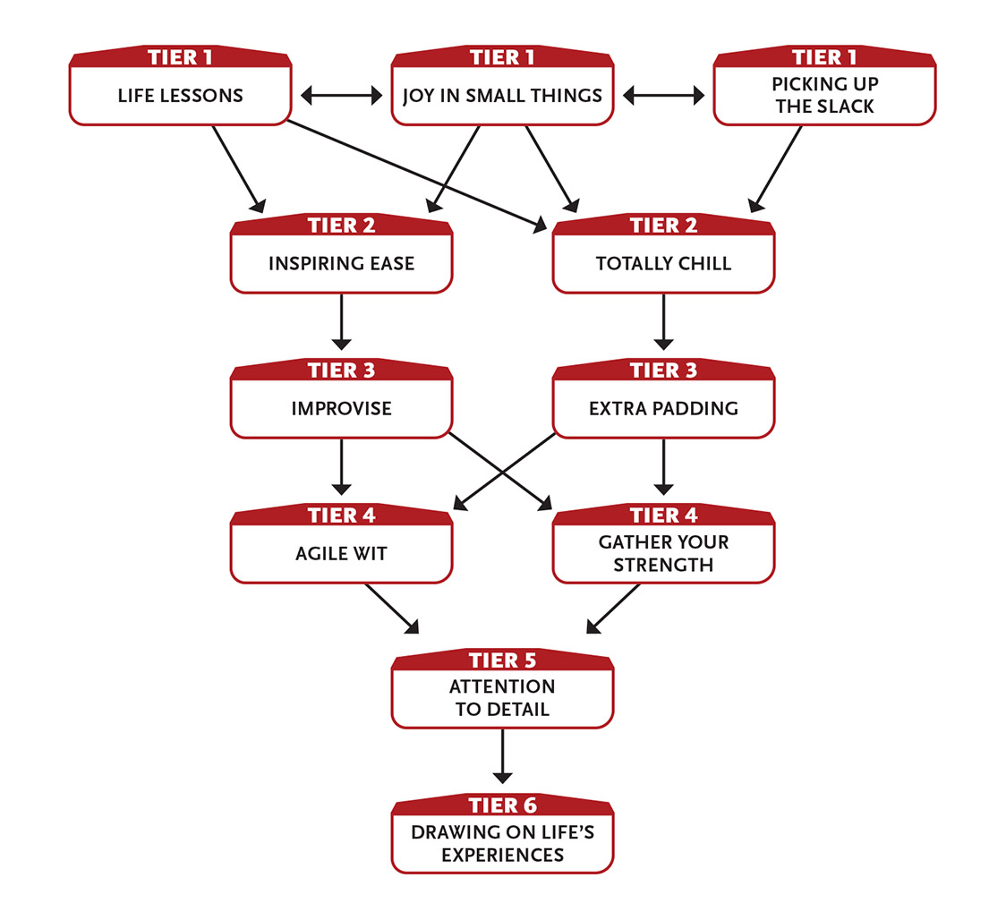

Tier 1
Joy in Small Things: When you learn or figure out something important (as determined by your GM), you regain 4 points to your Intellect Pool. Each use of this ability after the first time restores 1 fewer Pool point; this renews after you take a ten-hour recovery. Enabler.
Life Lessons: You’ve learned a little of this and that, and you have a knack for getting things done. Choose any two noncombat skills. When you use Effort on either of those skills, you can apply a free level of Effort. Enabler.
Picking Up the Slack (1 Intellect): You can fill in for a skilled ally when they’re unable to perform a specific task. If an ally within long range is trained (or more) in a skill but can’t attempt the task (such as if there’s a lock to be picked, but the skilled ally is unconscious or too far away), you gain an asset on that task. You cannot use this ability if you are trained (or better) in that skill. Enabler.

Tier 2
Inspiring Ease: Through stories, songs, art, or other forms of entertainment, you inspire your allies. When you and any number of allies spend a ten‑hour recovery together (yours or theirs), the allies are inspired by you. Once per day, each inspired ally can ease one task. This inspiration remains while you remain within a long distance of them. The inspiration is suspended at greater distances, but resumes automatically if you get within range. The inspiration ends if you use a ten‑hour recovery while away from the ally. Ten‑hour recovery to initiate.
Totally Chill: Your ten-minute recovery takes you only one action, and your hour-long recovery takes ten minutes.

Tier 3
Extra Padding (1+ Might): You carry around a little more weight than most—maybe muscle, maybe fat, or a mix of both. This extra padding provides extra protection from physical threats, allowing you to ignore a minor wound you just took (do not mark the wound on your character sheet).
This ability renews after your ten-hour recovery.
Effort: Ignore a moderate wound instead of a minor wound. Ignore a major wound instead of a minor wound (this requires two levels of Effort).
Enabler.
Improvise: (3 Intellect): If you aren’t trained in a task, you can improvise to gain an asset on that task—a tool you cobble together, sudden insight, or just dumb luck. The asset lasts until you use a ten-minute or longer recovery. Enabler.

Tier 4
Agile Wit: When attempting a Speed task, you can spend points from your Intellect Pool instead of your Speed Pool, and vice versa. Use the Edge stat for the Pool you’re spending points from.
Gather Your Strength: Your attack this round deals an additional 2 damage if you make it as a Last action instead of as an action or a First action. Enabler.

Tier 5
Attention to Detail: Your task this round (other than an attack) has an asset if you attempt it as a Last action instead of an action or First action. Enabler.

Tier 6
Drawing on Life’s Experiences (6 Intellect): You’ve seen a lot and done a lot, and that experience comes in handy. Ask the GM one question, and you’ll receive a general answer. The GM assigns a level to the question, so the more obscure the answer, the more difficult the task. Generally, knowledge that you could find by looking somewhere other than your current location is level 1, and obscure knowledge of the past is level 7. Action.

Employs Magnetism
You command metal and the power of magnetism.
- Genre themes: iron mage (fantasy), asteroid miner (science fiction), energy-wielder (superhero)
- GM intrusions: The metal twists, bends, or produces shrapnel. A lapse in concentration might cause something to slip or drop at just the wrong time.
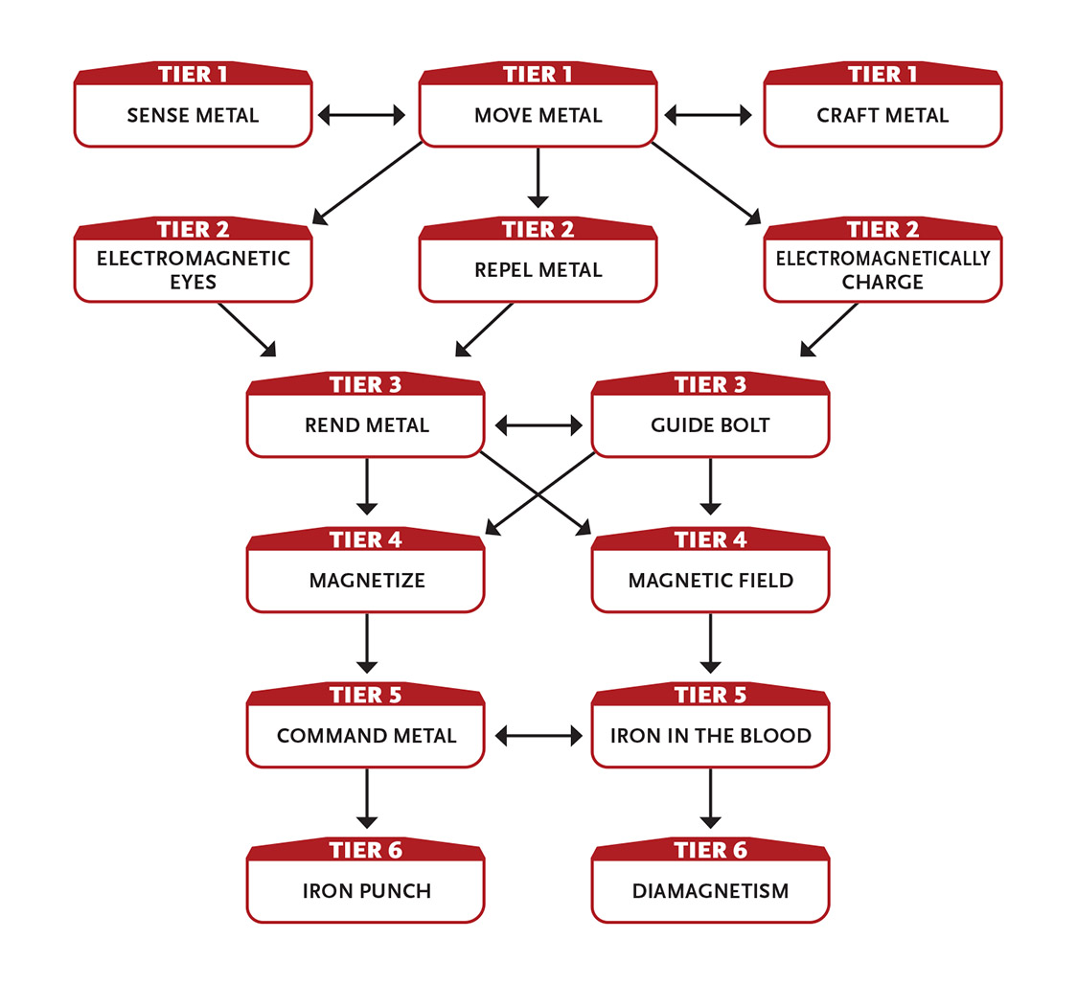

Tier 1
Craft Metal: You can manipulate metal easily, allowing you to craft metal objects without heat. You also gain an asset to all tasks involving crafting metal.
Move Metal (1 Intellect): Until you use a one-hour or longer recovery, you can exert force on metal objects within short range as your action. Each use of this ability requires an action, allowing you to move an object at a distance if it contains metal or is made of metal. You can only move or manipulate an object if you could physically do so with your own hands. For example, you could lift and pull a light metal object anywhere within range to yourself or move a heavy object (like a piece of furniture) an immediate distance. This power lacks the fine control to wield a weapon or move objects with much speed, so in most situations, it’s not a means of direct attack; however, you could pull a metallic object from another creature’s grasp, push a creature in metallic armor an immediate distance, or hinder a creature’s attack or defense by applying restraining pressure to an armored leg or arm or to a metallic weapon. Affecting an unwilling creature or their equipment requires an Intellect attack roll.
You can use your action to create a magnetic disruption within short range, hindering electronic devices, electronic machines, and machine creatures (such as robots) by two steps for one round.
Action to initiate; action to move metal or disrupt electronics.
Sense Metal (1 Intellect): If there is ferromagnetic metal of any kind within short range, you are aware of that fact, as well as the amount, type, and general location. Last action.

Tier 2
Electromagnetic Eyes (2 Intellect): You sense your environment using the electromagnetic fields that invisibly fill most locations—invisible to others, but not to you. You can “see” up to long range even in complete darkness, and you have an asset on perception tasks related to noticing hiding living creatures (which have their own electromagnetic fields) as well as metal and magnetic objects and powered devices. You can see otherwise invisible creatures normally.
You always know which way is north (assuming you’re on a planet with magnetic poles).
This ability lasts until you use a ten-minute or longer recovery.
Action to initiate.
Electromagnetically Charge (1+ Intellect): You gather energy from the electromagnetic fields that invisibly fill most locations, then use it to heal yourself, reducing the severity of one of your wounds. You are healed of a minor wound, reduce a moderate wound to a minor wound, or reduce a major wound to a moderate wound.
Alternatively, you can use this ability to restore charge to a mundane handheld device, such as a cell phone or small radio, that uses electricity and has lost its charge or whose batteries have been exhausted.
Each time you use this ability, the Intellect point cost increases by 1. The cost returns to 1 after you take a recovery.
Last action.
Repel Metal: By manipulating magnetism, you have an asset to block and dodge rolls against attacks that include metal, such as bullets, thrown knives, metal-tipped arrows and crossbow bolts, and so on.

Tier 3
Guide Bolt (3+ Intellect): When you make an attack with metallic ammunition—including bullets, thrown knives, metallic bolts, or metal-tipped arrows—on a target within short range, you can improve the attack’s aim and velocity, which grants an asset to the attack and inflicts an additional 3 damage. You can use this ability only once per round.
Effort: Affect an ally’s attack instead of your own if their attack passes within short range.
Enabler.
Rend Metal (3+ Intellect): You instantly tear, rip, or burst a metal object of up to level 3 that is within short range. You must be able to see the object and it can’t be bigger than half your size (or, if part of a larger object like a wall, a section that is no bigger than half your size). The affected object is destroyed; optionally, it also expels shrapnel, inflicting 1 damage per level on all creatures in immediate range (make separate Intellect attack rolls).
Affecting an unwilling creature’s equipment requires an Intellect attack roll, but the roll is eased by two steps.
Effort: Increase the maximum level of the metal object you can affect by 1.
Action.

Tier 4
Magnetic Field (5 Intellect): A field of magnetism around you pulls incoming, ranged, metallic projectile attacks (such as arrows, bullets, a thrown metal knife, and so on) to the ground. It also disperses energy attacks such as electricity, x-rays, lasers, and other attacks that are part of the electromagnetic spectrum. You are immune to such attacks for one round. You must be aware of an attack to foil it. Enabler.
Magnetize (4+ Intellect): Your touch permanently magnetizes an object (regardless of whether it is metallic) no larger than you with a level 5 magnetic force, or demagnetizes an object no larger than you whose magnetic force is level 5 or less. A magnetized object attracts metal brought within 1 foot (30 cm) of it. Pulling the metal away requires a successful Might task. Magnetizing or demagnetizing electronic equipment destroys it if its level is 5 or less. You can use magnetic abilities (such as Move Metal and Command Metal) on a magnetized object.
Alternatively, you can create a magnetic field that repels metal objects of level 3 or less (in effect, this is much like a force field that only affects metal things).
Effort: Increase the level of a new magnetic force by 1. Increase the maximum level of an existing magnetic force you want to demagnetize by 1.
Action.

Tier 5
Command Metal (5 Intellect): You reshape a metallic object you can see in short range as you desire. The item’s mass can be no greater than your own. You can affect multiple items at once as long as their combined mass does not exceed yours. You can fuse multiple items together. You can use this power to destroy a metal object (as the Rend Metal ability), or you can craft it into another desired shape (crudely, unless you succeed on a sculpting or crafting task). You can then move the new object anywhere within range. For example, you could take a few metal shields or panels, fuse them together, and use the resulting shape to block a doorway.
You can use this ability to attack one target within short range, causing a foe’s armor to constrict, rendering a metal item into shards that you fling across the battlefield, and so on. Regardless of the form of the attack, it is an Intellect attack that deals 7 damage.
Last action; action to attack.
Iron in the Blood: You have honed your magnetic senses, allowing you to sense and manipulate the trace amounts of iron in flesh and blood. You can now move creatures with Move Metal and attack them directly with Rend Metal (inflicting 5 damage with a successful attack) and Command Metal (inflicting 7 damage), although your Intellect attack is hindered when doing so.

Tier 6
Diamagnetism: You magnetize any nonmetallic object within short range so that it can be affected by your other magnetic powers, as if using Magnetize at range and on the fly (to permanently magnetize an object, you must spend Intellect as noted for Magnetize). Therefore, with Move Metal, you can move any object you can see. With Repel Metal, you have an asset to all block and dodge rolls, regardless of whether the incoming attack uses metal (even pure energy attacks bend slightly to your will). And so on.
Iron Punch (8+ Intellect): You magnetically pick up a heavy metallic object within short range and hurl it at a target within short range. With a successful Intellect attack, you deal 10 damage to the target and the object.
Effort: Affect an additional target that is adjacent to the first target.
Action.
Diamagnetism supersedes Magnetize, so if you have both, you can exchange Magnetize for another equal or lower-tier ability from this focus.

Entertains
You perform, mostly for the benefit of others.
- Genre themes: bard (fantasy, historical), entertainer (historical, real world, science fiction)
- GM intrusions: The audience is annoyed or offended. Musical instruments break. Paints dry in their pots. The words to a poem or song are forgotten.
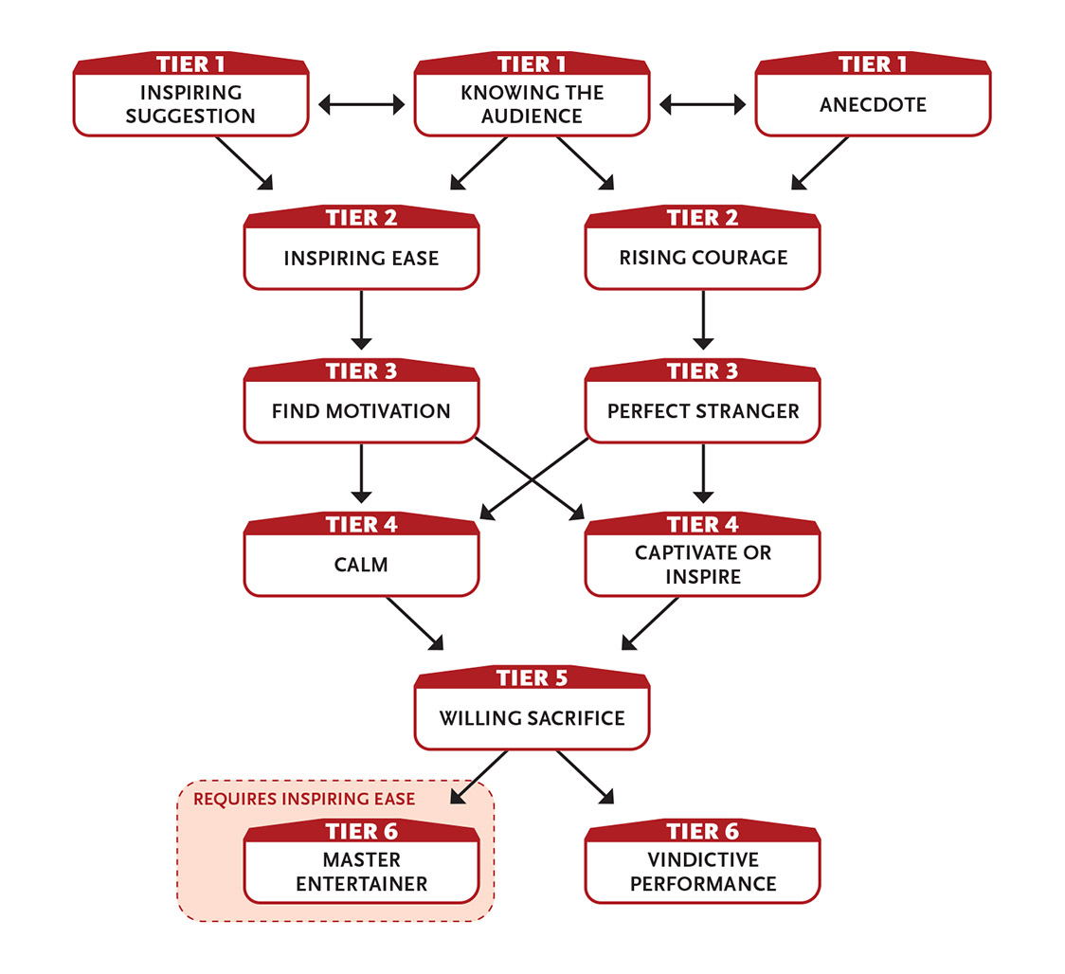

Tier 1
Anecdote (2 Intellect): You can lift the spirits of a group of creatures and help them bond together by entertaining them with an uplifting or pointed anecdote. Choose one task (other than an attack or defense task) related to your anecdote. Until you use a one-hour or longer recovery, those who pay attention to your story are trained in that task.
Alternatively, you can spend time interacting with a group of people within short range. As long as they are at least neutral toward you (rather than hostile), they become friendly toward you until you use a one-hour or longer recovery.
Action to initiate; one minute to complete.
Inspiring Suggestion (2 Intellect): When you make a helpful suggestion to an ally, they have a better chance of succeeding at what they’re doing. Choose an ally who can see and understand you, then suggest a specific action for them to take, such as “attack the leader” or “climb the wall.” If the ally chooses to take that exact action, they gain two assets on that task. First action.
Knowing the Audience (1 Intellect): You ascertain the general mood of a group of people within short range. If they are trying to conceal that information, you may attempt a difficulty 3 task to learn the truth of their attitude. On the following round, you also gain an asset to a single recognizing motive task regarding one person in that group to gain more detail and information about that individual. Last action.

Tier 2
Inspiring Ease: Through stories, songs, art, or other forms of entertainment, you inspire your allies. When you and any number of allies spend a ten-hour recovery together (yours or theirs), the allies are inspired by you. Once per day, each inspired ally can ease one task. This inspiration remains while you remain within a long distance of them. The inspiration is suspended at greater distances, but resumes automatically if you get within range. The inspiration ends if you use a ten‑hour recovery while away from the ally. Ten‑hour recovery to initiate.
Rising Courage (2 Intellect): A target you choose within immediate range has an asset to their next Intellect defense task and next initiative task. Enabler.

Tier 3
Find Motivation (3+ Intellect): When your mind would be negatively affected by an effect of level 4 or less (psychic commands, illness, fear, boredom, mind control, and so on), you can ignore the effect. If the effect lasts for a while (such as fear or mind control), it has no power over you until you use a ten-minute or longer recovery. If the effect is instantaneous (such as a psychic blast that inflicts damage), it doesn’t affect you at all.
Effort: Increase the maximum effect level you can ignore by 1.
Enabler.
Perfect Stranger (3 Intellect): You completely throw yourself into a role, becoming almost unrecognizable until you use a one-hour or longer recovery. This often involves altering your voice, posture, accent, or clothing to “sell” this new guise.
All tasks to pretend to be someone other than yourself are eased. Three times while this ability is active, if you use Effort on an interaction or knowledge task related to this role, you gain a free level of Effort.
Action to initiate.

Tier 4
Calm (3 Intellect): If you succeed on an Intellect attack against a living foe who can see and hear you, you prevent them from attacking anyone or anything for one round by way of your jokes, song, or other performance. Action.
Captivate or Inspire: You can use this ability in one of two ways.
Captivate: Your words keep the attention of all NPCs in immediate range that hear them for as long as you speak, if you succeed on a persuasion, deception, or intimidation skill roll against a difficulty level equal to the highest level of an NPC in the crowd.
Inspire: Your words inspire all NPCs that hear them, allowing them to perform tasks as if one level higher until you use a one-hour or longer recovery.
In either case, you choose which NPCs are affected. If anyone in the crowd is attacked while you’re trying to speak to them, you lose the crowd’s attention.
Action to initiate.

Tier 5
Willing Sacrifice: When you successfully draw the attack or take the attack meant for another character and you fail to dodge or block the attack, reduce the severity of the attack’s wound by one step (major to moderate, moderate to minor, minor to none).
You can draw or take more than one attack in a given round if all of the attacks were meant for one target.
Enabler.

Tier 6
Master Entertainer: Your allies affected by Inspiring Ease can ease a second task each day, or ease one task by two steps instead of just one.
Vindictive Performance (5 Intellect): When you tell a joke, perform a song or poem, draw a picture, relate an anecdote, or otherwise provide entertainment, you can select one creature within short range who is able to understand you. During your performance, you heap indirect but biting derision on this creature. If you succeed, the creature doesn’t realize that they’ve become the victim of your performance until you wrap up the entertainment at a moment you choose in a way that strikes home. The creature takes 6 Intellect damage (ignores armor) and loses their next turn. One or more actions to initiate.

Explores
You love discovering and exploring new locations, whether a tranquil valley, a dangerous wasteland, or a forbidding planet—and you have the necessary skills to survive and thrive in those places.
- Genre themes: druid or ranger (fantasy), survivor (postapocalypse, science fiction), planetary explorer (science fiction)
- GM intrusions: Maps get lost. An important detail is overlooked. An NPC disparages the character for being ignorant or uncivilized.
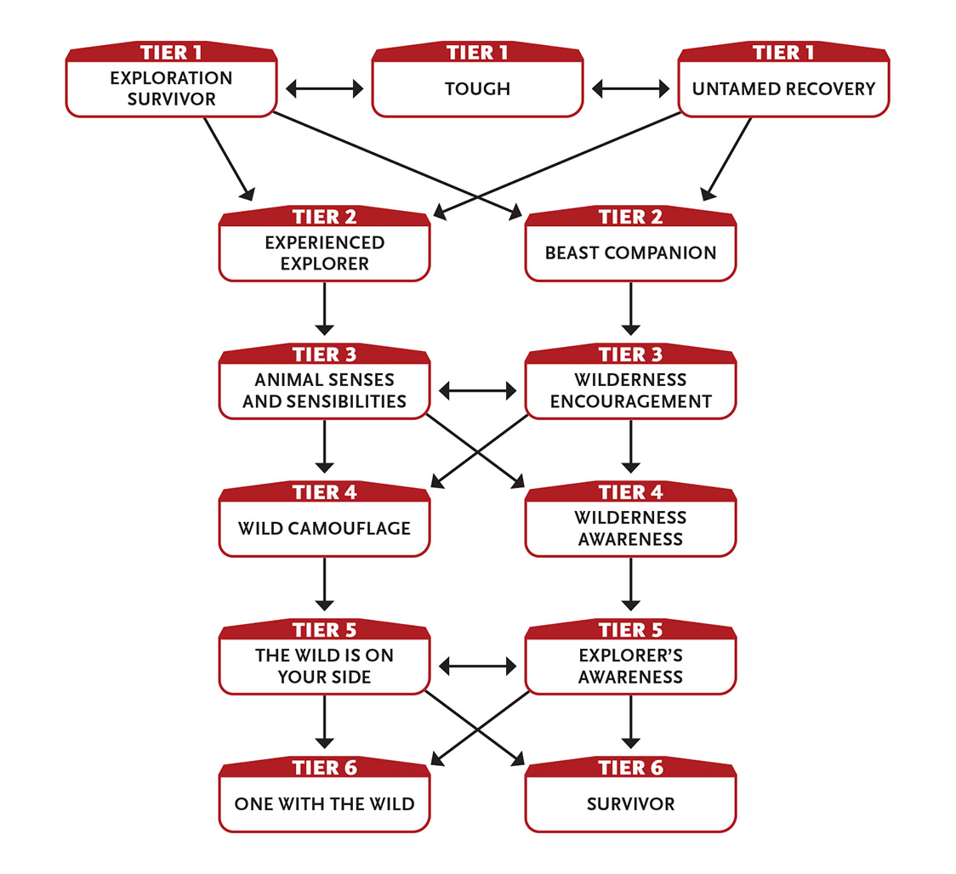

Tier 1
Exploration Survivor: You know how to survive in new and strange locations. After spending at least ten minutes in a region and succeeding on a outdoor survival task (generally difficulty 2, or whatever the GM determines is appropriate to the area), you find something useful you were seeking. The useful thing might be shelter in the form of a cave or tree hollow, materials to start a fire, fresh water, a game animal you bring down with ease, edible plants and fungi, or something to counteract a bleeding wound or poison.
You are able to feed yourself and five allies for as long as you remain in this region.
Once you’ve been to a notable location within a region (such as your campsite or a prominent landmark), you know the general direction and distance to it from where you are right now.
Enabler.
Tough: You can take an additional minor wound.
Untamed Recovery: You gain an extra one-action recovery each day.

Tier 2
Beast Companion: You gain a follower that is a level 2 beast of your size or smaller that accompanies you and follows your instructions. You and the GM must work out the appearance and personality of your beast. Its movement is based on its creature type (avian, swimmer, and so on).
If your beast companion dies, you can use your resources hunting in the wild for a few days to locate and befriend a new one.
Experienced Explorer: Your experience with creatures, plants, and substances in various regions gives you some additional protection against them. Your defense rolls against poison are eased and you reduce wounds from poison by one step (major to moderate, moderate to minor, minor to none). For example, if you are bitten by a snake whose poison inflicts a moderate wound, you take only a minor wound from the poison.
You are immune to natural diseases.
When in the wild, natural effects such as tall grass, thick brush, rugged terrain, landslides, and bad weather do not hinder you or slow your movement, and any wounds from them are reduced by one step.
Finally, you can find edible food and potable water in the wilderness, enough to feed yourself and a few other people, if given an hour or so to explore.

Tier 3
Animal Senses and Sensibilities: Most of the time, if you’re about to walk into an ambush or a trap that is level 4 or lower, the GM should alert you (though depending on the circumstances, you may not have time to warn your companions).
Even if you are unaware of an incoming attack, the attacker doesn’t gain any advantage against you, such as from surprise.
Wilderness Encouragement (3 Intellect): Your knowledge and experience allow you to help others rest and recover. While in the wilderness or when talking about your time in the wilderness, choose one ally within short range who can understand you (you can choose yourself). The ally can immediately make an extra one-action recovery or remove a moderate wound. You can’t use this ability on the same creature again until they’ve used one of their own recoveries. Action.

Tier 4
Wild Camouflage (4 Intellect): By adjusting your clothing, using various disguise tricks, and drawing upon your deep knowledge of your surroundings, you are hard to make out in the wilderness until you use a ten-minute or longer recovery. While you are camouflaged, you gain two assets to dodge and stealth. This effect ends early if you do something to reveal your presence or position—attacking, using a special ability with an obvious effect, moving a large object, and so on. Action.
Wilderness Awareness (4 Intellect): Your connection to the natural world extends to a degree that some would call supernatural. While in the wilderness, you can extend your senses 1 mile (1.6 km) in any direction and ask the GM a very simple, general question about that area, such as “Where is the enemy camp?” or “Is my friend Deithan still alive?” or “Where’s the most poisonous thing I could find?” If the answer you seek is not in the area, you receive no information. Action.

Tier 5
Explorer’s Awareness: You’re instinctively vigilant about potential threats, foes, obstacles, and hazards in your line of sight. When you use Effort on initiative and perception tasks, you gain two free levels of Effort. Enabler.
The Wild Is on Your Side (5 Intellect): Nature itself intervenes against your foes within short range. Until you use a ten-minute or longer recovery, rocks trip them, vines entangle them, insects bite them, small animals distract or confuse them, and so on, hindering all their tasks. You can only use this ability when in a wilderness environment. Enabler.

Tier 6
One With the Wild (6 Intellect): You and your allies gain an unusual connection to the wilderness within long range until you use a one-hour or longer recovery. This has three effects:
- Natural animals and plants in the area will not knowingly harm you or your allies.
- You and your allies increase their Might Edge, Speed Edge, and Intellect Edge by 1.
- Any recoveries made during this period restore twice as many points.
Action to initiate.
Survivor: If you have a minor or moderate wound, you can rally without using any Might points. This ability renews each time you take a recovery. Enabler.

Fights Dirty
You’ll do anything to win a fight: bite, scratch, kick, trick, and worse.
- Genre themes: troublemaker, loner (any genre)
- GM intrusions: People look poorly upon those who cheat or fight without honor. Sometimes a dirty trick backfires.
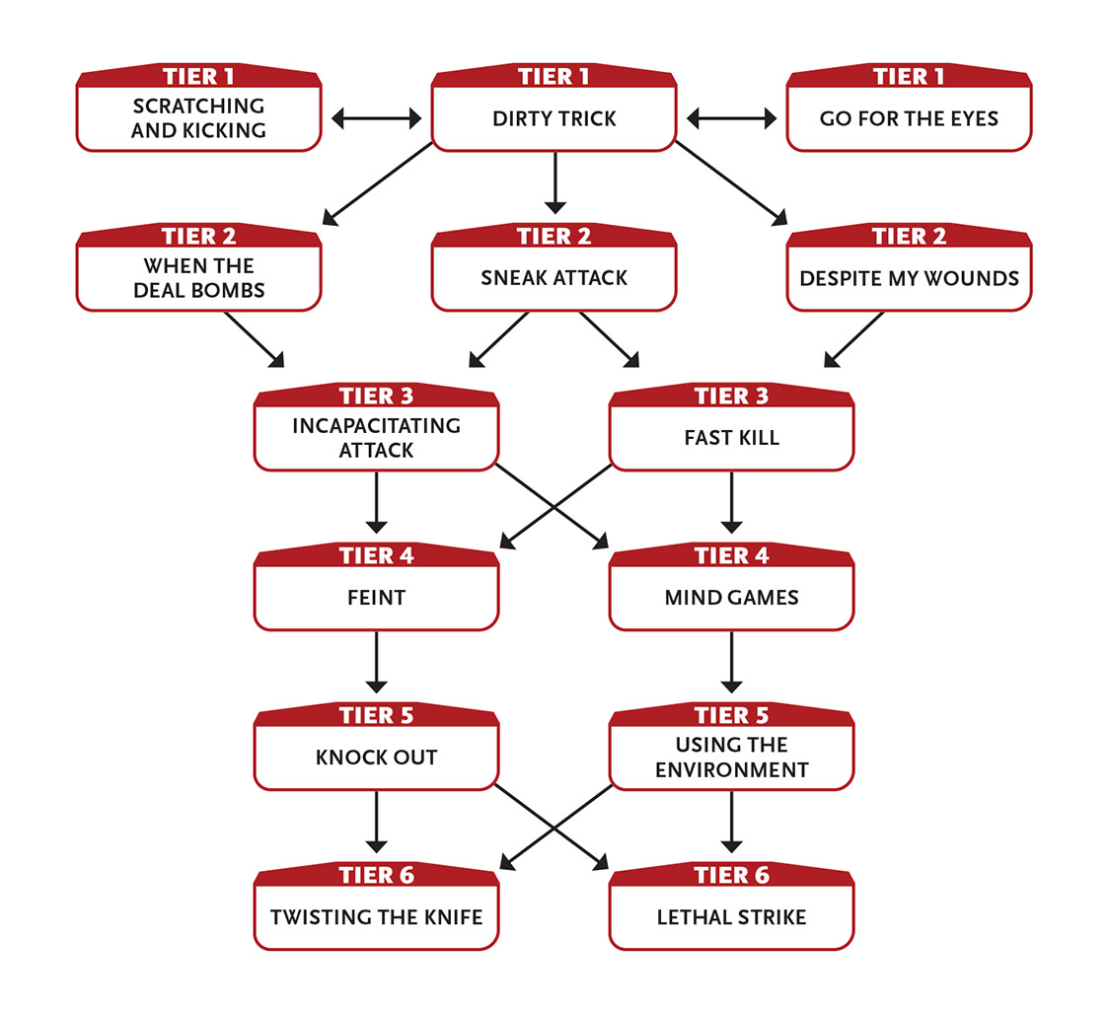

Tier 1
Dirty Trick (1 Intellect): You attempt to distract your foe (by getting them to look elsewhere, making a clumsy feint to set up your real strike, and so on) so you can follow up with an attack. Make an Intellect attack to deceive your foe; success means their defense against your melee attack this round is hindered. Because your foes catch on that you’re tricky, each time after the first that you use this ability in a combat encounter, the Intellect attack is hindered by one step.
Instead of following up with an attack, you can follow up with some other action, and if you succeed at an eased bluffing task against them, they don’t realize what you did. For example, you could distract a foe and then press the button that opens all of the lion cages, throw an incriminating object into a trash can, or even attempt to pickpocket them.
Enabler.
Go for the Eyes (2 Speed): You attempt to injure your foe’s eye, such as by gouging it or throwing dirt in their face. Make a hindered melee attack; success means their vision is impaired until you use a ten-minute or longer recovery, hindering their tasks that rely on sight (which is most tasks). Action.
Scratching and Kicking (1 Speed): Your melee attack deals an additional 1 damage due to it including some combination of scratching, kicking, and/or biting. Enabler.

Tier 2
Despite My Wounds: While you have two or more moderate wounds or one major wound, you get a free reroll on one action each round (as if you had spent 1 XP). Enabler.
Sneak Attack (1 Speed): If you attack a foe under one of the following conditions, your light melee or light ranged weapon attack inflicts an additional 5 damage on a successful hit. (This ability doesn’t work with medium or heavy weapons.)
- You attack with surprise.
- An ally uses their action to ease your attack.
- Your foe’s defenses are hindered due to some other ongoing direct distraction.
- Your foe is unable to take their next turn due to some disabling attack or situation.
First action.
When the Deal Bombs: There’s always a risk that someone you deal with will try to turn on you. After successfully charming, deceiving, interacting positively with, or using Fast Talk or a similar ability on a creature, if they become hostile to you within a day or so, you automatically reduce the wound severity of their first successful attack against you by one step. Enabler.
At tier 3: Instead of reducing the wound’s severity, you ignore it completely (no damage).

Tier 3
Fast Kill (2 Might or Speed): When you hit with a melee or ranged attack, you deal an additional 4 damage. You can’t use this ability in two consecutive rounds. Enabler.
Incapacitating Attack (4 Speed): Your successful attack also briefly incapacitates the target. Until you use a ten-minute or longer recovery (or until someone uses an action to give them aid), they are prone, unable to stand or crawl more than an immediate distance each round, and their defenses are hindered. Enabler.

Tier 4
Feint (2 Speed): If you use one action creating a misdirection or diversion, in the next round you can take advantage of your opponent’s lowered defenses. Make a melee attack roll against that opponent. You gain an asset on this attack. If your attack is successful, it inflicts an additional 4 damage. Action.
Mind Games (4 Intellect): You use lies and trickery, mockery, and perhaps even hateful, obscene language against a foe that can understand you. If you succeed, the foe is confused, enraged, or otherwise distracted enough that they lose their next turn, and on the turn thereafter, their tasks are hindered. Action.

Tier 5
Knock Out (5+ Might): Make a hindered melee attack against a foe of level 3 or lower. If the attack hits, instead of inflicting damage you knock them unconscious until you use a ten-minute or longer recovery (or someone uses an action to bring them back around).
Effort: Increase the maximum level of the foe you can affect by 1.
Action.
Using the Environment (4 Intellect): You can use the environment to your advantage. If there is something within immediate distance that plausibly could provide cover (a table, chandelier, banister, second foe, and so on), you have cover and an asset on your melee attacks.
It is a routine task (no roll required) for you to move anywhere that it is physically possible for you to reach as part of normal movement, climbing, or jumping, and you ignore obstacles and difficult terrain when you do so. For example, you could climb up a tapestry to a balcony or slide down a ship’s sail, but not slip through an arrow slit or enter a locked cage.
This ability lasts until you use a ten-minute or longer recovery.
Enabler.

Tier 6
Lethal Strike (6 Speed): With a swift and sudden melee or ranged weapon attack, you strike a foe in a vital spot. If you hit, you inflict an additional 7 damage. Action.
Twisting the Knife (4 Speed): If you’ve hit a foe with a melee weapon in this combat, you automatically hit them again with that same weapon (no roll required), dealing normal damage. You can’t use this ability with a special attack or if you want to use Effort to increase damage, but abilities that automatically affect your damage do apply to this attack. Action.

Fights Unarmed
You’re a scrapper and love a good fight. Punches, kicks, and full-body movements are your weapons.
- Genre themes: brawler or monk (fantasy), boxer or martial artist (real world, science fiction, superhero)
- GM intrusions: Brawlers trip and fall. Even the battlefield can work against you with things falling or collapsing. Striking certain foes hurts you as much as it hurts them. Opponents with weapons have greater reach. Complicated martial arts moves can knock you off balance.
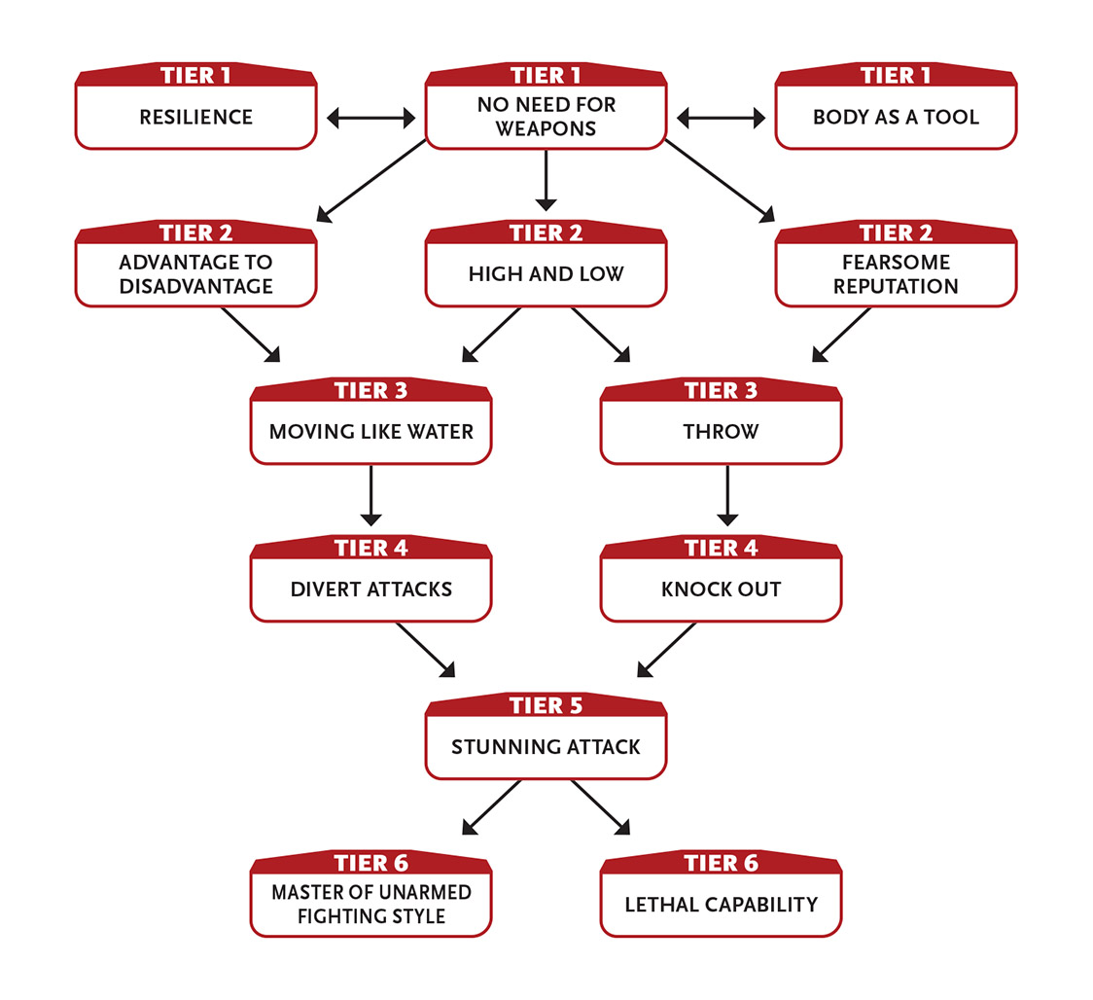

Tier 1
Body as a Tool: In addition to making your body a weapon, you can use it as a tool. You gain an asset to athletics and gymnastics tasks.
No Need for Weapons: You inflict an additional 2 damage with unarmed attacks.
Resilience: You can take one more moderate wound than normal.

Tier 2
Advantage to Disadvantage (3 Speed): You make a hindered attack featuring several quick moves against an armed foe. If you hit, you inflict damage and disarm them—choose whether you want to be holding their weapon or it is knocked to the ground 10 feet (3.5 m) away. For the rest of the combat encounter, you gain an asset on intimidation tasks against your foe.
First action.
Fearsome Reputation (3 Might or Intellect): You announce yourself (perhaps mentioning one of your intimidating deeds) to all foes within long range who can hear and understand you. Make a separate Intellect attack roll for each foe. Success means they are afraid of you, easing your tasks against them until you use a ten-minute or longer recovery. Action.
High and Low: You and an ally tag-team a foe for greater effectiveness. Choose one ally you can see. If you hit a foe that they’ve hit with a melee attack this turn, your attack inflicts an additional 2 damage. Enabler.

Tier 3
Moving Like Water (3 Speed): Until you use a ten-minute or longer recovery, if you fail to dodge an attack, you can still attempt to block it, but the block task is hindered. Enabler.
Throw (2 Might): When your unarmed attack damages a creature of your size or smaller, you throw that creature 1d20 feet away from you. The creature lands prone. Enabler.

Tier 4
Divert Attacks (4 Speed): Until you use a ten-minute or longer recovery, you automatically deflect, block, or dodge any ranged projectile attacks (no roll required). However, on your next turn after you’re attacked with ranged projectiles, all your other actions are hindered. Action to initiate.
Knock Out (5+ Might): Make a hindered melee attack against a foe of level 3 or lower. If the attack hits, instead of inflicting damage you knock them unconscious until you use a ten-minute or longer recovery (or someone uses an action to bring them back around).
Effort: Increase the maximum level of the foe you can affect by 1.
Action.

Tier 5
Stunning Attack: When making an unarmed attack, you can choose to have the attack roll be hindered; if you hit, in addition to the normal effect of the attack, the foe loses their next turn. Enabler.

Tier 6
Lethal Capability: You’ve mastered how to kill with a particular attack. You inflict an additional 5 damage with attacks of one specific type, such as unarmed attacks, or some other specific attack you prefer.
You can gain this ability more than once. Each time you do, choose a different specific attack.
Master of Unarmed Fighting Style: You inflict an additional 3 damage with unarmed attacks.
When you succeed on a Might defense roll to block an unarmed attack against you, reduce its severity by two steps instead of one (major to minor, moderate and minor to none).
Enabler.

Fights With Panache
You’re a swashbuckling daredevil who fights with a flamboyant style that’s entertaining to watch.
- Genre themes: pirate or swashbuckler (fantasy, historical), duelist or swordmaster (science fiction)
- GM intrusions: The display comes off looking silly, clumsy, or unattractive.
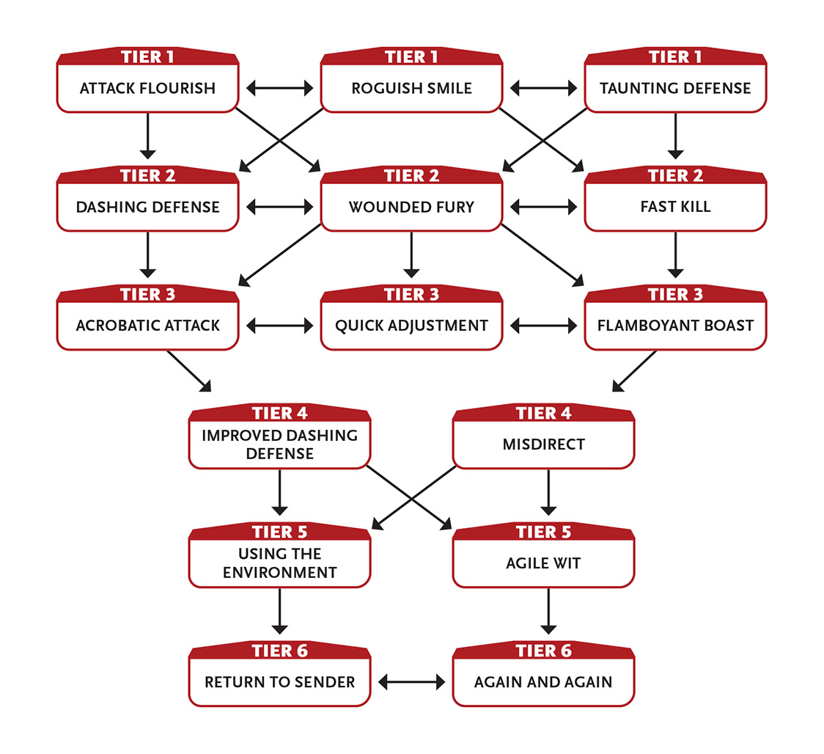

Tier 1
Attack Flourish: When you attack, you add stylish moves, entertaining quips, or a certain something that entertains or impresses others. One creature you choose within short range who can see you gains an asset to their next task if taken within a round or two. Enabler.
Roguish Smile (1+ Intellect): With a smile and perhaps a wink, you erase the last round from the memory of a target of level 3 or less within immediate distance (make an Intellect attack against them to succeed).
Effort: Increase the maximum level of the foe you can affect by 1.
Action.
Taunting Defense (2 Intellect): When you defend against a melee attack, your mocking moves, entertaining quips at your foe’s expense, or a certain something draws out your foe’s anger. Your foe’s attack is hindered, but if they hit, they deal an additional minor wound. Enabler.

Tier 2
Dashing Defense: When wielding a light or medium weapon against a foe of your size or smaller, if you fail to dodge an attack, you can still attempt to block it. Enabler.
Fast Kill (2 Might or Speed): When you hit with a melee or ranged attack, you deal an additional 4 damage. You can’t use this ability in two consecutive rounds. Enabler.
Wounded Fury: While you have at least three moderate wounds or at least one major wound, you gain one free level of Effort you can apply to your attack each round (easing your chance to hit or dealing 3 extra damage). This benefit lasts until you take your next ten-minute or longer recovery (or you no longer suffer from those wounds)
At tier 3: The benefit increases to two free levels of Effort.
Enabler.

Tier 3
Acrobatic Attack (1+ Speed): You leap into the attack, twisting or flipping through the air. If you use Effort on the attack roll, you get a free level of Effort on it.
If you roll a natural 17 or 18, instead of inflicting extra damage you can choose to have a minor effect.
You can’t use this ability if you can’t freely use the armor you’re wearing.
Enabler.
Flamboyant Boast (1 Intellect): You boastfully describe an act that you will accomplish, and then as an extra action on your turn, you attempt it. If an average person would find the action difficult (or impossible) and you succeed on it, non-allies who witnessed it are so amazed and confused that all actions they attempt on their next turn are hindered.
The GM will help you determine whether your boast is something that would significantly impress onlookers.
If you fail the boasted task, until you use a ten-minute or longer recovery your attempts to affect witnesses (with attacks, special abilities, or skills) are hindered.
Enabler.
Quick Adjustment (2 Speed): Your nonlethal attack (an attempt to disarm, an attack against an inanimate object, or an attack to subdue) is a First action. Enabler.

Tier 4
Improved Dashing Defense: One ally within immediate range who is using a light or medium weapon gains the benefit of Dashing Defense until your next turn. Enabler.
Misdirect (3 Speed): When an opponent misses you, you can redirect their attack to another target of your choosing that’s within immediate range of you. Make an unmodified attack roll against the new target (do not use any of your or the opponent’s modifiers to the attack roll, but you can apply Effort for accuracy). If the attack hits, the target takes damage equal to the attacking foe’s level. Enabler.

Tier 5
Agile Wit: When attempting a Speed task, you can spend points from your Intellect Pool instead of your Speed Pool, and vice versa. Use the Edge stat for the Pool you’re spending points from.
Using the Environment (4 Intellect): You can use the environment to your advantage. If there is something within immediate distance that plausibly could provide cover (a table, chandelier, banister, second foe, and so on), you have cover and an asset on your melee attacks.
It is a routine task for you to move anywhere that it is physically possible for you to reach as part of normal movement, climbing, or jumping, and you ignore obstacles and difficult terrain when you do so. For example, you could climb up a tapestry to a balcony or slide down a ship’s sail, but not slip through an arrow slit or enter a locked cage.
This ability lasts until you use a ten-minute or longer recovery.
Enabler.

Tier 6
Again and Again (6 Speed): You can take an extra action on your turn. Enabler.
Return to Sender (3 Speed): If you successfully block or dodge a melee attack, you can immediately make a melee attack against the attacking foe. You can’t use this ability again until after you take your normal turn. Enabler.

Fuses Flesh and Steel
Your body is partly or fully machine.
- Genre themes: cyborg or robot (science fiction, superhero)
- GM intrusions: People in most societies are afraid of someone who is revealed to have mechanical parts.
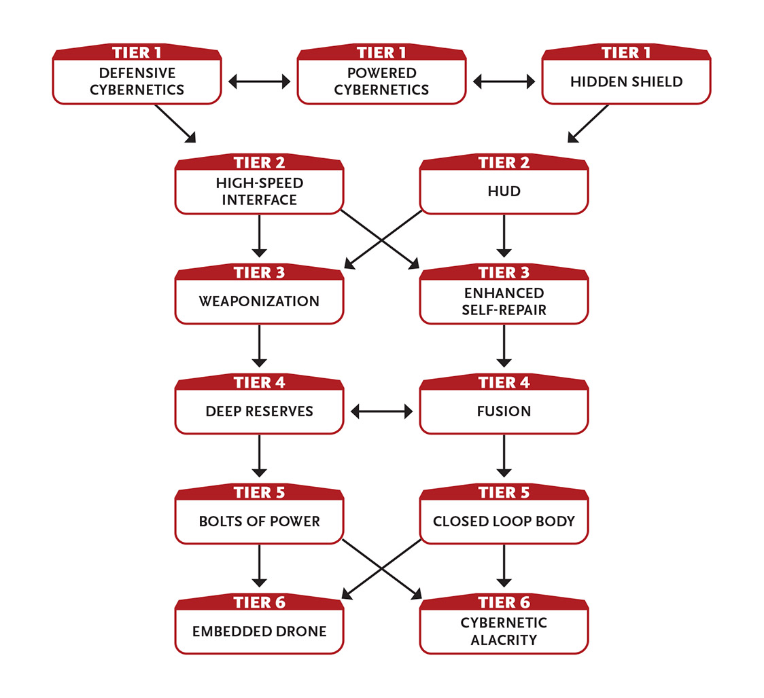

Tier 1
Defensive Cybernetics: Some of your body is made of durable machine parts, some internal, some external. Work with your GM to decide your exact form and configuration.
If you have a minor or moderate wound, you can rally to remove it as an action without using any Might points. This ability renews each time you take a recovery.
Hidden Shield: You have a shield built into your body (probably your arm) made of a composite of metal and advanced polymers. The shield is concealed until you wish to use it.
You can freely use the shield in one hand as a light melee weapon.
As an extra action on your turn, you can make a melee attack with the shield, but if you do so the main attack and shield attack are both hindered.
If your shield is destroyed due to blocking wounds, you cannot use it until you use your resources to repair it, taking about one day.
Powered Cybernetics (2+ Might): You can use your cybernetics to support and enhance your physical actions. When you roll on a task to carry, climb, jump, or smash and your roll is less than a 9, treat the roll as a 9. (This means you don’t get a GM intrusion if you roll a 1.) This ability renews when you take a recovery.
Enabler; action to carry, climb, jump, or smash.
Effort: Increase the minimum number rolled for this ability by 3.
At tier 3: The minimum number rolled for this ability increases to 12.

Tier 2
High-Speed Interface: By directly plugging into a machine or device within immediate range, you ease tasks to identify and operate it.
The interface allows you to interact with the device as fast as it can process information, which is usually faster than a regular person could manipulate the device (such as through a keyboard or voice interface).
HUD (0+ Intellect): You have a heads-up display (HUD) system that helps you perceive your environment. You can see in very dim light as though it were bright light. You can see in total darkness as if it were very dim light. You can see up to a short distance through fog, smoke, and other obscuring phenomena.
Effort: You can use Effort in varying amounts to gain alternate effects as follows:
- Combat HUD: If you use two levels of Effort, the HUD outlines your foes and predicts their attacks this round, giving you an asset on your next block or dodge task.
- Magnifier HUD: If you use one level of Effort, for the next two rounds the HUD magnifies your vision range to 5 miles (8 km) and allows you to see through level 4 or lower basic materials (such as wood, concrete, plastic, and stone) to a short distance in false color images.
- Scanner HUD: If you use two levels of Effort, for the next two rounds the HUD lets you see through level 4 or lower special materials (such as solid lead or an opaque force field) to an immediate distance in false color images. If you succeed on an Intellect task, you can see through level 5 or higher materials.
Enabler.

Tier 3
Enhanced Self-Repair: You reduce the Might cost of rallying to remove wounds by 2.
Weaponization: You have a weapon built into your body. Choose one light or medium one-handed weapon, such as a broadsword, baton, or medium pistol. You are trained in this weapon. You can hide or reveal this weapon as an extra action on your turn.
If your embedded weapon is a firearm, it reloads through a slot in your arm, can hold ten shots, and fires through a disguised barrel in the center of the palm of your hand.
Instead of embedding a weapon, you can embed a multitool that counts as either a set of light tools or a set of heavy tools (your choice when you gain this ability).

Tier 4
Deep Reserves: When others are exhausted, you can push through. You can transfer up to 6 points among your Pools in any combination, at a rate of 1 point per round. For example, you could transfer 3 points of Speed to Might and 3 points of Intellect to Might, which would take a total of six rounds. This ability renews when you use a ten-hour recovery. Action.
Fusion: You can fuse your manifest cyphers and artifacts with your body. You can use these fused devices with First actions (assuming their normal use requires a regular action).
Action to fuse item with your body or detach it.

Tier 5
Bolts of Power (5 Intellect): You simultaneously unleash four lightning bolts, making four separate attacks against targets within short range. Each bolt inflicts 4 damage, or 1 damage on a failed attack roll. Action.
Closed Loop Body: You don’t need to eat or breathe, and you suffer no ill effects from vacuum or extreme temperatures (though fire, cold, and other attacks are suffered normally).

Tier 6
Cybernetic Alacrity: Any time you use Effort on a noncombat Speed task, add your choice of the following options: a free level of Effort on the action or a minor effect on the action. Enabler.
Embedded Drone (3 Intellect): You have an embedded drone built into your body that you can launch and control until you use a one-hour or longer recovery (at which time it returns to you). The drone is no larger than 1 foot (30 cm) on a side. It has manipulators, allowing it to attempt to accomplish physical tasks, and a built-in firearm that it can use to make attacks. The drone can immediately take an action on the turn that you launch it. If the drone is destroyed, you can use your resources to restore it over several days. Action to initiate.
Embedded drone: level 4; long-range embedded pistol inflicts 4 damage; flies a short distance each round

Fuses Mind and Machine
Electronic aids implanted in your brain make you a mental powerhouse.
- Genre themes: cyborg or living computer (science fiction, superhero)
- GM intrusions: Machines malfunction and shut down. Powerful machine intelligences can take control of lesser thinking machines. Some people don’t trust a person who isn’t fully organic.
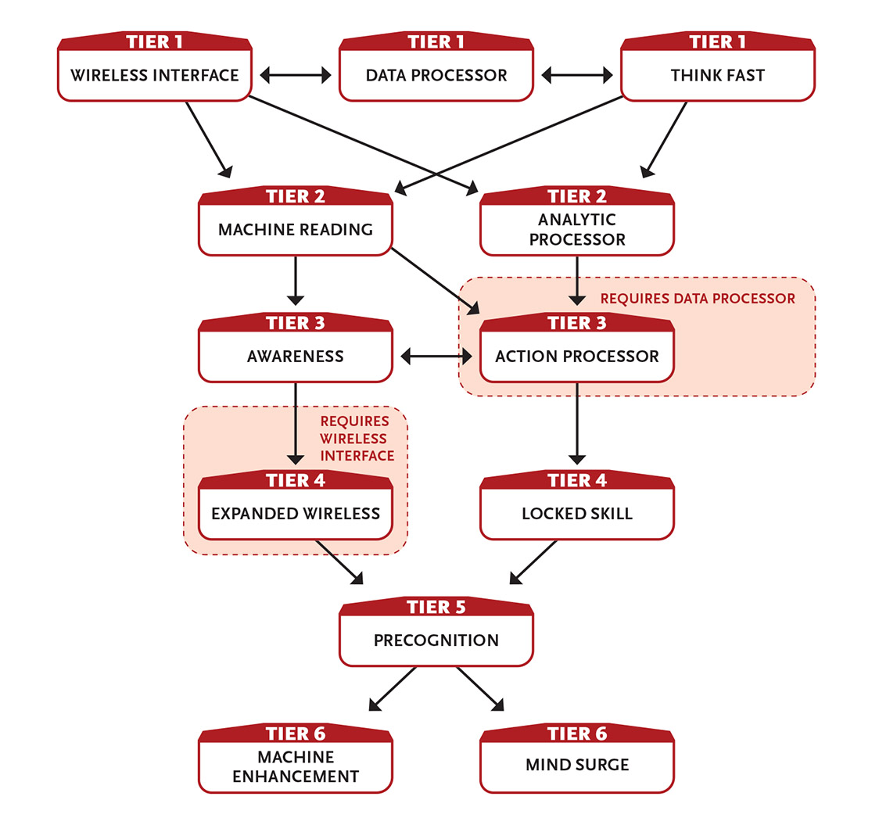

Tier 1
Data Processor (1+ Intellect): Drawing upon stored information and the ability to process incoming data at amazing speeds, you temporarily become trained in a mental task. Each time you activate this ability, choose one Intellect skill, such as hacking, Intellect defense, a knowledge skill, or perception; you become trained in that skill until you use a ten-minute or longer recovery.
Normally you can use this ability to become trained in only one skill at a time; activating it again replaces the previous use with a new trained skill.
Effort: Increase your maximum number of temporary trained skills by one.
Action to initiate.
Think Fast: Your mind is quick and elusive. You are trained in Intellect defense.
Wireless Interface (1+ Intellect): You can mentally communicate with machines within short range. Communication is two-way, but the machine must be willing and able to communicate. You don’t have to see the target, but you must know that it’s within range. You can have more than one active contact at once, but you must establish contact with each machine individually.
Once you’ve established contact, tasks involving that machine take half the normal time, and tasks that are an action become a First action.
Each contact lasts until you use a ten-minute or longer recovery.
Effort: Increase the duration so it lasts until you use a one-hour or longer recovery. Increase the range by a step (long, very long, 1 mile, 10 miles, or anywhere on the planet).
Action to establish contact.

Tier 2
Analytic Processor (4 Intellect): Ask the GM a question you want answered. The GM sets a difficulty for the answer—the more obscure the answer, the more difficult the task. If you succeed at an Intellect task against this difficulty, you get a short answer to the question. If you fail, you take 4 Intellect damage from digital feedback. Action.
Machine Reading (2 Intellect): You can read the surface “thoughts” of a machine within short range, even if it doesn’t want you to. You must be able to see it. Once you have established contact, you can read the machine’s thoughts until you use a ten-minute or longer recovery. Action to initiate.

Tier 3
Action Processor (4 Intellect): Your Data Processor ability can now grant you training in physical skills as well, such as athletics, gymnastics, dodging or blocking, or attacks with a specific weapon. This does not change how many skills Data Processor can simultaneously give you training in. Enabler.
Awareness (3 Intellect): You become hyperaware of your surroundings until you use a ten-minute or longer recovery. You are aware of all living things within long range (including their general position). By using an action to concentrate, you can choose one of them and attempt to learn their general health and power level. Action.
When you use Awareness, you are also aware of thinking machines in long range.

Tier 4
Expanded Wireless: The base range for Wireless Interface increases to anywhere on the planet.
Locked Skill: When you activate Data Processor, choose one of the skills it gives you training in; this is your “locked” skill. Your training in the locked skill lasts until you use a ten-hour recovery.
If you activate Data Processor again before you use this recovery, you can reset the duration of your locked skill or choose another skill to be your locked skill.
You can select this ability up to three times. Each time you select it, your maximum number of locked skills increases by one.
Enabler.

Tier 5
Precognition (6 Intellect): You dimly sense the future until you use a ten-minute or longer recovery. During this time, you gain the following benefits:
- You gain an asset on defense tasks.
- You can predict the actions of those around you. You gain an asset to seeing through deceptions and attempts to betray you as well as avoiding traps and ambushes.
- You know what people are probably thinking and what they will say before they say it. You gain an asset to all interaction tasks.
Enabler.

Tier 6
Machine Enhancement: Anytime you use Effort on an Intellect action, add your choice of the following options: a free level of Effort on the action or a minor effect on the action. Enabler.
Mind Surge: You have an extra one-action recovery each day that can only be used to replenish your Intellect Pool.

Grows to Towering Heights
You can grow larger and, with enough experience, to towering heights.
- Genre themes: giant (fantasy), alien (science fiction), bruiser (superhero)
- GM intrusions: Rapid growth knocks over furnishings or smashes through ceilings or hanging lights. An enlarged character breaks through the floor.
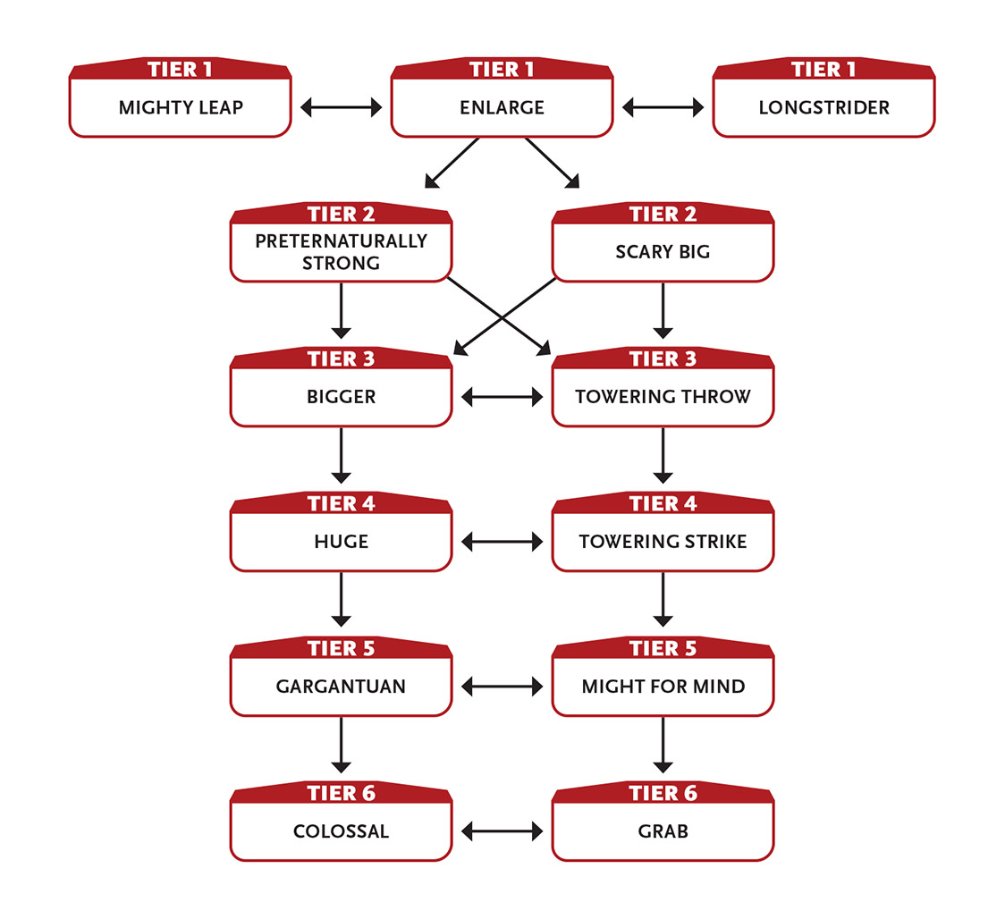

Tier 1
Enlarge (1+ Might): You grow to a height of 9 feet (3 m) until you use a recovery. Your equipment increases size with you. While enlarged, you add +1 to your Might Edge, you can ignore the first moderate wound you take, and your unarmed attacks inflict 4 damage. While enlarged, your dodge tasks are hindered.
Each time you use Enlarge, the Might cost increases by 1. The cost resets after you take a recovery.
Last action; enabler to use again to remain enlarged.
If you have multiple abilities that let you grow to a larger size, their effects don’t add together—you just get the benefits from the biggest one.
Longstrider: When you are larger than normal, your long-term movement speed (not your movement each round, but when walking, running, or hiking over a minute or longer) is doubled thanks to your bigger stride and your greater endurance.
Mighty Leap (1 Might): When you are larger than normal and jump, you move twice as far as normal, either horizontally or vertically. Enabler.

Tier 2
Preternaturally Strong (2 Might): When you roll for a carrying, climbing, jumping, or smashing task and your roll is less than a 9, treat the roll as a 9. (This means you don’t get a GM intrusion if you roll a 1.) While bigger than normal, each size increment (Enlarge, Bigger, Huge, Gargantuan, and Colossal) increases this minimum number rolled by 3. This ability renews when you take a recovery.
Enabler.
At tier 3: The minimum number rolled for this ability increases to 12.
Scary Big: Even when you’re not larger than normal, your presence is compelling; you have an asset to charm and intimidation tasks. If you have grown larger than your normal size, you have two assets. Enabler.

Tier 3
Bigger: When you use Enlarge, if you spend an additional 1 Might, you grow to a height of 12 feet (4 m). While bigger, you add +1 to your Might Edge, you can ignore the first two moderate wounds you take, your unarmed attacks inflict 6 damage, and you gain an asset to tasks that are easier for a larger creature to perform (like climbing or wading). While bigger, your dodge tasks are hindered by two steps. Enabler.
When you spend extra Might to use Bigger, Huge, Gargantuan, or Colossal, the benefits from those abilities replace the benefits you get from Enlarge.
Towering Throw (2 Might): When you deal damage to a creature of your size or smaller with an unarmed attack, you throw that creature 1d20 feet away from you. The creature lands prone. While bigger than normal, each increment (Enlarge, Bigger, Huge, Gargantuan, and Colossal) increases the distance you throw the creature by another 1d6 feet and deals an additional 1 damage upon their impact. Enabler.

Tier 4
Huge: When you use Enlarge, if you spend an additional 2 Might, you grow to a height of 16 feet (5 m). While huge, you add +1 to your Might Edge, you can ignore the first three moderate wounds you take, your unarmed attacks inflict 7 damage, and you gain an asset to tasks that are easier for a larger creature to perform (like climbing or wading). While huge, your dodge tasks are hindered by two steps. Enabler.
Towering Strike (3 Might): When you hit with a Might attack, you deal an additional 4 damage. While bigger than normal, each increment (Enlarge, Bigger, Huge, Gargantuan, and Colossal) inflicts an additional 1 damage. This ability renews after you take a recovery. Enabler.

Tier 5
Gargantuan: When you use Enlarge, if you spend an additional 5 Might, you can grow to a height of 30 feet (9 m). While gargantuan, you add +2 to your Might Edge, you can ignore the first three moderate wounds and first major wound you take, your unarmed attacks inflict 8 damage, and you gain two assets to tasks that are easier for a larger creature to perform (like climbing or wading). You can make an unarmed attack against all creatures in an immediate area (make separate attack rolls for each). While gargantuan, your dodge tasks are hindered by three steps. If you fall prone while gargantuan, you take a moderate wound and require a Last action to get up. Enabler.
Might for Mind: When performing a task that would normally require spending points from your Might Pool, you can spend points from your Intellect Pool instead, and vice versa.

Tier 6
Colossal: When you use Enlarge, if you spend an additional 7 Might, you grow to a height of 60 feet (18 m). While colossal, you add +2 to your Might Edge, you can ignore the first three moderate wounds and first two major wounds you take, your unarmed attacks inflict 9 damage, and you gain two assets to tasks that are easier for a larger creature to perform (like climbing or wading). You can make an unarmed attack against all creatures in an immediate area (make separate attack rolls for each). While colossal, you can’t effectively dodge attacks from creatures one-quarter your size or smaller (attacks from such creatures automatically hit you). If you fall prone while colossal, you take a moderate wound and require a Last action to get up. Enabler.
Grab: If you make an unarmed attack as a Last action, your attack deals 2 less damage and the target is grabbed. All the grabbed target’s tasks are hindered, including any attempts to escape your grip. As an attack, you can deal 4 damage to your grabbed foe (no attack roll required).
While bigger than normal, each increment (Enlarge, Bigger, Huge, Gargantuan, and Colossal) hinders the target’s escape attempts by an additional step and increases your grip damage by 1.
Last action to initiate; action to squeeze grabbed targets.

Howls at the Moon
For brief periods, you become a fearsome and powerful creature with control issues.
- Genre themes: lycanthrope (fantasy, superhero), genetic mishap (science fiction)
- GM intrusions: The change happens in an uncontrolled fashion. People are terrified of monsters. Self-control (if any) is lost during this transformation.
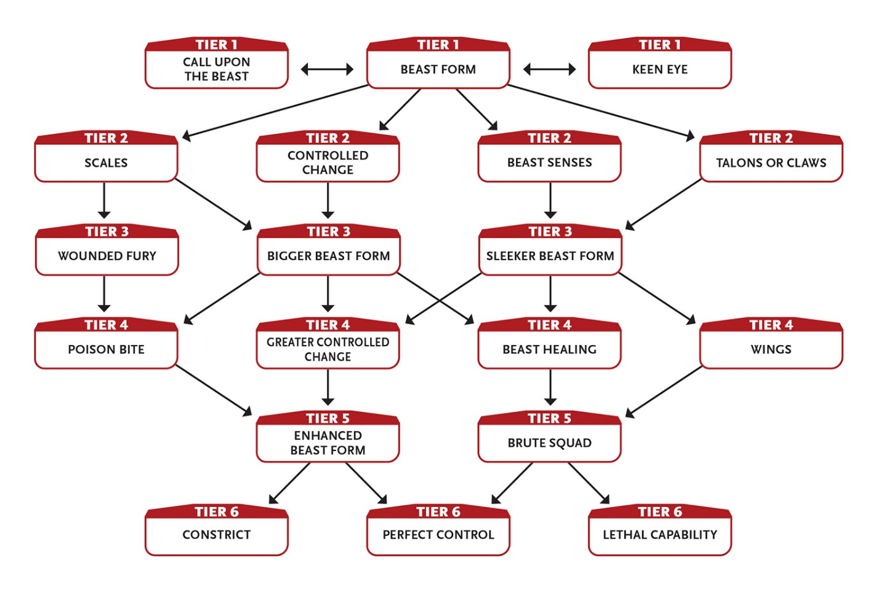

Tier 1
Beast Form (0+ Might): On five consecutive nights each month, you uncontrollably change into a monstrous beast until the first hint of dawn or the moon sets (but see below). Work with your GM to determine the details of this form. In this new form, you add +4 to your Might Pool, +1 to your Might Edge, +2 to your Speed Pool, and +1 to your Speed Edge; you ignore the first moderate wound you take; and you can freely use your unarmed attacks as light weapons (eased attack, 2 damage) or medium weapons (unmodified attack, 4 damage), whichever seems appropriate for that attack.
While in beast form, you can’t spend Intellect points for any reason other than to try to change to your normal form before the duration is over (a difficulty 4 task). In addition, you attack any and every living creature within short range. After you revert to your normal form, all your tasks are hindered until you use a one-hour or longer recovery. If you did not kill and eat at least one substantial creature while in beast form, the hindrance is two steps instead of one and lasts until you use a ten-hour recovery.
Effort: You can intentionally change into your beast form if you succeed at a difficulty 4 Intellect task. If you fail, you can keep trying each round (at no additional Might cost to activate this ability) until you succeed or decide to give up.
Enabler to involuntarily change into beast form; action to voluntarily change into beast form; action to change back to your normal form.
A PC in beast form usually loses or at least leaves behind their regular-sized clothing and armor.
Call Upon the Beast (1 Intellect): While not in beast form, you can call upon your beastly nature for a moment and give a menacing growl or have your eyes become more animal-like. If you do this, you gain a free level of Effort on an intimidation task. Enabler.
Keen Eye: You can see perfectly well half again as far as normal. You ignore attack and perception penalties for fog, smoke, mist, dim light, and very dim light.

Tier 2
Beast Senses: You have heightened senses; you have an asset to perception and initiative tasks. If you are in beast form, you have two assets, and even if you are unaware of an incoming attack, the attacker doesn’t gain any advantage against you, such as from surprise.
Controlled Change: You can try to use your Beast Form ability to change into your beast form on any night (a difficulty 4 Intellect task). Any transformations you make using this power are in addition to the five nights per month that you change involuntarily. Action to change.
Scales (2 Might): You grow scales all across your body until you use a ten-minute or longer recovery, during which time your block tasks are eased. Action when in your normal form; enabler when using Beast Form.
Talons or Claws (1 Might): You can make your fingertips grow sharp talons or claws (whichever matches your beast form) until you use a ten-minute or longer recovery, during which time your unarmed attacks deal an additional 1 damage. Action when in your normal form; enabler when using Beast Form.

Tier 3
Bigger Beast Form: When you use Beast Form, you grow larger, during which time you achieve a height of 12 feet (4 m). Being so large, your beast form gains the following additional benefits: you can ignore the first moderate wound you take, your unarmed attack rolls have an asset, you can freely use your unarmed attacks as heavy weapons (6 damage), and you gain an asset to tasks that are easier for a larger creature to perform (like climbing or wading). While in your bigger beast form, your dodge tasks are hindered. Enabler.
Sleeker Beast Form: When you use Beast Form, your beast form gains the following additional bonuses: +1 to your Might Edge, +2 to your Speed Pool, and +1 to your Speed Edge. Enabler.
Wounded Fury: While you have at least three moderate wounds or at least one major wound, you gain two free levels of Effort you can apply to an attack each round. This benefit lasts until you take your next ten-minute or longer recovery (or you no longer suffer from those wounds). Enabler.

Tier 4
Beast Healing: When you change into your beast form, you are immediately healed of one wound of any severity. This ability renews after you take a ten-hour recovery. Enabler.
Greater Controlled Change: It’s easier to change into and out of the shape granted by your Beast Form ability. Transforming either way is now a difficulty 2 Intellect task.
Poison Bite (4 Might): You grow fangs and an extended overbite or underbite, allowing you to make poisonous bite attacks as light unarmed attacks (eased attack, 2 damage) until you use a ten-minute or longer recovery. If your bite attack succeeds, the target takes an additional 5 damage (ignores armor) from poison and their tasks are hindered for one round. Action when in your normal form; enabler when using Beast Form.
Wings (4 Might): You sprout wings massive enough to give you the power to fly up to a long distance each round. You can carry a creature your size or smaller (if using Bigger Beast Form, you can carry up to three creatures of your normal size or smaller). Action when in your normal form; enabler when using Beast Form.

Tier 5
Brute Squad (8 Might): You can perform two Might tasks on this turn, one with your normal action and one with an extra action. For example, you could make a melee attack and smash open a door, throw a heavy couch and jump over a wall, or make two melee attacks. Enabler.
Enhanced Beast Form: When you use Beast Form, your beast form gains the following additional bonuses: +3 to your Might Pool, +2 to your Speed Pool, and you can ignore all minor wounds from physical attacks.

Tier 6
Constrict: While in beast form, if you make an unarmed attack as a Last action, your attack deals 2 less damage and you grab the target, possibly by wrapping part of your body around them. All the grabbed target’s tasks are hindered, including any attempts to escape. Each round they remain grabbed, you can use your action to inflict 5 damage on them (no roll required). Last action to initiate; action to constrict a grabbed target.
Lethal Capability: You’ve mastered how to kill with a particular attack. You inflict an additional 5 damage with your claws, your bite, or some other specific attack you prefer.
You can gain this ability more than once. Each time you do, choose a different specific attack.
Perfect Control: You no longer need to attempt an Intellect task to use Beast Form or revert back to your normal form. You can change back and forth as your action. While in beast form, you no longer have to eat a creature to avoid being hindered after you revert to normal.

Hunts
You are a stalking hunter who excels at bringing down your selected quarry, whether person or beast.
- Genre themes: assassin or ranger (fantasy), bounty hunter (real world, science fiction, superhero)
- GM intrusions: Your target notices you. The target isn’t as vulnerable as it seemed. Someone reacts poorly to knowing you hunt.
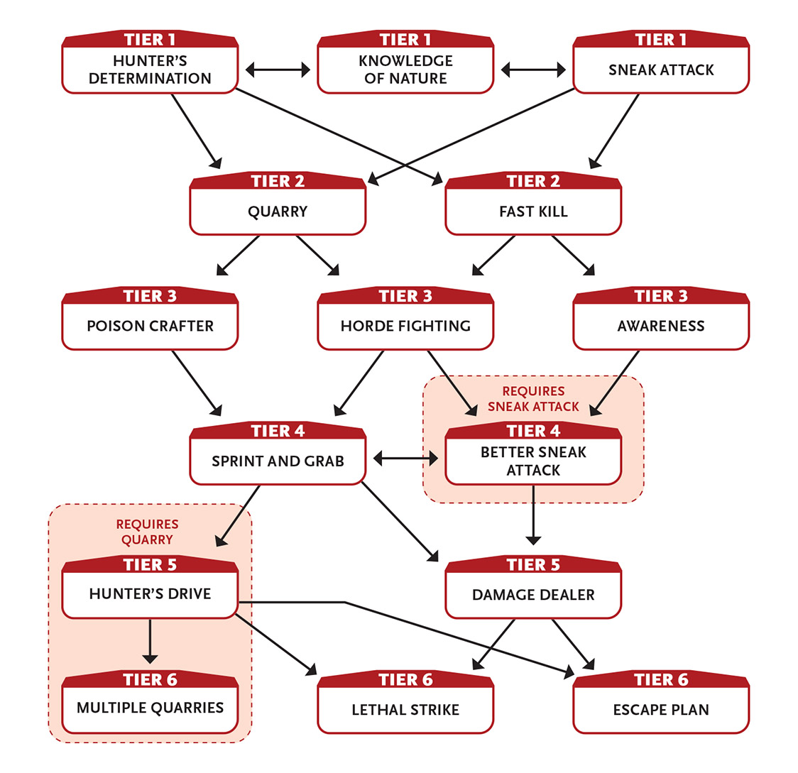

Tier 1
Hunter’s Determination: When you attack a foe and miss, you gain an asset on your attacks and defenses against that foe. If you miss them again, you gain a second asset against them. You lose these assets if you change targets or the combat ends. Enabler.
Knowledge of Nature: While in the wilderness, you can always find edible food of some kind and potable water if it exists. Likewise, you can find medicinal herbs or natural remedies that grant you an asset on treatments to heal wounds, disease, or poison.
Sneak Attack (1 Speed): If you attack a foe under one of the following conditions, your light melee or light ranged weapon attack inflicts an additional 5 damage on a successful hit. (This ability doesn’t work with medium or heavy weapons.)
- You attack with surprise.
- An ally uses their action to ease your attack.
- Your foe’s defenses are hindered due to some other ongoing direct distraction.
- Your foe is unable to take their next turn due to some disabling attack or situation.
First action.

Tier 2
Fast Kill (2 Might or Speed): When you hit with a melee or ranged attack, you deal an additional 4 damage. You can’t use this ability in two consecutive rounds. Enabler.
Quarry (2 Intellect): You pick a creature and focus your intention on pursuing them. Choose one creature you can see to become your quarry. You gain an asset on all tasks involving following, understanding, interacting with, attacking, or defending against your quarry. This asset includes hunting-related tasks, if appropriate, such as skinning, dressing, the best way to prepare and preserve any resulting game meat, and so on. You can have only one quarry at a time. Action to initiate.

Tier 3
Awareness (3 Intellect): You become hyperaware of your surroundings until you use a ten-minute or longer recovery. You are aware of all living things within long range (including their general position). By using an action to concentrate, you can choose one of them and attempt to learn their general health and power level. Action.
Horde Fighting: When two or more foes attack you at once in melee, you can use them against each other. Each round, choose whether you gain an asset to block and dodge rolls against them or to attack rolls against them. Enabler.
Poison Crafter: If you have about an hour, you can use your resources to craft one dose of poison you can use as a contact poison on a weapon. A weapon coated with the poison (requiring a Last action to carefully apply) inflicts an additional 2 damage until you use a one-hour or longer recovery.
Your experience with poison gives you some additional related benefits. You gain an asset on detecting, identifying, and resisting poison. Your defense rolls against poison are eased, and you take 2 less Speed damage from poison (if the poison inflicts Speed damage) or reduce wounds from poison by one step (major to moderate, moderate to minor, minor to none). For example, if you are hit by an attack that adds a moderate wound from poison, you only take a minor wound from the poison.
Poison crafting uses resource points—in this case, use Craft Cypher and the weapon augmentation cypher to create a poison you can apply to your weapon. The poison, a manifest cypher, applies toward your cypher limit.

Tier 4
Better Sneak Attack: When using Sneak Attack, you gain an asset on the attack. On your next turn, your target takes an additional 5 damage (ignores armor). The target can prevent this additional damage by taking a recovery, using any ability that heals it, or using its action to attend to the injury. Enabler.
Sprint and Grab (2 Speed): You move a short distance and make a melee attack to grab a foe of your size or smaller. (Unlike a normal situation of taking an action and moving a short distance, this doesn’t hinder your tasks.) A successful attack means you grab the foe and bring it to a halt if it was moving (this can be treated as a tackle, if appropriate). Action.

Tier 5
Damage Dealer: You’ve become better at killing with one kind of weapon. Choose one melee or ranged weapon. You inflict an additional 3 damage with this weapon. You can select this ability up to two times for any particular weapon (for a total of 6 damage).
Hunter’s Drive (5 Intellect): You gain greater prowess in the hunt. If your quarry is within 10 miles (16 km) of you, your movement rate is doubled if you are trying to reach them.
You gain an additional asset on tasks related to your quarry.
This ability lasts until you use a ten-minute or longer recovery.
Enabler.

Tier 6
Escape Plan: When you kill a foe, you can attempt a stealth task as an extra action on your turn to hide from anyone around, assuming that a suitable hiding place is nearby. Enabler.
Lethal Strike (6 Speed): With a swift and sudden melee or ranged weapon attack, you strike a foe in a vital spot. If you hit, you inflict an additional 7 damage. Action.
Multiple Quarries: When you activate Quarry, you can select four creatures you can see to be your quarry instead of just one. Each additional quarry you select adds 2 Intellect to the cost of Quarry. Enabler.

Infiltrates
Subtlety, guile, and stealth allow you to get in where others can’t.
- Genre themes: spy (all genres)
- GM intrusions: Spies are treated harshly when caught. Allies disavow infiltrators who get caught. Some secrets are better left unknown.
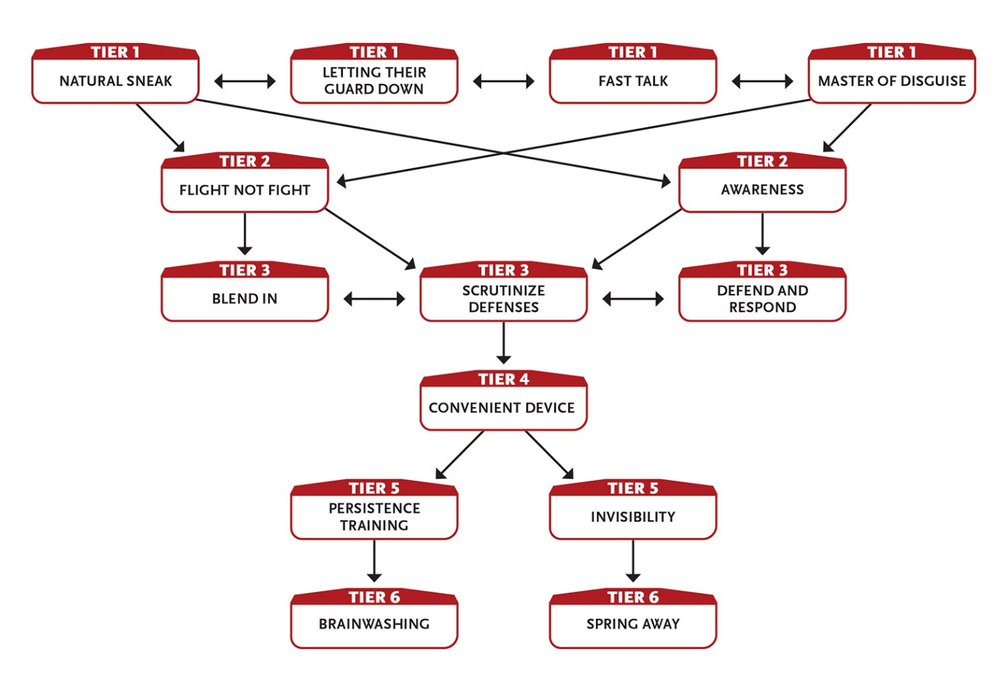

Tier 1
Fast Talk (1 Intellect): When speaking with an intelligent creature who can understand you and isn’t hostile, you convince that creature to take one reasonable action in the next round. A reasonable action must be agreed upon by the GM; it should not put the creature or its allies in obvious danger or be wildly out of character. Action.
Letting Their Guard Down (1 Intellect): If you interact with an intelligent NPC and successfully use disguise or deception against them, they reveal some minor additional information, such as which door is never locked, how many guards are on the upper level, or which way the king plans on ruling on a matter before him. Enabler.
Master of Disguise (2 Intellect): You disguise yourself in well under half the time—one Last action—rather than the minute or more normally required when attempting a disguise task, and if the disguise comes under direct scrutiny or challenge, you gain an additional asset to your disguise tasks to maintain the deception. Last action.
Natural Sneak (2+ Intellect): When you roll for a lockpicking, perception, pickpocketing, or stealth task and your roll is less than a 6, treat the roll as a 6. (This means you don’t get a GM intrusion if you roll a 1.) This ability renews when you take a recovery.
Effort: Increase the minimum number rolled for this ability by 3.
Enabler.
At tier 3: The minimum number rolled for this ability increases to 9.

Tier 2
Awareness (3 Intellect): You become hyperaware of your surroundings until you use a ten-minute or longer recovery. You are aware of all living things within long range (including their general position). By using an action to concentrate, you can choose one of them and attempt to learn their general health and power level. Action.
Flight Not Fight: If you use your action only to move, your dodge tasks are eased until your next turn. Enabler.

Tier 3
Blend In (4 Intellect): By changing your posture, your facial expression, and perhaps your clothing, you make yourself appear unimportant but not out of place for wherever you are. For example, you could look like a janitor in an office building, an orderly in a hospital, or a clerk in a police station. People can still see you, but those of level 3 or less attach no importance to your presence. If a higher-level creature notices you, you can attempt an Intellect task against their level to retain your unimportant-seeming status. While blending in, you gain two assets to dodge and stealth tasks. This effect ends if you do something to call attention to your presence or position—attacking, using an ability, moving a large object, and so on—or if you use a ten-minute or longer recovery. This ability works even if the NPC observes you through a security camera or similar device. Attempting to fool an animal (such as a guard dog or police dog) is hindered. Action to initiate.
Defend and Respond (3 Might or Speed): If you block or dodge a melee attack, you can immediately make a melee attack against your attacker. You can’t use this ability more than once per round. Enabler.
Scrutinize Defenses (3+ Intellect): When you spend an hour or so thoroughly exploring an area (whether directly, through surveillance footage or a blueprint, or questioning people familiar with the area) no larger than a long distance in diameter, you can ask the GM one question about the area’s defensive systems and procedures. The GM must answer you truthfully. For example, you could ask how often guards pass by a particular spot, what the guards are armed with (if anything), or if there are electronic or magical alarms. This ability resets when you use a ten-hour recovery.
Effort: Ask an additional question.
Action to initiate; one hour to complete.

Tier 4
Convenient Device (variable Intellect): Because you planned ahead or were given a special tool to overcome an obstacle, you produce a piece of equipment that removes one harmful or negative condition affecting you or an ally within immediate range. For example, if you are poisoned, you have an antidote. If an ally is blinded by pepper spray, you have a salve that negates the irritant. If you are handcuffed, you have a miniature lockpick or a pen laser that cuts metal. The device works only once (but you can use this ability again to produce another one). The Intellect cost for using this ability is equal to the level of the effect you’re trying to overcome. Action.

Tier 5
Invisibility (4+ Intellect): You become invisible. This effect ends if you do something to reveal your presence or position—attacking, using an ability, moving a large object, and so on.
Effort: Use this ability on a creature you touch instead of yourself; it lasts until they do something to reveal their presence or until you (not they) use a ten-minute or longer recovery.
Action to initiate.
An invisible character’s attack is eased by two steps. Attacks on an invisible character are hindered by four steps or are nearly impossible if the attacker has no idea where they might be.

Persistence Training (5+ Might): You immediately end mind control affecting you. You also regain your ability to take your next turn normally and/or take it without hindrance by shaking off a lingering disabling effect.
Effort: Use this ability on an ally within immediate range instead of yourself.
Enabler for yourself; action for another.

Tier 6
Brainwashing (6+ Intellect): You use trickery, well-spoken lies, and mind-affecting chemicals (or other means, like magic or high technology, as appropriate to your genre) to control the actions of another creature you touch. The creature must be level 3 or lower and you must succeed at an Intellect attack against them. Control lasts until you use a ten-minute or longer recovery, and if you can see them you decide on a case-by-case basis if they follow your orders or if they can act freely.
When the duration ends, the creature doesn’t remember being controlled or anything it did while under your command.
Effort: Increase the maximum level of the creature you can affect by 1.
Action to initiate.
Spring Away (5 Speed): After successfully dodging an attack or some other danger, you can immediately move up to a short distance. (This movement doesn’t hinder your tasks.) Once you use this ability, you can’t use it again until your next turn. Enabler.

Leads
Your natural leadership capability allows you to command others, including a loyal band of followers.
- Genre themes: bard (fantasy, historical), politician (historical, real world, science fiction)
- GM intrusions: Followers fail, betray, lie, become corrupted, get kidnapped, or die. A political opponent becomes prominent. An ally becomes aware of a broken promise.
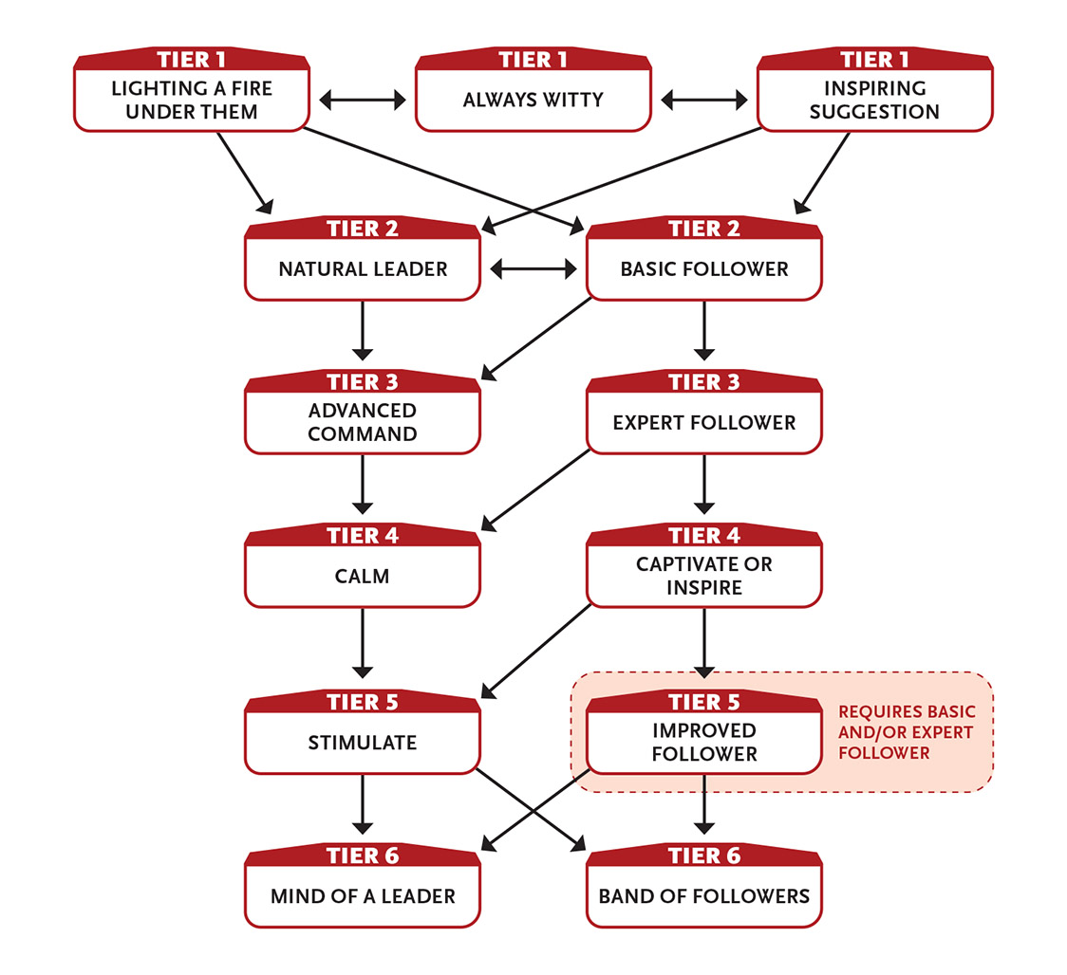

Tier 1
Always Witty: Every time you use a recovery, if your Intellect Pool isn’t already full, you get 1 extra point to restore to your Intellect Pool. You can select this ability up to three times.
Inspiring Suggestion (2 Intellect): When you make a helpful suggestion to an ally, they have a better chance of succeeding at what they’re doing. Choose an ally who can see and understand you, then suggest a specific action for them to take, such as “attack the leader” or “climb the wall.” If the ally chooses to take that exact action, they gain two assets on that task. First action.
Lighting a Fire Under Them: You issue a command to a follower or ally within short range and that person’s next action is a First action (if the action would have been Last, it happens normally). You can’t use this ability again until after your next ten-minute or longer recovery. Last action.

Tier 2
Basic Follower: You gain a level 2 follower who has two level 3 modifications (one of which is charm).
You can take this ability multiple times, each time gaining another follower.
Natural Leader (3+ Intellect): When you roll to bargain, bluff, charm, interrogate, or intimidate a character and your roll is less than a 9, treat the roll as a 9. (This means you don’t get a GM intrusion if you roll a 1.)
This ability renews when you take a recovery.
Effort: Increase the minimum number rolled for this ability by 3.
Enabler.
At tier 3: The minimum number rolled for this ability increases to 12.
A person manipulated by Natural Leader becomes more difficult to work with; the GM should treat them as one level higher for later uses of the ability.

Tier 3
Advanced Command (4+ Intellect): You give a command to a creature within short range who can hear and understand you. If you succeed at an Intellect roll against them, they obey that command for one round. If the command would cause direct harm to them or their allies, the attack is hindered.
Effort: Attempt to give them one command each following round (make an Intellect attack for each additional command); the ability ends when you fail the attack.
Action.
Expert Follower: You gain a level 3 follower who has three level 4 modifications of your choice.
Instead of gaining a new level 3 follower, you can advance an existing follower to level 3 and gain a new level 2 follower.
You can take this ability multiple times, each time gaining another follower.

Tier 4
Calm (3 Intellect): Through jokes, song, or other art, you prevent a living foe from attacking anyone or anything for one round. Action.
Captivate or Inspire: You can use this ability in one of two ways.
Captivate: Your words keep the attention of all NPCs that hear them for as long as you speak.
Inspire: Your words inspire all NPCs that hear them, allowing them to perform tasks as if one level higher until you use a one-hour or longer recovery.
In either case, you choose which NPCs are affected. If anyone in the crowd is attacked while you’re trying to speak to them, you lose the crowd’s attention.
Action to initiate.

Tier 5
Improved Follower: One of your followers increases their overall power, knowledge, and ability. Choose one of your followers. Their level increases by 1, their existing modifications each increase by 1, and they gain a new modification (equal to their base level plus 1).
You can take this ability once per tier, each time improving a follower (the same one or a different one).
Stimulate (6 Intellect): Your words encourage a target in immediate range who can understand you. The next action they take is eased by three steps. (For this task, the asset limit is three instead of two.) Action.

Tier 6
Band of Followers: You gain four level 3 followers, each with three level 4 modifications of your choice.
Instead of gaining four new level 3 followers, you can advance four existing level 2 followers to level 3 and gain a new level 2 follower in place of each of them.
Mind of a Leader (6 Intellect): When you develop a course of action to deal with a future situation, you can ask the GM one very general question about what is likely to happen if you carry out the plan, and you will get a simple, brief answer.
Each of the allies who know the plan (including you) gain an asset to one roll of their choice related to that future situation, as long as the situation occurs within a few days of creating the plan.
Action to initiate planning; enabler for asset.

Masters Telekinesis
You can telekinetically move objects with your mind without physically touching them.
- Genre themes: mind witch (fantasy), telekinetic (real world, science fiction, superhero)
- GM intrusions: One mental slip, and moving objects drop or fragile objects break. Sometimes the wrong item moves, falls, or breaks.
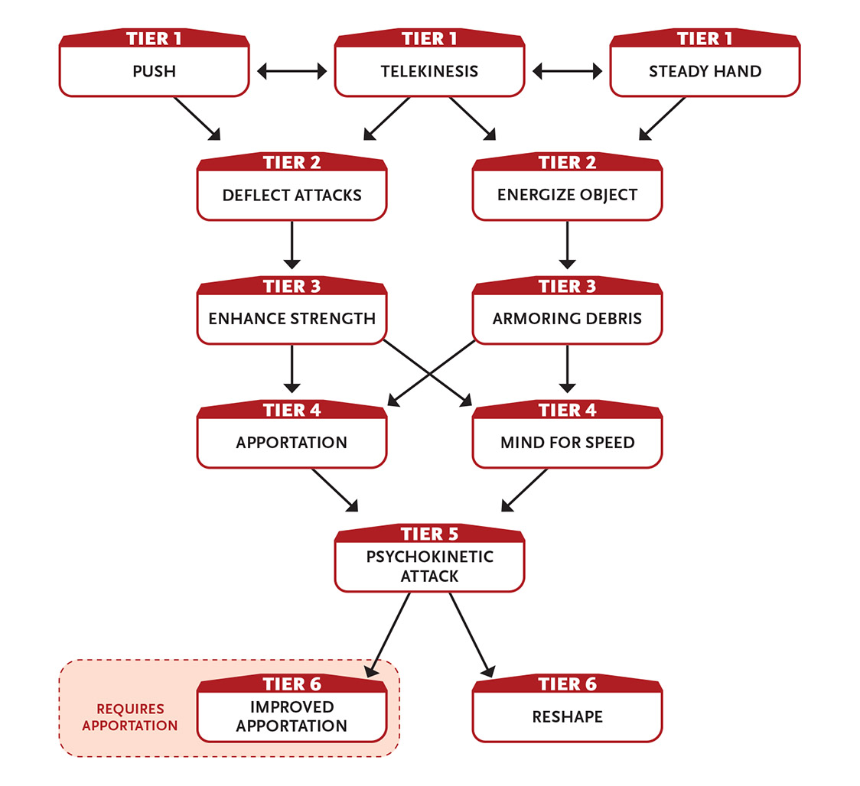

Tier 1
Push (2 Intellect): You telekinetically push a target within short range an immediate distance in any direction. You must be able to see the target, it must be your size or smaller, and it must not be affixed to anything. The push is quick, and the force is about as direct and crude as a kick or punch. Action.
Steady Hand (1 Intellect): Using your telekinesis to stabilize yourself or improve your grip, you gain a free level of Effort to use on one physical noncombat task. You can’t use this ability again until after you take a recovery action. Enabler.
Telekinesis (2 Intellect): You telekinetically affect an object you can see within long range that is not too heavy for you to physically affect if you were standing next to it and could use your hands normally. Options include closing or opening a door, writing a simple symbol or a few words with a writing instrument, transferring an object a short distance, wresting an object from another creature’s grasp (on a successful Intellect roll versus their level), pushing a creature an immediate distance (with a successful attack roll), or even hindering a creature’s attack or defense by applying restraining pressure to a leg or arm (with a successful attack roll). In all cases, the effect must occur over the course of one round. Action.

Tier 2
Deflect Attacks (4 Intellect): You automatically block, deflect, or dodge any ranged projectile attacks (no roll required). However, on your next turn after you’re attacked with ranged projectiles, all your other actions are hindered. This ability lasts until you use a ten-minute or longer recovery. Action to initiate.
Energize Object (2 Intellect): You channel energy into an object (like a melee or ranged weapon). Until you use a one-hour or longer recovery, any attack you make with the energized object inflicts an additional 1 damage from energy (if the weapon fires projectiles, such as bullets from a rifle, this damage applies to the projectiles). The energy drains out if you stop holding or carrying the object, but as an extra action on your turn, you can energize a different object. Action.
When you energize an object, you use psychokinetic energy, which tends to give affected weapons a subtle purple glimmer.

Tier 3
Armoring Debris (5 Intellect): You use nearby small objects from the environment (rocks, broken items, clumps of dirt, and so on) to intercept incoming attacks until you use a ten-minute or longer recovery. This allows you to attempt to better block wounds (block tasks are eased by one additional step; dodge tasks are unaffected). Action to initiate.
Enhance Strength (3+ Intellect): Until you use a ten-minute or longer recovery, you use your telekinesis to augment your physical actions. When you roll on a task using brute force, such as moving a heavy object or smashing down a door, and your roll is less than a 9, treat the roll as a 9. (This means you don’t get a GM intrusion if you roll a 1.)
Effort: Increase the minimum number rolled for this ability by 3.
Action to initiate.

Tier 4
Apportation (4 Intellect): You pull a physical object to you across almost any distance. You can choose any piece of normal equipment on the equipment list for your genre, or (once between each ten-hour recovery) you can let the GM randomly determine what object appears. You can’t use this ability to take an item held by another creature. The object appears next to you. Action.
Random Object
d20 Results
1–10 Standard equipment
11–12 Manifest cypher
13–20 Worthless junk

Mind for Speed: When performing a task that would normally require spending points from your Intellect Pool, you can spend points from your Speed Pool instead, and vice versa.

Tier 5
Psychokinetic Attack (5 Intellect): You can use this ability in one of two ways.
Heavy Throw: You telekinetically grab an object within short range and hurl it at a target within short range. (To throw a creature instead of an object, you first have to telekinetically grab them with a successful Intellect attack.) Make an Intellect attack against your target. If you succeed, your target and whatever you throw take 6 damage.
Shattering Burst: You unleash your power directly against an object up to half your size within short range. Make an Intellect attack (this is eased by three steps compared to using physical strength to attack the object). If you succeed, you instantly destroy the object.
Action.

Tier 6
Improved Apportation (6 Intellect): You pull a creature of level 3 or lower to you across almost any distance. You can choose a kind of creature that you’ve already encountered, or (once between each ten-hour recovery) you can let the GM randomly determine what creature appears. The creature appears next to you. They have no memory of anything before being called by you, but they have the general knowledge of a typical creature of their type. The creature is open to communicating and helping you. Action.
Random Creature
d20 Results
1–16 Level 3
17–18 Level 4
19–20 Level 5
Reshape (5 Intellect): You reshape matter within short range in an area no larger than a 5-foot (1.5 m) cube. If you use only one action on this ability, the changes you make are crude at best. If you spend at least ten minutes and succeed at an appropriate hindered crafting task, you can make complex changes to the material. You can’t change the nature of the material, only its shape. For example, you can make a hole in a wall or floor, seal up a hole, create a sword from a piece of iron, or break or repair a chain. Using this ability multiple times lets you make larger changes, such as building a wall, bridge, or similar structure. Action.

Masters Weaponry
You are a master user of a particular type of weapon, be it a sword, whip, dagger, bow, gun, or something else.
- Genre themes: fighter or paladin or ranger (fantasy), soldier or weapons master (historical, real world, science fiction, superhero)
- GM intrusions: Weapons break. Weapons can be stolen. Weapons can be dropped or forced out of your hand.
- Additional equipment: You have a weapon appropriate to your area of mastery.
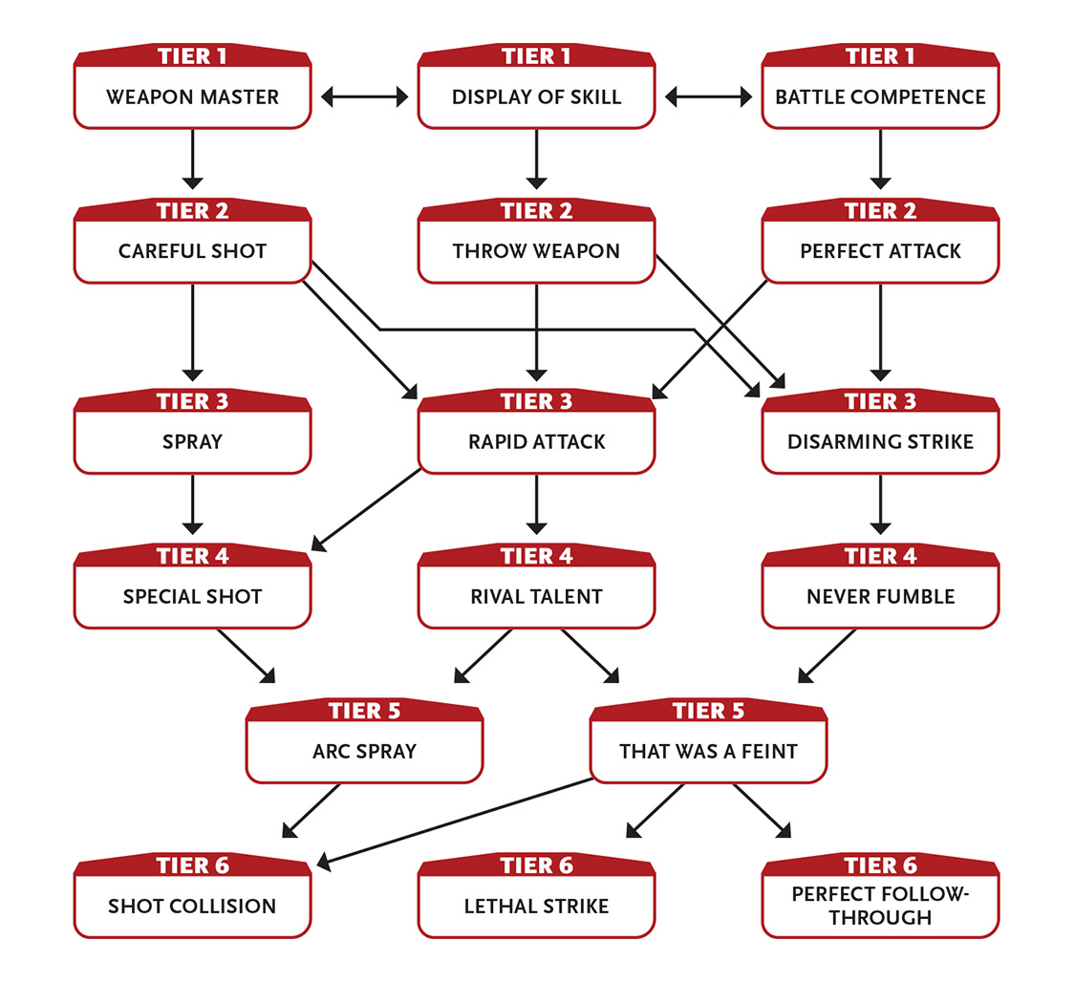

Tier 1
Battle Competence: You can freely use all weapons and all armor.
As an action, you learn the level of up to three creatures that you can see within short range. This ability can be foiled by disguises or shapechanging.
Enabler for weapon use; action for evaluating creatures.
The weapon use aspect of Battle Competence is a “catch up” ability for characters whose type doesn’t give them the ability to use most weapons and armor, and they don’t want to be limited to just their chosen weapon. Most characters with this focus won’t need the catch-up aspect of Battle Competence at all.
Display of Skill (2 Intellect): Seeing you use your weapon in combat (or perform showy moves outside of combat) gives one ally confidence that equates to a free level of Effort they can use on an action of their choice before their (or your) next ten-minute or longer recovery. Conversely, one foe can be cowed by this display, giving you a free level of Effort on a subsequent intimidation task. Enabler; action if used outside of combat.
Weapon Master: You’re proficient in using one kind of weapon (such as medium blades, light bashing, or heavy ranged) that would otherwise be unfamiliar to you. You can freely use this kind of weapon and suffer no penalty when using one.
You inflict an additional 1 damage with this kind of weapon.
You are trained in crafting your chosen kind of weapon. (Crafting training allows you to easily craft and repair weapons of that type using your resources.)
You can gain this ability multiple times. Each time you do so, pick a new kind of weapon to master.

Tier 2
Careful Shot: You can use Speed Effort or Intellect Effort to increase your ranged weapon damage.
In addition, if you use an action to line up your shot, the attack on your next turn inflicts 2 additional damage per level of Effort applied to increase damage (5 damage total per level of Effort).
Perfect Attack (2+ Might or Speed): Make an attack with your chosen weapon. If your roll is less than a 9, treat the roll as a 9. (This means you don’t get a GM intrusion if you roll a 1.)
If you succeed, the attack inflicts normal damage.
This ability doesn’t allow you to succeed at an attack that would be impossible, such as slashing a person a mile away or shooting an arrow at the moon.
This ability renews when you take a recovery.
Effort: Increase the minimum number rolled for this ability by 3.
Action.
At tier 3: The minimum number rolled for this ability increases to 12.
Throw Weapon (1+ Speed): You throw your light or medium melee weapon at a foe within short range as if it were a medium thrown weapon. Whether the weapon hits or misses, it rebounds back to your grasp if you succeed on a difficulty 3 Speed task (or difficulty 4 if the weapon is edged).
Effort: Throw a heavy weapon (instead of a light or medium weapon) as a Last action.
Action; Last action to throw heavy weapon.
If you throw your weapon and fail to catch it after it rebounds, it most likely ends up a short distance from you.

Tier 3
Disarming Strike (3 Speed): Make an attack against a foe with your chosen weapon. If you hit, you inflict 1 less damage than normal, but you disarm your foe, knocking their weapon to the ground 10 feet (3.5 m) away.
If your chosen weapon is a whip, you can instead choose to hinder your attack, and if it succeeds, the foe’s weapon lands in your other hand.
If your chosen weapon is a bow, you can instead choose to hinder your attack, and if it succeeds, the foe’s weapon is “nailed” to a nearby object or structure.
Action.
Rapid Attack (3 Speed): You make an additional attack on your turn with your chosen weapon. You can use this ability only once per round. Enabler.
Spray (2 Speed): If a weapon has the ability to fire rapid shots without reloading (usually called a rapid-fire weapon, such as a crank crossbow or submachine gun), you can spray multiple shots around your target to increase the chance of hitting, gaining an asset to the attack. This ability uses 1d6 + 1 attacks’ worth of ammunition or power (or all of the weapon’s stores, if it has less ammo or power than the number rolled). If the attack is successful, it deals 1 less damage than normal. You can also use this ability on multiple thrown weapons (such as stones, shuriken, daggers, and so on) if you’re carrying them on your person or they are all within reach. Action.

Tier 4
Never Fumble: If you roll a natural 1 when attacking with your chosen weapon, you can ignore or countermand the GM intrusion for that roll.
You can never be disarmed of your chosen weapon, nor will you ever drop it accidentally.
Rival Talent: You can tell a lot about someone by the weapon they wield. You ease all tasks (attacking, defending, influencing, tracking, and so on) against any foe using the same kind of weapon as your chosen weapon.
Special Shot: When you hit a target with a firearm attack, you can choose to reduce the damage by 1 point but hit the target in a precise spot. Some of the possible effects include (but are not limited to) the following:
- Shoot an object out of someone’s hand.
- Shoot the target’s leg, wing, or other limb they use to move, reducing their maximum movement speed to immediate for a few days or until they receive expert medical care.
- Shoot a strap holding a backpack, armor, or a similarly strapped-on item so that it falls off.
Enabler.

Tier 5
Arc Spray (3 Speed): If a weapon has the ability to fire rapid shots without reloading (usually called a rapid-fire weapon, such as a crank crossbow or submachine gun), you can fire your weapon at three targets (all next to one another) at once. Make a separate hindered attack roll against each target. Action.
That Was a Feint (5 Might or Speed): You immediately retry a failed attack roll with your chosen weapon, except this time you have an asset on the task. If this retry fails, you can’t use this ability to retry it again. Enabler.

Tier 6
Lethal Strike (6 Speed): With a swift and sudden melee or ranged weapon attack, you strike a foe in a vital spot. If you hit, you inflict an additional 7 damage. Action.
Perfect Follow-Through (8 Might or Speed): You can attack with your chosen weapon and take another action as an extra action on your turn. Enabler.
Shot Collision (4+ Speed): Once per round, if someone attacks you with a firearm, thrown weapon, or other physical projectile (such as an arrow, bullet, or crossbow bolt), instead of attempting a defense task, you can attempt to shoot the projectile out of the air. Make an attack against the projectile at the same difficulty as the defense task. If you hit, your shot deflects it, destroys it, or otherwise prevents it from hitting you.
If you wish, the successfully deflected object explosively shatters in an immediate radius you select between you and the attacker, dealing 2 damage to all creatures and objects in the area (roll a separate attack against each). If you apply Effort to increase the damage, you deal 2 additional damage per level of Effort (instead of 3); targets in the area take 1 damage even if you fail the attack roll.
Enabler.

Moves Like the Wind
You are an incredibly fast runner, whether moving toward a foe or away from danger.
- Genre themes: coward or messenger or scout (fantasy, historical, real world), athlete or coward or scout (real world, science fiction), speedster (superhero)
- GM intrusions: Quick movements sometimes lead to dropped items, slipping on uneven ground, or going the wrong way by accident.
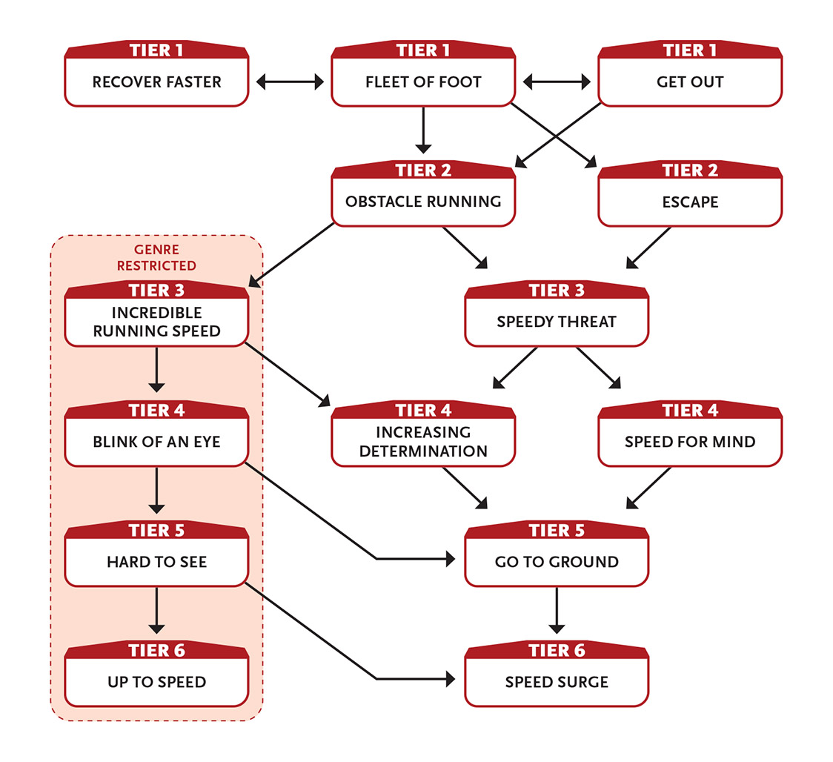
Some of the special abilities on the Moves Like the Wind flowchart are genre restricted, meaning those particular abilities are probably only suitable for a superhero, space opera, or other fantastic genre. The other abilities are suitable for most genres.

Tier 1
Fleet of Foot (1+ Speed): As an extra action on this turn you can move up to a short distance. (This movement doesn’t hinder your tasks.)
Effort: As an extra action on this turn you can move up to a long distance (instead of a short distance); this movement doesn’t hinder your tasks.
Enabler.
Get Out: If you move at least an immediate distance away from the most obvious threat or toward what promises to offer safety, one task you attempt next round is eased. Enabler.
Recover Faster: When you rally as your action, you gain an extra action on your turn that you can only use for moving. Enabler.

Tier 2
Escape (2+ Speed): When you roll to escape (such as slipping your restraints, squeezing through the bars, breaking the grip of a creature holding you, or pulling free from sucking quicksand) and your roll is less than a 9, treat the roll as a 9. (This means you don’t get a GM intrusion if you roll a 1.)
Effort: Increase the minimum number rolled for this ability by 3.
Action.
At tier 3: The minimum number rolled for this ability increases to 12.
Obstacle Running (3 Speed): Any movement you take this round ignores most difficult terrain that would otherwise slow your movement, allowing you to travel at normal speed through areas with rubble, fences, tables, and similar objects that you would have to climb over or move around. This movement might include sliding on a railing, briefly running along a wall, or even stepping on a creature to boost yourself over something. If an obstacle would normally require a Might or Speed task to overcome, such as swinging on a rope, balancing on a rope, or jumping over a hole, the task is eased. Enabler.

Tier 3
Incredible Running Speed: You move much farther than normal in a round.
When using Fleet of Foot, all distances you move are doubled.
If you run a long distance as your entire action, all your tasks are hindered by one step until the end of your next turn (instead of two steps).
As a Last action, you can run up to 500 feet (150 m), but all your tasks are hindered by two steps until the end of your next turn.
Enabler.
Speedy Threat: You spin and move such that your attacks are aided by your quick motion. If you move at least an immediate distance on your turn, your melee attack that turn gains an asset. Enabler.

Tier 4
Blink of an Eye (4 Speed): You move up to 1,000 feet (300 m). (This movement doesn’t hinder your tasks.) Last action.
Increasing Determination: If you fail at a noncombat physical task (such as pushing open a door or climbing a cliff) and then retry the task, the task is eased. If you fail again, you gain no special benefits. Enabler.
Speed for Mind: When attempting a Speed task, you can spend points from your Intellect Pool instead of your Speed Pool, and vice versa. Use the Edge stat for the Pool you’re spending points from. Enabler.

Tier 5
Go to Ground (4 Speed): As your action, you move up to a long distance and then attempt to hide. You gain an asset on the stealth task to blend in, disappear, or otherwise escape the senses of everyone previously aware of your presence (this movement doesn’t hinder your stealth task). Action.
Hard to See: When you move, you are a blur. It is impossible to make out your identity as you pass by someone at speed.
In addition, if you do nothing but move on your turn, your dodge and stealth tasks are eased by three steps until your next turn. Enabler.

Tier 6
Speed Surge: You immediately recover 1d6 + 6 points to your Speed Pool. This ability renews when you make a ten-hour recovery. Enabler.
Up to Speed: If you do nothing but move for three actions in a row, you accelerate greatly and can move up to about 200 mph (320 km/h)—about 2000 feet (600 m) each round—for ten minutes or about 35 miles (60 km). After this you must stop and take a recovery. Enabler.

Never Says Die
You never quit, can shrug off a beating, and always come back for more.
- Genre themes: fighter (fantasy), soldier or survivor (fantasy, real world, science fiction, postapocalypse), tank (superhero)
- GM intrusions: Sometimes, it’s equipment or weapons that give out.
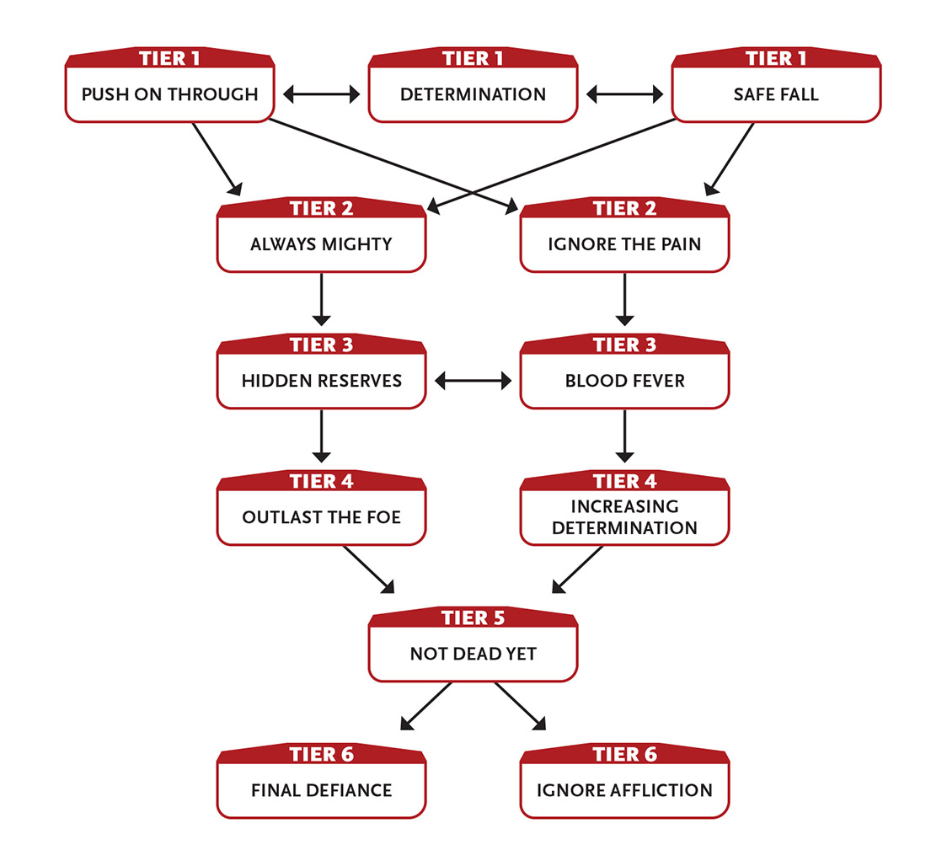

Tier 1
Determination: When you retry a failed task, in addition to the required level of Effort you must use, you gain a free level of Effort. You cannot use this ability again until after you have taken a recovery. Enabler.
Push on Through: Instead of a ten-minute recovery, you have a second one-action recovery—your first two recoveries are one action, the third is one hour, and the fourth is ten hours.
You can take one more moderate wound than normal.
You can use one of your one-action recoveries to allow an ally to use one of their ten-minute recoveries as an action.
Safe Fall: When you take a wound from a fall, reduce its severity by one step. Enabler.

Tier 2
Always Mighty: Every time you use a recovery, if your Might Pool isn’t already full, you get 1 extra point to restore to your Might Pool. You can select this ability up to three times.
Ignore the Pain: You ignore one step of hindrance from one major wound or from having taken all your moderate wounds.
You can choose this ability up to three times. Each time you choose it, it allows you to ignore another step of hindrance caused by wounds.
Enabler.

Tier 3
Blood Fever: While at least one of your Pools has no points, or while you have at least two moderate wounds or one major wound, you gain an asset to attacks or defense rolls (your choice), as well as to intimidation rolls. Enabler.
Hidden Reserves: When you use a one-action recovery, you add +1 to your Might Edge and your Speed Edge until you use a ten-minute or longer recovery. Enabler.

Tier 4
Increasing Determination: If you fail at a noncombat physical task (pushing open a door or climbing a cliff, for example) and then retry the task, the task is eased. If you fail again, you gain no special benefits. Enabler.
Outlast the Foe: If you have been in combat for five full rounds, you have an asset for all tasks in the remainder of the combat, and you deal an additional 1 damage per attack. Enabler.

Tier 5
Not Dead Yet: When you would normally be dead, you instead fall unconscious for one round and then awaken.
When you awaken this way, you immediately gain 1d6 + 6 points to restore your stat Pools, and you remove one moderate wound and one major wound.
Once you use this ability, your tasks are hindered until you use a ten-hour recovery.
If you die again before you make your ten-hour recovery, you are truly dead.
You can select this ability twice. The second time you select it, the healing increases to 1d6 + 12 and you remove double the number of wounds.

Tier 6
Final Defiance: When you would normally be dead, you instead remain conscious and active for one more round. (This ability activates before Not Dead Yet activates.)
As an extra action on your turn each round thereafter, you can attempt a difficulty 5 Might task to remain alive for one additional round.
During these extra rounds of life, all your tasks are hindered.
If by the last round you’re alive you do not receive healing, gain points in a Pool, or otherwise rally or remove a wound that killed you, Not Dead Yet activates.
Enabler.
Ignore Affliction (5 Might): Until you use a one-hour or longer recovery, you ignore any unwanted condition or affliction (such as disease, paralysis, mind control, broken limb, and so on, but not damage) and act as if it does not affect you. If the condition would normally last less than an hour, it is entirely negated. You can use this ability even if the condition prevents you from taking actions. Action.

Performs Feats of Strength
A muscled prodigy, you can haul incredible weight, hurl your body through the air, and punch through doors.
- Genre themes: fighter (fantasy), athlete (real world, science fiction), brick (superhero)
- GM intrusions: It’s easy to break delicate things or hurt someone accidentally.
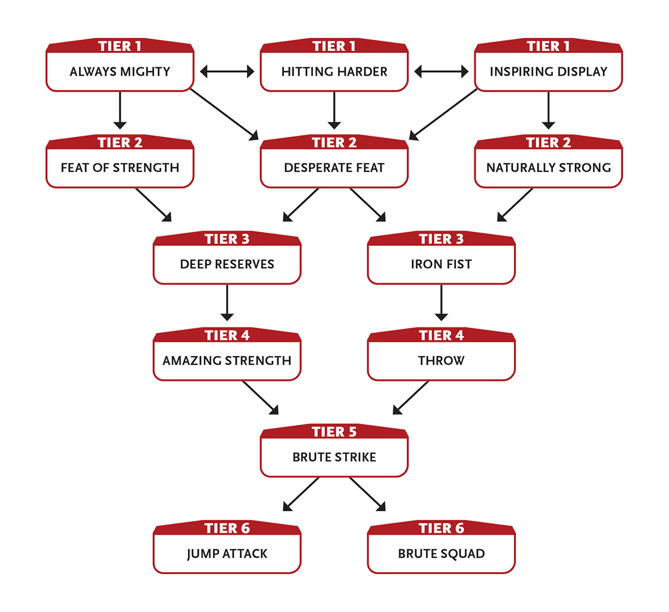

Tier 1
Always Mighty: Every time you use a recovery, if your Might Pool isn’t already full, you get 1 extra point to restore to your Might Pool. You can select this ability up to three times.
Hitting Harder: You inflict an additional 1 damage with unarmed attacks.
Inspiring Display (2 Might): After succeeding at a task that depends on brute force (such as smashing down a barred door, tearing open a locked container, lifting or moving a heavy object, or striking someone with a melee weapon), choose an ally who saw you. A chosen PC regains 2 points to a Pool of their choice; a chosen NPC regains 2 health. Enabler.

Tier 2
Desperate Feat: While you have at least one moderate or major wound, you add +1 Edge to the Pool of your choice. Enabler.
Feat of Strength (1 Might): Your physical action is impressive, inspiring an ally or intimidating a foe. After succeeding at a task that depends on brute force (such as smashing down a barred door, tearing open a locked container, lifting or moving a heavy object, or striking someone with a melee weapon), choose a creature who saw you succeed. If they are an ally, you ease their next task. If they are a foe, you can either hinder one of their tasks on their next turn or immediately attempt an eased intimidation task against them. Enabler.
Naturally Strong (2+ Might): When you roll on a task to carry, climb, jump, or smash, and your roll is less than a 9, treat the roll as a 9. (This means you don’t get a GM intrusion if you roll a 1.)
This ability renews when you take a recovery.
Effort: Increase the minimum number rolled for this ability by 3.
Enabler.
At tier 3: The minimum number rolled for this ability increases to 12.

Tier 3
Deep Reserves: When others are exhausted, you can push through. You can transfer up to 6 points among your Pools in any combination, at a rate of 1 point per round. For example, you could transfer 3 points of Speed to Might and 3 points of Intellect to Might, which would take a total of six rounds. This ability renews when you take a ten-hour recovery. Action.
Iron Fist: You inflict an additional 3 damage with unarmed attacks.

Tier 4
Amazing Strength: When you use Effort from your Might Pool on a noncombat task, you get a free level of Effort on that task. Enabler.
Throw (2 Might): When your unarmed attack damages a creature of your size or smaller, you throw that creature 1d20 feet away from you. The creature lands prone. Enabler.

Tier 5
Brute Strike (4 Might): When you hit with a Might attack, you deal an additional 6 damage. You can’t use this ability in two consecutive rounds. Enabler.

Tier 6
Brute Squad (8 Might): You can perform two Might tasks on this turn, one with your normal action and one with an extra action. For example, you could make a melee attack and smash open a door, throw a heavy couch and jump over a wall, or make two melee attacks. Enabler.
Jump Attack (5+ Might): You jump up to 4 feet (1 m) into the air and make a melee attack against a foe on the way up or down. If you hit, you inflict damage and can attempt a difficulty 4 Might roll to inflict an additional 4 damage and knock them prone.
Effort: Add 2 feet to the jump height and an additional 2 damage to the attack (whether or not you knock the target prone).
Action.

Quells Evil
You are skilled in finding, destroying, and banishing undead, demons, and creatures of similar ilk.
- Genre themes: cleric (fantasy), priest (real world with a touch of magic), spiritual super (superhero)
- GM intrusions: Some evil creatures are more powerful and resilient than they first seem. Too much evil contact risks contagion with evil influence.
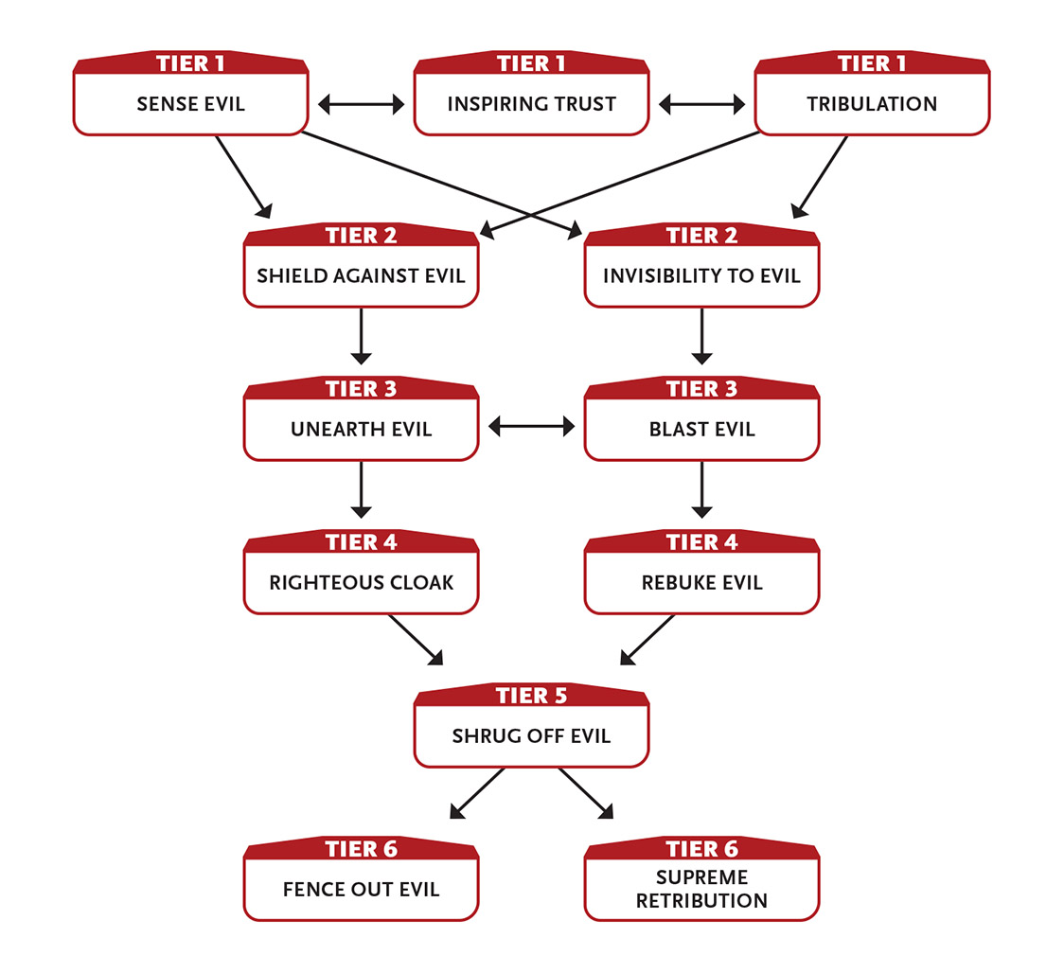

Tier 1
Inspiring Trust (1 Intellect): Allies in your presence that share your sense of good versus evil add +1 to their recoveries. Enabler.
Sense Evil (2+ Intellect): When you use an action to perceive undead, demons (or creatures possessed by demons), or creatures of similar ilk within immediate range, if you roll a 9 or less, treat the roll as a 9. (This means you don’t get a GM intrusion if you roll a 1.) This ability lasts until you use a ten-minute or longer recovery.
Effort: Increase the minimum number rolled for this ability by 3.
Action to initiate.
At tier 3: The minimum number rolled for this ability increases to 12.
Tribulation (1+ Intellect): You conjure pure spiritual energy to blast up to five undead, demons, and creatures of similar ilk of level 2 or less within short range. If you succeed on a separate Intellect attack against each foe, you choose whether they spend their next turn fleeing or lose their next turn.
Effort: Increase the maximum level of the foe you can affect by 1. Specify some other action for the creatures to perform for one round, such as attacking a foe of your choice.
Last action.
“Creatures of similar ilk” could include additional categories of ineffably evil entities, depending on the campaign. Work with your GM to determine the details if there are any questions. For instance, other hellish creatures, fallen angels, Lovecraftian creatures, creatures from the “Crawling Deeps,” or creatures born of “the Strange” might be just as anathematic as undead and demons.

Tier 2
Invisibility to Evil (2+ Intellect): You or a touched ally become becomes effectively invisible to undead, demons, or creatures of similar ilk of level 3 or less until you use a ten-minute or longer recovery. This effect ends if the target does something to reveal their presence or position—attacking, using an ability, moving a large object, and so on.
Effort: Increase the maximum level of foes who can’t perceive the invisible target by 1.
Action to initiate.
Shield Against Evil (1 Intellect): You bless yourself or a touched ally with protection against undead, demons, or creatures of similar ilk until you use a ten-minute or longer recovery. The protection eases defense rolls against the specified creature variety and grants immunity against mental influence, fear, and possession (from any source). Action.

Tier 3
Blast Evil (4 Intellect): You blast an adjacent immediate area with cleansing radiance, inflicting 3 damage on up to three targets in the area—make a separate attack roll against each. If the targets are undead, demons, or creatures of similar ilk, they take 6 damage instead. If any targets are possessed by a spirit, demon, or similar entity, they gain another opportunity to resist the effect and eject their possessor. Action.
Unearth Evil (4+ Intellect): You detect the faint whiff of undead, demons, and similar ilk from a great distance. When you use this ability, you generate a mental “heat map” of qualifying creatures within a 10-mile (16 km) radius. Affected creature locations are accurate to within about 100 feet (30 m). This takes anywhere from an hour to a full day of concentration, depending on what the GM feels is appropriate due to time, distance, or other mitigating circumstances. However, you don’t know in advance how long it will take. Creatures of level 4 or higher are aware that something has noticed them, but they don’t necessarily realize what.
Effort: Once you have established where each qualifying target is located, you retain a sense of their locations (so if they move, you are aware of their new position) until you use a one-hour or longer recovery (this requires two levels of Effort).
Action to initiate.
A heat map is a simple map of an area using colors to show the intensity of something in a visual way, like showing where things are “hot” or “cold”—or, in this case, “evil.”

Tier 4
Rebuke Evil (4+ Intellect): You rebuke one undead, demon, or creature of similar ilk within short range that you make a successful Intellect attack against. The affected creature does their best to accomplish a goal you specify in your rebuke, even if it would cause them or their allies harm, until you use a ten-minute or longer recovery.
Effort: Affect an additional foe (make a separate attack roll against each foe); you must give the same command to all affected creatures.
Last action.
Righteous Cloak (4 Intellect): You shine with wholesome light, automatically inflicting 4 damage (no roll needed) on anyone who tries to touch you or strike you with a melee attack. While Righteous Cloak is active, bright light illuminates a short area around you if you wish. This ability lasts until you use a ten-minute or longer recovery. Enabler.

Tier 5
Shrug Off Evil: You are immune to mental influence, fear, and possession (from any source).
You ignore one wound inflicted by undead, demons, or creatures of similar ilk. This aspect of this ability renews after you take a ten-hour recovery. Enabler.

Tier 6
Fence Out Evil (6+ Intellect): You encircle a short area in a transparent, immaterial wall of cleansing light until you use a ten-minute or longer recovery. When the wall appears, each undead, demon, or creature of similar ilk within its area—or that enters the area—automatically takes 3 damage (ignores armor) from the light (no attack roll required) each round. In addition, you can attempt an Intellect attack against a qualifying creature in the area each round as your action. If you succeed, that creature is affected as if you successfully used Rebuke Evil against them. Action to initiate; action for each targeted use.
Supreme Retribution (8 Intellect): You call down a shaft of roaring radiant flame in an immediate area within long range. Make separate Intellect attacks against each creature in the area. Success means you inflict 4 damage; all creatures take 1 damage even on a failed attack roll. Choose one creature in the area to take an additional 3 damage regardless of whether your attack succeeded or failed. Action.

Reveres a Supernatural Force
You are a member of a religious order that studies the mystical power that unites all things across galactic distances, granting you psychic and physical abilities.
- Genre themes: eldritch knight (fantasy), psychic knight (science fiction)
- GM intrusions: Sensing a sudden and massive number of deaths can be overwhelming. A foe reveals their own connection to the mystic power.
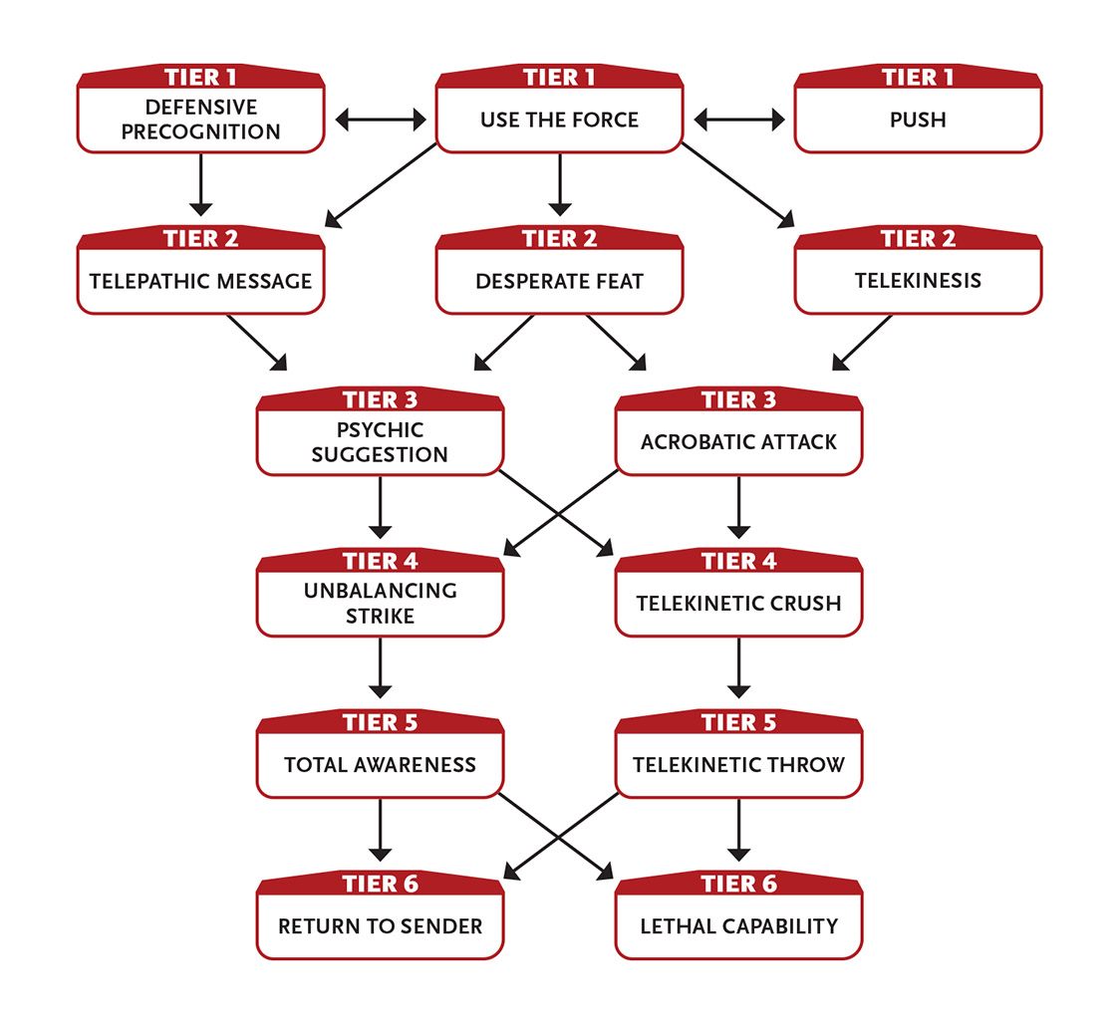

Tier 1
Defensive Precognition (4 Intellect): You automatically dodge all ranged attacks (no roll required). However, on your next turn after you’re attacked with a ranged attack, all your other actions are hindered. This ability lasts until you use a ten-minute or longer recovery. Action to initiate.
Push (2 Intellect): You telekinetically push a target within short range an immediate distance in any direction. You must be able to see the target, it must be your size or smaller, and it must not be affixed to anything. The push is quick, and the force is about as direct and crude as a kick or punch. Action.
Use the Force (2 Intellect): You gain an asset on a single noncombat task you attempt this turn. You cannot use this ability again until after you take a recovery. Enabler.

Tier 2
Desperate Feat: While you have at least one moderate or major wound, you add +1 Edge to the Pool of your choice. Enabler.
Telekinesis (2 Intellect): You telekinetically affect an object you can see within long range that is not too heavy for you to physically affect if you were standing next to it and could use your hands normally. Options include closing or opening a door, writing a simple symbol or a few words with a writing instrument, transferring an object a short distance, wresting an object from another creature’s grasp (on a successful Intellect roll versus their level), pushing a creature an immediate distance (with a successful attack roll), or even hindering a creature’s attack or defense by applying restraining pressure to a leg or arm (with a successful attack roll). In all cases, the effect must occur over the course of one round.
Action.
Telepathic Message (2+ Intellect): You can send a one-way telepathic message lasting about a minute. You must have at least seen the target before, and they must be on the same planet as you. The target recognizes the contact as a telepathic message and may recognize your mental “voice.”
Effort: Increase the range to anywhere in the same star system. Increase the range to anywhere in the same galaxy (this requires three levels of Effort). Action to initiate.

Tier 3
Acrobatic Attack (1+ Speed): You leap into the attack, twisting or flipping through the air. If you use Effort on the attack roll, you get a free level of Effort on it.
If you roll a natural 17 or 18, instead of inflicting extra damage you can choose to have a minor effect.
You can’t use this ability if your physical actions are hindered from wearing armor.
Enabler.
Psychic Suggestion (4 Intellect): If your Intellect attack succeeds, a target within short range takes the action you indicate on their next turn. If this action would cause direct harm to the creature or their allies, your mental attack is hindered. Action.

Tier 4
Telekinetic Crush (4 Intellect): Make a hindered Intellect attack against a nonliving foe (such as a robot or zombie). If you succeed, you crush them, inflicting 6 damage. Action.
Unbalancing Strike (4 Speed): Make a melee attack to knock your foe off balance. This attack is eased by two steps. If you succeed, you inflict damage and all actions they attempt on their next turn are hindered. Action.

Tier 5
Telekinetic Throw (5 Intellect): You telekinetically grab an object within short range and hurl it at a target within short range. (To throw a creature instead of an object, you first have to telekinetically grab them with a successful Intellect attack.) Make an Intellect attack against your target. If you succeed, your target and whatever you throw each take 6 damage. Action.
Total Awareness: You automatically and frequently use your special senses to check your immediate vicinity, making it very difficult to surprise, hide from, or sneak up on you. When you use Effort on initiative and perception tasks, you gain two free levels of Effort. Enabler.

Tier 6
Lethal Capability: You inflict an additional 5 damage with attacks of one specific type, such as a thrown knife, a shot with a blaster, unarmed attacks, or some other specific attack you prefer.
You can gain this ability more than once. Each time you do, choose a different specific attack.
Return to Sender (3 Speed): If you successfully block or dodge a melee attack, you can immediately make a melee attack against the attacking foe. You can’t use this ability again until after you take your normal turn. Enabler.

Rides the Lightning
You emit and manipulate lightning and thunder.
- Genre themes: wizard, nature cleric (fantasy), alien (science fiction), lightning wielder (superhero)
- GM intrusions: Targets other than those intended are shocked. Objects explode. Loud noises attract attention.
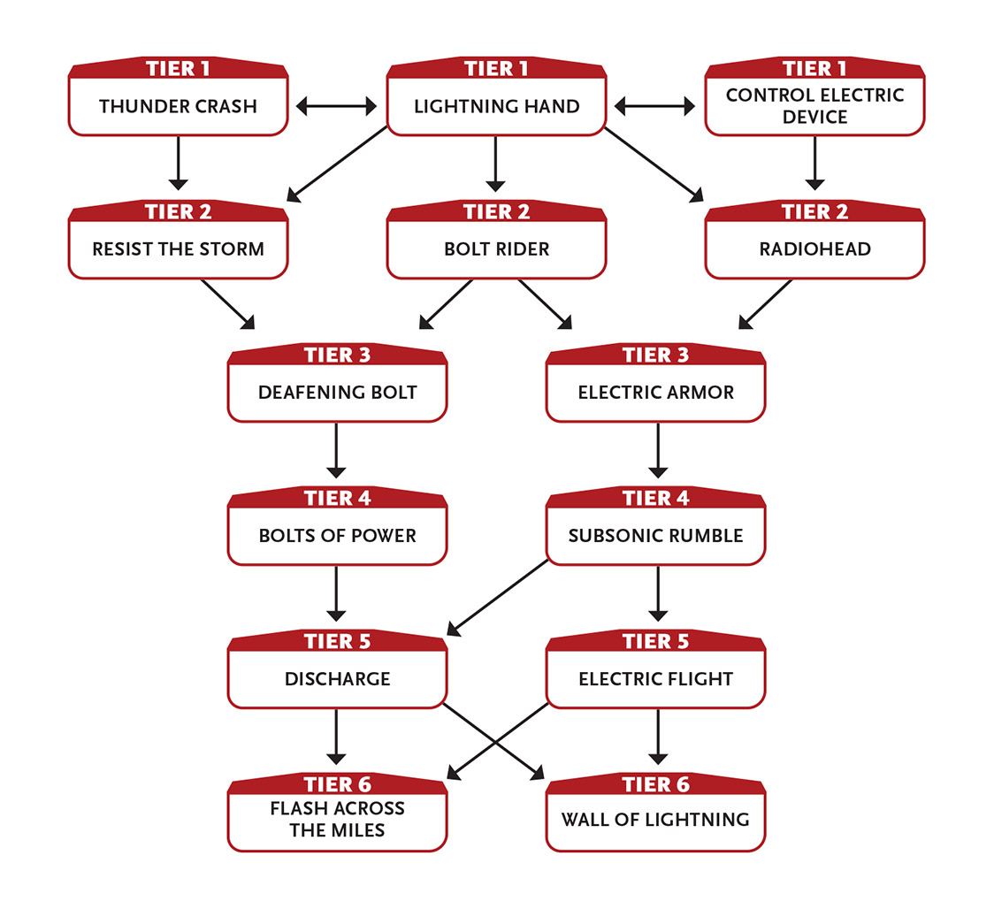

Tier 1
Control Electric Device (2+ Intellect): You can attempt to control or disrupt an electric device (in other words, a non-intelligent device or machine that is powered by electricity) at long range. Make an Intellect attack against the device. If your roll is less than a 12, treat the roll as a 12. (This means you don’t get a GM intrusion if you roll a 1.)
If you succeed, you can control the device as if you were next to it, even if normally you would have to touch it, read a screen, or manually operate it. If the machine is protected against casual access via some kind of security protocol, your tasks to hack or otherwise bypass that security are hindered unless you are within immediate range. If it is held by another creature, you must succeed against the creature’s level or the device’s level, whichever is higher.
If attempting to disrupt the device, success means it shorts out and, if you wish, also explodes in an immediate radius, dealing 1 damage to all creatures in the area (make separate Intellect attack rolls against each creature).
Effort: Increase the minimum number rolled for this ability by 3.
Action.
At tier 3: The minimum number rolled for this ability increases to 15.
Lightning Hand (1 Intellect): Your hands crackle with electricity, allowing you to make either one touch attack or one long-range lightning blast attack, inflicting 4 damage.
Alternatively, if you wield a weapon, it crackles with electricity and inflicts an additional 1 damage. This version of the ability lasts until you use a ten-minute or longer recovery.
Action for touch; enabler for weapon.
Touch attacks are effectively light unarmed attacks, and therefore are eased.

Thunder Crash (2 Intellect): You affect a target in long range with overwhelming thunder. With a successful Speed attack, you inflict 2 damage and induce a tremor in their body. Each round after this initial attack, as an extra action on your turn you can make another attack roll for the destructive tremor to inflict an additional 1 damage on the target. If you fail this roll, the tremor ends.
Action to initiate.

Tier 2
Bolt Rider (4 Intellect): You can move a long distance from one location to another almost instantaneously, carried by a bolt of lightning. You must be able to see the new location, and there must be no intervening barriers. Action.
Radiohead: You can transmit and receive radio transmissions across a broad range of frequencies. You can keep your radio communications entirely private, or relay them audibly as if you were a standard radio. If attempting to access an encrypted digital radio signal, you must succeed on an Intellect task against the encryption’s level. Communicating this way is as natural for you as verbal speech, which means sometimes you may overhear something interesting over the radio even when not searching for it. Enabler.
Resist the Storm: You’re resistant to the natural hazards of storms. Choose either electricity or sonic energy. If attacked with this kind of energy, reduce the severity of the wound by one step (major to moderate, moderate to minor, minor to none).
You can take this ability twice, each time selecting a different kind of energy.
Enabler.

Tier 3
Deafening Bolt (3 Intellect): You unleash a bolt of lightning at a target within long range. If your attack succeeds, the target takes 5 damage and is deafened until you use a ten-minute or longer recovery, during which time they can’t hear anything and their defense tasks are hindered. Action.
Electric Armor (3 Intellect): Lightning crackles across your body until you use a ten-minute or longer recovery. The electricity doesn’t harm you, but it automatically inflicts 3 damage on anyone who tries to touch you or strike you with a melee attack (no roll required).
While this ability is active, you ignore moderate and minor wounds from electricity.
While this ability is active, you can make a touch attack that inflicts 2 damage from electricity.
Enabler.

Tier 4
Bolts of Power (5 Intellect): You simultaneously unleash four lightning bolts, dealing 4 damage to up to four targets in short range; roll separately against each target. Even on a miss, your target still takes 1 damage. Action.
Subsonic Rumble (5 Intellect): You emit an unnerving subsonic rumble that most living creatures can’t hear but that affects them all the same. For creatures within short range, attempts to charm them, intimidate them, or frighten them are eased by two steps. You continue to emit this rumble until you use a ten-minute or longer recovery. Action to initiate.

Tier 5
Discharge (5+ Intellect): You take on a visible shine, tone, or crackling energy discharge. This is harmless unless you choose to direct it outward. While this ability is active, as an action you can strike up to three targets in short range (make separate Intellect attack rolls). Success means you inflict 4 damage.
This ability lasts until you use a ten-minute or longer recovery.
Effort: Increase the effect on a target so that in addition to taking damage, they lose their next turn.
Action to initiate.
Electric Flight (0+ Intellect): While Electric Armor is active, you can fly. You can move a short distance and take an action, or move a long distance as your action. (Unlike a normal situation of taking an action and moving a short distance, this doesn’t hinder your tasks.) You can carry one creature of your size or smaller with you. They aren’t harmed by your Electric Armor.
Effort: Cover and protect a passenger with Electric Armor as if they were you.
Enabler.

Tier 6
Flash Across the Miles (6+ Intellect): You move as a bolt of lightning almost instantaneously to a location you’re familiar with on the same planet. The location must be outdoors or open to the sky.
Effort: Travel to an indoor location if a lightning bolt could find an open route to that spot from the outside (such as through a window or doorway).
Action.
Wall of Lightning (8 Intellect): You create a barrier of crackling electricity composed of six 10-foot by 10-foot (3.5 m by 3.5 m) squares, each 1 inch (2.5 cm) thick, arranged as you wish. The wall is a level 7 barrier. One or both sides crackle with excess electricity; anyone within immediate distance of an energized side takes 10 damage (no rolls required), or double that if they pass through. The wall lasts until you use a ten-minute or longer recovery. Action to create.

Sneaks Through the Shadows
You use shadows and darkness to make your way unseen, moving quickly and smoothly, and you never seem to be where danger is. Maybe you use these abilities to hunt treasures, or maybe just to steal.
- Genre themes: burglar or thief or treasure hunter (fantasy), thief or spy (historical, real world, science fiction, superhero)
- GM intrusions: You get thrown in jail. Powerful enemies are made. You have a moment of clumsiness.
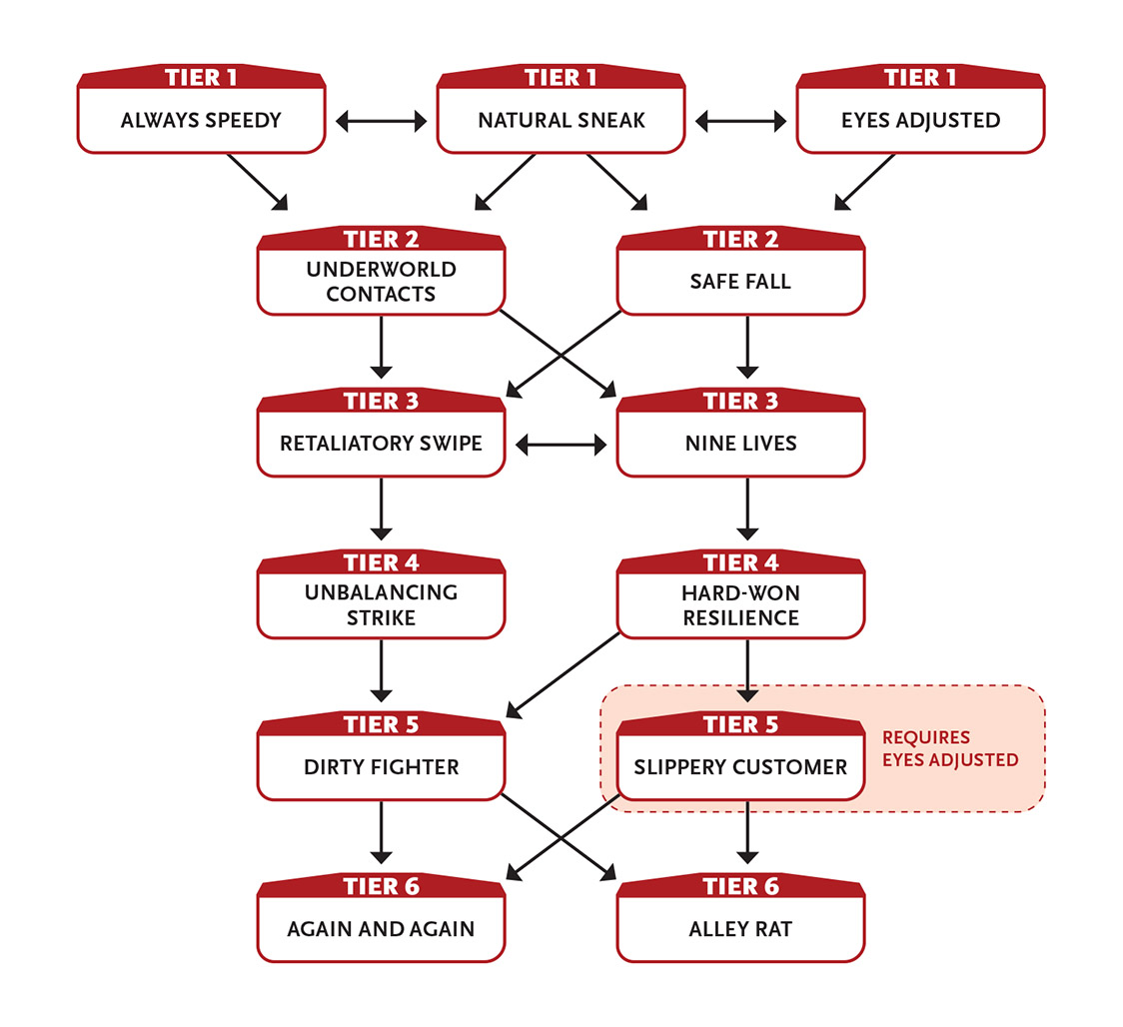

Tier 1
Always Speedy: Every time you use a recovery, if your Speed Pool isn’t already full, you get 1 extra point to restore to your Speed Pool. You can select this ability up to three times.
Eyes Adjusted: You can see in very dim light as though it were bright light. You can see in total darkness as if it were very dim light.
Natural Sneak (2+ Intellect): When you roll on a lockpicking, perception, pickpocketing, or stealth task and your roll is less than a 6, treat the roll as a 6. (This means you don’t get a GM intrusion if you roll a 1.)
This ability renews when you take a recovery.
Effort: Increase the minimum number rolled for this ability by 3.
Enabler.
At tier 3: The minimum number rolled for this ability increases to 9.

Tier 2
Safe Fall: When you take a wound from a fall, reduce its severity by one step. Enabler.
Underworld Contacts: You know many people in a variety of communities who engage in illegal activities. These people are not necessarily your friends and might not be trustworthy, but they recognize you as a peer. You and the GM should work out the details of your underworld contacts.

Tier 3
Nine Lives: You can use Might Effort or Speed Effort on block rolls.
Retaliatory Swipe (3 Speed): If a melee attack hits you, you can immediately make a melee attack against your attacker. You can’t use this ability more than once per turn. Enabler.

Tier 4
Hard-Won Resilience: Due to your experiences, you’ve been exposed to all sorts of terrible things and are developing a general resistance. You can take one more moderate wound than normal.
Unbalancing Strike (4 Speed): Make a melee attack to knock your foe off balance. This attack is eased by two steps. If you succeed, you inflict damage and all actions they attempt on their next turn are hindered. Action.

Tier 5
Dirty Fighter (2 Speed): Make a Speed attack against a foe within long range who you want to distract, blind, annoy, hamper, or otherwise interfere with. If you succeed, you hinder their attacks and defenses until you use a ten-minute or longer recovery. Action.
Slippery Customer: You ignore all penalties from very dim light and darkness.
You ignore penalties for actions in cramped spaces.
You gain an asset on stealth tasks in dim light, very dim light, and darkness.

Tier 6
Again and Again (6 Speed): You can take an extra action on your turn. Enabler.
Alley Rat (6 Intellect): While in a city, you attempt to find or create a significant shortcut, secret entrance, or emergency escape route where it looked like none existed. To do so, you must succeed at an Intellect task, with the difficulty set by the GM based on the situation. You and the GM should work out the details of your unexpected path, but it should let you move at least a short distance away from where you are now. Action.

Solves Mysteries
You’re a master of deduction, using evidence to find the answer.
- Genre themes: truthfinder (fantasy), detective (real world, science fiction, superhero)
- GM intrusions: Evidence disappears, red herrings confuse, and witnesses lie. Initial research can be faulty.
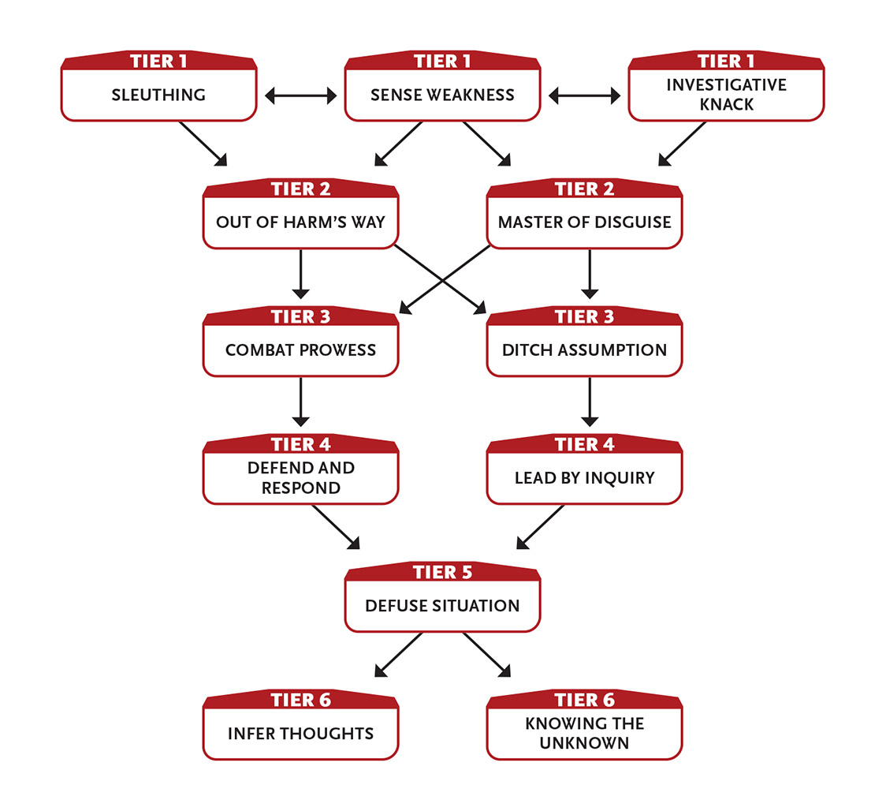

Tier 1
Investigative Knack (2+ Intellect): You have a keen eye for detail and can pick up subtle cues that indicate someone is lying or withholding information.
When you study an area for clues or converse with (or interrogate) someone for information, if you roll a 9 or less on your perception, interaction, or recognizing motive task, treat the roll as a 9. (This means you don’t get a GM intrusion if you roll a 1.) This ability lasts until you use a ten-minute or longer recovery.
Effort: Increase the minimum number rolled for this ability by 3.
Action to initiate.
At tier 3: The minimum number rolled for this ability increases to 12.
Sense Weakness (2 Intellect): After observing a creature for one round, you know of any special weaknesses they may have and your attacks inflict an additional 1 damage against them. Action to initiate.
Sleuthing (3 Intellect): When you’re tracking a target of interest, looking for anything out of the ordinary (such as a clue or a single piece of evidence) at the scene of interest, or otherwise attempting to learn something about a mystery, you can ask the GM one question about the task and get a very short helpful answer that might be obvious to the character, but not to the player who doesn’t have their character’s experience. Action.

Tier 2
Master of Disguise (2+ Intellect): You can create a disguise as a Last action instead of the minute or more typically required.
When you roll on a disguise task and your roll is less than a 6, treat the roll as a 6. (This means you don’t get a GM intrusion if you roll a 1.) This ability renews when you take a recovery.
Effort: Increase the minimum number rolled for this ability by 3.
Enabler.
At tier 3: The minimum number rolled for this ability increases to 9.
Out of Harm’s Way (2 Speed): When you succeed on a dodge task, you can immediately move an immediate distance even though it’s not your turn. Enabler.

Tier 3
Combat Prowess: You add +1 damage to one type of weapon attack of your choice: melee weapon attacks or ranged weapon attacks.
Ditch Assumption (4 Intellect): After careful observation and investigation (questioning one or more NPCs on a topic, searching an area or a file, reassessing your prior beliefs, or similar activity), you gain clarity on a topic—the GM identifies one false assumption you have regarding your current investigation. For instance, if you have come to mistakenly believe a fact, the GM lets you know. Alternatively, if you have several possible suspects for a crime, the GM eliminates one. However, if you’re not operating with false information or running down a red herring, and you don’t have incorrect suspects to eliminate, you learn nothing. This ability renews after you take a ten-hour recovery.
Ten minutes to initiate.

Tier 4
Defend and Respond (3 Might or Speed): If you block or dodge a melee attack, you can immediately make a melee attack against your attacker. You can’t use this ability more than once per turn. Enabler.
Lead by Inquiry: When you and any number of allies spend a ten-hour recovery together (yours or theirs), the allies are treated as if trained in perception and recognizing motive. This benefit remains while you remain within a long distance of them. The benefit is suspended at greater distances, but resumes automatically if you get within range. The benefit ends if you use a ten-hour recovery while away from the allies. Enabler.

Tier 5
Defuse Situation (4 Intellect): During the course of an investigation, your questions sometimes elicit an angry or even violent response. Through dissembling, verbal distraction, or similar evasion, you prevent a living foe from attacking anyone or anything for one round if you succeed on a charm, deception, intimidation, or other interaction task. Action.

Tier 6
Infer Thoughts (4+ Intellect): If you interact with or study a target of level 4 or less for at least a round, you gain so much insight into its surface thoughts that you’re essentially reading its mind (no roll required), even if the subject doesn’t want you to. You must be able to see the target. Once you have gained a sense of what it’s thinking—through its body language, its speech, and what it does and doesn’t say—you can continue to infer the target’s surface thoughts until you use a ten-minute or longer recovery as long as you can still see and hear the target.
Effort: Increase the maximum level of a target you can affect by 1.
Action to prepare; action to initiate.
Knowing the Unknown (6 Intellect): By accessing the resources appropriate to your character, you can ask the GM one question and get a general answer. The GM assigns a level to the question, so the more obscure the answer, the more difficult the task. Generally, knowledge that you could find by looking somewhere other than your current location is level 1, and obscure knowledge of the past is level 7. Gaining knowledge of the future is impossible. Action.

Speaks for the Land
Your spiritual connection to nature and the environment grants you mystical abilities.
- Genre themes: nature priest, plant druid (fantasy), plant psychic (real world, science fiction, superhero)
- GM intrusions: An injured natural (but dangerous) creature is discovered. Someone is poaching wildlife for their skins, leaving the carcasses to rot. A tree falls in the forest, one of the last elder trees.
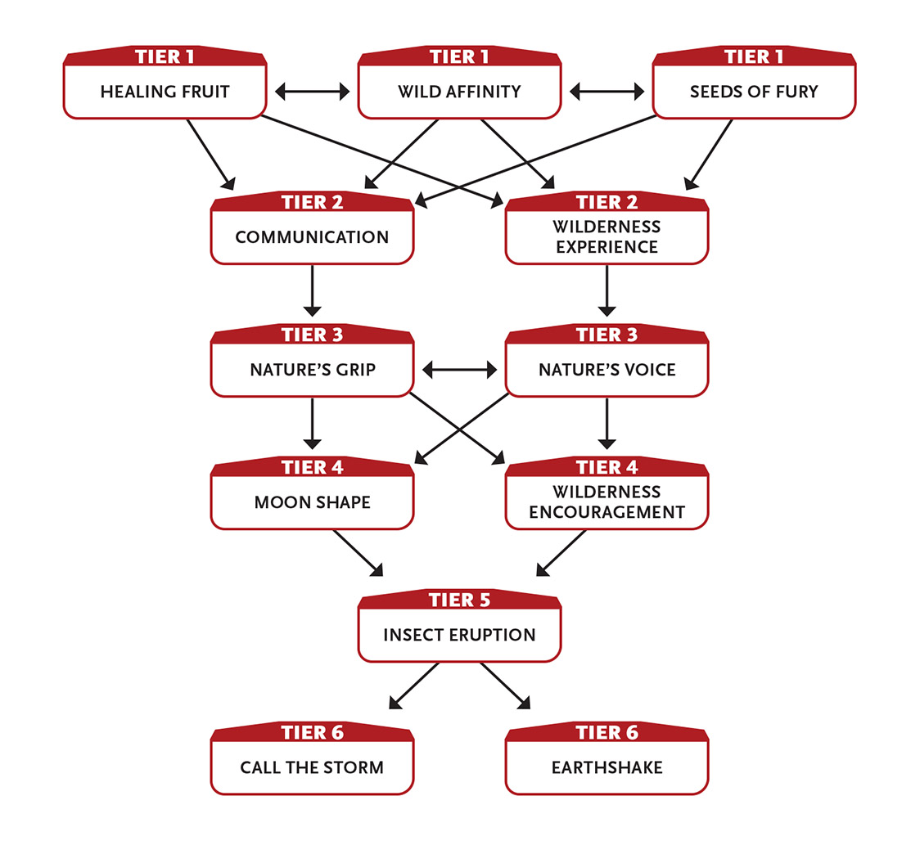

Tier 1
Healing Fruit (1 Intellect): You infuse one fruit or seed with healing magic. A creature that eats it regains 1d6 to a stat Pool of their choice or recovers a minor wound. A creature cannot gain this benefit again until they take a ten-minute or longer recovery. An uneaten fruit automatically loses its healing magic when you use a ten-minute or longer recovery. Action.
Seeds of Fury (1 Intellect): You throw a handful of seeds in the air that ignite and speed toward a target within long range, scratching the air with twisting smoke trails. A successful attack deals 3 damage and catches the target on fire, inflicting an additional 1 damage per round until the target uses an action to douse the flames or until you use a ten-minute or longer recovery. Action to initiate.
Wild Affinity: A natural wild animal in its right mind and in its natural environment will not attack you unless provoked or controlled.

Tier 2
Communication (2 Intellect): You can convey a basic concept to a creature that normally can’t speak or understand speech. The creature can also give you a very basic answer to a simple question. Action.
Wilderness Experience: Given an hour or so, you can always find edible food and potable water in the wilderness, enough to feed yourself and a few other people.
Your experience with venomous animals and poisonous plants gives you some additional protection against them. Your defense rolls against poison are eased and you reduce the severity of wounds from poison by one step (major to moderate, moderate to minor, minor to none). For example, if you are bitten by a snake whose poison inflicts a moderate wound, you’d only take a minor wound from the poison.
You are immune to natural diseases.
When in the wild, you ignore any task penalties and movement penalties affecting you due to tall grass, thick brush, rugged terrain, weather, and other natural causes.

Tier 3
Nature’s Grip (3+ Intellect): Make an Intellect attack against a foe within short range. Success means branches, grass, or other natural foliage snags and holds the foe until you use a ten-minute or longer recovery. The foe can’t move from their current position, and their physical tasks (including attacks and defense) are hindered.
If the foe tries to break free, you can continue to restrain them with another Intellect roll.
You can use this ability to repel entangling plants in an immediate area within short range, leaving a clear space with no obstructions.
Effort: Inflict 3 damage on the round the foe is first held.
Action.
Nature’s Voice (3+ Intellect): Make an Intellect attack roll to calm a nonhuman beast within long range that can see you. You must speak to them (although they don’t need to understand your words). They remain calm until you use a ten-minute or longer recovery or for as long as you keep using your action to calm them.
Effort: Affect an additional beast (2 Intellect).
Action.
The GM has final say over what counts as a nonhuman beast. Unless some kind of deception is at work, you should know whether you can affect a creature before you attempt to use Nature’s Voice on them. Aliens, extradimensional entities, very intelligent creatures, and robots never count.

Tier 4
Moon Shape (4+ Intellect): You become a primal beast ruled by fury and instinct until you use a one‑hour or longer recovery. You cannot activate this ability if you are not in moonlight (at least a half moon). In beast form, you add 8 points to your Might Pool and 2 points to your Speed Pool, and add +2 to your Might Edge and Speed Edge.
As a GM intrusion, you might enter a rage, attacking every living creature within short range. The rage lasts until you revert to your normal form.
Intentionally reverting to your normal form is a difficulty 2 Intellect task. Once back in your normal form, you are hindered until you use a one-hour or longer recovery. Furthermore, if you did not kill and eat at least one substantial creature while in beast form, your tasks are hindered until you use a ten‑hour recovery.
Effort: Activate this ability even if you are not in moonlight.
Action to change; action to revert.
Wilderness Encouragement (3 Intellect): Your knowledge and experience allow you to help others rest and recover. While in the wilderness or when talking about your time in the wilderness, choose one ally within short range who can understand you (you can choose yourself). The ally can immediately take an extra one-action recovery or remove a moderate wound. You can’t use this ability on the same creature again until they’ve used one of their own recoveries. Action.

Tier 5
Insect Eruption (6 Intellect): You call a swarm of insects to obey you until you use a ten-minute or longer recovery. The insects appear within long range and do as you command. They automatically hinder any number of foes within range (no rolls required).
If you use an action to concentrate the swarm on an immediate area, you can make an Intellect attack on each foe in that area; success means affected creatures take 2 damage.
You can use the swarm to move heavy objects through collective effort, eat through wooden walls, and perform other actions suitable for a supernatural swarm.
You can’t use this ability in an area where insects cannot reach, such as a sealed room.
Action to initiate.

Tier 6
Call the Storm (7 Intellect): You create dark, rumbling storm clouds in a very long area. As an action, you can make an Intellect attack to strike a foe with lightning, inflicting 4 damage (you can use Effort on the attack or damage normally). This ability lasts until you use a ten-minute or longer recovery.
Three actions to initiate; action to call a lightning strike.
Earthshake (8 Might or Intellect): You trigger a violent earth movement in a short area within very long range. Buildings and terrain features are damaged, reducing their levels by 1 to 3, shedding debris and rubble. All creatures in the area take 7 damage from shaking or 13 damage if in or adjacent to an affected building or terrain feature (no roll required). Last action.

Stands Like A Bastion
Your armor, along with your size, strength, incredible training, or machine enhancement, makes you difficult to move or hurt.
- Genre themes: stalwart warrior (fantasy), tank (science fiction, superhero)
- GM intrusions: Armor is damaged. Small foes conspire in ingenious ways.
- Additional equipment: You have a set of medium or heavy armor.
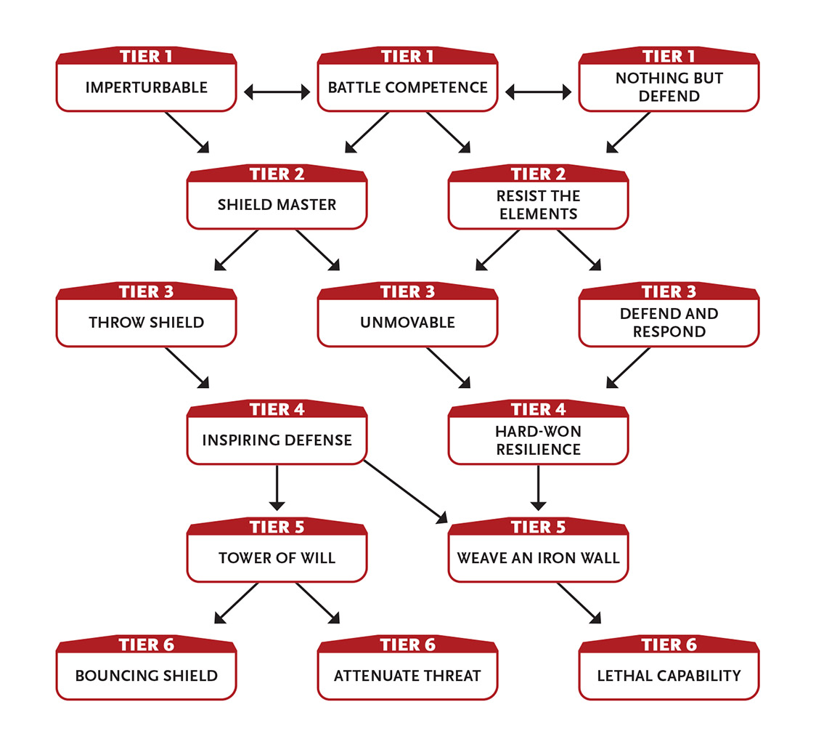

Tier 1
Battle Competence: You can freely use all weapons and all armor.
As an action, you learn the level of up to three creatures that you can see within short range. This ability can be foiled by disguises or shapechanging.
Enabler for weapon use; action for evaluating creatures.
Imperturbable: You have a sense of calm around you that affects others as well. You cannot be forced to flee against your will (such as from magical fear) and the defense rolls of allies within immediate range against such attacks are eased.
Nothing but Defend: When guarding, you gain an asset to all defense tasks. Action.

Tier 2
Resist the Elements: You become resistant to one type of harmful energy. Choose one kind of energy, such as fire or electricity. Reduce the severity of wounds from that energy by one step (major to moderate, moderate to minor, minor to none).
Shield Master: When you use a shield, it can take one more moderate wound than normal before being destroyed.

Tier 3
Defend and Respond (3 Might or Speed): If you block or dodge a melee attack, you can immediately make a melee attack against your attacker. You can’t use this ability more than once per turn. Enabler.
Throw Shield (0+ Speed): You throw your shield as a short-range light weapon. Whether the shield hits or misses, it bounces back to your grasp if you succeed on a difficulty 2 Speed task.
Effort: A successful hit with the shield also hinders the target for one round.
Action.
When using Throw Shield, if you throw your shield and fail to catch it when it rebounds, it most likely ends up a short distance from you.

Unmovable (3 Might): You avoid being knocked down, pushed back, or moved against your will as long as you are upright and able to take actions. Enabler.

Tier 4
Hard-Won Resilience: Due to your experiences, you’ve been exposed to all sorts of terrible things and are developing a general resistance. You can take one more moderate wound than normal. Enabler.
Inspiring Defense: When you succeed on a defense roll against an attack that would have dealt you an especially powerful blow or effect as determined by your GM, you regain 4 points to your Might Pool. Each use of this ability after the first time restores 1 fewer Pool point; this renews after you take a ten-hour recovery. Enabler.

Tier 5
Tower of Will: You have an asset to Intellect defense tasks and add +3 points to your Intellect Pool. Enabler.
Weave an Iron Wall (5 Might or Speed): You slash and weave your weapons so quickly, they almost resemble a wall. This barrier is large enough to block access through an immediate area. You must use your action every round to maintain the barrier. Any creature that attempts to cross through your barrier takes 10 damage (no roll needed); as an extra action you can attempt a melee attack against them, pushing them back if you succeed. Action to initiate.

Tier 6
Attenuate Threat: If you make your attack this round as a Last action instead of as an action or a First action, you can ignore one wound you take before the beginning of your next turn. Enabler.
Bouncing Shield (3+ Speed): You throw your shield as a light weapon at a foe in short range. Whether the shield hits or misses, it rebounds to attack two additional targets (the third target can be the same as the first target). Make separate attacks against each target. At the end of these attacks, the shield bounces back to your grasp if you succeed on a difficulty 2 Speed task; otherwise it lands within immediate range of you.
Effort: A successful hit with the shield hinders the target for one round.
Action.
Lethal Capability: You’ve mastered how to kill with a particular attack. You inflict an additional 5 damage with attacks of one specific type, such as a thrown knife, a shot with a firearm, a swing of an axe, unarmed attacks, or some other specific attack you prefer.
You can gain this ability more than once. Each time you do, choose a different specific attack.

Strikes With Mystic Might
Your unarmed techniques are infused with otherworldly energies, enabling you to move beyond the merely physical.
- Genre themes: mystic monk (fantasy, superhero)
- GM intrusions: Powerful strikes resonate, drawing unwanted attention or breaking nearby objects.
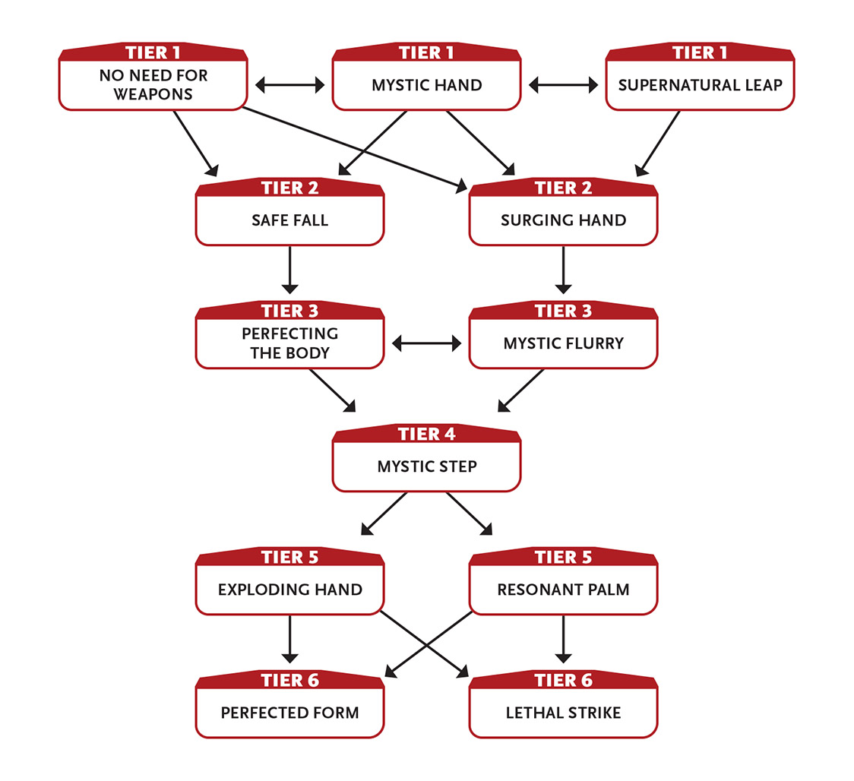

Tier 1
Mystic Hand: You inflict an additional 1 damage with unarmed attacks with your mystic source.
Once per round, if you take a wound and are not helpless, you can spend 3 Speed to reduce the wound’s severity by one step. Enabler.
No Need for Weapons: Your unarmed attacks (such as punches, kicks, elbows, or knees) inflict an additional 2 damage.
Supernatural Leap: When you jump, you move twice as far as normal, either horizontally or vertically. Enabler.

Tier 2
Safe Fall: When you take a wound from a fall, reduce its severity by one step. Enabler.
Surging Hand (2 Speed): You call upon your mystic source and project it at a target within short range, inflicting 4 damage with a successful Speed attack. Action.

Tier 3
Mystic Flurry: You inflict an additional 1 damage with unarmed attacks with your mystic source.
Perfecting the Body: Your daily kata infuse and protect you, granting you immunity from the effects of fear, mental control, disease, and poison.

Tier 4
Mystic Step (4+ Speed): You harness your mystic source to instantly transport yourself to a new location you can see within long range. If you appear within immediate range of a foe, you can make one unarmed attack against them as an extra action.
Effort: Reach a location within range that you can’t see directly because it’s blocked by a wall or structure.
First action.
If you try to use Mystic Step to reach a location that has no room for you, the ability automatically fails and you don’t leave your original location.

Tier 5
Exploding Hand (5 Speed): You call upon your mystic source and project it at a target within long range and two additional targets within immediate range of the first target. Make separate attacks against each. A successful attack inflicts 4 damage; even on a miss you still inflict 1 damage. Action.
Resonant Palm (7 Speed): You forge a mystic connection with a willing creature you touch or a foe you successfully attack (this attack deals 2 less damage than normal). At any point within the next ten days, you can attempt to affect the target in one of the following ways, no matter how far you are from them. This connection breaks once you make this attempt, you force a connection with a different creature, or ten days pass.
- Transfer one wound from the creature to yourself. No abilities, effects, or equipment can reduce the severity of this wound, but you can rally or attempt to heal it using normal methods.
- Make an eased unarmed attack against the target or an eased attack against them with one of your abilities, as if they were in range.
Last action to initiate; action to heal or attack the creature.

Tier 6
Lethal Strike (6 Speed): With a swift and sudden melee or ranged weapon attack, you strike a foe in a vital spot. If you hit, you inflict an additional 7 damage. Action.
Perfected Form: Your mystic source infuses you until you use a one-hour or longer recovery, granting you 3 points that you can add to any of your Pools, even if that would exceed their normal maximums. The points remain until you spend them or the duration expires.
In addition, while the duration lasts, your eyes and hands glow with the power of your mystic source, and you inflict an additional 3 damage with your unarmed attacks.
This ability renews after your next one-hour or longer recovery.
Last action.

Talks to Machines
You use your brain like a computer, interfacing “wirelessly” with any electronic device. You can control and influence them in ways that others can’t.
- Genre themes: golem whisperer (fantasy), coder (real world), cyber mind (science fiction, superhero)
- GM intrusions: The machine malfunctions or acts unpredictably.
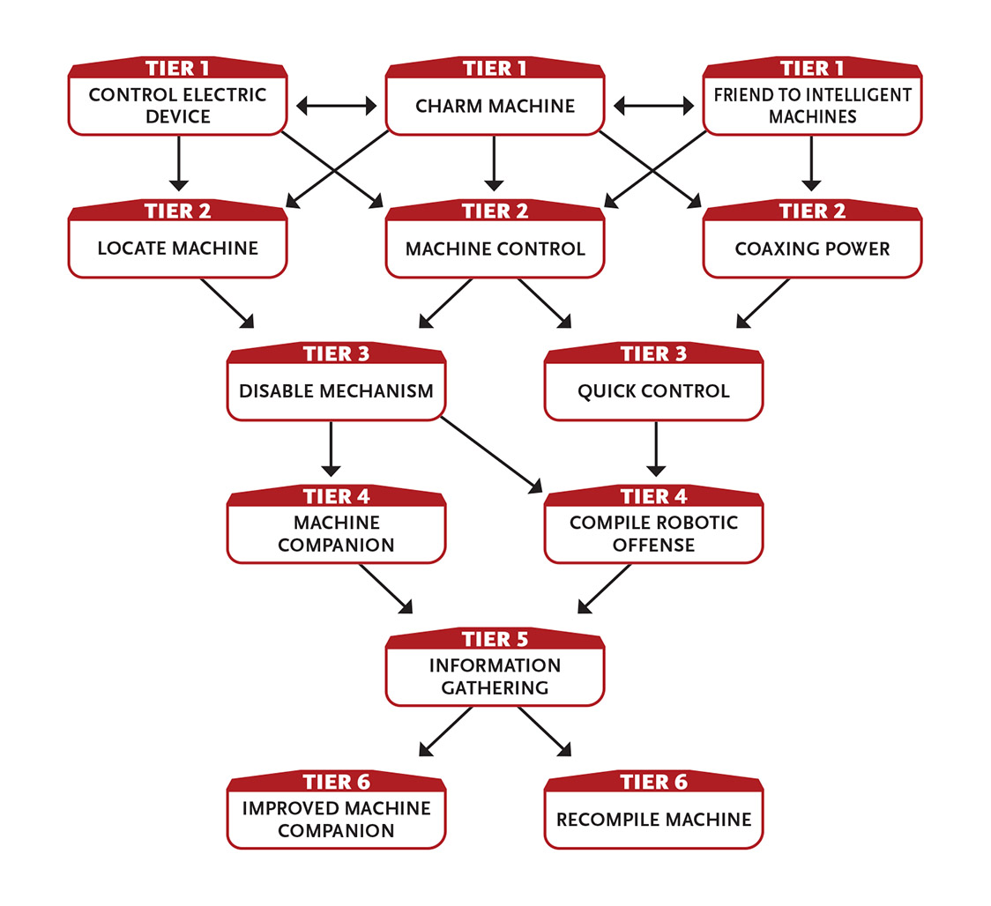
If you Talk to Machines, you can use your abilities at the indicated range, use them within range of a device you can remotely transmit data from, and (regardless of physical distance) affect networked machines that are on the same network you’re accessing.

Tier 1
Charm Machine (2 Intellect): You convince an unintelligent machine or robot within immediate range to “like” you with a successful Intellect attack roll. A machine that likes you is 50 percent less likely to function if said function would cause you harm. For example, if a foe attempts to detonate a bomb near you controlled by a detonator that likes you, there is a 50 percent chance that it won’t explode. The target likes you until you use a ten-minute or longer recovery. Action to initiate.
Control Electric Device (2+ Intellect): You can attempt to control or disrupt an electric device (in other words, a non-intelligent device or machine that is powered by electricity) at long range. Make an Intellect attack against the device. If your roll is less than a 12, treat the roll as a 12. (This means you don’t get a GM intrusion if you roll a 1.)
If you succeed, you can control the device as if you were next to it, even if normally you would have to touch it, read a screen, or manually operate it. If the machine is protected against casual access via some kind of security protocol, your tasks to hack or otherwise bypass that security are hindered unless you are within immediate range. If it is held by another creature, you must succeed against the creature’s level or the device’s level, whichever is higher.
If attempting to disrupt the device, success means it shorts out and, if you wish, also explodes in an immediate radius, dealing 1 damage to all creatures in the area (make separate Intellect attack rolls against each creature).
Effort: Increase the minimum number rolled for this ability by 3.
Action.
At tier 3: The minimum number rolled for this ability increases to 15.
Friend to Intelligent Machines: You have an asset to tasks to charm or positively interact with intelligent machines. You can use this asset if you attempt to hack or otherwise gain control of the intelligent machine (whether or not you know it is intelligent when you make the attempt), but never again for that machine regardless of whether the attempt succeeds. Enabler.

Tier 2
Coaxing Power (2 Intellect): You boost the power or function of a machine so that it operates at one level higher than normal, lasting until you use a one-hour or longer recovery. Action to initiate.
Locate Machine (2 Intellect): You can track down a specific machine from miles away. Choose a machine, robot, or intelligent device you’ve identified, either finding identifying information about them through network research or because you’ve personally interacted with them. If you succeed on an Intellect attack, you can sense their general direction or distance as long as they are within 10 miles (16 km) of you if you spend an action concentrating, checking your device, or something similar. If they are beyond that distance, you can only sense their general direction. A machine that becomes aware of your trace attempts to remove it; you must succeed on a new Intellect attack roll every ten hours to maintain the trace.
Action to initiate; action to update directional and/or distance information.
Machine Control (2+ Intellect): You use your knowledge of robot commands and controls against a robot, mechanized system, or intelligent machine within short range (or within short range of a device you can remotely transmit signals from). Choose whether you want to command one creature or deactivate multiple creatures, and make separate Intellect attack rolls against each target. If your roll is less than a 6, treat the roll as a 6. (This means you don’t get a GM intrusion if you roll a 1.)
Command: Success means you take active control of your target until you use a ten-minute or longer recovery, commanding it to do simple tasks on your behalf while you concentrate.
Deactivate: Success means you make affected targets unable to take actions for as long as you concentrate on them.
Effort: Increase the minimum number rolled for this ability by 3.
Action to initiate.
At tier 3: The minimum number rolled for this ability increases to 9.

Tier 3
Disable Mechanism (3+ Intellect): With a successful Intellect attack to hack a machine, robot, or device (intelligent or not) within immediate range, you disrupt it in one of the following ways:
- All the machine’s tasks are hindered until you use a ten-minute or longer recovery.
- The machine’s speed is halved.
- The machine can take no action for one round.
- The severity of the machine’s attacks are reduced by one step (minimum of a minor wound) until you use a ten-minute or longer recovery.
You must touch the machine, robot, or device to disrupt it (if you are making an attack, it inflicts no damage).
Effort: Increase the range to as far as you can directly see (through your own eyes, not through a remote camera or other interface). Target a machine through a network interface you have unrestricted access to (this requires two levels of Effort).
Action.
Quick Control (4 Intellect): A successful Intellect attack allows you to command a machine (intelligent or not) within short range to take one action within its capabilities on its next turn, regardless of its normal programming or attitudes. If this action would cause the machine direct harm to itself or its allies, your Intellect attack against it is hindered. (If you use this ability to command an intelligent machine, it likely becomes hostile to you afterward.) Action.

Tier 4
Compile Robotic Offense: Your attack against a robot or intelligent machine this round has an asset if you make it as a Last action instead of as an action or a First action. Enabler.
Machine Companion: You create, find, or otherwise acquire a level 3 intelligent machine companion follower that accompanies you and acts as you direct. If it’s destroyed, it can be restored using your resources if you spend a few days tinkering.

Tier 5
Information Gathering (5 Intellect): You speak wirelessly with any or all non-intelligent machines within 1 mile (1.6 km). You can ask one basic question about themselves or anything happening near them and receive a simple answer. For example, while in an area with many machines, you could ask about the location of a specific creature or individual, and if they are within range, one or more machines will probably provide the answer. Action.

Tier 6
Improved Machine Companion: You create, find, or otherwise acquire a level 5 intelligent machine companion follower that accompanies you and acts as you direct. If it’s destroyed, it can be restored using your resources after a few days of labor. If you already have a lower-level machine companion, you choose whether it is upgraded to level 5 or you retain the level 3 companion and gain a new level 5 companion.
Recompile Machine (8+ Intellect): With a successful Intellect attack against a machine (intelligent or not) of level 4 or lower within long range, you connect directly into their core system. Choose one of the following effects.
- The machine ceases all function—it is “bricked.”
- The machine reboots after a few rounds, then functions as an additional machine companion to you for about a day. After you finish a ten-hour recovery, you must reuse this ability on the machine to ensure it doesn’t reset back to its original programming (or sense of self, if an intelligent machine).
- The machine explodes, inflicting 4 damage to all creatures in immediate range; make a separate Intellect attack roll against each.
Effort: Increase the maximum level of the machine you can affect by 1.
Last action.

Tends to the Wounded
You can heal others with a touch, can alter time to help others, and are generally beloved by everyone.
- Genre themes: healer (fantasy), doctor (real world, science fiction, superhero)
- GM intrusions: Attempts to heal might cause harm instead. A community or individual needs a healer so desperately that they hold one against their will.
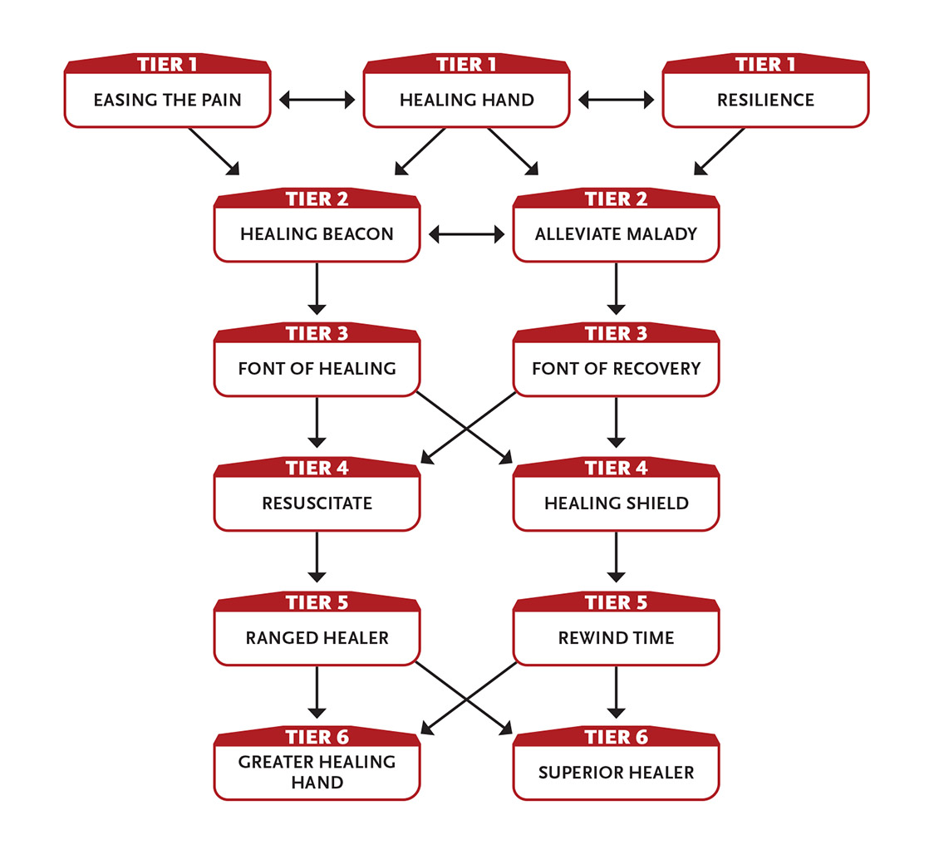

Tier 1
Easing the Pain: Allies within immediate range (including you) that take a recovery add +1 to their roll.
Healing Hand (1+ Intellect): With a touch, you reduce one wound’s severity by one step (unless the target can take no more wounds of that lower severity). A healed minor wound is gone completely, one moderate wound becomes a minor wound, or one major wound becomes a moderate wound.
Each time you use Healing Hand, the Intellect cost increases by 1. The cost returns to 1 after you take a recovery.
Last action.
Resilience: You can take one more moderate wound than normal.

Tier 2
Alleviate Malady (3 Intellect): You cancel or cure a disease, poison, or similar malady in a creature you touch if you succeed at an Intellect roll against the malady’s level. (Some maladies may require multiple successes to be cured.) Action.
Healing Beacon (3 Intellect): One of your allies automatically is healed whenever you use your healing power. Choose one ally to be your healing beacon. Until you use a one-hour or longer recovery, when you use Healing Hand or a similar ability, the beacon ally gets to reduce the severity of one of their own wounds too (as long as it’s not a higher severity than the one you’re healing). The beacon ally must be within short range of you to gain this healing.
The beacon ally doesn’t gain this effect if you directly heal them.
Action to initiate.

Tier 3
Font of Healing: You have healing power within you that others can access with a touch. If an ally uses their action to touch you and spends 2 Intellect, they choose whether they are healed of two minor wounds, healed of a moderate wound, or (if they spend 5 Intellect) healed of a major wound. Once the ally uses this ability, they can’t do so again until after they use a ten-hour recovery. Enabler.
Font of Recovery: You have restorative power within you that others can access with a touch. If an ally uses their action to touch you and they spend 1 Intellect, they choose whether they regain 1d6 Might points or regain 1d6 Speed points. Once the ally uses this ability, they can’t do so again until after they use a ten-hour recovery. Enabler.

Tier 4
Healing Shield: You bolster an ally’s health with healing power, protecting them against injury. Choose an ally within short range; they gain an asset that they can use on one block roll of their choice, which is expended once they use it. This ability renews when you take a recovery. Enabler.
Resuscitate (5+ Intellect): You can resuscitate an injured PC you touch. The character is healed of their choice of one major wound, one moderate wound, or three minor wounds.
If the character is dead from wounds but is otherwise in one piece and less than a minute has passed since they died, you can resuscitate them as described above if you succeed at a level 6 healing task.
If you use this ability on a dead NPC who has no health but is otherwise in one piece and has been dead for less than a minute, you resuscitate them with 1 health.
Each time you use Resuscitate, the Intellect point cost increases by 3. The cost returns to its base value after you use a recovery.
Action.

Tier 5
Ranged Healer: All of your short-range focus abilities work at long range. All of your touch and immediate range focus abilities work at short range.
Rewind Time (5 Intellect): You rewind time a few seconds, allowing someone to undo what they just did and take a different action. Choose a creature within short range who most recently took an action. Time rewinds to just before they took that action; it is now their turn. They can repeat the same action or try something different. The creature isn’t aware of what they did before or that you reversed time, but they might be aware that you did something. This ability renews when you use a recovery. Enabler.

Tier 6
Greater Healing Hand (4+ Intellect): You remove all of a touched character’s minor wounds, reduce two moderate wounds to minor wounds, or reduce two major wounds to moderate wounds.
Each time you use Greater Healing Hand, the Intellect point cost increases by 2. The cost returns to its base value after you use a recovery.
Enabler.
Superior Healer (0+ Intellect): If you have Font of Recovery or Font of Healing, the ally can spend 2 additional Intellect for twice the normal benefit.
If you have Resuscitate, it heals twice the normal number of wounds, and you can revive a creature who has been dead for no more than an hour.
If you have Healing Shield, the ally gains two assets instead of one, and can use them together on one block roll or separately on two different block rolls.
Effort: Extend the death time limit of Resuscitate to 24 hours, a week (two levels of Effort), a month (three levels of Effort), or a year (five levels of Effort).
Enabler.

Walks Through Walls
A bit translucent when you want to be, you can move through solid objects.
- Genre themes: magical being (fantasy), science prodigy (science fiction), phase walker (superhero)
- GM intrusions: The character is sent phasing into an unexpected dimension. The character becomes lost in a large solid.
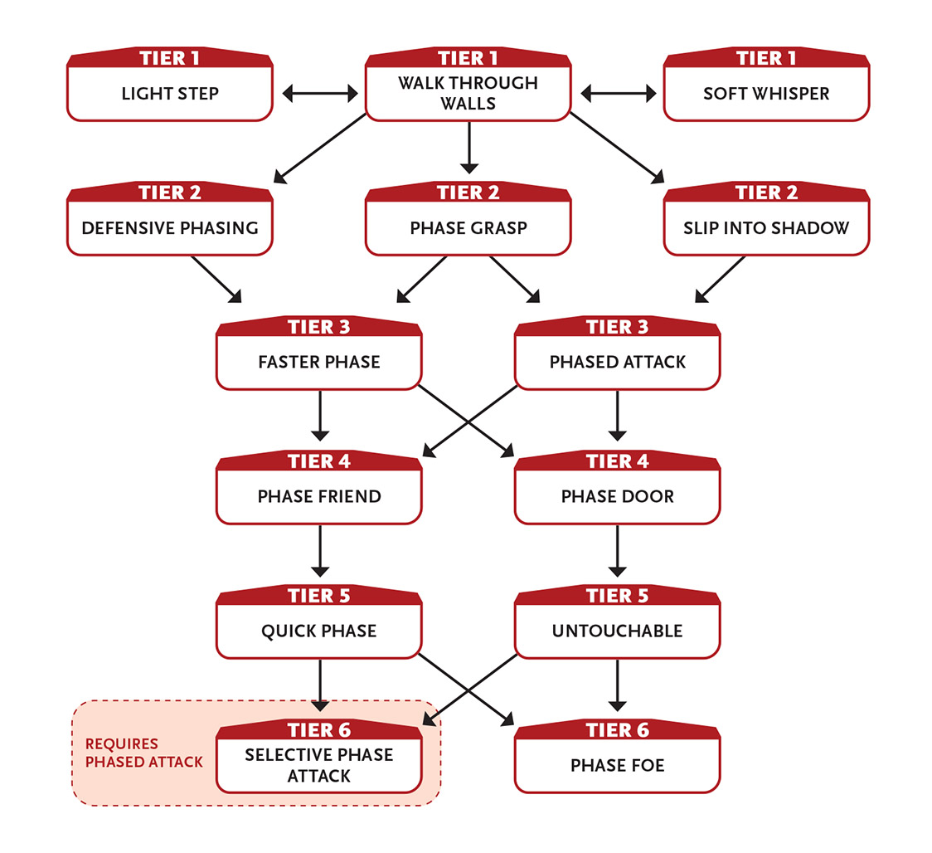

Tier 1
Light Step: You can reduce the weight of your footprints to about the weight of a piece of paper, which means you don’t trigger pressure plates or similar weight-based devices.
You also reduce your falling damage by one wound severity.
Soft Whisper (1 Intellect): You can say something to a being within immediate range that no one else will hear. Enabler.
Walk Through Walls (2+ Intellect): You can slowly pass through physical barriers of level 5 or lower at a rate of 1 foot (30 cm) per round (minimum of one Last action to pass through any barrier). You can perceive while phased within a barrier or object, which could allow you to peek through walls. You can’t use this ability to pass through energy barriers.
Effort: Increase the maximum level of the barrier you can pass through by 1.
Last action.

Tier 2
Defensive Phasing (2 Intellect or Speed): Until you use a ten-minute or longer recovery, you gain an asset to your dodge tasks as you selectively change your phase so that some attacks pass through you harmlessly. Action to initiate.
Phase Grasp (3 Intellect): You phase an object within long range so it vanishes and reappears in your hands or within immediate range of you. You must be able to see the object and it must be something you could carry with two hands. If the object is held by a creature or behind a barrier, you must succeed on an Intellect attack against the creature or barrier to transport it. Action.
Slip Into Shadow (0+ Intellect): Even if in full view of a target, your successful stealth task allows you to slip away from that creature and hide from view in a nearby shadow, behind a tree or furnishing, or in the next room as your action.
Effort: Increase the number of creatures you can hide from by one (attempt a separate stealth task against each).
Enabler.
At tier 3: The base number of targets you can attempt to hide from increases to three.
Slipping into shadow and other stealth-based tasks for someone who Walks Through Walls is partly enabled by their ability to phase into translucence.

Tier 3
Faster Phase: When you use Walk Through Walls, you pass through physical barriers faster, increasing your base rate by an additional 3 feet (1 m) per round, and doing so is an action rather than a Last action (you can take your normal movement before or after you use your phasing action). Enabler.
Phased Attack (3 Intellect): Attacks you make this turn ignore your foe’s armor. Enabler.

Tier 4
Phase Door (4+ Intellect): You can phase into an adjacent solid object and then phase out of any other solid object within long range of the first, even if the two objects are not connected. There must be no intervening barriers between the two objects, and you must be aware of or able to see the destination object.
Effort: Increase the traveling range by a long distance.
Action.
Phase Friend (4+ Intellect): When using a phasing ability, you bring along an ally within immediate range.
Effort: Bring an additional ally.
Enabler.

Tier 5
Quick Phase: When you use Walk Through Walls, you pass through physical barriers much more quickly, increasing your base rate by an additional 10 feet (3.5 m) per round.
Alternatively, you can phase up to 10 feet (3.5 m) as a First action.
Enabler.
Untouchable (6 Intellect): You change your phase state so that you can’t affect or be affected by normal matter or energy. Only mental attacks and special transdimensional energies, devices, or abilities can affect you, but likewise you can’t physically attack, touch, or otherwise affect anything. This lasts until you use a ten-minute or longer recovery. Action to initiate.

Tier 6
Phase Foe (8+ Intellect): You gather disrupting energy in your fingertip and touch a creature. If your attack succeeds, they are phased as if you used Untouchable on them. However, unless they can figure out how to control their movement while phased, which most creatures have no experience with, they sink through the ground or other solid matter. If they can’t later gain control or end the effect, they might be gone for good because when they become solid again after a minute, they’re probably deep underground. You can only use this ability against a target of level 4 or lower.
Effort: Increase the maximum level of the target you can affect by 1.
Action.
Selective Phase Attack: One attack each round you make using Phased Attack deals an additional 5 damage. Enabler.
Phased Attack used against a PC means their block attempts fail.

Wears a Sheen of Ice
You command the wintry power of cold and ice.
- Genre themes: elemental ancestry (fantasy), lord of ice (superhero)
- GM intrusions: Ice makes surfaces slippery. Extreme cold causes objects to crack and break.
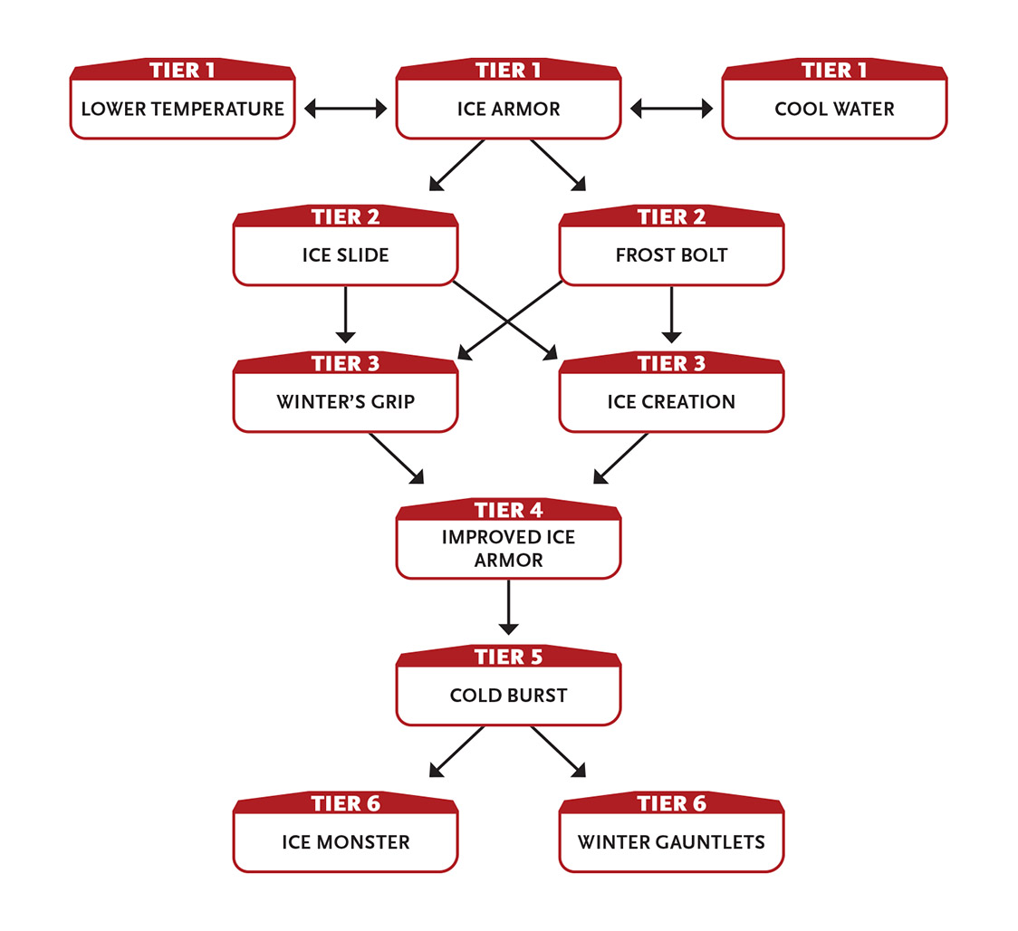

Tier 1
Cool Water (1 Intellect): You cause water in the air to condense, creating enough potable cold water to sustain five creatures for one day. Action.
Ice Armor (1 Intellect): You cover your body in a sheen of ice until you use a ten-minute or longer recovery, easing your Might defense rolls to block attacks.
In addition, reduce the severity of wounds from cold and ice effects used against you by one step (major to moderate, moderate to minor, minor to none). For example, if you are hit by a blast of cold that causes a moderate wound, you instead take a minor wound.
You can make a “cold touch” light unarmed attack against a foe, inflicting 2 cold damage from the ice armor if your attack succeeds.
Enabler.
Lower Temperature (1 Intellect): You make it up to 30˚ F (15˚ C) cooler in an immediate area until you make a ten-minute or longer recovery (this reduces wound severity from warm temperature environments by two steps). This effect is centered on you and moves with you. Action.

Tier 2
Frost Bolt (2 Intellect): You emit a ray of intense cold at a foe within short range. If it hits, it inflicts 4 damage from cold.
Instead of attacking with a ray, you can increase the intensity of the cold that Ice Armor has on your hands, adding 2 damage to your cold touch and to your melee and ranged weapon damage. This aspect of this ability lasts until you use a ten-minute or longer recovery.
Action; action to initiate more intense cold.
Ice Slide (2 Intellect): You create a path of smooth ice from yourself to a location within long range and safely slide to there. You must have a clear and unobstructed path to that location, but otherwise it can be above, below, or even across a gap. The ice melts away after a few seconds. Action.

Tier 3
Ice Creation (4+ Intellect): You create an object of your size or smaller that is made of level 3 ice. It is crude and can have no moving parts, so you can make a sword, a shield, a small wall, a short ladder, and so on. If you aren’t within short range of the object, it breaks or melts once you use a ten-minute or longer recovery.
You can choose this ability multiple times. Each additional time you choose it, you double the base size of the object you can create.
Effort: Double the maximum size of the object you can create. Increase the distance the object can be from you by one range category.
Action.
A wall of ice that is about 5 feet by 5 feet and 1 inch thick (1.5 m by 1.5 m and 3 cm thick) is about the same size as a person.

Winter’s Grip (3+ Intellect): Make an Intellect attack against a foe within short range. Success means they are restrained by a layer of ice until you use a ten-minute or longer recovery or until they use an action to break free. The foe can’t move from their current position, and their physical tasks (including attacks and defense) are hindered.
If Ice Armor is active and you instead touch the foe, the Intellect attack is eased and you add the 2 damage from your cold touch.
Effort: Inflict 3 damage from cold on the round the foe is first held.
Action.

Tier 4
Improved Ice Armor: Your Ice Armor eases your Might defense rolls to block attacks by an additional step.
The damage from your Ice Armor’s cold touch, Frost Bolt, and Winter’s Grip increases by 1.

Tier 5
Cold Burst (5+ Intellect): You emit a short-range burst of cold in all directions from yourself. Make an Intellect attack against any number of creatures in range; success means they take 5 damage from cold. Each level of Effort you use for extra damage increases the damage by 2 points, or 1 point on a failed attack.
Effort: Attempt to blind all targets you successfully hit (a successful second attack roll against a target means they are blinded, hindering all vision-based tasks by two steps, until you use a ten-minute or longer recovery).
Action.

Tier 6
Ice Monster (6 Intellect): You create an automaton made of snow or ice that is your general shape and size, lasting until you use a ten-minute or longer recovery. This NPC ally acts as you direct each round. Directing the monster is an action, and you can command it only when you are within long range of it. Without a command, the monster continues to follow your previous command. You can also give it a simple programmed action, such as “Wait here and attack anyone who comes within short range until they’re dead.” Action to create; action to direct.
Automaton: level 5; Armor 1; bash attacks deal 6 damage (half from intense cold)

Winter Gauntlets: Your Frost Bolt ray inflicts an additional 3 damage, or an additional 3 damage as part of a touch or weapon attack. Any creature you hit with Frost Bolt, cold touch, or a cold-enhanced weapon attack is restrained in place (as Winter’s Grip). Enabler.

Works for a Living
You take great satisfaction in a job well done, whether it’s coding, building houses, or mining asteroids.
- Genre themes: contractor (real world), technician, engineer (science fiction)
- GM intrusions: Repairs sometimes fail. Wiring can be tricky to decipher and still carry an electrical charge. Some people are rude to those who work for a living.
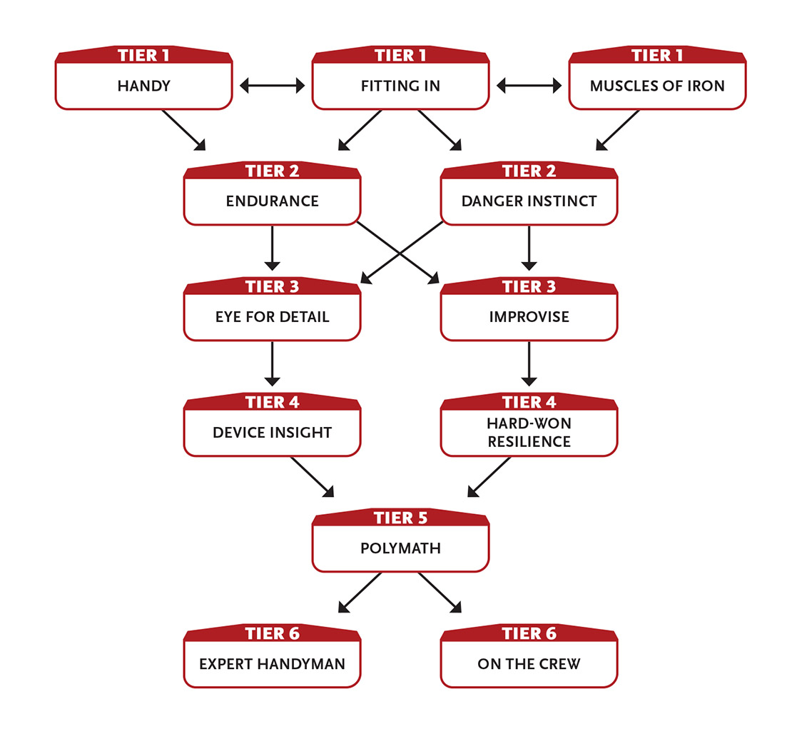

Tier 1
Fitting In (2 Intellect): You can blend in among any intelligent creatures other than the upper classes or the authorities. Working or common people can still see you, but those of level 3 or less attach no importance to your presence. If a higher-level creature notices you, you can attempt an Intellect task against their level to retain your unimportant-seeming status. This effect ends if you do something to call attention to your presence or position—attacking, using an ability, moving a large object, and so on—or if you use a ten-minute or longer recovery. Action to initiate.
Handy: You’re trained in crafting. Anytime you gain resource points, you gain 1 additional point, but that point can only be spent on repairing or crafting.
Muscles of Iron (2 Might): Until you use a ten-minute or longer recovery, all Might actions other than attack rolls that you attempt are eased. Enabler.

Tier 2
Danger Instinct (3 Speed): If you are attacked by surprise, whether by a creature, a device, or simply an environmental hazard (such as a tree falling on you), you can move an immediate distance before the attack occurs. If moving prevents the attack, you are safe. If the attack can still potentially affect you—if the attacking creature can move to keep pace, if the attack fills an area too big to escape, and so on—your defense against it is eased. Enabler.
Endurance: Any duration dealing with physical actions is either doubled or halved, whichever is better for you. For example, if the typical person can hold their breath for thirty seconds, you can hold it for one minute. If the typical person can march for four hours without stopping, you can do so for eight hours. In terms of harmful effects, if a poison paralyzes its victims for one minute, you are paralyzed for thirty seconds. The minimum duration is always one round. Enabler.

Tier 3
Eye for Detail (2 Intellect): When you spend five minutes or so thoroughly exploring an area no larger than a short distance in diameter or an object you have direct access to, you can ask the GM one question about the area or object. The GM must answer you truthfully. This ability resets when you use a ten-hour recovery. Five minutes to explore the area or object.
Improvise (3 Intellect): If you aren’t trained in a task, you can improvise to gain an asset on that task—a tool you cobble together, sudden insight, or just dumb luck. The asset lasts until you use a ten-minute or longer recovery. Enabler.

Tier 4
Device Insight (3 Intellect): When examining any unknown, alien, supernatural, or high-technology device, you can ask the GM one question to gain an idea of its capabilities, how it functions, how it can be activated or deactivated, what its weaknesses are (if any), how it can be repaired, or any other similar query. This insight is for difficult or strange things beyond those readily identified by using the appropriate knowledge or technical skill. Action.
Hard-Won Resilience: Due to your experiences, you’ve been exposed to all sorts of terrible things and are developing a general resistance. You can take one more moderate wound than normal.

Tier 5
Polymath (0+ Intellect): When you roll on a task you’re trained in (other than an attack or defense task) and your roll is less than a 12, treat the roll as a 12. (This means you don’t get a GM intrusion if you roll a 1.)
Effort: Increase the minimum number rolled for this ability by 3.
Enabler.
At tier 3: The minimum number rolled for this ability increases to 15.

Tier 6
Expert Handyman: When you use resource points to craft, repair, or build something, the resulting object is superior to other objects of a similar kind. Work with the GM to determine exactly how that manifests, but typically they are 2 levels higher than they’d otherwise be.
On the Crew (4+ Intellect): While you are working with a team of at least two other allies, you give them a short pep talk and grant yourself and them one of the following abilities until you use a ten-minute or longer recovery.
- +1 damage on attacks
- Ignore the first minor wound taken
- Add +6 to next recovery
Last action to initiate.

Mystic Source
A character who Strikes With Mystic Might relies on an otherworldly, magical source for their power, such as elemental fire, shadow, thorn, or something more esoteric like “The Six Lamps of the West”—work with your GM to flesh out the details. Whatever you choose is probably the same mystic power source used for the character’s higher-tier abilities as well.

Equipment
Services, such as example meals and boarding, are included under appropriate price categories for The Real World Genre, science fiction, and fantasy genres.
Equipment in Cypher plays only a small role. It’s far more important to focus on what you can do than on what you have. Still, sometimes it’s important to know if you’ve got enough rope or what kind of gun your space pilot has at their hip.

Currency and Prices
In the Cypher rules, when it comes to prices we talk in generalities rather than specifics. Instead of having exact currency values like “10 gold pieces” or “30 Imperial credits” or “50 exodollars,” we use general price categories like “inexpensive” and “expensive.”
The GM can figure out what those categories mean in their setting. In a fantasy setting, an inexpensive item might be 1 or 2 copper pennies, while an expensive item might require gold coins. In a futuristic setting, a moderately priced item might cost a few hundred credits, and a very expensive one costs kilocredits or megacredits.
Some GMs prefer exact currency numbers for items—so a backpack is 2 gold or 50 credits—and you’ll keep track of your character’s money much like you do in real life. If this is the case in your game, the GM will develop a detailed price list for the setting you’re playing in, you’ll track your character’s money on your character sheet to determine what you can afford, and you’ll never use the price categories after you initially build your character.
But some GMs might want to keep things simple and use only the general categories, indicating currency just as flavor now and then. In a fantasy game, looting a dungeon might net each character enough gold and gems for a couple of moderately priced items. In a spacefaring sci-fi game, hauling passengers to another star system might earn the whole PC crew enough for six expensive items after paying for fuel and such. In either case, the exact amounts don’t matter—the fantasy characters are probably trading old coins and jewelry for new things, and the sci-fi characters may be dealing with currencies from two different planetary economies.

Price Categories
There are five price categories for goods and services.
- An inexpensive item is something that people commonly buy. A simple meal or a drink in the bar. A pen and some paper. A book or magazine.
- A moderately priced item is something that people commonly buy, but not too often and not in great quantities. A small piece of furniture. A major entertainment. An expensive meal. A new outfit.
- An expensive item is something that would strain most people’s finances. Rent on a simple apartment. A major piece of furniture. A very nice outfit. The cost to travel a long distance (if appropriate to the setting).
- A very expensive item is probably out of the reach of most people except in very special circumstances. Jewelry. Luxury furnishings.
- An exorbitant item is something only the very rich can afford. A very nice house. A ship. Extremely expensive jewelry or art.
Each price category costs about ten times more than the one before it. For example, a moderately priced item is about ten times the cost of an inexpensive item. An expensive item is about ten times the cost of a moderately priced item. A very expensive item is about ten times the cost of an expensive one, a hundred times the cost of a moderate one, and a thousand times the cost of an inexpensive one. An exorbitant item is ten times the cost of a very expensive one.

Using the Price Categories
You can use the price categories in a variety of ways.
It’s easy for a GM to say to you, “You can afford two extra moderately priced things at the start of the game.” Then you can look on the list and pick two moderately priced items without worrying about their cost. Plus, this approach makes it clear that you get two items, not twenty inexpensive items (which might be a lot to carry) and not an expensive item (which might not be appropriate for a starting character). The categories make it easy to lump similar items together.
The GM can also say, “You can have whatever inexpensive items you want, and don’t worry about the cost.” For later stages of the campaign, when the PCs have more wealth, followers, and so on, the GM can do this with moderate or even expensive items. This allows the group to skip over playing through a shopping trip to get supplies, and you don’t have to track prices down to the last coin or credit.
You can use the categories to estimate the cost of a lower- or higher-quality item. If an average-quality shirt (like a T-shirt) is an inexpensive item, a nice shirt (like a button-down shirt for an office job) is a moderately priced item, and an exceptional shirt (fashionable and/or suitable for a fancy event) is an expensive item. If a typical broadsword is an expensive item, a rusted or low‑quality broadsword is a moderately priced item (and likely to break after a few fights), and a jeweled sword is a very expensive item.
Finally, you can use the categories as shorthand when evaluating loot, dividing up the spoils among the PCs, and resolving other story-based occurrences that crop up in the game without dealing in the minutiae of exact prices. This is especially useful in high‑powered games where your PCs are rich and powerful.

Context of Prices
The context in pricing often matters. In a real‑world setting on modern-day Earth, a matchstick is almost worthless (many establishments give away books of them), but it would be very valuable in an Iron Age or Stone Age society. A sword might be expensive in a fantasy setting, but mostly worthless in the far future other than as a collector’s item (although it hurts just the same if you’re hit with it), making it either inexpensive or very expensive. A motorcycle would be expensive in a real-world setting, moderate at best in a future setting—again, unless it’s a collector’s item—and utterly priceless in the Iron Age (as long as the fuel lasted) if it somehow found its way to 1000 BC (where it would be an artifact). In a fantasy setting, a magically fueled motorcycle might have the same value as a flying carpet or trained gryphon.
This is why you can’t have a standardized price list that applies to every setting, genre, and time period. It’s all about context.

Armor
One common piece of RPG equipment is armor, which protects characters from wounds. Various kinds of armor are described in this section, but they all fall into one of three armor categories—light, medium, or heavy.
Your type tells you what kind of armor you can freely use.
Light armor eases your block rolls and hinders your dodge rolls.
Medium armor eases your block rolls by two steps and hinders your dodge rolls by two steps.
Heavy armor eases your block rolls by three steps and hinders your dodge rolls by three steps.
If you cannot freely use the armor you are wearing, its dodge penalty also applies to all of your Speed tasks (not just to Speed defense rolls to dodge). For example, if you are wearing heavy armor but can’t freely use it, all of your Speed tasks are hindered by three steps. Any character can use a shield.
Armor GM intrusion: Your armor gets damaged (either from one big attack or from a lot of attacks over time), reducing how much it eases your block tasks by one step, but still hindering your dodge attacks the normal amount. For example, damaged leather armor might not ease block rolls at all and still hinder your dodge rolls.

Weapons
Not all characters can freely use all kinds of weapons. Your type determines which ones you are experienced with and can freely use, meaning that you don’t have a penalty when using that kind of weapon. If you attack using a weapon you can’t freely use, your attack roll is hindered. Obviously, warrior types like the Barbarian, Paladin, and Soldier can use all kinds of weapons, and other types like the Mage and Diplomat have a more limited selection.
In a few cases, your focus might add to the list of weapons you can freely use.There are three categories of weapons in the game.
Light weapons inflict 2 damage. Attacks with them are eased because they are fast and easy to use. Light weapons are punches, kicks, knives, handaxes, darts, very small handguns, and so on. Weapons that are particularly small are light weapons. If you wish, you can attack with a light weapon as a First action (First actions go first in the combat round).
Medium weapons inflict 4 damage. Medium weapons include broadswords, battleaxes, maces, crossbows, spears, typical handguns, light rifles, sawed-off shotguns, and so on. Most weapons are medium weapons. Anything that could comfortably be used in one hand (even if it’s often used in two hands, such as a quarterstaff or spear) is a medium weapon.
Heavy weapons inflict 6 damage. You must use two hands to attack with them. Heavy weapons include greatswords, greataxes, polearms, heavy crossbows, rifles, regular shotguns, assault rifles, and so on. Anything that must be used in two hands is a heavy weapon. Attacking with a heavy weapon is a Last action (Last actions go last in the combat round).
Because the weapon categories are generalized, if you want to use a specific weapon that’s not listed in this book, you can use the game stats for a similar weapon. For example, if you want your character to wield a katana, you can choose a broadsword from the equipment table and call it a katana. If you’d prefer a two-handed nodachi, choose a greatsword and call it a nodachi.
In general, light weapons are moderately priced items, medium weapons are expensive, and heavy weapons are very expensive. Ammunition for a ranged weapon is inexpensive.
The rest of this section is divided into sections based on genre, and those sections give more specific details on what weapons are available in each genre.
Keep in mind that in many genres, it’s not acceptable to run around carrying dangerous weapons. Your sword might not draw much attention in a fantasy game, or your oversized handgun in a sci-fi game, but carrying either of those weapons in a real-world game set on modern-day Earth is a different story.

Weapon Ranges
You can use a melee weapon to attack a foe that’s adjacent to you (next to you) or within reach (immediate range).
Some melee weapons are also meant to be thrown, such as knives and axes. You can throw this kind of weapon up to short range.
A ranged weapon specifies what its maximum range is; most ranged weapons can attack out to short range or long range. If your target is just at the limit of the weapon’s range, that’s called extreme range, and your attack against them is hindered.

Explosive Weapons
Bombs, grenades, missiles, and other explosives operate differently than weapons like swords and handguns—they can affect multiple targets in an area (usually an immediate area). When you attack with these kinds of weapons, make separate attack rolls for each creature in the area (although the GM may simplify this by having you make one attack roll, which they’ll compare to the difficulty of each target in the area). Success means the target takes the normal damage for the explosive weapon; failure typically means the target still takes a smaller amount of damage, usually 1 point.
You can throw a grenade or similar explosive a short distance. Otherwise, you need another weapon or device (such as a grenade launcher or rocket launcher) to shoot them at the target area.
You can use Effort for damage with explosive weapons, but each level of Effort adds only 2 damage (instead of the normal 3).
PCs in the area of an explosive weapon make block or dodge rolls instead of the attacking character making attack rolls.

Miscellaneous Items and Services
Exactly what items are available for sale varies greatly based on the setting—blasters and spaceships aren’t available in a typical fantasy game, and a sci-fi game probably doesn’t have many places where you could buy a sword. Items like food, lodging, and clothing are available in just about any setting, and in different levels of quality according to the price category. For example, you can buy an inexpensive meal, a moderately priced meal, an expensive meal, and so on. An inexpensive meal is light and probably not very nutritious. An expensive meal is available only in nice restaurants in certain locations. An exorbitant meal is probably a feast for a crowd, with the finest food and drink available.
Lodging for a night is similar, although the bottom end starts out worse. An inexpensive night’s lodging is probably a flea-ridden mat on the floor of a room filled with other lodgers. Moderate lodging is usually a private room with a decent bed. Very expensive lodging might be a suite of rooms with delicious meals and personal services (such as massages and laundry) included.
Inexpensive clothing is just a step up from rags, but moderately priced clothing is decent enough. For a formal party, you’d want expensive clothing. Rich people likely wear very expensive clothing most of the time, and put on exorbitant clothing (and jewelry) when they go to a fancy party.
Equipment Levels
Typical equipment is about level 4—less if it’s of inferior quality or materials, more if it’s of superior quality or materials. This means that in a setting based on the distant past, the default level might be 3, while in the future it might be 5 or 6. So an average serf’s tool in the Dark Ages is level 3, easily broken, while an average tool on a space station is level 6, made of advanced polymers. A tiny item like a ring or watch will usually have a lower level, and a large item like a car will have a higher level.

Cyphers
Cyphers are one-use abilities. In some settings, cyphers are physical items, like a magic potion or high-tech gizmo, but you shouldn’t think of them as regular equipment like backpacks, swords, and horses—they have special rules and often aren’t available to buy or sell. Cyphers are more like special abilities (from your type or focus) than common equipment. A later section has more information on cyphers, including how they work, how many you can carry, and how to get them.
Some character types and some foci allow you to craft cyphers, modify the power level of a cypher, or use a cypher more than once.
It is likely that if you play a character for a while, you’ll end up with a cypher you’ve had before, and that’s totally fine. It’s also okay if you end up with two of the same cypher at the same time, but if that happens you might want to discard one so you have more options.

Artifacts
Artifacts are like cyphers in that they’re more like special abilities than common equipment. Unlike cyphers, artifacts can be used more than once.
Every artifact has a special statistic called depletion, which is usually written as a number range, like “1 in 1d6” or “1–3 in 1d20.” When you use or activate an artifact, you roll the die in the depletion stat. If your roll is in the depletion range of numbers, the artifact works, but that is its last use.
Some rare artifacts have a depletion stat of “—” which means they never deplete.
Artifact depletion means you never have to keep track of how many charges an item has or its “battery level.”
The GM has more information about artifacts.

Real-World Equipment
The following items (and anything else appropriate to The Real World Genre, meaning modern-day Earth) are usually available for purchase.
For any game set in the modern day, catalogs or shopping websites can provide prices for any kind of item that you might need. Likewise for historical games, an internet search can quickly get you price lists from old mail-order catalogues.

Inexpensive Items
Item | Note
Bullets (50) | Ammunition for handguns and rifles
Case of beer
Duct tape roll | Level 2 adhesive, level 3 with multiple layers; eases various tasks
Energy bars, box of 12 | Reasonable one-day sustenance for two or three people
Fast food | One serving
Flashlight | Normal light out to short distance
Hostel room | One night in a shared room; traveler provides own bedding
Knife, simple | Light weapon; easily destroyed
Padlock with keys | Level 3 lock
Snack food
Trail rations (1 day)
Easily destroyed: The item might break on a GM intrusion, through frequent use, over time, or for no apparent reason at all.

Moderately Priced Items
Item | Note
Backpack
Bag of heavy tools
Bag of light tools
Binoculars | Asset for perception tasks at long range or longer
Bolt cutter | Cuts objects like bolts, chains, and bars up to level 5
Climbing gear | Asset for climbing tasks
Crowbar | Asset for prying open things
Electric lantern | Normal light in an immediate area, dim light in a short area; three to four hours
First aid kit | Asset for healing tasks; five uses
Hand grenade | Explosive weapon, can be thrown a short distance, inflicts 4 damage in immediate radius
Handcuffs | Level 4 restraints
Hunting knife | Light weapon
Leather jacket | Light armor
Machete | Medium weapon
Mobile phone
Nightstick | Light weapon
Rope | Nylon, 50 feet (16 m)
Shield | Can block wounds
Sleeping bag
Tent | Fits two adults

Expensive Items
Item | Note
Bow | Medium weapon, long range
Cold weather camping gear | Wounds from cold temperature environments are reduced by two steps
Computer/Laptop | Apps and internet, asset on knowledge‑based tasks
Disguise kit | Asset for disguise tasks; five uses
High-end meal | Hearty and extravagant meal for two or three at a high-end restaurant
Hotel room, moderate | One week in a modern room with wifi
Kevlar vest | Medium armor
Light handgun | Light weapon, short range
Lodge room | Extravagant couple of nights for two
Medium handgun | Medium weapon, long range
Nightvision goggles | Reasonably accurate vision in darkness up to long range
Portable hidden camera | Transmits at long range
Portable hidden microphone | Transmits at long range
Rifle | Medium weapon, long range, attack hindered if fired with one hand
Scuba gear | Breathe underwater for an hour, down to 130 feet (40 m)
Shotgun | Heavy weapon, immediate range, extreme range extends to short range, attack hindered if fired with one hand
Shotgun (sawed off) | Medium weapon, immediate range, extreme range extends to short range
Smartphone | Mobile phone with apps, internet access, and immediate-range flashlight, asset on knowledge tasks that can be found on the internet
Straightjacket | Level 4 restraint, hand tasks hindered by two steps

Very Expensive Items
Item | Note
Assault rifle | Heavy weapon, rapid-fire weapon, long range
Heavy handgun | Heavy weapon, long range
Heavy rifle | Heavy weapon, 300-foot (90 m) range
Military body armor | Heavy armor
Small boat | Sail or engine, comfortably carries about six people
Submachine gun | Medium weapon, rapid-fire weapon, short range
Used car | Fairly reliable, seats four

Exorbitant Items
Item | Note
Large boat | Sail or engine, comfortably carries twenty people
Luxury car | SUV, limousine, or anything with advanced features, comfortably seats four to six people
Sports car | Fast and flashy, seats two or three
If desired, the group can ignore ammunition amounts for guns, bows, and the like and simply rely on GM intrusions to indicate when one runs out of ammo. Running out of ammo is a great and easy intrusion for when a player rolls a 1 with a weapon that uses it.

Real-World Currency Equivalences
Here are some suggested real-world currency values (in US dollars) for the general price categories.
Category | Dollar Value
Inexpensive | $10–$20
Moderate | $100–$200
Expensive | $1,000–$2,000
Very expensive | $10,000—$20,000
Exorbitant | $100,000—$200,000

Fantasy Equipment
In a typical pseudo-Medieval fantasy setting, the following items (and anything else appropriate to that time period) are usually available.

Inexpensive Items
Item | Note
Arrows (12) | Ammunition for bow
Burlap sack
Candle | Dim light in an immediate area; one hour
Common meal
Crossbow bolts (12) | Ammunition for crossbow
Gallon of ale
Inn room, average | One night in your own decent room
Inn room, poor | One week sharing a cheap room or sleeping on the common floor
Iron rations (1 day)
Loaf of bread | Unsustainable sustenance for two or three people
Meat | One serving
Pitcher of cheap wine
Poor meal | Minimal sustenance for two or three people
Tinderbox | Asset for creating fire
Torch (3) | Normal light in an immediate area, dim light in a short area; one hour
Waterskin | For water, wine, beer, and so on
Wooden club | Light weapon

Moderately Priced Items
Item | Note
Backpack
Bedroll
Blowgun | Light weapon, short range
Bottle of good wine
Crowbar | Asset for prying open things
Dagger | Light weapon, melee or thrown short range
Good meal | Hearty sustenance for one person
Grappling hook
Guard dog | level 3, attacks and perception as level 4; suitable for patrolling an area but not for accompanying adventurers into dangerous locations
Hammer | Medium weapon, can be thrown up to short range
Handaxe | Light weapon, melee or thrown short range
Hand mirror | Useful for signaling or seeing around corners
Hides and furs | Light armor
Hourglass
Inn room, good | One night in a nice, clean room
Lantern | Normal light in an immediate area, dim light in a short area; three to four hours
Leather jerkin | Light armor
Lockpicks | Asset on lockpicking for mechanical locks
Mace | Medium weapon
Magnifying glass | Asset on perception to notice close-up details
Matchsticks (10) | Asset for creating fire
Oil flask | Fuels a lamp for three to four hours; can be prepped with a wick, lit, and thrown up to short range for 2 fire damage
Rapier | Light weapon
Rope | Hemp, 50 feet (16 m)
Shield | Can block wounds
Signal horn | Can be heard up to 1 mile (1.6 km) away
Spikes and hammer | 10 spikes
Tent | Fits two adults

Expensive Items
Item | Note
Bag of heavy tools
Bag of light tools
Banquet | Hearty and extravagant meal for one person
Battleaxe | Medium weapon
Blank book | For writing notes or spells, 100 pages
Book of lore | Asset on one type of knowledge tasks
Bow | Medium weapon, long range
Breastplate | Medium armor
Brigandine | Medium armor
Broadsword | Medium weapon
Chainmail | Medium armor
Compass | Points north, eases some navigation tasks
Disguise kit | Asset for disguise tasks; five uses
Healer’s kit | Asset for healing tasks; five uses
Light crossbow | Medium weapon, long range
Maul | Heavy weapon
Musical instrument | Guitar, harp, flute, hand drum, or something similar
Quarterstaff | Medium weapon (requires two hands)
Riding horse | level 3; moves a long distance each round
Saber | Medium weapon
GM intrusion: The character’s limited-use piece of equipment (like a healer’s kit, disguise kit, or or box of ammunition) has run out. Perhaps they used it all up and didn’t realize, they spilled some, it’s expired, or it’s been ruined somehow.

Very Expensive Items
Item | Note
Dwarven breastplate | Medium armor, eases block tasks by an additional step
Full plate armor | Heavy armor
Greatsword | Heavy weapon
Heavy crossbow | Heavy weapon, long range
Spyglass | Asset for perception tasks at long range or longer
Warhorse | level 4; moves a long distance each round

Exorbitant Items
Item | Note
Elven chainmail | Medium armor, encumbers as light armor
Sailing ship (small)

Fantasy Currency Equivalences
Here are some suggested fantasy currency values for the general price categories.
Category | Gold Piece Value
Inexpensive | Less than 1
Moderate | 1–10
Expensive | 100–500
Very expensive | 1,000–10,000
Exorbitant | 10,000+

Science Fiction Equipment
In a science fiction setting, the following items are usually available. An item marked with an asterisk (*) indicates fantastic-level technology (such as cybernetic limbs, multidimensional storage, and personal energy shields) available only in far-future or advanced-technology settings.
An asterisk (*) indicates fantastic-level technology (such as cybernetic limbs, multidimensional storage, and personal energy shields) available only in far-future or advanced-technology settings.

Inexpensive Items
Item | Note
Bullets (50) | Ammunition for handguns and rifles
Capsule room | One night in tiny, coffin-like pod
Cryo storage | One month (or more . . . ) in an unused deep freeze locker
Energy pack (50) | Ammunition for blaster weapons
Everlight* | Normal light out to very long distance, radio isotope power cell lasts years
Flashlight | Normal light out to short distance
Knife (simple) | Light weapon; easily destroyed
Needles (50) | Ammunition for needler
Nutritabs, sleeve | Reasonable one-day sustenance for two or three people
Snack food
Stim | Inhalant provides mild, low-level intoxication for one person
Survival rations (1 day)

Moderately Priced Items
Item | Note
Apex edge knife | Light weapon; resists breaking and damage as level 8 object
Auton* | Robot follower: level 1, one modification as level 2
Backpack
Bag of heavy tools
Bag of light tools
Binoculars | Asset for perception tasks at long range or longer
Bottle of good wine
Breather | Eight hours of breathable air
Climbing gear | Asset for climbing tasks
Communicator | Planetary range
Crowbar | Asset for prying open things
Digital intoxicant | Smart device app that makes character inebriated, easing social tasks and hindering physical tasks for one hour; any additional doses end the easing and each hinders all tasks by one step
Electric lantern | Normal light in an immediate area, dim light in a short area; three to four hours
Environment tent | Wounds from extreme temperature environments are reduced by two steps
First aid kit | Asset for healing tasks; five uses
Grenade | Equivalent to a bomb cypher (adhesion, fiery, flash, poison, shrapnel, or sonic)
Handcuffs | Level 4 restraints
Holographic suite | One night for two in a room using holograms for decoration
Hunting knife | Light weapon
Interface module | Electronic device that allows user to connect to a wide variety of different computer systems or computerized devices, usually for the purpose of hacking
Leather jacket | Light armor
Machete | Medium weapon
Nightvision goggles | Reasonably accurate vision in darkness up to long range
Restaurant meal | Nutritious (if desired) sustenance for one person
Restraints | Plastic wrist handcuffs, hinders escape attempts by two steps
Rope | Nylon, 50 feet (16 m)
Sleeping bag
Smart device | As modern smartphone, but available in various shapes (wristwatch, badge, glasses, and so on); has apps, internet access, and immediate-range flashlight, asset on knowledge tasks when searching the internet
Space-fit serum | Restores 3 points to one Pool; gives one month of protection against long-term health problems caused by space travel’s low gravity and cosmic radiation
Vacuum suit | Single-use mass-produced one-size-fits-all vacuum-protection “suit” of thin polymer; action to wear; GM intrusion on a roll of 1–2 on any physical action means the suit tears

Expensive Items
Item | Note
Advanced scanner* | Palm-sized device; two assets on tasks to detect and identify life forms, machines, metal deposits, electronic transmissions, energy fields, and power sources in long range
Armored bodysuit | Medium armor
Cloud spire room | Extravagant couple of nights for two
Computer/Laptop | Apps and internet, asset on knowledge-based tasks
Disguise kit | Asset for disguise tasks; five uses
Environment suit | 24 hours of breathable air; wounds from extreme temperatures are reduced by two steps
False ID | False identification accurate enough to get the character past most official checkpoints
High-end meal | Hearty and extravagant meal for two or three at a high-end restaurant
Holographic suite | A couple of weeks for two in a room using holograms for decoration
Light blaster pistol* | Light weapon, short range
Lightweight body armor | Medium armor
Medical field kit | Two assets for five healing tasks, then one asset for five healing tasks
Medium blaster pistol* | Medium weapon, long range
Needler | Light weapon, long range
Portable hidden camera | Transmits at long range
Portable hidden microphone | Transmits at long range
Portable scanner | Two-handed device; asset on tasks to detect and identify life forms, machines, metal deposits, electronic transmissions, energy fields, and power sources in long range
Shotgun | Heavy weapon, immediate range, extreme range extends to short range, attack hindered if fired with one hand
Shotgun (sawed off) | Medium weapon, immediate range, extreme range extends to short range
Spray-on impact armor | Device creates nanofiber armor over skin or clothing for ten minutes, protects as light armor without hindering dodge tasks; applicator depletion 1 in 1d10
Stunstick | Medium weapon, inflicts no damage, level 2 or lower creature loses their next action, level 3 or higher is hindered by two steps for a round or two
Surelock* | Level 6 lock, can be attached to any opening with level 8 adhesive
Wrist computer | Asset for most knowledge-based tasks

Very Expensive Items
Item | Note
Antigravity belt* | Provides flight at walking speed for an hour; several hours to recharge
Battlesuit | Heavy armor; 24 hours of breathable air; wounds from extreme temperatures are reduced by two steps
Carryall* | Backpack with dimensional-folding tech and unlimited capacity for items that fit through its mouth
Gravity regulator* | Belt device that regulates wearer’s gravity to 1G if within 0–3 G conditions
Heavy blaster pistol* | Heavy weapon, long range
Heavy blaster rifle* | Heavy weapon, 300-foot (90 m) range
Hovercraft | Comfortably carries about six people
Impact cloak* | Fashionable cloak with attached hood; hardens if wearer is attacked, protecting as heavy armor but encumbering as light armor
Infiltrator | Asset on lockpicking for mechanical locks
Jetpack | Flies a long distance each round, or 120 mph (190 kph) overland, refuel every 1,000 miles (1,600 km)
Monomolecular blade | Light weapon, ignores 1 point of physical armor, cuts through physical materials up to level 6
Nanodoctor* | Palm-sized device; reduces treatment time by 90%
Pulse laser pistol | Medium weapon, rapid-fire weapon, long range
Stealthsuit | Asset for stealth tasks
Vacuum assault rifle | Heavy weapon, rapid-fire weapon, long range; can switch to medium weapon configuration as an action
Vacuum pistol | Medium weapon, long range
Vacuum pistols and vacuum assault rifles use special self-propelling rounds that can fire in oxygen-free environments; the rounds produce no recoil, so firing the weapon doesn’t push or spin the character.

Exorbitant Items
Item | Note
Blast cannon | Heavy weapon, 10 damage, very long range, requires a tripod and two people to operate, rapid-fire weapon
Luxury car | SUV, limousine, or anything with advanced features, comfortably seats four to six people
Personal force field* | Eases block and dodge tasks for one hour; several hours to recharge
Robot servant | level 3, positive social interactions as level 4; not permitted to harm people or pets
Small spaceship | Comfortably carries about six people

Sci-fi Currency Equivalences
If the GM uses specific currency amounts and makes in-game prices about the same as the price of modern goods, that makes it easy for everyone to understand a quoted price. For example, if a nice sandwich costs $10 in modern-day Earth and 10 sol credits in a futuristic planetary exploration game, you have a reasonable idea of how much a ground car or apartment costs. With that in mind, here are some suggested sci-fi currency values for the general price categories, whether the GM is using sol credits, star dollars, Imperial credits, or platinum chips.
Category | Currency Value
Inexpensive | $10–$20
Moderate | $100–$200
Expensive | $1,000–$2,000
Very expensive | $10,000—$20,000
Exorbitant | $100,000—$200,000

Postapocalypse Equipment
In a postapocalyptic game set after a modern-era apocalypse, the following long-lasting and newly made modern items are generally available. Fuel, batteries, and devices that rely on such things, as well as items that break down quickly or are difficult to manufacture, will be much rarer. The GM might decide that such things are at least one price category more expensive than what they’re listed as in the Real‑World Equipment table, or say that they are essentially unavailable and treat them like artifacts rather than equipment.

Inexpensive Items
Item | Note
Animal hide | Light armor, odor hinders stealth tasks
Candle | Dim light in an immediate area; one hour
Duct tape roll | Level 2 adhesive, level 3 with multiple layers
Knife (simple) | Light weapon; easily destroyed
Plastic bag | Easily destroyed
Preserved food (1 day)
Shield | Can block wounds
Wooden club | Medium weapon

Moderately Priced Items
Item | Note
Backpack
Baseball bat | Medium weapon
Binoculars | Asset for perception tasks at long range or longer
Bolt cutter | Cuts objects like bolts, chains, and bars up to level 5
Bullets (50) | Ammo for handguns and rifles
Climbing gear | Asset for climbing tasks
Crank flashlight | Normal light out to short distance; recharges with built‑in crank
Crowbar | Asset for prying open things
First aid kit | Asset for healing tasks; five uses
Gas mask | Breathable air for four hours
Handaxe | Light weapon, melee or thrown short range
Leather jacket | Light armor
Machete | Medium weapon
Multitool knife | Light weapon; asset to small repair tasks
Padlock with keys | Level 3 lock
Rope | Nylon, 50 feet (16 m)
Scavenged doctor’s bag | Asset for healing tasks; five uses
Shield | Can block wounds
Sleeping bag
Water filter straw | Removes bacteria and parasites while drinking

Expensive Items
Item | Note
Antiradiation pill (5) | Asset on defense rolls against radiation effects for 12 hours
Electric lantern, solar | Normal light in an immediate area, dim light in a short area; three to four hours, recharges in eight hours of sunlight
Kevlar vest | Medium armor
Nightvision goggles | Reasonably accurate vision in darkness up to long range
Radiation detector | Alert noise increases with intensity
Radiation tent | Prevents radiation damage for three days
Riot gear | Medium armor

Postapocalypse Currency Equivalences
Postapocalyptic settings usually “reset” the common currency and amounts to small, manageable numbers, and they don’t generally have inflation to drive up prices of common items to more than what you can carry in one hand. Here are some suggested postapocalypse currency values for the general price categories. Depending on the setting, currency units might be bottle caps, teeth, bullets, cans of food, quarters, or gold rings.
Category | Currency Value
Inexpensive | 1–2
Moderate | 5–10
Expensive | 50–100
Very expensive | 500–1,000
Exorbitant | 10,000+

Superhero Equipment
A typical superhero game takes place in a real-world (modern-day Earth) setting, so you can use the Real-World Equipment table to see what sorts of things are available. Keep in mind that for most superheroes, powers and skills make the character, and equipment is almost irrelevant. However, the following items may be useful for a busy hero on the go.

Inexpensive Items
Item | Note
Homemade costume | Looks cheap, easily destroyed

Moderately Priced Items
Item | Note
Simple cape | Mostly cosmetic, easily destroyed
Spandex costume | Elastic, fairly durable

Expensive Items
Item | Note
Advanced synthetic costume | Elastic, durable, adapts to unusual superpowers (like stretching and invisibility)
Dramatic cape | Enhances dramatic entrances, risks getting snagged

Cyphers
The GM should have a general idea of what cyphers you have so they can create encounters that make those cyphers useful. It’s not fun if you have a climbing cypher and no opportunity to climb something.
Cyphers are one-use abilities that your character has, and they change from session to session. This spices up the game because you always have new options for dealing with challenges—you have different tricks up your sleeve each time. Maybe a cypher lets you turn a combat encounter into a negotiation or reveals information about your foes and how they tie in to the overall story.
Cyphers are things that a player might do by asking the right questions or rolling well, presented as a one-use character ability that explicitly tries something cool and different. There’s a lot of stuff on your character sheet that you can consistently rely on—skills, Pools, abilities, and so on; cyphers are the wild cards that give you fresh options and let you try something new. There are many different cyphers, and while none of them will break the game, they will be useful and interesting.
Many cyphers are the sort of thing that a realistic hero in a film or television show could do without any supernatural help, like having a burst of insight about the best way to use the nearby terrain, getting a surge of adrenaline to accomplish something exceptional, or being lucky enough to make that once-in-a-lifetime shot. In some ways they’re like a capability you had within yourself but can’t always rely on. Which means they’re pretty realistic, because on a typicalday you might not be able to jump over a fence, make a half-court shot, or evade a dangerous driver on the highway, but on thedays you do manage one of those things, it’s memorable.
You should think of cyphers less like gear or treasure and more like character abilities (from your type or focus) that you didn’t expect to have. The cyphers lead to fun game moments where you can say, “Oh, I’ve got a trick that’ll help with this situation,” and that trick is different every time you play. The cypher might be intuitive knowledge of the local computer network, calling in a favor from the Faerie Court, or an explosive device. It might be a hot-wired teleporter or a force field with just enough battery to last a few minutes. Or a powerful electromagnet or a prayer that cures disease. Cyphers keep the game fresh and interesting—your character has different options in every session.
Another way to think of cyphers is that they make a scenario fun and cool, but they don’t permanently change what your character is capable of. For example, an action movie franchise might frequently show that the hero is a skilled gunner or driver, but there’s only one movie where they have a gunfight while climbing a steep cliff, and in that scene the hero had a couple of moments where they slipped and almost died. In game terms, the hero is trained in guns and driving, not in climbing, but they had a cypher that made a climbing task merely difficult instead of deadly.

Use Them and Replace Them
Cyphers are single-use effects and are used up when you activate them. In other words, unlike an ability from your type or focus that you can use whenever you want, a cypher is something you use once and then it’s gone. They’re a game mechanic designed so that you discover them frequently, use them when you need them, and find more to replace them. Usually, you’ll find new cyphers at least once each game session, so don’t be afraid to use the ones you have—you’ll get more soon.
If you use an asset-granting cypher as part of helping another character, they gain all the assets from the cypher, and that number of assets is their asset limit for that task.

Cypher Limit
You can only have a small number of cyphers at a time, called your cypher limit (for most characters, the limit is two). The game does this to encourage you (the player) to use cyphers instead of hoarding them for an emergency.
Your type tells you how many cyphers you can have at a time. Some focus abilities and abilities at higher tiers increase your cypher limit.
When you create a new character and join a campaign, the GM should give you enough cyphers to put you at your cypher limit—“fill you up” or “top you off” with cyphers, as it were.
Sometimes the game rules talk about how many cyphers you are carrying. Saying “I have two cyphers” and “I’m carrying two cyphers” mean the same thing

Gaining New Cyphers
Every time your character has a significant rest (such as making a one-hour recovery) is a good time for the GM to award you more cyphers. You can think of this as a break between two significant scenes in a story; the characters have rested, have moved to a new location, or are about to face a new challenge, and now you have new cyphers to make use of.
To simplify things, the GM might offer new cyphers to all characters at the same time, even if not everyone is resting. For example, if you’re resting for an hour, your friend Sandy is searching the internet for a clue, and your friend Robin is standing guard, the GM could offer new cyphers to all three of you at the same time.
At any time, as your action you can “lose” (discard) one or more of your current cyphers. This frees up space (not actual space in your pockets) so you can “find” another cypher. For example, if you have a cypher that gets rid of a poison in your system and you don’t think you’re going to face any poisonous threats this session, you can lose that cypher and make room for a new one the GM is offering you. Of course, if your current cypher is immediately useful (like rallying a wound), you could use it (gaining its effect), which frees up a space for a new cypher.
Your GM might hand out cyphers randomly by rolling on one of the tables in this section or by drawing random cards from a deck of cyphers. Or they might plan ahead and choose what cyphers you find based on upcoming encounters—for example, a healing cypher if there’s a dangerous creature up ahead or a swimming cypher because soon you’ll have to cross a lake.
It’s okay to let the GM know when you’re out of cyphers or haven’t been at your cypher limit for a while. Even the best GMs sometimes forget to check on your cyphers, and reminding them means they get the fun job of handing out new cyphers to the group. After all, seeing how players come up with unexpected and creative uses for their cyphers is one of the perks of being a GM!

Example Cyphers
This section explains how to read a cypher description and has information on more than eighty nonphysical cyphers. Cyphers that are physical objects, called manifest cyphers, are covered later in the section.

Reading a Cypher Description
A cypher has a simple description and statistics. Here’s how to understand what those mean.
Name: Every cypher has a name. These are fun, evocative names, but they’re not necessarily something your character uses during the game—the name is there so you and the GM can keep track of what cypher you have. When you get a cypher, write its name down in the Cyphers section of your character sheet.
Effect: This is what the cypher does. Most cyphers only last for one action or perhaps one round. If the cypher doesn’t list a duration, it only affects one task. For example, the combat enhancer cypher entry says “You get two assets on a combat or noncombat task,” meaning it only affects one task.
You make all choices about a cypher when you use it. For example, if it affects one roll, you choose which roll. If it affects another creature, you choose the creature. If it happens in response to something another creature does, you choose which creature and what you’re responding to.
If you’re trying to affect an unwilling target, such as disarming a foe or scaring someone away, you have to succeed at an attack roll against them.
Cyphers are instant effects, which means using one isn’t an action. For example, the combat enhancer cypher is instant and adds two assets to your next attack or defense roll, so you can activate it on your turn and use it on your attack roll that turn. And because it doesn’t use an action, you can use it when it’s not your turn—such as on a defense roll in response to a foe’s attack against you.
Cyphers are level 4 effects. For most cyphers, the level doesn’t matter—it doesn’t affect what the cypher can do or how long it lasts.
Some cyphers say that you can use them before or after a roll. This means that if you roll and don’t like the number you got, you can use the cypher to affect the roll, but you have to do that before the GM tells you if you succeed or fail at the task.
If a cypher has an ongoing effect that lasts until you use a recovery, you can always end the effect earlier as an extra action on your turn, at no cost.
Explanation: This section gives you three non-supernatural suggestions for how to explain what’s happening in the story when you use the cypher. This makes the cypher less about math and game mechanics and more about what your character is doing as a person and their physical and mental presence in the scene. You can use these explanations or come up with your own (or the GM may have you skip the explanation).

Nonstandard Cyphers
Some of the cyphers here don’t follow the normal rules for cyphers, such as having a fixed duration (like “24 hours”) instead of lasting for one task or ending when you use a recovery. Those cyphers are marked with the following symbol to remind you that they’re not like most cyphers.

Random Cyphers
d00 | Cypher
01–03 | Amazing effort
04 | Berserk
05–06 | Best tool
07 | Bleed
08 | Burst of speed
09 | Calm sniper
10 | Collateral damage
11–12 | Combat enhancer
13 | Counterattack
14 | Crying jag
15–16 | Deflect wound
17 | Disarm
18 | Disease recovery
19 | Double attack
20 | Equipment cache
21 | Extended breath
22 | Feat of strength
23 | Focus fire
24 | Fortuitous moment
25 | Fortunate fluke
26 | Get to the point
27–28 | Hamper foe
29 | Horizon observer
30 | Ignite
31 | Improved acrobatics
32 | Improved blocking
33 | Improved charm
34 | Improved climbing
35 | Improved deception
36 | Improved dexterity
37 | Improved disguising
38 | Improved dodging
39 | Improved driving
40 | Improved escaping
41 | Improved healing
42 | Improved initiative
43 | Improved intimidation
44 | Improved jumping
45 | Improved lockpicking
46 | Improved perception
47 | Improved pickpocketing
48 | Improved repairing
49 | Improved sneaking
50 | Improved swimming
51 | Improvised range
52 | Improvised shelter
53 | Improvised shield
54 | Inhibit foe
55 | Inspire aggression
56 | Intellect replenisher
57 | Knockout
58 | Lucid moment
59 | Maintain temperature
60 | Make passage
61 | Master password
62 | Mental concentration
63 | Might replenisher
64–66 | Motivated aid
67 | Near-death experience
68–70 | Noncombat enhancer
71 | Not me
72 | Offensive object break
73 | Pacify beast
74 | Perfect moment
75 | Pidgin
76 | Poison recovery
77 | Press the advantage
78 | Push
79 | Quick disable
80 | Quick feint
81 | Quick funds
82 | Remembering
83 | Repel
84 | Restrain
85 | Reveal unseen
86 | Sated
87 | Secret
88 | Silent message
89 | Slippery
90 | Snap alert
91 | Speed replenisher
92 | Take one for the team
93 | Teach trick
94 | Traumatic amnesia
95–97 | Wound recovery
98–00 | Wounded desperation

Cypher Descriptions

Amazing Effort
Effect: You add two free levels of Effort to your task. You can use this cypher before or after you roll.
Explanation: Time to go all out. If you mess this up, someone dies. You don’t even know how you did that.

Berserk
Effect: You go berserk in combat. While in this state, you can’t use Intellect points, but you add +1 to your Might Edge or your Speed Edge (your choice). You end this effect early when you wish, and it ends automatically if no combat is taking place within range of your senses or if you use a ten-minute or longer recovery.
Explanation: That was the last straw. They hurt or insulted someone you care for deeply. They reminded you of a villain who once did you wrong.

Best Tool
Effect: When using a tool on a task, you get two additional assets on the task, even if that means exceeding the normal limit of two assets. You can use this cypher before or after you roll.
Explanation: Everything lines up perfectly. This is a tool the professionals use. It only needed a quarter turn more.

Bleed
Effect: Your successful physical attack gives your foe a bleeding wound that inflicts an additional 3 damage (ignores armor) on your next turn. The foe can prevent this additional damage by using any ability that heals them or using their action to stop the bleeding.
You can use this cypher before or after you roll. If you use Effort on the attack specifically for this cypher, the bleeding wound lasts an additional round for each level of Effort you use this way.
Explanation: You hit a large blood vessel on the surface of their skin. You nicked an artery. Head wounds bleed a lot.

Burst of Speed
Effect: As an extra action on your turn, you can move a short or long distance If you use this extra action to move a short distance, this doesn’t hinder your tasks. If you use this extra action to move a long distance, your tasks until your next turn are only hindered by one step instead of two.
Explanation: It was a little bit downhill the whole way. You were the fastest kid in school. Fear is a strong motivator.

Calm Sniper
Effect: If you use one action to aim at a target beyond extreme range, in the next round your attack roll against them gets three assets. (For this task, the asset limit is three instead of two.)
Explanation: You found the calm state that quiets your breathing and heartbeat. Your tactical position overcomes extreme-distance factors that would impede your attack, like the angle of the sun and the speed of the wind. You mastered the sniper level in your favorite videogame.

Collateral Damage
Effect: A melee or ranged attack by you or a foe also damages a nearby object (not something you or the foe have) up to level 4, automatically breaking or destroying it.
Explanation: Your backswing broke the table. Their shot shattered the window. Your follow-through cracked a steam pipe.

Combat Enhancer
Effect: You get two assets on a combat or noncombat task. You can use this cypher before or after you roll.
Explanation: This must be what bullet time feels like. They made a fatal mistake. Two hits—you hitting them, them hitting the floor.

Counterattack
Effect: In response to being hit with an attack, you immediately make an eased attack against that foe with an attack of your own, even though it is not your turn. Your attack must be of the same kind (melee or ranged) as the attack that hit you.
Explanation: You have an itchy trigger finger. You allowed yourself to get hit to set up a counterattack. They were at the perfect angle for you to respond.

Crying Jag
Effect: Make a hindered interaction roll against a foe in short range who can see and hear you. If you succeed, you upset them enough that they start crying. This might hinder them by two steps for about a round, make them leave the area for a while, or prompt one of their allies to comfort them.
Explanation: You found a topic they are really sensitive about. They were already having a bad day. You’re a mean drunk.

Deflect Wound
Effect: An attack on you that would inflict a minor or moderate wound instead doesn’t harm you at all.
Explanation: Some bit of your clothing or equipment deflected the damage. Something distracted your foe. You’re tougher than you thought.

Disarm
Effect: After a successful attack, you attempt to disarm a foe as an extra action. Make an attack roll (using the same Pool as the original attack). If you succeed, they immediately drop whatever they are holding in a hand that you choose, and it lands an immediate distance away. Instead of allowing it to fall to the ground, if you apply a level of Effort on this attack and you have a free hand, you can grab or catch whatever the foe dropped.
Explanation: You struck a nerve cluster. The thing is more slippery than they thought. You saw this trick in a movie once.

Disease Recovery
Effect: One disease of level 4 or lower that is currently in your system has no further effect on you.
Explanation: You have a strong immune system. You’ve been exposed to this disease before. The strain of infection was already weakened before it got to you.

Double Attack
Effect: In place of one attack, you make two hindered attacks with the same weapon.
Explanation: You have two fists. The weapon has a sensitive trigger. You had just enough time for a double tap.

Equipment Cache
Effect: You rummage around and create or find one piece of standard equipment (such as a weapon, piece of armor, or rope, but not a cypher or artifact) up to level 4. The piece of equipment persists for up to one day, unless it’s the sort of equipment that is expended after use (such as a box of bullets or a grenade).
An equipment cache cypher probably means you discover a forgotten stash of equipment or find something useful on a fallen foe.

Extended Breath
Effect: You have an extra minute’s worth of breathing in a situation where you can’t breathe normally, such as underwater or in space. During this time, you’re not distracted or hindered by needing air. Once this time is over, your need for air resumes at the point it was when you activated the cypher.
Explanation: You got really calm in order to conserve oxygen. Your air tank had one last lungful in it. You found a big bubble that you could make use of.
A typical person without training can hold their breath for about a minute, or two minutes if they remain still.

Feat of Strength
Effect: For one task, you have three assets in an appropriate skill requiring a lot of physical strength, such as breaking down a door, carrying a heavy weight, lifting a bed above your head, pulling someone out of a hole, or pushing a car off a cliff. (For this task, the asset limit is three instead of two.) You can use this cypher before or after you roll.
Explanation: You found a weak spot. You had leverage. You got a surge of adrenaline.

Focus Fire
Effect: If you attack a foe that your ally attacked this turn, you gain an asset on the attack, and if you hit you inflict an additional 5 damage. You can use this cypher before or after you roll.
Explanation: The foe is overwhelmed. Your ally distracted the foe. You and your ally practiced this combo.

Fortuitous Moment
Effect: Something happens that makes the encounter (or specifically your next action) a little easier for you. You can call for a player intrusion without spending any XP.
Explanation: You have friends everywhere. The universe finally gave you a break. All that good karma finally paid off.

Fortunate Fluke
Effect: Reroll the die you just rolled, even if it was a natural 1. You must use the new result, even if it’s a 1.
Explanation: Things don’t always turn out like they first appear. Luck favors the prepared. It’s not that you were lucky—it was that they were unlucky.

Get to the Point
Effect: During a conversation where you’re trying to charm, intimidate, convince, negotiate with, or influence a person, and the conversation is likely to take at least several minutes, make one interaction roll. If you succeed, you and the person wrap things up and come to a reasonable agreement in a matter of seconds.
Explanation: Bullet points are enough. They were ready to agree with you anyway. You’re being very intense right now.

Hamper Foe
Effect: Choose a foe you can see. Their attacks and defenses against you are hindered by four steps until your next turn.
Explanation: You’re familiar with their combat style. You practiced at the same military academy. They just got a cramp.

Horizon Observer
Effect: You have three assets on your long-distance perception task, affecting noticing things that are at least a long distance away. (For this task, the asset limit is three instead of two.) You can use this cypher before or after you roll.
Explanation: You’ve watched a lot of live sports from the nosebleed section. You can feel something in the air. You grew up in a very flat part of the world.

Ignite
Effect: An object within immediate range ignites in flame, taking 5 damage each round. If the object’s level is 4 or less, the fire destroys it within a few rounds; a higher-level object instead has its level reduced by 1 to 3. Nearby objects may catch on fire as it burns.
Explanation: You had a lighter or matchstick. There was an electrical spark or short circuit. A window or curved glass magnified the sunlight.

Improved Acrobatics
Effect: You have three assets on your acrobatics or balance task. (For this task, the asset limit is three instead of two.) You can use this cypher before or after you roll.
Explanation: Your ears popped and that slight vertigo finally went away. You gave your back a good crack to limber up. You practiced these exact moves when you were in school.

Improved Blocking
Effect: You have three assets on your block task. (For this task, the asset limit is three instead of two.) You can use this cypher before or after you roll.
Explanation: Your foe’s attacks are weak and ineffective. You’ve noticed a flaw in their attack strategy. Your armor is especially good against these attacks.

Improved Charm
Effect: You have three assets on your charm task. (For this task, the asset limit is three instead of two.) You can use this cypher before or after you roll.
Explanation: Something about your tone is comforting to them. You remind them of someone they like and respect. You happened to say just the right thing to put them in an agreeable mood.

Improved Climbing
Effect: You have three assets on your climbing task. (For this task, the asset limit is three instead of two.) You can use this cypher before or after you roll.
Explanation: This wall isn’t as smooth as it looked. You watched some climbing training videos last night. You’ve got an inspirational theme song playing in your head.

Improved Deception
Effect: You have three assets on your deception task. (For this task, the asset limit is three instead of two.) You can use this cypher before or after you roll.
Explanation: They were sympathetic to your lie. They didn’t get much sleep last night. Your explanation resonated with them.

Improved Dexterity
Effect: You gain three assets on one noncombat task requiring manual dexterity, such as pickpocketing, lockpicking, juggling, defusing a bomb, or performing surgery. (For this task, the asset limit is three instead of two.) You can use this cypher before or after you roll.
Explanation: You have a hidden talent for this sort of thing. It’s easier than it looks. Beginner’s luck.

Improved Disguising
Effect: You have three assets on your disguise task. (For this task, the asset limit is three instead of two.) You can use this cypher before or after you roll.
Explanation: People aren’t really paying attention to your look. You actually resemble the person you’re disguised as. You used a clever trick to turn something into a prop or costume piece.

Improved Dodging
Effect: You have three assets on your dodge task. (For this task, the asset limit is three instead of two.) You can use this cypher before or after you roll.
Explanation: Your foe’s attacks are slow and clumsy. You have the high ground. You’ve practiced against the foe’s combat style.

Improved Driving
Effect: You have three assets on your driving or piloting task. (For this task, the asset limit is three instead of two.) You can use this cypher before or after you roll.
Explanation: It’s just like riding a bike. You play a videogame with a vehicle like this. The vehicle has driver-assist technology.
The Improved Driving cypher works for most civilian-level vehicles (bicycles, motorcycles, mopeds, cars, small boats, and small planes) but is less effective when controlling a cruise ship, large passenger aircraft, or military tank.

Improved Escaping
Effect: You have three assets on your escaping task (from ropes, handcuffs, tight spaces, and so on). (For this task, the asset limit is three instead of two.) You can use this cypher before or after you roll.
Explanation: This type of handcuffs has a design flaw. The ropes weren’t as tight as planned. The cage bars were loose.

Improved Healing
Effect: You have three assets on your healing, medicine, or surgery task. (For this task, the asset limit is three instead of two.) You can use this cypher before or after you roll.
Explanation: They weren’t as badly hurt as it first appeared. You just studied how to treat this kind of injury. Everything easily popped back into place.

Improved Initiative
Effect: You have three assets on your initiative task. (For this task, the asset limit is three instead of two.) You can use this cypher before or after you roll.
If the GM calls for another initiative roll as part of the encounter (for example, if reinforcements arrive), this cypher applies to the new initiative roll as well.
Explanation: You noticed someone slowly reaching for a weapon. You had a feeling things were about to get dangerous. You heard something that drew your attention to a threat.

Improved Intimidation
Effect: You have three assets on your intimidation task. (For this task, the asset limit is three instead of two.) You can use this cypher before or after you roll.
Explanation: You remind a foe of someone they’re afraid of. That vein in your forehead just started throbbing. They greatly underestimated how tough you look.

Improved Jumping
Effect: You have three assets on your jumping task. (For this task, the asset limit is three instead of two.) You can use this cypher before or after you roll.
Explanation: You found the perfect spot on the floor to launch from. Your shoes were made for this. You’re very afraid.

Improved Lockpicking
Effect: You have three assets on your lockpicking task. (For this task, the asset limit is three instead of two.) You can use this cypher before or after you roll.
Explanation: Whoever locked it didn’t realize that it didn’t fully “click.” You just watched a video about this kind of lock. Your favorite videogame has a realistic lockpicking minigame.

Improved Perception
Effect: You have three assets on your perception task. (For this task, the asset limit is three instead of two.) You can use this cypher before or after you roll.
Explanation: You happened to be looking in the right direction. You got a hunch that something was out of place. You accidentally nudged the hidden thing.

Improved Pickpocketing
Effect: You have three assets on your pickpocketing task. (For this task, the asset limit is three instead of two.) You can use this cypher before or after you roll.
Explanation: Your mark’s pockets are especially loose. Something distracts your mark just as you’re about to steal from them. You’re just the right height to grab what you want from the mark.

Improved Repairing
Effect: For one repair task, you are trained in an appropriate kind of crafting for that repair, and can repair the device as if you spent 1 resource point on it.
Explanation: You used to rebuild this sort of device for fun. There’s a repair manual for the device nearby (or online). The device wasn’t really broken, just jammed or dirty.

Improved Sneaking
Effect: You have three assets on your hiding, sneaking, or stealth task. (For this task, the asset limit is three instead of two.) You can use this cypher before or after you roll.
Explanation: The people are distracted and not paying attention to you. Your shoes are especially quiet on this kind of floor. Someone just did maintenance on the floor to fix a loud squeak.

Improved Swimming
Effect: You have three assets on your swimming task. (For this task, the asset limit is three instead of two.) You can use this cypher before or after you roll.
Explanation: You remembered your old lifeguard training. You found a current moving in the direction you want to go. You thought you saw a shark.

Improvised Range
Effect: You attack with a weapon at a foe within short range even if the attack wouldn’t normally be effective or possible at that range. For example, you could throw a sword, use a punch or kick to propel a heavy object, or throw an empty pistol. Make an eased attack against the foe as if you were attacking them with the weapon normally; for example, skill in swords, unarmed combat, or pistols applies to the attack roll. If the attack succeeds, the foe takes damage as if you had hit them with the weapon in the normal way.
Explanation: You’ve been practicing this trick. Weapon training includes unorthodox attack methods. It’s basic physics.

Improvised Shelter
Effect: You find something in the area that is large enough to cover you, providing shelter from the weather or concealment from a pursuer. It might even block one attack before breaking or collapsing.
Explanation: This thick tangle of branches is unexpectedly sturdy. This old tarp blends in pretty well with the dirt. This heavy cardboard box is much bigger than you thought.

Improvised Shield
Effect: You use a piece of your equipment or an object within reach to block an attack, negating the wound from the attack as if you had used a shield. This probably destroys the object the way that a shield negates a major wound.
Explanation: That was an expensive chair. That sword was a family heirloom. Good thing you were next to that door.

Inhibit Foe
Effect: As a second action after a successful attack, you hamper your foe so that until your next turn the severity of the wounds their attacks inflict decreases by one step.
Explanation: Your attack hobbled them. They were demoralized by your aggression. They were distracted by something.

Inspire Aggression
Effect: A foe of level 4 or less within short range uses their next turn to attack a creature of your choice within short range. The attacking creature inflicts damage equal to their level.
Explanation: You convinced them the creature said or did something unforgivable. Your taunt confused them. They thought the creature they attacked was on your side.

Intellect Replenisher
Effect: You restore 4 points to your Intellect Pool.
Explanation: Your coffee just kicked in. Something just reminded you of your favorite person. Your theme music just started playing.

Knockout
Effect: As a second action after a successful melee attack, make a Might or Intellect roll against your foe (hindered by two steps if the foe is level 5 or higher). If you succeed, you knock them out (or something similar that incapacitates them, such as knocking the wind out of them) for a few rounds.
Explanation: A good bonk on the head can take out almost anyone. You and your high school friends used to choke each other out for fun. You learned how to do a solar plexus jab by watching a lot of boxing matches.

Lucid Moment
Effect: You ignore the effects and symptoms of a mental disorder, brain injury, or other impairing mental condition until you use a ten-hour recovery. Examples include clinical depression, generalized anxiety disorder, delusions, manias, phobias, dementia, obsessive-compulsive disorder, attention deficit hyperactivity disorder, and schizophrenia.
Explanation: Your medication dosage is precisely what you need right now. You’ve found a way to compensate for a little while. Some unknown factor (such as diet, exercise, or rest) has swung things your way.

Maintain Temperature
Effect: Until you use a one-hour or longer recovery, you’re resistant to hot or cold temperatures, as if you were wearing appropriate clothing. For example, you could walk through the Sahara Desert without getting heatstroke or a sunburn, or go out in the snow without risking frostbite or hypothermia.
Explanation: You grew up with weather like this. You’ve always run a little hot/cold. That extra-large hot/cold drink was exactly what you needed.

Make Passage
Effect: As part of your movement, you create or use an opening in a barrier (up to level 4) and pass through it.
Explanation: The floor was rotting away. The drywall was poorly installed. The mortar between the bricks was weak.
You can also use a make passage cypher to open an existing door or gate, or even have an elevator arrive when you need it.

Master Password
Effect: You have three assets on your computer or hacking task. (For this task, the asset limit is three instead of two.) You can use this cypher before or after you roll.
If you succeed, your interaction with the device is better than you expected in some way. For example, you might gain access to a secure folder on a computer, the device might think you’re an administrator, follow-up tasks with the device might be eased, or you might be able to use it for a longer time before it deactivates or you get locked out of the system.
Explanation: You accidentally guessed the master password. Your biometrics are almost identical to those of the device’s creator. The device is glitching.

Mental Concentration
Effect: You have three assets on your Intellect defense task. (For this task, the asset limit is three instead of two.) You can use this cypher before or after you roll.
If you fail your Intellect defense task, the attack inflicts 4 less Intellect damage (or, if you are out of Intellect and the attack would inflict wounds, it reduces the severity of the wound by one step).
Explanation: Eye of the tiger. Keep your eye on the ball. Your friends are counting on you.

Might Replenisher
Effect: You restore 4 points to your Might Pool.
Explanation: You’re not as tired as you thought. You were faking an injury. Something just made you really angry.

Motivated Aid
Effect: If you use your action to help someone, they gain a total of three assets on their task. (For this task, the asset limit is three instead of two.) You can use this cypher before or after they roll.
Explanation: You couldn’t stand to see them fail. You remembered when they went out of their way for you. You want them to owe you a favor.

Near-Death Experience
Effect: If you died within the last minute, you revive. Whatever injury, wound, or effect that supposedly killed you is undone. You are hindered until you take a recovery. The number of moderate wounds you can take permanently decreases by one.
You can use this cypher on an ally instead of yourself. If they are an NPC, instead of being hindered until they take a recovery, they’re hindered until they rest for an hour; their maximum health decreases by 5 (to a minimum of 1).
Explanation: It must have bounced off your thick skull. You’re not dying today. Your guardian angel is keeping busy.

Noncombat Enhancer
Effect: You get two assets on a noncombat task. You can use this cypher before or after you roll.
Explanation: Wow, you’re really good at this! Fake it until you make it. Your horoscope said this would happen today.

Not Me
Effect: You have three assets on your deception or charm task to convince an intelligent creature that you are someone other than who you actually are. (For this task, the asset limit is three instead of two.) You can use this cypher before or after you roll.
This cypher doesn’t allow you to impersonate a specific individual. Instead, you convince the target that you’re someone belonging to a certain category of people. For example, “I’m just making a delivery.” “I work in maintenance.” “I’m selling baked goods; want some?”
Explanation: You’re good at impressions. You happened to have something that served as a convincing prop. The target didn’t really care that much or was distracted.

Offensive Object Break
Effect: A common nearby object (one that is close enough for you to touch) harms a foe within immediate range of it, either by striking them or by breaking and its pieces hitting them. This automatically inflicts 4 damage if the foe’s level is 4 or less, or 1 damage if the foe is of level 5 or higher. This can’t affect objects that are fixed in place or held by another creature.
Explanation: You tipped over the vase. You smashed the glass pitcher. You shoved the sculpture.

Pacify Beast
Effect: You have two assets on your interaction, intimidation, or charm task to calm a beast or make it uninterested in attacking you or your allies. If you have food or a treat appropriate to the beast’s diet or interests, you get an additional asset on this attack. These assets can exceed the normal limit of two assets on a task. You can use this cypher before or after you roll.
After a while, the creature reverts to its previous behavior or leaves, as appropriate to the situation (a guard dog would continue to guard, but a wild bear would wander off).
For a pacify beast cypher, “beast” refers to creatures of animal-level intelligence and may include unintelligent aliens, magical creatures, and exotic life forms that fill a similar role in the local ecology.
Explanation: You grew up on a farm. You always had a way with animals. This creature is just scared and hungry.

Perfect Moment
Effect: You treat your next action as if you had rolled a natural 20.
Explanation: Your trainer wouldn’t let you stop until you got this move right. You dreamed about this and now it’s happening exactly as you dreamed it. That shot was one in a million, kid.
Because rolling a natural 20 means you get back any points you used to apply Effort on the task, there’s no reason not to apply as much Effort as you can afford on this task, since you’ll immediately get the points back.

Pidgin
Effect: Using gestures, facial expressions, and a few meaningful words, you’re able to understand and be understood by someone even though you don’t have a common language. This communication is simple and limited (like “caveman talk”) but is enough to express concepts like friend, enemy, help, danger, sunrise/sunset, give, trade, and so on. After a few minutes of communicating like this, the other person probably ends the conversation out of boredom, frustration, or having other things to do; in any case, this understanding ends if you use a ten-minute or longer recovery.
Explanation: You have an expressive face. You and they have a talent for pantomime. Some words in your language are similar to related words in their language.

Poison Recovery
Effect: One poison of level 4 or lower that is currently in your system has no further effect on you.
Explanation: The wound was only a scratch and barely any poison got into you. You’ve spent time building up a resistance to this particular poison. A medication you’re taking interferes with the poison.

Press the Advantage
Effect: Against a foe who has already taken damage in this combat, your attack inflicts an additional 5 damage. You can use this cypher before or after you roll for the attack.
Explanation: You got the scent of blood. Your attacks hit them right where they were most wounded. The foe started to panic.

Push
Effect: After a successful melee or ranged attack, you attempt to move a foe as an extra action. Make a Might or Speed attack (using the same Pool as the original attack). If this attack succeeds, you also move the foe horizontally an immediate distance. If you use a level of Effort on the attack specifically for this cypher, the successful attack also knocks them prone.
Explanation: They were surprised by how strong you are. You caught them off-balance. They tripped on something.

Quick Disable
Effect: You have three assets on your task to deactivate, pause, disable, or shut down a device. (For this task, the asset limit is three instead of two.) You can use this cypher before or after you roll.
If you succeed, attempts to reverse what you did are hindered by two steps (even if you’re the one trying). For example, you could shut down a sentient artificial intelligence and make it hard for anyone to reactivate it, or pause the countdown clock on a time bomb and make it hard to start it up again.
Explanation: You tried so many keyboard combinations that the thing froze up. You told it to print all files to the network printer. If all else fails, start cutting wires.

Quick Feint
Effect: If you succeed at an Intellect task against a foe you’re in melee with, you make a feint, misleading them. You have three assets on your melee attack against them this turn. (For this task, the asset limit is three instead of two.)
Explanation: Their shoes are untied. Aim high, stab low. You are not left-handed.

Quick Funds
Effect: You come up with the money or other resources required to purchase an item that is inexpensive, moderately priced, or expensive.
Explanation: You have a line of credit. You found the coins hidden beneath a loose board. It’s a loan from someone.

Remembering
Effect: You remember about a minute’s worth of details from your past, even if at the time it didn’t seem like you were paying attention. For example, you could remember all the details of a person’s outfit, the exact words of an overheard conversation, the license plates of several vehicles leaving a crime scene, or the password you saw someone type on a computer.
Instead of remembering a past action, you can use this cypher to memorize something that’s happening now or about to happen within one minute.
Explanation: You were only pretending that you weren’t observing. What they said became an earworm and it just now clicked. You got an unexpected bit of clarity about what happened.

Repel
Effect: Make an Intellect attack against a foe within short range. If you succeed, they decide to leave the area for some reason and stay away until you take a recovery. If they can’t get away, all their tasks against you are hindered by two steps until you take a recovery.
Explanation: You scared them away. They have to use the bathroom. They remembered an important appointment.

Restrain
Effect: As an extra action after a successful melee attack, make a Might or Speed roll against your foe (hindered if the foe is level 5 or higher). If you succeed, you restrain them (with an armlock, a headlock, a length of rope, or something similar) and the foe is unable to attack or move away from their current position. The foe can use their action to escape the restraints, but if you actively interfere (costing you your next action) you can make an eased roll against them to restrain them for another round.
Explanation: You’ve watched a lot of wrestling. Reunions for your family tend to get unruly. You have a knack for ropes.

Reveal Unseen
Effect: Until your next turn, you ignore all penalties associated with attacking or defending against a foe who has cover, has a superior position, is camouflaged, or is invisible.
Explanation: They accidentally revealed exactly where they are. You got a weird feeling and guessed right. They stumbled or were distracted and briefly moved out of cover.

Sated
Effect: You can go without food and water for a while, as if you’d just eaten a very filling meal and had plenty of fluids.
Explanation: You had a big breakfast. You eat like a bird. You’re basically a camel.

Secret
Effect: You can ask the GM one question and get a general answer. The GM assigns a level to the question, so the more obscure the answer, the more difficult the task. Generally, knowledge that you could find by looking somewhere other than your current location is level 1, and obscure knowledge of the past is level 7. Gaining knowledge of the future is level 10, and such knowledge is always open to interpretation. The cypher cannot provide an answer to a question above level 4.
Explanation: You just watched a documentary about this. Someone left behind a note with relevant information. The answer was on the tip of your tongue.

Silent Message
Effect: Using only gestures and facial expressions, you silently communicate a concept to an ally who can see you. The concept can be anything you could say verbally in about twenty words or ten seconds, and your ally understands exactly what you mean.
Explanation: You spent one semester working as a mime in an amusement park. You’re a big fan of silent movies. You and the ally had the same military training.

Slippery
Effect: You find and use something nearby that makes an immediate area slippery and hard to pass through, such as a pan full of warm grease, a bag of marbles, a bucket of soapy water, or a planter full of wet soil. Movement tasks in the area are hindered at least for a few rounds or until the area is cleaned up.
Explanation: The kitchen had a tray full of greasy runoff from a recent meal. The old plumbing only needed a hard kick to start spraying water everywhere. A kid left behind a bag of marbles.

Snap Alert
Effect: You end one effect that is limiting your actions, such as being stunned, unconscious, terrified, or blinded.
Explanation: No sleeping on the job. Heroes get things done. Pull yourself together.

Speed Replenisher
Effect: You restore 4 points to your Speed Pool.
Explanation: You took a moment for a really good stretch. You cracked your back or neck and it made a really satisfying noise. That knot in your muscle finally relaxed.

Take One for the Team
Effect: When you take the attack against a foe of level 4 or less, the attack inflicts no damage, and you also don’t take the extra minor wound that you’d normally incur.
Explanation: The foe was too surprised by your move to make a telling blow. Your movement to intercept partially deflected the attack. You got instant karma.

Teach Trick
Effect: If you spend about ten minutes interacting with a beast (such as a dog, cat, bear, or other common animal), you can teach it one basic trick that it can physically perform (roll over, heel, spin, shake, go to an indicated place within long range, and so on). The beast’s knowledge of this trick doesn’t expire, but after a fewdays it probably needs a reminder about the trick in order to do it well.
Explanation: You have a good connection to this beast. This animal is unusually smart. This might actually be an escaped pet.

Traumatic Amnesia
Effect: Make a Might, Speed, or Intellect attack against someone in immediate range who you’ve just surprised, harmed, or threatened. If you succeed, their memory of what just happened is confused, hindering by two steps their recollection of you and the details of the last minute or so.
Explanation: You did or said something that triggered them. They were already on the verge of a crisis. They startle easily.

Wound Recovery
Effect: You heal two minor wounds, heal a moderate wound, or reduce a major wound to a moderate wound.
Explanation: The hit wasn’t as bad as it looked. You can tough this one out. Your foe must have pulled their punch.

Wounded Desperation
Effect: You gain an asset on your attack, and the attack inflicts an additional 5 damage.
You can only activate this cypher if you are hindered from wounds.
Explanation: It was fight or die. The adrenaline kicked in. They hurt you and you needed to settle the score.

Manifest Cyphers
Up till now, this section has talked about cyphers as nonphysical things—a burst of inspiration, unexpected good luck, and so on. That’s the default way a Cypher game handles cyphers, and it works well for realistic stories where people can’t break the laws of physics or do supernatural things.
Some genres handle cyphers differently. Fantasy heroes often have magic potions, scrolls, or amulets. Space opera heroes might find mysterious devices from an ancient precursor species. Superheroes and some kinds of modern spy games can include clever gizmos with special abilities. All of these things are cyphers, but in a physical form. They’re called manifest cyphers, and they do the weird stuff—turn you invisible, teleport you a hundred miles, make you immune to fire, and so on. Because they are physical objects, you can give a manifest cypher to an ally or hide it somewhere for later (assuming someone doesn’t find your stash and take it), perhaps so you can pick up a new cypher.
Your cypher limit is the maximum number of cyphers you can have at a time, counting both nonphysical cyphers and manifest cyphers.
A manifest cypher’s level may interact with some character abilities, such as Prepare Spell in the Casts Spells focus

Reading a Manifest Cypher Description
A manifest cypher has a simple description and statistics. Here’s how to understand what those mean.
Name: Every manifest cypher has a name related to what it does. The name isn’t necessarily the name of the physical item itself—it’s an easy name so you and the GM can keep track of what manifest cypher you have.
Effect: This is what the manifest cypher does. Most cyphers have a duration like “until your next ten-minute or longer recovery”; these cyphers end when you decide to use that recovery (not at the end of the recovery time). If the cypher doesn’t list a duration, it only affects one task. For example, the description of an energy blast cypher says it projects a ray of destructive energy, meaning it creates one blast and is done.
You make all choices about a manifest cypher when you use it. For example, if it affects one roll, you choose which roll. If it affects another creature, you choose the creature. If it happens in response to something another creature does, you choose which creature and what you’re responding to.
If you’re trying to affect an unwilling target, such as disarming a foe or scaring someone away, you have to succeed at an attack roll against them.
Manifest cyphers are not instant effects; activating one uses your action.
Genre Items: Any particular manifest cypher has a different form depending on the genre of the game. In a fantasy game, a manifest cypher that turns you invisible might be a magic item called a potion of invisibility, but in a sci-fi game it might be a jacket made of hair-thin circuits called a stealthshroud. This name is probably what people in the game world call the cypher. The manifest cypher descriptions in this section include some genre‑appropriate names for each cypher.

Manifest Cypher Power Levels
Some character types and foci allow you to choose a manifest cypher each day and use it like a standard character ability with a Pool point cost. The tables in this section categorize most manifest cyphers as low, medium, advanced, high, or ultra power for this purpose.
If you want to choose a cypher randomly, first roll on the Random Manifest Cyphers table to determine the power level, then roll on the associated power level table.
Manifest cyphers are level 6 effects. For most cyphers, the level doesn’t matter—it doesn’t affect what the cypher can do or how long it lasts.

Random Manifest Cyphers
d00 | Cypher Power | Icon
01–45 | Low
46–80 | Medium
81–92 | Advanced
93–98 | High
99–00 | Ultra

Low-Power Manifest Cyphers
d00 | Name | Page
01–02 | Comprehension
03–05 | Contingent activator
06–08 | Darksight
09–10 | Depth scanner
11–12 | Device controller
13–15 | Disguise module
16–17 | Eagleseye
18–19 | Endure climate
20–23 | Energy resistance
24–28 | Enhanced climbing
29–33 | Enhanced jumping
34–36 | Enhanced reflexes
37–40 | Enhanced strength
41–44 | Enhanced swimming
45–47 | Fear
48–50 | Friction reducer
51–52 | Image projector
53–54 | Information scanner
55–56 | Insanity suppressor
57–58 | Instant outfit
59–60 | Instant servant
61–64 | Knowledge augmentation
65–67 | Obstacle bomb
68–69 | Range extender
70–72 | Remote viewer
73–75 | Retaliation
76–77 | Sound dampener
78–79 | Speeding bullet
80–81 | Sustenance
82–83 | Telepathy
84–86 | Tracer
87–88 | Trick embedder
89–92 | Virtual shield
93–95 | Water breathing
96–98 | Weapon augmentation
99–00 | Zone of privacy

Medium-Power Manifest Cyphers
d00 | Name | Page
01–03 | Adhesion bomb
04–06 | Decay metal
07–08 | Disease immunity
09–12 | Energy blast
13–15 | Extra cyphers
16–17 | Flash bomb
18–20 | Flight
21–22 | Frost wall
23–24 | Future potential
25–26 | Giant size
27–28 | Inferno wall
29–30 | Instant building
31–33 | Instant healing
34–36 | Intellect booster
37–40 | Intellect restorer
41–43 | Intense perception
44–46 | Lightning wall
47–49 | Memory wipe
50–51 | Mental vigilance
52–54 | Might booster
55–58 | Might restorer
59–60 | Motion sensor
61–62 | Object duplicator
63–64 | Paralyzer
65–66 | Penultimate key
67–69 | Poison immunity
70–71 | Reality spike
72–73 | Remote mapper
74–75 | Repair
76–78 | Sleep inducer
79–81 | Speed booster
82–85 | Speed restorer
86–88 | Stamina enhancer
89–91 | Summon creature
92–94 | Telekinesis
95–96 | Teleporter (bounder)
97–98 | Tiny size
99–00 | Uninterruptible power source

Advanced-Power Manifest Cyphers
d00 | Name | Page
01–07 | Corrosive bomb
08–12 | Enhanced armor
13–19 | Enhanced dodging
20–26 | Fiery bomb
27–31 | Force field
32–37 | Freezing bomb
38–41 | Gravity bomb
42–48 | Homing projectile
49–53 | Invisibility
54–56 | Mind control
57–62 | Nullification
63–65 | Phase changer
66–68 | Phasing ray
69–74 | Poison bomb
75–77 | Regeneration
78–83 | Shock bomb
84–90 | Shrapnel bomb
91–97 | Sonic bomb
98–00 | Teleporter (traveler)

High-Power Manifest Cyphers
d00 | Name | Page
01–30 | Cluster bomb
31–70 | Question
71–80 | Resurrection
81–00 | Teleporter (planetary)

Ultra-Power Manifest Cyphers
d00 | Name | Page
01–13 | Gigantic bomb
14–23 | Incredible speed
24–33 | Invulnerability enhancement
34–46 | Overpowered bomb
47–56 | Penultimate enhancement
57–68 | Perfection
69–78 | Teleporter (interstellar)
79–90 | Ultimate enhancement
91–00 | Ultimate healing
Your GM might use these tables to skew found manifest cyphers toward or away from a particular power level.

Manifest Cypher Descriptions

Adhesion Bomb
Effect: Creates an immediate-radius explosion of sticky goo up to a short distance away. Make separate Speed attacks against each creature in the area. Success means they are held in place. The goo lasts until you use a ten-minute or longer recovery but can be cut, broken, or burned (inflicting 4 damage from fire to anyone held in it). NPCs can break free as an action (you can prevent this by making a Speed roll against them).
Genre Items: scroll of web (fantasy); restraint grenade (sci-fi)
Rather than strands of sticky goo, some adhesion bombs fill the area with quick-hardening foam, constricting vines, spectral tentacles, or similar effects with the same result.

Cluster Bomb
Effect: Upgrades a bomb cypher (such as a fiery bomb or shrapnel bomb) to have long range and create an additional delayed effect. When the upgraded cypher explodes, it also creates four additional bombs that each move a short distance in a different random direction, then explode on the next round in the same way as the original (unmodified) bomb cypher.
Once a cluster bomb cypher is used to upgrade another cypher, the cluster bomb is expended and no longer counts toward your cypher limit.
Genre Items: scroll of metamagical destruction (fantasy); bomb cascade (sci-fi)
Some GMs might decide that if a character finds a cluster bomb cypher, it’s actually an existing bomb cypher that’s already been upgraded with a cluster bomb cypher.

Comprehension
Effect: Over a few minutes of interacting with a creature or device that uses a language you don’t understand, you learn the language and can communicate using it. This learning is permanent and does not count toward your cypher limit.
Genre Items: scroll of translation (fantasy); translator implant (sci-fi)
Some comprehension cyphers have a preset language rather than allowing you to choose an unfamiliar language. A comprehension cypher works even if you normally don’t use language—for example, if you’re naturally telepathic.

Contingent Activator
Effect: You create a remote link with a manifest cypher you are touching and specify a condition that will activate the linked cypher. For example, if you create a contingent link with a healing cypher, you could specify that it activates if you take a major wound or if you are knocked unconscious. The linked cypher can still be activated normally (without the contingent trigger). The contingent activator counts against your cypher limit until the linked cypher is used, lost, or discarded.
Genre Items: candle of contingent activation (fantasy); remote control (sci-fi)

Corrosive Bomb
Effect: Creates an immediate-radius explosion of acid up to a short distance away. Make separate Speed attacks against each living creature in the area. Success means they take 4 damage; failure means they still take 2 damage.
Genre Items: scroll of acid burst (fantasy); corrosion grenade (sci-fi)

Darksight
Effect: Until you use a ten-hour recovery, you can see in darkness out to immediate range as if it were dim light, and out to short range as if it were very dim light. You can use this cypher on up to six creatures, in which case it lasts until they use a one-hour or longer recovery (one individual ending the cypher doesn’t affect the duration for other creatures).
Genre Items: potion of darksight (fantasy); nightsight drops (sci-fi)

Decay Metal
Effect: You create a stream of liquid or foam that covers an area about 3 feet by 3 feet (1 m by 1 m) within an immediate distance. Metal in the area of level 6 or less becomes as brittle as thin glass (level 0) to a depth of about 6 inches (15 cm). To affect metal of level 7 or higher, you must succeed at an Intellect attack against it.
Genre Items: rusting gauntlet (fantasy); metal metaoxidizer (sci-fi)

Depth Scanner
Effect: Until you use a ten-minute or longer recovery, you can see through opaque matter. As an action, you can concentrate on something within immediate range, seeing through it to a depth of 2 feet (60 cm) for one round as if it were transparent. You can see through substances up to level 6 (typically wood, flesh, plastic, stone, and even metal, but specially reinforced or exotic materials may remain opaque).
Genre Items: crystal lens of piercing vision (fantasy); x-ray goggles (sci-fi)

Device Controller
Effect: Attach one part of this cypher to an unintelligent device or machine. Until you use a one-hour or longer recovery, if you are holding the other part of the cypher, you can mentally control that device at long range, making it do anything it could do normally. For example, you could activate or deactivate a computer, open or close a door, pilot a vehicle, and so on. You can only control one device with this cypher—removing the remote part and reattaching it to a different device has no effect.
Genre Items: glove of manipulation (fantasy); ultrapotent remote (sci-fi)

Disease Immunity
Effect: Cures any disease of level 6 or lower that is currently in your system. Against diseases of level 7 and higher affecting you, make a new defense roll (with two assets) against the disease; success means you overcome it.
Until you use a one-hour or longer recovery, you are immune to diseases of level 6 and lower, and you get two assets against diseases of level 7 and higher.
Genre Items: amulet of fortitude (fantasy); immune system stimulant (sci-fi)

Disguise Module
Effect: Until you use a one-houror longer recovery, you are disguised as another person. About half of these cyphers allow you to disguise yourself as a person you’ve interacted with (your choice of who), and the other half have a preset generic disguise (such as a security guard, business person, or store clerk). Disguise tasks to pretend to be that person are eased by two steps.
Genre Items: oil of the doppelganger (fantasy); biomorphic restructurer (sci-fi)
Some disguise modules take a couple of minutes to fully change your appearance, either to or from the disguise.

Eagleseye
Effect: Until you use a one-hour or longer recovery, you can see ten times as far as normal as if using powerful binoculars, without interfering with your ability to see things up close.
Genre Items: potion of farsight (fantasy); nanobinocs (sci-fi)

Endure Climate
Effect: For oneday, you’re resistant to hot or cold temperatures, as if you were wearing appropriate clothing. For example, you could walk through the Sahara Desert without getting heatstroke or a sunburn, or go out in the snow without risking frostbite or hypothermia.
Genre Items: ring of comfort (fantasy); environmental regulator (sci-fi)

Energy Blast
Effect: Projects a ray of destructive energy at a target within very long range, inflicting 8 damage. You may instead split the ray and fire at two targets within range that are within a short distance of each other (make separate attack rolls for each target), inflicting 5 damage on each. Roll a d00 to determine the type of energy.
d00 | Energy Type
01–15 | Cold
16–40 | Electricity
41–50 | Force
51–80 | Heat/concentrated light
81–85 | Magnetic wave
86–90 | Molecular bond disruption
91–00 | Radiation
Genre Items: crystal fire dart (fantasy); one-shot blaster (sci-fi)

Energy Resistance
Effect: Choose one type of energy or special attack damage, such as acid, cold, electricity, fire, shadow, or thorn. Until you use a one-hour or longer recovery, if you take a wound caused by this sort of attack, reduce the severity of the wound by one step. For example, if mitigating fire damage, a moderate wound from fire becomes a minor wound. Alternatively, you can use this cypher on an object, hindering this kind of energy attack against it by two steps until you use a one-hour or longer recovery.
Genre Items: potion of fire resistance (fantasy); countermeasure spray (sci-fi)

Enhanced Armor
Effect: Until you use a one-hour or longer recovery, your block tasks are eased and the severity of any wounds you take (blocked or not) is reduced by one step.
Genre Items: oil of armor enhancement (fantasy); tensile nanoinjection (sci-fi)

Enhanced Climbing
Effect: Until you use a one-hour or longer recovery, you can climb or walk on walls and ceilings as easily as walking on floors, moving at your normal ground movement speed. You must keep at least two extremities (hands or feet) in contact with the surface to climb it.
Genre Items: potion of spider climbing (fantasy); nanotube grips (sci-fi)

Enhanced Dodging
Effect: Until you use a one-hour or longer recovery, your dodge tasks are eased, and even if you fail a dodge task, the severity of the wound is reduced by one step.
Genre Items: amulet of defense (fantasy); deflecting force field (sci-fi)

Enhanced Jumping
Effect: Until you use a one-hour or longer recovery, you can make incredible jumps. A standing vertical jump (up or down) of 10 feet (3.5 m) or a standing horizontal jump of 20 feet (6 m) is a routine task for you. Running at least a short distance before the jump doubles how far you can go as a routine task. If you attempt a longer jump, you get two assets on the roll and you don’t get a GM intrusion if you roll a 1.
Genre Items: potion of jumping (fantasy); batrachian augmentation (sci-fi)

Enhanced Reflexes
Effect: Until you use a one-hour or longer recovery, you have an asset on noncombat tasks requiring manual dexterity, such as pickpocketing, lockpicking, juggling, defusing a bomb, or performing surgery.
Genre Items: potion of adept fingers (fantasy); hand stabilizer (sci-fi)

Enhanced Strength
Effect: Until you use a one-hour or longer recovery, you have an asset on noncombat tasks requiring raw strength, such as breaking down a door, lifting a heavy boulder, or bending a metal gate.
Genre Items: belt of strength (fantasy); muscle augmenter (sci-fi)

Enhanced Swimming
Effect: Until you use a one-hour or longer recovery, you can easily and effectively swim at a superhuman level. You can swim an immediate distance as your turn and still take another action, swim a short distance as your entire action, or swim a long distance as your entire action if you succeed at a difficulty 4 swimming task (to “run”). Your swimming tasks (such as to avoid a current or whirlpool) are eased by two steps. Your melee attacks while swimming ignore the normal penalties for fighting in water.
Genre Items: potion of swimming (fantasy); drag‑suppressing nanosuit (sci-fi)

Extra Cyphers
Effect: Until you use a one-hour or longer recovery, your cypher limit increases by two. Once you activate this cypher, it doesn’t count against your cypher limit.
Genre Items: bag of safe storage (fantasy); stabilization field (sci-fi)

Fear
Effect: Make an Intellect attack against a foe within short range. If you succeed, they are filled with fear of you and attempt to flee the area, remaining away until you use a ten-minute or longer recovery. If they can’t get away, all their tasks against you are hindered until you use a ten-minute or longer recovery.
Genre Items: rune of fear (fantasy); amygdala stimulator (sci-fi)
Some creatures (such as automatons and mindless entities) cannot feel fear and are immune to a fear cypher.

Fiery Bomb
Effect: Creates an immediate-radius explosion of fire or heat up to a short distance away. Make separate Speed attacks against each creature in the area. Success means they take 4 damage; failure means they still take 2 damage.
Genre Items: scroll of fireball (fantasy); incendiary grenade (sci-fi)

Flash Bomb
Effect: Creates an immediate-radius explosion of bright light up to a short distance away. Make separate Speed attacks against each creature in the area. Success means they are blinded until you use a ten-minute or longer recovery.
Genre Items: scroll of blindness (fantasy); flash grenade (sci-fi)

Flight
Effect: Until you use a one-hour or longer recovery, you can fly at your normal ground movement speed in any direction. You can carry additional weight (up to about the weight of an average adult human), slowing your movement to about an immediate distance as your action, but any more weight than that prevents you from flying.
Genre Items: cloak of flying (fantasy); jetpack (sci-fi)
The specific mechanism of your flight varies for each flight cypher. One might carry you on a translucent force field that you mentally control, another might temporarily give you wings, and another might propel you with jets of air.

Force Field
Effect: You create a level 6 force field up to a short distance away. Choose whether the force field is a cube, sphere, wall, or path. A force cube or sphere is about an immediate distance across. A wall is an immediate distance high and a short distance wide (or vice versa). A path is like a wall, but horizontal instead of vertical. The force field otherwise conforms to the space available (stopping at solid obstacles but not exerting pressure on them). The force field lasts until you make a one-hour or longer recovery. You can use a force cube or sphere to trap foes within its area; make Intellect attacks against each foe to contain them. Gas can’t permeate the force field, but the volume inside a cube or sphere is enough that anyone inside probably won’t suffocate.
Genre Items: cube of force (fantasy); force field generator (sci-fi)
Individual force fields may be invisible, transparent, translucent, or opaque.

Freezing Bomb
Effect: Creates an immediate-radius explosion of intense cold up to a short distance away. Make separate Speed attacks against each creature in the area. Success means they take 4 damage; failure means they still take 2 damage.
Genre Items: scroll of cold burst (fantasy); cryonic grenade (sci-fi)

Friction Reducer
Effect: Until you use a one-hour or longer recovery, an immediate area within short range becomes extremely slippery. Movement tasks (acrobatics, balance, physical attacks and defense, running, and so on) in the area are hindered by three steps.
Genre Items: oil of slipperiness (fantasy); defrictioning spray (sci-fi)

Frost Wall
Effect: You create a wall of swirling frost up to a short distance away, lasting until you use a ten-minute or longer recovery. The wall is up to 30 feet by 30 feet by 1 foot (9 m by 9 m by 30 cm) and it conforms to the space available. Anything passing through it takes 3 damage.
Genre Items: frost diamond (fantasy); cryoplane module (sci-fi)

Future Potential
Effect: Choose one ability from your focus that you don’t currently have. The ability must be one you could select as an advancement at your current tier or one tier higher. Until you use a one-hour or longer recovery, you can use this ability as if you had chosen it as an advancement (you must pay any Pool point or other costs to activate the ability, as normal). For example, if you’re a tier 1 character with the Blazes With Fire focus, you can use this cypher to temporarily learn one tier 1 focus ability you don’t know or one tier 2 focus ability.
Genre Items: potion of future glory (fantasy); personal tachyon extractor (sci-fi)

Giant Size
Effect: Until you use a ten-minute or longer recovery, you grow to about one and a half times your normal size. While at this larger size, you add 4 points to your Might Pool and +2 to your Might Edge, but your Speed defense rolls are hindered. When the cypher ends, your Might Edge returns to normal, you lose the penalty to Speed defense, and you take 4 Might damage.
If an NPC uses this cypher, they temporarily gain 4 health, ease their Might tasks by two steps, and hinder their Speed defense tasks.
Genre Items: potion of growth (fantasy); bodily expander (sci-fi)

Gigantic Bomb
Effect: Upgrades a bomb cypher (such as a fiery bomb or shrapnel bomb) to affect a short area instead of an immediate area.
Once a gigantic bomb cypher is used to upgrade another cypher, the gigantic bomb is expended and no longer counts toward your cypher limit.
Genre Items: scroll of enlarged magical burst (fantasy); bomb expander (sci-fi)
Some GMs might decide that if a character finds a gigantic bomb cypher, it’s actually an existing bomb cypher that’s already been upgraded with a gigantic bomb cypher.

Gravity Bomb
Effect: Creates an immediate-radius explosion of increased gravity up to a short distance away. Make separate Speed attacks against each creature in the area. Success means they take 3 damage, are knocked to the ground, and can’t take physical actions for one round. Failure means they still take 1 damage but are not knocked down and can act normally.
Genre Items: lodestone (fantasy); singularity grenade (sci-fi)

Homing Projectile
Effect: You launch a self-guiding projectile at a foe within long range. Make a Speed attack against this foe. Success means it inflicts 8 damage. Failure means it misses but will try again one round later on your turn (requiring another attack roll, but not an action). The projectile is expended if it misses four times.
The type of damage depends on the cypher, with cold, electricity, fire, piercing, or poison being the most common.
Genre Items: seeking arrow (fantasy); seeking drone (sci-fi)

Image Projector
Effect: Projects a specific illusory or holographic scene in an immediate area up to a short distance away from you. The scene remains in place after it is created, and it includes appropriate movement, sound, and scent. For example, the scene might contain a ferocious wolf that paces back and forth but doesn’t leave the area. The scene lasts until you use a one-hour or longer recovery.
Roll to determine the image.
d00 | Image
01–10 | Copy of you that imitates your movements and speech (10-foot [3.5 m] cube)
11–30 | Terrifying creature, perhaps extinct or fictional (10-foot [3.5 m] cube)
31–40 | Huge machine or natural feature that obscures sight (30-foot [9 m] cube)
41–50 | Beautiful pastoral scene (50-foot [16 m] cube)
51–60 | Food that looks delicious but may not be familiar (10-foot [3.5 m] cube)
61–80 | Solid color that obscures sight (50‑foot [16 m] cube)
81–00 | Incomprehensible scene that is disorienting and strange (20-foot [6 m] cube)
Genre Items: illusion gem (fantasy); hologram projector (sci-fi)

Incredible Speed
Effect: You can take one extra action on your turn (but no more than once per turn). For example, you can take all your normal actions on your turn, then take an extra action to move or attack. The cypher ends after you use this ability three times or if you use a one-hour or longer recovery.
Genre Items: potion of haste (fantasy); accelerative harness (sci-fi)

Inferno Wall
Effect: You create a wall of shimmering heat or flickering flames up to a short distance away, lasting until you use a ten-minute or longer recovery. The wall is up to 30 feet by 30 feet by 1 foot (9 m by 9 m by 30 cm) and it conforms to the space available. Anything passing through it takes 3 damage.
Genre Items: inferno ruby (fantasy); infernoplane module (sci-fi)

Information Scanner
Effect: Until you use a one-hour or longer recovery, you gain an exceptional awareness of objects, creatures, and locations you’re viewing. If you use an action to scrutinize a target within short range, you learn relevant details, such as its level, its name, its species (if a creature), if it is magical or technological, and possibly other facts (such as a person’s address and phone number, the general purpose or function of a device or magic item, and so on). After you’ve used this sense six times, the cypher ends.
Genre Items: amulet of scrutiny, wand of magic detection (fantasy); facial recognition datalink (sci-fi)

Insanity Suppressor
Effect: You ignore the effects and symptoms of a mental disorder, brain injury, or other impairing mental condition until you make a ten-hour recovery. Examples include clinical depression, generalized anxiety disorder, delusions, manias, phobias, dementia, obsessive-compulsive disorder, attention deficit hyperactivity disorder, and schizophrenia, as well as external effects (such as poisons, psychic attacks, or magic) that cause erratic or uncontrolled behaviors (including fear and rage).
Genre Items: circlet of mental clarity (fantasy); cortical modulator (sci-fi)

Instant Building
Effect: Creates a simple one-room building in a space adjacent to you. The building’s minimum size is 10 feet by 10 feet by 20 feet (3.5 m by 3.5 m by 6 m). It consists of one room, a door, and a transparent window, and it is made from a durable, nonflammable material similar to sandstone. The building is permanent and immobile once created. If there isn’t sufficient room for the building to reach its full size, it fills the available space, but its appearance and growth does not apply any force or pressure against the confining surfaces.
Genre Items: scroll of secure shelter (fantasy); structural fabrication unit (sci-fi)

Instant Healing
Effect: You heal a moderate or major wound, as well as all of your minor wounds.
Genre Items: potion of healing (fantasy); stimpack (sci-fi)

Instant Outfit
Effect: You create a fashionable outfit. It fits you perfectly and is very flattering. When you activate the cypher, you can specify what the outfit looks like or describe an event or situation and allow the cypher to become something appropriate. Until you take a ten‑hour recovery, the outfit gives you an asset on interaction tasks, after which it becomes normal clothing that doesn’t provide any additional benefit.
Genre Items: costume chrysoberyl (fantasy); clothier nanospray (sci-fi)

Instant Servant
Effect: Creates (or turns into) a humanoid automaton (level 1) that is roughly 2 feet (60 cm) tall and lasts until you use a one-hour or longer recovery. It cannot speak but it can understand your verbal commands (commanding it is not an action). Like a follower, it can perform tasks independently or assist you with your tasks. It never intentionally moves farther than long range from you. It is not artificially intelligent or capable of initiating actions on its own and does only as commanded. At the GM’s discretion, it might have specialized knowledge, such as how to operate a particular device or how to get to the home of the person who created it.
Genre Items: servant stone (fantasy); disposable robot (sci-fi)

Intellect Booster
Effect: Until you use a one-hour or longer recovery, your Intellect Edge increases by 1.
Genre Items: potion of mental clarity (fantasy); brain stimulator (sci-fi)

Intellect Restorer
Effect: You restore 6 points to your Intellect Pool.
Genre Items: potion of meditation (fantasy); synaptic rejuvenator (sci-fi)

Intense Perception
Effect: Until you use a one-hour or longer recovery, you ignore all penalties associated with attacking or defending against a foe who has cover, has a superior position, is camouflaged, or is invisible.
Genre Items: lenses of true seeing (fantasy); multispectrum sensor lenses (sci-fi)

Invisibility
Effect: You become invisible. The invisibility is suspended if you do something to reveal your presence or position, such as attacking, using a character ability, moving a large object, and so on. You can reactivate the suspended invisibility by using an action to focus on hiding; otherwise, it ends after you use a one-hour or longer recovery.
Genre Items: potion of invisibility (fantasy); stealthshroud (sci-fi)
An invisible character’s attack is eased by two steps. Attacks on an invisible character are hindered by four steps or are nearly impossible if the attacker has no idea where they might be.

Invulnerability Enhancement
Effect: Until you use a recovery, you ignore all minor, moderate, and major wounds.
Genre Items: potion of invulnerability; neutrino shield (sci-fi)

Knowledge Augmentation
Effect: Until you use a one-hour or longer recovery, you gain two assets in one area of knowledge. Roll on the table below to find what kind of knowledge the cypher provides.
d00 Knowledge
01–07 Astronomy
08–15 Biology
16–23 Chemistry
24–31 Geology
32–39 History
40–47 Magic lore
48–54 Mathematics
55–61 Philosophy
62–69 Physics
70–77 Psychic lore
78–84 Psychology
85–92 Religious lore
93–00 Other (campaign-specific)
Genre Items: potion of knowledge (fantasy); academic implant (sci-fi)
Knowledge augmentation GM intrusion: The character becomes addicted to the instant training from the cypher, permanently hindering one skill that they’ve used this sort of cypher for.

Lightning Wall
Effect: You create a wall of arcing electricity up to a short distance away, lasting until you use a ten-minute or longer recovery. The wall is up to 30 feet by 30 feet by 1 foot (9 m by 9 m by 30 cm) and it conforms to the space available. Anything passing through it takes 3 damage.
Genre Items: lightning topaz (fantasy); electroplane module (sci-fi)

Memory Wipe
Effect: Make an Intellect attack against one thinking creature within long range that you can see. If you succeed, they lose their next turn and have no memory of the previous hour.
Genre Items: scroll of mind fog (fantasy); amnesia emitter (sci-fi)

Mental Vigilance
Effect: Until you use a one-hour or longer recovery, you gain two assets on Intellect defense tasks and reduce the severity of any mental wound you take by one step.
Genre Items: crown of iron will (fantasy); cerebral stimulator (sci-fi)

Might Booster
Effect: Until you use a one-hour or longer recovery, your Might Edge increases by 1.
Genre Items: potion of strength (fantasy); muscle stimulator (sci-fi)

Might Restorer
Effect: You restore 6 points to your Might Pool.
Genre Items: potion of stamina (fantasy); stem cell cocktail (sci-fi)

Mind Control
Effect: Make an Intellect attack against a foe within short range (if the foe is level 7 or higher, the attack is hindered by two steps). Success means the creature becomes calm and doesn’t attack you or your allies unless threatened or attacked, lasting until you use a ten-minute or longer recovery. The creature obeys your verbal commands. If you command them to do something against their ethics or moral code (such as betray or attack their allies or harm themselves), you must succeed at another Intellect attack against them (at the same difficulty as the original attack); otherwise they break free of your control.
If you use this cypher against a nonsapient creature (typically something with animal-level intelligence), it lasts until you use a one-houror longer recovery.
Genre Items: scroll of mind control (fantasy); cerebral dominator (sci-fi)

Motion Sensor
Effect: Until you use a one-hour or longer recovery, you know when any movement occurs within short range and when large creatures or objects move within long range (you can tell the difference between the two). You sense this motion even if the source is hidden, behind a barrier, or invisible. When you detect this motion, you also know the number and size of what is moving.
Genre Items: potion of alertness (fantasy); omnidar (sci-fi)

Nullification
Effect: Choose one ongoing effect within long range, such as an energy wall, illusion, or paralysis effect. If the effect is caused by an artifact, cypher, or creature ability and is level 5 or lower, it ends immediately; you can affect something of level 6 or higher if you succeed at a hindered Intellect attack against it.
If the effect is caused by a PC ability, you and the other PC both make Intellect rolls. If your roll is better than theirs, the effect ends.
Genre Items: dispelling rune (fantasy); omniscrambler (sci-fi)

Object Duplicator
Effect: You duplicate a touched item that you can hold in one hand (such as a weapon, shield, or piece of equipment), creating a working copy. The original item must be level 6 or less. The duplicated item persists until you take a one-hour or longer recovery, unless it’s the sort of equipment that is expended after use (such as a box of bullets or a grenade).
Genre Items: promethean clay (fantasy); nanoreplicator (sci-fi)

Obstacle Bomb
Effect: Turns a short area within long range into difficult terrain, lasting until you take a one-hour or longer recovery. Most cyphers of this type create something appropriate to the location (ice, heavy snow, mud, rubble, bushes, and so on), but some create strange or fantastic obstacles (giant thorns, shadowy limbs, marbles, and so on).
Genre Items: thorn burst rune (fantasy); rubble bomb (sci-fi)

Overpowered Bomb
Effect: Upgrades a bomb cypher that inflicts damage (such as a fiery bomb or shrapnel bomb) so it inflicts an additional 4 damage.
Once an overpowered bomb cypher is used to upgrade another cypher, the overpowered bomb is expended and no longer counts toward your cypher limit.
Genre Items: scroll of empowered magical burst (fantasy); bomb expander (sci-fi)
Some GMs might decide that if a character finds an overpowered bomb cypher, it’s actually an existing bomb cypher that’s already been upgraded with an overpowered bomb cypher.

Paralyzer
Effect: Make an Intellect attack against a foe within short range (if the foe is level 7 or higher, the attack is hindered by two steps). If you succeed, they are stunned and unable to take actions until you use a ten-minute or longer recovery.
Genre Items: crystal paralysis dart (fantasy); neurosuppressor (sci-fi)

Penultimate Enhancement
Effect: Until you use a one-hour or longer recovery, you have the ability to add three assets to one task. (For this task, the asset limit is three instead of two.) The cypher ends after you use this ability one time.
Genre Items: potion of heroism (fantasy); probability adjuster (sci-fi)

Penultimate Key
Effect: Until you use a one-hour or longer recovery, when you roll to unlock or lock something, if you roll an 18 or less, treat the roll as an 18. (This means you don’t get a GM intrusion if you roll a 1.) This ability only works on devices that use a key, such as doors, cabinets, treasure chests, and so on.
Genre Items: chime of opening (fantasy); universal locksmith (sci-fi)

Perfection
Effect: Until you use a one-hour or longer recovery, you have the ability to perform one task perfectly. When you activate this ability as part of the task, you treat the task as if you had rolled a natural 20. This cypher ends after you use this ability one time.
Genre Items: potion of liquid luck (fantasy); quantum probability focuser (sci-fi)

Phase Changer
Effect: Until you use a one-hour or longer recovery, you can go out of phase, allowing you to pass through solid objects up to level 6. When in this insubstantial state, you cannot make physical attacks or be physically attacked. You can remain out of phase until you use a recovery, and can end the effect whenever you want.
Genre Items: ghost salve (fantasy); paradimensional shield (sci-fi)

Phasing Ray
Effect: Choose part of a physical structure within short range, such as a wall, floor, or other space up to about 10 feet by 10 feet (3.5 m by 3.5 m). Until you use a one-hour or longer recovery, that area goes out of phase, allowing creatures and objects to pass through it as if it weren’t there. The area looks the same as it did before (for example, a wall still blocks light and you can’t see through it). The cypher can’t affect structures above level 5.
Genre Items: oil of ghost wall (fantasy); paradimensional resonator (sci-fi)

Poison Bomb
Effect: Creates an immediate-radius explosion of toxic gas up to a short distance away. Make separate Speed attacks against each creature in the area. Success means they take 4 damage; failure means they still take 2 damage. About half of these cyphers inflict Might damage and half inflict Speed damage.
Genre Items: venom emerald (fantasy); toxin grenade (sci-fi)

Poison Immunity
Effect: Until you use a one-hour or longer recovery, you are immune to poison of level 5 and lower, and you get two assets on defense tasks against poisons of level 6 and higher. (For this task, the asset limit is three instead of two.)
Genre Items: amulet of fortitude (fantasy); antivenom injection (sci-fi)

Question
Effect: You can ask the GM one question and get a general answer. The GM assigns a level to the question, so the more obscure the answer, the more difficult the task. Generally, knowledge that you could find by looking somewhere other than your current location is level 1, and obscure knowledge of the past is level 7. Gaining knowledge of the future is level 10, and such knowledge is always open to interpretation. The cypher cannot provide an answer to a question above level 6.
Genre Items: tome of divination (fantasy); omnilibrarian (sci-fi)

Range Extender
Effect: Until you use a one-hour or longer recovery, the range of any ranged weapon you use increases by one category (immediate to short, short to long, long to very long, very long to 1,000 feet [300 m]). A weapon with a range greater than very long has its range doubled.
Genre Items: oil of far shots (fantasy); sniper scope (sci-fi)

Reality Spike
Effect: The cypher physically locks itself in its current position forever (even if it is in midair). It can be dislodged with a successful level 6 Might action or by a creature of level 7 or higher, but this destroys the cypher and ends the effect.
Genre Items: immovable rod (fantasy); locational mooring (sci-fi)

Regeneration
Effect: Until you use a one-hour or longer recovery, you regain 1 point to one of your Pools each round (you choose which Pool each time). If all of your Pools are full, this recovery pauses until at least one of your Pools is no longer full.
Genre Items: ring of regeneration (fantasy); healing stimulant (sci-fi)

Remote Mapper
Effect: You launch a tiny object that moves at great speed, mapping and scanning an area you choose, starting a short distance away. The object travels up to a total of 3,000 feet (900 m), scanning an area 1800 feet (540 m) per level away from it, creating a path that optimizes how much area it can cover. It identifies basic layout, creatures, and major energy sources and either transmits this information back to you (perhaps by telepathy or an electronic signal) or returns to you to show what it saw. Its movement is blocked by any physical or energy barrier.
Genre Items: spying crystalline eye (fantasy); infiltration drone (sci-fi)

Remote Viewer
Effect: Choose a location within very long range. Until you use a one-hour or longer recovery, you can concentrate to see, hear, and smell through the cypher, no matter how far it is from you. The cypher doesn’t grant you any additional senses; for example, if the location of the cypher is dark, you can’t see anything where it is unless you normally can see in the dark.
Genre Items: demon eye crystal (fantasy); microcamera (sci-fi)

Repair
Effect: You repair an object that is damaged or neglected, restoring it to its full working condition if it originally was level 6 or lower. For example, you can restore a broken laptop or rusted sword to be as good as new. If the object was originally level 7 or higher, it isn’t fully repaired but instead regains 1 to 2 levels lost to damage. The repair happens at an accelerated pace; depending on the genre, it might be instantaneous or happen over the course of about a minute. This repair doesn’t cost you resource points.
Genre Items: rune of repairing (fantasy); repairbot (sci-fi)

Resurrection
Effect: If you died within the last hour, you revive. Whatever injury, wound, or effect supposedly killed you is undone. You are hindered until you take a recovery. The number of moderate wounds you can take permanently decreases by one.
You can use this cypher on another creature instead of yourself. If they are an NPC, instead of being hindered until they take a recovery, they’re hindered until they rest for an hour; their maximum health decreases by 5 (to a minimum of 1).
Genre Items: rod of resurrection (fantasy); Lazarus module (sci-fi)

Retaliation
Effect: Until you use a one-hour or longer recovery, anyone within melee range striking you automatically takes 2 damage (no action or roll needed). The source of this damage depends on the cypher; some create a burst of electricity or fire, some inject a toxin or destructive nanites, and others temporarily cover your body with spikes or sharp scales.
Genre Items: fire shield rune (fantasy); deterrence field (sci-fi)

Shock Bomb
Effect: Creates an immediate-radius explosion of electricity up to a short distance away. Make separate Speed attacks against each creature in the area. Success means they take 4 damage; failure means they still take 2 damage.
Genre Items: scroll of lightning burst (fantasy); amperage grenade (sci-fi)

Shrapnel Bomb
Effect: Creates an immediate-radius explosion of sharp shrapnel up to a short distance away. Make separate Speed attacks against each creature in the area. Success means they take 4 damage; failure means they still take 2 damage.
Genre Items: exploding dagger (fantasy); shrapnel grenade (sci-fi)

Sleep Inducer
Effect: Make an Intellect attack against each living creature in an immediate area within short range (if the creature is level 7 or higher, the attack is hindered by two steps). Success means the creature falls asleep until you use a ten-minute or longer recovery. Damage, extremely loud noise, or a violent action (such as shaking them) awakens a sleeper.
Genre Items: scroll of sleep (fantasy); somnotron (sci-fi)

Sonic Bomb
Effect: Creates an immediate-radius explosion of intense sound up to a short distance away. Make separate Speed attacks against each creature in the area. Success means they take 3 damage and are deafened until you use a ten-minute or longer recovery. Failure means they still take 1 damage but are not deafened.
Genre Items: scroll of sonic burst (fantasy); decibel grenade (sci-fi)

Sound Dampener
Effect: Until you use a one-hour or longer recovery, sound within immediate range of you is dampened, giving everyone in the area an asset on stealth tasks and hindering sound‑based attacks and effects originating within or entering the area.
Genre Items: scroll of silence (fantasy); decibel suppressor (sci-fi)
A deaf creature’s perception tasks to hear are hindered by two to four steps depending on the extent of their hearing loss.

Speed Booster
Effect: Until you use a one-hour or longer recovery, your Speed Edge increases by 1.
Genre Items: potion of agility (fantasy); nerve stimulator (sci-fi)

Speed Restorer
Effect: You restore 6 points to your Speed Pool.
Genre Items: potion of soothed reflexes (fantasy); primephetamine (sci-fi)

Speeding Bullet
Effect: Your movement speed increases until you use a one-hour or longer recovery. You can move a short distance as part of another action (instead of an immediate distance) without hindering your tasks, or a long distance as your entire action (instead of a short distance) and only hinder your tasks by one step, or a very long distance as your entire action (instead of a long distance) and hinder your tasks by two steps until the end of your next turn.
Genre Items: longstrider potion (fantasy); sprint module (sci-fi)

Stamina Enhancer
Effect: Until you use a one-hour or longer recovery, the number of moderate wounds you can take increases by one.
Genre Items: amulet of constitution (fantasy); dermal enhancer (sci-fi)

Summon Creature
Effect: A random level 6 creature from somewhere in the world (or perhaps another world or dimension) appears in a location of your choice within short range. The creature attacks the closest foe (switching to new foes if it defeats the initial one) until you use a ten-minute or longer recovery, after which it returns to where it came from.
Genre Items: scroll of monster summoning (fantasy); zoology portal (sci-fi)
In some settings, a summon creature cypher might actually create a single-use combat robot or temporarily clone a creature instead of bringing one from elsewhere.

Sustenance
Effect: For oneday you can go without food and water without any ill effects, as if you’ve been eating and drinking healthily during this time.
Genre Items: amulet of sustenance (fantasy); nutrition recycler (sci-fi)

Telekinesis
Effect: Until you use a one-hour or longer recovery, you can move objects and creatures within short range using your mind. Choose whether you want to use this ability with strength or finesse.
Strength: You attempt to pull, push, or lift a target and move them up to a short distance. The target must be no larger than yourself and no heavier than your weight. Make an Intellect attack against the target. If you succeed, you move the target a short distance in any direction, either gently or with force. If they hit something, at your discretion they take 4 damage from the impact. If you use a level of Effort on the attack specifically for this cypher, the successful attack also knocks them prone.
Finesse: You can manipulate an object or creature with finesse for one round as if you were touching it directly. For example, you could type on a keyboard, turn a doorknob and open a door, yank something from a creature’s grasp, or lift something out of a creature’s pocket. Using telekinesis this way requires a roll only if performing the task directly would require one.
The cypher ends after you have used the telekinesis six times.
Genre Items: ring of telekinesis (fantasy); personal tractor beam (sci-fi)

Telepathy
Effect: Until you use a ten-minute or longer recovery, you can telepathically communicate (sending and receiving) with any number of thinking creatures within long range. You must be able to perceive them to initiate contact, but thereafter, as long as they’re in range you can remain in contact with them.
Genre Items: circlet of telepathy (fantasy); telepathy module (sci-fi)

Teleporter
Effect: You teleport to a location within range, arriving safely. The teleportation includes your equipment but cannot bring other creatures with you. If you can’t fit in the chosen destination, you appear in the closest open space to it. Roll to determine what kind of teleportation the cypher can perform.
d00 | Type | Power Level
01–50 | Bounder | Medium
51–80 | Traveler | Advanced
81–95 | Planetary | High
96–00 | Interstellar | Ultra
Bounder: A location within 500 feet (150 m) that you can see, or up to 500 feet in the direction and distance you specify (such as “200 feet west and 20 feet upward”).
Traveler: A location within 500 miles (800 km) that you can see or have previously visited or seen.
Planetary: A location on the same planet that you can see or have previously visited or seen.
Interstellar: A location in the same galaxy that you can see or have previously visited or seen.
Genre Items: scroll of teleportation (fantasy); portal gun (sci-fi)

Tiny Size
Effect: Until you use a ten-minute or longer recovery, you shrink to about one-tenth your normal size. While at this smaller size, you add 4 points to your Speed Pool and +2 to your Speed Edge, but all of your Might actions are hindered by two steps. When the cypher ends, your Speed Edge returns to normal, you lose the penalty to Might actions, and you take 4 Speed damage.
If an NPC uses this cypher, they ease their Speed tasks by two steps and hinder their Might tasks by two steps.
Genre Items: potion of shrinking (fantasy); bodily compressor (sci-fi)

Tracer
Effect: Choose a target within short range. Until you take a ten-hour recovery, you know the direction and distance to that target, as long as it is within 100 miles (160 km) of you.
Genre Items: crystal spider dart (fantasy); microtracker (sci-fi)

Trick Embedder
Effect: Choose a non-intelligent beast within short range. The beast immediately learns two tricks of your choosing that they can physically perform (roll over, heel, spin, shake, go to an indicated place within long range, and so on). The beast never forgets this trick.
Genre Items: beast trick rune (fantasy); pheromonal training dart (sci-fi)
You can use a trick embedder to teach tricks to a hostile or indifferent beast, but that won’t make them obey you.

Ultimate Enhancement
Effect: Until you use a recovery, all your tasks are eased by two steps.
Genre Items: potion of superheroism (fantasy); improbability adjuster (sci-fi)

Ultimate Healing
Effect: You heal all your minor, moderate, and major wounds.
Genre Items: potion of ultimate healing (fantasy); advanced stimpack (sci-fi)

Uninterruptible Power Source
Effect: You attach the cypher to another device of up to level 6, providing power to it until you use a ten-hour recovery.
Genre Items: power stone (fantasy); microgenerator (sci-fi)
Typically a modern or sci-fi uninterruptible power source cypher is providing electrical power, but exotic technology might be able to activate a gasoline engine or a nuclear-powered machine.

Virtual Shield
Effect: Until you use a one-hour or longer recovery, you are protected as if you were using a shield. The cypher immediately ends if you use this protection to negate a major wound.
Genre Items: scroll of shield (fantasy); ablative armor (sci-fi)

Water Breathing
Effect: Until you use a ten-hour recovery, you can breathe water as well as you do air. You can use this cypher on up to six creatures, in which case it lasts until they use a one-hour or longer recovery (one individual ending the cypher doesn’t affect the duration for other creatures).
Genre Items: potion of water breathing (fantasy); respiratory fluid (sci-fi)

Weapon Augmentation
Effect: Choose a physical weapon such as a sword or pistol. Until you use a one-hour or longer recovery, attacks with that weapon inflict an additional 2 damage (a projectile weapon such as a bow, crossbow, or pistol adds this damage to the projectile). The source of this extra damage depends on the cypher; some add a special effect such as cold, electricity, fire, or poison, others release a burst of necromantic energy or cell-disrupting nanites, and others just make the weapon innately more effective (such as by sharpening a blade or increasing the mass of a projectile at the moment of impact). Instead of using the cypher on a manufactured physical weapon, you can use it on a part of your body you make unarmed attacks with, such as a fist or foot.
Genre Items: oil of weapon enhancement (fantasy); density modulator (sci-fi)

Zone of Privacy
Effect: Until you use a one-hour or longer recovery, an area within immediate range of you becomes shielded against effects outside the area that attempt to see, hear, or otherwise sense what occurs inside. Any attempts to do so allow you to roll an Intellect defense task; success means the area appears as a blur to any sense applied.
Genre Items: amulet of nondetection (fantasy); surveillance scrambler (sci-fi)

Power Boost Cyphers
Power boost cyphers are a variety of cypher only available to superhero characters in some superhero games. They increase, modify, or improve a character’s existing special ability. For example, a burst boost cypher turns a single-target attack into an area attack centered on you; depending on your character, type, and focus, this might mean you’re throwing a fan of knives all around you, rapidly teleporting and attacking multiple foes, or releasing a blast of fire in all directions.
The GM decides if power boost cyphers are in the game and can award one in place of a regular cypher. Power boost cyphers may be nonphysical cyphers or manifest cyphers, as decided by the GM.
When you activate a power boost cypher, you choose which ability it affects. You can modify the effect to fit your superhero character as needed. So if you are a strong, punching hero, a burst boost cypher might allow you to strike the ground and affect everyone around you.
If a power boost cypher doesn’t include a duration, it only affects one task.

Random Cyphers for Superheroes
Superheroes can use regular cyphers as well as power boost cyphers. This random generation table includes both.
d00 | Cypher
01–04 | Amazing feat
05–08 | Area boost
09–12 | Burst boost
13–16 | Damage boost
17–20 | Efficacy boost
21–24 | Range boost
25–28 | Shift boost
29–32 | Source boost
33–36 | Split boost
37–00 | Roll on Random Cypher table

Power Boost Cypher Descriptions

Amazing Feat
Effect: You perform an amazing feat not normally defined by your powers or one that would normally be beyond your limits. For example, you use your flame blasts to weld metal, or you push your super-strength so you can catch a falling helicopter.

Area Boost
Effect: Your ability affects a larger area. If it normally affects one creature, it also affects the immediate area around that creature. Abilities that already affect an area increase to the next larger area size (immediate to short, short to long, long to very long, very long to 1,000 feet [300 m] across).

Burst Boost
Effect: Your single-target ranged attack emanates from you. The range decreases to immediate (centered on you), but it affects everything within immediate range. If the ability is an attack, you gain an asset on your attack roll against creatures in the area.

Damage Boost
Effect: Your attack ability inflicts additional damage as if you had applied two levels of Effort to damage.

Efficacy Boost
Effect: You get two assets on an ability that requires a skill roll. You can use this cypher before or after you roll.

Range Boost
Effect: The range of your ability increases. If the ability affects only yourself, you can use it on someone you touch. Otherwise, its range increases by one range category (immediate to short, short to long, and so on).

Shift Boost
Effect: You gain one additional power shift for one round. This shift must be a category of shift that you already have. For example, if you have shifts in Dexterity and Resilience, you can gain an additional shift in either Dexterity or Resilience for one round.

Source Boost
Effect: Your ability costs 6 fewer Pool points.

Split Boost
Effect: Your ability affects twice as many targets or twice as many areas. For example, if you have a mind control ability that affects one creature, you can use it on two creatures; if you have a blast of fire that affects an immediate area, you can affect two immediate areas. The targets or areas must be within range of you but otherwise do not have to be near each other. Choosing the same target twice or overlapping two areas has no effect. If the ability is an attack, make separate attacks for the targets or areas.

Technology-Duplicating Cyphers
Depending on the time period and genre of the game, some technological items can do what manifest cyphers can do. For example, a shrapnel bomb cypher might be impressive to a wizard or barbarian in a fantasy game, but to a modern character, it’s just a grenade. To keep cyphers distinct from regular equipment, most modern and sci-fi campaigns will only use nonphysical cyphers, and if the PCs ever find a manifest cypher, it’s truly strange and rare, like a device created by aliens. That paradigm also makes sense because in a modern game your cypher limit shouldn’t prevent you from carrying a mobile phone, three grenades, and nightvision goggles all at the same time—those things are all equipment, not manifest cyphers.

Rules of the Game

Cypher Core Concepts
Cypher uses a twenty-sided die (d20) to determine the results of most actions. Whenever a roll of any kind is called for and no die is specified, roll a d20. Higher is always better for a d20 roll.

This is How You Play Cypher
As the player, you tell the GM what you want your character to do. This is called the task.
The GM decides how easy or hard that task might be—this is called setting the difficulty. The task might be so easy that it’s considered routine (and therefore just works, no roll required). But if there’s a chance of failure, the GM decides how hard the task will be on a scale from 1 (really easy) to 10 (basically impossible).
You and the GM determine if anything about your PC can reduce the difficulty, making it more likely that you succeed. This is called easing the difficulty, and it might be a combination of a character skill, equipment, or putting extra Effort into the task (there’s more information on all of those options later in this section).
Easing a task happens in one or more steps, reducing the difficulty by 1 for each step that you ease it. For example, if your character has to succeed at a difficulty 3 climbing task, but you’re trained in athletics, that reduces the difficulty by one step, down to difficulty 2.
Other circumstances can hinder the task’s difficulty, if the situation isn’t in your favor, increasing the difficulty by one or more steps.
If you reduce the difficulty of a task to 0 or less, it’s routine, and you automatically succeed without a roll.
If the task still isn’t routine after these adjustments, the GM uses the task difficulty to determine your target number—the number you must roll on the d20 to succeed at the task. Examples of different target numbers are shown on the Task Difficulty table.
The target number is always three times the task’s difficulty, so a difficulty 2 task has a target number of 6, while a difficulty 5 task has a target number of 15.
To succeed at the task, you must roll the target number or higher on a d20. (Higher is always better for a d20 roll.) The GM doesn’t have to tell you what the difficulty or target number is, but might give a hint, especially if your PC would reasonably know if the action was easy, average, difficult, or impossible.
You roll a d20. If the roll is equal to or higher than the target number, you succeed. If not, you probably fail. Either way, the task attempt is considered your action.

GM Intrusions
A GM intrusion is a tool the GM has to provide an additional challenge for a character (or all the characters). It’s the moment in the story when the hero is running out of the burning building and part of the ceiling collapses around them. When the protagonist’s opponent in a fistfight suddenly pulls out a knife. When the knight is battling the dragon, and the beast’s eggs begin to hatch and little dragons come out to protect their mother. These moments happen all the time in stories, and we want to replicate those moments of tension, danger, and excitement in the stories we tell in our games as well.
A GM can, whenever it seems appropriate to the story, introduce a GM intrusion. Usually this is either a surprising development (the floor beneath you collapses) or an unexpected event triggered by a PC’s action (the sleeping vampire awakens). A GM intrusion is typically brief and simple, although it can sometimes have a big effect on the story. The GM states the details of the intrusion and ends with “What do you do?”
A GM intrusion can be the result of a character’s mistake, but just as often it comes as an event on the winds of fate. It’s not a punishment. It’s a way to heighten the tension and make things more exciting.
The GM awards 2 experience points (XP) to the player affected by the intrusion. The player then awards one of those XP to another player of their choosing (for whatever reason they want).
Reacting to an Intrusion: After the GM intrudes, you can spend 1 XP (assuming you have any to spend) on your next turn to react to the GM intrusion to help deal with whatever new situation the GM introduced.
Intruding on an Automatic Success: One surprising way the GM can intrude is when you attempt an action that should be routine (an automatic success). For example, if you’re climbing a wall and, through skill and Effort, you’ve reduced the difficulty to 0, you might assume that everything goes according to plan and it’s a smooth climb without any issues, but the GM might intrude (offering you 2 XP) and say that part of the wall starts to crumble and suddenly you’re at risk of falling.
Free GM Intrusion: If you roll a 1 on a task, the GM gets a “free” intrusion—they get to intrude, and they don’t give out any XP for it.

GM Intrusion Examples
- The character’s weapon slips from their grip and skitters across the floor.
- The rope the character is climbing begins to fray.
- The character slips on slick rocks by the river’s edge and falls into the rushing water.
- The NPC a character is trying to charm gets an important phone call that interrupts the whole conversation.
- The characters’ car gets a flat tire in the middle of racing to somewhere important.
- A foe becomes enraged and makes an additional, unexpected attack out of initiative order.
- Reinforcements show up for the bad guys.

Player Intrusions
A player intrusion is when you (the player) intervene to alter something in the campaign, making things easier for your character, and ideally more interesting for the story. Conceptually, it is the reverse of a GM intrusion: instead of the GM giving you XP and introducing an unexpected complication for a character, you spend 1 XP and present a solution to a problem or complication. What a player intrusion can do usually introduces a change to the world or current circumstances rather than directly changing your character. For example, a player intrusion that a cypher you just used still has an additional use would be appropriate, but a player intrusion that your character suddenly heals would not.
If you have no XP to spend, you can’t use a player intrusion. Using an intrusion does not require you to use an action to trigger it—it just happens.
What follows are a few examples of player intrusions. Not every intrusion listed here is appropriate for all situations. The GM may allow you to come up with other player intrusion suggestions, but they are the final arbiter of whether the suggested intrusion is appropriate for the character and suitable for the situation. If the GM refuses the intrusion, you don’t spend the 1 XP, and the intrusion doesn’t occur.
Advantageous Malfunction: A dangerous device malfunctions before it can affect you. It might harm the user or one of their allies for a round, or activate a dramatic and distracting side effect for a few rounds.
Convenient Idea: A flash of insight provides you with a clear answer or suggests a course of action with regard to an urgent question, problem, or obstacle you’re facing.
Friendly NPC: An NPC you don’t know, someone you don’t know that well, or someone you know but who hasn’t been particularly friendly in the past chooses to help you, though they don’t necessarily explain why. Maybe they’ll ask you for a favor in return afterward, depending on how much trouble they go to.
Inexplicably Unbroken: An inactive, ruined, or presumed-destroyed device temporarily activates and performs a useful function relevant to the situation. This is enough to buy you some time for a better solution, alleviate a complication that was interfering with your abilities, or just get you one more use out of a depleted cypher or artifact.
Old Friend: A comrade in arms from your past shows up unexpectedly and provides aid in whatever you’re doing. They are on a mission of their own and can’t stay longer than it takes to help out, chat for a while after, and perhaps share a quick meal.
Perfect Setup: You’re fighting at least three foes and each one is standing in exactly the right spot for you to use a move you trained in long ago, allowing you to attack all three as an action. Make a separate attack roll for each foe.
Perfect Suggestion: A follower or other already-friendly NPC suggests a course of action with regard to an urgent question, problem, or obstacle you’re facing.
React to a GM Intrusion: After the GM intrudes, you could decide to use your next turn to react to the GM intrusion in a way that changes the story complication that the GM just introduced into something that improves your situation.
Serendipitous Landmark: Just when it seems like you’ve lost the path, something suggests to you the best path forward from this point, such as a trail marker, a landmark, or simply the way the terrain or corridor changes.
Unexpected Gift: An NPC hands you a physical gift you were not expecting, one that helps put the situation at ease if things seem strained, or provides you with a new insight for understanding the context of the situation if there’s something you’re failing to understand or grasp.
Weak Strain: The poison or disease turns out not to be as debilitating or deadly as it first seemed, and the wounds it inflicts are reduced by one severity.
Weapon Break: Your foe’s weapon has a weak spot. In the course of the combat, it quickly becomes damaged and loses 1 to 3 levels.

Glossary of Game Terms
ACTION: Anything a character does that is significant—punch a foe, leap a chasm, activate a device, use a special ability, and so on. Each character can take one action in a round.
ASSET: An object, situation, or assistance that helps you with a task, easing your roll. A really good asset can ease your roll by two steps. Assets can never ease a task by more than two steps—any more than two steps doesn’t count. (If something eases a task but isn’t called an asset, it’s not an asset.)
CHARACTER: Any creature in the game capable of acting, whether it is a player character (PC) run by a player or a nonplayer character (NPC) run by the game master (GM). In Cypher, even bizarre creatures, sentient machines, and living energy beings can be “characters.”
COMBAT SKILL: An attack skill like medium blades or bows, or a defense skill like block, dodge, or Intellect defense.
DIFFICULTY: A measure of how easy it is to accomplish a task. Difficulty is rated on a scale from 1 (lowest) to 10 (highest). Altering the difficulty to make a task harder is called “hindering.” Altering it to make a task easier is called “easing.” All changes in difficulty are measured in steps. Difficulty often equates directly with level, so opening a level 3 locked door probably has a difficulty of 3.
EASE: A decrease in a task’s difficulty, usually by one step. If something is eased but doesn’t say by how many steps, that’s shorthand for reducing difficulty by one step.
EDGE: A characteristic for your PC representing how good you are using your Might, Speed, or Intellect. Also see STAT.
EFFORT: Spending points from a stat Pool to reduce the difficulty of a task. You decide whether or not to apply Effort on your turn before the roll is made. Your Effort score indicates how much Effort you can use on an action (characters usually start with Effort 1, meaning they can reduce a task’s difficulty by one step). NPCs never apply Effort.
EXPERT: Having an amazing amount of skill in a task. Being an expert eases the task by three steps. So if you are an expert in athletics, all your athletics tasks are eased by three steps. Expert is better than trained or specialized.
EXTRA ACTION: A special case where an ability or effect gives you another action in a round in addition to the normal action you take on your turn. Because it’s a separate action, you can use your full Effort on it even if you’ve used all your other Effort on a different task this round.
FREELY USE: Able to use a kind of equipment (such as medium armor or heavy weapons) without penalty. If you can’t freely use the weapon you’re attacking with, your attacks with it are hindered. If you can’t freely use a kind of armor (such as medium armor), the dodge penalty for the armor applies to all of your Speed tasks.
HINDER: An increase in a task’s difficulty, usually by one step. If something is hindered but doesn’t say by how many steps, that’s shorthand for increasing the difficulty by one step.
INABILITY: The opposite of trained—you’re hindered whenever you attempt a task that you have an inability in. If you also become trained in the task, the training and the inability cancel each other out and you can try the task normally.
LEVEL: A way to measure the strength, difficulty, power, or challenge of something in the game. Everything other than you in the game has a level. NPCs and objects have levels that determine the difficulty of any task related to them. For example, an opponent’s level determines how hard they are to hit or avoid in combat. A door’s level indicates how hard it is to break down. A lock’s level determines how hard it is to pick. Levels are rated on a scale from 1 (lowest) to 10 (highest).
POOL: A defining characteristic for your PC, representing your raw, innate ability in Might, Speed, or Intellect. Also see STAT.
ROLL: A d20 roll made by a PC to determine whether an action is successful. Although the game occasionally uses other dice, when the text simply refers to “a roll,” it always means a d20 roll.
ROUND: A length of time about five to ten seconds long. There are about ten rounds in a minute. When it’s really important to track precise time, use rounds. Basically, it’s the length of time to take an action in the game, but since everyone more or less acts simultaneously, all characters get to take an action each round.
SPECIALIZED: Having an exceptional amount of skill in a task. Being specialized eases the task by two steps. So if you are specialized in athletics, all your athletics tasks are eased by two steps. Specialized is better than trained.
STAT: One of the three defining characteristics for PCs: Might, Speed, or Intellect. Each stat (short for statistic) has two values: Pool and Edge. Your Pool represents your raw, innate ability, and your Edge represents knowing how to use what you have. Each stat Pool can increase or decrease over the course of play—for example, you can spend points from your Might Pool when you rally to remove a wound, lose points from your Speed Pool if you take certain types of damage like poison, spend points from your Intellect Pool to activate a special ability, or rest to recover points in your all your Pools after a long day of marching. Anything that requires spending from a stat, damages a stat, restores or heals a stat, or boosts or penalizes a stat affects the stat’s Pool.
TASK: Something your character attempts, often as an action. The GM determines the difficulty of the task. In general, a task is something that you do and an action is you performing that task, but they often come down to the same thing.
TRAINED: Having a reasonable amount of skill in a task. Being trained eases the task. For example, if you are trained in athletics, all athletics tasks for you are eased. If you become very skilled at that task, you become specialized instead of trained. And if you become even more skilled, you become an expert instead of specialized. You do not need to be trained to attempt a task.
TURN: The part of the round when a character or creature takes its actions. For example, if a Paladin and a Bard are fighting an orc, each round the Paladin takes an action on their turn, the Bard takes an action on their turn, and the orc takes an action on its turn. Some abilities or effects last only one turn, or end when the next turn is started.

Character Stats and Pools
As mentioned earlier, your character has three statistics (or stats): Might, Speed, and Intellect.

Might
Your Might stat is for physical activities that require strength, power, or endurance.

Speed
Your Speed stat is for physical activities that require agility, flexibility, or fast reflexes.

Intellect
Your Intellect stat is for mental activities that require force of will, memory, or mental power.

Stats and Tasks
You can generalize all tasks into three categories: Might tasks, Speed tasks, and Intellect tasks. Breaking down a door is usually a Might task, picking a lock is usually a Speed task, and solving a puzzle is usually an Intellect task. These tasks usually require an action.
A defense task is when you roll to avoid or prevent something unwanted from happening to your character. Resisting a poison is a Might defense task. Dodging an arrow is a Speed defense task. Resisting mind control is an Intellect defense task. Defense tasks usually do not require an action.
(The word “roll” can be used interchangeably with “task,” especially when the GM asks you to attempt a task, such as “Make an Intellect roll to hack the computer” or “Make a Speed defense roll to resist the charm spell.”)
The GM sets the difficulty of the task on a scale of 1 to 10. This can be modified by advantages and disadvantages in play.

Pools
Each stat has a Pool of points, so your character has a Might Pool, Speed Pool, and Intellect Pool. Starting characters have at least 8 points in all three Pools, and it’s common for a starting character’s best Pool to have 14 or more points.
You use your Pool points for various things, such as using Effort or activating special abilities. For example, your Soldier character might have a combat maneuver that costs points from your Speed Pool, or your Wizard character might have a spell that costs points from your Intellect Pool.
In general, there’s no penalty for spending a Pool down to 0 points. It just means you can’t use Effort from that stat or use abilities that cost points from that stat.

Taking Action
Something your character does during your turn is an action. (Often, the term task is used interchangeably with action, but technically a task is an activity you attempt and an action is you performing that task. So while they can be synonymous, it’s not always true—for example, defense tasks don’t require your action.)
Most basic actions are routine (difficulty 0), so you don’t need to make a roll and you succeed automatically. For example, you might do one of these things:
- Walk across a room
- Open a door
- Throw a stone into a nearby bucket
- Introduce yourself to a stranger
All of these things are actions. None of them requires a roll.
To make sure one player doesn’t hog all of the GM’s attention, normally the players take turns saying what their character does. If the exact order in which these actions happen doesn’t matter, the order you say them to the GM doesn’t matter either, as long as everyone gets a chance to act and the GM knows what everyone is doing. For example, the GM might go clockwise around the table (or video screen during an online game) to talk to each player, ask a random player to go first, or start with the person who just brought some snacks to the table.
So your character might search a room for clues, another character might spend some time treating a wound, and a third character might try to pick a lock on a mysterious door. An allied NPC might do something, too.
In a time-intensive situation like combat, the order that things happen in matters a lot. You’ll make an initiative roll to see whether you get to act earlier or later in combat.
Some things your character attempts don’t require an action. As noted above, your defense rolls to avoid attacks do not happen on your turn but instead in response to your foes’ attacks on their turns. And whenever you use a special ability tagged as an enabler, you usually don’t use an action—the ability is already affecting you, happens automatically, or requires so little effort on your part that it doesn’t distract you from your regular action.

Task Difficulty
Task Difficulty | Description | Target Number | Guidance
0 | Routine | 0 | Anyone can do this basically every time.
1 | Simple | 3 | Most people can do this most of the time.
2 | Standard | 6 | Typical task requiring focus, but most people can usually do this.
3 | Demanding | 9 | Requires full attention; most people have a 50/50 chance to succeed.
4 | Difficult | 12 | Trained people have a 50/50 chance to succeed.
5 | Challenging | 15 | Even trained people often fail.
6 | Intimidating | 18 | Normal people almost never succeed.
7 | Formidable | 21 | Impossible without skills or great effort.
8 | Heroic | 24 | A task worthy of tales told for years afterward.
9 | Immortal | 27 | A task worthy of legends that last lifetimes.
10 | Impossible | 30 | A task that normal humans couldn’t consider (but one that doesn’t break the laws of physics).
The GM uses the Task Difficulty table to determine the difficulty of the task, which in turn sets the target number you need to roll to succeed. If you’re acting against an NPC, that NPC’s level is the difficulty. You can look at the table to see the target number, but a shortcut is simply taking the difficulty and multiplying it by 3. That’s the target number. You’ll notice that at difficulty 7 and above, the target number is higher than 20, and since you’re rolling a d20, those targets are impossible. However, you can ease the difficulty of a task in many ways. Lowering the difficulty means lowering the target number.
If your task is opposed by a creature, the GM will likely use their level to decide the difficulty. So to attack a level 3 mugger, the task is level 3 and you need to roll a 9. If a level 4 psychic tries to control your mind, the task to resist will be level 4.
All NPCs have levels. Objects and obstacles also have levels. If you need to pick a level 5 lock or smash through a level 6 barrier, the GM will use those levels to determine the difficulty.

Easing Tasks
You can potentially ease (decrease the difficulty) of any task to 0, making it routine and negating the need for a roll. Walking across a narrow wooden beam is tricky for most people, but for an experienced gymnast, it’s routine. Repairing a car might be difficult for most people, but for a professional mechanic, it’s routine.
There are three main ways for characters to ease tasks: skills, assets, and Effort.

Skill
A skill is something your character is better at than the average person. Athletics, hacking, history, perception, and stealth are all examples of skills. You can even be trained in a combat skill like guns or dodging.
There are three possible levels to a skill: trained, specialized, and expert (but you can usually become expert in a skill only if your character has a special ability allowing it). Trained means you’re good at it, specialized means you’re great at it, and expert means you’re amazing at it. For example, a high school or college gymnast is probably trained in gymnastics, an Olympic competitor is probably specialized in gymnastics, and a gymnast who breaks world records is probably an expert in gymnastics.
Being trained eases your task by one step, being specialized eases it by two, and being an expert eases it by three. A skill can never ease a task by more than three steps.

Asset
An asset is any object, situation, or assistance that helps you with a task. If you’re trying to force open a door, a crowbar is an asset. If you’re trying to put out a fire, a rainstorm is an asset. If you’re trying to climb over a fence, your friend giving you a boost (in other words, helping) is an asset. If you’re fighting a monster, the monster being distracted by strong winds is an asset.
An asset usually eases a task by one step. A really good asset (or two regular assets) can ease a task by two steps. Assets can never ease a task by more than two steps—any more than two steps doesn’t count.
The game rules tell you if something is an asset so you know if the two-asset limit applies. If it’s not called an asset, it’s not an asset. For example, medium armor eases block tasks by two steps, but it’s not an asset.

Effort
Effort is when your character tries harder than normal at a task. Because you’re pushing yourself to succeed, this costs points from one of your stat Pools. Which Pool these points come from depends on what kind of task it is; use your Might Pool for Effort on Might tasks, your Speed Pool for Effort on Speed tasks, and your Intellect Pool for Effort on Intellect tasks.
Using Effort costs 3 Pool points and eases the task by one step—this is often called applying one level of Effort. Remember to subtract your Edge from this cost.
You have to decide to use Effort (and spend the points for it) before you make the roll.
When you use Effort on an attack, you choose whether you’re easing the roll by one step or increasing the damage by 3.
Applying More Effort: Tier 1 characters can only use one level of Effort on a task—your Effort score on your character sheet is the maximum number of levels of Effort you can use. More advanced characters can increase their Effort score (up to a maximum of six). Levels of Effort beyond the first one only cost 2 points instead of 3. So applying two levels of Effort costs 5 points (3 + 2), using three levels cost 7 points (3 + 2 + 2), and so on.
Effort on Multiple Tasks: Your Effort limit is per task or per action, so if you do multiple things in a turn, you can use Effort up to your limit on each of them. For example, you can use Effort up to your limit when making an attack on your turn, then use Effort up to your limit again when a foe attacks you on their turn, then use it up to your limit again when a second foe attacks you on their turn. And if you have an ability that gives you an extra action on your turn, that’s a separate task, so you could use Effort up to your limit again. Of course, using Effort on four tasks in a round would cost a lot of Pool points!
Multiple Levels of Effort: If your Effort is 2 or higher, you can split your Effort between easing the attack roll and increasing the damage. For example, if your Effort is 3, you could use three levels of Effort on the attack roll, or two levels on the attack roll and one level on the damage, or one level on the attack roll and two levels on the damage, or three levels on the damage; your total Effort on the task is three, within your Effort limit.

Edge
Your Might, Speed, and Intellect Pools each have a linked Edge stat—Might Edge, Speed Edge, and Intellect Edge. Edge works like a “discount” when you spend points; whenever you spend points from a Pool, reduce the point cost by your Edge for that stat (to a minimum point cost of 0, which means it’s free).
Generally, you can use your Edge only once per action (no “double-dipping”). So if you apply Effort to ease your pistol shot’s chance of hitting and apply more Effort to increase damage, the two levels of Effort you apply (5 points from your Speed Pool) get the discount of your Edge only once. Or if you spend 1 Speed to activate a special attack and use a level of Effort on that attack, you only get the discount from your Edge once. An easy way to handle using your Edge is to add up the entire Pool cost for an action (such as the cost of a Blast and one level of Effort to ease the attack), then subtract your Edge once from the total.
Some people get Edge and Effort confused. One way to remember the difference is you have an Edge, but you use Effort. Another way is to rename your Edge stat to something like “Mastery” or “Superiority,” representing how you’re naturally better at using that stat.

Free Level of Effort
Some character abilities give you a free level of Effort on a task. This free level doesn’t cost you any Pool points, and it doesn’t count toward your Effort limit. However, even if you have free levels of Effort, you’re still limited to applying a maximum of six levels of Effort on a task.
Effort requires spending points from the stat Pool appropriate to the action, minus any Edge you have in that Pool. Each level of Effort eases the task by one step.
By using skills, assets, and Effort, you can ease a task by a maximum of eleven steps: one to three steps from skills, one or two steps from assets, and one to six steps from Effort.

Rolling the Die
As previously stated, to determine success or failure, you roll a d20. If you roll the target number or higher, you succeed. Most of the time, that’s the end of it—nothing else needs to be done.
When you roll, tell the GM the result on the d20 and also by how many steps you’re easing it, based on whatever skill, Effort, and other assets you’re using, if any. Unless the GM tells you otherwise, they probably only want to know if your roll is eased and, if so, by how many steps (not a breakdown of what contributes to each step). For example, you might say, “I rolled a 12, eased by two steps,” or “eased by two steps, rolled a 12.” (Ask your GM how they prefer to hear this: the roll followed by how much you eased it, or how much you eased it followed by the roll. GMs can process the difficulty-adjusting math in different ways, so try to say it in the way that makes it easier for them.)
Note that because you can’t roll above a 20, that means that difficulty 7 or higher tasks (which have a target number of 21 or higher) are impossible unless you have some way to lower the difficulty. Not even a 20 is a success in this situation—which makes sense, because otherwise rolling a 20 would let you do impossible things like jump over the moon.
Maybe you’re familiar with the phrase “a natural 20” or other “natural” roll on a d20. Many non-Cypher games have you add a number to your roll, so there’s a difference between rolling an 18 with a +2 for a total of 20 and actually rolling a “natural 20” on the die, which means the exact number that comes up on the d20. In Cypher, you never modify the die roll, so every roll is a “natural” something.

The Player Always Rolls
In Cypher, the players always drive the action. That means you—the player—make all the die rolls. If you leap out of a moving vehicle, you roll to see if you succeed. If you search for a hidden panel, you roll to determine whether you find it. If a rockslide falls on you, you roll to try to get out of the way. If you attack a foe, you roll to see if you hit. If a foe attacks you, you roll to see if you dodge the blow.
As shown by the last two examples, you roll whether your character is attacking or defending. Thus, something that improves defenses might ease or hinder your rolls depending on whether it’s helping your character or an NPC. For example, if your character uses a low wall to gain cover from an NPC’s attacks, the wall eases your defense rolls. If an NPC uses the wall to gain cover from your character’s attacks, it hinders your attack rolls.
NPCs don’t roll dice, so if an NPC is hindered, it instead eases your roll against them, and vice versa. For example, if an NPC’s defense is hindered, it eases your attack roll against them.

Special Rolls
If you roll a 1, 17, 18, 19, or 20, special rules come into play. More information on each of these results is in the following sections.
1: GM intrusion
17: +1 damage bonus
18: +2 damage bonus
19: +3 damage bonus or minor effect. If the roll was a damage-dealing attack, it deals 3 additional damage, or you can choose a minor effect in addition to the normal results of the task. If the roll was something other than an attack, you can choose a minor effect in addition to the normal results of the task.
20: +4 damage bonus or major effect. If the roll was a damage-dealing attack, it deals 4 additional damage, or you can choose a major effect in addition to the normal results of the task. If the roll was something other than an attack, you can choose a major effect in addition to the normal results of the task. And the point cost for the action (if any) decreases to 0, so if you spent points from a stat Pool on the action, you regain those points as if you had not spent them at all.

GM Intrusion
The GM has the ability to use a GM intrusion at any time—it’s one of the ways you earn XP. However, an intrusion that happens when you roll a 1 is a special case because they don’t have to award you any XP—it’s “free” for the GM.
When you roll a 1, something occurs to complicate your character’s situation. The GM decides what the intrusion is.
For example, there could be unexpected difficulty with your task (you slip while trying to climb a wall), something unrelated affects the situation (a dangerous creature wanders into the area), or your attack or defense has a mishap (you clip an ally with your backswing, or your foe finds a weak spot in your armor).

Damage Bonus
If you’re making an attack roll for an attack that inflicts damage, rolling a 17 or higher means you get to add extra damage to the attack: +1 for a 17, +2 for an 18, +3 for a 19 (if you don’t choose a minor effect), or +4 for a 20 (if you don’t choose a major effect).
This extra damage only happens if the attack hits your foe. For example, if you roll a 17 but you needed an 18 to hit, you miss and don’t inflict any damage at all.
Also, as noted above, this extra damage only happens if you’re rolling for an attack, and only if the attack would inflict damage. For example, if you’re rolling to defend against an NPC’s attack and you roll an 18, that doesn’t mean your foe takes damage from your defense. And if you’re attacking with a mind control ability and you roll a 19, that doesn’t mean your mind control also inflicts +3 damage.

Minor Effect
A minor effect happens when you roll a 19. Most of the time, a minor effect is slightly beneficial to your character, but not overwhelming. A climber gets up the steep slope a bit faster. A repaired machine works a bit better. A character jumping down into a pit lands on their feet. Either the GM or you can come up with a minor effect that fits the situation, but both must agree on what it should be.
Don’t waste a lot of time thinking of a minor effect if nothing appropriate suggests itself. Sometimes, in cases where only success or failure matters, it’s okay to have no minor effect. Keep the game moving at an exciting pace.
If you roll a 19 on an attack roll to inflict damage, instead of a minor effect, you can add +3 damage.
The following are other common minor effects for combat:
- Damage object: Your attack can harm the foe and an object of your choice they are holding. Add +3 damage to your total, then split your damage between the foe and the object.
- Distract: For one round, all of your foe’s tasks are hindered.
- Knock back: Your foe is knocked or forced back a few feet. Most of the time, this doesn’t matter much, but if the fight takes place on a ledge or next to a pit of lava, it might be significant.
- Move past: As an extra action on your turn, you can move a short distance at the end of your attack. For example, you could use this to get past a foe guarding a door.
- Strike a specific body part: You strike a specific spot on the defender’s body. The GM rules what special effect, if any, results. For example, hitting a tentacle wrapped around an ally might ease the ally’s escape task by two steps. Hitting a foe in the eye might blind it for one round. Hitting a creature in its one vulnerable spot might bypass its defenses against your attack.
In situations other than combat, the minor effect is even more open-ended and you’re encouraged to use your creativity. The rules of thumb are: it should be positive or helpful to you or your friends, and it should deal with the task you are dealing with. In a social interaction, the person you’re talking to might reveal an additional bit of valuable information or might be predisposed to future interactions with you (easing a future attempt involving them).
Usually, the GM just has the desired minor effect occur and there’s no second roll needed. For example, rolling a 19 against a relatively weak foe means it is knocked off the cliff; the minor effect makes the round more exciting, but the defeat of a minor creature has no significant impact on the story. Other times, the GM might rule that an additional roll is needed to achieve the effect—the special roll only gives you the opportunity for a minor effect. This mostly happens when the desired effect is very unlikely, such as pushing a 50-ton dinosaur off a cliff. If you just want to deal +3 damage, no extra roll is needed.

Major Effect
A major effect happens when you roll a 20. Most of the time, a major effect is quite beneficial to your character. A climber gets up the steep slope in half the time. A jumper lands with such panache that those nearby are impressed and possibly intimidated. A defender makes a free attack on a foe.
Either you or the GM can come up with a major effect that fits the situation, but you both must agree on what it should be. As with minor effects, don’t spend a lot of time agonizing over the details of a major effect. In cases where only success or failure matters, a major effect might offer the character a one-time asset to use the next time they attempt a similar action. When nothing else seems appropriate, the GM could simply give you an extra action on your turn that same round.
If you roll a 20 on an attack roll to inflict damage, instead of a major effect, you can add +4 damage.
The following are other common major effects for combat.
- Disarm: The foe drops one object that it is holding.
- Impair: For the rest of the combat, all tasks the foe attempts are hindered.
- Knock down: The foe is knocked prone. It can get up on its turn.
- Stun: The foe loses its next action.
As with minor effects, out of combat the major effect offers a lot of room for creativity. If you’re scaling a wall, you might have memorized the handholds you used last time you climbed it, so that now, going up is simply routine. If you’re trying to charm an NPC, you might not just succeed, but also win them over as an ongoing friend.
Usually the GM just has the desired major effect occur, but as with a minor effect, sometimes they might require an extra roll if the effect is unusual or unlikely.

Retrying a Task After Failure
If you fail a task (whether it’s climbing a wall, picking a lock, trying to figure out a mysterious device, or something else) you can attempt it again, but you have to use Effort when retrying it. A retry is a new action, not part of the same action that failed, and it takes the same amount of time as the first attempt did. Additional retries may be possible if your first retry fails, but the same rule applies: you have to apply at least one level of Effort each time.
Sometimes the GM might rule that retries are impossible. Perhaps you only have one chance to convince the leader of a group of thugs not to attack, and after that, no amount of talking will stop them.
The retrying rule doesn’t apply to something like attacking a foe in combat because combat is always changing and fluid. Each round’s situation is new, not a repeat of a previous situation, so a missed attack can’t be retried (other than as a new attack action on the following round).

Distance, Range, and Movement
Instead of precise distances like 10 feet (3.5 m) or 90 feet (27 m), Cypher uses simple range categories for most distances: immediate, short, long, and very long.
Immediate distance or immediate range is what’s in reach of your character or within a few steps. If you’re standing in a prison cell or a small room, everything in the room is within immediate distance. At most, immediate distance is 10 feet (3.5 m).
Short distance is anything greater than immediate distance extending up to 50 feet (16 m) or so.
Long distance is anything greater than short distance extending up to 100 feet (30 m) or so.
Very long distance is anything greater than long distance extending up to 500 feet (150 m) or so.
Beyond very long distance, ranges are always specified—1,000 feet (300 m), a mile (1.6 km), and so on.
Narratively, immediate distance is right there, practically next to the character. Short distance is nearby. Long distance is farther off. Very long distance is really far off.
Rarely, you might need even bigger range categories, like the following:
Planetary: On the same planet.
Interplanetary: Within the same solar system.
Interstellar: Within the same galaxy.
Intergalactic: Anywhere in the same universe.
Interdimensional: Anywhere.
All weapons and special abilities (including creature abilities) use these terms for ranges. For example, melee weapons have immediate range—they are close-combat weapons, and you can use them to attack anyone within immediate distance. A thrown knife (and most other thrown weapons) has short range. A bow has long range. Magic spells vary, but a particular one might be short range.
Cypher uses these categories for areas, too—an immediate area is an area about an immediate distance across, a short area is a short distance across, and so on. Because the categories aren’t precise, it doesn’t matter if the area is a cube or sphere.

Movement
When you take an action, you can also move an immediate distance. In other words, you can take a few steps over to the control panel and activate a switch. You can lunge across a small room to attack a foe. You can open a door, then move through it.
As your entire action for a turn, you can move a short distance (instead of an immediate distance).
You can take an action and also move a short distance (instead of an immediate distance), but all your tasks are hindered until the end of your next turn.
As your entire action for your turn, you can run a long distance, but all your tasks are hindered by two steps until the end of your next turn.
For example, if your party is fighting a group of cultists, you can likely attack any cultist in the general melee—they’re all within immediate range. Exact positions aren’t important. Creatures in a fight are always moving, shifting, and jostling, anyway. However, if one cultist stayed back to fire a pistol, if you want to make a melee attack against them you could use your entire action to move that short distance and be ready to attack them on your next turn. Or you could move that distance and attack that turn, but the attack (and all your tasks until the end of your next turn) would be hindered. It doesn’t matter if the cultist is 20 feet (6 m) or 40 feet (12 m) away—it’s simply considered a short distance. It does matter if the cultist is more than 50 feet (16 m) away because that distance would require a long move.
Many Cypher rules avoid the cumbersome need for precision. Does it really matter if the ghost is 13 feet away from you or 18? Probably not. That kind of needless specificity only slows things down and draws away from, rather than contributes to, the story. For the same reason, provided metric conversions from imperial are approximations.

Timekeeping
Time in the game passes in minutes, hours, days, and weeks. Thus, if you walk overland for 15 miles (24 km), that takes about eight hours of time in the game world, even if it only takes a few seconds at the game table.
Like distances, precision timekeeping is rarely important. Most of the time, saying things like “That takes about an hour” works fine. Almost all time-limited things in Cypher, such as cypher effects and character abilities, are written so they last until you use a recovery, which is your character having a rest in order to restore Pool points. For example, a flying spell or potion doesn’t have a specific duration like five minutes—it lasts until you use a ten-minute or longer recovery.
This puts control over these durations in your hands. You never have to ask the GM how much time has passed. Things last until something you do triggers the thing’s ending. This also means you may have some interesting tactical options, like deciding to push on without resting even though your Pools are low because you want to keep one of your abilities active for a while longer without having to spend Pool points to restart it.
Using resource points usually has a timekeeping component—for instance, it might take you a few hours or a few days to use resource points to fix an engine.

Actions and Initiative
A round in combat is about five to ten seconds. The length of time is variable because sometimes one round might be a bit longer than another. You don’t need to measure time more precisely than that. You can estimate that on average there are about ten rounds in a minute. In a round, everyone—each character and NPC—gets to take one action.

Initiative
An initiative roll determines who goes first, second, and so on in a round. For PCs, initiative is a Speed roll, and each player makes a roll for their own character. For NPCs, the GM typically uses the NPC’s target number (based on their level) to determine their initiative. Like all d20 rolls in Cypher, a higher initiative roll is better, meaning you get to go earlier.
Most of the time, it’s only important to know which PCs act before the NPCs and which PCs act after the NPCs. If your initiative roll is equal to or higher than the NPC’s initiative, you get to go before they do; if your roll is lower than the NPC’s initiative, you go after them.
The order in which the PCs act relative to each other usually isn’t important. You could take your turns in initiative order (highest to lowest), or you could go clockwise around the table (skipping the characters who go after the NPCs), and so on.
For example, Charles, Tammie, and Shanna’s characters are in combat with some level 2 guards. The GM has the players make initiative rolls. Charles rolls an 8, Shanna rolls a 15, and Tammie rolls a 4. The target number for a level 2 creature is 6, so each round Charles (8) and Shanna (15) act before the guards, then the guards (6) act, and finally Tammie (4) acts. It doesn’t matter whether Charles acts before or after Shanna, as long as they both think it’s fair.
Each character gets to take one action coupled with (optionally) a non-attack activity as part of their turn, such as moving an immediate distance, shutting a door, giving something to another character, drinking a potion or using something they’re holding, or something else minor—as long as it’s not an attack.
After everyone—all PCs and NPCs—in the combat has had a turn, the round ends and a new round begins. In that new round and all following rounds, everyone acts in the same initiative order as they did in the first round (although PCs can mix it up a bit if they want to).
Since the action moves as a cycle, anything that lasts for a round ends where it started in the cycle. If you use an ability on an opponent that hinders their defenses for one round, the effect lasts until you act on your next turn.
The characters cycle through this order until the logical end of the encounter (the end of the fight or the completion of the event).
Because you want your initiative roll to be higher instead of lower, you and your GM might find it easier to think of each step eased as +3 on your roll, so rolling a 12 eased by one step is like rolling a 15.

Easing Initiative Rolls
Initiative can be eased just like any other roll, using skill, Speed Effort, assets, and so on.

First Actions
A small number of options in the game are fast and can be done as a First action instead of an action. With a First action, you have the option to jump ahead to the front of the initiative order, ahead of everyone else. If you do this, you can perform your First action (and only your First action), and the rest of your turn happens later.
Once your First action is done, everyone else’s turns happen in the normal initiative order. After everyone else’s turns using their actions are done, you have the option to perform a follow-up non-attack activity such as moving an immediate distance, picking up something off the floor, drawing or putting away a weapon, or something else minor—as long as it’s not an attack. This is referred to as a Follow-up action, and it only comes into play for characters using a First action.
If more than one character wants to take a First action, they all happen at the start of the round, in initiative order. For example, if your initiative is 18 and your ninja opponent’s is 15 and you both take a First action, your First action goes first, the ninja’s First action goes second, and then everyone else gets to go in the normal initiative order.
On later rounds after the round you used a First action, the initiative order goes back to normal. In other words, just because you took a First action in a round doesn’t mean you get to go first every round after that.
First actions are always optional. Anything labeled as a First action can be used as an action. Just because something is a First action doesn’t mean you have to go first—you always can choose to do it in the normal initiative order, which means you don’t have to delay anything else you want to do that round to a Follow-up action.

Last Actions
A small number of actions in the game are slow and have to be done as a Last action. A Last action always happens at the end of the round, after everyone else has acted (even after the Follow-up action of someone who performed a First action this round). If you perform a Last action, on that round you can’t do anything else (not even move an immediate distance). Last actions are typically those that take longer than a normal action, such as swinging a heavy greatsword or casting a complicated spell.
It’s best to think of a Last action as happening over the course of the round, not just at the end. It’s simply resolved at the end because the action takes a bit longer or happens more slowly than normal.
If more than one character takes a Last action, they happen at the end of the round, in initiative order.
On later rounds after the round you used a Last action, the initiative order goes back to normal. In other words, just because you took a Last action in a round doesn’t mean you have to go last every round after that.
You can attack with a heavy weapon as a Last action and still move an immediate distance before or after the attack, but your attack is hindered.

Example Actions
First Action
Attack with a light weapon
Close or open a door
Drop or pick up something
Move an immediate distance
Fall prone
Give something to/take something from an adjacent ally
Drink a potion or use a simple item already in hand

Action
Attack with a light weapon or medium weapon
Use a typical character ability
Activate or use a device
Move a short distance
Use a one-action recovery

Last Action
Attack with a heavy weapon
Pick a lock
Run a long distance

Delay or “Ready Your Action”
You can always wait until later in the initiative order to take your turn. For example, you may want a stronger ally to approach a foe before you attack, or you may want an ally to use a healing ability on you before you take your turn. Waiting like this generally changes the initiative order only for that round; at the start of the next round, everyone goes back to the initiative they rolled.
You can also tell the GM that you want to wait until something specific happens, and if that thing happens you get to go right before it (unless that wouldn’t make sense, like waiting to attack someone before they walk through a doorway). For example, if a goblin threatens you with a knife, you can tell the GM “If they slash at me, I’m going to hit them with my sword.” On the goblin’s turn, they try to stab you, so you make your sword attack before that happens. This is also a good way to deal with a ranged foe who is using cover to pop up, shoot, and drop down out of view again. You could say, “I wait to see them rise up from behind cover and then I shoot them.”
Lastly, any action can be used as a First action if you spend the entire round before it just readying. The best use of this is being on watch (sometimes called “overwatch”), ready for action in response to something specific happening, such as someone coming through a door.

Extra Action on Your Turn
Normally you can only take one action on your turn. But sometimes, the description of an ability, cypher, or other effect says that you can take an extra action on your turn. This extra action is usually very specific, such as making a second attack or attempting a stealth task after attacking a foe. Because it’s a separate action from your normal action on your turn, you can use your full Effort on the extra action, even if you already hit your Effort limit on a different task this round.
You can use an extra action on your turn even if you use a Last action.
An “extra action on your turn” and an “additional action on your turn” mean the same thing.

Attack
An attack is anything that you do to someone that they don’t want you to do. Slashing a foe with a curved dagger is an attack, blasting a foe with a lightning spell is an attack, wrapping a foe in magnetically controlled metal cables is an attack, and controlling someone’s mind is an attack. An attack always requires a roll to see if you hit or otherwise affect your target (if an ability is an attack and doesn’t require a roll, it will tell you so).
In the simplest kind of attack, such as if you’re trying to stab an NPC bandit with a knife, you roll and compare your result to your foe’s target number (usually set by their level). If your roll is equal to or greater than the target number, the attack hits. Just as with any kind of task, the GM might modify the difficulty based on the situation, and you can try to ease the task using skills, assets, or Effort.
A less straightforward attack might be a special ability that stuns a foe with a mental blast. However, it’s handled the same way: you make a roll against the NPC’s target number. Similarly, an attempt to tackle a foe and wrestle it to the ground is still just a roll against the foe’s target number.
Attacks are sometimes categorized as “melee” attacks, meaning that you hurt or affect something within immediate reach, or “ranged” attacks, meaning that you hurt or affect something at a distance.
Melee attacks can be Might or Speed actions—you choose which one (and that determines whether you’d use Might Effort or Speed Effort to ease the attack). Physical ranged attacks (such as bows, thrown weapons, and blasts of fire from a mutation) are almost always Speed actions, but attacks from a special ability such as a lightning spell or a mind blast tend to be Intellect actions.
A special ability that requires touching a target (sometimes called a “touch attack”) is a melee attack. If the attack misses, the power is not wasted, and you can try again each round as your action until you hit the target, use another ability, or take a different action that requires you to use your hands. These attempts in later rounds count as different actions, so you don’t have to keep track of how much Effort you used on it last time or how you used Edge. For example, if in the first round you use Effort but your touch attack misses, in the next round you can try the touch attack again and decide whether or not you want to use Effort at all.
You are encouraged to describe every attack you make with flavor and flair. One attack roll might be a stab to your foe’s left side. A miss might be your sword slamming into the wall. Combatants lunge, block, duck, spin, leap, and make all kinds of movements that should keep combat visually interesting and compelling.
Many things can modify the difficulty of a combat task, including cover and illumination. Examples of this are described later in this section.

Damage
Damage is handled different ways in the game depending on whether the target is a player character, a nonplayer character, or an object.

Damage to PCs
Attacks on you that inflict physical damage appear as wounds. The attacker’s stats indicate the severity of the wound they inflict.

Wounds
Creatures, NPCs, and physical hazards typically inflict damage to PCs in the form of wounds. Wounds have three categories of severity—minor, moderate, and major.
A core character can take three minor wounds, three moderate wounds, and three major wounds. Your type might allow you to take additional wounds, and some characters have abilities that allow them to take more than the normal number of wounds.
Each time you take a wound, mark off the appropriate wound box on your character sheet.
Minor Wounds: These are nicks, scratches, bruises, and other inconsequential injuries that no longer hurt after a few hours. Individual minor wounds don’t negatively affect your character in any way.
When you’ve taken all of your minor wounds, any other minor wounds you take become (“roll over to”) moderate wounds.
Moderate Wounds: These are open cuts, weapon grazes, sprains, minor fractures, and other injuries that no longer hurt after a few days. Individual moderate wounds don’t negatively affect your character in any way.
When you’ve taken all of your moderate wounds, all of your actions are hindered, and any other moderate wounds you take become (“roll over to”) major wounds.
Major Wounds: These are fractures, large open cuts, gunshot wounds, and other significant injuries that generally take anywhere from days to weeks to recover from.
Each individual major wound hinders all of your actions. When you take your third major wound, you die.
The GM may decide that you might take a wound for punching or kicking a hard object, whether or not you succeed in damaging it. A character who mainly attacks with punches and kicks—such as a Monk, a superhero, or someone who Fights Unarmed—probably doesn’t need to worry about that.

Damage to Pools
Some special attacks may instead damage your Pools, such as a disease that inflicts Might damage, a numbing poison that inflicts Speed damage, or a psychic attack that inflicts Intellect damage. A few very dangerous attacks can inflict wounds and Pool damage at the same time.
If damage reduces your stat Pool to 0, any further damage to that stat (including excess damage from the attack that reduced the stat to 0) turns into wounds.
Pool Damage to Wound Conversions
Pool Damage | Wound Type
1 to 4 | Minor
5 to 8 | Moderate
9+ | Major
For example, if your Intellect Pool has 3 points and you take 6 points of Intellect damage, your Intellect Pool drops to 0 and the remaining 3 points convert to a minor wound.
This conversion to wound damage doesn’t change the type of incoming damage or your defenses against it. For example, if your Intellect defense tasks are eased and you’re attacked by a psychic blast, your defense against it is still eased even if your Intellect Pool is at 0 and the Intellect damage you take converts to wounds.

Inflicting Damage on NPCs
An NPC has a stat called health, which often is the same as their target number (three times their level). When an NPC takes damage of any kind, they lose health (the GM tracks this). When their health reaches 0 or lower, they’re defeated.

The attack you use either has standard base damage or specifies how much damage it inflicts when it hits an NPC. For instance, weapons inflict 2, 4, or 6 damage depending on whether they are light, medium, or heavy weapons respectively, whereas a Blast spell from a Mage specifies that it inflicts 4 damage. And so on.
There are many ways to add damage to your attack, including character abilities (such as Combat Prowess from the Paladin type), using Effort, or getting a special roll of 17 or higher.
If your attack brings an NPC to 0 or lower health, you decide whether it kills them or they’re merely unconscious. You don’t have to declare this ahead of time; if the GM says your attack defeats the NPC, you can tell the GM if you only want to knock them out. (The GM also has the option of having the NPC surrender near or at 0 health.)
An NPC may have an Armor stat (usually 1, 2, or 3) that reduces physical damage they take. If the NPC’s Armor reduces the incoming damage to 0 or less, the NPC takes no damage at all. For example, a strange crab mutant covered in a thick shell probably has 3 Armor, so damage from every physical attack against them is reduced by 3 points. Mental attacks like a psychic blast ignore Armor, and some unusual physical attacks (such as poison on a blade) can bypass Armor.

Damage to Objects
An object doesn’t have wounds or stat Pools. Instead, its level acts like Armor and health. To damage an object, make an attack roll against its level. If you are successful and inflict enough damage to get through its Armor, the excess damage reduces its level on a one-for-one basis. If you damage it enough that its level becomes 0, the object is broken and no longer works. If you keep attacking the level 0 object and inflict additional damage equal to its original level, you destroy it.
For example, if you attack a level 2 window and inflict 4 damage, 2 points get through its Armor, reducing it from level 2 to level 0. Now the window is broken; parts of it still have glass, but there’s enough gone that you could carefully crawl through it. If you inflict 2 more damage, the window is completely destroyed.
Objects have levels and therefore target numbers, but usually the GM doesn’t need to keep track of the level of every single thing near you. Something easy to break in the real world is level 1 or 2, something that takes a little work to break is level 3 or 4, and something hard to break without tools is level 5 or higher.

If you attack a level 6 steel door and inflict 7 damage, 1 point gets through its Armor and reduces it to a level 5 door. Another hit for 7 damage means 2 points get through and make it a level 3 door. Another hit for 7 damage means 4 points get through and reduce its level to 0. Now the door is broken and no longer an obstacle. If you inflict another 6 or more damage to it, you destroy it.
If you’re using another physical tool (such as a stick or sword) to attack an object, the tool has to be as hard as the object; otherwise the attack has no effect. For example, you can’t break a steel door by hitting it with a flimsy plastic chair.
Shields: A shield being used defensively by a PC is a special case for objects taking damage—it takes wounds like a PC instead of reducing its level.
The GM may treat hacking and lockpicking tasks like damaging an object—the lock or system has a level, and your roll inflicts “damage.” When its level becomes 0, you’ve opened the lock or hacked the system.

Recoveries
You can replenish your character’s stat Pools by resting, which allows you to take a recovery. You can take four recoveries in a day: one action, ten minutes, one hour, and ten hours. (Some characters have abilities that modify these numbers.)
When you take a recovery, roll a d6 and add your tier to see how many points you recover. You can divide these recovered points among your stat Pools however you wish, up to your maximum in a Pool. For example, if your recovery result is 5 and you’re down 6 points of Might and 2 points of Speed, you can recover 5 points of Might, or 3 points of Might and 2 points of Speed, or any other combination adding up to 5 points.
When you use a recovery, you get the benefits from it when you complete the entire recovery time. For example, if you use a ten-hour recovery, you get Pool points at the end of that ten-hour period. If the recovery time is interrupted (such as if a creature attacks you), after the interruption you can continue the recovery and get its benefits when the full time is completed.
You can use your recoveries in any order. For example, you might use a lot of Pool points during a battle, take a ten-minute recovery to get some of them back, spend more Pool points while negotiating with some pirates, take an hour rest, get in another fight, and use a one-action recovery during the fight. You could even use two recoveries back to back, like having a ten-minute rest followed by a one-hour rest.
You choose when you take your recoveries. For example, just because another character is spending ten minutes resting doesn’t mean you have to use your ten-minute recovery at that time.
Usually your ten-hour recovery means you’re stopping for the night to eat and sleep. When that rest ends, you’re starting a new day and have all four of your recoveries available again.
You can use your one-action recovery as a Last action (even if you’re not in a round-by-round situation) to get an additional +2 on your roll.

Healing Wounds
There are four ways to heal a wound: rallying, treatment, rest, and exceptional healing abilities. All these methods remove a wound so you can erase it from your character sheet, but there are advantages and disadvantages to each.

Rallying
Rallying allows you to remove a wound. You simply spend the indicated Might points. Rallying is fast and never requires a roll, but in most genres, rallying only works with minor and moderate wounds. When you rally, it’s because the wound wasn’t as bad as it seemed; because you’re shrugging it off, toughing it out, or taking a moment to catch your breath; because you’re lucky; or for some similar narrative reason.
You cannot use Might Edge to reduce the cost of rallying.
Wounds Removed | Might Cost | Time Required
One minor wound | 2 | One action
One moderate wound | 5 | One action
One major wound | N/A | Except for the superhero genre and similarly superheroic games, you can’t rally to remove a major wound; you have to use treatment, rest, or an exceptional healing ability.

Treatment
Treatment to remove a wound is an Intellect task, using the healing skill. It requires a roll and time based on the severity of the wound, but it doesn’t cost any Might points. Treatment is slower than rallying but sometimes faster than resting, and it works best when a skilled person is involved.
An ally can use treatment on you; you both spend the time, and they make the roll.
In some genres, like epic fantasy and many real-world settings, treatment times could take longer. In more heroic settings, like space opera and superheroes, treatment times are probably less. The GM will let you know what the treatment time is for their game if it’s different than the suggested time for that genre.
Wounds Removed | Task Difficulty | Treatment Time
One minor wound | 0 (routine) | One minute
One moderate wound | 3 | Ten minutes
One major wound | 6 | One hour

Suggested Treatment Time by Genre
Real world: Ten minutes for a minor wound, one hour for a moderate wound, and one week for a major wound.
Real world (action): Last action for a minor wound, one minute for a moderate wound, and ten minutes for a major wound.
Fantasy (dungeon fantasy, swords & sorcery): One minute for a minor wound, ten minutes for a moderate wound, and one hour for a major wound.
Fantasy (epic fantasy): Ten minutes for a minor wound, one hour for a moderate wound, and one week for a major wound.
Hard science fiction: Ten minutes for a minor wound, one hour for a moderate wound, and one week for a major wound.
Space opera: Last action for a minor wound, one minute for a moderate wound, and ten minutes for a major wound.
Postapocalypse: Ten minutes for a minor wound, one hour for a moderate wound, and one week for a major wound.
Superhero: Last action for a minor wound, one minute for a moderate wound, and ten minutes for a major wound.

Rest
When you rest (or require treatment), it’s because the wound was as bad as it first seemed. Resting takes time, and it happens when you use a ten-minute or longer recovery—in addition to restoring Pool points, you remove wounds.
Recovery | Wound Removal (in Addition to Restored Pool Points)
Ten-minute | Remove all minor wounds
One-hour | Remove one moderate wound or all minor wounds
Ten-hour | Remove all moderate wounds and, with a successful difficulty 6 Might task, remove one major wound; in place of removing one moderate wound, you can remove all minor wounds
Resting is slow but happens automatically as part of using your recoveries.

Exceptional Healing Abilities
Some character abilities, cyphers, magic, advanced technology, and other amazing effects can quickly remove wounds or reduce their severity (such as turning a major wound into a moderate wound). How this works is explained in the individual abilities; in most cases, it happens instantly and doesn’t cost the injured person any Might points.

Special Damage
In the course of playing the game, you may face all manner of threats and dangers that can harm you in a variety of ways, only some of which are easily represented by wounds or damage.
Being dazed hinders all your tasks, usually for about one round. You might be dazed by being struck hard on the head, exposed to extremely loud sounds, or affected by a mental attack. When this happens, for the duration of the daze effect, all of your tasks are hindered.
Being stunned means you lose your turn; you can’t take any actions except to defend yourself.
When you’re exposed to poison—whether the venom of a serpent, rat poison slipped into a burrito, cyanide dissolved in wine, or an overdose of acetaminophen—you make a Might defense roll to resist it. Failing this roll might mean you take a wound, lose points directly from your Speed or Intellect Pool, are hindered for a while, or experience a special effect like paralysis, unconsciousness, or something stranger.
Diseases work like poisons, but their effect occurs every day, so you must make a Might defense roll each day or suffer the effects. Disease effects are as varied as poisons: wounds, hindrance, damage to Pools, and so on. Many diseases inflict damage that cannot be restored through conventional means—you need specialized treatment, such as healing magic or a specialist doctor.
Paralytic effects cause you to drop to the ground, unable to move. Unless otherwise specified, you can still take actions that require no physical movement. For example, if you have a telepathy ability, you probably can still use it while physically paralyzed.
Psychic attacks that directly blast or otherwise hurt your mind usually damage your Intellect Pool. Other mental effects could have the same effect.
Other special effects might make you blind or deaf, so dizzy that you can’t stand without immediately falling over, or unable to breathe. Even stranger effects might alter gravity just for you, teleport you somewhere, mutate you, alter your memories, make you hallucinate, or cause incredible pain. The GM handles how this affects you and how the effect can be removed.

Modifying Attack and Defense
There are a lot of factors in combat that could make your attack roll easier (eased) or harder (hindered). This section presents various examples. Your GM will let you know if any of these come into play for a particular encounter. It’s not on you to monitor all these possible scenarios.
Remember, these modifiers affect NPC attacks as well as your attacks. So if you’re on higher ground, your attacks against your foe are eased; if they’re on higher ground, their attacks against you are eased (your defense is hindered).

Easing Attacks
One Step
Attacker on higher ground
Target dazed
Melee attack on prone target
Target on guard but unaware of attacker’s location

Two Steps
Surprise (first attack ambush on unaware target)
Attacker invisible
Target blinded
Ranged attack from hidden position on unaware target

Automatic Hit
Target paralyzed or unconscious

Hindering Attacks
One Step
Attacking after moving a short distance
Target is behind sturdy cover
Attacker dazed
Ranged attack on prone target
Ranged attack at extreme range (the limit of the weapon range)
Target in dim light, within short range
Target in very dim light, within immediate range
Target is guarding
Ranged attack on target in mist
Melee attack on target in very dense mist
Attacker in deep water (waist or deeper; aquatic creatures ignore this)
Attacker underwater using stabbing weapon
Attacker underwater using special ranged weapon (and range is reduced by one range category)
Target is moving very fast (doing nothing but running, on a fast mount, in a vehicle, and so on)
Attacker on a moving mount or in a moving vehicle (training in riding or driving ignores this penalty)
Attacker on a listing ship, vibrating platform, and so on (training in balancing or sailing ignores this penalty)
High gravity (all physical tasks, including attacks; thrown and projectile weapon attacks reduced by one range category)
Low gravity or zero gravity (all physical tasks, including attacks; thrown and projectile weapon attacks increased by one range category)

Two Steps
Target in very dim light, more than immediate range but within short range
Attacker underwater using bashing or slashing weapon
Attacker trying to disarm target
Attacker aiming for specific limb (to hinder target for the rest of combat or slow their movement)

Three Steps
Attacker trying to blind target for a few rounds

Four Steps
Target in darkness or invisible but attacker has a sense of where they might be

Not Attackable
Target in darkness or invisible; attacker has no idea where they might be (attack fails without a roll unless you spend 1 XP to make a lucky shot)
Target entirely behind sturdy cover (if the attack can break through the cover, the attack is only hindered)
Ranged target in very dense mist (as darkness)
Attacker underwater using thrown weapon, bow, crossbow, and so on, and most firearms

Illumination
Normal light: the assumed level of light for most situations; outdoors in daylight
Dim light: a night with a bright full moon, or the illumination provided by a torch, flashlight, or desk lamp
Very dim light: starry night with no visible moon, or the glow provided by a candle or an illuminated computer control panel
Darkness: no light at all, such as a moonless night with cloud cover or a room with no lights
As a GM intrusion, the GM could have an NPC in darkness make a lucky shot against you even though they can’t see you.

Easing Skill Tasks
One Step
Run immediate distance before a jump
Move at half speed when sneaking
Wear camouflage or appropriate gear when sneaking (asset)
Dim light when sneaking
Many things to hide behind when sneaking
Pole for jumping (asset)
Saddle for riding (asset)

Hindering Skill Tasks
One Step
Any action after moving a short distance on your turn (hindrance ends at the end of your next turn)

Two Steps
Any action after using your turn to run a long distance (hindrance ends at the end of your next turn)

Defending
Defending is something you do in response to being attacked. It happens when it’s not your turn, and it doesn’t use your action for the round.
Even if you don’t know an attack is coming, you usually can still make a defense roll, but the GM might say that you can’t use skill or Effort to ease the defense task. In extreme circumstances, like being betrayed by an NPC you thought was a friend, the GM might say that the surprise attack automatically hits you.
Defending is otherwise like an extra action—the GM sets the difficulty, you can reduce the difficulty with skills and Effort and so on, and you make a roll to see if you succeed.
Each time you defend, it’s a singular instance, so any Effort or Edge you used on your last turn doesn’t limit what you can do when defending. If you’re attacked multiple times, you can apply Effort to each as if it were an extra action.
Defending against an attack happens on your foe’s turn, not your turn, so defending counts as a separate action if you want to use Effort.
When you are attacked, you decide whether you try to block it or dodge it (not both).

Block
Blocking is an attempt to lessen an attack’s force against you so it does less harm.
To block, make a Might defense roll. If you fail, you are hit and take the wound from the attack. If you succeed, you reduce the wound’s severity by one step—an attack that inflicts a major wound only gives you a moderate wound, a moderate wound attack gives you a minor wound, and a minor wound attack doesn’t wound you at all.
Limits of Blocking: Some attacks only have to touch you to be effective, like a giant frog’s sticky tongue or an undead’s life-draining touch. You can use block against these kinds of attacks, but even a successful block means the foe was able to touch you, so additional effects from the attack can still affect you. This includes attacks that restrain or move you (like being grabbed by a giant or pushed by a charging bull).

Dodge
Dodging is an attempt to completely avoid being hit.
To dodge, make a Speed defense roll. If you fail, you are hit and take the wound from the attack. If you succeed, you are not hit and take no wound from the attack.
Dodge tasks against an area attack are hindered.
Wearing armor hinders your Speed defense rolls to dodge. If you cannot freely use the armor you are wearing, its dodge penalty also applies to all of your Speed tasks (not just to Speed defense rolls to dodge).
You can still try to block or dodge while hindered due to something like having your hands tied behind your back or being drugged, but that hindrance applies to your block or dodge.Completely helpless or unconscious Cs can’t attempt to block or dodge.

Armor and Shields
Armor makes it easier to block but harder to dodge, based on armor category: light, medium, or heavy armor.
Light Armor: Block rolls are eased. Dodge rolls are hindered.
Medium Armor: Block rolls are eased by two steps. Dodge rolls are hindered by two steps.
Heavy Armor: Block rolls are eased by three steps. Dodge rolls are hindered by three steps.
If you cannot freely use the armor you are wearing, its dodge penalty also applies to all of your Speed tasks (not just to Speed defense rolls to dodge). For example, heavy armor hinders dodge rolls by three steps; if you are wearing heavy armor but can’t freely use it, all of your Speed tasks are hindered by three steps.
PC armor and NPC Armor work differently. Note the capitalization of “Armor” for NPCs—that’s to signify a game mechanic. NPCs don’t necessarily wear actual physical armor like your character might, but instead may have an inherent ability to take less damage from attacks. Or they may wear physical armor. Either way, their Armor stat indicates how much less damage they take from an attack.
Special attacks or a GM intrusion as part of an attack might damage your armor, reducing how much it eases your block tasks (but not affecting how much it hinders your dodge tasks).

Shields: You use a shield to protect yourself from an attack. If you have a shield and succeed at a block roll, instead of reducing the wound’s severity by one step, you can have the shield take the entire wound from the attack so you take no damage. For example, if you succeed at blocking an attack that inflicts a major wound, you can reduce the severity to a moderate wound or have the shield take the major wound.
Your type tells you what kind of armor you can freely use. All characters can use shields.

A shield can take three minor wounds, two moderate wounds, and one major wound.
Just like a player character, when a shield runs out of minor wounds, additional minor wounds become (“roll over to”) moderate wounds, and when it runs out of moderate wounds, additional moderate wounds become (“roll over to”) major wounds.
When a shield takes a major wound, it is broken, ruined, or destroyed and no longer has any effect. (Minor and moderate wounds don’t reduce a shield’s effectiveness, other than that they eventually run out and the shield only has a major wound left.)
The GM might use a GM intrusion to knock your shield off your arm or destroy it even if it has wounds left.
Historically, shields lasted maybe one or two battles before being reduced to flinders.

Other Defenses
Some effects and NPC attacks might bypass blocks and dodges. For example, a trap that releases poison gas might have you make a Might defense roll (not a block roll), and a mental blast from a psychic monster might have you make an Intellect defense roll (not a dodge roll). Some characters are trained in Might defense, Speed defense, or Intellect defense for these situations.
Sometimes an attack provokes two defense actions. For example, if a venomous snake tries to bite you, you can try to block or dodge its attack, but if you fail, you’ll take a wound and also need to make a Might defense roll against the poison in the bite. (And if you fail that, you might take damage directly to your Speed Pool.)
You can always choose to not defend against an attack, in which case it automatically hits you.
Non-Rest Recovery: If a defense roll fails, some attacks may confer an ongoing hostile effect that requires you to use a recovery to end them. More serious or long-lasting hostile effects may require you to use multiple recoveries (or one with a specific duration, such as a one-hour or ten-hour recovery) to give you a chance to end the effect with a successful defense roll. If you use a recovery this way, you don’t get any of the benefits a recovery normally grants, but it still takes the indicated time.
For example, suppose Ray’s character is possessed by a demon. In that case, he can use a ten-hour non-rest recovery to attempt another Intellect defense roll to break the demon’s control, but doing so doesn’t give him any Pool points or remove any wounds for that recovery.

Area Attacks
An area attack is an attack or effect that affects an area rather than a single target, such as a grenade, a landslide, or a special ability or creature ability that inflicts damage in an area.
If you are in the area, you make a defense roll against the area attack to see if it affects you. Block rolls work normally against area attacks, but dodge rolls against area attacks are hindered.
If you’re making the area attack and there are NPCs in the area, make one roll per NPC when that’s specified by a special ability you’re using. (When an ability or effect lets you attack multiple creatures on your turn, each attack after the first one is an extra action on your turn.) Sometimes your GM might ask that you make just one roll for the attack, and they’ll apply the result to all the NPCs.
Some area attacks always deal at least a minimum amount of damage, even if the attacks miss or if a PC makes a successful defense roll. A given special ability usually indicates that if so.
When you use Effort to increase the damage of an area attack, it adds only 2 damage per level of Effort (instead of the normal 3). However, you only have to apply Effort once when using the ability, not for each individual attack roll made—unless the attack specifies that you make each roll as an extra action on your turn. In that case, then Effort works normally.

Doing Something Else
In the game, you can try anything you think of, although that doesn’t mean anything is possible. Guided by logic, you and the GM will find all kinds of actions and options that aren’t covered by a rule. That’s a good thing.
You shouldn’t feel limited by the game mechanics when taking actions. Just because you don’t have a skill doesn’t mean you can’t attempt that kind of task. For example, even if you’ve never picked a lock, you can still try; the GM might hinder the task because of your inexperience, but you can still attempt it.
Remember: your character is not just a piece on a game board with a specific list of things you’re allowed to do. That’s why this “Doing Something Else” section is in the book. Like a person in The Real World Genre, you can try anything you can think of (even if succeeding is impossible).
An action that doesn’t affect anyone but you or doesn’t harm anything doesn’t require an attack roll. For example, you can use a flying ability on yourself without a roll.

Cooperative Actions
There are many ways multiple characters can work together. However, you can’t use more than one of these at the same time.
Help: If you use your action to help someone with a task, you give them an asset on the task. If you’re trained, specialized, or expert in that task, you give them an additional asset (for a total of two assets). If you have an inability in a task, your help has no effect.
Sometimes you can help by performing a task that complements what another person is attempting. If your complementary action succeeds, you give the other person an asset on their task. For example, if your friend is trying to charm a ship captain to let your group on board, you could try to supplement their words with a flattering lie about the captain (a deception action), a display of knowledge about the region where the ship is headed (a navigation action), or a direct threat to the captain (an intimidation action). If your roll is a success, your friend’s charm task gets an asset.
Distraction: When you use your turn to distract a foe, that foe’s attacks are hindered for one round. A distraction might be yelling a challenge, firing a warning shot, or a similar activity that doesn’t harm the foe. This can’t hinder a foe by more than one step, no matter how many people are trying to distract them.
Draw the Attack: When an NPC attacks another character, you can try to get the NPC to attack you instead (usually by prominently presenting yourself, shouting taunts, and so on). In most cases, this succeeds without a roll—the opponent attacks you instead of the other character. Against an intelligent or determined foe, you may have to succeed at an Intellect action to draw their attack; if you succeed, the foe attacks you, and (because you had to make yourself a bit vulnerable to get them to attack you) your defense is hindered by two steps. Two characters attempting to draw an attack at the same time cancel each other out.
Take the Attack: If an NPC’s attack would hit another character (usually by the other character failing their defense task), you can throw yourself in front of the successful attack to save them. The attack automatically succeeds against you and it inflicts an additional minor wound. Once you take an attack this way, you can’t do so again until the start of your next turn.

Crafting, Building, and Repairing
Unless you have a character ability that allows you to craft or repair something quickly, this sort of activity is handled by spending resource points.

Guarding
You can stand guard as your action, lasting until you decide to stop. When guarding, you don’t make attacks, but all your defense tasks are eased. If a foe tries to get by you or take an action you’re guarding against (such as moving through a door or attacking your friend), you can attempt an eased Speed task against the foe. Success means the foe can’t take that action this turn and their turn is wasted.
Helping someone with their defenses gives them an asset on all their defense tasks (not just one defense roll) until your next turn.
You may want to delay rather than guard if you are looking to prevent a very specific event.
If an NPC is guarding, you have to succeed at a hindered Speed task against them in order to do the thing they’re guarding against.

Interacting With NPCs
You can attempt to influence NPCs and other creatures, usually by talking with them. Trying to charm, intimidate, bluff, bribe, calm, or otherwise interact with an NPC may require an Intellect roll against the NPC’s level.
Interacting usually requires a common language or some other way to communicate. Trying to influence someone who doesn’t understand your language relies on tone of voice, gestures, and so on, and is probably hindered by at least one or two steps.
When determining initiative for a group of NPCs of different levels, the GM might speed things up by having all of them act together instead of separately.
NPC ally: NPC allies, unlike followers, are usually only temporary. In general, unless indicated differently by an ability, an NPC ally uses their action (on your turn) to help you with (easing) a task if they can—that’s the default. In combat, you should decide if the ally helps you attack (giving you an asset on your attacks) or defend (giving you an asset on your block or dodge rolls).
The GM might determine that a particular NPC ally can’t help with certain tasks.

Followers
Some PCs have the ability to gain followers from a type or focus ability. Depending on the ability, the follower might be a person (such as a bodyguard), a beast (such as a loyal horse or faithful hound), some kind of robot, or even a “monster” such as a zombie.
A follower is someone who you have inspired, asked, created, or otherwise recruited to help you with a variety of endeavors. A follower puts your interests ahead of (or at least on par with) their own. Your follower does not need to be paid, fed, or housed, but you can certainly make such arrangements.
Most of the time, the follower just helps you with whatever actions you’re taking, which gives you an asset on the task. For example, if you’re trying to climb a wall, they’ll help you climb. In combat, you should decide if the follower is helping you attack (giving you an asset on your attacks) or defend (giving you an asset on your block or dodge tasks).
Instead of helping your tasks, you can have the follower act on their own, such as scouting ahead, guarding a location while you’re away, or directly attacking a foe so you can do something else. The GM has information on handling follower actions, including when a creature attacks your follower.
A follower has a level, which determines their health and (if they attack directly) how much damage they inflict in combat. A follower may have modifiers to their level for certain tasks; for example, a scout follower might be level 2 with a level 3 modifier for perception. (A follower can have an inability just like a PC does, but that’s uncommon.)
Your follower gets better at things as you advance as a PC: for every two tiers you gain after acquiring the follower, increase the follower’s level and its modifier levels by 1. For example, if you gained a scout follower at tier 2 and you advance to tier 4, the scout’s level increases to 3 and their perception modifier to 4. Depending on your focus, you might gain an ability that increases your follower’s levels even more.
If your follower’s level or modification is 5 or higher for a task, them helping you with that task gives you two assets instead of one. For example, if your follower is level 3, but level 5 for athletics, they give you two assets when they help you climb.
If your follower dies, you dismiss them, or you otherwise lose them, and you later gain a replacement, all of the level increases (and other improvements, if any) to your original follower apply to the new follower.

Advancing Your Character
As you swore to the archmage on her deathbed, you finally open the rebuilt Tower of Sorcery to new students. Weary and stained with miles of travel across a postapocalyptic landscape, you and your companions break into a preserved nuclear power plant, still on standby but ready to hum back to life with some maintenance and care. Scarred with blaster fire, you and your starship’s squadron destroy the last of the robot smuggling ring that has been haunting the border stars. Blood dripping from your axe, you put down the berserker king, exacting vengeance a generation overdue. A handy bit of detective work now complete, you and your team identify the serial killer terrorizing the city.
Experience points (XP) are rewards you gain for your character’s accomplishments. You use XP to benefit and improve your character—avoid a bad roll, learn more skills, gain new abilities, and so on.
Ask your GM whether the game will use character arcs, story awards, or both.

Earning XP
The most common ways to earn XP are through GM intrusions, character arcs, and story awards. Usually experience points are earned during a game session, and sometimes they’re earned between sessions. In a typical session, you generally earn about 4 XP from all sources.
XP are meant to be used. Hoarding them is not a good idea. If you save up 10 or more, the GM might make you spend some on an advancement.

GM Intrusion
At any time, the GM can intrude on the situation with an unexpected complication for your character. When the GM intrudes, they give you 2 XP. You then must immediately give 1 of those XP to another player and explain why you’re giving it to them—maybe they had a good idea, they brought snacks to the game, their character saved someone’s life, or you just think they could use some XP.
As a general rule, the GM intrudes at least once each session, but no more than once or twice each session per character.

Character Arc
A character arc is how your character becomes more invested in the story of the game. Just like in a book or a television show, your character progresses through their own personal story and changes over time. You choose what character arc you want for your character, and why. By progressing toward that goal, you earn XP.
It’s your choice to take a character arc. The GM can’t force one on you, but they might suggest one or two arcs that will relate your character to the events in the story. On the other hand, the GM can also tell you that your idea for an arc isn’t appropriate for the story or isn’t long enough to be a character arc.
If you don’t have a character arc of your own, at least pick up an Aid a Friend arc so you have a connection to the current story and are earning some XP for helping another character with their arc.

Initial Character Arc: When you create a character, you can choose one free character arc. This helps define your starting role in the story—revenge, earning money, joining a prestigious organization, and so on. For example, if your character begins the game with an arc to find their brother’s murderer, that establishes some interesting and useful information about your character: they had a brother, they probably were close to the brother, the brother was in a dangerous situation, and the character is strongly motivated to find the one who killed him. Tell the GM what your character arc is so they can incorporate it into the overall story for the game. (It’s up to you whether you want to tell the other players or their characters about it, or keep it a secret for now.)
An arc is specific to your character, but it’s common for other PCs to help you with your arc and for you to help them. Two or more characters can even have the same arc at the same time—maybe the person who murdered your brother also killed a friend of another PC, so you’re both motivated to bring the killer to justice.
Arc Steps and Rewards: When you finish a game session, talk to the GM about whether you think you’ve made progress on your character arc. If the GM agrees that you have, that counts as a “step” in your character arc, and you get 1 XP for it. For example, in the hunt for your brother’s murderer, discovering their identity is probably a step, learning the city they live in is a step, confronting them is a step, and so on. You get 1 XP for each step you complete (as does any character whose arc is to help you on this arc).
Character arcs have different steps that mark the character’s progress through the arc. Each arc eventually reaches a climax and then finishes with a step that is a final resolution.
Character arcs are the most straightforward way that a character earns XP. Typically, PCs will earn about half their total experience points from arcs or other GM awards.
It’s okay if a character arc falls by the wayside and you never finish it.
Completing an Arc: Eventually you reach a climax point in the arc where you either succeed or fail at what you’ve set out to do. Not every arc ends in victory. If you succeed, you earn 4 XP. If you fail, you still earn 2 XP. For example, finding and killing your brother’s murderer or getting them imprisoned is a success, and it’s a failure if they escape or an innocent person is punished for the crime.
After a successful arc, there’s usually one more step (the resolution) where you reflect on what happened, wrap up loose ends, and figure out what’s next, which earns you a final 1 XP.
Taking Additional Arcs: You can take on a new character arc whenever you want by spending 1 XP. There’s no limit to how many you can have at one time, but it’s best to have no more than three or four so your attention doesn’t get scattered. In most cases, you can’t have more than one of the same character arc at the same time (such as two arcs to avenge a death, two arcs to establish a business, and so on).
Think of character arcs in terms of episodes in a TV show. If a problem gets introduced and solved in the same episode, it’s probably not a character arc. If the same problem keeps happening over several episodes, that could be a character arc.

Example Character Arcs
Here are two sample character arcs with the individual steps outlined.

Avenge
Someone close to you or important to you in some way has been wronged. The most overt version of this arc is to avenge someone’s death. When you take this arc, you might declare (publicly or privately) your intentions, such as killing the offender, imprisoning them for their crime, or returning something valuable to its proper owner.
Step(s): Tracking the Guilty. You track down the guilty party. The details of this step depend on what you know—learning their identity, discovering their location, and so on. You repeat this step as many times as needed. Each of these steps is worth 1 XP.
Step: Finding the Guilty. You finally find the guilty party, or find a path or make a plan to reach them. Now all that’s left is to confront them. This step is worth 1 XP.
Climax: Confrontation. You confront the guilty party. This might be a public accusation and demonstration of guilt, a trial, or an attack to kill, wound, or apprehend them—whatever you choose to be appropriate. Success means you earn 4 XP; failure means you earn 2 XP.
Resolution: After a successful confrontation, you resolve the outcome and its later ramifications, then decide what to do next. This step is worth 1 XP and completes the arc.

Join an Organization
You want to join an organization. This might be a guild, corporation, military organization, secret society, religion, or something else. There’s probably a specific reward you’re interested in for doing so, such as wealth, status, access to secrets, or learning a special combat technique or magic spell. When you take this arc, you’ve learned what you can about the organization and what you have to do to become a member, and you’ve decided to make it happen.
Step(s): Making a Contact. Friends on the inside are always important. With one or more people like this on your side, you can move forward to prove yourself to the organization. This step is worth 1 XP.
Step(s): Performing a Deed. The organization might want to test your worth, or this might be a ceremony you must take part in. It might include paying some sort of dues or fee. Or all of these things. This step is worth 1 XP.
Climax: Proving Your Worth. This is the point at which you attempt to show the organization that they would be better off with you as a member. This is usually a significant challenge related to the needs and goals of the organization, such as defeating a powerful member of a rival group, uncovering secret information or an object the group needs or wants, and so on. Success means you earn 4 XP; failure means you earn 2 XP.
Resolution: After successful proof of your worth, you consider your efforts and assess what your membership gets you. This step is worth 1 XP and completes the arc.

Additional Arc Ideas
The following are some common character arcs. Work with your GM to figure out the steps, climax, and resolution for your specific arc. Note that some of these arcs have similar themes (such as Avenge and Defeat a Foe); the GM has more information on the nuances of the steps and details.
Aid a Friend: You promise to help a friend with their character arc. As you help them complete the steps, climax, and resolution for their arc, you earn the same XP that they do for it.
Assist an Organization: You set out to accomplish something that will benefit an organization.
Birth: You are becoming a parent. (This may require you to get a partner or surrogate, in which case you may want to start the Romance arc first.)
Build: You’re going to build a physical structure—a house, fortress, workshop, defensive wall, and so on.
Cleanse: Someone or something has been contaminated (with a curse, evil spirits, radiation, and so on), and you want to rid them of these influences.
Create: You want to make something, such as a painting, novel, machine, or powerful magic item.
Defeat a Foe: Someone stands in your way or is threatening you, and you must overcome the challenge they present.
Defense: A person, place, or thing is threatened, and you want to protect them.
Develop a Bond: You want to get closer to another character, such as making a friend, finding a mentor, or establishing a contact with someone in a position of power.
Enterprise: You want to create and run a business or start an organization (such as a guild, church, or school).
Establish: You want to prove yourself as someone of importance, whether that means socially, financially, romantically, or within a group you belong to.
Explore: There’s something unknown you want to explore to learn its secrets, such as an area of wilderness, a new planet, or a strange dimension.
Fall From Grace: Your life takes a downturn because of actions you take—a mistake harms someone you care about, you treat someone badly, or the like. (This is more of an arc you as a player choose for your character rather than something your character chooses for themself.)
Finish a Great Work: Something that was begun in the past must now be completed—finishing a monument, developing the final steps of the cure for a disease, and so on.
Growth: Willingly or unwillingly, you are going to change, becoming less selfish, braver, or something similar.
Instruction: You teach a pupil in an area of knowledge that you have—lore, a combat style, a rare type of magic, and so on.
Justice: You try to right a wrong or bring a wrongdoer to justice.
Learn: You want to learn something, usually a whole area of knowledge such as a language, how to play an instrument, or how to be a good cook.
Master a Skill: You’re skilled, but you want to become the best at something (not necessarily a skill). This often follows a Learn arc.
Mysterious Background: There’s something important you don’t know about your past, and you want to find out.
New Discovery: You want to invent a new device, process, spell, or the like. (This arc is similar to Finish a Great Work or Learn, but you’re blazing a new trail.)
Raise a Child: You raise a child (whether your biological offspring or not) to adulthood. This is obviously a long-term arc.
Recover: You need to heal from a significant wound or trauma—severe damage, amputation, seeing a close friend die, and so on.
Redemption: You’ve done something very wrong, but you want to atone and make it right. (This arc is similar to Justice or Undo a Wrong, but you are the wrongdoer. Possibly a follow-up to a Fall From Grace arc.)
Repay a Debt: You owe someone something, and it’s time to make good.
Rescue: Someone or something of great importance has been taken, and you want to get them or it back.
Restoration: You want to restore your good name, recover what you’ve lost, or rebuild what has been destroyed. (This arc may be a follow-up to Fall From Grace.)
Revenge: Someone did something that harmed you, and it’s time to make them pay. (Unlike the Avenge arc, you are the injured party.)
Romance: You want to create a romantic relationship with someone—one person in particular, or perhaps by opening your heart and finding someone new.
Solve a Mystery: You want to solve a crime or similar action committed in the fairly recent past, asking the right questions and finding the answers.
Theft: Someone else has something you want.
Train a Creature: You want to domesticate and train a beast.
Transformation: You want to be different in a specific way, such as becoming a ghost or taking on the power of a dragon. (This arc is different from Growth in that this is a physical change rather than emotional or spiritual.)
Uncover a Secret: You seek a piece of hidden knowledge that you want, such as a unique focus ability or combat technique, a key to open a sealed door, or the true name of a devil.
Undo a Wrong: Someone did something horrible, with ramifications that are still felt even if it happened long ago, such as the burning of a library or people being driven from their homeland. (This arc is different from Justice in that it’s about undoing the harm that was done.)

Story Awards
A group session often deals with events that are above and beyond individual character arcs. Because you are making progress through the parts of the story the GM wants to tell, you earn XP for this, too—usually 1 to 3 XP per session, depending on what you accomplish. Common story events that earn XP include:
- Exploring a new area
- Rescuing someone from harm
- Discovering a threat or secret
- Retrieving an important object
- Learning significant information
- Defeating a powerful foe
Instead of getting XP from character arcs or story awards, some GMs might just tell you (and the other players) that it’s time to advance your characters a step. That way, every character is the same tier.

Optional Rule: Splitting XP
Some players want to use all their XP for advancement and never use it on rerolls. Others spend it freely on rerolls and barely have any left for advancement. Neither option creates a well-rounded experience for the character or the group. As a compromise, you can split your XP, using half for things that happen during gameplay (such as rerolls and player intrusions) and the other half for advancements.
Alternatively, you might be required to use XP from GM intrusions only for rerolls and player intrusions, and use XP from character arcs and story awards only for advancements.Experience points should not be a goal unto themselves. Instead, they are a game mechanic to simulate how—through experience, time, toil, travail, and so on—you become more skilled, more able, and more powerful.

Spending Experience Points
Most XP are spent on rerolls, player intrusions, and advancement. More rarely, they might be spent on lucky shots.

Rerolling
The most straightforward way to use XP is to reroll any roll in the game (yours or another player’s). This costs 1 XP per reroll, and you use the better of the two rolls. For example, if you’re trying to dodge a dragon’s bite and you roll a 4, you can spend 1 XP to reroll it and take whichever of the two rolls is better.
You can reroll as many times as you wish, taking the best of all the rolls, as long as you have the XP to spend for each reroll.
Most players use XP to reroll a d20 for a skill, attack, or defense task, but you could use it on a recovery or an artifact depletion roll if you think it’s worth it.

Player Intrusion
You can spend 1 XP for a player intrusion, altering something in the campaign to benefit your character.

Character Advancement
A beginning character is tier 1. Progressing to the next tier involves four steps, each costing 4 XP. You can buy these advancements in any order, but only once per tier. In other words, you have to buy all four advancements, which moves you up to the next tier. At each new tier, the four advancement options are available for you to buy again.
PC tiers are a little like levels, but they go only from 1 to 6 and mechanically work very differently than levels. For example, a PC’s tier does not determine a task’s difficulty.

The four main advancements are as follows. (In addition to the indicated benefit, each time you advance your character you gain 1 or more resource points.)
- Increasing Capabilities: Permanently add 4 to your stat Pools, allocating the points among your Pools however you wish.
- Moving Toward Perfection: Increase one of your Edge stats by +1.
- Extra Effort: Increase your Effort score by +1. (Your Effort has a maximum of 6; no matter how advanced your character is, you can’t go beyond Effort 6.)
- Skill: Become trained in a skill, such as athletics or charm.
- You can use this advancement to cancel out an inability in a skill.
- If you are tier 2 or higher, you can use this advancement to improve that skill from trained to specialized.
- If you are tier 2 or higher, you can use this advancement to become trained in an attack skill or defense skill.
- You can use this advancement to become trained in one of your abilities that requires a roll, like a Mage becoming trained in attacking with the Blast ability (assuming you are tier 2 or higher if the ability is an attack, like Blast).
- If you are tier 4 or higher, you can use this advancement to improve one of your attack or defense skills from trained to specialized.
In place of one of the above advancements, you can choose from the following options. (Your other three advancements have to be from the options listed above.)
- Other: Choose one of the five special options:
- Recovery: Add +2 to your recoveries.
- Focus: Choose another focus ability of your current tier or lower, according to your focus’s flowchart.
- Armor: Be able to freely use all kinds of armor.
- Weapons: Be able to freely use all kinds of weapons.
- Genre: If you are tier 3 or higher, choose another genre ability.

Reaching a New Tier
When you’ve bought four advancements and reach a new tier, you automatically get one new focus ability for free.
Your focus has a flowchart showing how its early abilities connect to and unlock its later abilities. Your new focus ability can be anything on the flowchart as long as it’s your current tier or lower and connected by a line to an ability you already have.
For example, if your focus is Abides in Stone and your tier 1 abilities are Intimidating Presence and Stoneknowing, on the flowchart those are connected to the tier 2 abilities Stone Bash and Field of Stones, so both of those are options for you. Neither of your abilities is connected to Golem Grip, so you can’t choose that when you reach tier 2.
This happens again for each tier—buy four advancements, automatically get a new focus ability for free, and repeat.
Tier 3: Upon reaching tier 3, you automatically get a new genre ability for free. Choose this ability from the appropriate list for the genre of the game you’re playing. You get to do this again at tier 6 and (if the game advances past tier 6) every three tiers thereafter (tier 9, 12, and so on).

Lucky Shot
Sometimes you might know there’s a foe nearby but you don’t have any idea where they are, such as if they’re invisible, you’re blinded, or you’re in complete darkness. Under these circumstances, you usually can’t attack them—your attack automatically fails. However, you have the option of spending 1 XP to make a lucky shot in their general area. If you do this, your attack is hindered by four steps.
Making a lucky shot is a rare use of XP. Some characters may go an entire campaign without doing so.

React to a GM Intrusion
A player can’t refuse a GM intrusion. However, on your next turn you could choose to use a player intrusion to ameliorate the effects of the GM’s intrusion. For instance, if the GM uses an intrusion to say you’re out of ammo, on your turn you could spend 1 XP (the cost of a player intrusion) to find an extra clip of ammo hidden in your equipment. If the GM’s intrusion is that you fall into the river, on your turn you can use a player intrusion (assuming you have 1 XP to spend) to snag a low-hanging branch from a nearby tree. You haven’t undone the GM intrusion, but you’ve found a way to react positively to it.

Resource Points
Resource points are a way to accomplish goals you set for yourself. They allow you to choose what you want to do and then advance toward that goal. Need to know a secret way into the castle? Need to get the ship’s hyperdrive back online? Need to convince someone to keep an eye on things while you’re gone? Spend resource points.
Resource points represent a high-level synthesis of your character’s available time, access to appropriate resources, luck, perhaps additional financial resources not listed on your character sheet, and any other factors that might contribute to accomplishing a particular goal.

Gaining Resource Points
Each time you advance your character (such as by learning a new skill, increasing your Effort score, adding another point to your Edge, and so on), you also gain 1 resource point. Starting at tier 3, you gain 2 resource points (instead of 1) each time you advance. At tier 5, you gain 3 resource points (instead of 2) each time you advance.
The GM may award you additional resource points depending on the situation.

Goals and Activities
The following is not a comprehensive list of goals and activities, but it gives a general idea of what you can accomplish by spending resource points (or, in the case of resting and carousing, what you don’t accomplish).
Carouse (0 Resource Points): Most times, carousing merely means enjoying ale drinks at an inn, but occasionally, interesting things happen as a result.
You can spend resource points to befriend someone, which is probably a necessary step in the Develop a Bond arc.
Rest (0 Resource Points): Resting, relaxing, visiting friends and/or loved ones, or otherwise taking it easy.
Collaborate (1+ Resource Points): You help another character with their endeavor by contributing your resources to their effort. You both gain the benefit—sharing the new connection made, making the new friend, or learning the interesting information together.
If the character you’re helping is crafting an object, doing something that benefits only them, or otherwise pursuing a singular goal, don’t contribute your resource points on the collaboration unless you just want to help (and not because you feel obligated or expect something in return).
Craft Cypher (1+ Resource Points): You can craft a specific manifest cypher appropriate to your genre from the list of manifest cyphers. Your crafting skill determines the power level of cypher you can craft, and the power level determines the resource point cost.
Some character types have a special ability that allows them to craft cyphers without spending resource points. Of course, these characters can still spend resource points to craft something outside their area of expertise. For example, a Witch can use Brew Potion to make a potion cypher without spending resource points, but the character could spend resource points to make a “magic arrow” cypher.

Cypher Crafting Requirements
Resource Points | Cypher Power Level | Training Required
2 | Low power | Trained
3 | Medium power | Specialized
4 | Advanced power | Expert
Craft Object (1 Resource Point): If you are trained in crafting, you craft an item appropriate to your genre of up to level 4. This might be a piece of furniture, a weapon, an art object, a garment, and so on (but not a cypher or artifact). Higher-level and higher‑technology items cost more resource points and require at least specialization in crafting; work with your GM for the point cost and details.
Obviously, you need to be trained in an appropriate kind of crafting to create or repair something. Being trained in tailoring doesn’t help you forge a sword, and vice versa.Make a Contact (1+ Resource Points): You make a useful contact that may help you in one future task, such as a local blacksmith, the innkeeper, a guild rep for the starpilot’s union, the magistrate, and so on. The contact isn’t your ally, but they slip you a warning, give you a heads up when something interesting happens, give you a discount on a service, or something similar. The contact’s level is 3 if you spend 1 resource point, 5 if you spend 2 points, and 7 if you spend 3 points. You can’t usually make a contact higher than level 7 using resource points.
Make Investment (1 Resource Point): You invest some funds (at least an expensive amount) in an NPC’s business, expedition, or other venture. If things go well with the venture, you might earn dividends (regular income) from it in the future.
Repair Object (1 Resource Point): If you are trained in crafting, you repair an item appropriate to your genre of up to level 4. The repairs you can do depend on the genre you’re playing. For example, if playing in a modern real-world game, you could repair a broken or failing engine, an electrical outlet, an air conditioner, and so on. If you’re playing in a science fiction game, you can repair more complicated genre-appropriate items such as a water purifier, hovercar, blaster weapon, ship’s hyperdrive, and so on.
Research (1+ Resource Points): You learn a useful piece of information, such as a demon’s name, the general layout of an important place like a castle or battlecruiser, who you really need to talk to in order to begin negotiations, a computer password, and so on. The higher the level of information you wish to learn (usually equal to the level of the most important NPC involved or the level of the secret the GM determines), the higher the resource point cost.
Resource Points | Information Level
1 | 1–3
2 | 4–5
3 | 6–7
Information above level 7 usually can’t be researched using resource points; it happens during actual game sessions.
Restore Follower (1+ Resource Points): If your follower dies, is destroyed, is severely incapacitated, or is otherwise lost, you can spend resource points to revive, replace, heal, or rediscover the follower, returning them to their normal healthy and active state. This resource point cost is half the follower’s level (minimum 1). How much time it takes depends on the ability that gave you the follower (usually several days); if the ability doesn’t specify how much time it takes, you need to spend about a week.
Befriend (2+ Resource Points): You tentatively make a friend (such as a drinking buddy at a tavern, another adventurer, an artist or performer, and so on) who has a strong potential to remain your friend for a long time. Your friend might be convinced to accompany you on a single outing (such as a date, a trip, or perhaps even an adventure if they have that skill set). If this friend ends up hurt or worse while with you, the resource point cost for befriending anyone else doubles. The resource point cost of the friend is equal to twice the friend’s level, up to a maximum of level 7. Work with your GM to determine your friend’s details.
Note that you can also make friends with NPCs you meet through the normal course of play without spending resource points. The “befriend” goal merely offers another option.
Craft Artifact (5+ Resource Points): If you are specialized or expert in crafting, you can create an artifact appropriate to your genre of up to level 5. The artifact usually only grants a single benefit, such as easing a particular task or attack, or inflicting additional damage if an attack hits. The Cypher GM’s Guide has many examples of simple artifacts; work with your GM to figure out the details of what you can make.

Spending Time
Most things you use resource points for take time to accomplish, with the amount of time depending on your goal. In a real-world game, fixing an electrical outlet might take an hour or two, making a friend might require a few nights out on the town, and repairing an engine might take the better part of a week. In a sci-fi game where you have a workshop with advanced fabrication machines, building a vehicle or a suit of power armor might be something you design on a computer for a few hours and set aside to be 3D- or 4D-printed overnight. There’s no hard and fast rule; it just needs to fit the story and make sense. The time you spend could be entirely during downtime but is more likely intertwined with everything else your character does, including adventuring.
4D printing is an as‑yet‑unavailable technology that can print metal, silicone, plastic, and organic materials, creating anything from working circuits and electronics parts to food items or living replacement organs.
Once you’ve put in the amount of time required, you spend the resource points and accomplish the goal. Usually, no roll is required.

NPC Crafting
If you don’t have the skill to craft or repair something, you can commission a skilled NPC to do it for you. This might require an interaction roll for the NPC to get the job done on your timeline. The NPC’s crafting takes the same amount of time and costs you the same number of resource points as if you had done the crafting yourself.
Commissioning an NPC to do work for you has the same net effect as paying them money or other goods to do so; it’s just using a different sort of currency. What the spent resource points represent depends on you, your abilities, and what the NPC needs. For example, the resource points spent on a blacksmith making you a sword might represent strange ingredients you’ve collected in your travels, a blessing on or healing of a member of the blacksmith’s family, or scaring away a group of thieves. These activities are usually handled between game sessions and don’t require rolls—although, as with any situation, the GM might complicate things with a GM intrusion.

Advancement Beyond Tier 6
Eventually you may reach tier 6 and get a free choice from the most powerful abilities for your focus!
But what’s next?
There are no focus abilities or genre abilities above tier 6, but you can keep advancing beyond tier 6 by spending XP on the usual advancement options, and after four advancements you reach a new tier.
When you reach a new tier, you automatically get a new focus ability for free (just like for advancing to tier 2, tier 3, and so on). This might be another tier 6 ability unlocked on your focus flowchart, or maybe you’ll pick a lower-tier ability so you can explore another branch of the flowchart. Eventually (after many tiers) you’ll have gained all of the abilities for your focus. However, even at that point, the other advancement options are still available, so you’ll still be able to advance by learning or improving a skill, adding points to your Pools, and so on.
Remember that at every third tier after 6 (tier 9, 12, and so on), you automatically get to choose another genre ability for free.
If you haven’t done so already, tiers above 6 are a good time to use skill advancement to become trained or specialized in an attack ability from your focus, type, or genre.

Credits
Designers and Developers Monte Cook, Bruce R. Cordell,
Sean K. Reynolds
Creative Director Monte Cook
Editor and Proofreader Ray Vallese
The Monte Cook Games Team
Chief Creative Officer and Founder Monte Cook
Senior Designer and Founder Shanna Germain
Chief Operating Officer Charles Ryan
General Manager Tammie Webb Ryan
Customer Support Manager Jennifer Walls
Marketing Manager Kate Evans
Social Media Coordinator Olivia Ryan
Art Director Bear Weiter
Graphic Designer Javier P. Beltrán
Managing Editor Teri Litorco
Associate Editor Dominique Dickey
Senior Designer Bruce R. Cordell
Designer and Developer Sean K. Reynolds
We make games that inspire us, with people who inspire us, for people who inspire us. We don’t use AI-generated content. Every product we make (including this one) is crafted by human hands, minds, and hearts. Read more about our values at:
© 2026 Monte Cook Games, LLC.
CYPHER and its logo are trademarks of Monte Cook Games, LLC in the U.S.A. and other countries. All Monte Cook Games characters and character names, and the distinctive likenesses thereof, are trademarks of Monte Cook Games, LLC.

