GAM/IT2022/F/0070

Multi Threaded Java Application

**Part 01 - Create a simple thread class**

public class simplethread extends Thread{

public void run(){

System.out.println(Thread.currentThread().getId()+"is executing the thread");

}

}

public static void main(String[] args) {

simplethread thread1=new simplethread();

simplethread thread2=new simplethread();

thread1.start();

thread2.start();

}

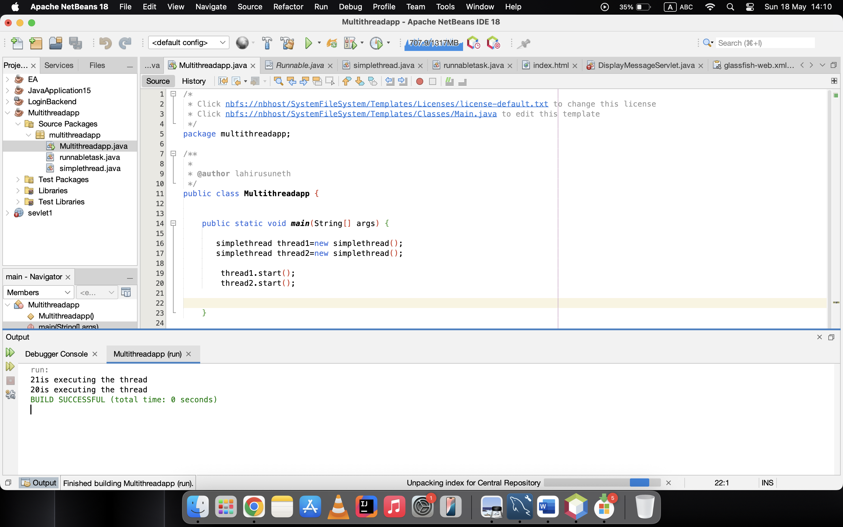**Part**

**2: Using Runnable Interface**

* Create a Runnable Class

public class runnabletask implements Runnable{

@Override

public void run(){

System.out.println(Thread.currentThread().getId()+"is executing the runnable task.");

}

public static void main(String[] args) {

runnabletask task1 = new runnabletask();

runnabletask task2 = new runnabletask();

Thread thread1 = new Thread(task1);

Thread thread2 = new Thread(task2);

thread1.start(); // Starts thread1

thread2.start();

}

}

}

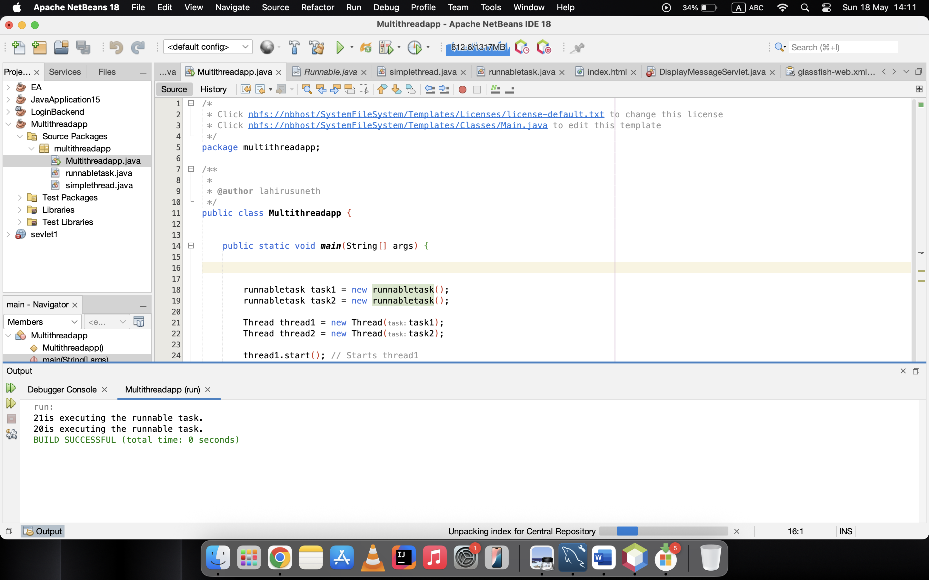

**Part 3: Synchronizing Threads**

* Synchronizing Shared Resources

public class Counter {

private int count = 0;

// Synchronized method to ensure thread-safe access to the counter

public synchronized void increment() {

count++;

}

public int getCount() {

return count;

}

}

public class SynchronizedExample extends Thread{

private Counter counter;

public SynchronizedExample(Counter counter) {

this.counter = counter;

}

@Override

public void run() {

for (int i = 0; i < 1000; i++) {

counter.increment();

}

}

public static void main(String[] args) throws InterruptedException {

Counter counter=new Counter();

// Create and start multiple threads

Thread thread1 = new SynchronizedExample(counter);

Thread thread2 = new SynchronizedExample(counter);

thread1.start();

thread2.start();

// Wait for threads to finish

thread1.join();

thread2.join();

System.out.println("Final counter value: " + counter.getCount());

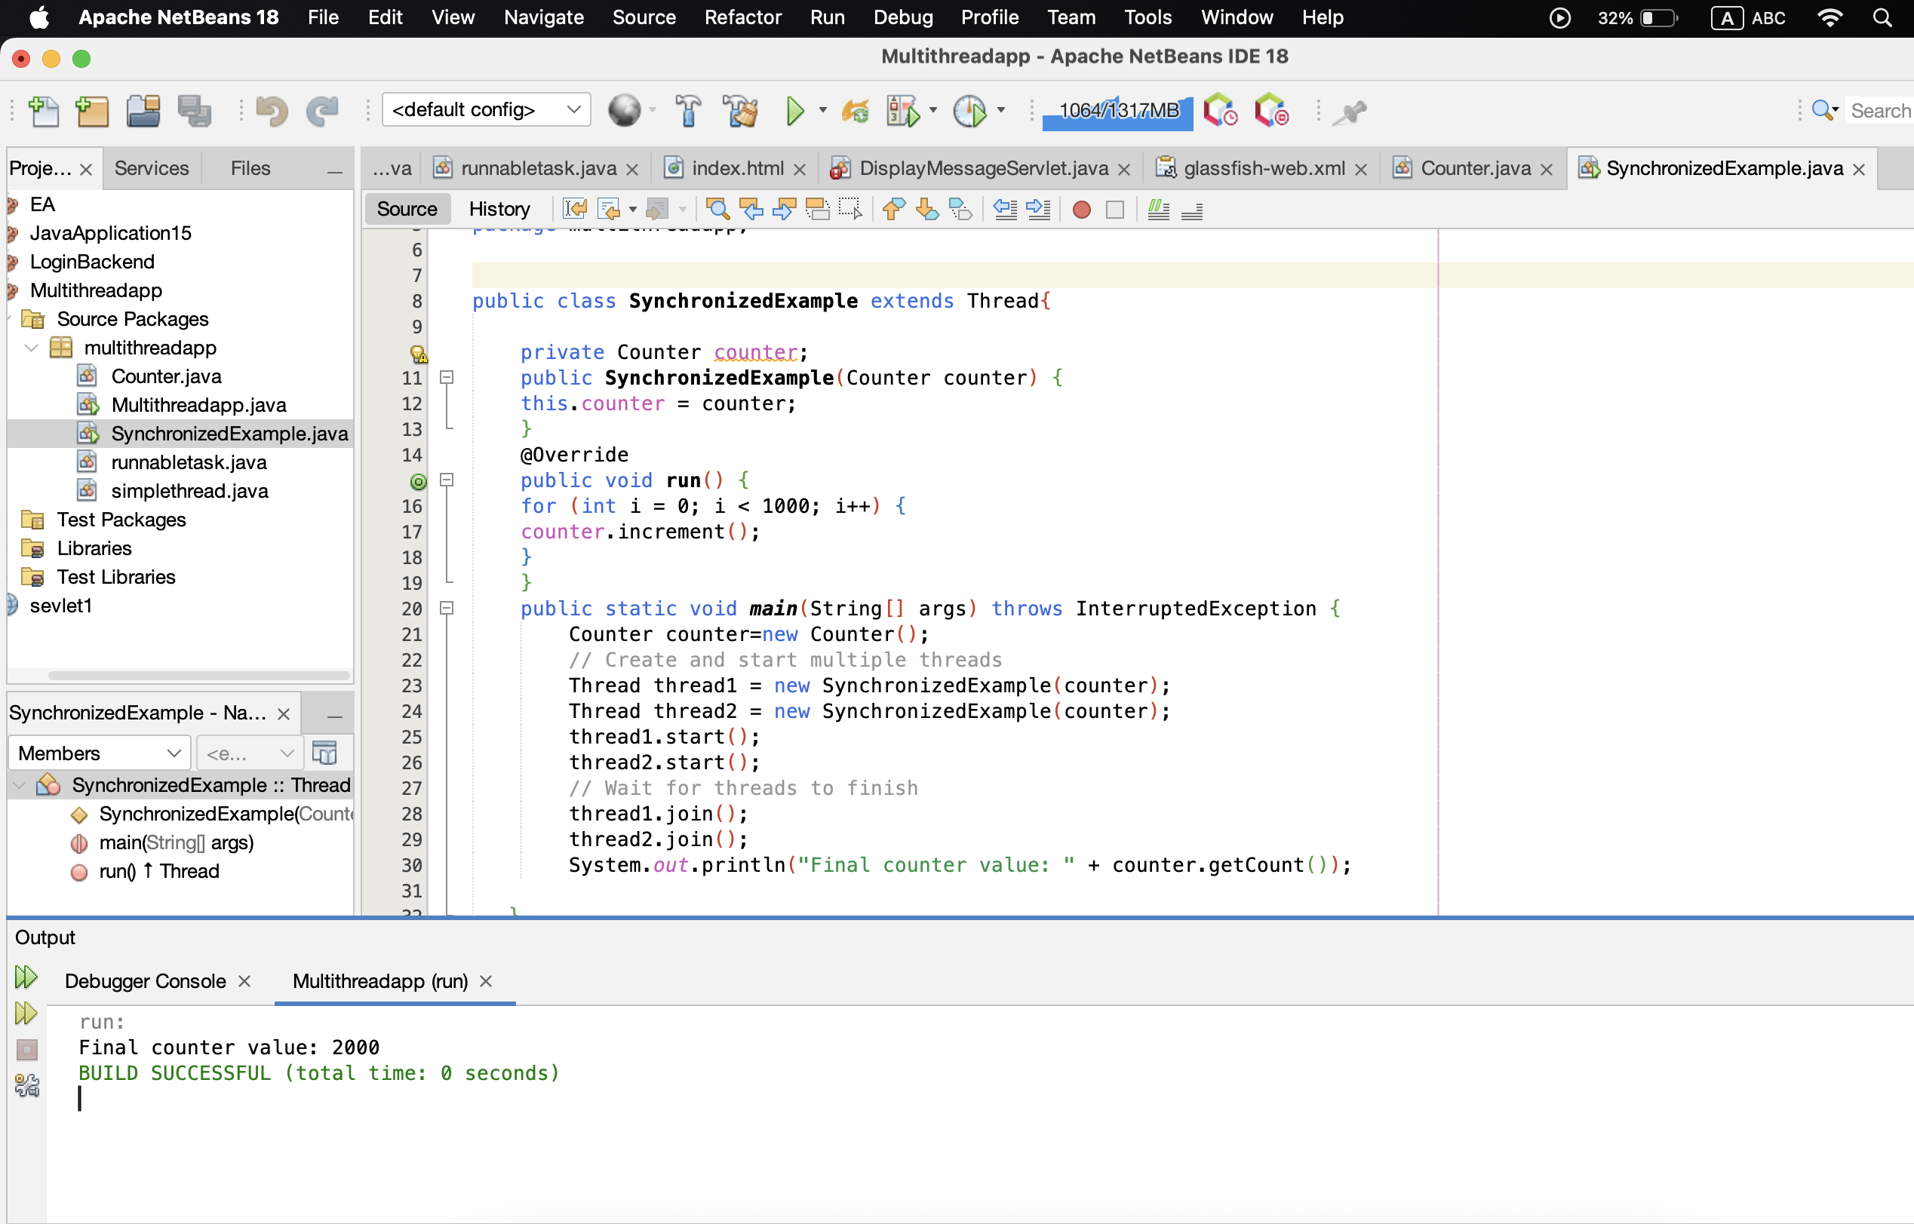

**Part 4: Thread Pooling**

* Using ExecutorService for Thread Pooling

import java.io.IOException;

import java.nio.CharBuffer;

import java.util.concurrent.ExecutorService;

import java.util.concurrent.Executors;

public class Task implements Runnable{

private final int taskId;

public Task(int taskId) {

this.taskId = taskId;}

@Override

public void run() {

System.out.println("Task " + taskId + " is being processed by " +

Thread.currentThread().getName());

}

public int read(CharBuffer cb) throws IOException {

throw new UnsupportedOperationException("Not supported yet."); // Generated from nbfs://nbhost/SystemFileSystem/Templates/Classes/Code/GeneratedMethodBody

}

}

public class ThreadPoolExample {

public static void main(String[] args) {

// Create a thread pool with 3 threads

ExecutorService executorService = Executors.newFixedThreadPool(3);

// Submit tasks to the pool

for (int i = 1; i <= 5; i++) {

executorService.submit (new Task(i));

}

// Shutdown the thread pool

executorService.shutdown();

}

}

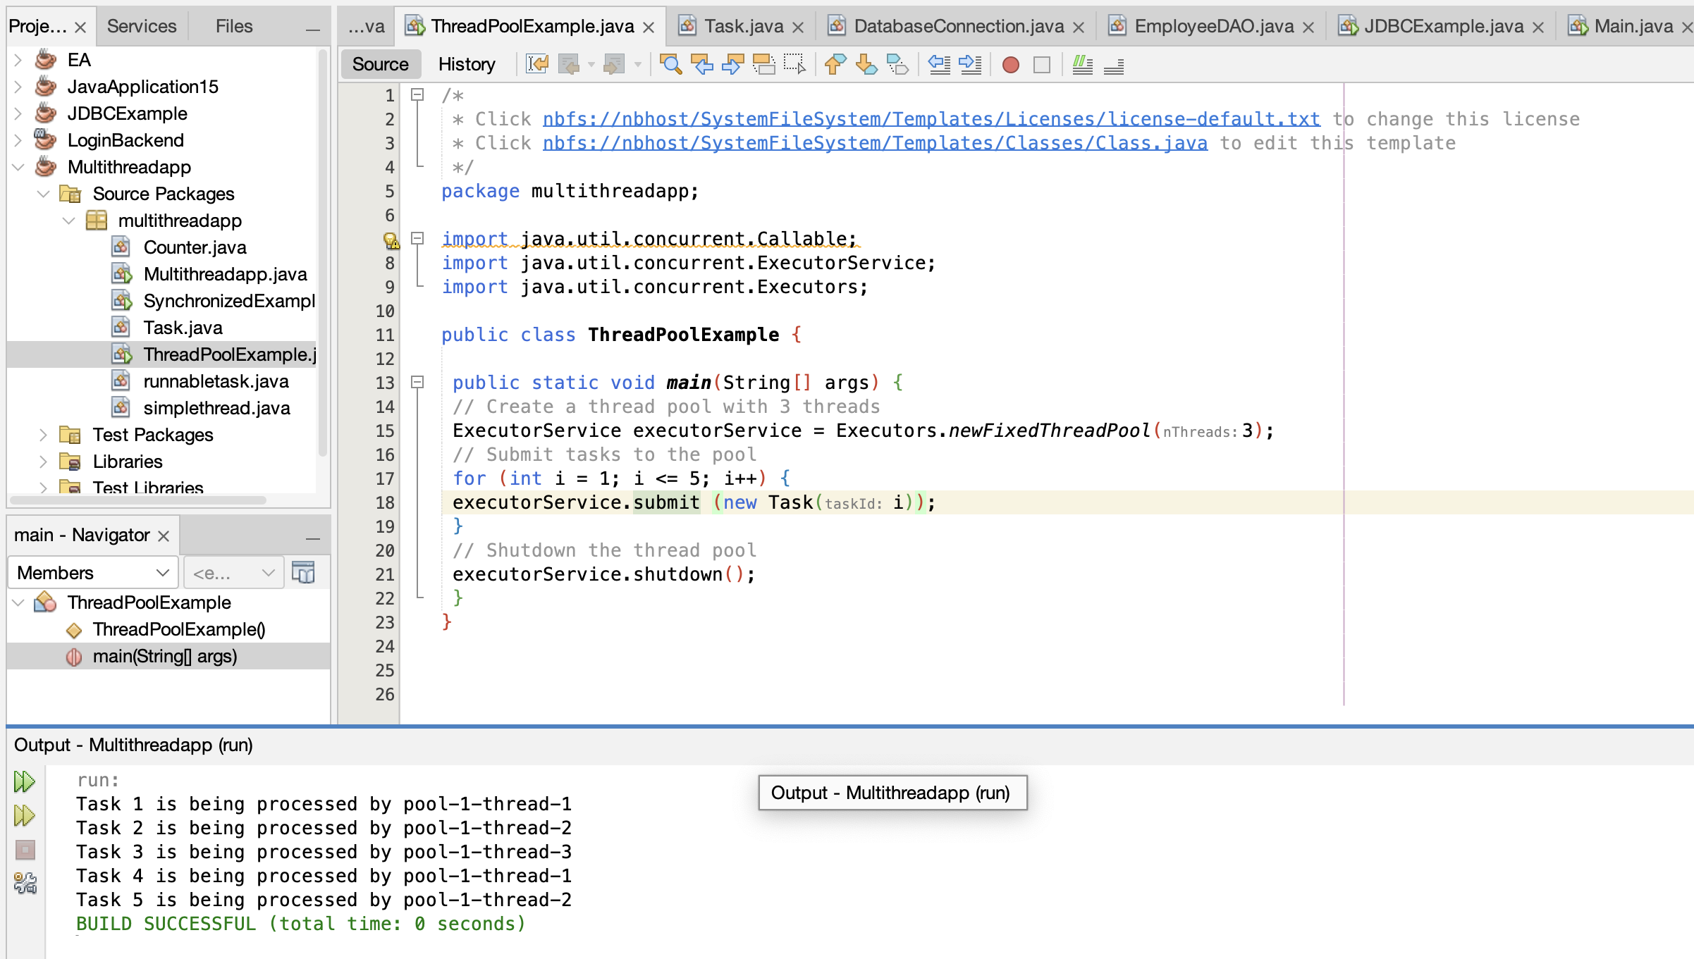

**Part 5: Thread Lifecycle and States**

public class ThreadLifecycleExample extends Thread{

@Override

public void run() {

System.out.println(Thread.currentThread().getName() + " - State: " +Thread.currentThread().getState());

try {

Thread.sleep(2000); // Simulate waiting state

}

catch (InterruptedException e) {

e.printStackTrace();

}

System.out.println(Thread.currentThread().getName() + " - State aftersleep: " + Thread.currentThread().getState());

}

public static void main(String[] args) {

ThreadLifecycleExample thread = new ThreadLifecycleExample();

System.out.println(thread.getName() + " - State before start: " +thread.getState());

thread.start(); // Start the thread

System.out.println(thread.getName() + " - State after start: " + thread.getState());

}

}

