GAM/IT/2022/F/0070

Java Servlet Practical Lab Sheet

Lab Task 1: Simple Servlet - Display Static Message

import jakarta.servlet.ServletException;

import jakarta.servlet.annotation.WebServlet;

import jakarta.servlet.http.HttpServlet;

import jakarta.servlet.http.HttpServletRequest;

import jakarta.servlet.http.HttpServletResponse;

import java.io.IOException;

import java.io.PrintWriter;

@WebServlet(urlPatterns = {"/displayMessage"})

public class DisplayMessageServlet extends HttpServlet {

protected void doGet(HttpServletRequest request, HttpServletResponse response)

throws ServletException, IOException {

response.setContentType("text/html");

PrintWriter out = response.getWriter();

out.println("<html><body>");

out.println("<h1>Welcome to the Java Servlet Lab!</h1>");

out.println("</body></html>");

}

Lab Task 2: Get User Input from Form and Display

**HTML Form (index.html):**

<!DOCTYPE html>

<html>

<body>

<head><title>Input Form</title></head>

<form action="getUserInput" method="POST">

Name: <input type="text" name="username" required><br>

<input type="submit" value="Submit">

</form>

</body></html>

**Servlet Code (GetUserInputServlet.java):**

package com.example;

import java.io.IOException;

import java.io.PrintWriter;

import javax.servlet.ServletException;

import javax.servlet.annotation.WebServlet;

import javax.servlet.http.HttpServlet;

import javax.servlet.http.HttpServletRequest;

import javax.servlet.http.HttpServletResponse;

@WebServlet("/getUserInput")

public class GetUserInputServlet extends HttpServlet {

protected void doPost(HttpServletRequest request, HttpServletResponse

response)

throws ServletException, IOException {

String username = request.getParameter("username");

response.setContentType("text/html");

PrintWriter out = response.getWriter();

out.println("<html><body>");

out.println("<h1>Hello, " + username + "!</h1>");

out.println("</body></html>");

}

}

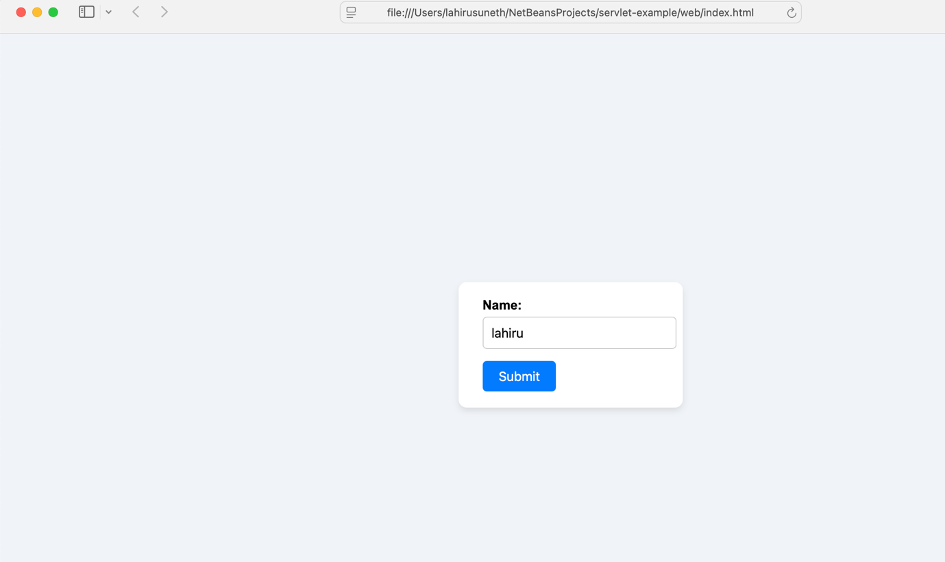

Lab Task 3: Get Multiple Inputs, Perform Calculation, and Display Result

**HTML Form (calculate.html):**

<!DOCTYPE html>

<html>

<head>

<title>Sum Calculator</title>

<style>

body {

font-family: Arial, sans-serif;

background-color: #f0f4f8;

display: flex;

justify-content: center;

align-items: center;

height: 100vh;

margin: 0;

}

form {

background-color: #ffffff;

padding: 20px 30px;

border-radius: 10px;

box-shadow: 0 4px 8px rgba(0, 0, 0, 0.1);

}

input[type="number"] {

padding: 8px;

margin: 10px 0;

width: 100%;

border: 1px solid #ccc;

border-radius: 5px;

}

input[type="submit"] {

background-color: #007bff;

color: white;

padding: 10px;

width: 100%;

border: none;

border-radius: 5px;

cursor: pointer;

font-size: 16px;

}

input[type="submit"]:hover {

background-color: #0056b3;

}

label {

display: block;

margin-top: 10px;

}

</style>

</head>

<body>

<form action="calculateSum" method="POST">

<label for="num1">First Number:</label>

<input type="number" name="num1" id="num1" required>

<label for="num2">Second Number:</label>

<input type="number" name="num2" id="num2" required>

<input type="submit" value="Calculate Sum">

</form>

</body>

</html>

**Servlet Code (CalculateSumServlet.java):**

import jakarta.servlet.ServletException;

import jakarta.servlet.annotation.WebServlet;

import jakarta.servlet.http.HttpServlet;

import jakarta.servlet.http.HttpServletRequest;

import jakarta.servlet.http.HttpServletResponse;

import java.io.IOException;

import java.io.PrintWriter;

/**

*

* @author User

*/

@WebServlet(urlPatterns = {"/calculateSum"})

public class CalculateSumServlet extends HttpServlet {

@Override

protected void doPost(HttpServletRequest request, HttpServletResponse response)

throws ServletException, IOException {

// Retrieve and parse the input numbers from the request

int num1 = Integer.parseInt(request.getParameter("num1"));

int num2 = Integer.parseInt(request.getParameter("num2"));

// Calculate the sum

int sum = num1 + num2;

// Set response content type

response.setContentType("text/html");

// Generate HTML response

PrintWriter out = response.getWriter();

out.println("<!DOCTYPE html>");

out.println("<html>");

out.println("<head>");

out.println("<title>Sum Result</title>");

out.println("<style>");

out.println("body { font-family: Arial, sans-serif; background-color: #f0f8ff; text-align: center; padding-top: 50px; }");

out.println("h1 { color: #333; }");

out.println("</style>");

out.println("</head>");

out.println("<body>");

out.println("<h1>The sum of " + num1 + " and " + num2 + " is: <strong>" + sum + "</strong></h1>");

out.println("</body>");

out.println("</html>");

}

}

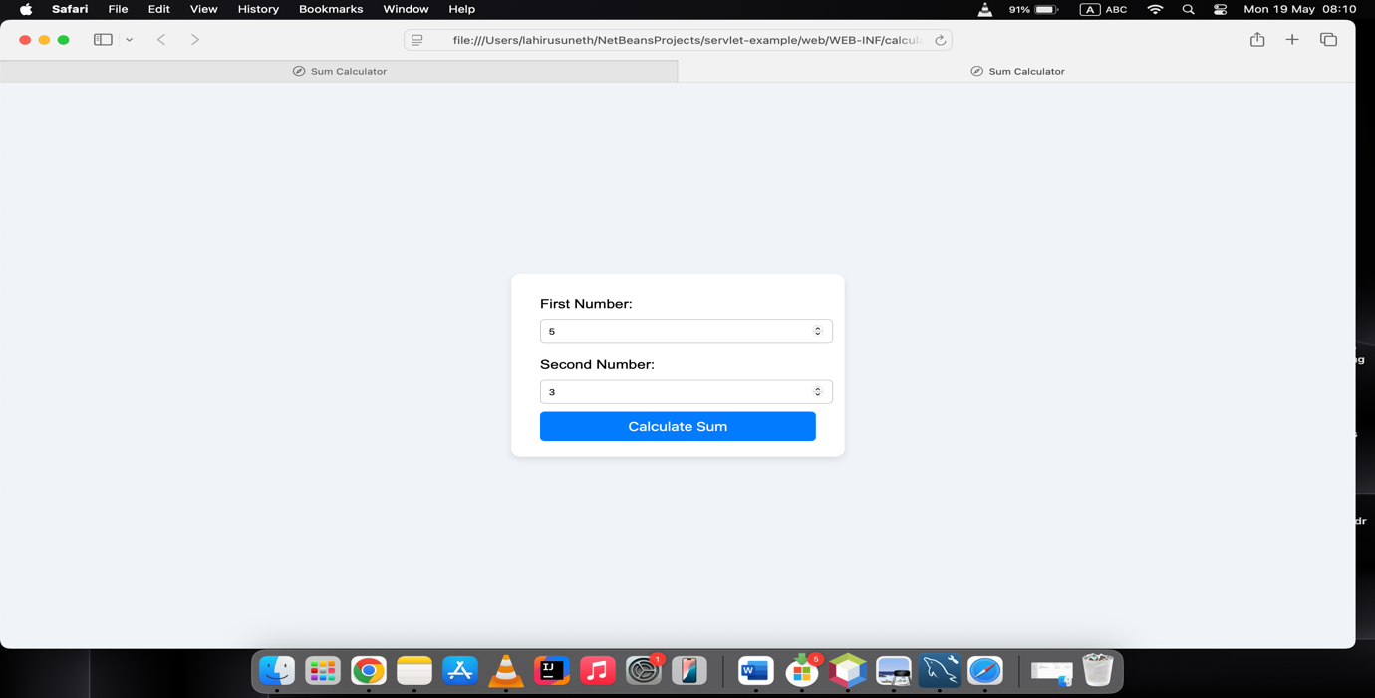

Lab Task 4: Java Servlet with Database CRUD Operations

**Database Setup (MySQL example):**

CREATE DATABASE stock_management;

USE stock_management;

CREATE TABLE stock (

id INT AUTO_INCREMENT PRIMARY KEY,

product_name VARCHAR(255),

quantity INT

);

**HTML Form (stockForm.html):**

<!DOCTYPE html>

<html>

<head>

<title>Stock Management</title>

<style>

body {

font-family: Arial, sans-serif;

background-color: #eef2f7;

display: flex;

justify-content: center;

align-items: center;

height: 100vh;

margin: 0;

}

form {

background-color: #ffffff;

padding: 30px 40px;

border-radius: 10px;

box-shadow: 0 4px 10px rgba(0, 0, 0, 0.1);

width: 300px;

}

h2 {

text-align: center;

margin-bottom: 20px;

color: #333333;

}

label, input[type="text"], input[type="number"] {

display: block;

width: 100%;

margin-bottom: 15px;

}

input[type="text"],

input[type="number"] {

padding: 10px;

border: 1px solid #ccc;

border-radius: 6px;

font-size: 14px;

}

input[type="submit"] {

width: 100%;

padding: 10px;

margin-top: 10px;

margin-bottom: 5px;

background-color: #007bff;

color: white;

border: none;

border-radius: 6px;

cursor: pointer;

font-size: 16px;

transition: background-color 0.3s;

}

input[type="submit"]:hover {

background-color: #0056b3;

}

input[type="submit"]:nth-child(4) {

background-color: #28a745;

}

input[type="submit"]:nth-child(4):hover {

background-color: #1e7e34;

}

input[type="submit"]:nth-child(5) {

background-color: #dc3545;

}

input[type="submit"]:nth-child(5):hover {

background-color: #c82333;

}

</style>

</head>

<body>

<form action="stockAction" method="POST">

<h2>Manage Stock</h2>

<label for="product_name">Product Name:</label>

<input type="text" name="product_name" id="product_name" required>

<label for="quantity">Quantity:</label>

<input type="number" name="quantity" id="quantity" required>

<input type="submit" name="action" value="Add Product">

<input type="submit" name="action" value="Update Product">

<input type="submit" name="action" value="Delete Product">

</form>

</body>

</html>

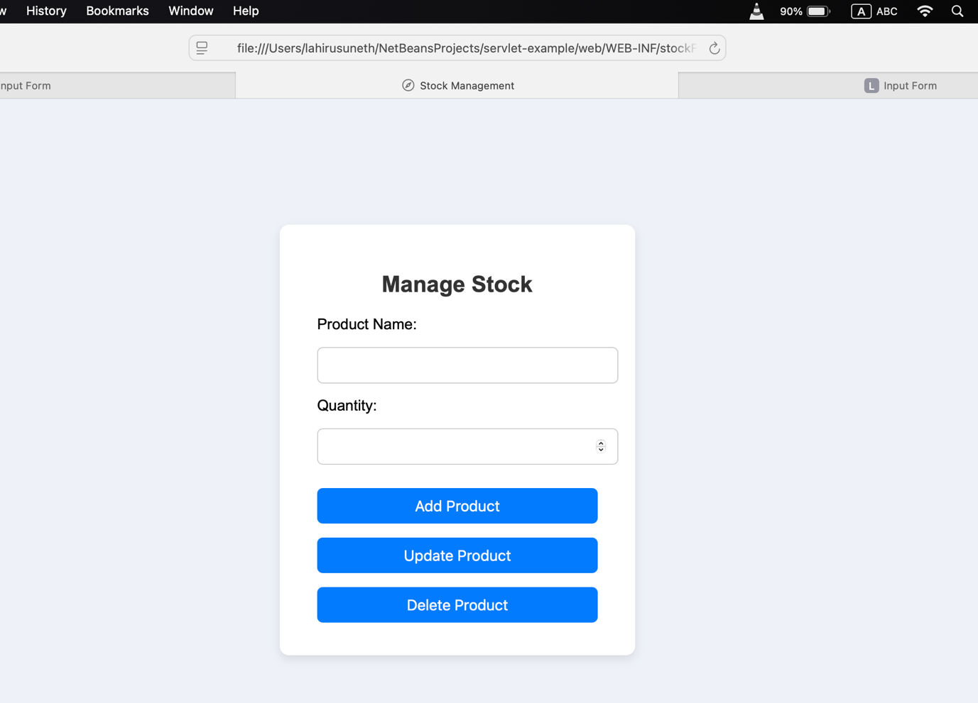

Lab Task 5: Display Data from Database on Another Web Page

**Servlet Code (DisplayProductsServlet.java):**

/*

* Click nbfs://nbhost/SystemFileSystem/Templates/Licenses/license-default.txt to change this license

* Click nbfs://nbhost/SystemFileSystem/Templates/JSP_Servlet/Servlet.java to edit this template

*/

import jakarta.servlet.ServletException;

import jakarta.servlet.annotation.WebServlet;

import jakarta.servlet.http.HttpServlet;

import jakarta.servlet.http.HttpServletRequest;

import jakarta.servlet.http.HttpServletResponse;

import java.io.IOException;

import java.io.PrintWriter;

import java.sql.*;

/**

*

* @author User

*/

@WebServlet(urlPatterns = {"/DisplayProducts"})

public class DisplayProductsServlet extends HttpServlet {

private Connection getConnection() throws SQLException {

try {

Class.forName("com.mysql.cj.jdbc.Driver"); // Load MySQL JDBC driver

} catch (ClassNotFoundException e) {

throw new SQLException("MySQL JDBC Driver not found.", e);

}

String url = "jdbc:mysql://localhost:3306/stock_management?useSSL=false&allowPublicKeyRetrieval=true&serverTimezone=UTC";

String username = "root";

String password = "uthpala"; // Use your MySQL password if set

return DriverManager.getConnection(url, username, password);

}

@Override

protected void doGet(HttpServletRequest request, HttpServletResponse response)

throws ServletException, IOException {

response.setContentType("text/html");

PrintWriter out = response.getWriter();

try (Connection conn = getConnection()) {

Statement stmt = conn.createStatement();

ResultSet rs = stmt.executeQuery("SELECT * FROM stock");

out.println("<html><head><title>Stock List</title></head><body>");

out.println("<h1> Stock List</h1>");

out.println("<ul>");

while (rs.next()) {

out.println("<li>" + rs.getString("product_name") + ": " + rs.getInt("quantity") + "</li>");

}

out.println("</ul>");

out.println("</body></html>");

} catch (SQLException e) {

e.printStackTrace();

out.println("<h1> Database Error: " + e.getMessage() + "</h1>");

}

}

}