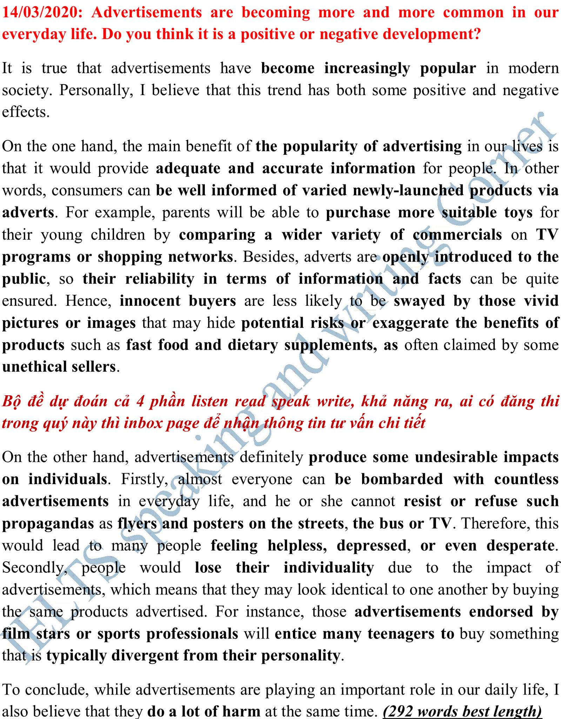

**Advertising is becoming more and more common in our everday life. Do you think that is positive or negative impacts.**

It is observed that advertising is so entwined in our daily lives. Although advertising brings a wide range of benefits to our society, many individuals believe that consumers are being bombard with it. This essay will discuss both perspectives .

On the one hand, advertising generally relects unlimited creativity of human beings. Despite having a variety of commercials in the market, people are still capable of inventing newly-lanched approaches to meet requirements of providers. Take the refreshment beverage industry as an example, coca-cola has not changed its taste for several years, yet their profit is still conpicously escalating. This is often linked to the catchy marketing made by the company. Similar to pepsi and fanta. Furthuremore, advertising may enhance the betterment of technologies applied to commercials such as high-quality camera or state-of-the-art intrumental tools.

On the other hand, advertisement is problematic when it comes to trustworthy. As advertising often propagates their brighter sides, thus providing an incomplete pictures of the products. Herbal products or weight loss supplements, for instances . It is believed that the only way to lower their weight is through proper diet and exercises, which is cofirmed by heath experts. One of my friends buys this products and then immediately regrets. Apart form that, it is critisized that providers manipulate consumers into the following will of advertisement. By being omnipresent, advertising persude consumers to make an implusive purchase.For example, consumers generally buy more and more clothes that look the same as social influencers or celebrities who usually get paid to wear those.

In conclusion, on the whole, based on above reasons, although advertisement is full of controversy, the advantages seem to outweigh the drawbacks.

**Advertising is becoming more and more common in our everday life. Do you think that is positive or negative impacts**

It is common that advertising is entwined in our daily life. Besides its advantages, many people believe that there is a wide range of disadvantages that should be considered. This essay will discuss both perspective

On the one hand, advertising has a prominent effect on our modern life. Firstly, it helps bring the issues of importance to light such as texting while driving, acholoic controllers. Message boards or alarming signs, for instance, inform drivers about upcomming hazards or potential threats that may occur on the high way. These help them increase their safty as well as adjust proper routes. Secondly, advertising is a valuable intrumental tools. As advertising is likely to speed the acceptance of products faster than word of mouth. Take the beverage industry as an example, coca-cola profits are conpicously acclerating for several years even though its taste remain unchanged. This is often linked to the catchy commercials like funny videos or appealing images.

On the other hand, advertising is also full of controversy. With constantly omnipresent marketing, providers are unable to manipulate consumers into the following will of advertisements. For example, may consumers are willing to queue hours or even days to buy the latest smart phones whereas the old ones still perform perfectly. This is a result of unreasonable persception propagated by cell phone companies. Or in fashion industry, those advertisements endorsed by film stars or sports professional will entice many teenaggers to buy something that is typically divergent from their personality.

In conclusion, on the whole, based on above reasons, although advertising has a variety of drawbacks, it seem to me that the benefits outweigh.

**Bài sửa**

It is common that advertising is entwined in our daily life. Besides its advantages, many people believe that there is a wide range of disadvantages that should be considered. This essay will discuss both perspectives

On the one hand, advertising has a prominent effect on our modern life. Firstly, it helps bring the issues of importance to light such as texting while driving, alcoholic controllers. Message boards or alarming signs, for instance, inform drivers about upcoming hazards or potential threats that may occur in a high way. These help them increase their safety as well as adjust proper routes. Secondly, advertising is a valuable instrumental tool. As advertising is likely to speed the acceptance of products faster than word of mouth. Take the beverage industry as an example, coca-cola profits are conspicuously accelerating for several years even though its taste remains unchanged. This is often linked to the catchy commercials like funny videos or appealing images.

On the other hand, advertising is also full of controversy. With constantly omnipresent marketing, providers are unable to manipulate consumers into the following will of advertisements. For example, many consumers are willing to queue hours or even days to buy the latest smartphones whereas the old ones still perform perfectly. This is a result of unreasonable perception propagated by cell phone companies. Or in the fashion industry, those advertisements endorsed by film stars or sports professionals will entice many teenagers to buy something that is typically divergent from their personality.

In conclusion, on the whole, based on above reasons, although advertising has a variety of drawbacks, it seems to me that the benefits outweigh.