# Chapter One

He was a dark and stormy knight…

Next paragraph is empty:

Next paragraph is white space:

## Chapter Two

### Ordered and Unordered Lists

* One
* Two
* Three

1. First
2. Second
3. Third

#### Chapter 4

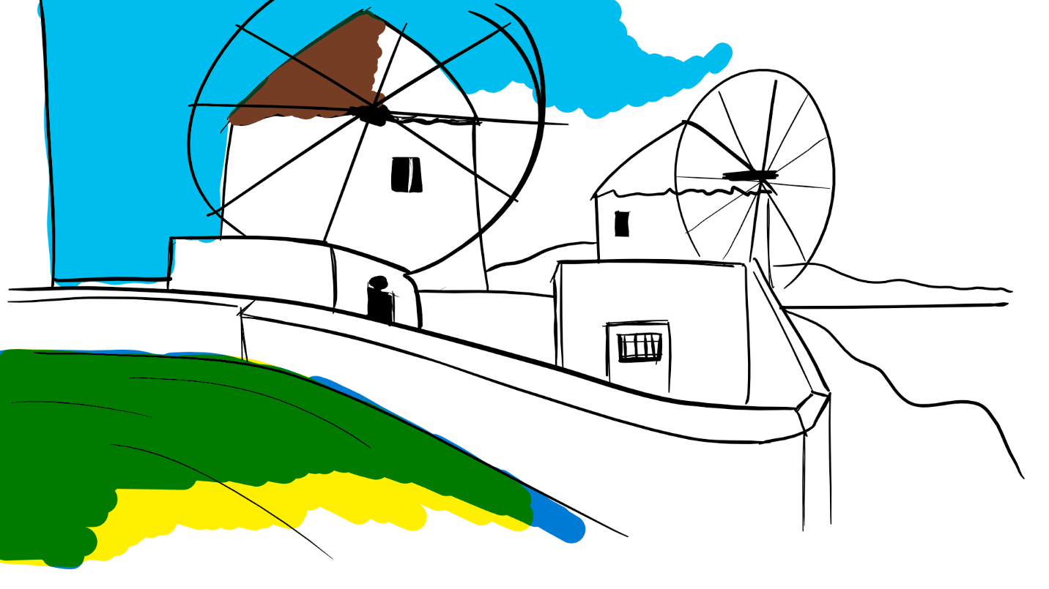

##### Chapter Five

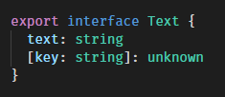

###### Chapter 6: Tables

|  |  |
| --- | --- |
| Coral | 5 |
| Kodabears | 6 |