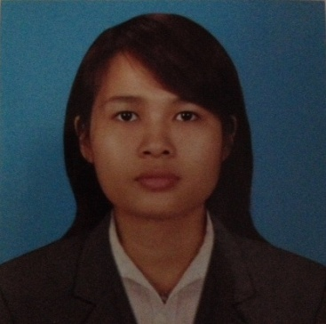 **KHIN THANDAR WIN**

No.(8),Shwe Phone Pwint Pagoda Road,

Pazudaung T/s.Yangon.Myanmar.

Date of birth : **31 December 1976**

Phone No : **09-791669177**

Email : **khinthandarwin82@gmail.com**

**PERSONAL PROFILE**

I am in the connection with **Vacancy** within your **Company** for which you feel I may be suited. Please find enclosed a copy of my Curriculum Vitae.

I am an ambitious young professional looking for an opportunity to progress. I seek advancement and wish to work in a team orientated environment and making a valuable contribution to success with my experience.

**Key Skills:**

* Determined and effective under pressure and able to meet deadlines
* Enthusiastic team-worker
* Honest and reliable
* Able to communicate in Japanese and English
* Creative imaginative and capable at finding solutions and alternatives
* Computer literate in Word, Excel, Access, Power Point and Internet
* Active, flexible and adaptable
* Willing and able to learn new skills and methods

**EDUCATION & QUALIFICATIONS**

**University Of Yangon (1995-2002)**

* Bachelor Of Science (Zoology) (University Of Yangon)

**B.S.C College Of Yangon (1995)**

* English Typewriting and Bookkeeping

**The British Council (1997)**

* Elementary B level

**YES Language Centre (1997)**

* Conversation Course

**The Gemmological Science Centre (1997)**

* Basic Course

**WIN Japanese Language School (1998 – 2001)**

* Basic Course
* Intermediate Course
* Basic Conversation Course
* Pre-advanced Course
* Advanced Course
* Level-2 Kanji Course

**MOMIJI Japanese Language Centre (1999 – 2000)**

* Pre-advanced II Course
* Advanced Course

**Stamford – City Business Institute (2000-May)**

* Professional Certificate In Personal Selling

**PRO Computer Center (2001)**

* Windows 98 Course

**INFORMATICS Computer Centre (2002-Oct to 2002-Dec)**

* Computerised Accounting (ACCPAC Plus 6.1A)
* C&C++ Programming Course

**PC Power Computer Training Centre (2005)**

* Basic Hardware Course

**U Aung Win Diploma Training Centre (2007-2009)**

* Level I+II Course
* Level III Course

**Asia Language and Business Academy (2008)**

* IELTS Class

**WORK EXPERIENCE**

**2004-2005 MO MO Beauty Saloon(Yangon)**

**Japanese Teacher, Translator & Interpreter**

* **Taught Japanese language to the staff and translated and interpreted between Myanmar language to Japanese.**

**2005-2006 NAGANO Japanese Language Centre(Yangon)**

**Japanese Teacher**

* **Taught Japanese language to the Myanmar student, assistant teacher for Japanese teacher, Taught Myanmar language to Japanese teacher.**
* **Supported to office administration**

**2007 Visited to Japan**

**2007-2011 Full Wealth General Service Co.,Ltd (Yangon)**

**General Manager**

* **Reorganized and managed company regulation, staff recruiting and staff training.**
* **Supporting for the managing director expatriate**

**2011-2013 VAC (Vietnam Accounting & Consulting) (Yangon)**

**Office Administration & HR**

* **Managed to office administration, supporting to company set up.**
* **Translated and interpreted between Japanese language to Myanmar.**
* **Staff Recruiting and calculated the daily payment account.**
* **Supporting for the director**

**2014-2015 Freelance Japanese guide, Translator and Interpreter**

**2015-Aug SHOWA GLOVE MYANMAR Co.,Ltd. (Thilawa, Thalyin)**

**General Affair & Human Resource Department**

* **Managed to office administration, supporting for Japanese expatriate, Interpreter and translation.**
* **Supported to director**
* **Human resources and Payroll, Staff recruiting, Staff training.**

**2015-Oct to Present Freelance Japanese guide, Translator and Interpreter**

**COMPUTER KNOWLEDGE**

* iOffice 2007
* Word, Outlook Express, Excel.

**PERSONAL DETAIL**

Sex **:** Female

Marital Status **:** Single

Race/ Nationality : Myanmar (Burma)

Religion **:** Buddish