|  |
| --- |
| **Huynh Minh Tai** |
| Software Engineering |
| **Date of birth**: Jan 21, 1993 |
| **Gender**: Male |
| **Email**: minhtaifu@gmail.com |
| **Address**: HoChiMinh, Vietnam |
|  |
|  |
|  |
|  |
|  |

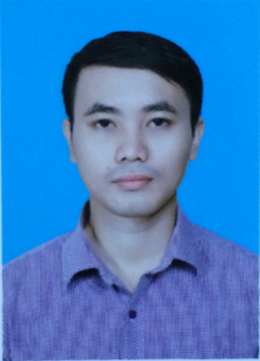

**EDUCATION**

Oct 2011 - Apr 2016 FPT University

Major: Software Engineering

GPA: 7.2/10

**TECHNICAL** **SKILL**

|  |  |
| --- | --- |
| Java | * With knowledge of Core Java. * Have experience with Servlet, JSP, Spring. |
| C#, .NET | * Have experience in web development and window application using Microsoft technology (ASP.NET, C#, MS SQL Server). |
| SQL | * Good knowledge of MS SQL Server |
| HTLM, CSS, Javascript, Ajax | * Basic knowledge about AJAX, AngularJS. * Experience with HTML5 /CSS3 and Web Responsive. |

**WORKING EXPERIENCE**

Jul 2016 – Dec 2017 FPT Software

|  |  |
| --- | --- |
| Project Name | REGSYS |
| Description | Create a registration system to register patient’s information sending from hospital, and send examination result back to hospital |
| Team size | 12 |
| My responsibilities | * Coding * Create Basic design and functional specification document * Unit testing |
| Technologies used | C#, WCF, Entity Framework, MS SQL 2012 |

|  |  |
| --- | --- |
| Project Name | GBOOK |
| Description | Create system relating to the service was provided in car navigation. |
| Team size | 30 |
| My responsibilities | * Coding * Unit Testing |
| Technologies used | C#, Entity Framework, MS SQL 2008 |

**LANGUAGES SKILL**

English Limited working Proficiency

Japanese Limited working Proficiency (JLPT N3, 2015/12)