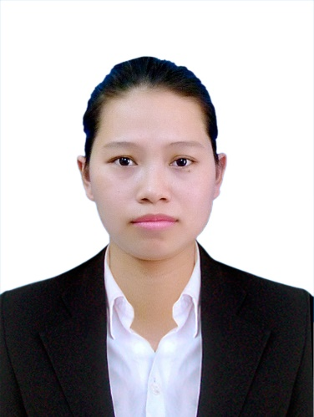**NGUYEN THI MONG THAM**

Date of birth: 02/12/1994

Place of birth: Dong Nai Province

Gender: Female

Phone: 01285746786

Email: tham21294@gmail.com

Address: D5Street, 25 District, Ho Chi Minh City

**OBJECTIVE**

* Use what I have learned and improve myself by making contribution to society
* Experience a challenging job in a dynamic and professional working environment

**EDUCATION**

August 2012 - April 2018 Foreign Trade University Ho Chi Minh City

Major: International Business Economics

GPA: 7.36/10

March 2015 – april 2016 Meros Japanese Language School in Tokyo, Japan

July 2017 Level N2 - Japanese Language Proficiency Test (JLPT)

**VOLUNTEER AND ACTIVITIES**

**Volunteer:**

* Joining program “Green Summer Campaign” organized in Ho Chi Minh City
* Joining program “Blood Donation” organized by Foreign Trade University

**Activities:**

Doing part-time work in Toky

* Cashier at Seven Eleven Convenience Stores
* Staff at AEON Super Maket

Doing part-time work in Viet Nam

* Cashier at Family Mart Convenience Stores
* Japanese Tutor
* Waitress at Palace Wedding Restaurant

**Achievements:**

* Improved my soft skills in communication and teamwork
* Improved my Japanese skill in listening and speaking
* Improved my soft skills to face with difficult situations

**OTHER INFORMATION**

**Character:**

* Hard working, Optimistic and Responsible

**Interests/hobbies:**

* Travelling with family and friends
* Joining in social and volunteer activities
* Reading books